

Notice of variation and consolidation with introductory note
The Environmental Permitting (England & Wales) Regulations 2016

Dŵr Cymru Cyfyngedig

Gorsgoch Wastewater Treatment Works
Track off B4338
Gorsgoch
Llanybydder
Ceredigion
SA40 9TR

Variation number
PAN-031692

Permit number

BG0043501

Gorsgoch Wastewater Treatment Works

Permit number BG0043501

Introductory note

This introductory note does not form a part of the notice.

The following notice gives notice of the variation and consolidation of an environmental permit.

This permit variation is to reflect asset improvements that have been agreed between Natural Resources Wales and Dŵr Cymru Cyfyngedig as part of the National Environment Programme. Under the WFD Prevent Deterioration driver the following limits have been revised: BOD 26 mg/l LUT, Total Suspended Solids 39 mg/l LUT, and Ammonia 18.5 mg/l LUT effective from 22/12/2027.

The schedules specify the changes made to the permit.

The status log of a permit sets out the permitting history, including any changes to the permit reference number. It is not backdated before 6th April 2010.

Status log of the permit
Description | Date | Comments
Regulator-initiated  variation PAN-022933 | Duly made 08/03/2024 | A Total Phosphorus limit has been added, with a further reduction from 31/03/2032. The BOD limit has been amended. Effective dates stated in Tables S3.1. OSM Tier 2 has changed to Tier 3.
Variation determined  BG0043501 | 25/06/2024 | Varied and consolidated permit issued in modern condition format to Dŵr Cymru Cyfyngedig
Regulator-initiated variation PAN-031692 | 06/02/2026 | The BOD, Suspended Solids, and Ammonia limits have been amended. Effective dates stated in Tables S3.1.
Variation determined BG0043501 | 20/03/2026 | Varied permit issued to Dŵr Cymru Cyfyngedig.

End of introductory note.
Notice of variation and consolidation
The Environmental Permitting (England and Wales) Regulations 2016

The Natural Resources Body for Wales (“Natural Resources Wales”) in exercise of its powers under regulation 20 of the Environmental Permitting (England and Wales) Regulations 2016 varies and consolidates

permit number

BG0043501

issued to

Dŵr Cymru Cyfyngedig (“the operator”)

whose registered office is

Linea

Fortran Road

St Mellons

Cardiff

CF3 0LT

company registration number 02366777

to operate a water discharge activity at

Gorsgoch Wastewater Treatment Works

Track off B4338

Gorsgoch

Llanybydder

Ceredigion

SA40 9TR

to the extent set out in the schedules.

The notice shall take effect from 25/03/2026.

Name | Date
Joanne Fitton | 25/03/2026

Authorised on behalf of Natural Resources Wales.

Schedule 1
No conditions have been varied by the consolidated permit as a result of a Natural Resources Wales initiated variation.

Schedule 2 – consolidated permit

Consolidated permit issued as a separate document.
Permit
The Environmental Permitting (England and Wales) Regulations 2016

Permit number

BG0043501

This is the consolidated permit referred to in the variation and consolidation notice for variation PAN-031692 authorising

Dŵr Cymru Cyfyngedig (“the operator”),

whose registered office is

Linea

Fortran Road

St Mellons

Cardiff

CF3 0LT

company registration number 02366777

to operate a water discharge activity at

Gorsgoch Wastewater Treatment Works

Track off B4338

Gorsgoch

Llanybydder

Ceredigion

SA40 9TR

to the extent authorised by and subject to the conditions of this permit.

The permit variation and consolidation shall take effect from 25/03/2026.

Name | Date
Joanne Fitton | 25/03/2026

Authorised on behalf of Natural Resources Wales.

Conditions
- Management
  - General management
    - The operator shall manage and operate the activity:
      - in accordance with a written management system that identifies and minimises risks of pollution so far as is reasonably practicable, including those risks arising from operations, maintenance, accidents, incidents, non-conformances and those drawn to the attention of the operator as a result of complaints; and
      - using sufficient competent persons and resources.
    - Records demonstrating compliance with condition 1.1.1 shall be maintained.
    - Any person having duties that are or may be affected by the matters set out in this permit shall have convenient access to a copy of the permit.
- Operations
  - Permitted activities
    - The only activity authorised by the permit is the activity specified in schedule 1 table S1.1.
  - The site
    - The discharge activity shall take place at the discharge point marked on the site plans at schedule 7 to this permit, and as listed in table S3.2.
- Emissions and monitoring
  - Emissions to water
    - The limits given in schedule 3 table S3.1 shall not be exceeded.
    - The limits in schedule 3 table S3.1 to which this condition applies may be exceeded where: in any series of samples of the discharge taken at regular but randomised intervals in any period of twelve consecutive months as listed in column 1 of schedule 3A, no more than the relevant number of samples, as listed in column 2 of schedule 3A, exceed the applicable limit for that relevant parameter.

      - For the emission limits in schedule 3 table S3.1 to which this condition applies, no sample of the discharge taken at a time when unusual weather conditions are adversely affecting the operation of the waste water treatment works, shall be taken into account in deciding whether or not the emission limit has been complied with.
      - On any occasion where unusual weather conditions adversely affect the operation of the waste water treatment works, the operator shall use its best endeavours to mitigate that adverse effect.
      - For any sample of the discharge taken to be considered for the purposes of (a) above, the operator shall notify Natural Resources Wales in writing within 14 days of becoming aware that an emission limit has been exceeded. That notification shall include a full description of the unusual weather conditions and their impact on the operation of the works.
    - The permitted Dry Weather Flow limit in schedule 3 table S3.1 is set at the operator’s planned annual 80% exceeded daily volume discharged.
  - Emissions of substances not controlled by emission limits
    - The operator shall take appropriate measures to minimise so far as reasonably practicable the polluting effects of the emissions of substances in the discharge not controlled by emission limits (excluding odour).
  - Monitoring
    - The operator shall, unless otherwise agreed in writing by Natural Resources Wales, undertake the monitoring specified in the following tables in schedule 3 to this permit:
      - point source emissions specified in tables S3.1 and S3.4;
      - inlet quality specified in tables S3.1 and S3.4.
    - The operator shall maintain records of all monitoring required by this permit.
    - Monitoring equipment, techniques, personnel and organisations employed for the emissions monitoring programme and the environmental or other monitoring specified in condition 3.3.1 shall have either MCERTS certification or MCERTS accreditation (as appropriate), where available, unless otherwise agreed in writing by Natural Resources Wales.
    - An accessible monitoring point shall be provided and maintained to enable the emissions monitoring programme and the environmental or other monitoring to be carried out at the monitoring point specified in table S3.4 of schedule 3 and shown marked on the site plans in schedule 7.
    - The monitoring programme for the parameters subject to schedule 3B shall be:
      - pre-scheduled to cover a calendar year and the programme recorded before the start of a calendar year sample period; and
      - samples collected at approximately equal intervals during the year, including samples from different days of the week and different times. Approximately 10% of samples should be outside the normal sampling window which is 9am-3pm, Monday to Friday.
    - After becoming aware, or following a notification that a sample has not been taken on the schedule 3B Monitoring Programme pre-scheduled date, or is lost, or a result for that sample cannot be reported, the operator shall record the details and reschedule the sample.
- Information
  - Records
    - All records required to be made by schedule 3, 4 and 5 to this permit shall:
      - be legible;
      - be made as soon as reasonably practicable;
      - if amended, be amended in such a way that the original and any subsequent amendments remain legible, or are capable of retrieval; and
      - be retained, unless otherwise agreed in writing by Natural Resources Wales, for at least 6 years from the date when the records were made.
    - The operator shall maintain convenient access, in either electronic or hard copy, to the records, plan and management system required to be maintained by this permit.
  - Reporting
    - The operator shall send all reports and notifications required by the permit to Natural Resources Wales using the contact details supplied in writing by Natural Resources Wales.

    - Within the time period after the end of the reporting period specified in schedule 4 table S4.1 the operator shall, unless otherwise agreed in writing by Natural Resources Wales, submit reports of the monitoring and assessment carried out in accordance with the conditions of this permit, as follows:
      - in respect of the parameters and monitoring points specified in schedule 4 table S4.1;
      - for the reporting periods specified in schedule 4 table S4.1 and using the forms specified in schedule 4 table S4.2; and
      - giving the information from such results and assessments as may be required by the forms specified in those tables.
  - Notifications
    - Natural Resources Wales shall be notified as soon as reasonably practicable following detection, within the site of the regulated facility of:
    - any malfunction, breakdown or failure of equipment or techniques, accident, or emission of a substance not controlled by an emission limit which has caused, is causing or may cause significant pollution; and
    - any breach of a limit specified in schedule 3 table S3.1 (including individual exceedances of limits which are covered by condition 3.1.2).
Any other significant adverse environmental effects, which may have been caused by the activity, shall also be notified to Natural Resources Wales as soon as reasonably practicable following detection.
    - The information provided under condition 4.3.1 shall be supported by sending the information listed in schedule 5 to this permit within the time period specified in that schedule.
    - Where Natural Resources Wales has requested in writing that it shall be notified when the operator is to undertake monitoring and/or spot sampling specified in schedule 3B, the operator shall inform Natural Resources Wales when the relevant monitoring and/or spot sampling is to take place. The operator shall provide this information to Natural Resources Wales at least 14 days before the date the monitoring is to be undertaken.
    - Natural Resources Wales shall be notified within 14 days of the occurrence of the following matters, except where such disclosure is prohibited by Stock Exchange rules:
Where the operator is a registered company:
      - any change in the operator’s trading name, registered name or registered office address; and
      - any steps taken with a view to the operator going into administration, entering into a company voluntary arrangement or being wound up.
Where the operator is a corporate body other than a registered company:
      - any change in the operator’s name or address; and
      - any steps taken with a view to the dissolution of the operator.
    - Where the operator proposes to make a change in the nature of the activity by increasing the concentration of, or the addition of, or allowing the introduction of, a substance to the activity to an extent that the operator considers could have a significant adverse environmental effect on the receiving waters, and the change is not permitted by emission limits specified within schedule 3 table S3.1 or the subject of an application for approval under the EP Regulations or under the terms of this permit:
      - Natural Resources Wales shall be notified in writing at least 14 days before the increase or addition or allowing the introduction; and
      - the notification shall contain a description of the proposed change.

  - Interpretation
    - In this permit the expressions listed in schedule 6 shall have the meaning given in that schedule.
    - In this permit references to reports and notifications mean written reports and notifications, except where reference is made to notification being made “as soon as reasonably practicable”, in which case it may be provided by telephone.

Schedule 1 – Operations
Table S1.1 Activities
Description of activity | Limits of specified activity
Discharge of secondary treated sewage effluent via Final Effluent Discharge Point | N/A

Schedule 2 – Waste types, raw materials and fuels
Schedule 2 not in use.

Schedule 3 – Emissions and monitoring
Table S3.1a Point Source emissions to water (other than sewer) – emission limits and monitoring requirements
Effective up to and including 21/12/2027
Effluent and discharge point | Parameter | Limit (including unit) | Reference Period | Limit of effective range | Monitoring frequency | Compliance Statistic
Secondary treated sewage effluent via Final Effluent Discharge Point | Dry weather flow | 18.6 m³/day | Total daily volume | N/A | N/A | Condition 3.1.4 applies
 | ATU-BOD as O₂ | 40 mg/l | Instantaneous (spot sample) | N/A | As specified in schedule 3B | Look up table  (Conditions 3.1.2 and 3.1.3 apply)
 | Suspended solids (measured after drying at 105°C) | 60 mg/l | Instantaneous (spot sample) | N/A | As specified in schedule 3B | Look up table  (Conditions 3.1.2 and 3.1.3 apply)
 | Total phosphorus as P | 5 mg/l | Instantaneous (spot sample) | N/A | As specified in schedule 3B | Annual mean  (Condition 3.1.3 applies)
 | Visible oil or grease | No significant trace present so far as is reasonably practicable | Instantaneous (visual examination) | N/A | N/A | No significant trace  (Condition 3.1.3 applies)

Table S3.1b Point Source emissions to water (other than sewer) – emission limits and monitoring requirements
Effective from 22/12/2027, up to and including 30/03/2032
Effluent and discharge point | Parameter | Limit (including unit) | Reference Period | Limit of effective range | Monitoring frequency | Compliance Statistic
Secondary treated sewage effluent via Final Effluent Discharge Point | Dry weather flow | 18.6 m³/day | Total daily volume | N/A | N/A | Condition 3.1.4 applies
 | ATU-BOD as O₂ | 26 mg/l | Instantaneous (spot sample) | N/A | As specified in schedule 3B | Look up table  (Conditions 3.1.2 and 3.1.3 apply)
 | Ammoniacal nitrogen (expressed as N) | 18.5 mg/l | Instantaneous (spot sample) | N/A | As specified in schedule 3B | Look up table  (Conditions 3.1.2 and 3.1.3 apply)
 | Suspended solids (measured after drying at 105°C) | 39 mg/l | Instantaneous (spot sample) | N/A | As specified in schedule 3B | Look up table  (Conditions 3.1.2 and 3.1.3 apply)
 | Total phosphorus as P | 5 mg/l | Instantaneous (spot sample) | N/A | As specified in schedule 3B | Annual mean  (Condition 3.1.3 applies)
 | Visible oil or grease | No significant trace present so far as is reasonably practicable | Instantaneous (visual examination) | N/A | N/A | No significant trace  (Condition 3.1.3 applies)

Table S3.1c Point Source emissions to water (other than sewer) – emission limits and monitoring requirements
Effective from 31/03/2032
Effluent and discharge point | Parameter | Limit (including unit) | Reference Period | Limit of effective range | Monitoring frequency | Compliance Statistic
Secondary treated sewage effluent via Final Effluent Discharge Point | Dry weather flow | 18.6 m³/day | Total daily volume | N/A | N/A | Condition 3.1.4 applies
 | ATU-BOD as O₂ | 26 mg/l | Instantaneous (spot sample) | N/A | As specified in schedule 3B | Look up table  (Conditions 3.1.2 and 3.1.3 apply)
 | Ammoniacal nitrogen (expressed as N) | 18.5 mg/l | Instantaneous (spot sample) | N/A | As specified in schedule 3B | Look up table  (Conditions 3.1.2 and 3.1.3 apply)
 | Suspended solids (measured after drying at 105°C) | 39 mg/l | Instantaneous (spot sample) | N/A | As specified in schedule 3B | Look up table  (Conditions 3.1.2 and 3.1.3 apply)
 | Total phosphorus as P | 3 mg/l | Instantaneous (spot sample) | N/A | As specified in schedule 3B | Annual mean  (Condition 3.1.3 applies)
 | Visible oil or grease | No significant trace present so far as is reasonably practicable | Instantaneous (visual examination) | N/A | N/A | No significant trace  (Condition 3.1.3 applies)

Table S3.2 Discharge points
Effluent Name | Discharge Point | Discharge point NGR | Receiving water/Environment
Secondary treated sewage effluent | Final Effluent Discharge Point | SN 47618 50678 | Unnamed tributary of Afon Grannell

Table S3.3 Storm sewage discharge settings
Table S3.3 not in use.

Table S3.4 Monitoring points
Effluent and discharge point | Monitoring type | Monitoring point NGR | Monitoring point reference
Secondary treated sewage effluent via Final Effluent Discharge Point | Final effluent sampling | SN 47590 50490 | Final Effluent Sample Point
Schedule 3A - Look up table
Look up table
Number of samples taken in any period of 12 months | Maximum number of samples permitted to exceed limit for given parameter
4–7 | 1
8–16 | 2
17–28 | 3
29–40 | 4
41–53 | 5
54–67 | 6
68–81 | 7
82–95 | 8
96–110 | 9
111–125 | 10
126–140 | 11
141–155 | 12
156–171 | 13
172–187 | 14
188–203 | 15
204–219 | 16
220–235 | 17
236–251 | 18
252–268 | 19
269–284 | 20
285–300 | 21
301–317 | 22
318–334 | 23
335–350 | 24
351–365 | 25
Schedule 3B - OSM tier 3 sampling frequency
Parameter | ‘Normal frequency’ of samples per year | Reduced Sampling frequency after 12 consecutive months of numeric permit compliance, samples per year or pro rata over the remainder of a year | On numeric limit failure return to normal frequency as soon as reasonably practicable, samples per 12 months | Out of hours samples
Sanitary | 24 | 12 | 24 | For 24 samples 2 out of hours samples per annum
Non sanitary | 12 | 12 | 12 | For 12 samples 1 out of hours sample per annum

Schedule 4 – Reporting
Parameters, for which reports shall be made, in accordance with conditions of this permit, are listed below.
Table S4.1 Reporting of monitoring data
Parameter | Monitoring point reference | Reporting period | Period begins
Operator Self-Monitoring - ATU-BOD as O₂, suspended solids (measured after drying at 105°C), total phosphorus as P | Final Effluent Sample Point | Quarterly  Report to be submitted within 28 days | 1st of month
Operator Self-Monitoring summary report | Final Effluent Sample Point | Annually  Report to be submitted within 2 months of the end of the calendar year | 1st January

Table S4.2 Reporting forms
Parameter | Reporting format
OSM - ATU-BOD as O₂, suspended solids (measured after drying at 105°C), total phosphorus as P | Quarterly - Electronic format specified by Natural Resources Wales
Operator Self-Monitoring summary report | Annually - Summary report of compliance with the monitoring programme specified in Table 3.1 and schedule 3B in a format specified by Natural Resources Wales

Schedule 5 – Notification
These pages outline the information that the operator must provide.
Units of measurement used in information supplied under Part A and B requirements shall be appropriate to the circumstances of the emission. Where appropriate, a comparison should be made of actual emissions and authorised emission limits.
If any information is considered commercially confidential, it should be separated from non-confidential information, supplied on a separate sheet and accompanied by an application for commercial confidentiality under the provisions of the EP Regulations.

Part A
Permit Number | BG0043501
Name of operator | Dŵr Cymru Cyfyngedig
Location of Facility | Gorsgoch Wastewater Treatment Works, Track off B4338, Gorsgoch, Llanybydder, Ceredigion, SA40 9TR
Time and date of the detection

(a) Notification requirements for any malfunction, breakdown or failure of equipment or techniques, accident, or emission of a substance not controlled by an emission limit which has caused, is causing or may cause significant pollution.
To be notified within 24 hours of detection unless otherwise agreed in writing by Natural Resources Wales.
Date and time of the event
Reference or description of the location of the event
Description of where any release into the environment took place
Substances(s) potentially released/type or nature of sewage released
Best estimate of the quantity or rate of release of substances and/or duration of discharge
Best estimate of the environmental impact of the discharge
Measures taken, or intended to be taken, to stop any emission
Description of the failure or accident.

(b) Notification requirements for the breach of a limit specified in schedule 3 table S3.1 (including individual exceedances of limits which are covered by condition 3.1.2).
The information specified below is to be notified to Natural Resources Wales as soon as reasonably practicable following detection.
Monitoring point reference/ source
Self-monitoring regime (where relevant) | e.g. OSM
Type of failure | e.g. LUT failure/LUT exceedance/upper tier/other
Date of sample/event
Parameter
Result and units
Limit and units

(c) Notification requirements for the detection of any significant adverse environmental effect
To be notified within 24 hours of detection.
Description of where the effect on the environment was detected
Substances(s) detected
Concentrations of substances detected
Date of monitoring/sampling

Part B – to be submitted as soon as reasonably practicable unless otherwise agreed in writing by Natural Resources Wales
Any more accurate information on the matters for notification under Part A.
Measures taken, or intended to be taken, to prevent a recurrence of the incident/breach/exceedance
Measures taken, or intended to be taken, to rectify, limit or prevent any pollution of the environment which has been or may be caused by the emission

Name*
Post
Signature
Date
* authorised to sign on behalf of the operator

Schedule 6 – Interpretation
“abnormal operating conditions” include but are not limited to, the circumstances described in Regulation 40(1) of, or paragraph 6(5) of Schedule 21 to, the Environmental Permitting Regulations 2016 (illegal discharge to sewer), unusual weather, or during a defined period where the permit authorising the permitted activity has been varied for reasons such as capital works construction.
“accident” means an accident that may result in pollution.
“annually” means once every year.
“application” means the application for this permit, together with any additional information supplied by the operator as part of the application and any response to a notice served under Schedule 5 to the EP Regulations.
“appropriate measures” for the purposes of the emission of substances not controlled by emission limits condition (condition 3.2.1) do not require the operator to undertake treatment to a level beyond that specified in schedule 1 table S1.1, or to carry out routine monitoring for substances not controlled by emission limits.
“ATU-BOD as O₂” means the biochemical oxygen demand (measured after 5 days at 20°C with nitrification suppressed by the addition of allylthiourea).
“COD as O₂” means the chemical oxygen demand (measured using the standard dichromate procedure).
“emissions of substances not controlled by emission limits” means emissions of substances to air, water or land from the permitted activities, which are not controlled by an emission limit.
“EP Regulations” means The Environmental Permitting (England and Wales) Regulations SI 2016 No.1154 and words and expressions used in this permit which are also used in the Regulations have the same meanings as in those Regulations.
“Formula A” is defined as (PG+I+E) + 1360P + 2E litres/day. Where P = population served, G = water consumption per head per day (litres/head/day) I = infiltration (litres/day) E = trade effluent flow to sewer (litres/day)
“MCERTS” means the Environment Agency’s Monitoring Certification Scheme.
“monitoring frequency” as used in Table S3.1 in the context of event duration monitoring is the temporal interval at which a change in state between no discharge and discharge is to be detected.
“Natural Resources Wales” means the Natural Resources Body for Wales established by article 3 of the Natural Resources Body for Wales (Establishment) Order 2012. The Natural Resources Body for Wales (Functions) Order 2013 transferred the relevant functions of the Countryside Council for Wales, and functions of the Environment Agency and the Forestry Commission in Wales to the Natural Resources Body for Wales.
“quarter” means a calendar year quarter commencing on 1st January, 1st April, 1st July or 1st October.
“significant pollution” means a high level impact incident as indicated by NRW incident classification system.
“unusual weather conditions” includes, but is not limited to:
    - low ambient temperatures, or the freezing of mechanical equipment in the works;
    - significant snow deposits;
    - tidal or fluvial flooding;
    - weather conditions causing unforeseen loss of power supply to the sewage treatment that could not be ameliorated by the reasonable provision and operation of standby generation facilities.
“Urban Waste Water Treatment (England and Wales) Regulations 1994 (UWWTR)” means Urban Waste Water Treatment (England and Wales) Regulations 1994 SI 2841and the words and expressions used in this permit which are also used in the Regulations have the same meanings as in those Regulations.
“year” means calendar year ending 31st December.

Schedule 7 – Site plans
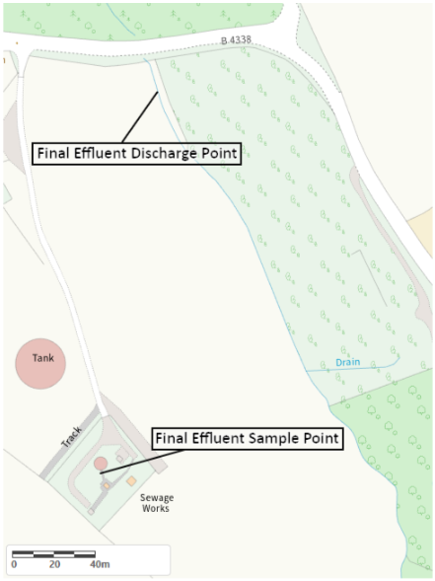
Site Plan 1

© Crown Copyright and database right 2026. Ordnance Survey licence number 100019741.

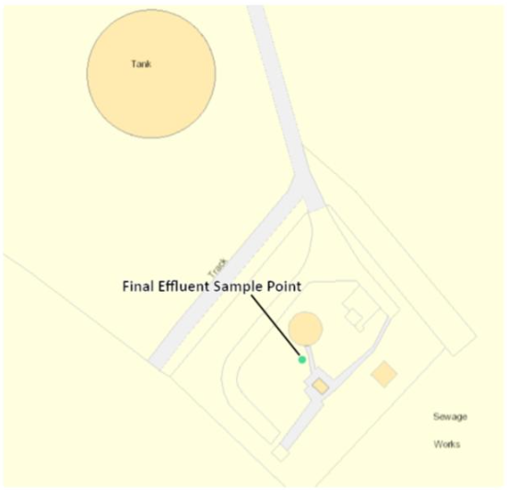
Site Plan 2

© Crown Copyright and database right 2026. Ordnance Survey licence number 100019741.

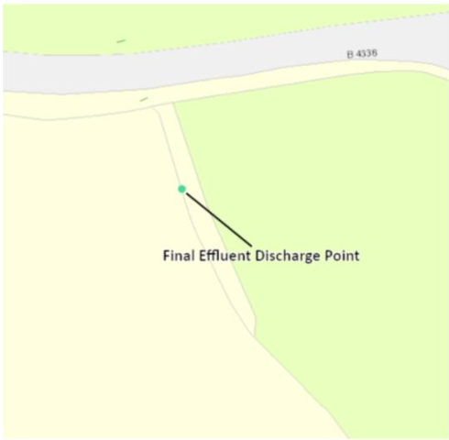
Site Plan 3

© Crown Copyright and database right 2026. Ordnance Survey licence number 100019741.

END OF PERMIT

