Annex (iv) – SSSI Assessment Form
SSSI Assessment for permit/licence and deployment applications | 
To be completed by Permitting Officers for any applications for a permission which Natural Resources Wales has considered under S28I duty to notify SNCB and take their advice into account. This applies to all proposed permissions within a SSSI, and to operations outside the SSSI boundary which are likely to damage its special features.
NRW as a Section 28G authority has, when exercising its functions, a general duty to take reasonable steps, consistent with the proper exercise of its functions, to further the conservation and enhancement of the flora, fauna or geological or physiological features by reason of which the site is of special interest’

Part 1 – SSSI Assessment
Part 2 – Formal notification to SNCB (to be completed if part 1 assessment concludes likely damage, not likely to damage because of conditions or you cannot conclude no likely damage)
Part 3 – Decision
Pink text – drafting notes, to be deleted before completion/consultation.
Blue text – examples, to be replaced with permission-specific information and text turned to black.

Part 1 – SSSI Assessment

- Permitting officer/team | Bryan Burn / Waste Permitting
- Permit application reference and site name | PAN-031595 Tir William Richard Farm  Llangynidr, Crickhowell, Powys. NP8 1LL
- a. SSSI name(s)  b. location  c. NRW Operational Area/Environment Team | a. SSSI River Usk (Upper Usk) / Afon Wysg (Wysg Uchaf)  b.Cyffredyn  c.Mid Waste Regulation team/South Powys (Radnorshire and Brecnok) Environment Team
- Brief description of proposal | The activity is not wholly or partly within the SSSI. Nearest boundary is approximately 60 metres on near to flat ground.  Landspreading deployment under standard rules permit SR2010 No4  Land spreading application to spread a one waste 17 05 02 on land at Tir William Richard Farm, Llangynidr, Crickhowell, Powys. NP8 1LL.  The application activity is for the recovery of waste silt that has been dredged as part of maintenance operations on an inland freshwater course, the Mon & Brec canal. The recovery activity will result in agricultural improvement without causing harm to the environment.  The agricultural land will benefit from the spreading activity due to:  The replenishment of soil. Dredging sediments are made up of mainly inorganic material with some organic matter and have a similar make-up to mineral topsoil. The application of dredging sediments will add volume to the existing topsoil, which replenishes the field and replaces soil that is lost due to erosion. In addition to agricultural benefit, the application of sediments helps to maintain the landscape.  The addition of nutrients. Dredging sediments are typically a good source of phosphate, often potash and to a smaller extent nitrogen (the availability of N in dredgings is assumed to be 3%). The amounts of organic matter in dredging sediment can vary depending on the source and origins of the sediment but can typically range between 1% - 15%.  The quantity of waste applied per hectare shall not exceed that in the agreed deployment form and in any case no more than stated quantities of waste shall be spread on the land in any period of 12 months:  • In the case of dredging spoil from inland waters, (17 05 06) 5,000 tonnes per hectare.  The sediments will be spread using a rear discharge spreader at a rate of up to 2,000 t/ha (1,429 m3 at 1.4 t/m3 assumed density of silt), after which they will be ploughed into the existing topsoil to a depth of circa 40cm. There will be no spreading within 10m of a watercourse, or 50m of a borehole or well used for drinking water abstraction.  All of the fields are improved grassland used for grazing. Following any spreading, the dredging silt will be ploughed into the soil and then fields will be reseeded with grass in the same year.  Application of waste silts is intended to follow the dredge in the Spring of 2026 and possibly into the early Summer, assuming suitable field and weather conditions. The regulator will be notified ahead of spreading.  The sediments will be applied as a soil replacement, providing agronomic benefit as a source of organic carbon, N, P and K, plus trace nutrients, under a SR2010No4 Mobile Plant permit. The application rate is appropriate for the amount of dredgings removed and the available field areas, the application will not exceed the statutory maximum rate of 5,000 t/ha. Full characterisation of the sediments are provided in the analysis report ‘25083916’.  Farm location: 316308, 219494  Fields:  1 CD1 Easting = 316055 Northing = 219485  2 CD2 Easting = 316231 Northing = 219486  3 IV WG2 Easting = 316986 Northing = 219515  4 IV WG3 Easting = 317142 Northing = 219548  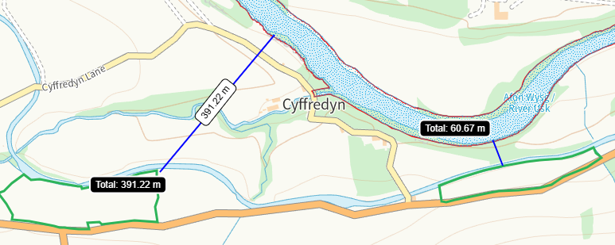
- What aspects of the proposed permission are likely to damage the SSSI features of special interest?
https://cdn.cyfoethnaturiol.cymru/662000/SSSI_1232_Citation_EN001606d.pdf
https://cdn.cyfoethnaturiol.cymru/662060/SSSI_1232_PDO_EN0015196.pdf
https://cdn.cyfoethnaturiol.cymru/662070/SSSI_1232_SMS_EN001cd6b.pdf

The following activities are likely to cause damage:
1. Cultivation, including ploughing, rotovating, harrowing and re-seeding.
5. Application of manure, fertilisers and lime except to agriculturally improved permanent grass, forest and all other unimproved riparian habitats.
7. Dumping, spreading, discharging or storage of any materials.
26. Use of vehicles, vessels or craft likely to damage semi-natural habitats or disturb
species of interest.

The following SSSI(s) features and potential impacts have been considered to assess the likelihood of damage:

The site supports the following species covered by EC Directive 92/43/EEC on the conservation of natural habitats and of wild flora and fauna:

Atlantic stream crayfish Austropotamobius pallipes - Annex II and V
Common otter Lutra lutra - Annex II and IV
Atlantic salmon Salmo salar - Annex II and IV
Bullhead Cottus gobio - Annex II
Twaite shad Alosa fallax - Annex II and V
Allis shad Alosa alosa - Annex II and V
River lamprey Lampetra fluviatilis - Annex II and V
Brook lamprey Lampetra planeri - Annex II
Sea lamprey Petromyzon marinus - Annex II
Freshwater pearl mussel Margaritifera margaritifera - Annex II and V
Otter, Atlantic stream crayfish and freshwater pearl mussel are also listed in Schedule 5 of the Wildlife and Countryside Act 1981 as amended.
Most of the River Usk (Upper Usk) lies within the Brecon Beacons National Park.

- Summary of any informal advice received from internal experts (if required and including pre-app advice) | n/a
- Recommendation | The proposed permission is not likely to damage any of the flora, fauna or geological or physiological features which are of special interest  See above and  Impact pathways have been identified to the SSSI due to the waste types, method and timing of spreading, distance and local topography and suitable no spread buffers to field boundaries and watercourses.  The wastes will be applied following the Codes of Good Agricultural Practice.  All handling of the wastes will be done in accordance to current regulations and relevant mitigation strategies will be adopted.  No waste will be spread within 10m of any ditch, pond or surface water, within 50m of any spring, well, borehole.  Spreading will only be undertaken when weather conditions are suitable within restrictions outlined in CoGAP and any relevant closed periods.  Machinery operations will take account of soil conditions, slopes etc.  Liquid spreading machinery will be turned off and lifted away from soil prior to turning at the end of each run.  Machinery will be checked daily when in use, regularly serviced and spreading equipment calibrated. Umbilical hoses will be regularly checked for damage to prevent leaks.  Machinery turns will not be executed in the buffer strips.  All spillages will be reported immediately to the NRW.
- Signature and date assessment made | Bryan Burn 19/03/26
- Officers name and job title | Bryan Burn, Waste Permitting Officer

