PAN-031990 My Map Report:
Application maps
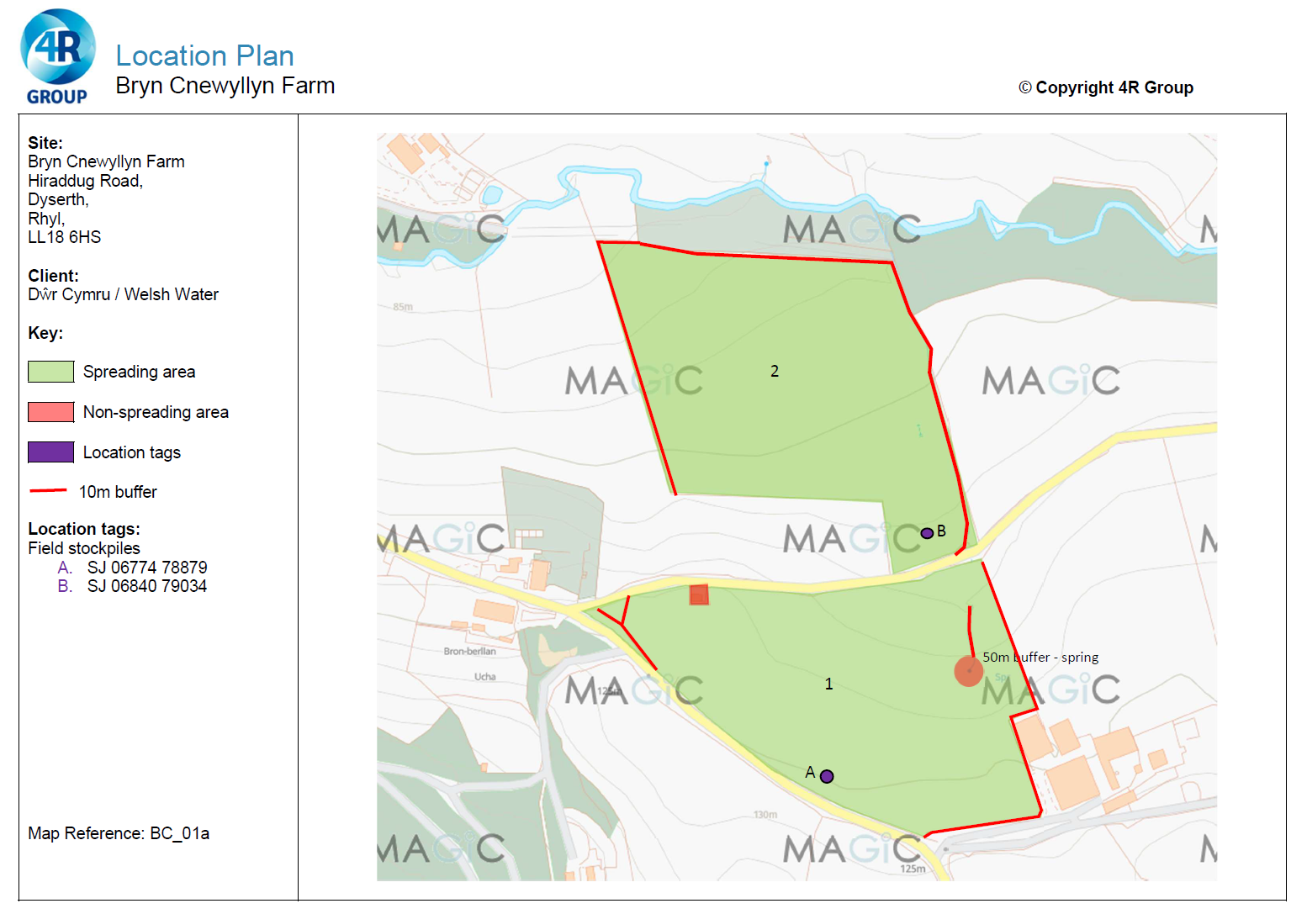
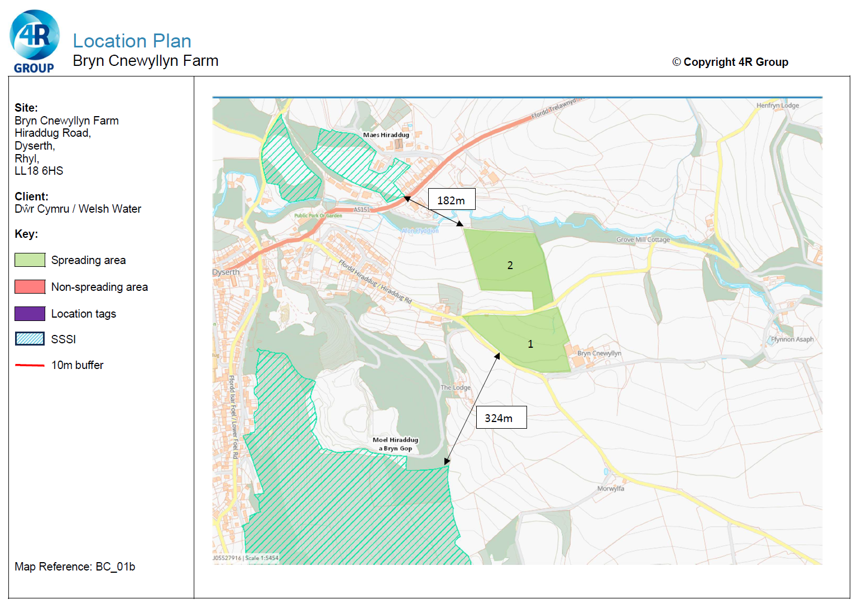
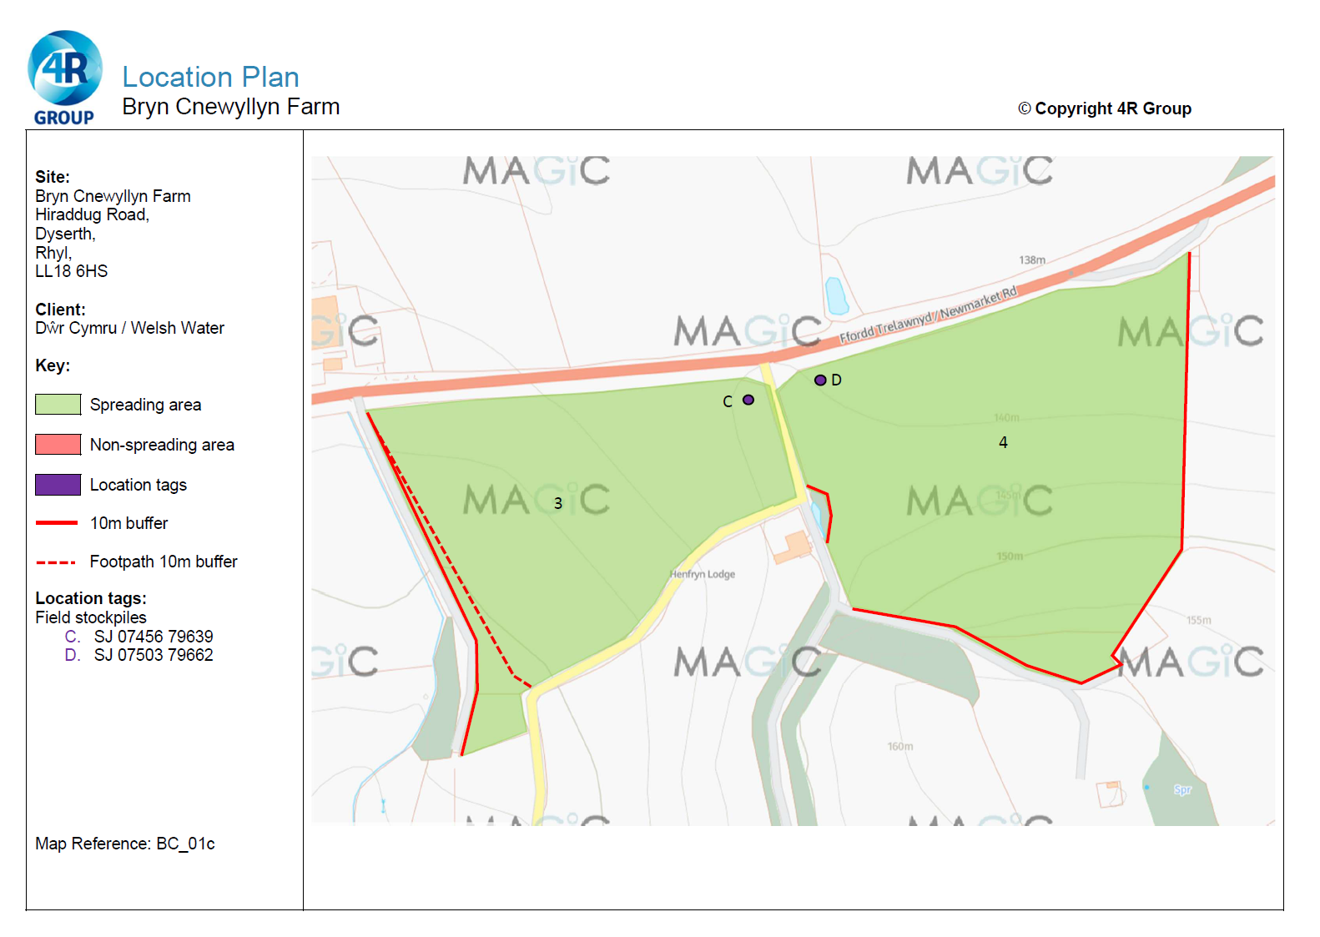
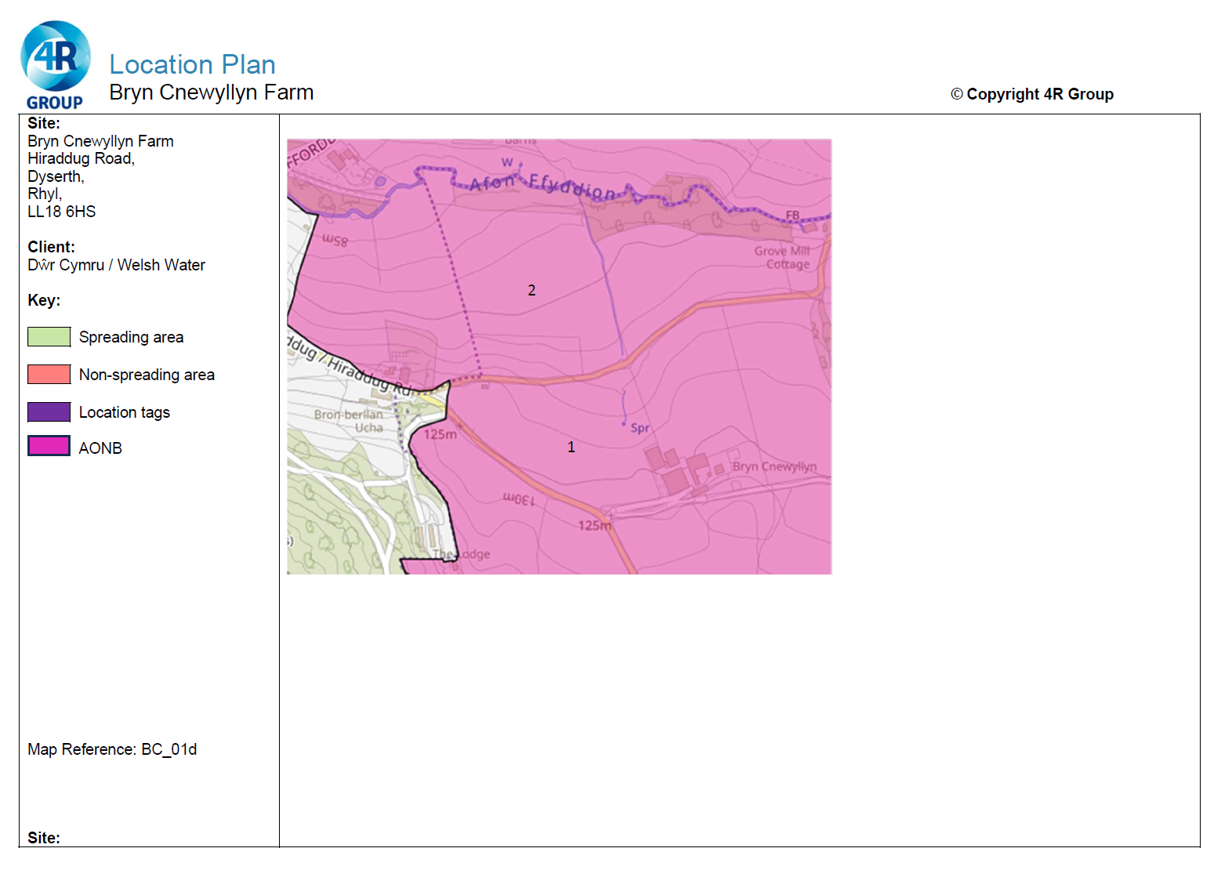
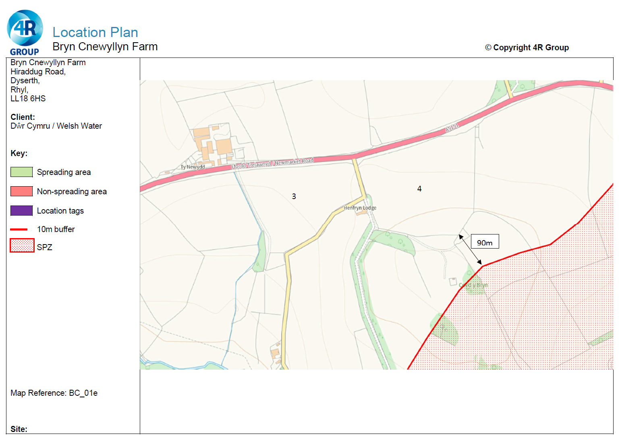
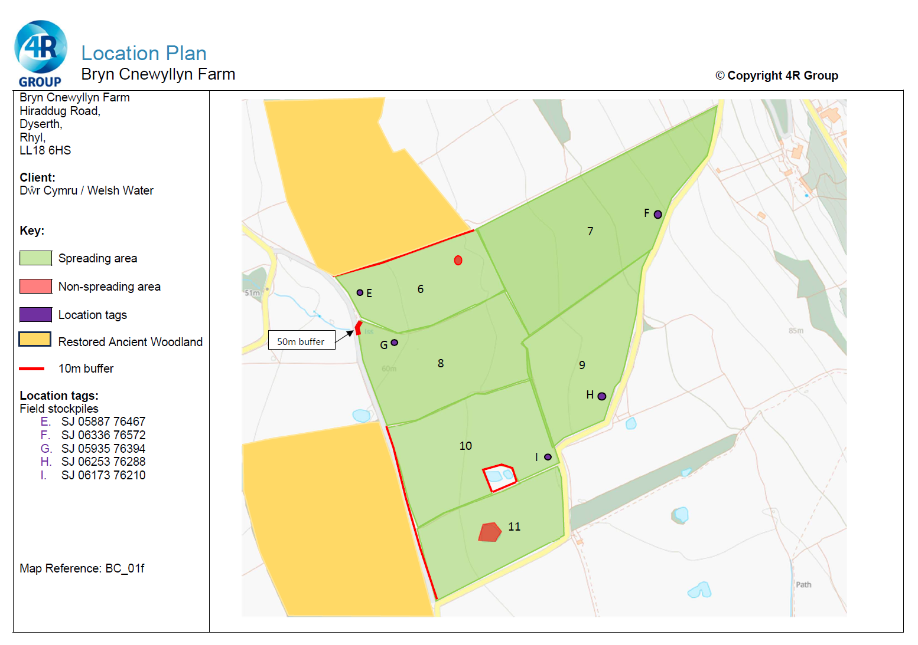
Deployment Boundaries and storage
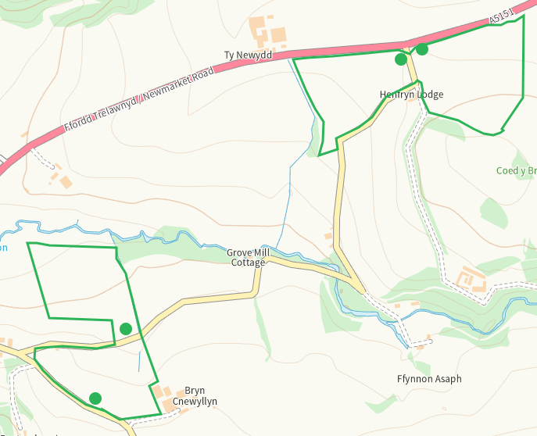
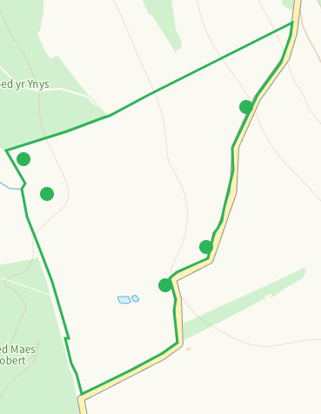
Detailed river network 10m
Within 1 and 2, buffered on application map
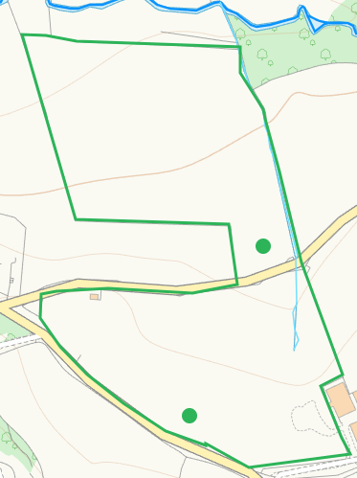
Watercourse W of 3 and pond adjacent W of 4, buffered on application map
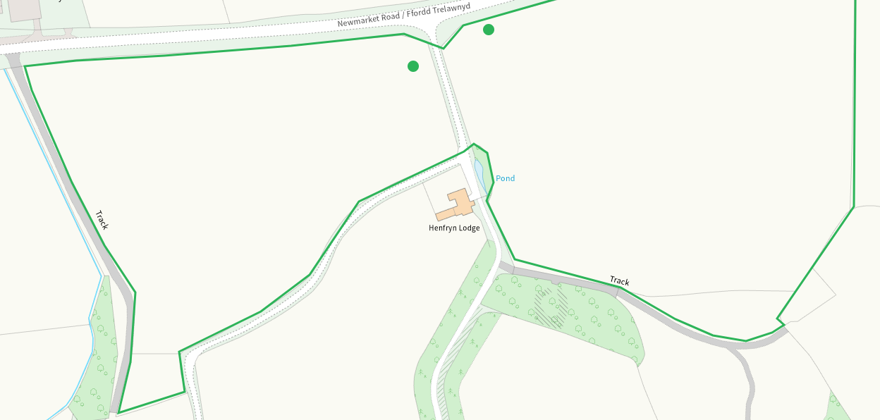
Watercourse W of 6 and pond within 6, buffered on application map
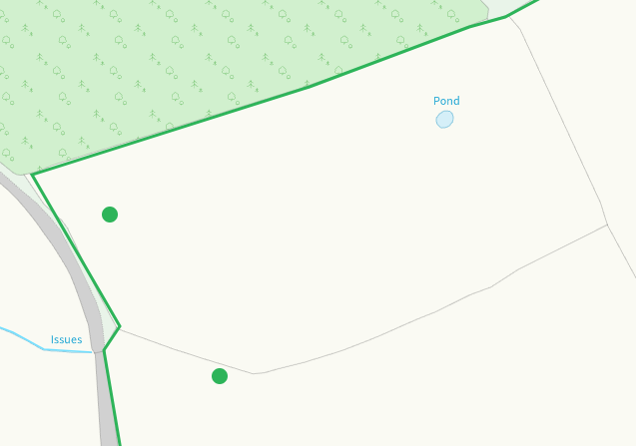
Ponds within and adjacent to 10 and 11, buffered on application map
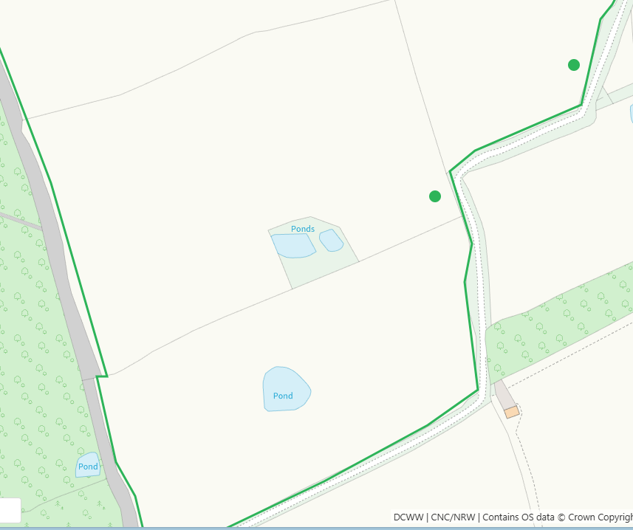
None at other feilds
Groundwater source protection zones
none
Any well, spring (or issue) or borehole used for the supply of water for human consumption including from a private water supply or supplies within 50m.
Spring within 1, buffered on application map
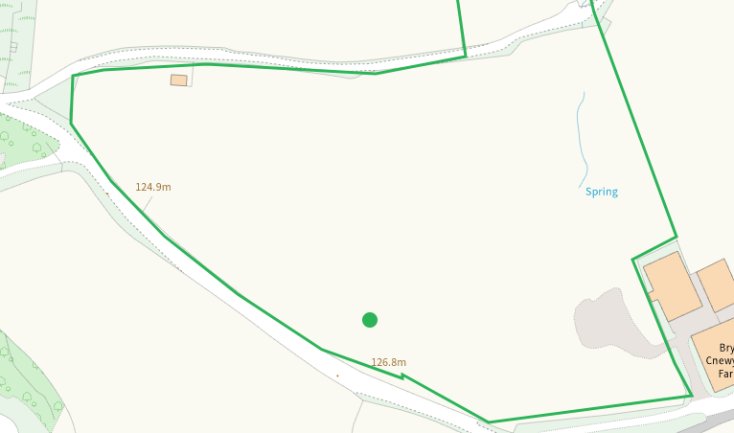
Issue adjacent to 8, buffered on application map
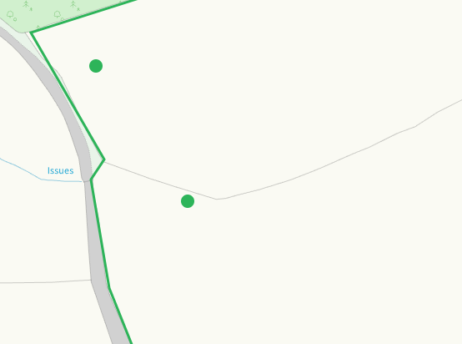
None at other fields
Any well, spring (or issue) or borehole used for the supply of water for human consumption including from a private water supply or supplies within 250m.
Well N of 2, shown on application map
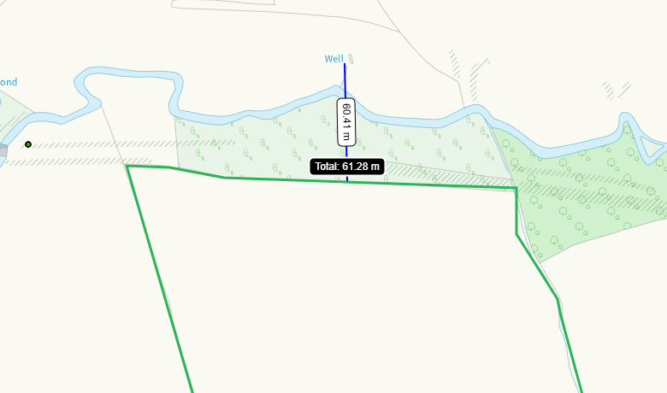
Spring S of 4, shown on application map
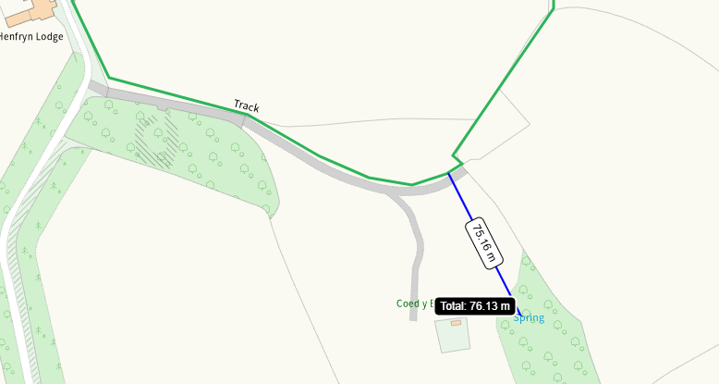
Wells N and E of 7, nil risk
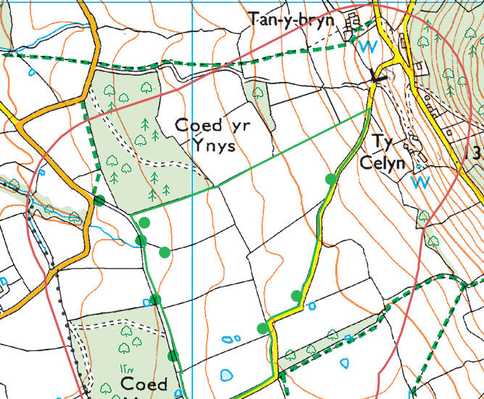
Within Groundwater Safeguard Zone
no
European designated sites- Natura 2000 (SPA, pSPA, SAC or cSAC) or Ramsar- or SSSI within 500m

SSSI Maes Hiraddug NW of 2
SSSI Moel Hiraddug a Bryn Gop SW of 1
both shown on application map
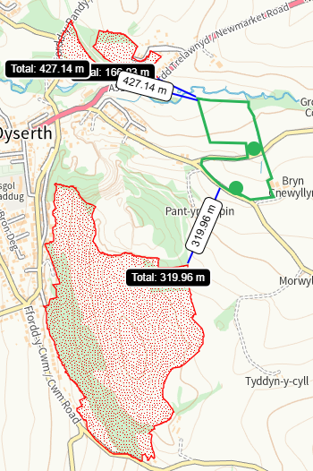
None at other feilds
Other protected sites within 500m:
- Protected Species-

Multiple in range, nil risk from the activity
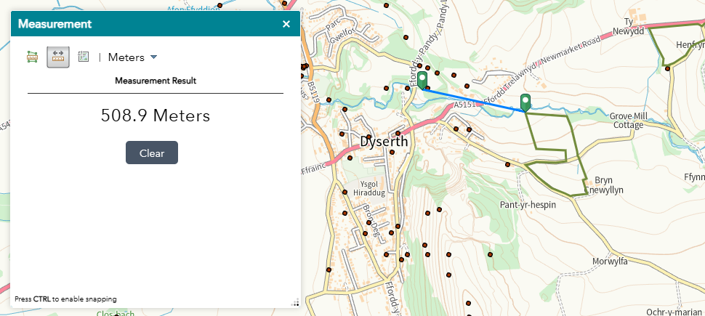

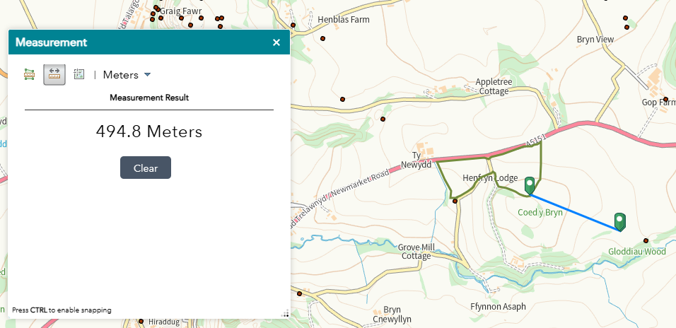

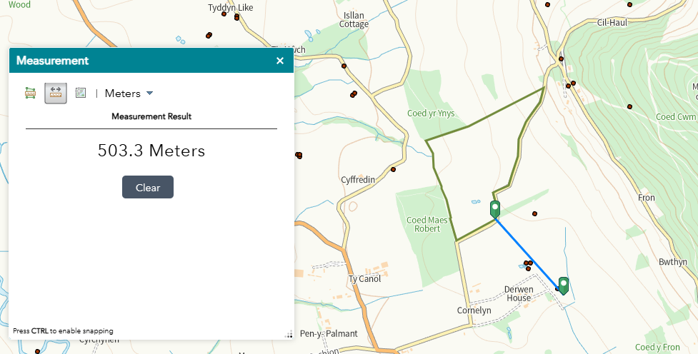
- Protected Habitats-
Lowland dry acid grassland and Lowland calcareous grassland within range, low risk
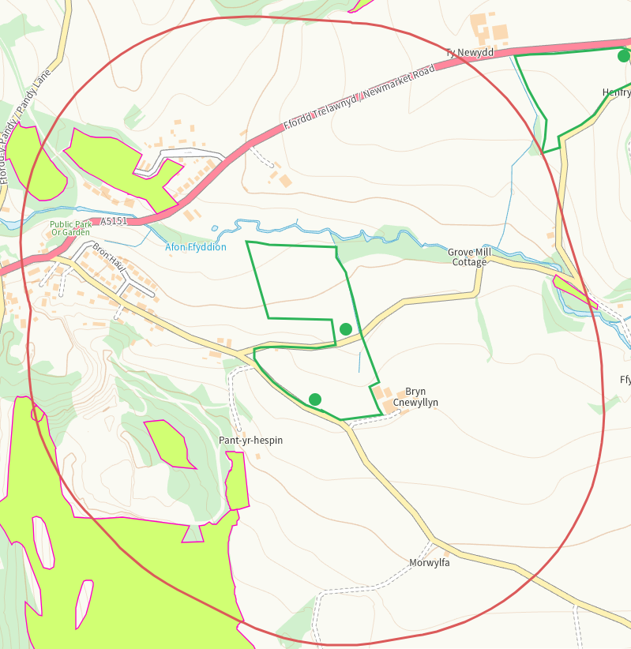

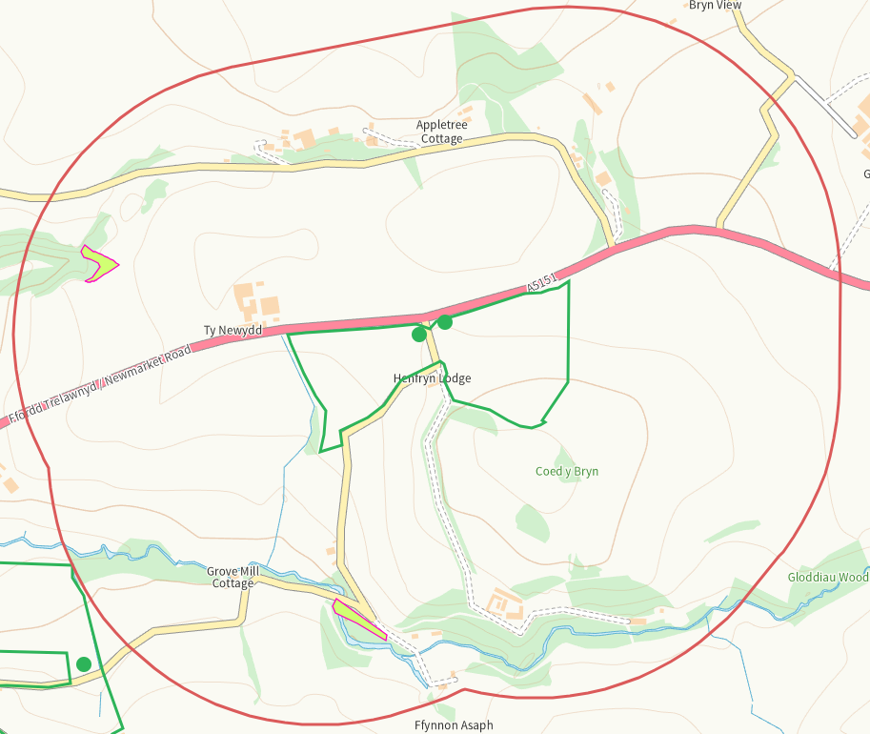

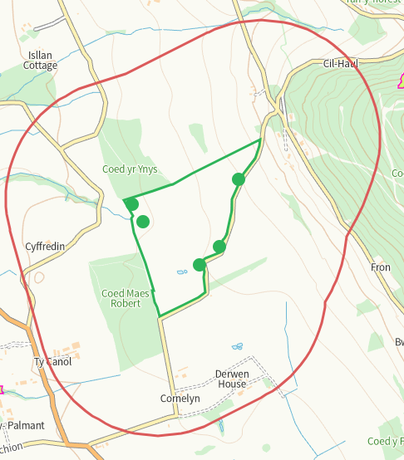

- Scheduled Ancient Monument-
Moel Hiraddug Hillfort SW of 1, identified as SSSI on application map
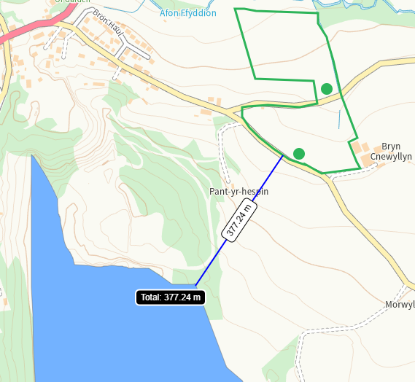
None at other feilds
- Local Nature Reserve- none
- National Nature Reserve- none
- Ancient Woodlands-
See comments re SINC some of which are also ancient woodland within range of 3 and 4
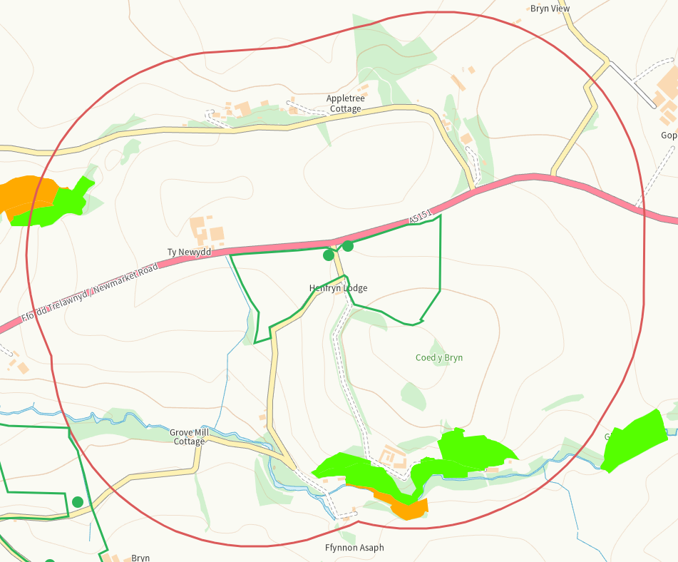

Multiple within range of 6-7, those adjacent are on application map with buffers

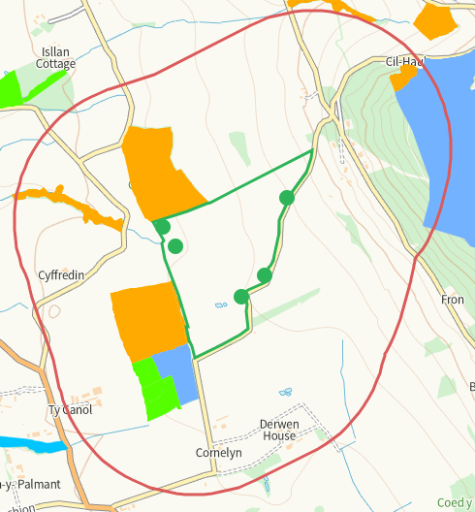
- Local Wildlife Sites (SINC)-
Coed Ty Newydd N of 2 and NW of 3 not shown on application map, nil risk
Moel Hiraddug W of 1, although SSSI on application map the SINC area is not fully addressed, nil risk
Prestatyn-Dyserth Walkway NW of 2 not identified, nil risk

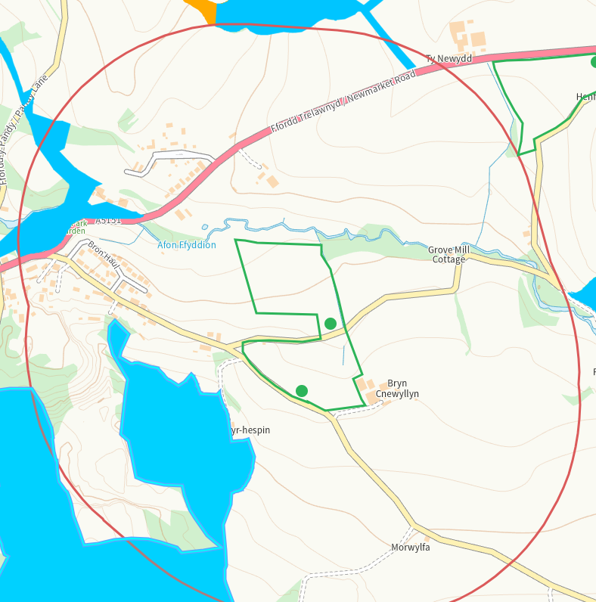

Henfryn Hall Wood S of 3 and 4, not on application map, nil riskI
Also part of the area is designated as Coed Henfryn Hall
Coed Gloddiau and Grassland is SE of 4 not identified, nil risk

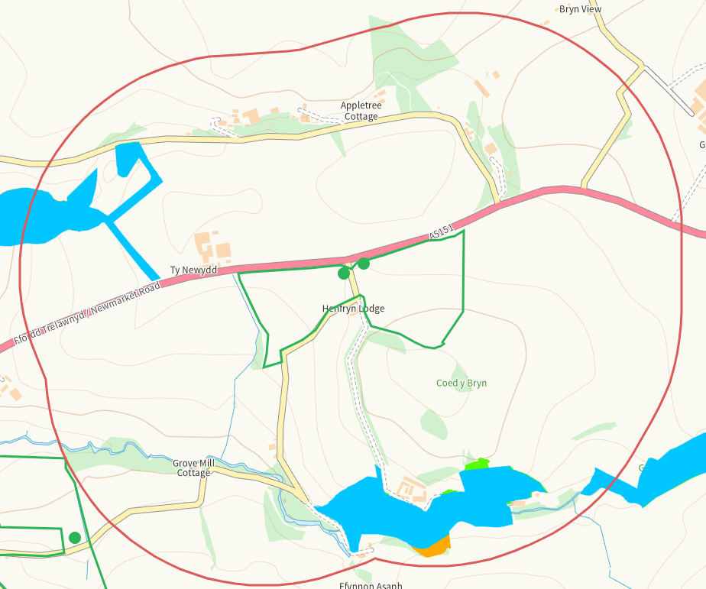

- National Park- none
- Nitrate Vulnerable Zone (NVZ)- ALL Wales
- Groundwater Safeguard Zone- none

Flood risk
none
Public rights of way
Within 3, on application map
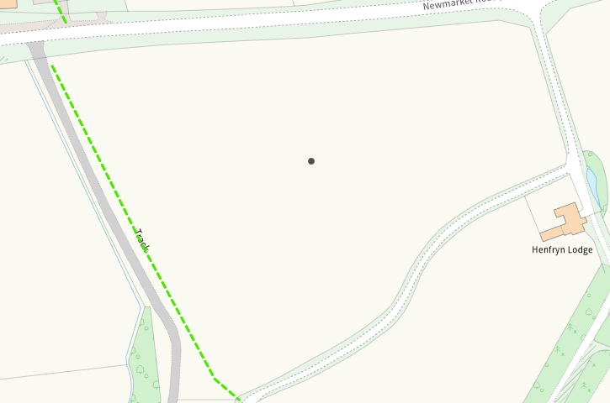
None at other feilds
Distance from Main Farm Address
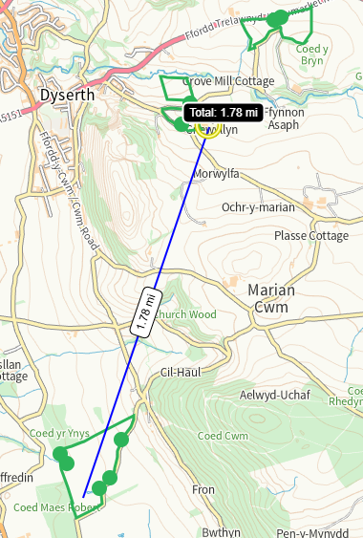
Slope Map

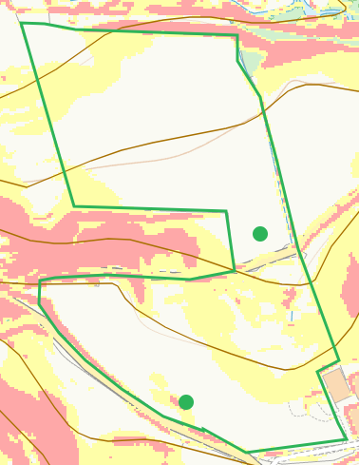

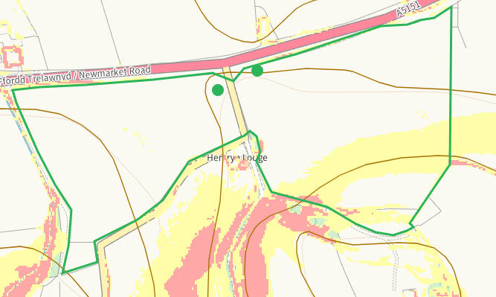

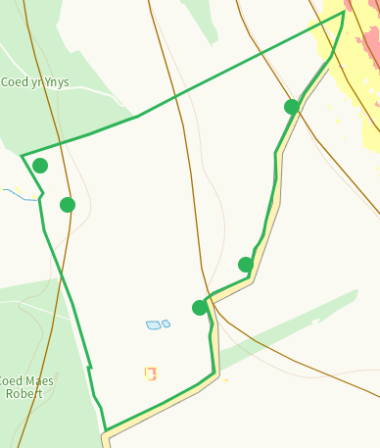

END

