Dear Chris,
I am reaching out regarding the marine elements of the Western Link 2 project on behalf of National Grid Electricity Transmission (NGET) and Scottish Power Energy Networks (SPEN). NGET and SPEN are developing proposals for a new tri-pointed subsea High Voltage Direct Current (HVDC) link between two landfalls in Ayrshire, Scotland and Dinas Dinlle in Gwynedd, Wales. The Project, known as Western Link 2 (WL2) will reinforce the electricity transmission system enabling large volumes of renewable energy generated in Scotland to be transmitted to Wales, reducing grid constraints and reducing terrestrial infrastructure demands.
Further to our recent discussions I write to you on behalf of NGET and SPEN to request a Screening Opinion pursuant to Regulation 11 of the Marine Works (Environmental Impact Assessment) Regulations 2017 (‘the EIA Regulations’) with regard to the Marine Cable Works located in Welsh Waters. A separate screening request to Marine Directorate’s Licensing Operations Team (MD-LOT), Department for Agriculture, Environment, and Rural Affairs (DAERA) and the Marine Management Organisation (MMO) for aspects of the project in other waters. Background to the Project including a plan and details of the Marine Cable Works are provided with this request.
The project
The project crosses multiple jurisdictions to provide grid reinforcement on the west coast of Great Britain between Scotland and Wales. In a first-of-a-kind development, the project will create a multi-terminal HVDC 525 kV, 2-GW solution that will enhance transmission between Scotland and Wales and provide connection for the MachairWind offshore windfarm.
Western Link 2 will transport clean energy from offshore sources along Scotland’s western coast to a proposed converter station in Ayrshire, being brought forward by SP Energy Networks.
From there, National Grid plans to develop a new high-voltage direct current (HVDC) link to carry this energy to the Gwynedd coastline in North Wales. The proposed route will pass through Scottish, Northern Irish, Isle of Man and Welsh waters.
In North Wales, we are also developing proposals to connect the link to the national electricity network. This would include a landfall point on the Gwynedd coast, an underground cable, and a new converter station near the existing Pentir Substation.
Figure 1 below schematically illustrates the concept of the project, alongside its main infrastructure.

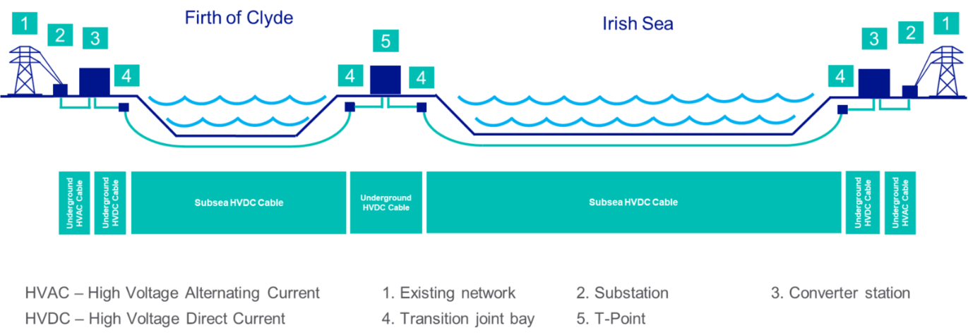

Figure 1. Schematic of the proposed project works
The marine scheme
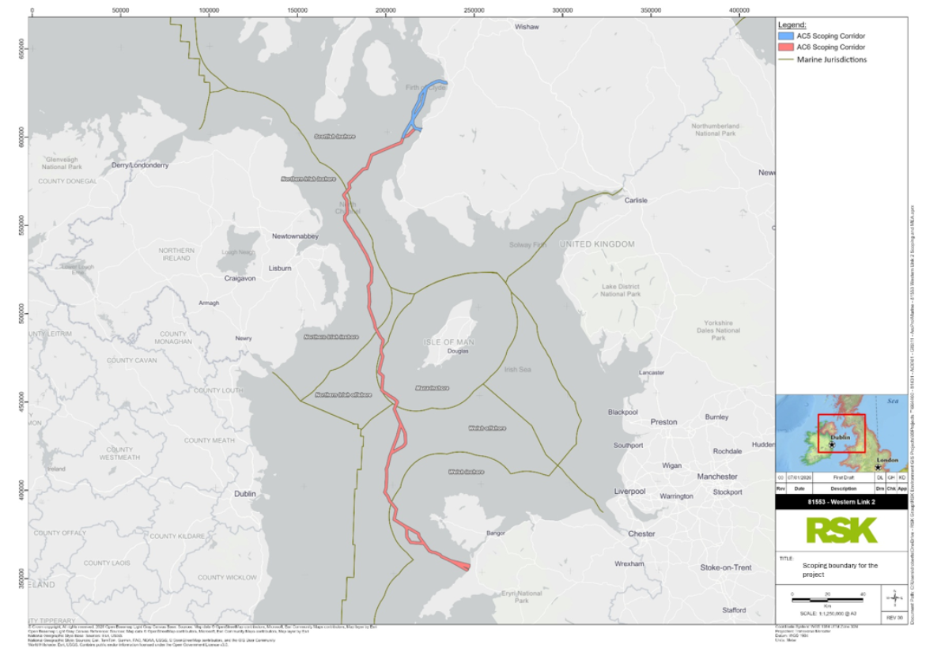
The proposed route corridor traverses through Scottish inshore, Northern Irish inshore and offshore, Manx, and Welsh inshore and offshore waters. The route corridor extends for approximately 134 km in Scottish waters, 100 km in Northern Irish waters (87 km inshore and 13 km offshore), 37 km in Manx waters and 173 km in Welsh waters (93 km inshore and 80 km offshore), see figure 2 below.

Figure 2. Project scoping boundary

Pre-construction works
Seabed clearance activities will be required prior to offshore cable installation to ensure that the proposed submarine cable corridor is clear of boulders, dropped objects, unexploded ordnance (UXO), and other obstacles.
It is anticipated that the following sequence of activities will be required for pre-installation activities:
survey/inspection
UXO identification and clearance (as necessary)
boulder clearance (optional)
pre-lay grapnel run (PLGR) (optional)
third-party cable crossing construction
seabed sweep (optional).

Construction – cable lay and burial
Cables will be laid via a cable lay vessel and the process shall be monitored and controlled. There are three potential methods that may be used for cable installation and burial:
pre-cut trenching and cable lay – trench is prepared (e.g., with a mechanical trencher or displacement plough, and the cable is laid into the trench in a separate operation)
simultaneous lay and burial – may be conducted using a cable plough whereby the plough’s share cuts into the soil, opening a temporary trench which is held open by the side walls of the share, cable is subsequently guided through the plough into the opened trench and pushed down by a depressor before the soil naturally backfills over the cable
- cable lay and post-lay burial – cable is laid on the seabed and then the trencher, in a separate pass, passes over the cable and buries it into the seabed
Cables will be buried where feasible; a desk-based cable burial risk assessment (CBRA) is being undertaken for the project.
Whereby it is not possible for cable burial, additional protection may be required. The requirements of which would be determined through design development which will be informed by offshore survey works. Based on previous project understanding it is understood the following may be considered:
- rock placement
- concrete mattresses/concrete half shells
- sand/grout/rock bags
- imported sand placement
- cylindrical half shells
- articulated pipe.

The Need for EIA
We request that the Natural Resources Wales provide their Screening Opinion to confirm or otherwise if they require an Environmental Impact Assessment (EIA) of the marine scheme to be undertaken as part our application for a marine licence under the Marine and Coastal Access Act 2009. None of the components which make up the Marine Works, or indeed the wider Project, are explicitly identified as ‘EIA development’ under Schedule 1 or 2 of the EIA Regulations. Nevertheless, we consider it appropriate to seek a Screening Opinion in order to ensure our application for a marine licence comprises the information which you require. In providing your Screening Opinion we ask that you consider:
1. The need for EIA for the Marine Cable Works taking into account Schedule 3 of the EIA Regulations, and;
2. The need for EIA for the Marine Cable Works should another component of the Project (the terrestrial Scottish Point of Connection Works or the terrestrial Welsh Point of Connection Works) require EIA and Marine Cable Works not (i.e. if in response to (1) you consider EIA is not required would your Screening Opinion change if another component of the Project required EIA).

Following receipt of your Screening Opinion, we will be in contact to discuss the specific scope of, and approach to the environmental assessment required (Marine Environmental Appraisal (MEA)). This will ensure that the required reports will provide sufficient environmental information to allow DAERA to determine the marine licence application for the Marine Cable Works.
We have provided extra information in Annex 1 below.

Yours sincerely
Lydia Tabrizi

Lydia Tabrizi (Pronouns: she/her)
Senior Marine Consents Officer
Land, Planning & External Affairs
Strategic Infrastructure
nationalgrid
lydia.daryani-tabrizi@nationalgrid.com
+44 7548 107178

Annex 1
Designated Sites
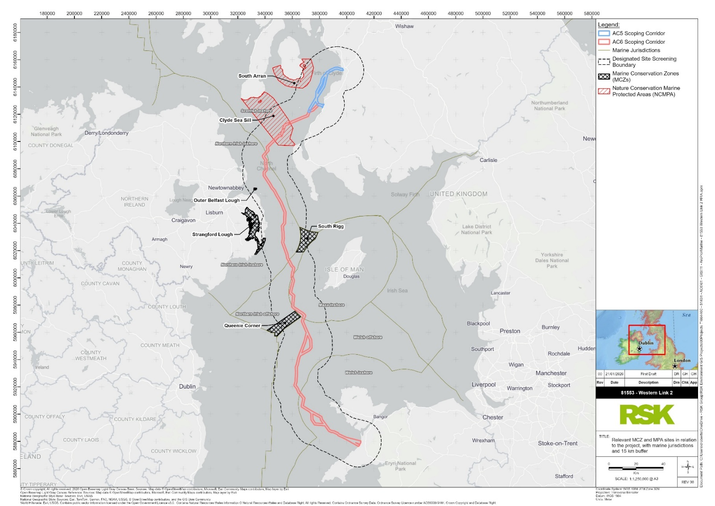
MPAs and MCZs

Figure 3. Relevant MCZ and MPA sites in relation to the project.

Clyde Sea Sill MPA
The proposed route passes through The Clyde Sea MPA. This MPA covers an area of 712 km² and constitutes a dynamic seabed environment attributed to heavy tidal influence. The MPA directly overlaps with the survey area.
Distinctive habitat gradients exist in the MPA; mixed substrates are found in tide-swept conditions off Kintyre, rippled fine-medium sands in the centre of the sill, and sandy-mud habitats on the Galloway side. Toward the north-west of the MPA a colony of breeding black guillemot return each breeding season.
Queenie Corner MCZ
The Queenie Corner MCZ, located in the western Irish Sea covers an area of 146 km² and reaches depths of up to 50 m. The MCZ is 1.5km away from the scoping boundary.
The site protects subtidal mud and benthic communities, in tandem supporting a wider range of species (i.e., Norway lobster [Nephrops norvegicus], shrimps, crabs, bivalves etc.). The fine mud habitats are characterised by the burrows and mounds formed by burrowing organisms.
South Rigg MCZ
The South Rigg MCZ covers an area of 143 km², located in the western Irish Sea. Depths range between 50 and 150 m in the site.
The site protects an array of habitat features, ranging from fine sediments to rocky habitats. Muddy habitats within the site are characterised by burrowing species (i.e., mud shrimp (Callianassa subterranea) and Norway lobster). Subtidal sediments provide suitable substrate for a range of species, including echinoderms; whilst the rockier outcrops support sponges, soft corals, anemones and the squat lobster (Munida rugosa)
This MCZ is 6.83km from the scoping area.
South Arran MPA
The South Arran MPA covers an area of 280 km² and encompasses the waters from north of Drumadoon Point on the west coast, to Corriegills Point on the east.
Across the site, maerl beds, bands of seagrass fringes and burrowed mud habitats are distributed throughout. These habitats support a range of species.
This MPA is 9.13km from the proposed route.
Outer Belfast Lough MCZ
Belfast Lough, a large sea inlet off the eastern coast of Ireland is the location of the Outer Belfast Lough MCZ, covering an area of 2.51 km². The outer lough encompasses a variety of habitats, such as subtidal sand, subtidal mixed sediments, sediment dominated bays and rocky shores. The ocean quahog is also distributed in aggregations throughout within the lough. Subtidal (sublittoral) sand habitats further supports species such as the masked crab (Corystes cassivelaunus), king scallop (Pecten maximus) and sand burrowing brittlestar (Amphiura brachiata). This site is 9.13km from the scoping boundary.
Strangford Lough MCZ
Formerly an MNR, Strangford Lough was afforded protection as a MCZ under the Marine Act (Northern Ireland) 2013 when the act came into force.
The MCZ extends from MHWS and further than the overlapping SPA, SAC, ASSI and Ramsar site.
No formal citation for the MCZ site appears to exist, however, relevant internationally and nationally important species have been considered and assessed as part of the accompanying HRA screening report. The assessment contained within this report is isolated to the inlet feature.
The Lough covers an area encompassing approximately 150 km², constituting a shallow sea lough, 50 km² of which lies between MHWS and MLWS. The intertidal and marine environment supports a number of species including marine seabird, wading bird and marine mammal features (assessed as part of the accompanying HRA screening report). The main characteristic of the site is the sea inlet of the Lough itself that emerged from the last Ice Age, ranging in depths of 10 to 66 m (Strangford and Lecale Area of Outstanding Natural Beauty, 2026).
This site is 12.83km from the scoping boundary.
Special Areas of Conservation (SACs)
The proposed route passes through two SACs, namely North Anglesey marine SAC and North Channel SAC. Both are designated for Harbour porpoise (Phocoena phocoena).
The North Anglesey Marine and North Channel SAC directly overlap with the marine route corridor, as such individuals originating from these sites have the highest potential to be impacted by continuous noise and associated disturbance from vessels.
Harbour porpoise are documented along the North Wales coastline in moderate densities; presence largely being associated with the noted sites, however density estimates depict presence throughout the marine route corridor, including in nearshore areas.
Harbour porpoise may show decreased presence and abundance in relation to increased vessel presence and continuous noise disturbance, although the likelihood is low.
The proposed route traverses 1.46km away from Pices Reef SAC, notably the route was adapted to avoid this area during early routing.
No direct habitat loss within the Pisces Reef Complex SAC is expected due to a lack of spatial overlap. However, temporary loss/distance of the feature may occur, associated with smothering of habitats and species as a result of suspended sediment increases. Turbidity impacts may also impede local water quality within the site.
Any alterations to local seabed morphology are expected to be localised (confined to the marine route corridor footprint) and short-term and not impede the reef feature of the site.
No changes to sediment transport pathways nor hydrodynamic regimes are expected consequent of the project. Any perturbation to sediment transport would be highly localised, short-lived within the ranges of natural variability, such that indirect impacts to the reef feature are not expected.
The greatest potential for disturbance associated with sediment resuspension is expected during the construction phase (and decommissioning), attributed to pre-sweeping activities. While activities during operation are expected to be more localised and small-scale in terms of disturbance to the seabed.
A complete list of SACs with potential connectivity to project related activities will be included within the voluntary scoping exercise.
Special Protection Areas (SPAs)
The proposed route passes through the Irish Sea Front SPA which is designated for Manx shearwater (Puffinus puffinus) and Anglesey Terns SPA which is designated for Common tern (Sterna hirundo), breeding), Arctic tern (Sterna paradisea), breeding, Roseate tern (Sterna dougalli), breeding and Sandwich tern (Sterna sandvicensis), breeding.
A complete list of SPAs relevant to the project, with potential connectivity, will be included within the voluntary scoping exercise.
Potential pathways for impact to features of designated sites
The project has the potential to directly and indirectly impact features of designated sites, including via the following:
- disturbance to the seabed
- physical presence of vessel(s)
- underwater noise
- marine discharges and releases
- introduction of invasive non-native species
- changes in distribution of prey species
- electromagnetic field effects (EMF)
- thermal loading
Disturbance to the seabed
Seabed habitats and associated benthic species will be directly disturbed by the project, alongside through indirect impacts associated with sediment resuspension. Direct, permanent loss of habitats is expected in the immediate footprint of the marine route corridor, consequent of cable installation and associated placement of cable protection (where required).
Sediment resuspension and consequent smothering may extend beyond this and lead to temporary loss of habitat whereby recovery is possible. In addition, temporary loss of habitat may occur in the intertidal, should open-cut techniques be implemented during construction; trenches will be backfilled allowing for recovery to occur
The greatest sediment resuspension impacts associated with the project are expected from pre-sweeping due to significant volumes of sediment remobilised. This may lead to substantial smothering of neighbouring benthic habitats and species, alongside potential asphyxiation of more mobile species. Sediment resuspension may additionally impact mobile species, through the reduction in visual acuity and impacts to foraging success.
While it is appreciated routine maintenance activities will infer localised disturbance to the seabed, this is expected to be of smaller magnitude when compared with construction. Pre-sweeping is not expected under routine operations.
The recoverability of sediments in the marine environment is largely dependent on sediment type and energy of the benthic environment. Surficial seabed sediments within the Irish Sea are broadly organised into sedimentary provinces, with fine-grained muds and muddy sands occurring within lower-energy depositional environments in the eastern and western parts of the basin, separated by a central belt of sands and gravels. Areas of exposed or shallow bedrock are present within the North Channel and to the north-west of Anglesey. Each substrate type supports a range of dynamic benthic communities that are adapted to certain disturbance. Notably, habitats associated with sandy gravel are generally expected to exhibit relatively high resilience and recoverability following cessation of short-term impacts.
The data from a marine survey undertaken in 2025 is still being analysed and a further survey will be undertaken in summer of 2026. Data from these surveys will be used to inform the Marine Environmental Assessment.
Physical presence of vessel/s
Vessels and equipment associated with the project may lead to disturbance of species in the immediate vicinity; marine mammals are expected to only be sensitive to elevations in vessel traffic. Vessels will be mobilised across all project phases, though associated impacts are expected to be more temporary during the operation and maintenance phase.
The level of disturbance will be greater for species with small or spatially restricted populations. Disturbances can also result in changes to behaviour and lead to impacts on species.
Marine mammals are most vulnerable to collisions from vessels. Vessel strikes are a known cause of injury and/or mortality in marine mammals, with collisions potentially occurring with vessels of all sizes. The more serious incidents tend to be caused by very large vessels, with large slow-moving whales considered most susceptible to vessel strike. Vessels going at speeds of 14 knots or more are also more likely to cause incidents. Injuries sustained can include fracturing, bruising, nicks or slicing off parts of fins, and the most serious accidents can result in death of the animal, although death may not be immediate.
Fish species are not considered to be sensitive to vessel presence in the context of pre-existing vessel presence in the project area.
A number of species are particularly sensitive to disturbance (e.g. auk, diver, cormorant and seaduck species), both visual and auditory, that may result in displacement from the area. The level of disturbance will be greater for species that spend more time on the surface of the water; species with small or spatially restricted populations will also be more vulnerable. Disturbances can also result in changes to behaviour and lead to impacts on energy budgets of bird species; this may be of particular concern within the background context of avian flu.
Based on known species-specific sensitivities to disturbance from vessels and taking into account local populations, marine birds have been grouped into the following sensitivities.
Mitigation measures to minimise impacts, where possible, will be discussed in the MEA.
Underwater noise
Vessels produce continuous, low levels of noise and therefore may induce disturbance to noise sensitive species. Underwater noise impacts will be greatest should trenched installation techniques be established, due to the requirement of a cofferdam in the intertidal and the potential need for piling (impulsive noise generation).
Only continuous noise sources are expected during the operations and maintenance phase, though associated impacts are expected to be more temporary during this phase in comparison with construction and decommissioning phases.
Marine mammals and certain fish species are sensitive to noise and therefore have the potential to be disturbed via underwater noise sources. Impacts may include direct changes in behaviour (i.e. avoidance) or indirect disturbance (i.e. masking).
Impulsive underwater noise has the potential to induce significant behaviour response, specifically should individuals be within the expected impact range distance. It is appreciated a vibratory pile may be used for cofferdam installation, which concludes overall lower impacts to noise sensitive species in comparison to impact pile driving. Studies on vibratory piling have concluded maximum impact distances of up to 584 m from the sound source for high-frequency cetaceans, noting a significant reduction in distance for other cetacean species.
Noise from vessels is considered unlikely to cause disturbance to noise sensitive species, except when in very close proximity to a vessel. In addition, there is considered to be a moderate pre-existing vessel presence in the project area, such that any additional vessel mobilisation is not expected to contribute significantly to pre-existing background noise levels.
The potential exposure of seabirds to underwater noise varies largely with their feeding ecology, with some species at higher risk than others. Those that forage utilising plunge diving (i.e. gannets) or those that spend significant amounts of time underwater (i.e. auks and scoters) have the potential to be impacted via underwater noise. Other species (i.e. terns, gulls and shearwaters) have very shallow dive are less likely to be impacted inherently due to limited exposure. Waterfowl species do not fully immerse themselves in the water when they are feeding (e.g. wading and dabbling.) and as such are not expected to be impacted by underwater noise as a result.
Appropriate mitigations, such as those suggested by JNCC guidelines, will be considered for the Marine Environmental Assessment (MEA) to mitigate potential impacts where possible.
Marine discharges and releases
Accidental pollution such as spills or containment releases associated with all phases of the project and use of project vessels may cause direct mortality or injury of species.
Discharges may lead to reductions in water quality and increase turbidity in the surrounding environment. Indirect effects to habitats and species, through reduced fitness, smothering, reduction of available prey species and reductions in visual acuity impacting foraging success may also occur.
However, only routine vessel discharges regulated under MARPOL Regulations are expected across all project phases. Any accidental releases are not foreseen due to embedded mitigation and best practice, this will be included in the MEA.
Introduction of invasive non-native species
External cable protection may encourage colonisation of invasive non-native species, alongside project vessels and equipment facilitating the spread of invasives.
This may lead to native species being forced out of their natural range and leading to a species shift in the area following disturbance. Species most impacted will likely be those associated with the benthic environment (Annex I habitats), though more mobile species may also be impacted through changes in prey species (discussed in the proceeding section).
Changes in distribution of prey species
It is expected that benthic habitat loss and/or disturbance may have implications on foraging success due to changes in prey distribution.
Species with demersal life stages forage on the seabed and may therefore experience temporary loss of foraging opportunities during and immediately after project installation. Impacts to prey availability in the intertidal will become most significant should trenching techniques be employed. Where trenchless techniques are used, impacts to the intertidal in relation to benthic habitat loss and/or disturbance and associated impacts to prey species are not envisaged.
Diving birds forage on the seabed and may therefore experience temporary loss of foraging opportunities during and immediately after project installation. In addition, wading species that forage on exposed mud and sandflats will be impacted during construction in the intertidal at the proposed landfall locations. Impacts to prey availability in the intertidal will become most significant should trenching techniques be employed. Where trenchless techniques are used, impacts to the intertidal in relation to benthic habitat loss and/or disturbance and associated impacts to prey species are not envisaged.
While it is appreciated that repair and remedial works may be temporary in nature, should remedial works involve additional external cable protection, there will be additional benthic habitat loss and/or disturbance during this phase.
Electromagnetic field effects (EMF)
Subsea cables emit EMF in the marine environment and are only applicable once the cable is in operation. The bundling of cables can reduce field exposure.
Species have been documented responding to fields in a form of behavioural response, displacement and or exclusion.
Thermal loading
During operations of subsea cabling, heat loss occurs due to resistance of the cable. This loss can induce localised heating of the surrounding sediment.
Calculations undertaken for comparative projects (Viking Link) noted that thermal heating in excess of 2⁰C at 20 cm sediment depth would only occur should bundled cables be buried at depths of less than 0.75 m. The draft CBRA indicated a recommended a minimum burial depth of between 0.6 to 1.75 m for the project. A final CBRA however is to be developed and will inform the Marine Environmental Assessment (which will accompany the marine licence).
Associated impacts are limited to species with demersal life stages and certain Annex I habitats.
Other authorities
Similar to the nature of this request, we have submitted a screening request to DAERA. We have also had confirmation from the MMO that they refuse to screen the WL2 project. This is because “The MMO does not consider the regulated activity under Part 4 of the Marine and Coastal Access Act (MCAA) 2009: deposits of cable protection to constitute a ‘Project’ under either Schedule A1 or Schedule A2 of the MWRs. The MMO acknowledges that the Project Categories listed under the Schedules of the MWRs should not be interpreted too restrictively, as to exclude an activity that is not obviously listed under the schedules, however, there must be a clear link between activity and the Project Categories under the schedules. In the case of Western Link 2 the only regulated activity is the deposit of cable protection which is not listed under the Schedules.” A copy of this letter has been included in the attachments.

International Convention for the Prevention of Pollution from Ships

