Annex (iv) – SSSI Assessment Form
SSSI Assessment for permit/licence and deployment applications | 
To be completed by Permitting Officers for any applications for a permission which Natural Resources Wales has considered under S28I duty to notify SNCB and take their advice into account. This applies to all proposed permissions within a SSSI, and to operations outside the SSSI boundary which are likely to damage its special features.
NRW as a Section 28G authority has, when exercising its functions, a general duty to take reasonable steps, consistent with the proper exercise of its functions, to further the conservation and enhancement of the flora, fauna or geological or physiological features by reason of which the site is of special interest’

Part 1 – SSSI Assessment
Part 2 – Formal notification to SNCB (to be completed if part 1 assessment concludes likely damage, not likely to damage because of conditions or you cannot conclude no likely damage)
Part 3 – Decision
Pink text – drafting notes, to be deleted before completion/consultation.
Blue text – examples, to be replaced with permission-specific information and text turned to black.

Part 1 – SSSI Assessment

- Permitting officer/team | Liz Cole  Water resources permitting
- Permit application reference and site name | PAN-028006 Farmpoint Ltd
- a. SSSI name(s)  b. location  c. NRW Operational Area/Environment Team | a. River Wye (Lower Wye)  River Lugg  Burfa Boglands  b. Knobley, Walton, Presteigne  c. Mid Wales/ North Powys Environment Team
- Brief description of proposal

Application to vary existing abstraction licence WA-055-0008-0003 which authorises abstraction from underground strata via a borehole at NGR SO 26150 61520 at a rate of 120m³/day; 20,739m³ year at Nobley, Presteigne, Powys. The borehole is located approximately 80 metres west of Knobley Brook, which joins the Hindwell Brook which discharges into the River Lugg SSSI and subsequent River Wye.

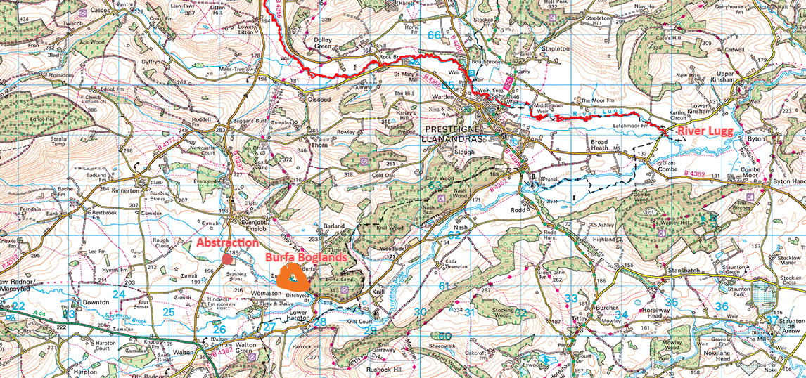

The abstracted water is used to rear chickens; the daily volumes abstracted depend upon their growth stage and subsequent washdown of the rearing sheds. A chicken rearing cycle lasts 49 days, from when one day old chicks are introduced into the rearing sheds, until their removal and subsequent washdown.
The applicant originally proposed to remove the hands off flow (HoF) restriction within the licence, condition 9.2 which is as follows:

‘No abstraction shall take place when the flow in the River Lugg as gauged at Byton gauging station is equal to or less than 105,000 cubic metres per day. 105,000 cubic metres per day is equal to a level of 0.360 metres at the Byton gauging station.’
The HoF condition has been included in the current licence as during original determination not enough evidence was provided to demonstrate that the groundwater abstraction does not impact upon nearby surface waters. The HoF set is equivalent to the River Wye Abstraction Licensing Strategy HoF of 1,900 Ml/d (418 mgd) at Redbrook gauging station.

During determination of this variation application the applicant changed their proposal to allow their abstraction to be restricted to that performed in their pumping test when the HoF on the River Lugg is active, rather than a total cessation of abstraction.

Relevant documents:

Pump test report – demonstrating impacts of abstracting during low flow HoF conditions.
Pump test Appendix F – excel data
Water usage report
Pump test daily water usage- excel data
Groundwater investigation consent (GIC) issued to allow for test pumping, reference PAN-021897.

- What aspects of the proposed permission are likely to damage the SSSI features of special interest?

The following activities are likely to cause damage:
To all three identified SSSI sites:
‘Changing of water levels and tables and water utilisation including irrigation, storage and abstraction from existing water bodies and through boreholes.’

The following SSSI(s) features and potential impacts have been considered to assess the likelihood of damage:

Burfa boglands
Features - a mixture of wetland habitats, including broadleaved woodland, marshy grassland and swamp, with associated unimproved dry grassland, supporting a great variety of plants.
Mechanism of impact – A potential reduction in flows of the Knobley Brook resulting from the groundwater abstraction. It is known from assessment of the original abstraction licence application that the wetland within the site is spring-fed and these springs are too far away to be influenced by the licensed abstraction which is upstream and over 1.2 km outside of the SSSI boundary. There are no proposed changes to the abstraction when the HoF is not active. The pump testing results show that impacts to water features in the immediate vicinity are negligible when the operational abstraction is carried out during low flow condition. Therefore no impact pathway possible.

River Lugg
Features – a largely natural river supporting river plant communities, otter populations, Annex II habitat Directive fish communities including brown trout, salmon, bullhead, lamprey. The Management plan states that natural flow regime of the river should be maintained, and that abstraction levels should be managed to protect the characteristic flow regime of the river, including seasonal base flows and flushing flows.
Mechanism of impact - There is potential that un-constrained abstraction during drier periods i.e. when the currently licensed Hands-off-flow (HoF) (as measured at Byton Gauging Station, equal to 105ML/day) is active; could mean that flows in the nearby Knobley Brook are reduced, which in turn could potentially reduce flows in the River Lugg. A reduction in flows has the potential to impact fish movement, spawning success and population numbers, as well as the general river ecology.
Mitigation measures - The applicant’s pump testing was carried out during a dry (HoF in place) period. The daily abstraction varied during the testing, increasing in a stepped nature linked to the growth rate of the chickens – known as the ‘operational’ abstraction. By simply removing the current HoF condition on the licence this could mean that the abstractor could in theory abstract at their maximum daily rate of 120m³/day for up to 173 days in any year (totalling 20,739m3 their annual licenced quantity). As this was not how the pump testing was conducted; the impacts of this pattern of abstraction are unknown and therefore surface water interaction cannot be ruled out. The licence will contain a varied HoF condition, whereby their abstraction is linked to a stepped rate, which simulates their pump testing abstraction during low flow conditions. NRW are satisfied that the result of the pump testing indicate that impacts to nearby surface waters are negligible when the operational abstraction is carried out during low flow conditions. Outside of low flows; the operator will be able to abstract up to a maximum of 120m³/day as they are currently authorised to do. By controlling the abstraction during low flow HoF conditions the operator may continue to abstract, albeit in a restricted manner. The following conditions will be included in the varied licence:

9.1 (i) The Licence Holder shall operate the abstraction on 49 day cycles throughout the year. Day one of each cycle being the day live chicks arrive on site.
(ii) The Licence Holder shall record the calendar date and corresponding cycle day number during each 49 day cycle.
(ii) The Licence Holder shall send a copy of the record required by Condition 9.1(ii) above to NRW within 28 days after the 31 March in each year and also within 28 days of being so requested in writing by NRW.
(iv) Each record shall be kept and be made available during all reasonable hours for inspection by NRW for at least 6 years.

9.2 When the flow in the River Lugg as gauged at Byton gauging station is equal to or less than 105,000 cubic metres per day, maximum quantities abstracted per cycle day shall not exceed the volumes specified in Table 1 below:

Table 1
Cycle day number | Maximum daily abstraction volume cubic metres per day
Day 1 to 5 | 25
Day 6 to 10 | 45
Day 11 to 15 | 55
Day 16 to 20 | 75
Day 21 to 25 | 85
Day 26 to 32 | 96
Day 33 to 39 | 80
Day 40 to 49 | 25

River Wye (Lower Wye)
Features – a large linear ecosystem supporting a range of flora, fauna, invertebrate. It provides essential migration routes in including those for fish species such as Salmon, Brook lamprey, trout and habitats for mammas such as otter and bats.
Mechanism of impact - Fish are especially affected by low water levels, particularly at peak migration times (April-June and October-November). It is important that there is sufficient flow for the adult fish to reach all of their spawning grounds; often located in tributaries on the River Wye. A reduction in flows local to the abstraction could reduced spawning activity/fish movement, and consequently have knock-on effect for otters as they rely on sufficient fish stocks to support their populations.
Mitigation measures – as per River Lugg see above, the HoF condition shall be varied to limit abstraction to that conducted during the pump testing which NRW are satisfied has negligible impact to nearby water features.

- Summary of any informal advice received from internal experts (if required and including pre-app advice) | Application ICE pack consultation  Meeting notes  Discussions with Geoscience to understand results of pump testing.
- Recommendation

The proposed permission is not likely to damage any of the flora, fauna or geological or physiological features which are of special interest because of conditions.

.

- Signature and date assessment made | L Cole 11/03/2026
- Officers name and job title | Liz Cole Senior Water Resources Officer

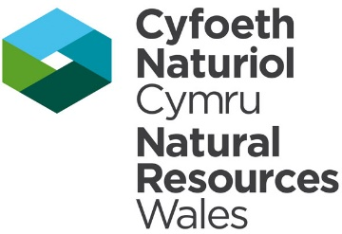
Permitting
Formal Notification under Section 28I of the Wildlife and Countryside Act 1981

Part 2 Formal notification under S28I – To be completed for all permit applications assessed as: not likely to damage because of conditions, likely to damage SSSI and those where we are unable to conclude no likely damage.

- Date Notice of intention to permit activity likely to damage SSSI sent to NRW (SCNB) | 12/03/2026  We have assessed that PAN-28006 is likely to damage River Lugg and River Wye (Lower) SSSIs and request your formal advice. We have assessed that this damage could be mitigated by including conditions.  Information on the permit application can be found in Part 1 of this form
- Advice received from NRW (SNCB) | Advice received via HRA OGN 200 Form 3 confirming agree with SSSI assessment.  A comment was made regarding impact to Burfa Bogland SSSI, however the text has been updated in this assessment to fully reflect that impact to this site is not possible as it was previously confirmed (during assessment of original licence) that this site is too far away to be influenced by the abstraction.
- Name and job title of conservation/marine officer (sign and date) | Sarah Revill, Senior Marine Advisor, Marine Area  Advice & Management Team 01/04/2026  North Powys Environment Team 09/04/2026
Part 3 – To record NRW decision following SNCB Advice
- DECISION | The permission is not likely to damage any of the flora, fauna or geological or physiological features which are of special interest because of conditions
- Natural Resources Wales (Section 28G Authority) (permitting service) is minded to | Issue the permission with conditions to ensure no damage to SSSI
- Is decision in line with advice from SNCB  . | Yes
- Signature and date assessment completed | 13/05/2026
- Officers name and job title | Liz Cole Senior water resources officer

