OGN 200 Form 1A

Record of a Habitats Regulations Assessment
Plan or project name, brief description or application reference number | PAN-028006

HRA iteration/version | Draft 1

1. Plan or Project Details
Information about the plan or project
1 | Date application received | 10/01/2025
2 | Applicant details | Farmpoint Limited. Nobley, Walton, Presteigne, Powys, LD8 2NU.  Application submitted by agent Envireau Water on behalf of applicant.
3 | NRW team responsible for carrying out, or requiring to be carried out, the plan or project, and name of lead officer | N/a
4 | Activity/ies proposed | Application to vary existing abstraction licence WA-055-0008-0003 which authorises abstraction from underground strata via a borehole at NGR SO 26150 61520 at a rate of 120m3/day; 20,739m3 year at Nobley, Presteigne, Powys. The applicant originally proposed to remove the hands off flow (HoF) restriction within the licence, condition 9.2 which is as follows:  ‘No abstraction shall take place when the flow in the River Lugg as gauged at Byton gauging station is equal to or less than 105,000 cubic metres per day. 105,000 cubic metres per day is equal to a level of 0.360 metres at the Byton gauging station.’  The HoF condition has been included in the current licence as during original determination no evidence was provided to demonstrate that the groundwater abstraction does not impact upon nearby surface waters. The HoF set is equivalent to the River Wye Abstraction Licensing Strategy HoF of 1,900 Ml/d (418 mgd) at Redbrook gauging station.  During determination of this variation application the applicant changed their proposal to allow their abstraction to be restricted to that performed in their pumping test when the HoF on the River Lugg is active, rather than a total cessation of abstraction.  By updating condition 9.2 in the current abstraction licence this will allow the licence holder to continue to operate, albeit still restricted during low flow conditions.
5 | Relevant legislation or statutory basis | Water Resources Act 1991, as amended by Water Act 2003.
6 | Location | Nobley Farm, Walton, Presteigne.
7 | Plan or project documents, including any application documents | Application form WRA & WRD  Pump test report  Pump test Appendix F – excel data  Water usage report  Pump test daily water usage- excel data
8 | Environmental Statement | Not applicable
9 | Pre-application correspondence | Groundwater investigation consent (GIC) issued to allow for test pumping, reference PAN-021897
10 | NRW team responsible for preparing this HRA report, and lead officer | Liz Cole Water resources permitting
11 | Team or person responsible for approving the plan or project (competent authority role) | Liz Cole Water resources permitting

2. Determining the need for a Habitats Regulations Assessment
2.1 Is there any possibility that the plan or project could negatively affect any European sites? | Yes
2.2 Is the whole of the plan or project directly and only connected with or necessary to the management of one or more European sites, for the purposes of conserving the habitats or species for which the European site(s) is/are designated? | No
2.3 Is there a possibility that the plan or project could affect any other feature of the European site(s) concerned, or of another European site, in a way that would undermine that feature’s conservation objectives?

3. Considering the likelihood of a significant effect (LSE)

3.1 Renewal of a project authorisation on the same or more restrictive terms as an extant authorisation
Is this a renewal of an extant authorisation which complies with NRW approved criteria for ruling out significant effects of renewals (see Part 2 of OGN200) without conducting a project-specific LSE test? | No

3.2 Likelihood of significant effects (LSE) test

3.2.1 Which European sites might be affected by the plan or project?
(a) | Based on the plan or project specification or information provided in the application, it is considered that these European sites have features which could be negatively affected by the plan or project | River Wye SAC  Severn Estuary SAC & Ramsar (added following Marine advisory comments received 09/04/26)
(b) | The potential for the plan or project to negatively affect these European sites was also initially considered, but can be ruled out without further consideration | Severn Estuary SPA – birds are the features of this site and due to mid Wales location and small scale of the proposal no effects upon this site features are possible.

3.2.2 Screening for likelihood of significant effect
TABLE 3.2.2 Screening assessment
River Wye SAC
Atlantic salmon Salmo salar, Brook lamprey Lampetra Planeri, Bullhead Cottus gobio
SCREEN IN as potential for the groundwater abstraction to reduce nearby surface water levels in Knobley Brook which is located approx. 80 metres east. The Knobley Brook could provide salmon spawning and juvenile habitat; and Bullhead have been found in fish surveys conducted in the Brook. The Knobley Brook is functionally linked to the River Lugg which discharges into the River Wye.

Sea lamprey Petromyzon marinus, River Lamprey Lampetra fluviatilis, Twaite shad Alosa fallax, Allis shad Alosa alosa
All SCREEN OUT: these species are known to not access this far up the catchment and therefore will not be negatively affected by the potential to reduced flows in the local vicinity/functionally linked Knobley Brook.

European otter Lutra lutra
IN -COMBO as potential to reduce nearby surface water levels in Knobley Brook which is located approx. 80 metres east. The Knobley Brook could provide salmon spawning and juvenile habitat; and Bullhead have been found in fish surveys conducted in the Brook. The Knobley Brook is functionally linked to the River Lugg which discharges into the River Wye. A reduction in prey availability is possible in theory; although as the otter are a mobile feature and fish a large area the impact from the proposed abstraction changes alone will not be significant, however in combination with other proposals there is a risk that otter impacts via prey reduction could occur.

Water courses of plain to montane levels with the Ranunculion fluitantis and Callitricho-Batrachion vegetation, & Transition mires and quaking bogs
SCREEN OUT . Thes are non mobile features and will therefore not be affected by the proposal.

White-clawed crayfish Austropotamobius pallipes
SCREEN OUT – this feature is not mobile and will not access this far up the catchment and therefore will not negatively affected by the potential to reduced flows in the local vicinity/functionally linked Knobley Brook.

Severn Estuary SAC

Estuaries (includes migratory fish species salmon, eel, sea trout and Allis Shad)

SCREEN IN - as potential for the groundwater abstraction to reduce nearby surface water levels in Knobley Brook which is located approx. 80 metres east. The Knobley Brook could provide salmon spawning and juvenile habitat. The Knobley Brook is functionally linked to the River Lugg which discharges into the River Wye then onto the Severn Estuary.

River lamprey, Sea lamprey, & Twaite shad
SCREEN OUT – these migratory fish species do not access this far up in the catchment.

Subtidal banks, Intertidal mudflats and sandflats, Atlantic salt meadows, & Reefs
SCREEN OUT - Habitat features that contain no mobile fish features.

Severn Estuary Ramsar
Estuaries & Assemblage of migratory fish species (Sea lamprey, River lamprey, Twaite Shad, Allis Shad, Salmon, Sea Trout, Eel).

SCREEN IN - as potential for the groundwater abstraction to reduce nearby surface water levels in Knobley Brook which is located approx. 80 metres east. The Knobley Brook could provide salmon spawning and juvenile habitat. The Knobley Brook is functionally linked to the River Lugg which discharges into the River Wye then onto the Severn Estuary.

Bewick’s Swan, European white-fronted goose, Dunlin, Redshank, Shelduck, Gadwall, & Internationally important assemblage of waterfowl.

SCREEN OUT – no potential impact as these bird features access a huge area of the estuary for prey.

TABLE 3.2.3 Screening decision of the plan or project ‘alone’
(a) If the screening conclusion for all features for all sites in Table 3.2.2 is ‘SCREEN OUT’ | The plan or project is not likely to have a significant effect on any European site, and no further consideration under the Habitats Regulations is required in order to determine the approval/application.
(b) If the conclusion for any features in Table 3.2.2 is ‘SCREEN IN’ | The plan or project is likely to have a significant effect on one or more European sites and therefore an appropriate assessment is required.
(c) If there are no features in Table 3.2.2 that are ‘SCREEN IN’ and any features that are ‘IN COMB’ | The plan or project is not likely to have a significant effect on any European sites when considered alone, but the possibility of significant effects in combination with other plans and projects needs to be considered.

4. Appropriate assessment of the plan or project when considered alone

4.1 Assessment of plan or project as defined
Table 4.1 Appropriate assessment of the plan or project as defined
European site name: River Wye | Can adverse effects on site integrity be ruled out? ‘YES’ or ‘NO’
Atlantic salmon Salmo salar, Brook lamprey Lampetra Planeri, Bullhead Cottus gobio  Should water levels in the Knobley Brook be reduced there is potential to negatively impact these features. A reduction in water levels/flows could reduce species populations by inhibiting fish movement and negatively impacting water quality by reduced dilution capacity. The Knobley Brook provides a potential spawning area for Salmon and there is a risk that these areas be reduced/and a reduction in access to them from a reduction in flows. A consent to pump test was issued to the operator’s consultant to investigate the effects of abstraction during low flow conditions (Groundwater Investigation Consent [GIC] reference PAN- 021897) . The results of this testing have been submitted in a pump test report. The pump testing monitored local surface waters (included the Knobley Brook) whilst the ‘operational’ abstraction took place during low flow conditions. The testing was not conducted at the maximum authorised licenced abstraction rate of 120m³/day; it reflected the ‘operational’ abstraction at the farm which varies on a daily basis dependent upon the size of the chickens being watered. The graph below demonstrates how the operational abstraction occurs, a chicken cycle is known as a ‘crop’ and last for 49 days in total from the introduction of one day old live chicks until their removal followed by a wash down of the farm sheds.  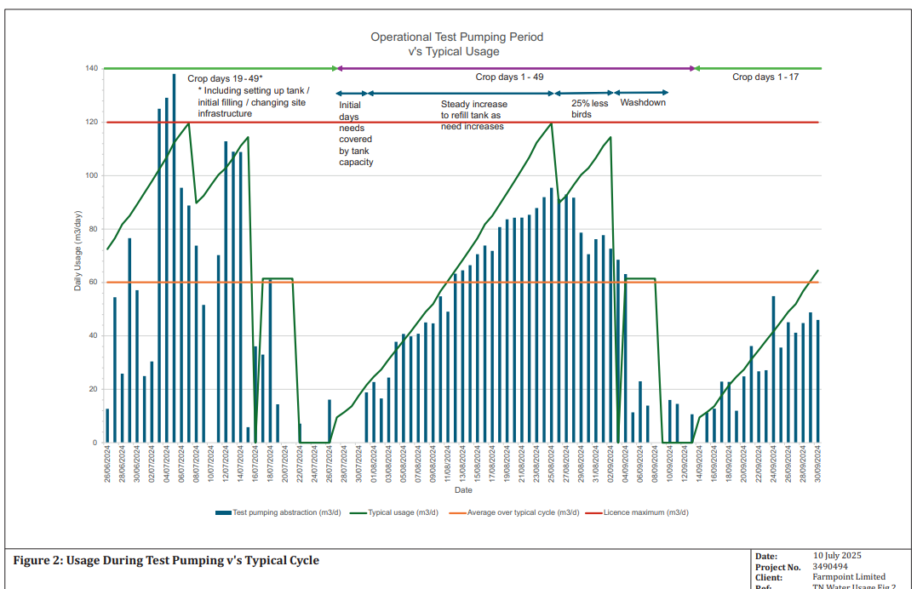  NRW is satisfied that the operational abstraction does not pose a significant risk of impact to flows in the nearby Knobley Brook. This is demonstrated by the pumping test results as follows:  - The fall in water level in the abstraction borehole during the short term test is typical with an initial rapid drawdown followed by a levelling off; with the opposite occurring following cessation of pumping.  - The constant rate test was conducted when background water levels were already in recession (as testing occurred during low flow conditions, as consented in the GIC) and the testing did not significantly influence the rate of this drop.  - Surface water levels remain almost constant throughout the long-term constant rate test.  - There is no evidence of recharge from or interaction with the local watercourse. Recharge in the abstraction borehole is via infiltration into the aquifer.  - During testing the abstraction borehole continues to drawdown; if there was interaction with the nearby watercourse then the drawdown would decrease indicating recharge from it.  By simply removing the HoF condition from the licence as originally applied for by the applicant there is a risk that the operator could abstract at the maximum rate of 120m³/day for a sustained period i.e., for up to 173 days per year (annual abstraction rate of 20,739m³ / 120m³ daily abstraction rate = 173). The current licence quantities condition do not reflect the operational abstraction which was captured during the pumping test. Impact to the Knobley Brook is unknown from a sustained maximum daily abstraction rate of 120m3; there is a risk of a reduction in local water levels and consequently negatively impact fish species. | No
European site name: Severn Estuary SAC & Ramsar | Can adverse effects on site integrity be ruled out? ‘YES’ or ‘NO’
Estuaries - includes migratory fish species salmon, eel, sea trout and Allis Shad & Assemblage of migratory fish species (Ramsar)  Should water levels in the Knobley Brook be reduced there is potential to negatively impact these features. A reduction in water levels/flows could reduce species populations by inhibiting fish movement and negatively impacting water quality by reduced dilution capacity. The Knobley Brook provides a potential spawning area for Salmon and there is a risk that these areas be reduced/and a reduction in access to them from a reduction in flows. A consent to pump test was issued to the operator’s consultant to investigate the effects of abstraction during low flow conditions (Groundwater Investigation Consent [GIC] reference PAN- 021897) . The results of this testing have been submitted in a pump test report. The pump testing monitored local surface waters (included the Knobley Brook) whilst the ‘operational’ abstraction took place during low flow conditions. The testing was not conducted at the maximum authorised licenced abstraction rate of 120m³/day; it reflected the ‘operational’ abstraction of the farm which varies on a daily basis dependent upon the size of the chickens being watered. The graph below demonstrates how the operational abstraction occurs:  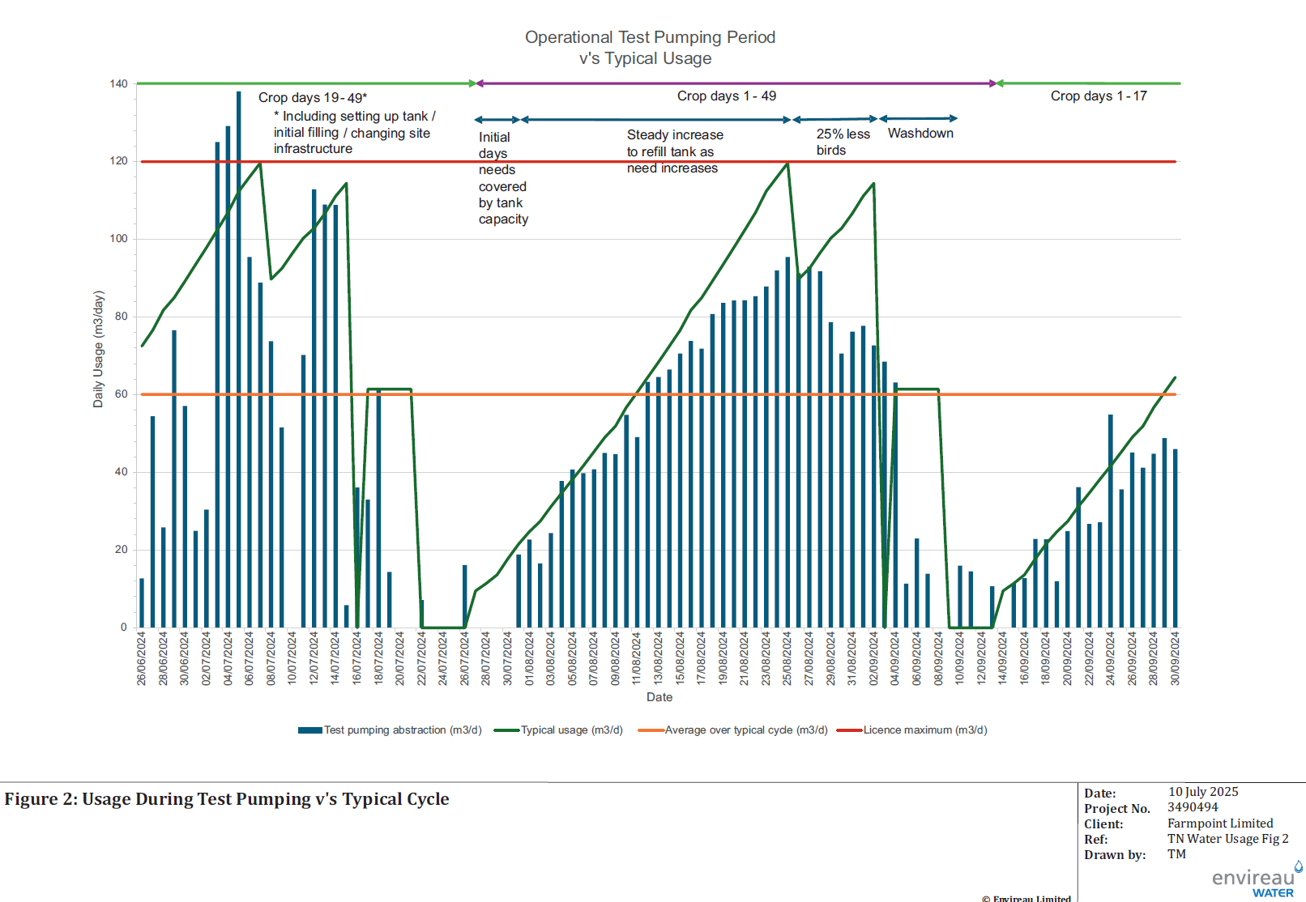  The testing confirmed the following:  - The constant rate test was conducted when background water levels were already in recession (as testing occurred during low flow conditions, as consented in GIC) and the testing did not significantly influence the rate of this drop.  - Surface water levels remain almost constant throughout the long-term constant rate test.  - There is no evidence of recharge from or interaction with the local watercourse. Recharge in the abstraction borehole is via infiltration into the aquifer.  - During testing the abstraction borehole continues to drawdown; if there was interaction with the nearby watercourse then the drawdown would decrease indicating recharge from it.  By simply removing the HoF condition from the licence as originally applied for by the applicant there is a risk that the operator could abstract at the maximum rate of 120m³/day for a sustained period i.e., for up to 173 days per year (annual abstraction rate of 20,739m³ / 120m³ daily abstraction rate = 173). The current licence quantities condition do not reflect the operational abstraction; which was captured during the pumping test. Impact to the Knobley Brook is unknown from a sustained maximum daily abstraction rate of 120m3; there is a risk of a reduction in local water levels and consequently negatively impact fish species. | No

4.2 Appropriate assessment of the plan or project taking into account additional conditions or restrictions imposed by the competent authority
Table 4.2 Appropriate assessment of the plan or project taking into account additional conditions or restrictions
European site Feature | Adverse effect(s) | Can adverse effect(s) be mitigated by additional imposed conditions or restrictions?  ‘YES’ or ‘NO’ | Additional imposed mitigation measure(s) | Can adverse effect on site integrity be ruled out?  ‘YES’ or ‘NO’
River Wye Atlantic salmon Salmo salar  Brook lamprey Lampetra Planeri  Bullhead Cottus gobio | Reduction in spawning habitat and access to it, reduction in flows/dilution, increase in temperatures. | YES | The current licence conditions do not reflect the operational abstraction which was tested during the pump testing. By altering condition 9.2 in the licence so that when the River Lugg HoF is active abstraction is limited to that conducted during the pump test NRW are satisfied that the risk of impact to the local surface waters is negligible. The abstraction shall be limited to tabulated quantities which have been set to reflect the operational abstraction.  The operator will be required to record daily the day of the chicken cycle operation and their abstraction quantities to ensure compliance.  The following conditions have been included within the varied abstraction licence:  9.1 (i) The Licence Holder shall operate the abstraction on 49 day cycles throughout the year. Day one of each cycle being the day live chicks arrive on site.  (ii) The Licence Holder shall record the calendar date and corresponding cycle day number during each 49 day cycle.  (ii) The Licence Holder shall send a copy of the record required by Condition 9.1(ii) above to NRW within 28 days after the 31 March in each year and also within 28 days of being so requested in writing by NRW.  (iv) Each record shall be kept and be made available during all reasonable hours for inspection by NRW for at least 6 years.  9.2 When the flow in the River Lugg as gauged at Byton gauging station is equal to or less than 105,000 cubic metres per day, maximum quantities abstracted per cycle day shall not exceed the volumes specified in Table 1 below:  By including the above conditions the operator has the flexibility to abstract how they wish (up to maximum licenced quantities) when flows in the Lugg are sufficient i.e. when no HoF is active. When low flow conditions occur the abstraction must be reduced; as opposed to a complete cessation of abstraction. The pump testing has demonstrated that the operational abstraction during low flows is sustainable. | YES
  Table 1
  Cycle day number | Maximum daily abstraction volume cubic metres per day
  Day 1 to 5 | 25
  Day 6 to 10 | 45
  Day 11 to 15 | 55
  Day 16 to 20 | 75
  Day 21 to 25 | 85
  Day 26 to 32 | 96
  Day 33 to 39 | 80
  Day 40 to 49 | 25
Severn Estuary SAC & Ramsar  Estuaries (includes migratory fish species salmon, eel, sea trout and Allis Shad) & Assemblage of migratory fish species |  | YES |  | YES

4.3 Concluding the appropriate assessment of the plan or project alone
Table 4.3 Conclusion of the appropriate assessment alone
(a) If Table 4.1, or the right hand column of Table 4.2 if applicable, is ‘YES’ for all features | It has been ascertained that the plan or project, when considered alone, will not adversely affect the integrity of any European sites.
(b) If there are any ‘NO’s in the right hand column of Table 4.2 | It has not been ascertained that the plan or project, when considered alone, will not adversely affect the integrity of one or more European sites.
(c) Are there any residual effects of the plan or project (net of mitigation measures) which, though not adverse on their own, could be significant when considered in combination with the effects of other plans or projects?

5. In combination assessment
Table 5.1 Identification and assessment of in combination effects
European site name: River Wye
Potential in combination effects to be considered:

Impact to otter prey availability due to potential impacts to fish populations.

In combination assessment:

No other plans or projects have been identified to have been submitted where potential effects could interact with this proposal e.g. nearby other water abstraction proposals which could also impact upon fish prey availability for otter
Can significant or adverse in combination effects be ruled out for all features?

Yes

Table 5.2 In combination assessment: results
(a) If the answer for all features considered in Table 5.1 is ‘YES’ | The plan or project, when considered in combination with other plans and projects, is either not likely to have a significant effect on, or will not adversely affect the integrity of, any European site.
(b) If the answer for any features considered in Table 5.1 is ‘NO’ | The plan or project in its current form is likely to have a significant effect on, or an adverse effect on, European site/s in combination with other plans or projects.

6. Conclusion
HRA is not required because there is no conceivable impact on any European sites.
(As documented in section 2.1)
HRA is not required because the whole of the plan or project is directly connected with or necessary to the management of one or more European sites, for the purposes of conserving the habitats or species for which the site(s) is/are designated, and the plan or project is not likely to have a significant effect on any other European sites.
(As documented in section 2.2 and 2.3)
This project is a renewal of a current permission which complies with NRW agreed criteria for ruling out likely significant effects of a renewal without conducting a project-specific LSE test. Therefore, it is considered not likely to have a significant effect on any European sites, either alone or in-combination with other plans or projects.
(As documented in section 3.1 of this form)
The plan or project has been screened for likelihood of significant effects and is considered not likely to have a significant effect on any European sites. (As documented in section 3.2 of this form, and section 5 if applicable)
In light of the conclusions of an appropriate assessment it has been established that the plan or project will not adversely affect the integrity of any European sites, taking into account any conditions or restrictions as applicable, either alone or in-combination with other plans or projects.  (As documented in section 4 of this form, and section 5 if applicable) | X
In light of the conclusions of the appropriate assessment, it has not been ascertained that the plan or project will not adversely affect the integrity of any European sites, as documented in section 4 of this form, and section 5 if applicable.
Approval for the plan or project cannot be given unless either:
- the plan or project specification, and/or the terms under which it might be approved, are modified so as to remove the risk of adverse effects, and a revised HRA is prepared, or
- the plan or project (not being an SSSI consent*) satisfies the requirements for a derogation and a Derogation Notice is prepared and submitted for consideration by the appropriate authority, normally Welsh Ministers
(*SSSI consents cannot be given as derogations)
Signed: L Cole

Name: Liz Cole
Position: Senior water resources officer

Date: 10/03/2026
Was this HRA conclusion an escalated decision? YES or NO

7. Consultation with the ANCB and how sections 2, 3, 4 and 5 of this HRA report (as applicable) take into account that advice.
Relevant section of the HRA report | Correspondence and/or meetings with the ANCB | Description of how the comments from the ANCB have been taken into account
2
3 |  | Fisheries email concerning HRA for original application dated 16/11/2021 confirming that Knobley Brook likely to be accessible to Salmon, resident brook lamprey and Bullhead.  Section 3.2.1 updated as Severn Estuary SAC & Ramsar missing from table, as advised by Marine advisory response received 09/04/26.
4 |  | 03/10/2025 – Geoscience email discussing impacts from operational abstraction and nearby surface waters and confirming that it does not significantly affect nearby water features.
5

9. Appendix: supporting information
Pump test report
Pump test Appendix F – excel data
Water usage report
Pump test daily water usage- excel data
Groundwater investigation consent (GIC) issued to allow for test pumping, reference PAN-021897

