PAN-032143 My Map Report:
Application maps
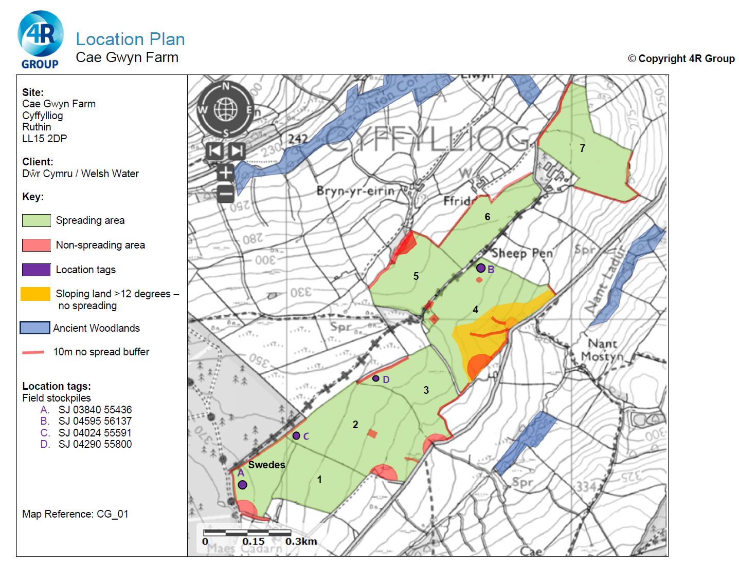
Deployment Boundaries and storage
Storage location B is incorrect RFI
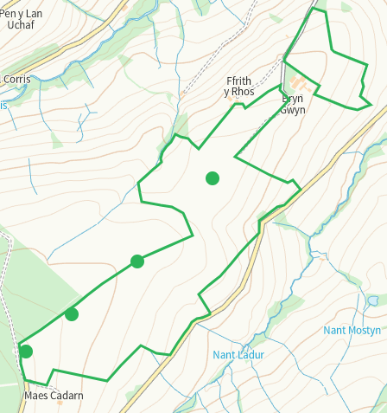

Detailed river network 10m
Multiple watercourses and ponds within range all buffered.
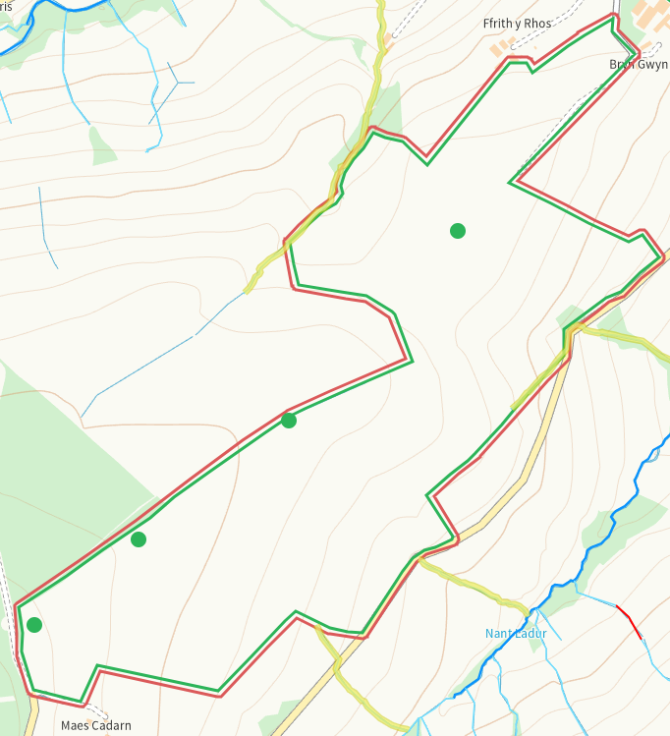
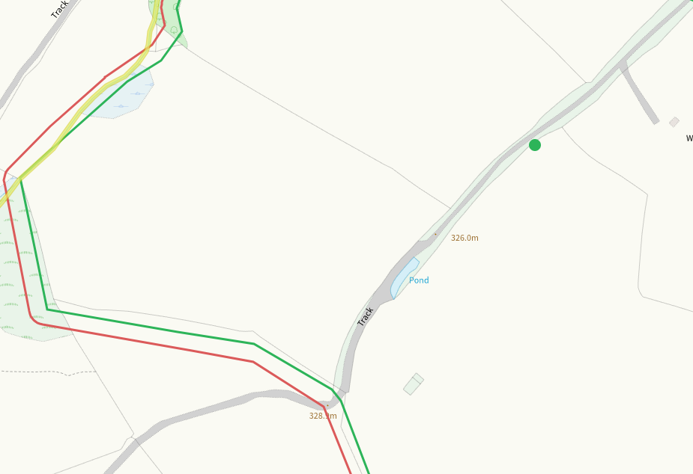
Groundwater source protection zones
none
Any well, spring (or issue) or borehole used for the supply of water for human consumption including from a private water supply or supplies within 50m.
Issue S of 1, buffered
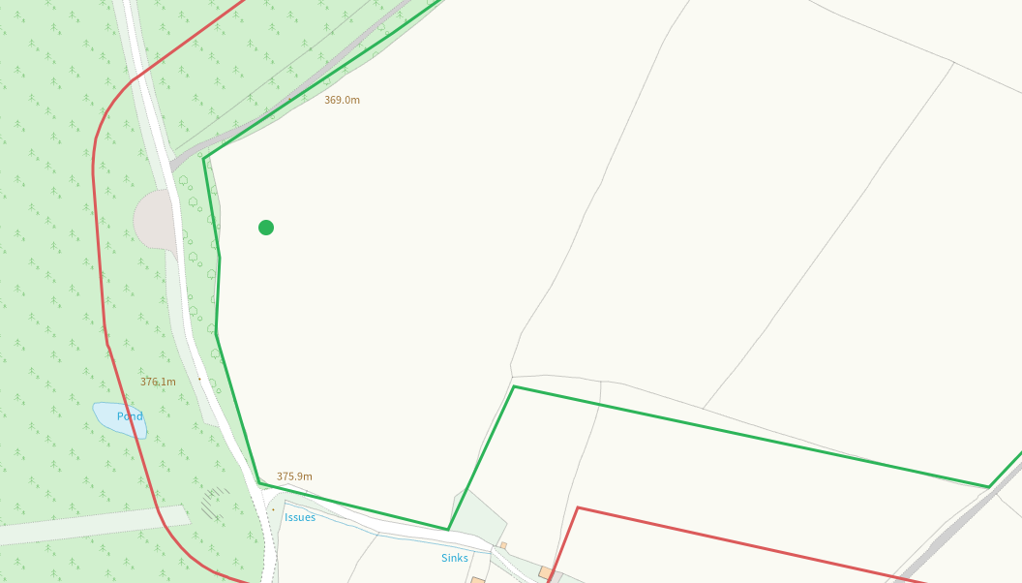
Issue S of 2, buffered
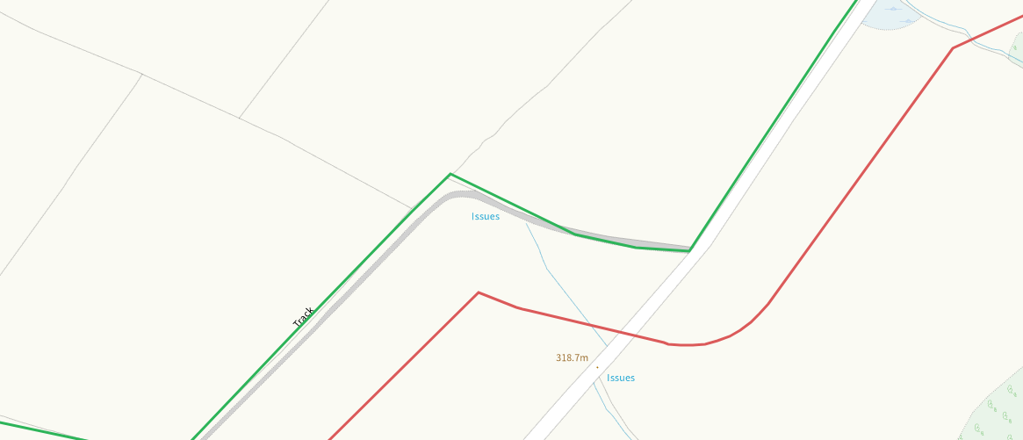
Issue S of 3, buffered
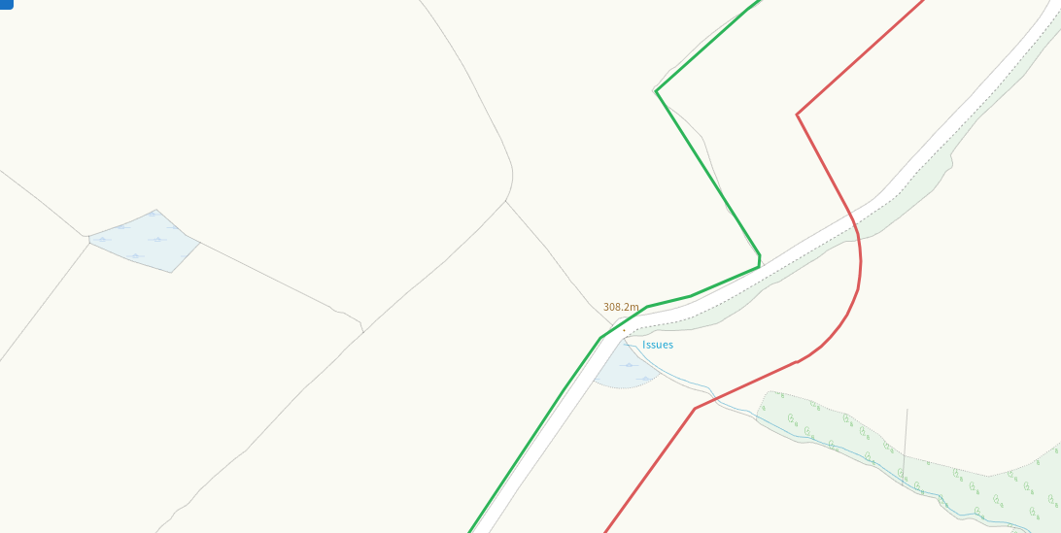
Issue within 4, buffered
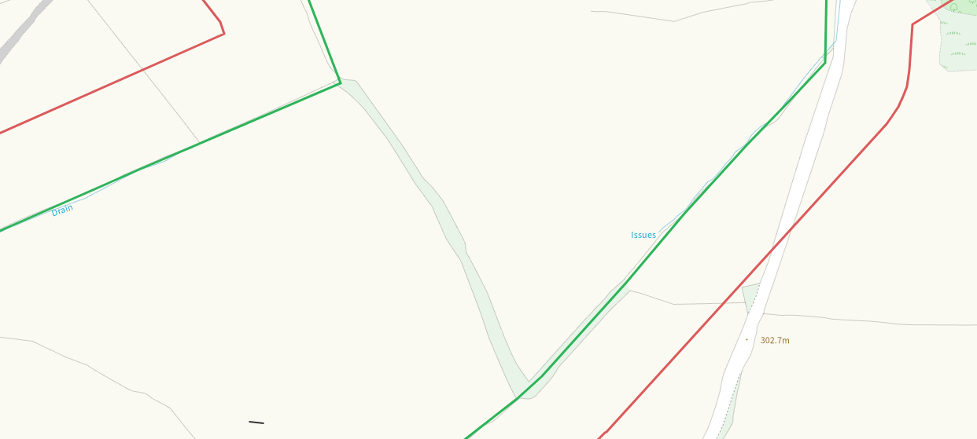
Any well, spring (or issue) or borehole used for the supply of water for human consumption including from a private water supply or supplies within 250m.
Some within range, nil risk from the activity.
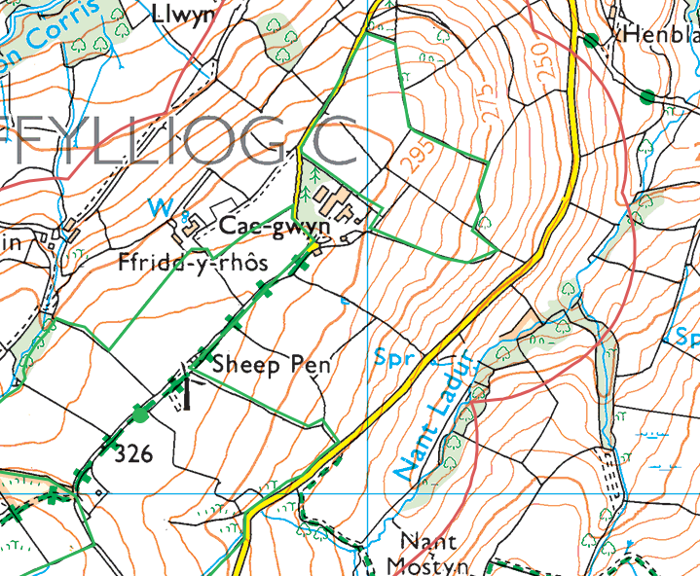
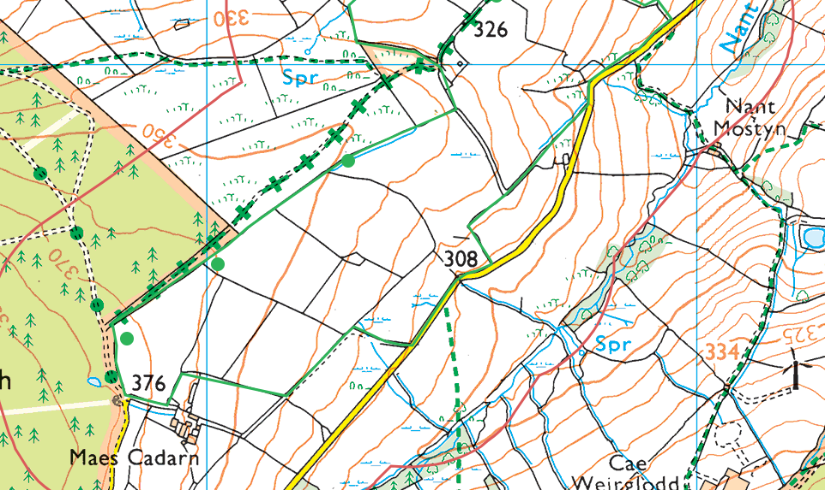
Within Groundwater Safeguard Zone
none
European designated sites- Natura 2000 (SPA, pSPA, SAC or cSAC) or Ramsar- or SSSI within 500m
none
Other protected sites within 500m:
- Protected Species-
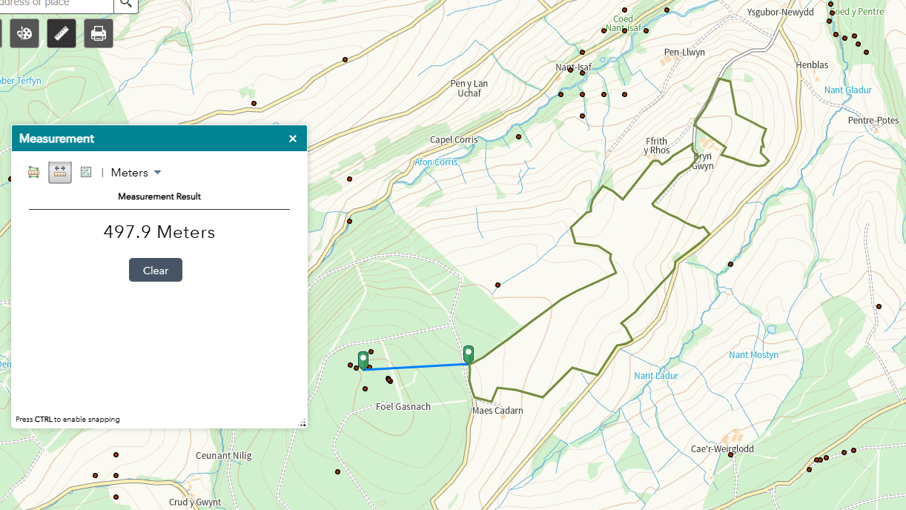

- Protected Habitats-
Some within range, nil risk from the activity.
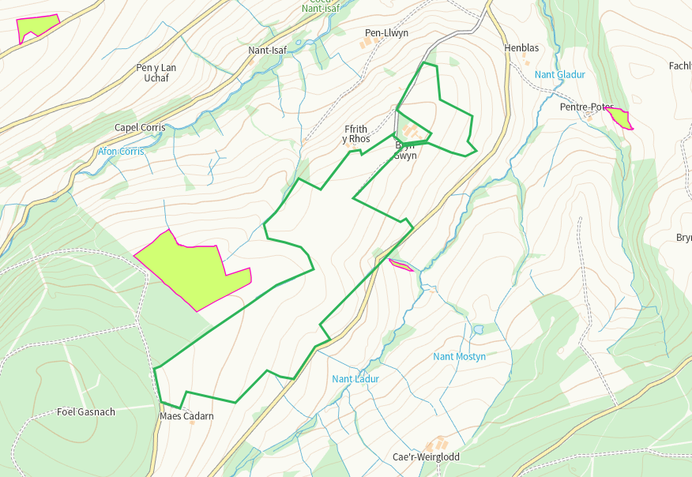

- Scheduled Ancient Monument- none
- Local Nature Reserve- none
- National Nature Reserve- none
- Ancient Woodlands-
Some within range, shown on maps
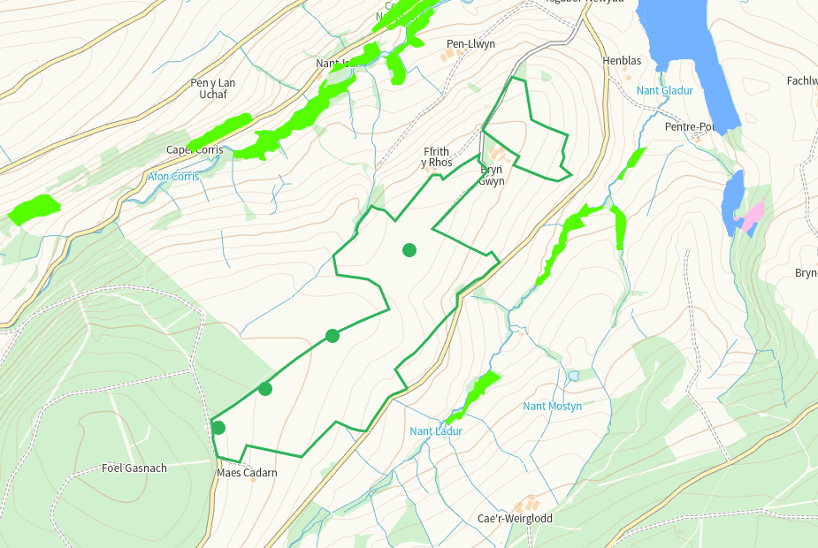

- Local Wildlife Sites (SINC)-
Coed y Pentre / Nant Ladur (2 areas) to the E
Afon Corris woods to the N
Noth identified as ancient woodland on maps, nil risk from the activity
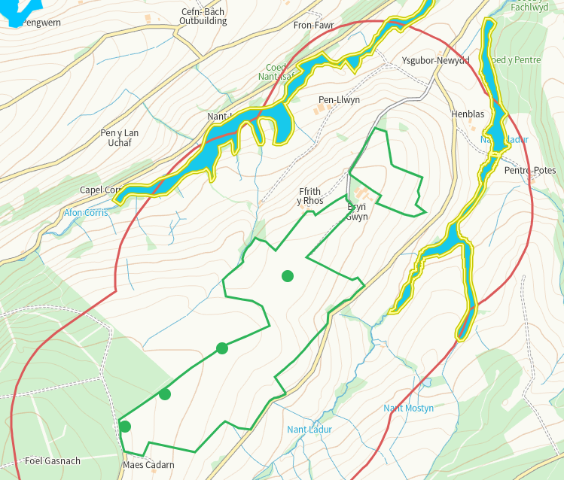

- National Park- none
- Nitrate Vulnerable Zone (NVZ)- ALL Wales
- Groundwater Safeguard Zone- none

Flood risk
None
Public rights of way
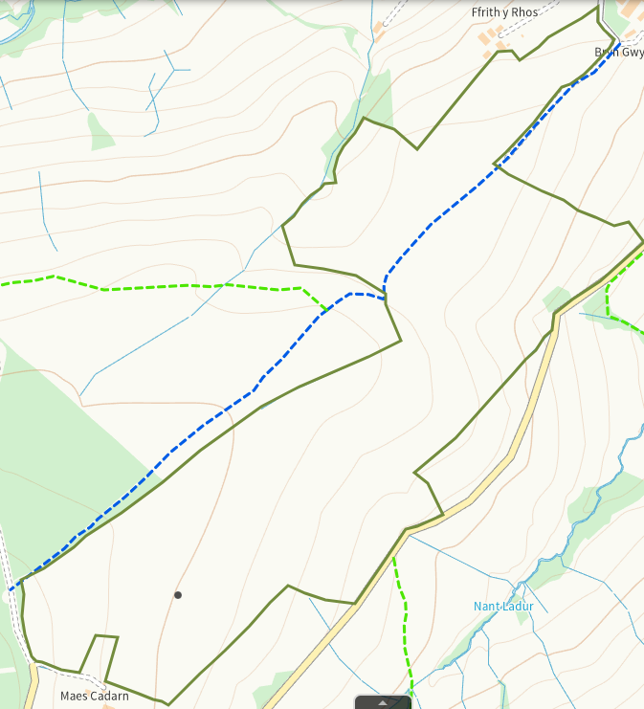

Distance from Main Farm Address
Adjacent
Slope Map
Areas of 12+ are buffered
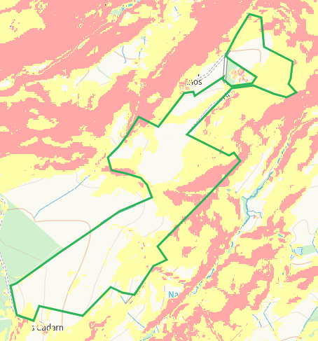

END

