PAN-032332 My Map Report:
Application maps
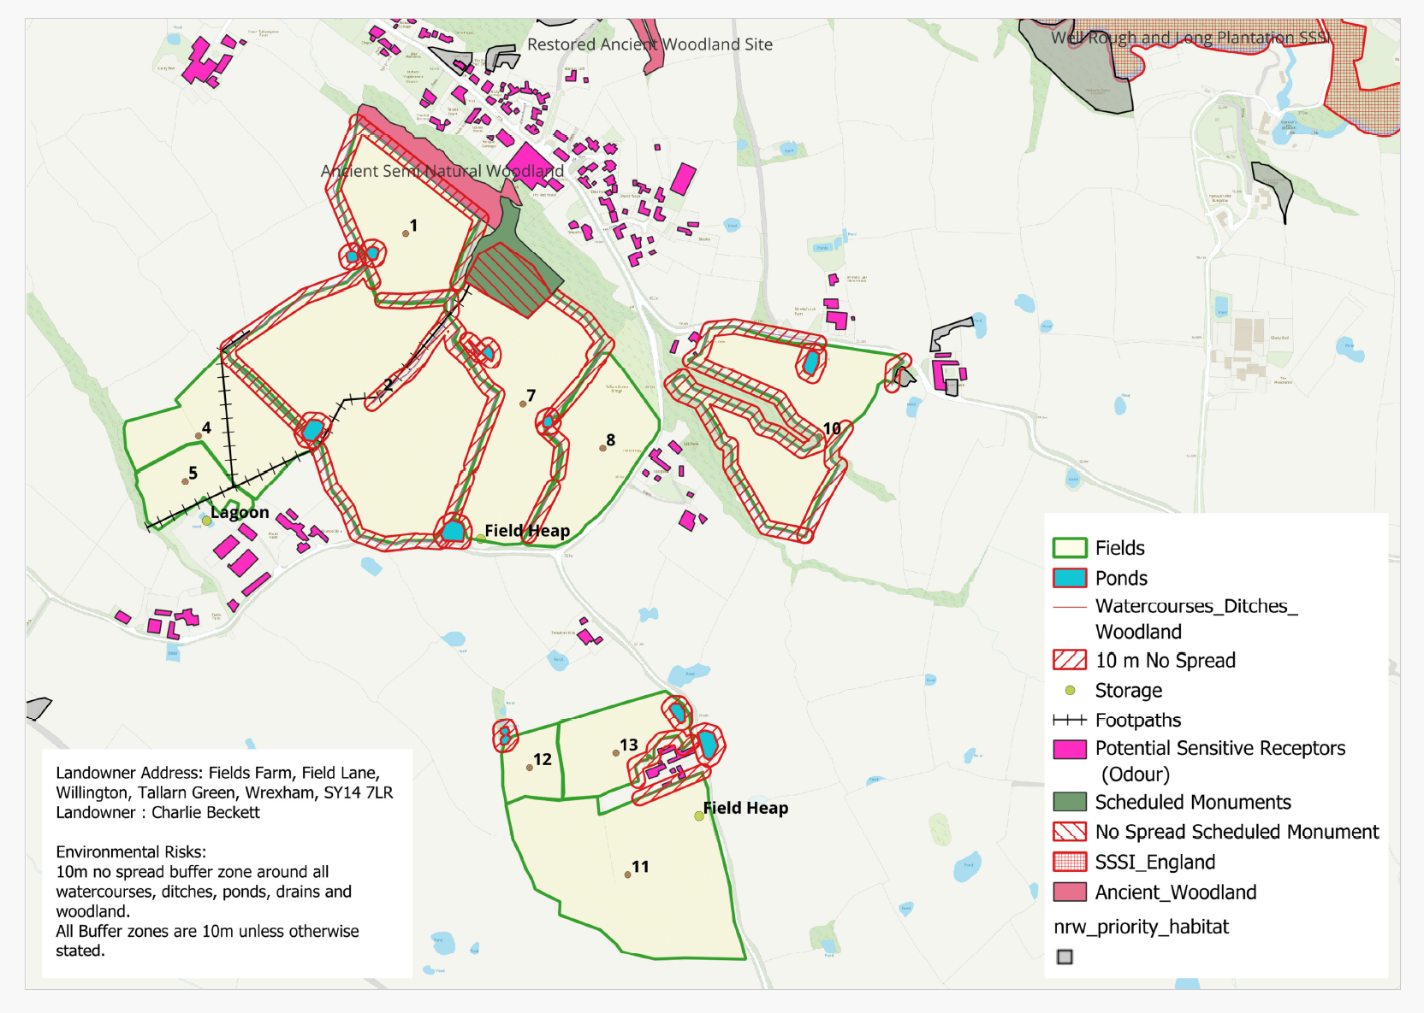
Deployment Boundaries and storage
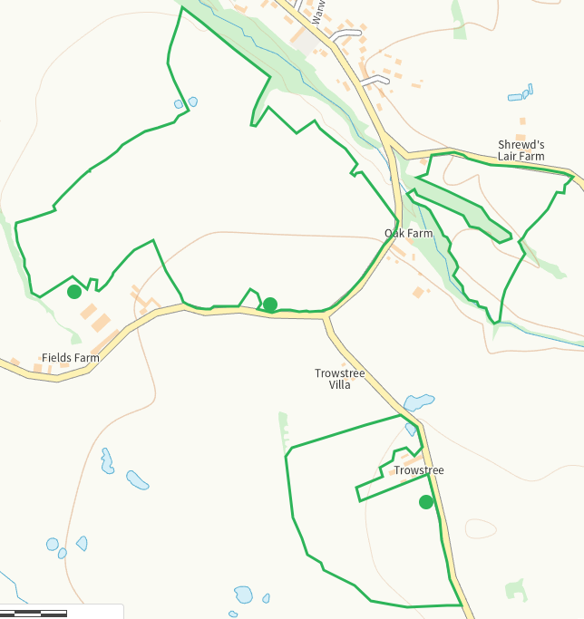
Detailed river network 10m
All watercourses and ponds identified and suitably buffered
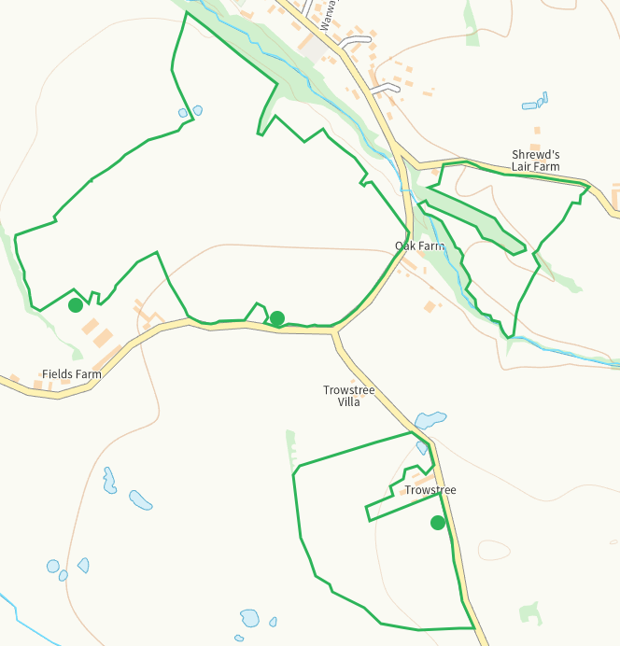

Groundwater source protection zones
none
Any well, spring (or issue) or borehole used for the supply of water for human consumption including from a private water supply or supplies within 50m.
Water quality permit number CM0209601 N of 7 not identified but no spread area puts it beyond 50m. nil risk.
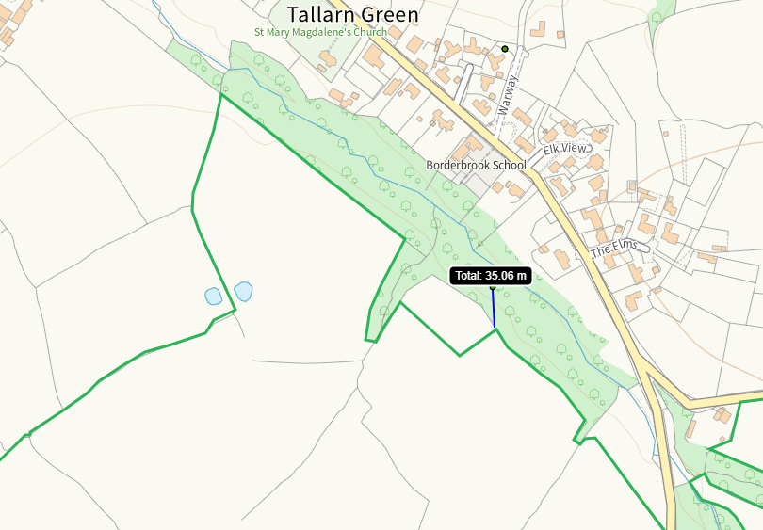
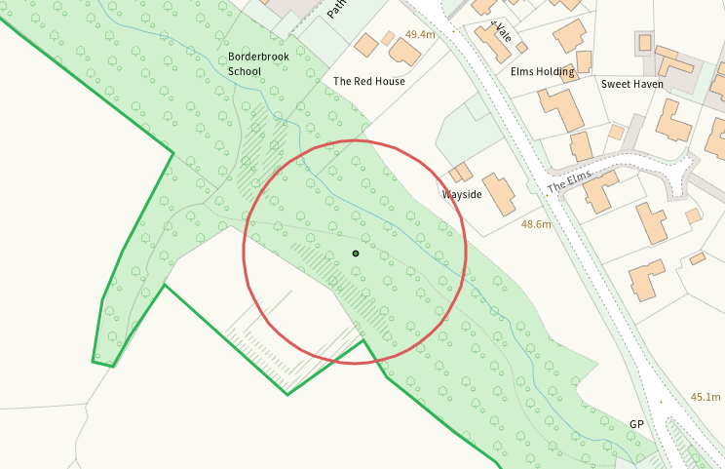
Any well, spring (or issue) or borehole used for the supply of water for human consumption including from a private water supply or supplies within 250m.
NALD deregulated abstraction (borehole) S of 5. Nil risk.
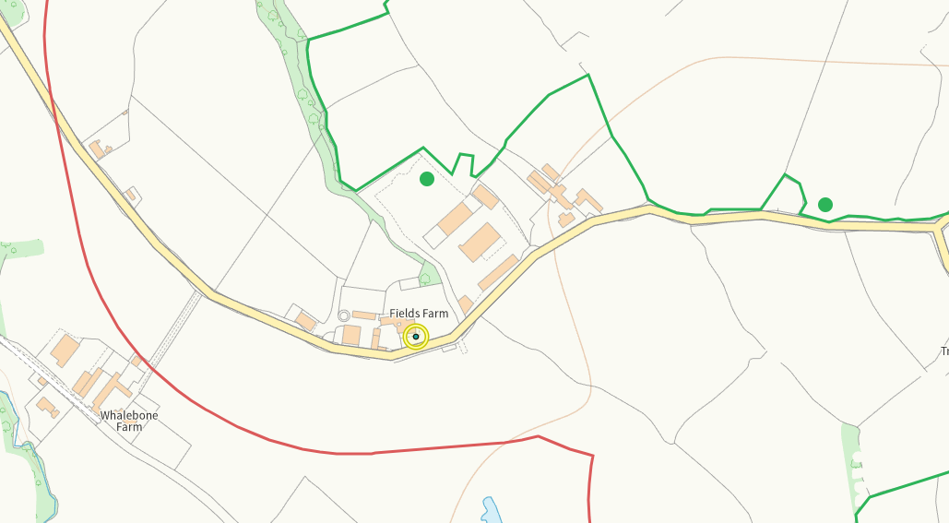
Water quality permit number G0433501 NE of 1. Nil risk
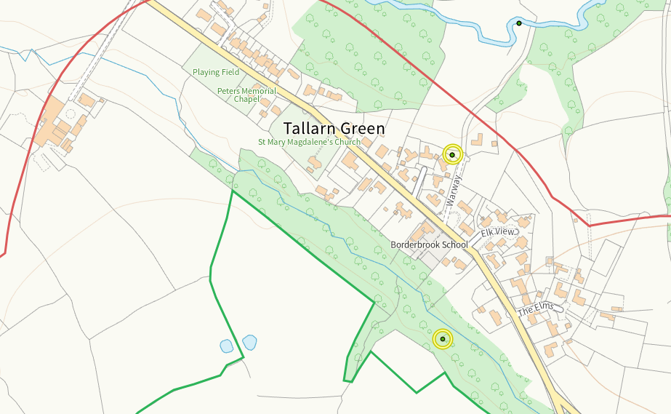
Within Groundwater Safeguard Zone
none
European designated sites- Natura 2000 (SPA, pSPA, SAC or cSAC) or Ramsar- or SSSI within 500m
SSSI Well Rough NE of deployment, identitifed in application. Nil risk, see annexe iv on DMS
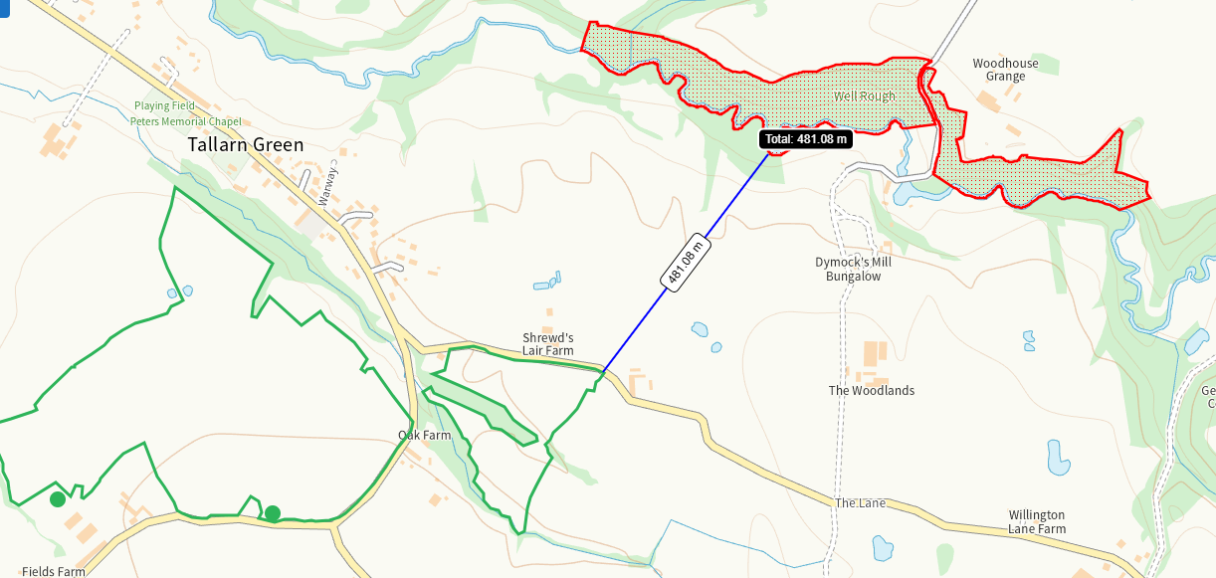
Other protected sites within 500m:
- Protected Species-
Multiple in range, notably GCN within the ponds dated 2007. Species are addressed in the application with mitigation and control measures. Low risk from the activity.
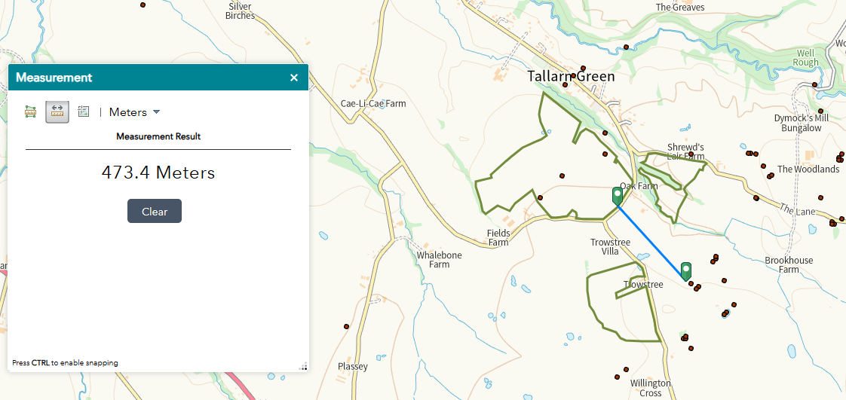
- Protected Habitats-
Habitats are noted in the application and SSRA

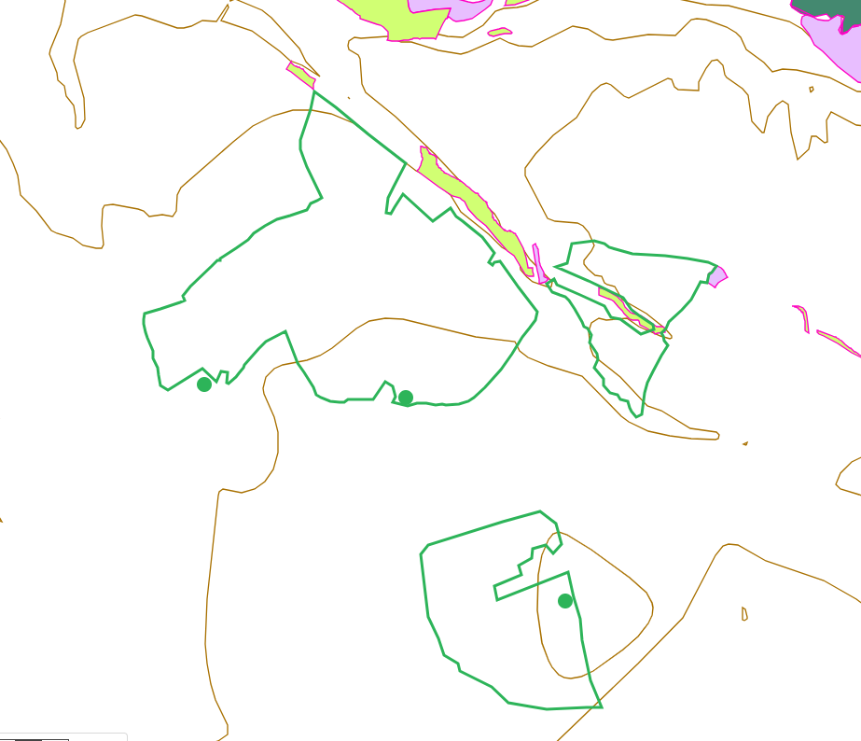

- Scheduled Ancient Monument-
Tallarn Green Moated Site adjacent to 7. No spread buffers in place and identified in SSRA. Nil risk
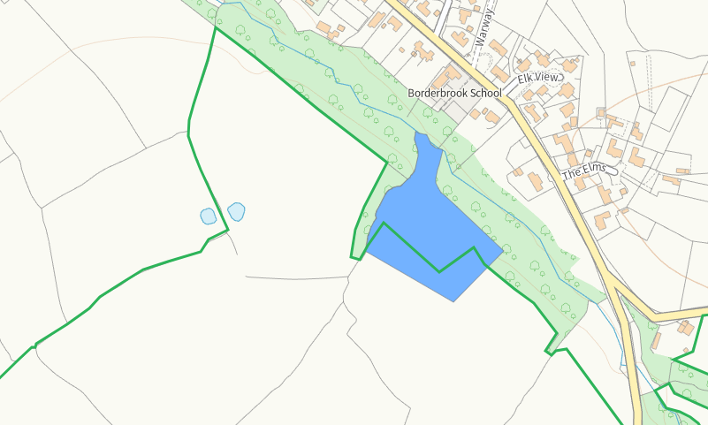
- Local Nature Reserve-
- National Nature Reserve-
- Ancient Woodlands-
Adjacent to 1, on map and buffered. Also noted in the SSRA
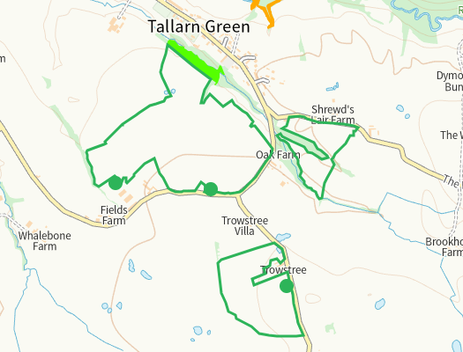
- Local Wildlife Sites (SINC)-
Tallarn Green Meadows N of 1. Not shown on map or in SSRA. Nil risk

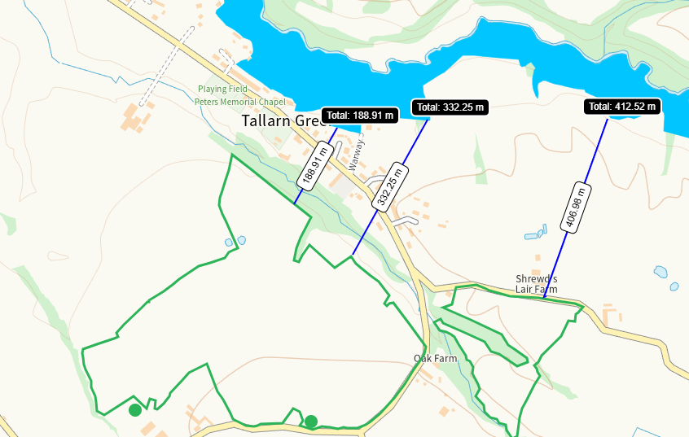
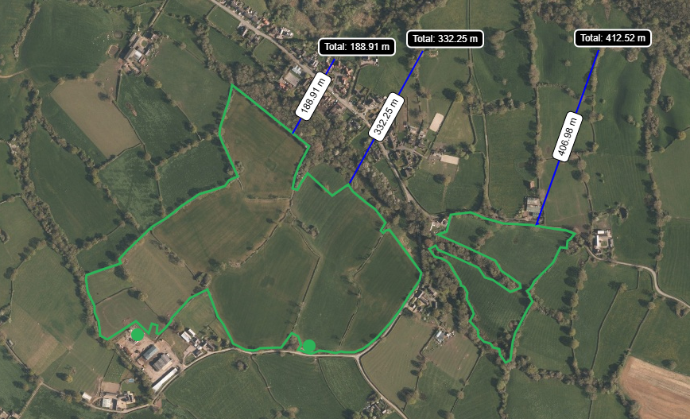

- National Park- none
- Nitrate Vulnerable Zone (NVZ)- ALL Wales
- Groundwater Safeguard Zone- none

Flood risk
Flood risk addressed in application.
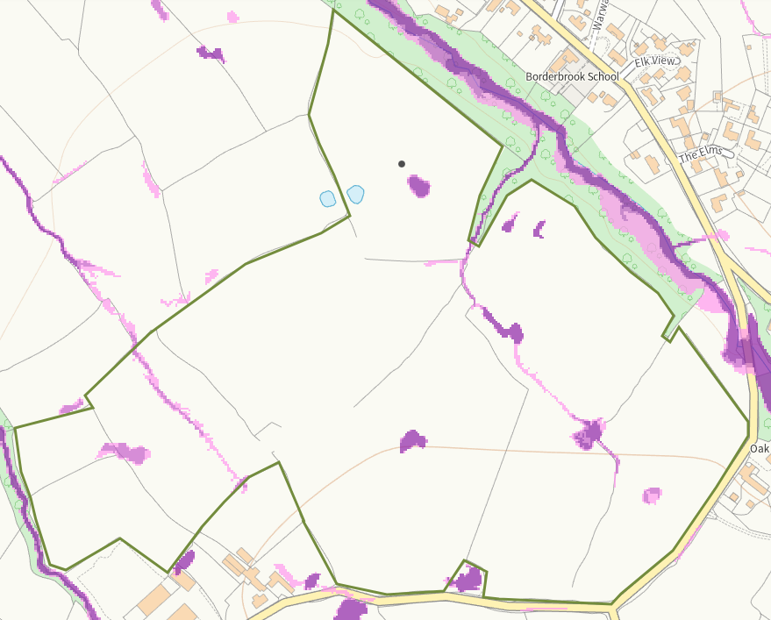
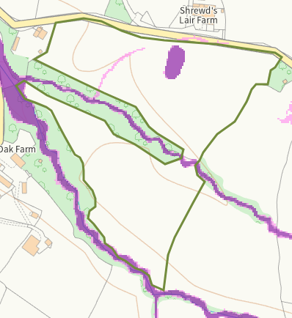
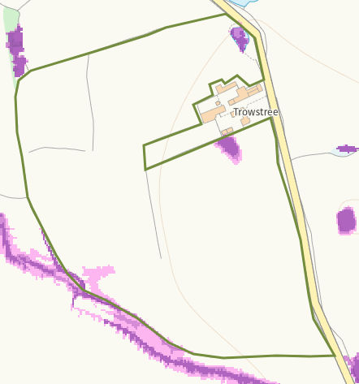
Public rights of way
Footpaths within fields, shown on application map
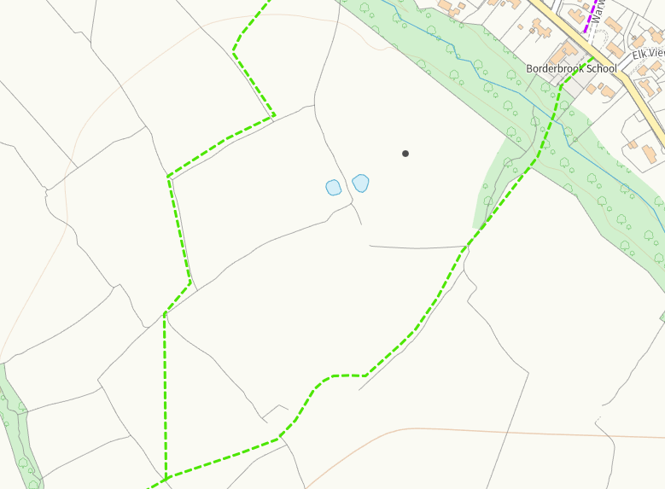
Distance from Main Farm Address
Adjacent
Slope Map
All fields 0-7, except 10 which shows areas of 12+, no spread areas are not in place. The areas fall to watercourses RFI
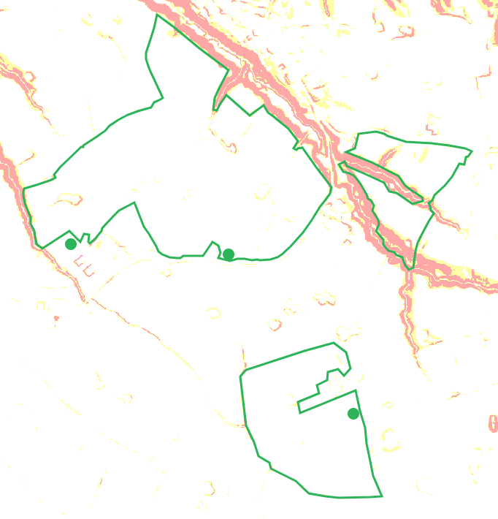
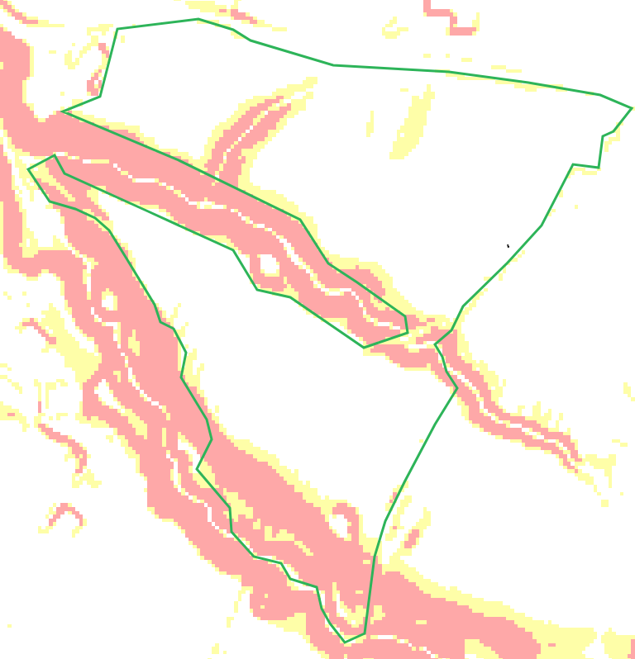
END

