PAN-030803 Mapping Report
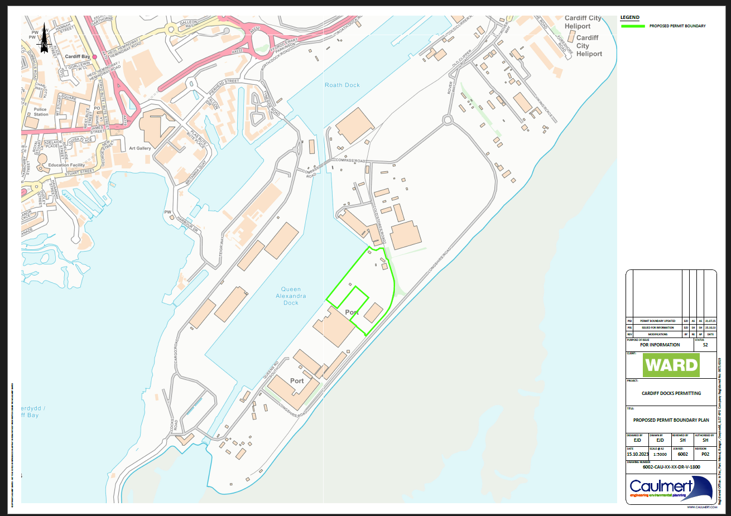
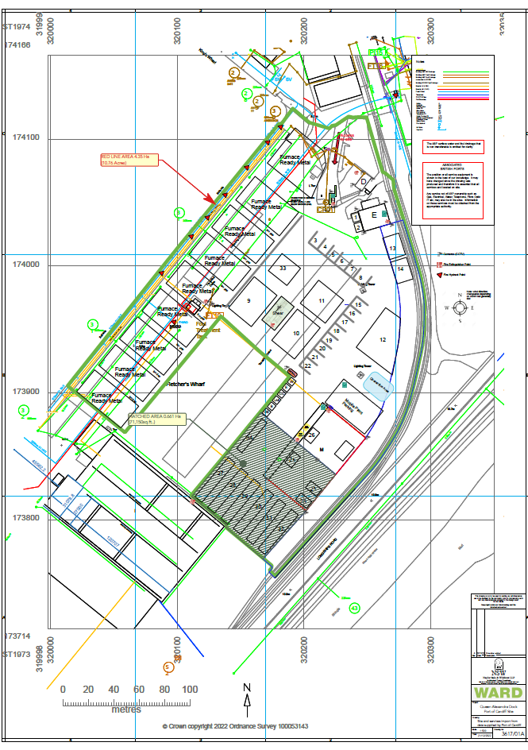
sites of special scientific interest (SSSIs)
- Severn Estuary SSSI
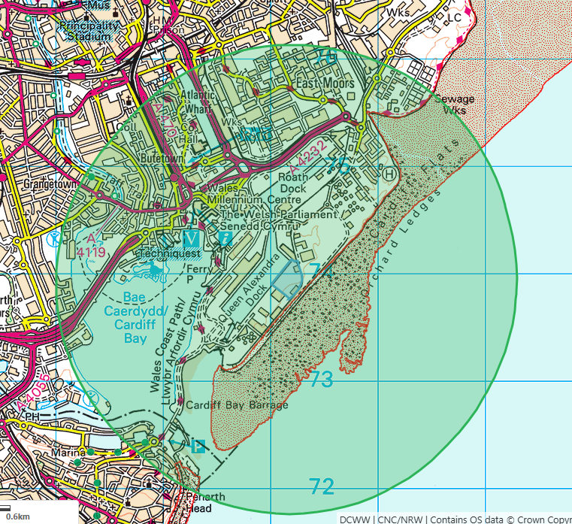
special areas of conservation (SACs)
- Severn Estuary (Wales)
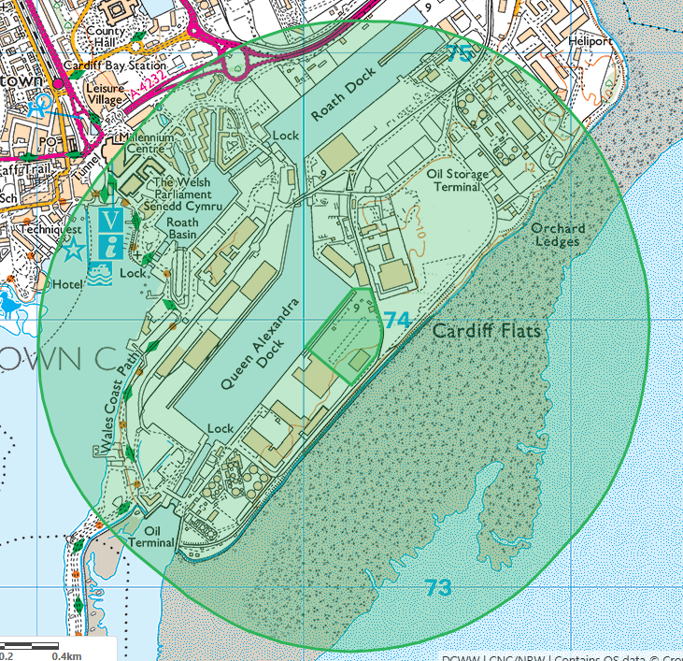
special protection areas (SPAs)
- Severn Estuary (Wales)
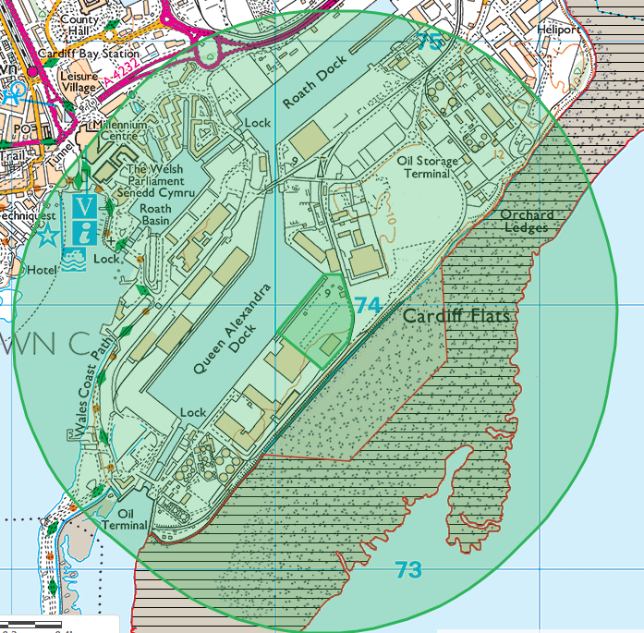
Ramsar sites (wetlands)
- Severn Estuary (Wales)
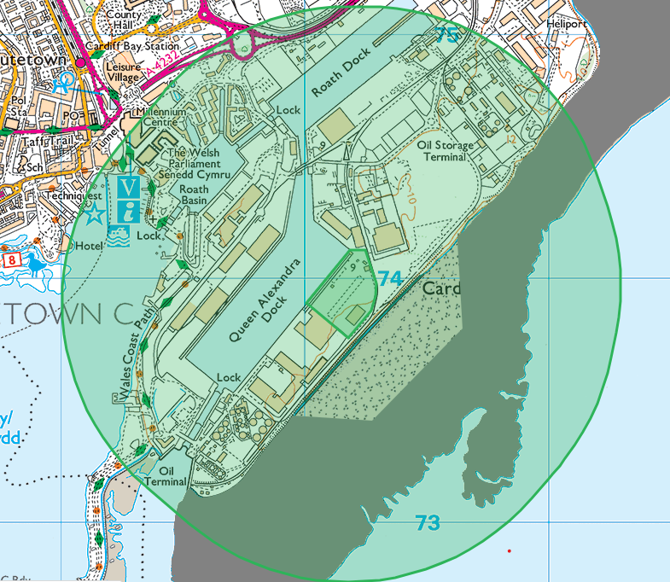
local sites- nature reserves (national/local)
- CARDIFF BAY WETLANDS AND HAMADRYAD PARK local nature reserve
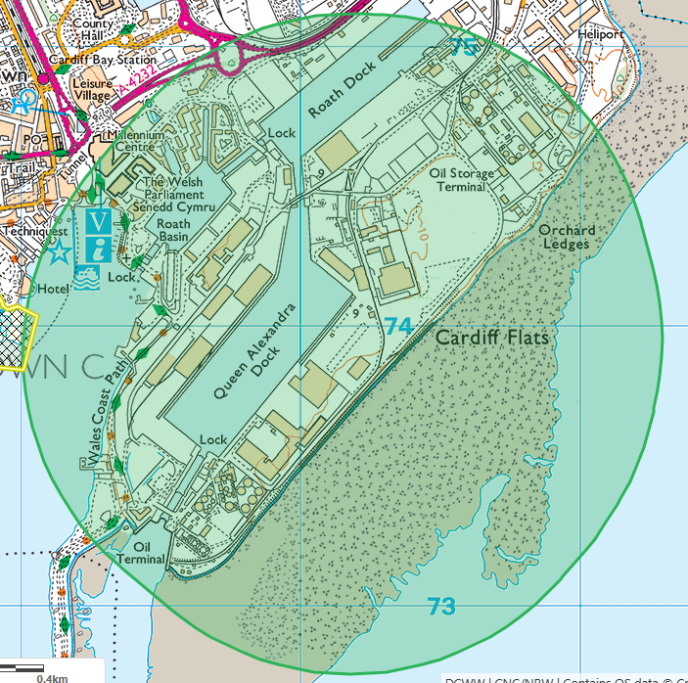
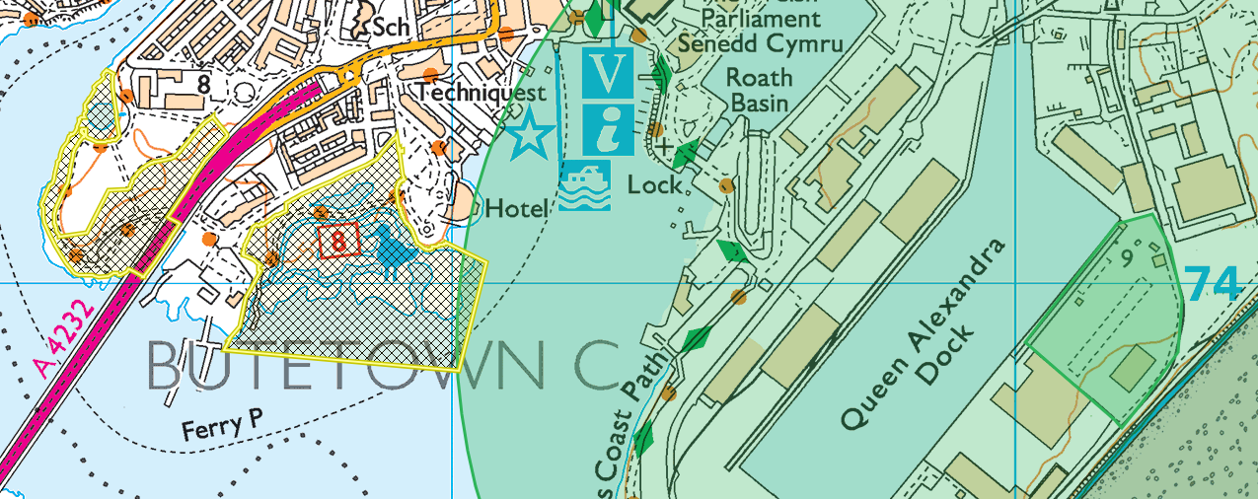

Flooding
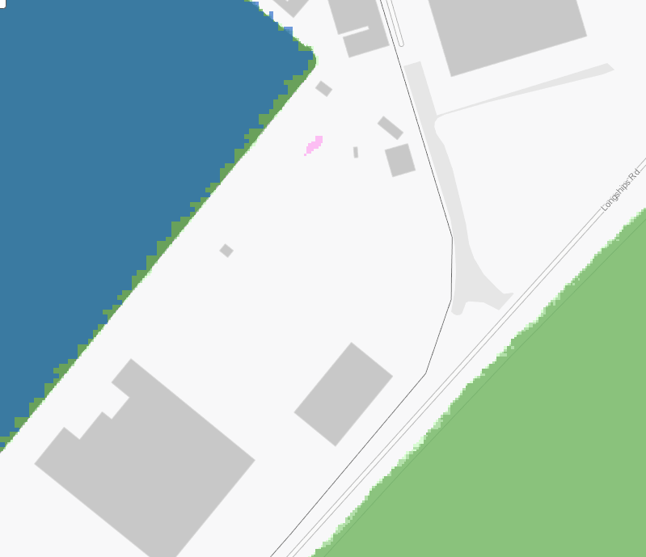
protected habitats/species and section 6/7 species
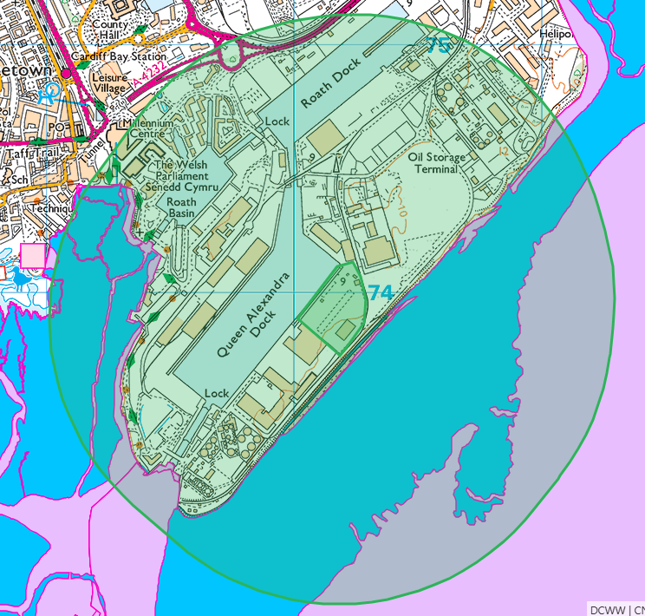
Habitats:
- Intertidal mudflats (River Severn Estuary)

Species (Cardiff Bay/River Severn Estuary):
- Atlantic Salmon migratory route X2
- European Eel migratory route X2
- River Lamprey migratory route X2
- Sea Lamprey migratory route X2
- Smelt migratory route
- Twaite Shad migratory route
- Unidentified Shad migratory route

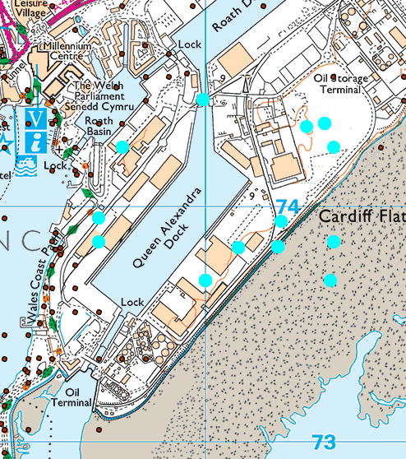
Fish/eels in estuary/Cardiff bay, various birds (Cardiff mudflats/foreshore), various butterflies/moths, hedgehogs
historic items (ancient monuments, historic sites etc.)
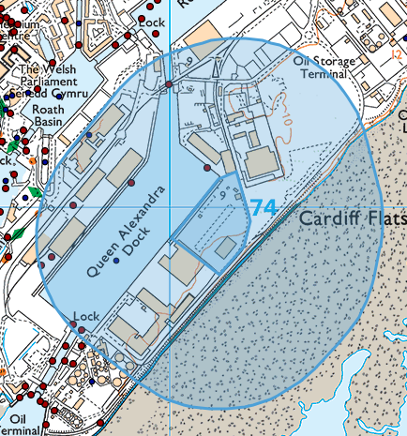
2x historic monuments with no information other than id numbers (281380 and 308795)
World heritage sites:
- Imports Wharf, Cardiff Bay- wharf- intact
- Alexandra Dock Camp, Alexandra Dock, Cardiff- condition unknown
- Alexandra Dock Capstan 3, Cardiff Bay- capstan- Destroyed
- Alexandra Dock Capstan 4, Cardiff Bay- capstan- condition unknown
- Alexandra Dock Drinking Fountain, Cardiff Bay- drinking fountain- - condition unknown
- King Wharf Railway Bridge, Cardiff Bay- railway bridge- Intact
- Kings Wharf, Cardiff Bay- wharf- Destroyed
- Customs and Excise Office, Cardiff Bay- office- Destroyed

Aquifers
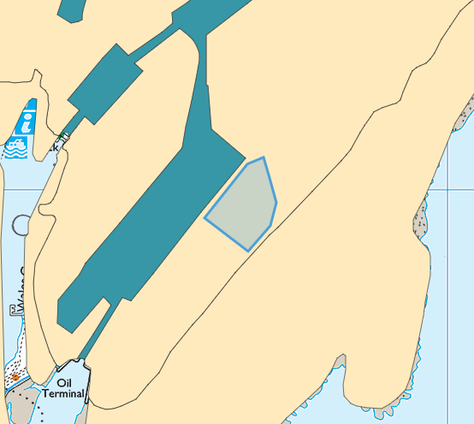
- Aquifer Designation (Superficial)- TIDAL FLAT DEPOSITS- CLAY, SILT AND SAND- Minor+Non- Secondary (undifferentiated)
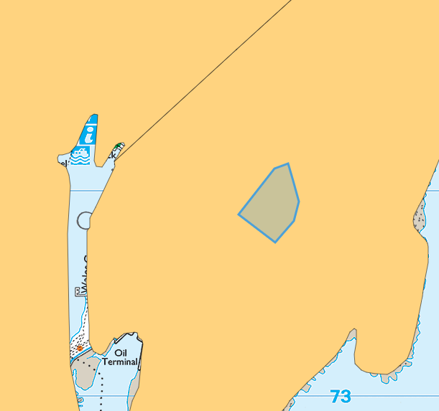
- Aquifer Designation (Bedrock)- MERCIA MUDSTONE GROUP- secondary B
local wildlife sites
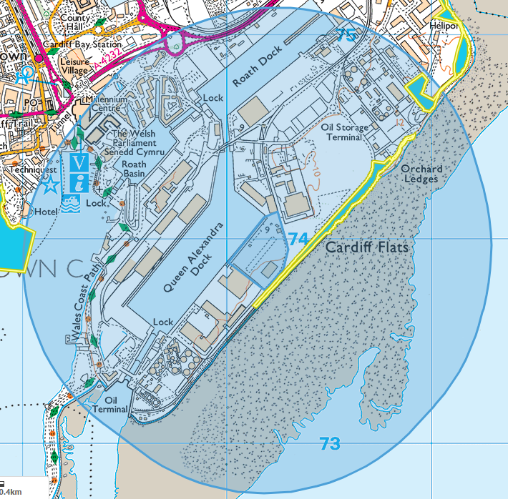
- Beach Sidings (SITE_CODE 174)- Calcareous grassland and scrub developing on former dock sidings with a unique population of Childling Pink. For further information on please contact Cardiff Council - MBHarris@cardiff.gov.uk
- Cardiff Bay Wetland Reserve (SITE_CODE 12). For further information on please contact Cardiff Council - MBHarris@cardiff.gov.uk
- Cardiff Heliport Fields (SITE_CODE 13) Calcareous grassland with Common Broomrape, Bee Orchid and Grass-leaved Vetchling. For further information on please contact Cardiff Council - MBHarris@cardiff.gov.uk

surface water courses (sinks/issues/springs/wells etc.)
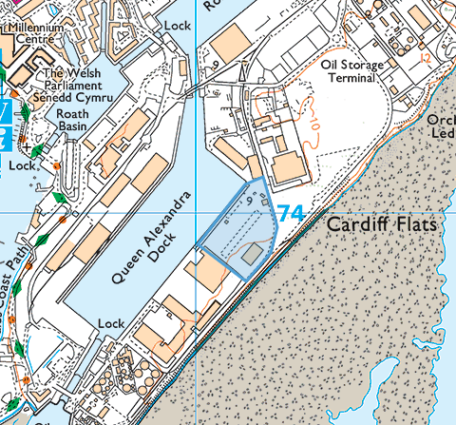

local residents
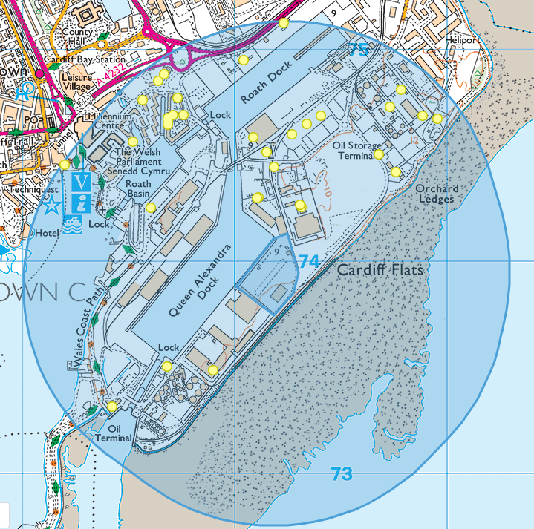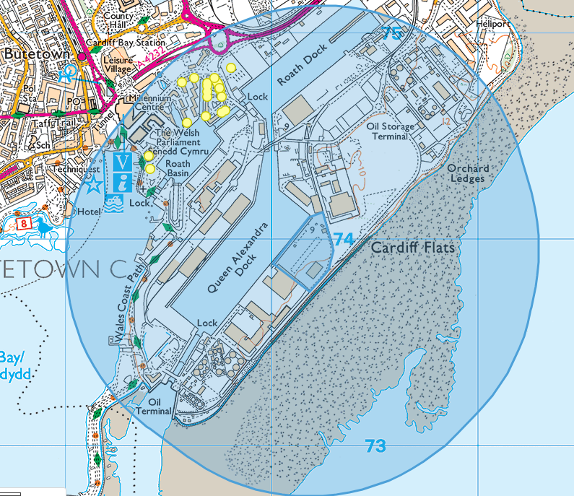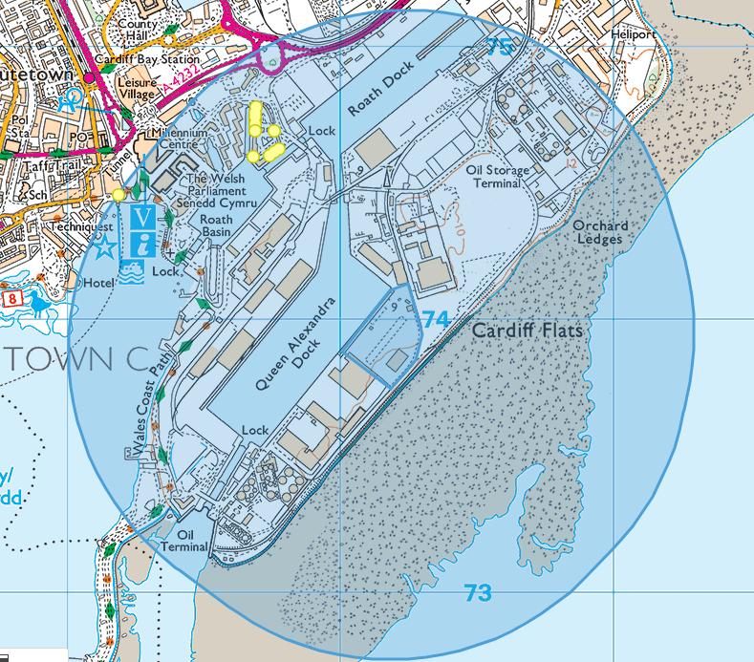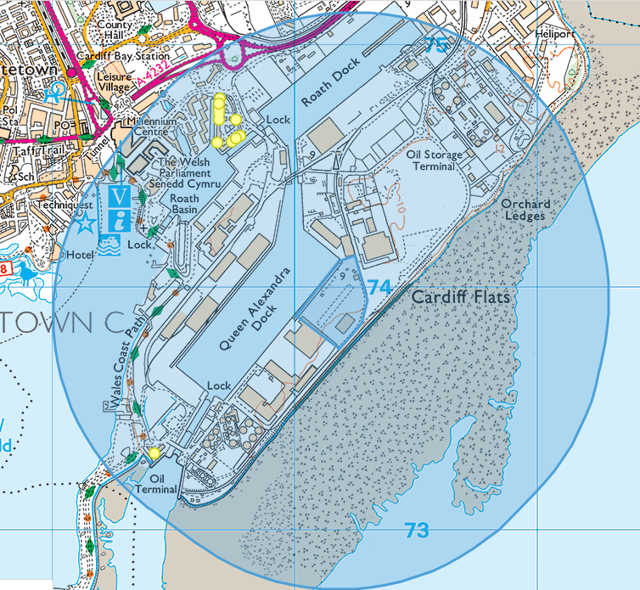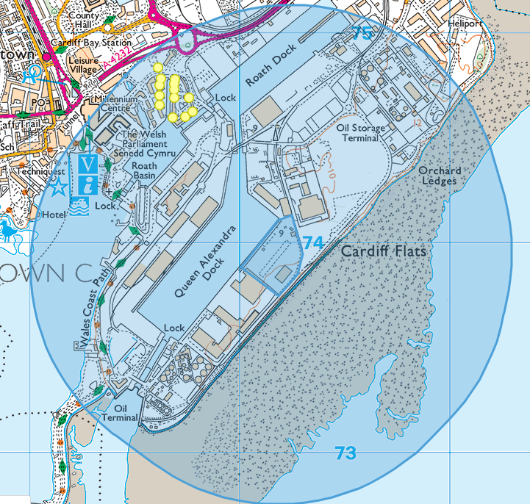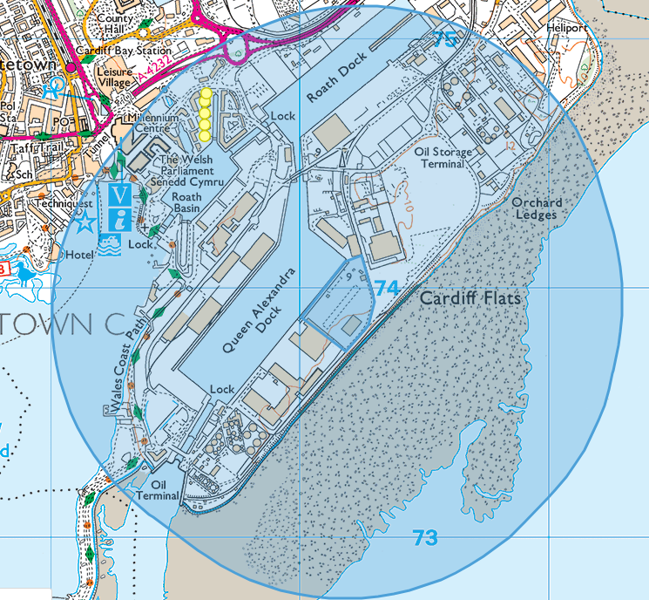
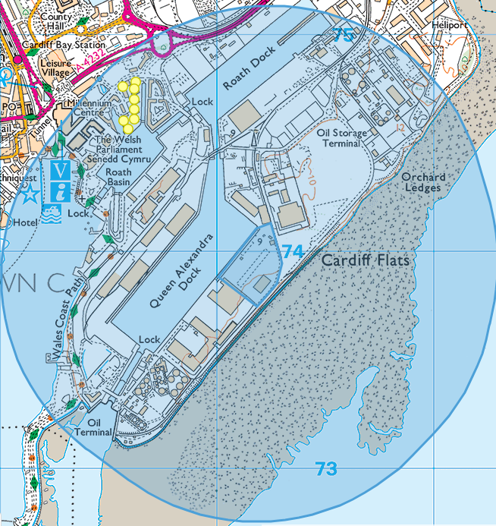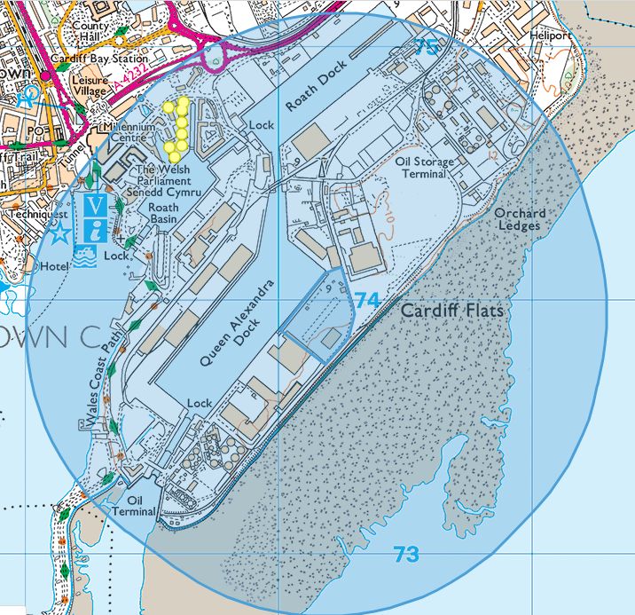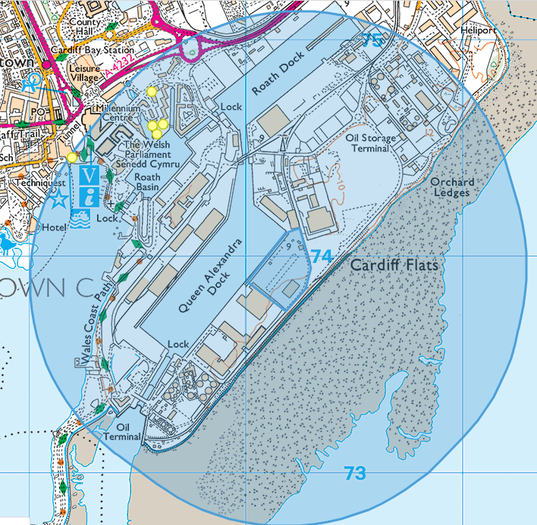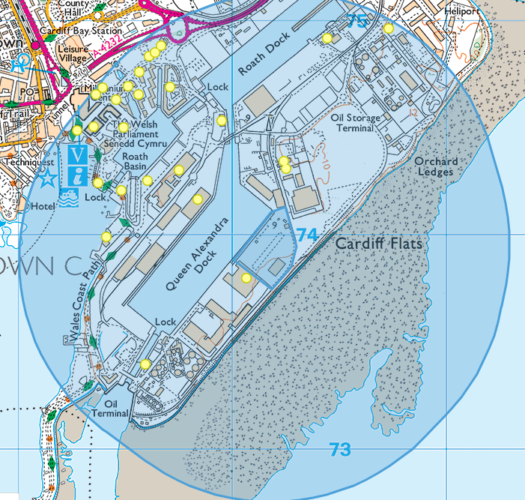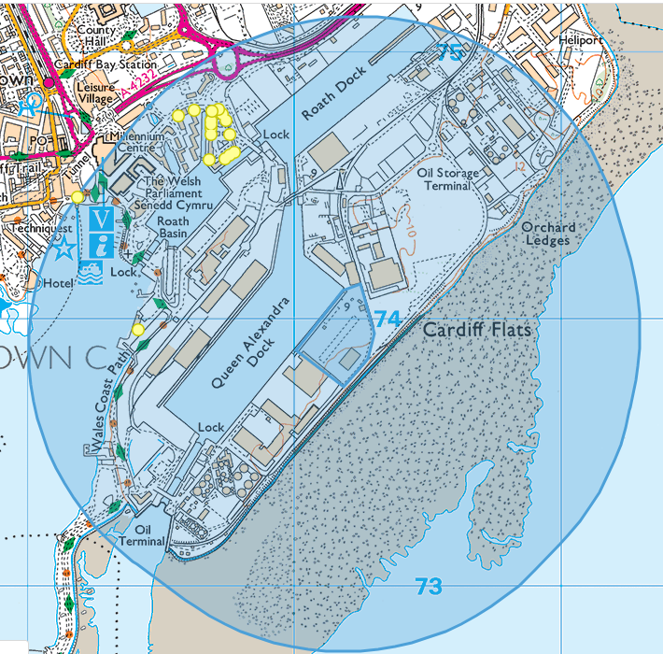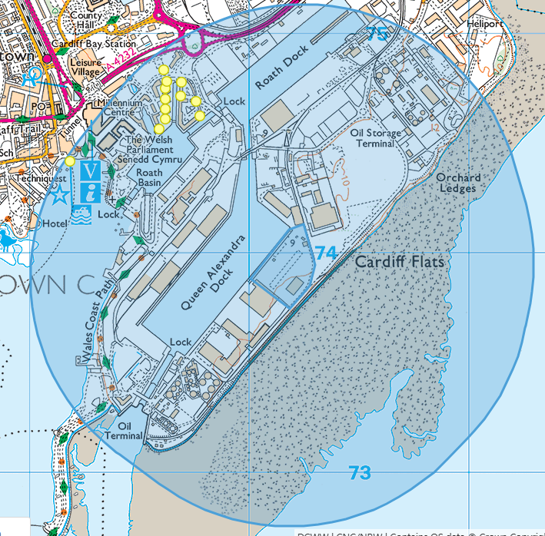
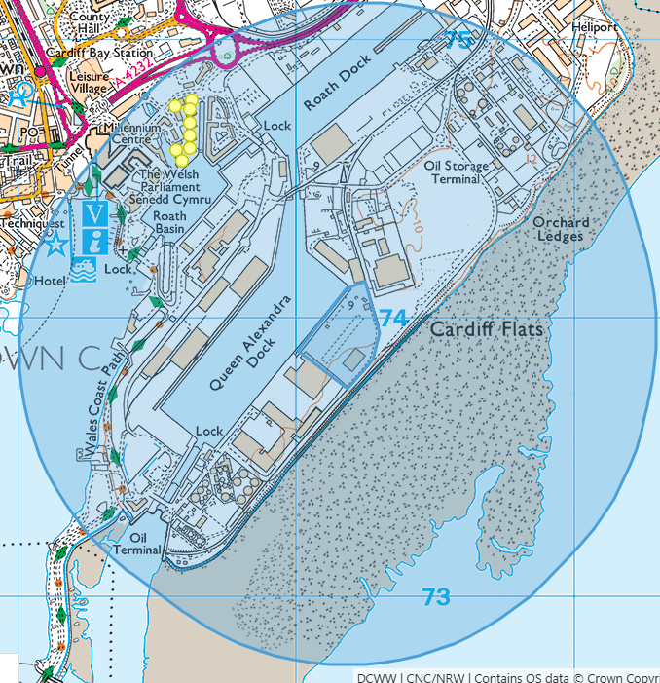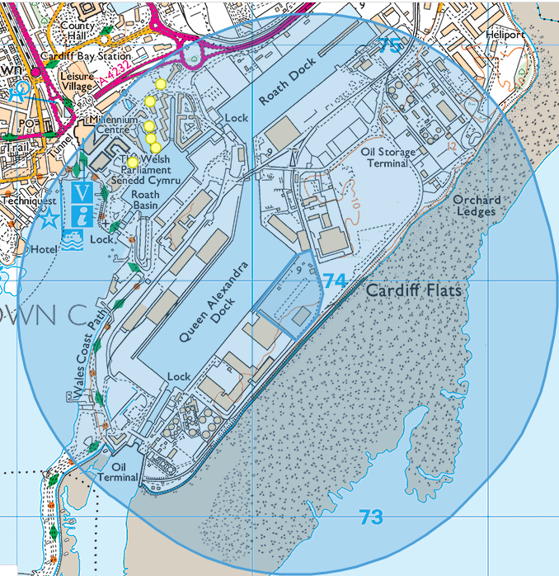
920 addresses within 1km of the site
- Cardiff Bay/Mermaid Quay recreation and associated businesses
- Wales Coastal Path
- Business/industry around Queen Alexandra Dock and Roath Dock
- National Assembly for Wales
- Cardiff Harbour Authority

None:
- national parks
- areas of outstanding natural beauty (AONBs
- marine conservation zones
- ancient woodlands
- source protection zones

