Annex (iv) – SSSI Assessment Form
SSSI Assessment for permit/licence and deployment applications | 
To be completed by Permitting Officers for any applications for a permission which Natural Resources Wales has considered under S28I duty to notify SNCB and take their advice into account. This applies to all proposed permissions within a SSSI, and to operations outside the SSSI boundary which are likely to damage its special features.
NRW as a Section 28G authority has, when exercising its functions, a general duty to take reasonable steps, consistent with the proper exercise of its functions, to further the conservation and enhancement of the flora, fauna or geological or physiological features by reason of which the site is of special interest’

Part 1 – SSSI Assessment
Part 2 – Formal notification to SNCB (to be completed if part 1 assessment concludes likely damage, not likely to damage because of conditions or you cannot conclude no likely damage)
Part 3 – Decision
Pink text – drafting notes, to be deleted before completion/consultation.
Blue text – examples, to be replaced with permission-specific information and text turned to black.

Part 1 – SSSI Assessment

- Permitting officer/team | Rachel Mallinson /Water Quality Permitting
- Permit application reference and site name | PAN-031110  Bryntysilio Outdoor Education Centre, Llantysilio, LL20 8BS  SJ 19521 43453
- a. SSSI name(s)  b. location  c. NRW Operational Area/Environment Team | a. Dinas Bran 31WJD  b. located approx. 2.3km away from the Discharge with no viable pathway for impact.  c. Denbighshire ET  a. Afon Dyfrdwy ( River Dee) 31WDW  b. Discharge direct to River Dee SSSI  c. Denbighshire ET  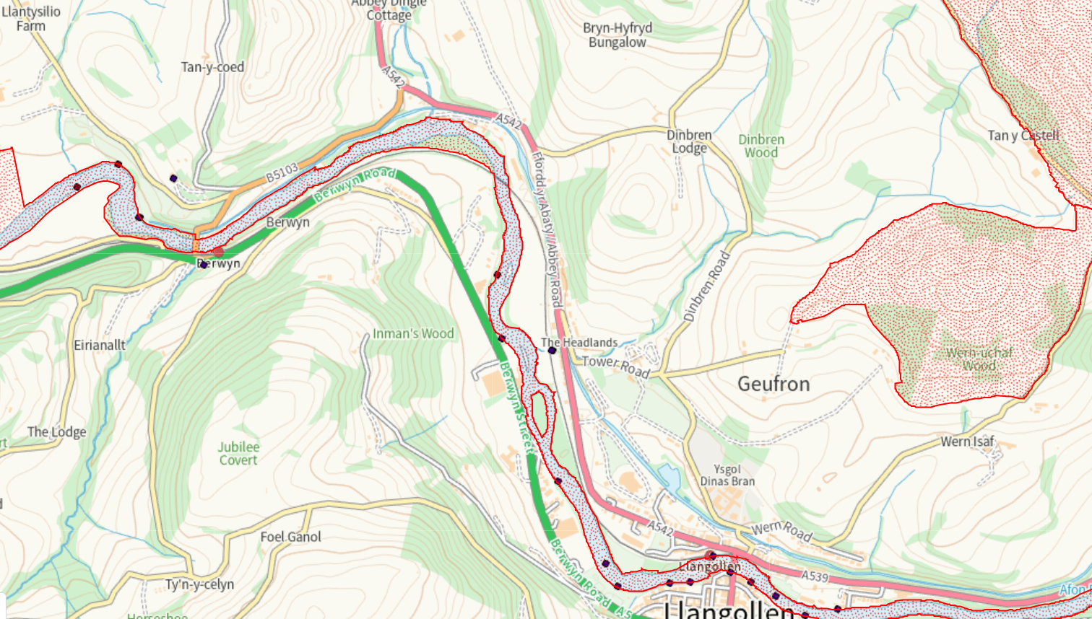  Dinas Bran SSSI  River Dee SSSI  Discharge Point
- Brief description of proposal | PAN-031110 application is for the re-regulation of an existing discharge of 14 m3/d of treated sewage effluent to the River Dee.  The new discharge arises from a 148 bed Outdoor Education Centre. with a total of 100 people with a maximum discharge rate of 14.2 m³/d to the River Dee.  The new discharge will be via secondary biological treatment with a bolt on tertiary treatment, using Aluminium dosing, to reduce Phosphorus concentration to 0.5mg/l.  The treatment system proposed will produce effluent quality of < 3 mg/l Ammonia,< 6 mg/l BOD and < 0.5mg/l Phosphorus.  They will be using a compact dosing station using Aluminium to reduce Phosphorus emissions.
- What aspects of the proposed permission are likely to damage the SSSI features of special interest?

The following activities are likely to cause damage:

Dumping, spreading or discharging of any materials.

The following SSSI(s) features and potential impacts have been considered to assess the likelihood of damage:

There is a pathway for impact due to the discharge being direct to the River Dee SSSI

2. Features of Special Scientific Interest:
2.1 Fish (Salmon, bullhead, brook lamprey, river lamprey, sea lamprey)
2.2 Otter
2.3 Aquatic and shingle dwelling invertebrates (club-tailed dragonfly, the stonefly Isogenus nubecula and the weevil Baris lepidii)
2.4 Floating water plantain
2.5 Four river habitat types
2.6 Saltmarsh transition habitats
2.7 Vascular plants (slender hare’s-ear, sea barley, and hard-grass)
2.8 Geology: Natural exposures of Upper Carboniferous rocks at Dee Bridge
2.9 Geology: Fluvial landforms and processes related to the development of the River Dee near Rhewl, and between Holt and Worthenbury

The proposal is for the re-regulation of an existing discharge of 14m3/d of treated sewage effluent to the River Dee.
Arising from a 148 bed Outdoor Education Centre. with a total of 100 people with a maximum discharge rate of 14.2 m³/d to the River Dee.

The new discharge will be via secondary biological treatment with a bolt on tertiary treatment, using Aluminium dosing, to reduce Phosphorus concentration to 0.5mg/l.

The treatment system proposed will produce effluent quality of < 3 mg/l Ammonia,< 6 mg/l BOD and < 0.5mg/l Phosphorus.

The existing unregulated discharge has been assessed to be loading 14.4mg/l/day of Phosphorus to the river Dee. This is based on assumed average Phosphorus loading of 8mg/l.

This proposal is to discharge 14.2 m³/d and to maintain loading, achieving nutrient neutrality, the discharge is required to have a concentration of no more than 1.02mg/l of Phosphorus. The applicant has applied for a limit of 0.5mg/l.

RQP modelling has concluded, the discharge based on concentration of 0.5mg/l Phosphorus (as applied for) will have 0% deterioration/change on the Phosphorus concentrations within the River Dee.

Modelling of Ammonia and BOD concluded 0% deterioration/change in relative water quality of the River Dee.
Dosing with Aluminium is used to facilitate flocculation and coagulation for removal of Phosphorus to meet the 0.5mg/l limit proposed by the applicant. The management of this system is automated with a failsafe design to ensure dosing is proportional to the inflow from the biological treatment plant and will not dose if the pumps in the preceding plant have a fault or fail to reset.
Where Aluminium is proposed for treatment, appropriate regulation is required.

Full modelling assessment can be found at PAN-031110 RQP Modelling.docx

The proposed activity is not likely to damage the SSSI.
- Summary of any informal advice received from internal experts (if required and including pre-app advice) | N/A
- Recommendation | The proposed permission is not likely to damage any of the flora, fauna or geological or physiological features which are of special interest because of conditions.
- Signature and date assessment made | Rachel Mallinson  12/03/2026
- Officers name and job title | Rachel Mallinson  Water Quality Permiting Officer


Permitting
Formal Notification under Section 28I of the Wildlife and Countryside Act 1981

Part 2 Formal notification under S28I – To be completed for all permit applications assessed as: not likely to damage because of conditions, likely to damage SSSI and those where we are unable to conclude no likely damage.

- Date Notice of intention to permit activity likely to damage SSSI sent to NRW (SCNB) | n/a
- Advice received from NRW (SNCB) | Dear Rachel  ADVICE UNDER SECTION 28I OF THE WILDLIFE AND  COUNTRYSIDE ACT 1981  Site of Special Scientific Interest: Afon Dyfrdwy (River Dee)  Having considered the likely impact of the operations described in your notice dated  13/03/2026 on the special features of the site listed above, NRW advises that; in carrying out  your authority’s role as a section 28G authority:  You may permit the operation.  I note that you intend to impose conditions and concluded that the operation will not result in  damage to features of the protected site.  Once you have received this advice you may make your decision before the expiry of the 28  day period required under section 28I(4).  Written notice is required if it is intended to alter these operations in any way or to permit any  further work.  Note that this advice only relates to the above-mentioned legislation – other authorisations may  be required.  Yours sincerely  Elizabeth Felton
- Name and job title of conservation/marine officer (sign and date) | Richard May, Officer 2, Environment Team.  02/04/2026
Part 3 – To record NRW decision following SNCB Advice
- DECISION | The permission is not likely to damage any of the flora, fauna or geological or physiological features which are of special interest because of conditions in Schedule 3 Table S3.1 to limit the emissions of Total Phosphorus and Ammonical Nitrogen through the use of chemical dosing. This will prevent nutrient overloading in the watercourse to protect and enhance the aquatic environment.
- Natural Resources Wales (Section 28G Authority) (permitting service) is minded to | Issue the permission with conditions to ensure no damage to SSSI
- Is decision in line with advice from SNCB | Yes
- Signature and date assessment completed | R.Mallinson 23/04/2026
- Officers name and job title | Rachel Mallinson, Water Quality Permitting Officer

