Permit
The Environmental Permitting (England & Wales) Regulations 2016

Greenacres Skip Hire Ltd

Greenacres Skip Hire Ltd
Dwrbach
Fishguard
SA65 9RE

Permit number

EPR/DB3695CZ

Permit
The Environmental Permitting (England and Wales) Regulations 2016
Permit number

EPR/DB3695CZ

The Natural Resources Body for Wales (“Natural Resources Wales”) authorises, under regulation 13 of the Environmental Permitting (England and Wales) Regulations 2016

Greenacres Skip Hire Ltd (“the operator”),

whose registered office is

Celtic Link Business Park

Ffordd Trebrython

Dwrbach

Fishguard

Wales

SA65 9RE

company registration number 08853846

to operate waste operations at

Dwrbach

Fishguard

SA65 9RE

to the extent authorised by and subject to the conditions of this permit.

Under regulation 27(2) of the Regulations, standard rules SR2008No7 are conditions of this permit.

Name | Date
Huw Davies | 13/05/2026

Authorised on behalf of Natural Resources Wales

Schedule 1 - Site plan

This is the plan referred to in the standard rules SR2008No7

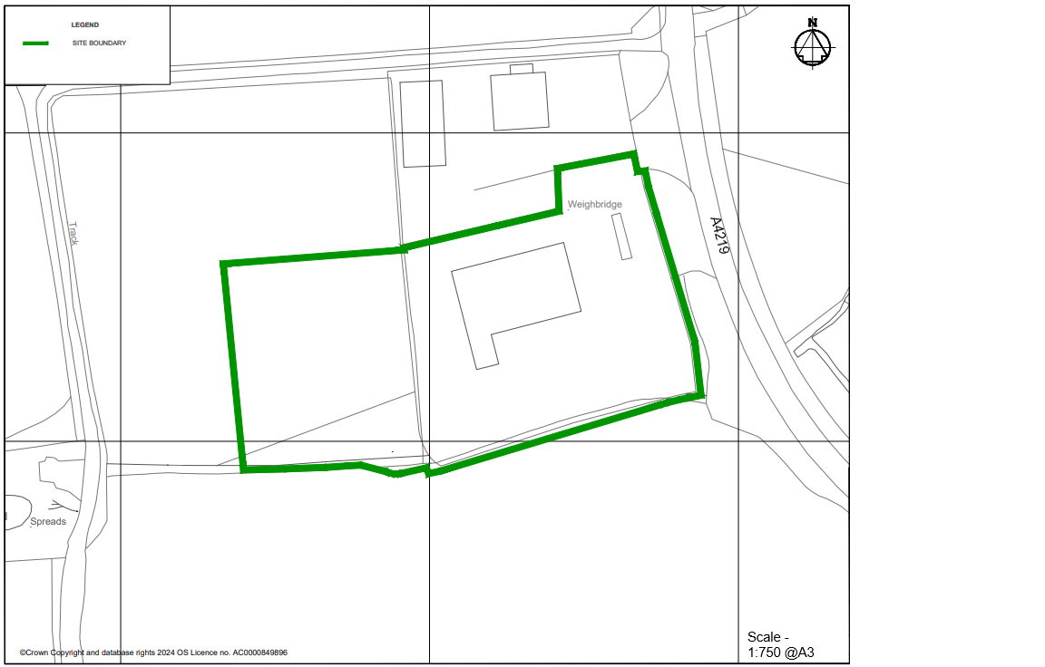

END OF PERMIT

