PAN-032366 Mapping Report:
Application map
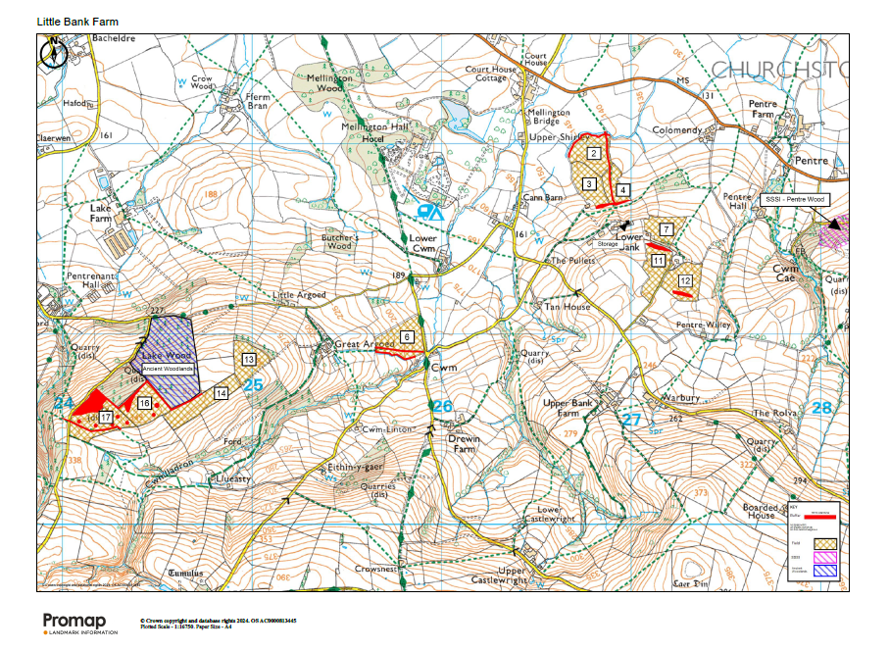
Deployment Boundaries and storage
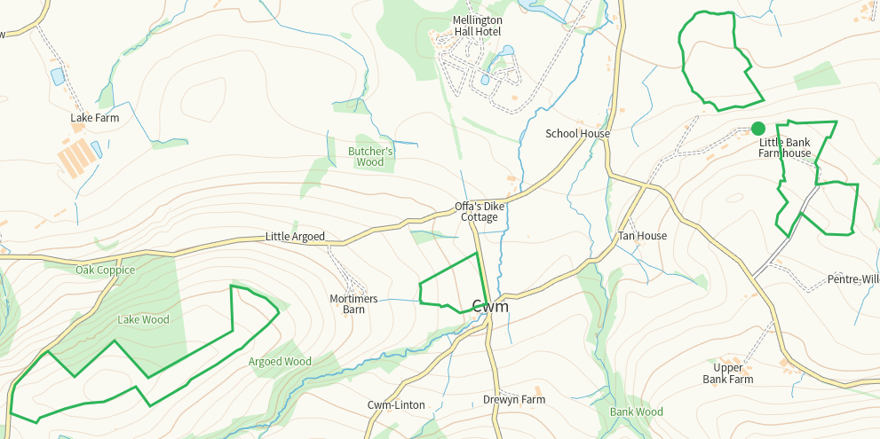
Detailed river network 10m
N of 2, buffered on application map
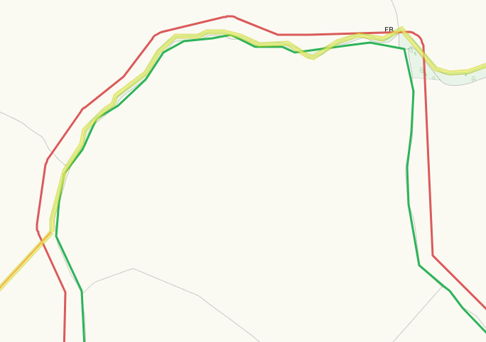
S of 6, buffered on application map
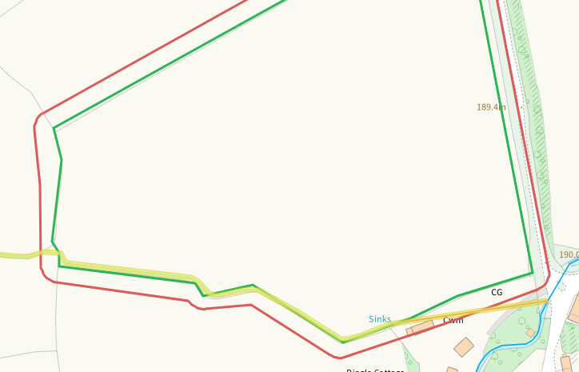
Groundwater source protection zones
none
Any well, spring (or issue) or borehole used for the supply of water for human consumption including from a private water supply or supplies within 50m.
None in range
Any well, spring (or issue) or borehole used for the supply of water for human consumption including from a private water supply or supplies within 250m.
Some within range but nil risk due to distance, built environment and method of application to fields
Within Groundwater Safeguard Zone
none
European designated sites- Natura 2000 (SPA, pSPA, SAC or cSAC) or Ramsar- or SSSI within 500m
None in range

Other protected sites within 500m:
- Protected Species-
Some recorded but nil risk from the activity
- Protected Habitats-
Within range of 6, nil risk
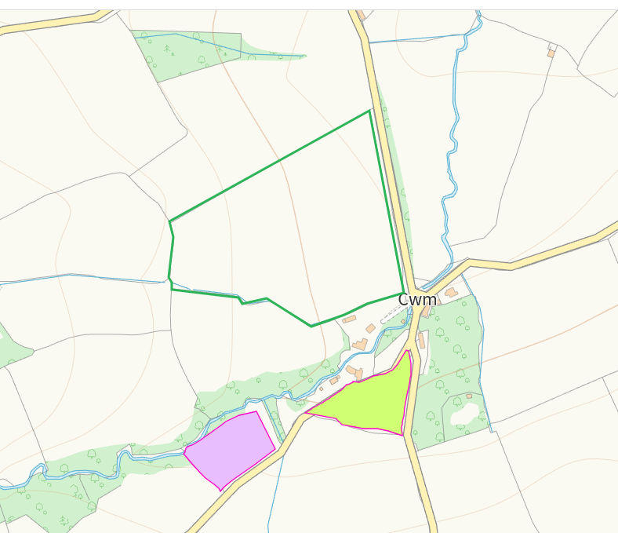
- Scheduled Ancient Monument-
Nil risk
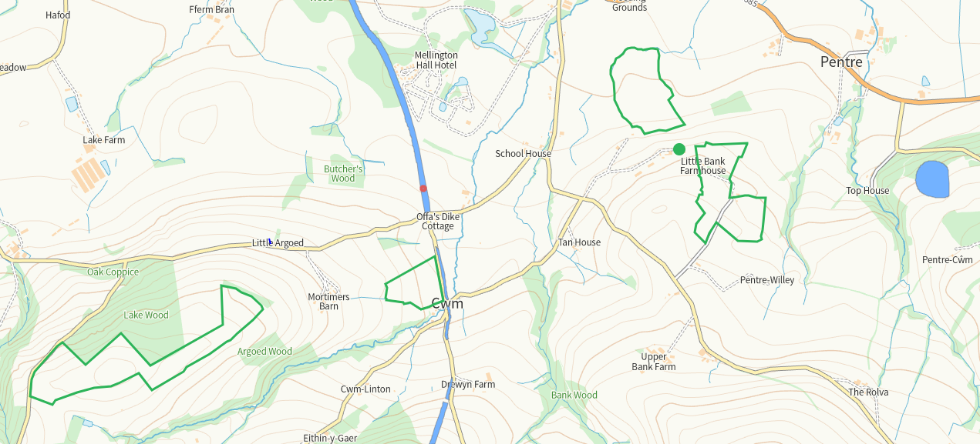
- Local Nature Reserve-
- National Nature Reserve-
- Ancient Woodlands-
Areas adjacent are suitably buffered
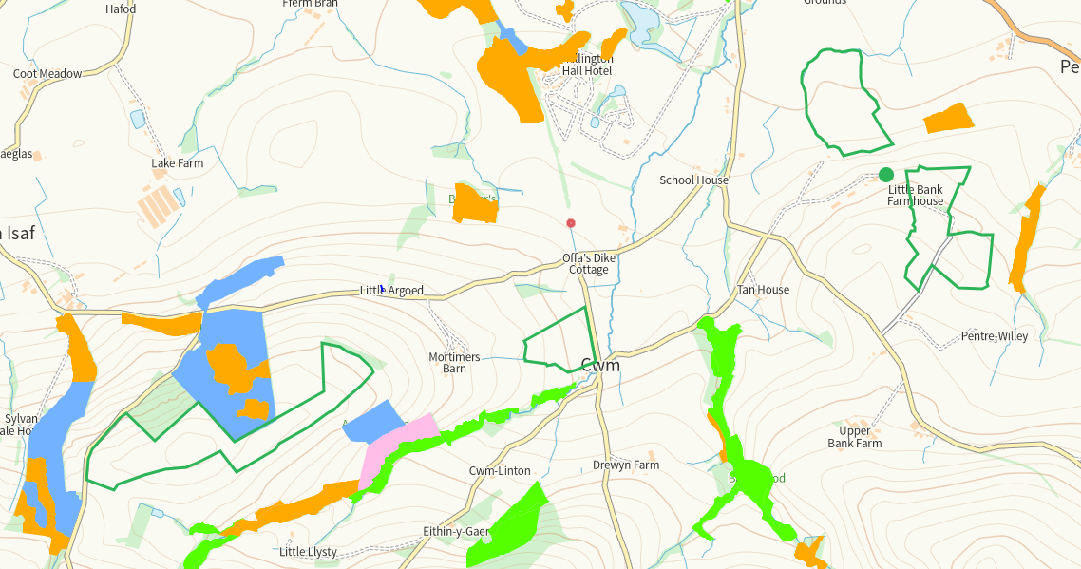
- Local Wildlife Sites (SINC)-
Drewyn Dingle within range, not on application map. Nil risk
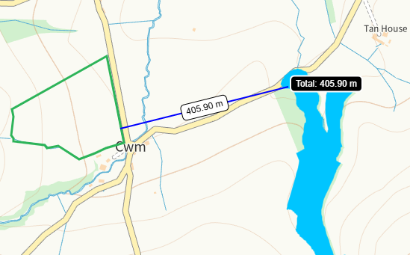

Cwm Lladron within range, shown on application map as river. Potential risk as grounds falls towards but given application methods nil.

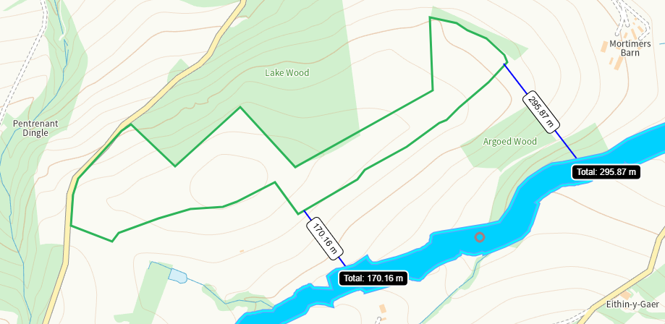
- National Park- none
- Nitrate Vulnerable Zone (NVZ)- ALL Wales
- Groundwater Safeguard Zone- none

Flood risk
none
Public rights of way
Shown and buffered on application map
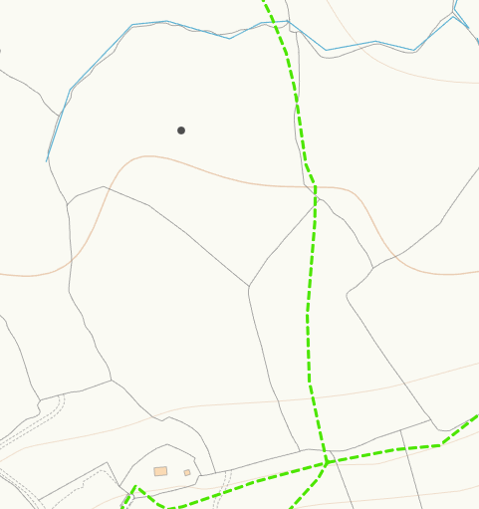
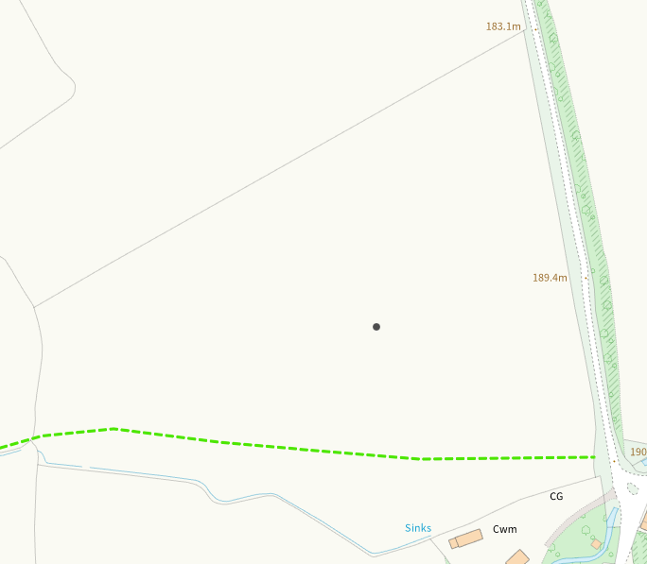
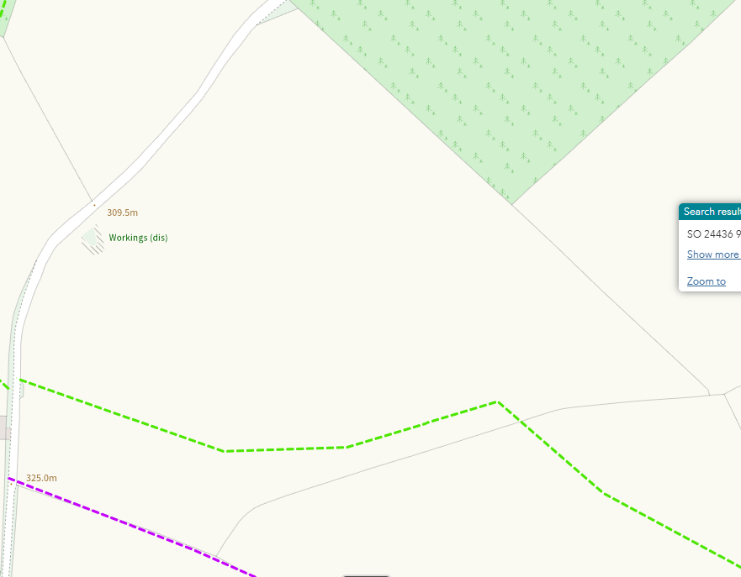
Slope Map
Fields 2, 3, 4 0-7 buffered to S of 3 and 4 and N of 2
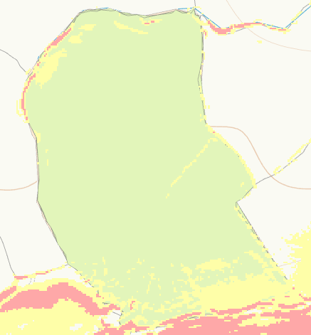
Fields 7, 11, 12 0-7, 12+ latter is buffered on application map
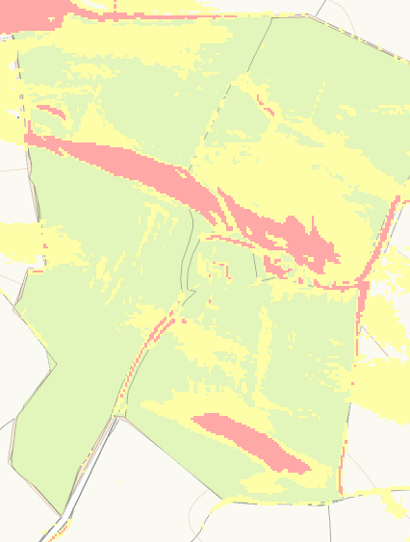
13 0-7 and 7-12
14 0-7 and 7-12
16 0-7, 7-12, 12+ latter is buffered on application map
17 0-7, 7-12 and 12+ latter is buffered on application map
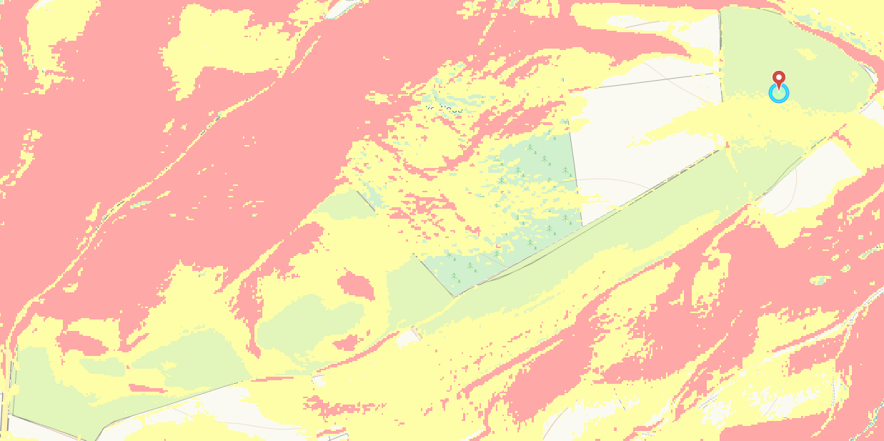
END

