Annex (iv) – SSSI Assessment Form
SSSI Assessment for permit/licence and deployment applications | 
To be completed by Permitting Officers for any applications for a permission which Natural Resources Wales has considered under S28I duty to notify SNCB and take their advice into account. This applies to all proposed permissions within a SSSI, and to operations outside the SSSI boundary which are likely to damage its special features.
NRW as a Section 28G authority has, when exercising its functions, a general duty to take reasonable steps, consistent with the proper exercise of its functions, to further the conservation and enhancement of the flora, fauna or geological or physiological features by reason of which the site is of special interest’

Part 1 – SSSI Assessment
Part 2 – Formal notification to SNCB (to be completed if part 1 assessment concludes likely damage, not likely to damage because of conditions or you cannot conclude no likely damage)
Part 3 – Decision
Pink text – drafting notes, to be deleted before completion/consultation.
Blue text – examples, to be replaced with permission-specific information and text turned to black.

Part 1 – SSSI Assessment

- Permitting officer/team | Alex Cowell - Water Resources Permitting Team
- Permit application reference and site name | PAN-030979 - Point of Ayr Gas Terminal
- a. SSSI names  b. locations  c.NRW Operational Area/Environment Team | a. Gronant Dunes and Talacre Warren  b. Approx. 940m North  c. North / Flintshire & Wrexham Environment Team  a. Dee Estuary  b. Adjacent to working area  c. North / Flintshire & Wrexham Environment Team
- Brief description of proposal | An application for a new full abstraction for the purpose of dewatering.  Liverpool Bay Carbon Capture Scheme is a major UK net-zero infrastructure project that involves extensive demolition and construction works at Point of Ayr Gas Terminal. A series of excavations are required to be made as part of the demolition works at the site. Specialist dewatering is required for all excavations presented to allow the works to be undertaken in dry and stable conditions. Dewatering works will take place sequentially, with only one area being dewatered at any time.  A remediation strategy has been developed alongside NRW and will be implemented to reduce risks from groundwater contamination. Abstracted groundwater is to be discharged via a v­notch settlement tank and a Granular Activated Carbon (GAC) unit to treat any PFAS contamination present within the groundwater. The GAC system is capable of dealing with the modelled peak abstraction of 17.6 l/s (maximum licenced quantity).Regulated under EPR/DP3934EW/V004.  This assessment is for the abstraction activity in isolation. Impacts of water discharge have been considered during determination of the EPR permit variation.
- What aspects of the proposed permission are likely to damage the SSSI features of special interest?

The following activities are likely to cause damage:

Alterations to water levels and tables due to groundwater abstraction.

The following SSSI(s) features and potential impacts have been considered to assess the likelihood of damage:

The following ‘Operations Requiring Consent’ (or other activities associated with the permission) that may cause damage) are relevant to the proposed permission.

- Alterations to water levels and tables and water utilisation including irrigation, storage and abstraction from existing water bodies and through boreholes. Also the modification of current drainage regime.

Gronant Dunes and Talacre Warren

Please see PAN-030979 - Hydrogeological Impact Assessment.pdf:
The extract below explains that this protected site is not groundwater or surface water dependent, and therefore impacts can be ruled out.

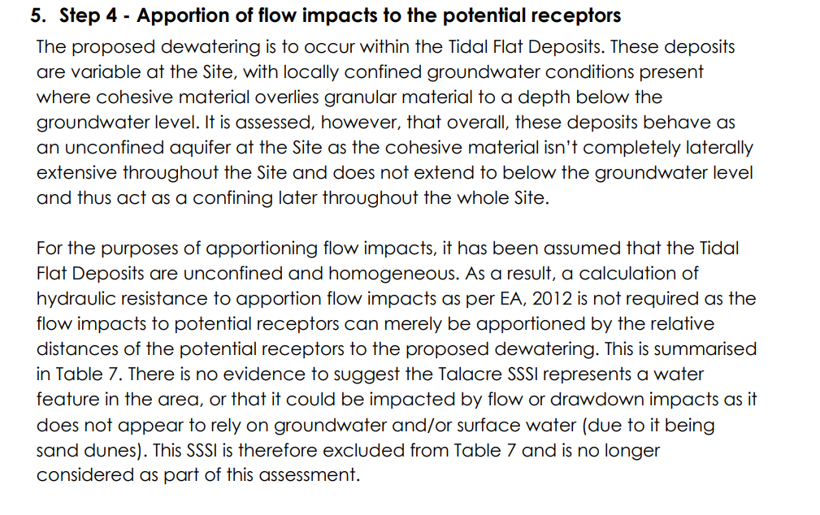

Dee Estuary

Abstraction drawdown/ Hydrological connectivity

The proposal is non-consumptive, all abstracted groundwater will be discharged via the site discharge stream, regulated under EPR/DP3934EW/V004.

Providing the dewatering works are carried out sequentially (only one area dewatered at any time), as applied for, NRW Geoscience Team agree with the conclusions of the Hydrogeological Impact Assessment - no drawdown impacts to sensitive receptors resulting from the abstraction.

Pollution

Discharge regulated under EPR/DP3934EW/V004.

Birds - Supporting Habitat – Non-physical disturbance

Disturbance could be caused by the initial starting of pumps which could startle birds, however, birds typically become habituated to the sound of running pumps. Given the activity proposed, any birds in the locality would become habituated to the sound and the small potential area of supporting habitat that could be impacted.

- Summary of any informal advice received from internal experts (if required and including pre-app advice) | Geoscience agree with conclusions of HIA.
- Recommendation | The proposed permission is not likely to damage any of the flora, fauna or geological or physiological features which are of special interest
- Signature and date assessment made | A.Cowell  01/04/2026
- Officers name and job title | Alex Cowell – Water Resources Permitting Team.

