OGN 200 Form 1B

Record of a Habitats Regulations Assessment
All staff using this form should be familiar with OGN200 and should have had appropriate training in HRA.
A separate version of this form is available with guidance notes on how to complete it. You should refer to those notes when using this form.
Plan or project name, brief description or application reference number | PAN-030979 - Point of Ayr Gas Terminal

HRA iteration/version | HRA Version: 1.0

1 Plan or Project Details
Information about the plan or project
1 | Date application received | 20/11/2025
2 | Applicant details | Saipem Limited  Saipem House, 12-42 Wood Street, Kingston Upon Thames, Surrey, KT1 1TG
3 | NRW team responsible for carrying out, or requiring to be carried out, the plan or project, and name of lead officer | N/A
4 | Activity/ies proposed | An application for a new full abstraction for the purpose of dewatering.  Liverpool Bay Carbon Capture Scheme is a major UK net-zero infrastructure project that involves extensive demolition and construction works at Point of Ayr Gas Terminal. A series of excavations are required to be made as part of the demolition works at the site. Specialist dewatering is required for all excavations presented to allow the works to be undertaken in dry and stable conditions. Dewatering works will take place sequentially, with only one area being dewatered at any time.  A remediation strategy has been developed alongside NRW and will be implemented to reduce risks from groundwater contamination. Abstracted groundwater is to be discharged via a v­notch settlement tank and a Granular Activated Carbon (GAC) unit to treat any PFAS contamination present within the groundwater. The GAC system is capable of dealing with the modelled peak abstraction of 17.6 l/s (maximum licenced quantity). Regulated under EPR/DP3934EW/V004.  This HRA is for the abstraction activity in isolation. Impacts of water discharge have been considered during determination of the EPR permit variation.
5 | Relevant legislation or statutory basis | Environment Act 1995  Water Resources Act 1991 as amended by the Water Act 2003  Water Resources (Abstraction and Impounding) Regulations 2006  Article 3 of the Natural Resources Body for Wales (Establishment) Order 2012  The Natural Resources Body for Wales (Functions) Order 2013
6 | Location | Underground strata comprising of Tidal Flat Deposits at Point of Ayr Gas Terminal, Station Road, Talacre, Holywell:  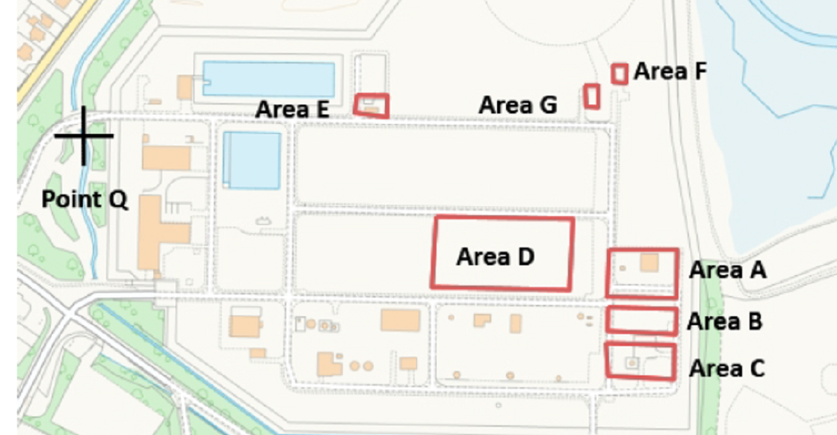  Map 1: Dewatering excavations  All of the water abstracted will be returned to the unnamed stream at National Grid Reference SJ 11965 84064 marked ‘Point Q’ on the map.
7 | Plan or project documents, including any application documents | Documents saved to DMS PAN-030979
8 | Environmental Statement | N/A
9 | Pre-application correspondence | N/A
10 | NRW team responsible for preparing this HRA report, and lead officer | Water Resources Permitting Team  Alex Cowell
11 | Team or person responsible for approving the plan or project (competent authority role) | As above

2. Determining the need for a Habitats Regulations Assessment
2.1 Is there any possibility that the plan or project could negatively affect any European sites? | Yes
2.2 Is the whole of the plan or project directly and only connected with or necessary to the management of one or more European sites, for the purposes of conserving the habitats or species for which the European site(s) is/are designated? | No
2.3 Is there a possibility that the plan or project could affect any other feature of the European site(s) concerned, or of another European site, in a way that would undermine that feature’s conservation objectives? | N/A

3. Considering the likelihood of a significant effect (LSE)

3.1 Renewal of a project authorisation on the same or more restrictive terms as an extant authorisation
Is this a renewal of an extant authorisation which complies with NRW approved criteria for ruling out significant effects of renewals (see Part 2 of OGN200) without conducting a project-specific LSE test? | No

3.2 Likelihood of significant effects (LSE) test

3.2.1 Which European sites might be affected by the plan or project?
(a) | Based on the plan or project specification, or information provided in the application, it is considered that these European sites have features which could be negatively affected by the plan or project | The Dee Estuary:  - SAC  - SPA  - Ramsar
(b) | The potential for the plan or project to negatively affect these European sites was also initially considered, but can be ruled out without further consideration | N/A

3.2.2 Screening for likelihood of significant effect
Table 3.2.2 Screening assessment
Designated site feature | Relevant conservation objectives | Screening conclusion – SCREEN OUT’, ‘SCREEN IN’ or ‘IN COMB’ | Explanation
European site name: The Dee Estuary SAC
Feature 1: Estuaries | To maintain the feature in favourable condition, as defined below:  - aggregate total extent of all communities is maintained;  - spatial distribution of communities is maintained;  - extent of individual habitat features is maintained;  - variety and relative proportions of sediment and rocky substrate is maintained;  - variety and extent of any notable sediment communities is maintained;  - the variety and extent of notable intertidal hard substrata communities is maintained; and  - spatial and temporal patterns of salinity, suspended sediments and nutrients concentrations are maintained within limits sufficient to satisfy the requirements of the above. | SCREEN OUT | Abstraction drawdown/ Hydrological connectivity  The proposal is non-consumptive, all abstracted groundwater will be discharged via the site discharge stream, regulated under EPR/DP3934EW/V004.  Providing the dewatering works are carried out sequentially (only one area dewatered at any time), as applied for, NRW Geoscience Team agree with the conclusions of the Hydrogeological Impact Assessment - no drawdown impacts to sensitive receptors resulting from the abstraction.  Pollution  Discharge regulated under EPR/DP3934EW/V004.
Feature 2: Mudflats and sandflats not covered by seawater at low tide (intertidal mudflats and sandflats) | To maintain the feature in favourable condition, as defined below:  - the total extent of mudflat and sandflat communities is maintained;  - the proportions of individual mudflat and sandflat communities are maintained;  - the topography of the intertidal flats and the dynamic processes of channel migration and sinuosity across the flats are maintained; and  - the abundance of typical species of the mudflat and sandflat feature is maintained. | SCREEN OUT
Feature 3: Salicornica and other annuals colonising mud and sand | To maintain the feature in favourable condition, as defined below:  - the total extent of pioneer saltmarsh vegetation communities is maintained;  - the presence of pioneer saltmarsh vegetation communities as part of transitions from the intertidal sediment communities to the higher saltmarsh are maintained;  - the abundance of typical species of the pioneer saltmarsh vegetation communities is maintained;  - the abundance of notable species of pioneer saltmarsh vegetation communities is maintained; and  - the overall extent and abundance of common cord grass Spartina anglica is not increasing with the pioneer saltmarsh zone. | SCREEN OUT
Feature 4: Atlantic salt meadows | To maintain the feature in favourable condition, as defined below:  - the total extent of Atlantic salt meadow vegetation communities is maintained;  - the proportions of individual Atlantic salt meadow vegetation communities are maintained;  - the zonation of Atlantic salt meadow vegetation communities and their transitions to fresh water and terrestrial vegetation are maintained;  - the morphology of saltmarsh creeks and pans and the process of their evolution are maintained;  - the extent of ungrazed areas of salt meadow within the estuary is maintained and there is no increase in grazing intensity over the rest of the salt meadow;  - the relative abundance of the typical species of the Atlantic salt meadow vegetation communities is maintained; and the abundance of notable species of the Atlantic salt meadow vegetation communities is maintained. | SCREEN OUT
Feature 5: Annual vegetation of drift lines | To maintain the feature in favourable condition, as defined below:  - the extent of coarse sediment / shingle formations capable of supporting drift line vegetation communities is maintained;  - the presence of annual drift line vegetation communities is maintained; and  - the presence of the typical species of the annual drift line vegetation communities is maintained. | SCREEN OUT
Feature 6: River lamprey (Lampetra fluviatilis) | To maintain the feature in favourable condition, as defined below:  - the migratory passage of both adult and juvenile river lamprey through the Dee Estuary between Liverpool Bay and the River Dee is unobstructed by physical barriers and / or poor water quality;  - the five year mean count of river lampreys recorded by the Chester Weir fish trap is no less than 55 under the monitoring regime in use prior to notification; and  - the abundance of prey species forming the river lamprey’s food resource within the estuary is maintained. | SCREEN OUT
European site name: The Dee Estuary SPA
Sandwich tern | Conservation objectives: -  - The 5 year mean peak population is maintained.  - The abundance of common species within the estuary is maintained.  - Breeding sites are not subject to significant disturbance  - Existing unrestricted bird sightlines of at least 200m are maintained in each direction around roosting sites and feeding areas.  - Aggregations of roosting or feeding are not subject to significant disturbance. | SCREEN OUT | The dewatering areas are situated outside of the areas designated under the SPA:  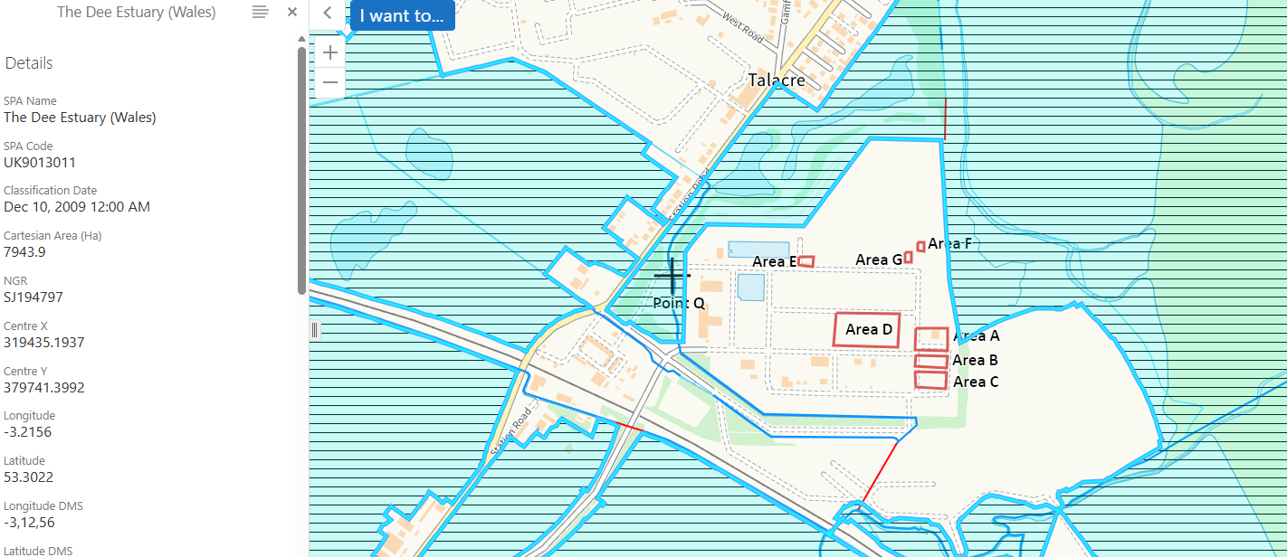  Abstraction drawdown/ Hydrological connectivity  As noted for the SAC above, no drawdown impacts anticipated to local receptors.  Supporting Habitat – Non-physical disturbance  As part of the planning conditions for the project a Construction Environmental Management Plan (CEMP) and Noise and Vibration Management Plan (NVMP) have been produced and the relevant Planning Condition discharged by FCC following consultation with NRW. While there is no single statutory decibel (dB) limit for noise, established conservation guidelines ( NatureScot Research Report 1283 - Disturbance Distances Review: An updated literature review of disturbance distances of selected bird species 2022) typically enforce buffer zones of 100–300 metres around breeding colonies to manage disturbance, including noise. Most studies relate to recreational disturbance and highlight the significance of disturbance from dog walkers and close proximity to humans.  The equipment required for the abstraction of groundwater is a 65 kVA silenced generator to run a deep well dewatering system (rated at 73 dBA @ 1m) and a silenced piston dewatering pump (rated at 49 dBA @7m).  The nearest breeding colony to the Point of Ayr Terminal is at the Royal Society for the Protection of Birds (RSPB) Point of Ayr-Dee Estuary Reserve, within sand dunes shingle spit approximately 0.6km north-east of the Terminal. There is also a larger breeding colony at Gronant Dunes, approximately 1.7km west of the site Red Line Boundary. Considering these distances from works and the surveys carried out during the Winter of 25/26 noting no evidence of disturbance from heavy demolition works caused to overwintering birds; there is a a low risk of disturbance to the breeding little terns (and other coastal breeding bird species) from these proposed abstraction works.  Pollution  Discharge regulated under EPR/DP3934EW/V004.
Little tern |  | SCREEN OUT
Common tern |  | SCREEN OUT
Bar – tailed godwit |  | SCREEN OUT
Internationally important species of regularly occurring migratory species |  | SCREEN OUT
Internationally important assemblage of water birds |  | SCREEN OUT
European site name: The Dee Estuary Ramsar
Redshank  Shelduck  Teal  Pintail  Oystercatcher  Grey Plover  Knot  Dunlin  Black-tailed godwit  Curlew  Bar-tailed godwit | Conservation objectives: -  - The mean population size is maintained  - Habitats are maintained.  - The extent and spatial distribution of saltmarsh vegetation less than 10 cm in height is maintained  - the abundance of waterbird prey species10 are maintained at levels sufficient to support the population size.  - Existing unrestricted bird sightlines of at least 200m are maintained in every direction around roosting sites, loafing and feeding areas  - aggregations of roosting, loafing or feeding waterbirds are not subject to significant disturbance | SCREEN OUT | As above.

TABLE 3.2.3 Screening decision of the plan or project ‘alone’
(a) If the screening conclusion for all features for all sites in Table 3.2.2 is ‘SCREEN OUT’ | The plan or project is not likely to have a significant effect on any European site, and no further consideration under the Habitats Regulations is required in order to determine the approval/application.
(b) If the conclusion for any features in Table 3.2.2 is ‘SCREEN IN’ | The plan or project is likely to have a significant effect on one or more European sites and therefore an appropriate assessment is required.
(c) If there are no features in Table 3.2.2 that are ‘SCREEN IN’ and any features that are ‘IN COMB’ | The plan or project is not likely to have a significant effect on any European sites when considered alone, but the possibility of significant effects in combination with other plans and projects needs to be considered.

6. Conclusion
The plan or project has been screened for likelihood of significant effects and is considered not likely to have a significant effect on any European sites. (As documented in section 3.2 of this form, and section 5 if applicable) | x
Signed: A.Cowell

Name: Alex Cowell Position: Water Resources Permitting Officer

Date: 01/04/2026

Was this HRA conclusion an escalated decision? YES or NO

7. Consultation with the ANCB and how sections 2, 3, 4 and 5 of this HRA report (as applicable) take into account that advice.
Relevant section of the HRA report | Correspondence and/or meetings with the ANCB | Description of how the comments from the ANCB have been taken into account
3 | Geoscience Team Meeting – dated 17/03/2026 (saved to DMS) | Providing the dewatering works are carried out sequentially (only one area dewatered at any time) as specified by the applicant, agreed with the conclusions of the HIA – no impacts envisaged to local receptors. PFAS considered under variation to installation permit.
4
5

8. Countersignature
I have reviewed the HRA documented in this form and confirm that I agree*/do not agree* with the conclusion recorded in section 6. (*delete as applicable)

Additional comments (if any):

Signed:

Name:

Position:

Date:

9. Appendix - Supporting information

