PAN-032362 My Map Report:

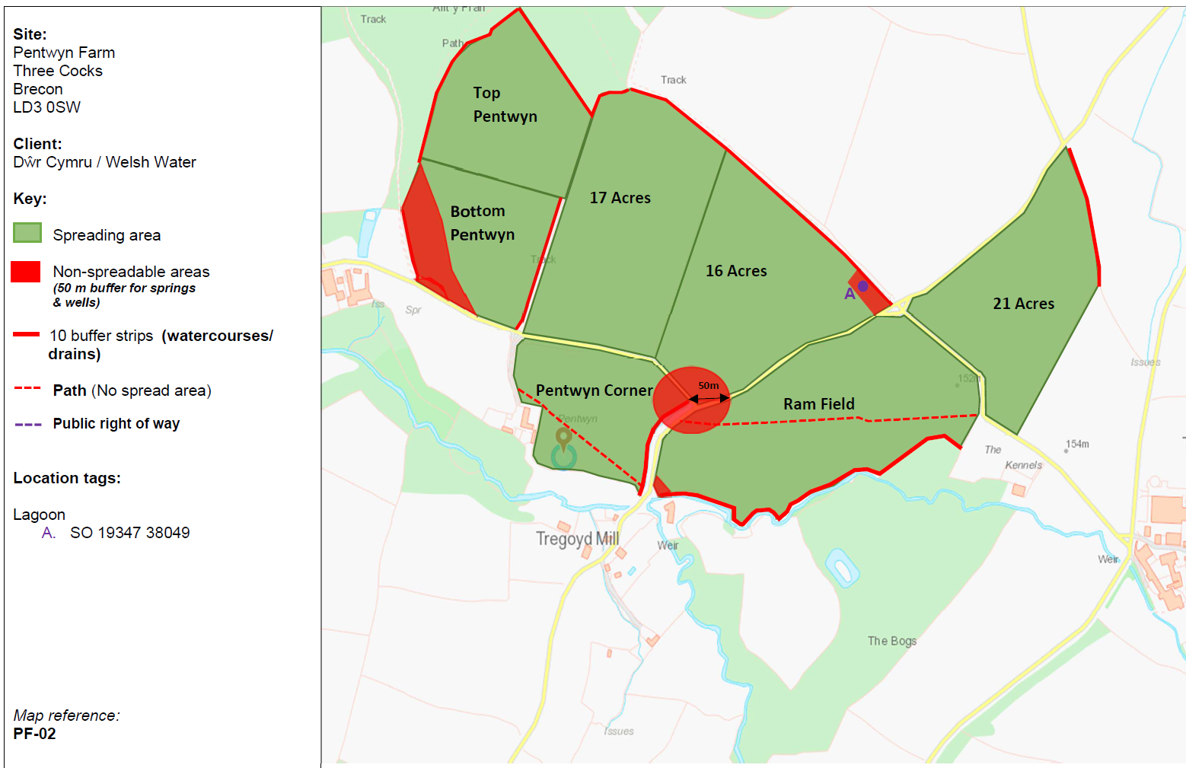
Submitted maps:

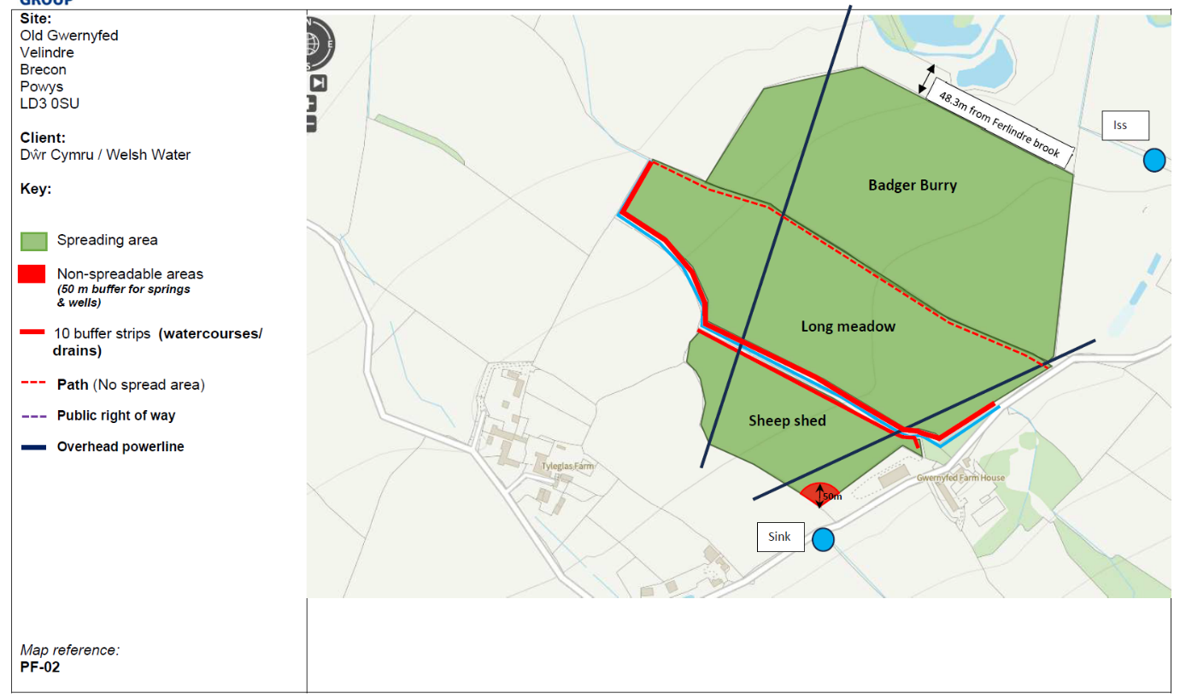

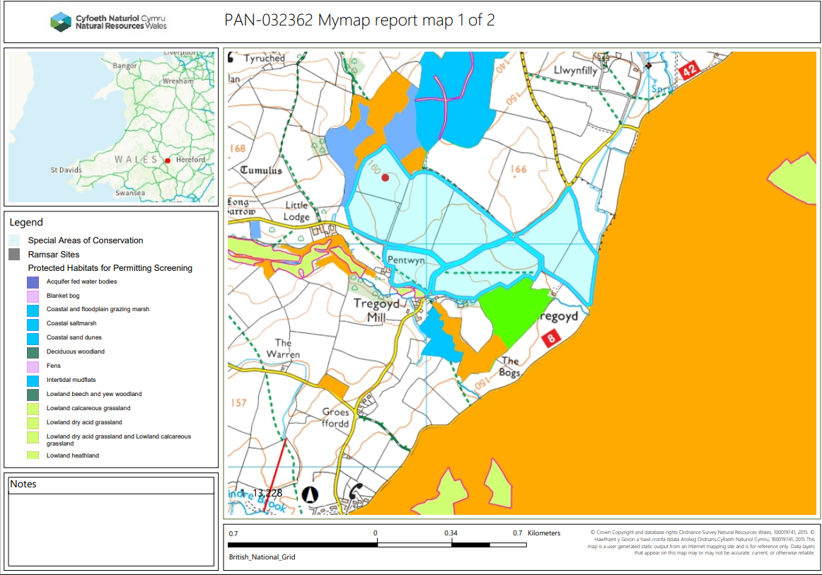
MyMap report Map:

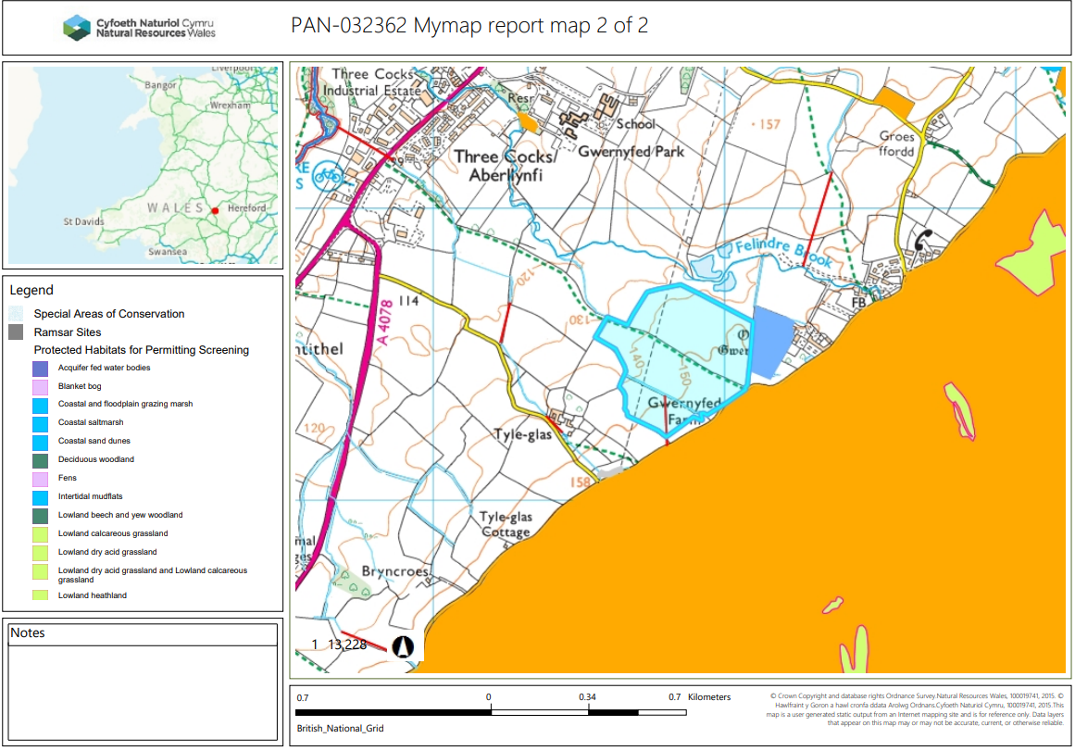

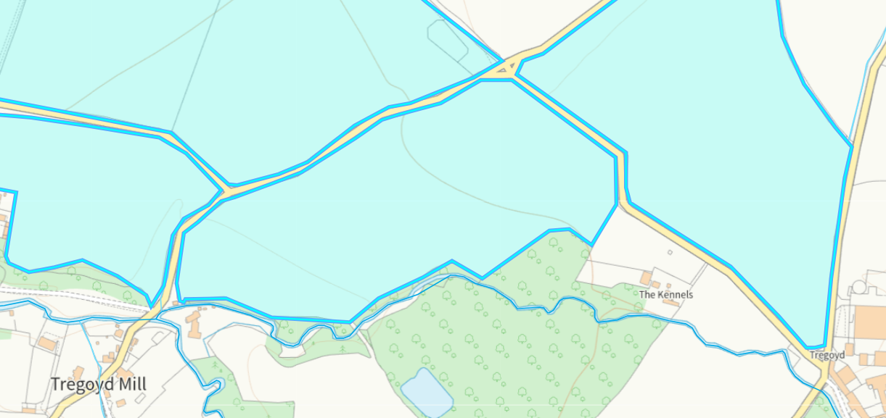
Detailed river network:
Fields Pentwyn Corner, Ram field and 21 acres border a water course on the southern edge of the fields. A 10 meter no spread buffer zone has been implemented to mitigate the risk of wastes entering the water course in compliance with SR2210no4. No action required.
Fields Long meadow and sheep shed border a water course. A 10 meter no spread buffer zone has been implemented to mitigate the risk of wastes entering the water course in compliance with SR2210no4. No action required.
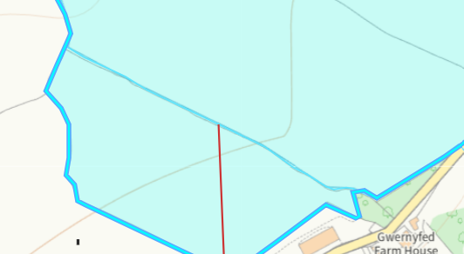

Groundwater protection zones (source) none in range.

Wells, springs or boreholes used for the supply of water for human consumption including from a private water supply or supplies - none in range.

any springs wells or boreholes not used to supply water for domestic or food production purposes within 50m - none in range

European designated sites- Natura 2000 (SPA, pSPA, SAC or cSAC) or Ramsar- or SSSI within 500m

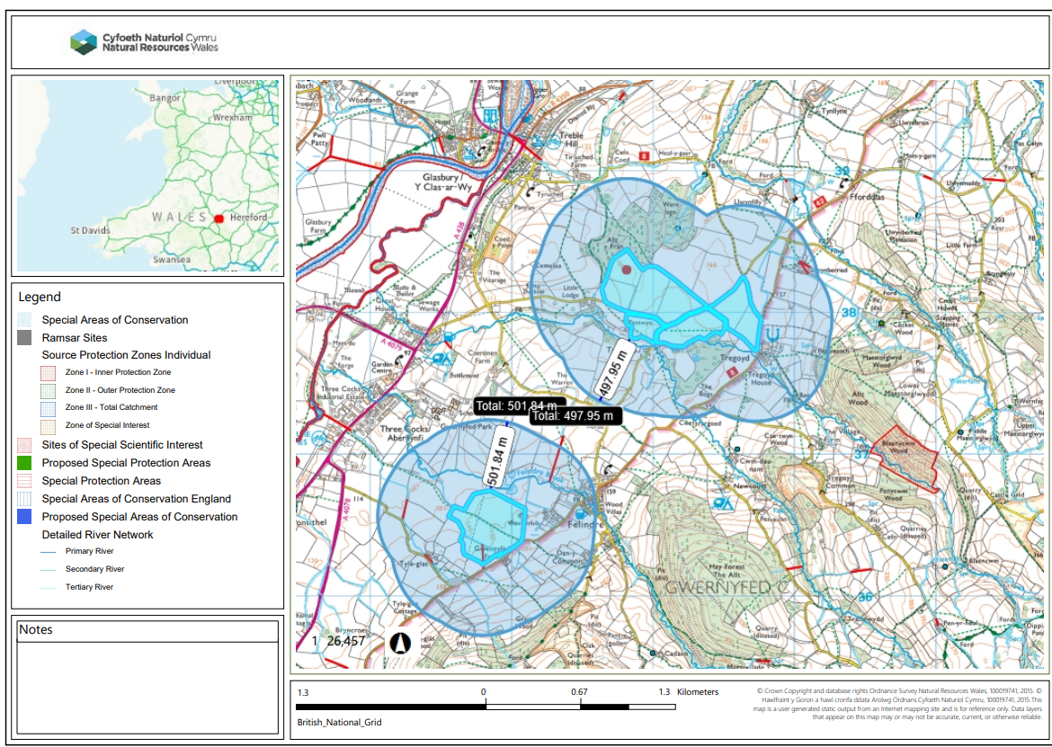
The fields in this deployment are not within a Source Protection Zone 2, and/or 500 meters or less from a European site, Ramsar, SSSI. The applicant has paid a high risk fee. In fact this deployment is a medium risk deployment. Therefore a refund of the fee difference to the applicant needs to be arranged. It was also not needed to supply a SSRA within this deployment application as a result.

Other protected sites:
- Protected Species- Nothing to note.

- Protected Habitats
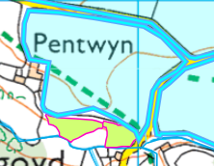
Field Pentwyn Corner borders a protected habitat: Lowland dry acid grassland and Lowland calcareous grassland. The protected habitat is not within the spreading area and is unlikely to be affected, no action required.

- Scheduled Ancient Monument-

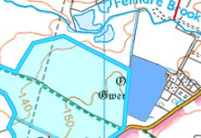
Field Badger Burry borders a schedule ancient monument: Gardens, Parks and Urban Spaces (post medieval). It is not considered there would be any detriment to this ancient monument due to it being locate outside of the spreading area. No action required.

- Local Nature Reserve- None in range.

- National Nature Reserve- None in range.

- Ancient Woodlands-

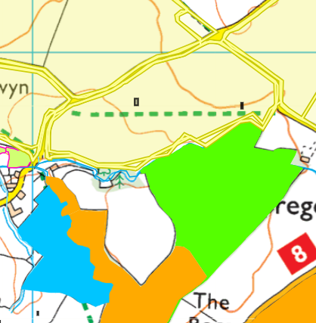
Field Ram field borders an ancient semi natural woodland & Restored Ancient Woodland Sit. This has been highlighted on the submitted spreading maps and there is a 10 meter no spread buffer zone to mitigate the risk of wastes entering the ancient woodland. No action required.

- Local Wildlife Sites (SINC)-

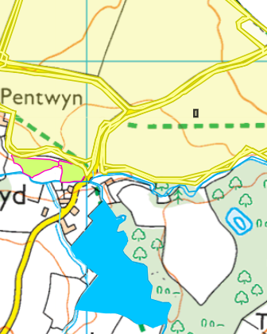
Field Ram field & Pentwyn corner is located approximately 60 meters from the Tregoyd House Meadow SINC. This has been highlighted on the submitted spreading maps and there is a 10 meter no spread buffer zone to mitigate the risk of wastes entering the SINC. No action required.

- National Park-
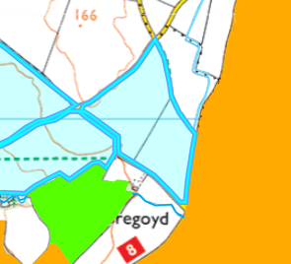
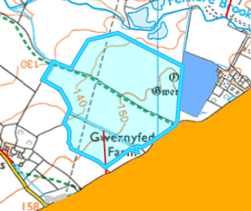
Field Badger Burry, Long Meadow, Sheep Shed & 21 Acres borders the Bannau Brycheiniog / Brecon Beacons.

This has been highlighted on the spreading maps. There is a physical boundary between fields Badger Burry, Long Meadow, Sheep Shed ( a road) so no action is required here as wastes are very unlikely to enter the national park.

Field 21 Acres is also located approximately 137 meters from the national park and is very unlikely wastes will enter the national park. No action required.

- Groundwater Safeguard Zone- None in range.

- Hedges- noting to note.

- Ditches- see slope map below

- Local residents, Housing, schools, Workplaces, Recreational facilities
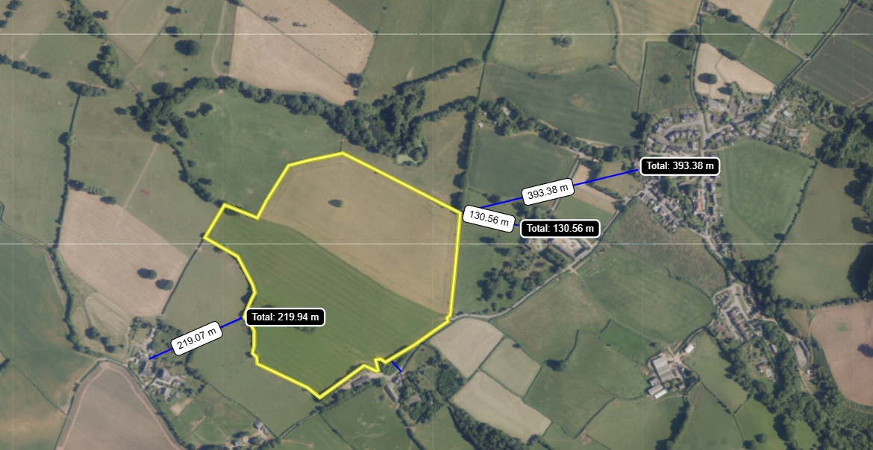

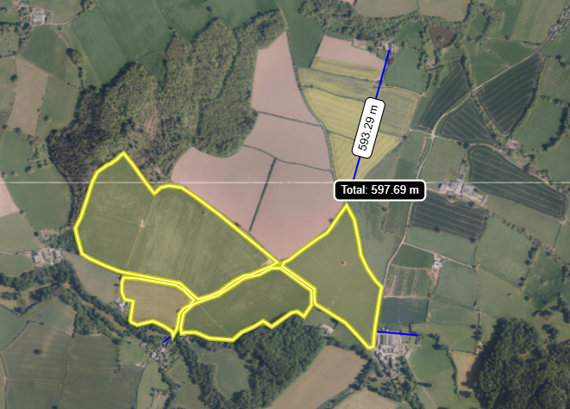
The fields in this deployment are located close to residential properties ranging from 30 meters to 597 meters. This deployment will be spreading potentially odorous waste (EWC 19 06 06, Liquid digestate from anaerobic treatment) as highlighted in TGN 8.01. The applicant has submitted an odour management plan as part of this deployment application and has been assessed against the guidance. The odour management plan has been considered in the determination of this deployment and has been concluded that if the odorous wastes are spread in accordance with the odour management plan that odour risk can be effectively mitigated.

Slope Map

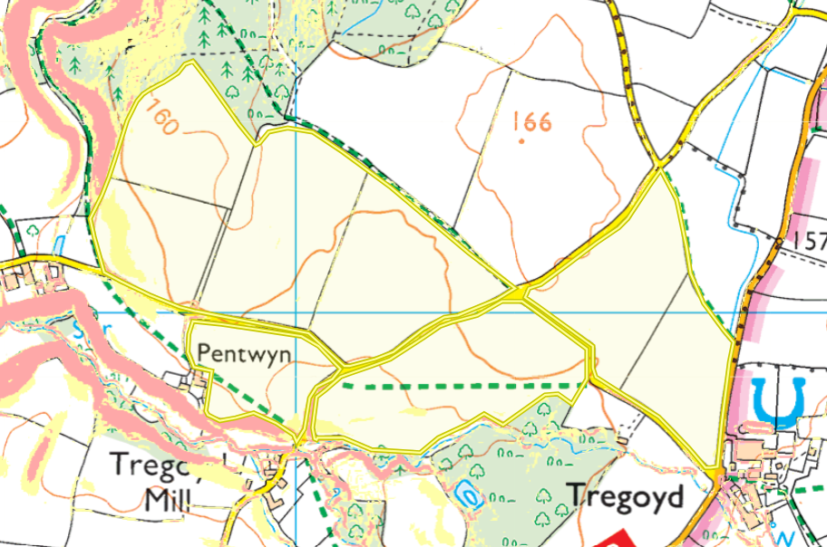
Field Bottom Pentwyn contains areas of moderately sloping land 7-12º (in yellow). There is an implemented no spread area in the area moderately sloping to mitigation the risk of runoff from applying non stackable waste streams in this deployment. NRW consider this to be appropriate mitigation, no further action was required.

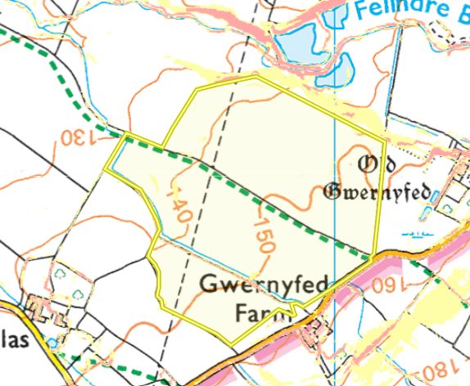
Field Bottom Long meadow contains small areas of moderately sloping land 7-12º (in yellow) which are contain to the field only. It is therefore not considered this field poses a surface runoff risk to the wider environment; the fields also have implemented no spread buffer zone around the southern and western side of the fields. No action required.

Conclusion: There is an implemented no spread areas in the area moderately sloping to mitigation the risk of runoff from applying non stackable waste streams in this deployment. No more than 50t/ha of liquid sludge will be spread on a field in any 3-week period. The wastes will be spread via a dribble bar which is also an appropriate application method for the non-stackable waste streams. NRW consider this to be appropriate mitigation, no further action was required.

The rest of the fields in this deployment: Top Pentwyn ,Pentwyn Corner ,17 Acres ,16 Acres, Ram Field A, Ram Field B, 21 Acres, Badger Burry & Sheep Shed are located on flat to gently sloping land and do not pose a surface runoff risk.

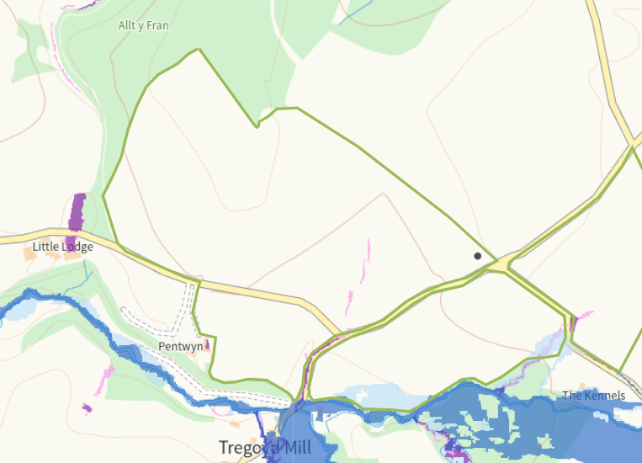
Flood risk

Field Ram field southern edge contains an area that is prone to flooding from small water courses. However the submitted deployment map has included a 10 meter no spread area 10 meters along the southern field boundary. NRW has concluded this is acceptable mitigation in conjunction with wastes not being spread in periods of heavy rain (the spreading of wastes will comply with the weather restrictions outline in CoGAP).

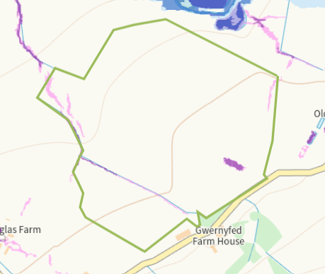
Field long Meadow contains very small areas of land prone to flooding from small water courses. However these are contained to the fields, in conjunction with wastes not being spread in periods of heavy rain (the spreading of wastes will comply with the weather restrictions outline in CoGAP the risk to the wider environment in negligible. No action required.

Public rights of way – The submitted deployment map matches the Mymap record for public rights of way, no action required.

