


Environmental Permit Management
System Manual
Supporting Statement
Love2Stay Mid Wales
Moat Lane, Caersws, SY17 5SB
May 2026
SA54913/Man_1.1

Applicants Details
TW & PA Leisure Ltd

Issued by
Richard Harman
IEng FIHE
Partner and Head of Engineering

Project
Environmental permit management system for wastewater treatment and discharge activity at Love2Stay Mid Wales

Discharge name
Sewage treatment plant effluent

Issue 1.0 – First draft issue – 22/04/2026
Issue 1.1 – Finalised issue – 05/05/2026

Contents

1. Introduction 4
2. Site Details & Contacts 6
3. Site Operations 7
4. Contingency & Accident Planning 10
Appendix A – Wastewater Treatment System Plan 14
Appendix B – Marsh Ultra:Polylok Maintenance Manual 15

Introduction

  - This management system has been prepared in accordance with the Environmental Permitting Regulations, setting out the operation details and requirements for the treated water discharge at the Love2Stay Mid Wales Leisure Park. This is a working document and should be reviewed annually and any relevant updates made, such as contact details or maintenance arrangements.

  - This system (including any attachments) has been prepared with care and due diligence in relation to the Environmental Management System at Love2Stay Mid Wales, and solely for the purpose for which it is provided. Unless we provide express prior written consent, no part of this report should be reproduced, distributed or communicated to any third party. We do not accept any liability if this report is used for an alternative purpose from which it is intended, nor to any third party in respect of this report.

  - This document has been prepared to set out the Management System required for the private foul wastewater treatment system located at love2Stay Mid Wales. This document supports and application for an Environmental Permit relating to the wastewater treatment system and the discharge to an unnamed ordinary watercourse at Moat Lane. The system provided is for the treatment of domestic foul wastewater only. There are no connections to the system for surface water or backwash and separate systems are provided for these elements at the site. Note that only domestic wastewater flows are permitted to discharge to the system, as flows from other sources will likely result in a lack of treatment and pollution of the downstream watercourse. An overview of the system can be seen in Figure 1. Refer also to the wastewater system location plan shown on drawing number SA54913-BRY-ST-PL-C-0101 in Appendix A.
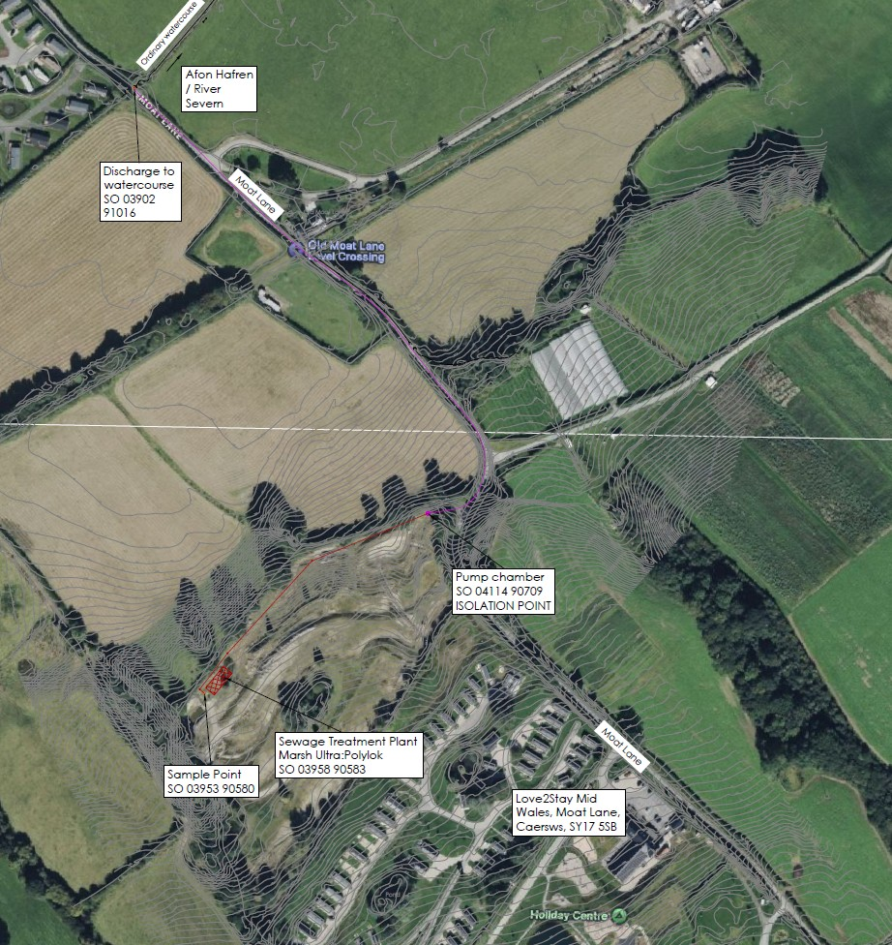
Figure 1 – System location overview

Site Details & Contacts

  - The maximum daily outflow volume from the treatment plant is 60.6m3. The composition of the outflow shall not exceed more than:
- 20 milligrams per litre of biological oxygen demand (measured after 5 days at 20*c with nitrification suppressed by the addition of allylthiourea.
- 30 milligrams per litre of suspended solids (measured after drying at 105*c)
- 20 milligrams per litre of ammoniacal nitrogen (expressed as N).

  - The park managers live on the site and have the overall reasonability for day-to-day management for the grounds and the wastewater treatment system. Contact details for the site manager is:

- Regional manager, Lee Bebb 07747 831033
- Park manager, Adam Bebb 01686 688869

Contact can also be made via email, addressed to:

- Lee Bebb lee.bebb@love2stay.co.uk
- Site manager/office midwales@love2stay.co.uk

Incident Reporting
  - The NRW pollution and environmental emergency reporting service can be contacted via the following details:

T: 0300 065 3000

Online: https://naturalresources.wales/about-us/contact-us/report-an-incident/?lang=en

Site Operations

  - Staff are on site 24/7. The site manager shall be responsible for monitoring the plant. Other operational staff shall also be made aware of the plant and the required action to report issues through the site manager. Further action can then be taken by the site manager, by calling the appointed specialist drainage engineer.

  - The site manager shall pay close attention to the park occupancy and the need for the correct decommissioning and recommissioning should there be a change in the level of occupation at the park. However, at the time of preparing this statement the park is occupied throughout the year and there is no closed season. Any adjustments required to the plant due to site occupancy levels shall be made in accordance with the Marsh Industries Ultra:Polylok operational manual included in Appendix B

  - A daily visual inspection of the treatment plant and pump chamber is required, so the site manager will arrange for these inspections by a competent person. The visual inspection will be a walkover of the plant and pump chamber to ensure there are no foul smells, and the outflow in the sample chamber is running clear.

Training
  - Training shall be provided by the site owner if the site manager or staff do not have the required technical knowledge and competence to carry out the regular inspections. Such training can be provided by the maintenance contractor. The site manager shall train other site staff on the plant operation, and in particular with regards to the alarms or other indicators that there could be a problem with the system, such as unpleasant smells.

Planned Maintenance
  - The maintenance and operational contractor must refer to the Marsh Ultra:Polylok maintenance manual, the summary of areas to service and maintain are listed below:
- General view
- Compressor
- Media (within aeration chamber)
- Structural integrity
- Electrical elements
  - At least an annual maintenance inspection and service is required for both the treatment plant and the pump chamber by a competent service provider. We recommend that a call-off contract with 24/7 drainage service provider is maintained.

  - Desludging of the plant should take place every 30 days. The sludge emptying company shall be via a licensed waste carrier (details of current contract below).

  - It is imperative that no gross solids or fats enter the system; therefore, any grease traps throughout the site must be maintained in accordance with the manufacturers’ instructions.

  - A contract is in place for servicing the treatment plant with Metro Rod Mid Wales and Shropshire branch Contact Metro Rod: T 01938 554 050E midwalesandshropshire@metrorod.co.uk

  - Due to maintenance being carried out by an external party, no equipment will normally be retained on site.

Maintenance Records
  - Maintenance records for the treatment plant must be retained on site for inspection by NRW. This should include details of the dates when the plant has been emptied and serviced, including for one-off incidental visits made.

Details of Permit
  - Details of the permit will be contained on the national permit register, which is managed by the NRW. In addition to this, there will be a site notice on the fence next to the treatment plant and in the site office, containing the following:
- Permit holder’s company name
- Emergency contact details
- Statement that the site is permitted by the Natural Resources Wales
- The permit number
- NRW telephone number 0300 065 3000

Permit number: **Enter permit number here**

Record Keeping & Complaints
  - To ensure competence of the person(s) maintaining and servicing the system, records should be kept for each company. Other records which will need to be retained are:

- Permits issued to the site
- This management system
- Site risk assessments (where required)
- Manufacturer operating and maintenance procedures
- Service reports
- All visitors related to the wastewater treatment plant and watercourse
- Compliance checks by NRW
- Complaints register with findings of investigation (name and contact details of person who expressed concern, detail on complaint, date of complaint and date of action taken to review and remedy issues)

Climate Change
  - The impacts of climate change are likely to have a negative impact upon the operation of the treatment plant. These impacts are discussed in Chapter 4.

Contingency & Accident Planning

  - Accidents, extreme weather, or other environmental incidents could impact upon the operation of the plant, which could therefore result in a pollution event. The following discussion identifies the reasonably foreseeable issues which could impact upon the operation of the plant, and the mitigation measures or other actions required. This can be read alongside the general advice provided by NRW for small sewage plants and discharges:
https://naturalresources.wales/permits-and-permissions/water-discharges-and-septic-tanks/discharges-to-surface-water-and-groundwater/develop-an-environment-management-system-for-the-discharge-of-up-to-20-cubic-metres-per-day-of-sewage-effluent/?lang=en

Power Failure, Breakdown, or Fire
  - Whilst power outages are a rare occurrence in the UK, should the power fail, the system has limited time before the bacteria within the aerobic zone will start to depopulate. It is recommended for the site manager to have details on file for a generator hire company, which would allow for normal operation of the treatment plant during power outages. It is imperative that the blower unit runs 24 hours a day, 7 days a week, to ensure the bacteria in the biozone remains active. Note that if a power failure occurs, the outlet pump will also not operate and the pump wet well will fill up.

  - The pump chamber has only 24 hours of storage for peak flows during a power outage or pump failure event. Therefore, when either of these issues occur the Site Manager must arrange for a licenced waste carrier to empty the pump chamber daily until the overall system is recommissioned.

  - Should the treatment plant break down or a fire occur in the control kiosk, the site manager should contact the designated plant servicing company, who is to be available 24/7. The site manager(s) live on the site full time, therefore if the alarm from the treatment plant is raised or power fails at the site, the manager should carry out the relevant remedial tasks. We note the system has a red beacon alarm installed, which will identify any if issues are occurring. Note that if a fire occurs, this will likely require the kiosk to be replaced.

  - If the treatment plant has no power or is inoperable for greater than 24 hours, the whole system will need shutting down and re-commissioning. This is due to the likely loss of active bacteria in the biozone. Note that should the treatment plant experience a period of extended inactivity, uncontrolled anaerobic activity in the biozone will likely create harmful substances within the wastewater which could cause pollution if released to the watercourse. Therefore, should this occur, the outlet pump shall be shut down, and the tanks shall be emptied by a licenced wastewater carrier. The plant shall then be recommissioned in accordance with the manufacturer’s instructions.

  - Note that the consequences of the pump chamber overflowing is that sewage effluent will runoff across the land and likely into Moat Lane, which will create an environmental and public health hazard. The pump system is fitted with a visual and audible alarm system. We recommend that all staff are notified of this, so this can be monitored on an ongoing basis.

Flood Risk
  - The treatment plant and pump chamber are located in very low flood risk areas according to the NRW Flood and Coastal Erosion Risk Maps. However, localised flood risk could still occur with the overall system, as any surface water entering the system will likely have a negative effect on the treatment process. Therefore, during periods of extreme rainfall we recommend that the Site Manager should monitor the overall system and look for signs of surface water flooding around the overall system. If surface water flows are observed into the system, remedial action shall be taken to prevent this.

Drought
  - Whilst the watercourse normally has water flowing in it through the year, climate change increases the likelihood of drought occurring, which could result in the watercourse temporarily drying up. With no water flowing within the watercourse, the treated effluent flows from the treatment plant have a high potential of causing pollution due a lack of dilution, resulting in harm to aquatic habitat. In drought situation, action must therefore be taken to monitor the watercourse flows at the outfall point from the treatment plant. This is easily inspected at the Moat Lane culvert at the outfall point.

  - In the event that the watercourse dries up, then the pump shall be shut down and daily emptying of the pump chamber shall be carried out by a licenced wastewater carrier to ensure that no flows enter the watercourse. The pump can be switched on again when normal flows resume in the watercourse following significant rainfall.
Spillage Events
  - Spillage events can cause pollution in different ways, as is discussed below.

  - A spillage or release of a chemical or biological liquid (such as high quantities of milk) entering the upstream sewer system will likely result in an adverse impact to the treatment plant biozone, which could result in pollution. Note that surface water entering the system will also have a similar effect. Temporary sewer system blockages can also result in pollution due to temporary overloading of the system. The site operator shall provide information to all guests and occupants with regards to the DOs and DON’Ts of what can and must not enter the sewers. Guest should be asked to report any issues, with a ‘no blame’ culture adopted.

  - In the event of a spillage event being reported or detected, the maintenance contractor shall be called immediately.

  - The second type of spillage is the release of untreated sewage from the site sewers and treatment system, due to a blockage or leak event. Should this occur then the maintenance contractor shall be called immediately. The site manager should consider if steps can be taken to temporarily isolate the leak. Finally, any spillage events must be reported to NRW.

Overloading
  - Overloading of the treatment plant will impact its ability to correctly treat wastewater to the required levels and likely result in pollution. This must be prevented via good site management of guests, to ensure that the site maximum occupancy level is not exceeded. The system capacity has been designed around the site peak occupation levels for an overall population of 620PE including staff and day guests to the café. The Site Manager shall therefore manage bookings and occupation levels so that the system capacity is not exceeded. A record of the number of guests is held via the site booking system.

Unauthorised Entry, Tampering, or other Damage
  - Malicious damage, tampering or damage to the treatment plant or kiosk will likely result in the incorrect operation of the system. If any damage is noted, the maintenance contractor shall be called to inspect the system and any required remedial action taken.

Incident Records
  - Any issues that present themselves should be handled as detailed within this management system. Record keeping of the events is imperative and are to be kept in the site folder.

Appendix A – Wastewater Treatment System Plan

Drawing number SA54913-BRY-ST-PL-C-0101_A3 (P)

Appendix B – Marsh Ultra:Polylok Maintenance Manual

