OGN 72 Appendix 2
Operational guidance note

Reference number: 72
Document Owner: Integrated Water Planning Team
What is this document about?
WFD Compliance Assessment template
Before completing this template for a WFD compliance assessment, refer to OGN72 for definitions, processes and further links to useful websites.
Who is this document for?
Internal NRW staff who need to complete an a WFD compliance assessment
Contact for queries and feedback
Integrated Water Planning Team
Version History
Document version | Date published | Summary of changes
1 | September 2020 | Document created and ready for trialling
2 | Dec 2020 | Document updated following trial
2.1 | Feb 2021 | Final draft
3 | Feb 2024 | Updated

To report issues or problems with this guidance contact: guidance.development@cyfoethnaturiolcymru.gov.uk

WFD Compliance Assessment of a new abstraction licence and impoundment licence.

Stage 1 step 1: proposal details.

Project details where an external party has applied to NRW for any form of authorisation

Application reference number & link to documents | PAN-030740 - Abstraction  PAN-030741 - Impoundment
Date application received | 22/10/2025
Applicant details | WM Jones & Co (Sylvia Jones & Harri Mostyn Jones)
Activity proposed | The applicant, WM Jones & Co, have applied for a new abstraction licence and a new impoundment licence for a 100kW Hydroelectric Power (HEP) scheme on the Afon Gennog at Blaen-y-nant, Llanberis, Gwynedd.  This scheme was previously licenced in 2013 under licence numbers WA/065/0016/009 & WA/065/0016/016 and is built and operational however, the previous licences lapsed due to a failed vesting. As a result, the Licence Holder has applied for new licences to authorise the existing abstraction and impoundment. This application is to re-licence the scheme as per the previous licences, with no proposed changes.  The following maximum abstraction rates are proposed: 190 litres per second (l/s), 684 cubic metres per hour (m³/hour), 16,416 cubic metres per day (m³/day) and 5,991,840 cubic metres per year (m³/year).  The intake design consists of a concrete weir with a Coanda intake screen with 2mm aperture size. The scheme also includes a gravity feed penstock pipe, powerhouse and discharge outlet pipe fitted with a 10mm screen.  The intake structure is designed to physically secure a residual flow of Q95 (14 litres per second) and an abstraction of 50% of the available flow (above the residual flow all year up to a maximum of 190 litres per second (1.09 x Qmean)).  The intake design includes the following:  - 2 millimetre (mm) Coanda screen  - A flow split with a 50% take of available flow  - V-notch to secure residual flow.  All abstracted water will be discharged to SH 62267 56921. The pipe will be fitted with a 10mm vertical bar screen.  Abstraction licence and impoundment licence which include the following activities:  - New Abstraction  - Discharge of water  - Maintenance of impoundment structures - typically considered green light activities, provided any maintenance meets the terms of NRW's low risk impoundment position statement, therefore not considered as part of this assessment for the current proposal.
Relevant legislation | - Water Environment (Water Framework Directive) (England and Wales) Regulations 2017  - Environment Act 1995  - Water Resources Act 1991 as amended by the Water Act 2003  - Water Resources (Abstraction and Impounding) Regulations 2006  - Article 3 of the Natural Resources Body for Wales (Establishment) Order 2012  - The Natural Resources Body for Wales (Functions) Order 2013  - The Conservation of Habitats and Species Regulations 2017
List other permissions that may be required where known | - Planning Consent (to cover construction aspects detailed above)  - Ordinary Watercourse Consent (all intakes, pipeline crossings and outfall/discharge are on ordinary watercourse)
Location (include map where appropriate) | Abstraction and impoundment point at: SH 62109 56648  Discharge point at: SH 62267 56921  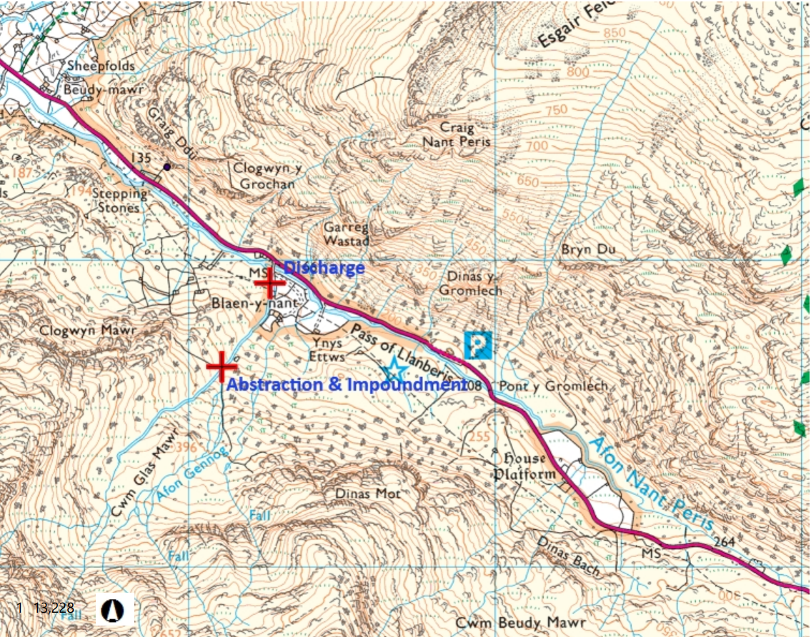
Application documents | Application form WRA  Application form WRD  Application Form WRE  Plan – Site Plan and Landownership  Report – Geomorphological Statement  Drawing – Weir Front Elevation, Levels & Calculations  Drawing – Weir GA and Nomenclature  Drawing – Weir Overall Dimensions  Drawing – Weir Positioning  Drawing – Weir Section View C-C and Right End Elevation  Drawing – Weir Section Views B-B and C-C  Drawing – Weir Side Elevation and Baseslab Section
Environmental Statement | N/A
List ongoing maintenance requirements. All structures will require maintenance | Intakes, intake pipes, penstock, turbine house, turbine, generator, discharge location.
Timing of works | Scheme built and in situ - previous licences conditioned a‘ no in-river works’ period of 17 October and 15 May in any year.
Pre-application correspondence | Pre-application undertaken for original licences (submitted on 08/10/2012), no pre-application for this proposal
NRW team responsible for drafting this WFD Compliance Assessment report, and name of lead officer | Hannah Pearce  Senior Permitting Officer (Water Resources)
Date of assessment | 30/01/2026

Stage 1, step 2 : Collate baseline information on all water bodies at risk from the proposal.
Date of classification information: 2024 cycle 3 (interim) classification
Water body ID | Water body name | Water body type | HMWB | Overall water body status | Morphology status* | Relevance to the proposal
GB110065054010 | Nant Peris | River | No -Natural | Good | Not high | Proposal is hydrologically linked – potential risk
GB110065054040 | Seiont | River | No -Natural | Moderate | No information – assumed good | Proposal is hydrologically linked – potential risk
GB110065054020 | Caledffrwd | River | No -Natural | Good | No information – assumed good | Proposal is hydrologically linked – potential risk
GB31033730 | Llyn Padarn | Lake | Yes | Moderate | N/A | Proposal is hydrologically linked – potential risk
GB31033828 | Llyn Peris | Lake | Yes | Moderate | N/A | Proposal is hydrologically linked – potential risk
GB521006501100 | Seiont | Transitional | No -Natural | Good | Not high | Proposal is hydrologically linked – potential risk
GB681010120000 | Menai Strait | Coastal | No -Natural | Good | No information – assumed good | Proposal is hydrologically linked – potential risk
GB621010380000 | Caernarfon Bay North | Coastal | No -Natural | Moderate | Not high | Proposal is hydrologically linked – potential risk
*where there is no information, or a null value then assume it is at good status for morphology (or hydromorphology for TraC water bodies) or, if the water body is designated HMWB the morphological status is not applicable (please be aware that these water bodies are still sensitive to physical modifications).

Stage 1, Step 3: Risk Screening
Complete for each water body listed above that is either in the water body or hydrologically linked with potential risk

Water body name: Nant Peris
Water body ID: GB110065054010
Question number | Risk screening questions | Name of activity | Screening decision – delete as appropriate
Q1.1 | Is the proposal in a water body at high status or high status for morphology or hydromorphology? | No | No – go to Q1.2
Q1.2 | Is the activity listed in Annex D as a green activity?  Complete new row for each activity | Abstraction in accordance with flow standards as set out in NRW guidance or Abstraction Licence Strategies. | Yes – go to Q1.3  Abstraction of 50% of the available flow up to a maximum of 190 litres per second (1.09 x Qmean) with a HoF of Q95
Q1.2 |  | Impounding structure | Yes – go to Q1.3  The impoundment is built and operational as per the previous impoundment licence. No changes to the structure are being applied for as part of this application (no increase in crest level or impounding area/securing of a different flow regime/alterations to fish pass design)
Q1.2 |  | Maintenance of existing structures | Yes – go to Q1.3  Like for like maintenance and repair e.g. repointing; void filling; re-positioning rock/block work on an existing structure (provided footprint or elevation does not change); replacement of damaged bricks; re-facing/skimming existing structure.
Q1.3 | Are there any potential cumulative/in combination impacts? Or is there Local Expert Override*? | No | No – go to Q1.4
Q1.4 | Is the water body at Good overall status? | Yes | Yes, no further WFD assessment needed - Go to conclusion and authorisation section
Q1.5 | Record best practice measures that the works include to help achieve the objectives of the water body. | Include all measures then proceed to Authorisation section
*Expert judgement may be required i.e. for complex or cumulative interactions; or a particularly sensitive site/activity (including target water bodies).

Water body name: Seiont
Water body ID: GB110065054040
Question number | Risk screening questions | Name of activity | Screening decision – delete as appropriate
Q1.1 | Is the proposal in a water body at high status or high status for morphology or hydromorphology? | No | No – go to Q1.2
Q1.2 | Is the activity listed in Annex D as a green activity?  Complete new row for each activity | Abstraction in accordance with flow standards as set out in NRW guidance or Abstraction Licence Strategies. | Yes – go to Q1.3  Abstraction of 50% of the available flow up to a maximum of 190 litres per second (1.09 x Qmean) with a HoF of Q95
Q1.2 |  | Impounding structure | Yes – go to Q1.3  The impoundment is built and operational as per the previous impoundment licence. No changes to the structure are being applied for as part of this application (no increase in crest level or impounding area/securing of a different flow regime/alterations to fish pass design)
Q1.2 |  | Maintenance of existing structures | Yes – go to Q1.3  Like for like maintenance and repair e.g. repointing; void filling; re-positioning rock/block work on an existing structure (provided footprint or elevation does not change); replacement of damaged bricks; re-facing/skimming existing structure.
Q1.3 | Are there any potential cumulative/in combination impacts? Or is there Local Expert Override*? | No | No – go to Q1.4
Q1.4 | Is the water body at Good overall status? | No - moderate | No - Go to Q1.5
Q1.5 | Record best practice measures that the works include to help achieve the objectives of the water body. | - 2 millimetre (mm) Coanda screen and 10mm screening at discharge  - A flow split with a 50% take of available flow  - V-notch to secure residual flow (Q95).  - Return of all abstracted water at SH 62267 56921

Water body name: Caledffrwd
Water body ID: GB110065054020
Question number | Risk screening questions | Name of activity | Screening decision – delete as appropriate
Q1.1 | Is the proposal in a water body at high status or high status for morphology or hydromorphology? | No | No – go to Q1.2
Q1.2 | Is the activity listed in Annex D as a green activity?  Complete new row for each activity | Abstraction in accordance with flow standards as set out in NRW guidance or Abstraction Licence Strategies. | Yes – go to Q1.3  Abstraction of 50% of the available flow up to a maximum of 190 litres per second (1.09 x Qmean) with a HoF of Q95
Q1.2 |  | Impounding structure | Yes – go to Q1.3  The impoundment is built and operational as per the previous impoundment licence. No changes to the structure are being applied for as part of this application (no increase in crest level or impounding area/securing of a different flow regime/alterations to fish pass design)
Q1.2 |  | Maintenance of existing structures | Yes – go to Q1.3  Like for like maintenance and repair e.g. repointing; void filling; re-positioning rock/block work on an existing structure (provided footprint or elevation does not change); replacement of damaged bricks; re-facing/skimming existing structure.
Q1.3 | Are there any potential cumulative/in combination impacts? Or is there Local Expert Override*? | No | No – go to Q1.4
Q1.4 | Is the water body at Good overall status? | Yes | Yes, no further WFD assessment needed - Go to conclusion and authorisation section
Q1.5 | Record best practice measures that the works include to help achieve the objectives of the water body. | Include all measures then proceed to Authorisation section

Water body name: Llyn Padarn
Water body ID: GB31033730
Question number | Risk screening questions | Name of activity | Screening decision – delete as appropriate
Q1.1 | Is the proposal in a water body at high status or high status for morphology or hydromorphology? | No | No – go to Q1.2
Q1.2 | Is the activity listed in Annex D as a green activity?  Complete new row for each activity | Abstraction in accordance with flow standards as set out in NRW guidance or Abstraction Licence Strategies. | Yes – go to Q1.3  Abstraction of 50% of the available flow up to a maximum of 190 litres per second (1.09 x Qmean) with a HoF of Q95
Q1.2 |  | Impounding structure | Yes – go to Q1.3  The impoundment is built and operational as per the previous impoundment licence. No changes to the structure are being applied for as part of this application (no increase in crest level or impounding area/securing of a different flow regime/alterations to fish pass design)
Q1.2 |  | Maintenance of existing structures | Yes – go to Q1.3  Like for like maintenance and repair e.g. repointing; void filling; re-positioning rock/block work on an existing structure (provided footprint or elevation does not change); replacement of damaged bricks; re-facing/skimming existing structure.
Q1.3 | Are there any potential cumulative/in combination impacts? Or is there Local Expert Override*? | No | No – go to Q1.4
Q1.4 | Is the water body at Good overall status? | No - moderate | No - Go to Q1.5
Q1.5 | Record best practice measures that the works include to help achieve the objectives of the water body. | - 2 millimetre (mm) Coanda screen and 10mm screening at discharge  - A flow split with a 50% take of available flow  - V-notch to secure residual flow (Q95).  - Return of all abstracted water at SH 62267 56921

Water body name: Llyn Peris
Water body ID: GB31033828
Question number | Risk screening questions | Name of activity | Screening decision – delete as appropriate
Q1.1 | Is the proposal in a water body at high status or high status for morphology or hydromorphology? | No | No – go to Q1.2
Q1.2 | Is the activity listed in Annex D as a green activity?  Complete new row for each activity | Abstraction in accordance with flow standards as set out in NRW guidance or Abstraction Licence Strategies. | Yes – go to Q1.3  Abstraction of 50% of the available flow up to a maximum of 190 litres per second (1.09 x Qmean) with a HoF of Q95
Q1.2 |  | Impounding structure | Yes – go to Q1.3  The impoundment is built and operational as per the previous impoundment licence. No changes to the structure are being applied for as part of this application (no increase in crest level or impounding area/securing of a different flow regime/alterations to fish pass design)
Q1.2 |  | Maintenance of existing structures | Yes – go to Q1.3  Like for like maintenance and repair e.g. repointing; void filling; re-positioning rock/block work on an existing structure (provided footprint or elevation does not change); replacement of damaged bricks; re-facing/skimming existing structure.
Q1.3 | Are there any potential cumulative/in combination impacts? Or is there Local Expert Override*? | No | No – go to Q1.4
Q1.4 | Is the water body at Good overall status? | No - moderate | No - Go to Q1.5
Q1.5 | Record best practice measures that the works include to help achieve the objectives of the water body. | - 2 millimetre (mm) Coanda screen and 10mm screening at discharge  - A flow split with a 50% take of available flow  - V-notch to secure residual flow (Q95).  - Return of all abstracted water at SH 62267 56921

Water body name: Seiont
Water body ID: GB521006501100
Question number | Risk screening questions | Name of activity | Screening decision – delete as appropriate
Q1.1 | Is the proposal in a water body at high status or high status for morphology or hydromorphology? | No | No – go to Q1.2
Q1.2 | Is the activity listed in Annex D as a green activity?  Complete new row for each activity | Abstraction in accordance with flow standards as set out in NRW guidance or Abstraction Licence Strategies. | Yes – go to Q1.3  Abstraction of 50% of the available flow up to a maximum of 190 litres per second (1.09 x Qmean) with a HoF of Q95
Q1.2 |  | Impounding structure | Yes – go to Q1.3  The impoundment is built and operational as per the previous impoundment licence. No changes to the structure are being applied for as part of this application (no increase in crest level or impounding area/securing of a different flow regime/alterations to fish pass design)
Q1.2 |  | Maintenance of existing structures | Yes – go to Q1.3  Like for like maintenance and repair e.g. repointing; void filling; re-positioning rock/block work on an existing structure (provided footprint or elevation does not change); replacement of damaged bricks; re-facing/skimming existing structure.
Q1.3 | Are there any potential cumulative/in combination impacts? Or is there Local Expert Override*? | No | No – go to Q1.4
Q1.4 | Is the water body at Good overall status? | Yes | Yes, no further WFD assessment needed - Go to conclusion and authorisation section
Q1.5 | Record best practice measures that the works include to help achieve the objectives of the water body. | Include all measures then proceed to Authorisation section

Water body name: Menai Strait
Water body ID: GB681010120000
Question number | Risk screening questions | Name of activity | Screening decision – delete as appropriate
Q1.1 | Is the proposal in a water body at high status or high status for morphology or hydromorphology? | No | No – go to Q1.2
Q1.2 | Is the activity listed in Annex D as a green activity?  Complete new row for each activity | Abstraction in accordance with flow standards as set out in NRW guidance or Abstraction Licence Strategies. | Yes – go to Q1.3  Abstraction of 50% of the available flow up to a maximum of 190 litres per second (1.09 x Qmean) with a HoF of Q95
Q1.2 |  | Impounding structure | Yes – go to Q1.3  The impoundment is built and operational as per the previous impoundment licence. No changes to the structure are being applied for as part of this application (no increase in crest level or impounding area/securing of a different flow regime/alterations to fish pass design)
Q1.2 |  | Maintenance of existing structures | Yes – go to Q1.3  Like for like maintenance and repair e.g. repointing; void filling; re-positioning rock/block work on an existing structure (provided footprint or elevation does not change); replacement of damaged bricks; re-facing/skimming existing structure.
Q1.3 | Are there any potential cumulative/in combination impacts? Or is there Local Expert Override*? | No | No – go to Q1.4
Q1.4 | Is the water body at Good overall status? | Yes | Yes, no further WFD assessment needed - Go to conclusion and authorisation section
Q1.5 | Record best practice measures that the works include to help achieve the objectives of the water body. | Include all measures then proceed to Authorisation section
Water body name: Caernarfon Bay North
Water body ID: GB621010380000
Question number | Risk screening questions | Name of activity | Screening decision – delete as appropriate
Q1.1 | Is the proposal in a water body at high status or high status for morphology or hydromorphology? | No | No – go to Q1.2
Q1.2 | Is the activity listed in Annex D as a green activity?  Complete new row for each activity | Abstraction in accordance with flow standards as set out in NRW guidance or Abstraction Licence Strategies. | Yes – go to Q1.3  Abstraction of 50% of the available flow up to a maximum of 190 litres per second (1.09 x Qmean) with a HoF of Q95
Q1.2 |  | Impounding structure | Yes – go to Q1.3  The impoundment is built and operational as per the previous impoundment licence. No changes to the structure are being applied for as part of this application (no increase in crest level or impounding area/securing of a different flow regime/alterations to fish pass design)
Q1.2 |  | Maintenance of existing structures | Yes – go to Q1.3  Like for like maintenance and repair e.g. repointing; void filling; re-positioning rock/block work on an existing structure (provided footprint or elevation does not change); replacement of damaged bricks; re-facing/skimming existing structure.
Q1.3 | Are there any potential cumulative/in combination impacts? Or is there Local Expert Override*? | No | No – go to Q1.4
Q1.4 | Is the water body at Good overall status? | No - moderate | No - Go to Q1.5
Q1.5 | Record best practice measures that the works include to help achieve the objectives of the water body. | - 2 millimetre (mm) Coanda screen and 10mm screening at discharge  - A flow split with a 50% take of available flow  - V-notch to secure residual flow (Q95).  - Return of all abstracted water at SH 62267 56921

Conclusion of WFD Regulations 2017 Compliance Assessment & Authorisation

WFD stage 1 screening has been completed and the activity/project have been ruled out as not requiring any further WFD Regulations 2017 assessment. Or, further assessment is not required because there is no conceivable impact pathway to any water body or Protected Area.
WFD stage 2 scoping has been completed and the activity/project is considered as having no risk of causing deterioration or preventing any water body or WFD Protected Area from reaching its objectives and taking account of the advice from technical officers - is considered compliant with the WFD Regulations 2017.
In light of the conclusions of a detailed compliance assessment (Stage 3), and taking account of the advice received from technical specialist advisors, it has been established that the activity/project has no potential to cause deterioration of any water body or prevent a water body or WFD Protected Area from meeting its objectives, taking into account any legally binding avoidance measures or restrictions as applicable, either alone or in-combination with other activities.
In light of the conclusions of the detailed compliance assessment, it has not been ascertained that the project has no potential to cause deterioration or prevent water bodies or WFD Protected Areas from meeting their objectives, as documented in stage 3 of this form. If the conclusion of stage 3 detailed compliance assessment identifies a risk of deterioration of one or more water bodies that cannot be mitigated or may prevent a water body or WFD Protected Area from meeting its objectives, then approval for the project cannot be given unless either:
• the project specification, and/or the terms under which it might be approved, are modified so as to remove the risk of deterioration or prevention of achievement of objectives, and a revised compliance assessment report is prepared, or
• the project satisfies the requirements of Regulation 19 (Article 4(7) (including 4.8 & 4.9) of the Water Framework Directive, and is approved by the NRW executive team.
Name of authorising officer | Hannah Pearce
Job title and date | Senior Permitting Officer (Water Resources)  05/02/2026
Technical specialist comments | Internal consultation sent on 06/02/2026 stating that the activity has been screened out as not requiring further internal WFD assessment in line with OGN 072. No concerns raised, no requirement for further assessment
Name, job title and date | See ICEPack saved here to the DMS, dated 28/01/2026

Consultation with technical advisors/specialists
Relevant section of the WFD compliance assessment | Date(s) of correspondence* and any meeting(s) with technical advisor(s) and include the name of the technical advisor | Description of how the comments from technical advisors have been considered
N/a
*Attach a copy or a link on DMS to written correspondence for the audit trail

Where there is a dispute on the conclusion the decision should be taken by the Leadership Team member of the team exercising the competent authority role

