CRoW Appendix 4 (140_10_SD02)  CRoW Act 2000: Natural Resources Wales application for permission - Formal Notice |  | 
Natural Resources Wales Formal Notice.
Requirements of Section 28I of the Wildlife & Countryside Act 1981 as amended by the Countryside and Rights of Way Act (CRoW) 2000.
Duty in relation to granting any consent, licence or permit for activities likely to damage Sites of Special Scientific Interest (SSSI).
- Natural Resources Wales area/region/NPS hub: | Bro Morgannwg – the UTA Vale of Glamorgan
- Name of SSSI: | Coedydd y Barri / Barry Woodlands  Cog Moors  Hayes Point to Bendrick Rock
- Type of permission: | Environmental Permit
- Date for Natural Resources Wales permit determination:
- Predicted 28 day date for response from NRW conservation/ecology (under S28 I(4)):
- Natural Resources Wales reference no: | PAN-026441
- National grid reference: | ST 13900 68400
- Description of proposal: | Address: Barry Plant, Cardiff Road, Barry, Vale of Glamorgan, CF63 2YL  Request for a normal permit variation to install 4 silica silos including offloading to feed into W115 production facility. Each silo will have an authorised release point to air of particulates only with a filtration unit to meet BAT (<10 Mg/m³). The applicant also proposes to install an upgraded LEV in W115 to protect workers, with an associated stack and authorised release point (<10 Mg/m³).  Silica will be unloaded locally into the silos from sea bulk containers or tankers. The unloading operation will happen inside a 2 walled unloading shed. During commissioning vent monitoring will be carried out to confirm the design conditions are met. If required these vents can be periodically monitored. This will be done using MCERTS operators either Dow personnel or a suitable MCERTS accredited company.
- Is the proposed activity within (wholly or partially) the SSSI boundary? | NO  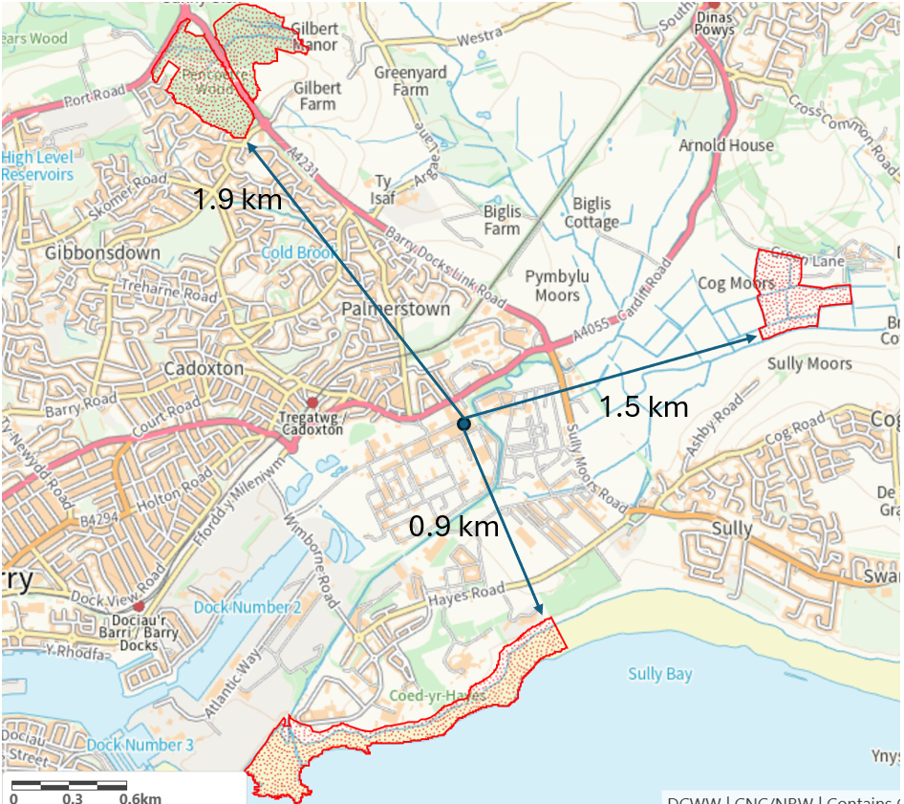
- Has there been any pre-application discussion or correspondence with NRW conservation/ecology | NO
- What aspect(s) of the proposed permission may damage the features which are of special interest for the SSSI?
The following ‘Operations Requiring Consent’ (or other activities associated with the permission) that may cause damage) are relevant to the proposed permission.

7. Dumping, spreading or discharging of any materials.

The permit variation may cause additional emissions of particulates (PM₁₀ and PM_{2.5} from the 5 authorised release points)

The following SSSI features and mechanisms of impact have been considered to assess the likelihood of damage:

Coedydd y Barri / Barry Woodlands. Coedydd Y Barri/Barry Woodlands is of special interest for its semi-natural broadleaved woodland. The woodland comprises a series of 14 blocks, 120 ha in area.

The proposed permission is not likely to damage any of the flora which are of special interest because the submitted H1 assessment confirmed that emissions of PM₁₀ and PM_{2.5} from the 5 authorised release points are insignificant and can therefore be screened out. Furthermore, the IAQM Guidance on the Assessment of Mineral Dust Impacts for Planning guidance document indicates that impacts on sites that are greater than 1km from the source of particulates are negligible and do not need to be assessed. Whilst related to quarries, the guidance is applicable to emissions of particulates from installations. Hence there no potential to damage any of the flora, fauna or geological or physiological features which are of special interest.

Cog Moors. Cog Moors is situated approximately 2 km east of Barry and consists of a series of fields adjacent to Sully Brook. This site is of special interest for its large continuous area of damp mesotrophic (neutral) semi natural grassland, which is associated with several stands of tall sedges, and for populations of two uncommon plant species. The site is 12.9 ha in area.

The proposed permission is not likely to damage any of the flora which are of special interest because the submitted H1 assessment confirmed that emissions of PM₁₀ and PM_{2.5} from the 5 authorised release points are insignificant and can therefore be screened out. Furthermore, the IAQM Guidance on the Assessment of Mineral Dust Impacts for Planning guidance document indicates that impacts on sites that are greater than 1km from the source of particulates are negligible and do not need to be assessed. Whilst related to quarries, the guidance is applicable to emissions of particulates from installations. Hence there no potential to damage any of the flora, fauna or geological or physiological features which are of special interest.

Hayes Point to Bendrick Rock. This 1.8 km stretch of coastline lies to the southeast of Barry on the northern shore of the Bristol Channel. The whole length of the cliff line and foreshore provides excellent exposures through important rock sections of Triassic age while the vicinity of Bendrick Rock is one of the best localities in Britain for fossil footprints. The site is 29.5 ha in area.

The proposed permission is not likely to damage any of the geological features which are of special interest because the SSSI features are not sensitive to this activity and so there is no potential to damage any of the flora, fauna or geological or physiological features which are of special interest.

- Decision
i) The proposed permission is not likely to damage any of the flora, fauna or geological or physiological features which are of special interest.

Emissions of particulates have been shown to be insignificant and so there is no likelihood of damage to any of the flora, fauna or geological or physiological features which are of special interest to Barry Woodlands SSSI or Cog Moors SSSI. There is no potential to damage Hayes Point Bendrick Rock as there is no relevant impact pathway.

Natural Resources Wales is minded to:

Issue the permission

- Name and job title of Natural Resources Wales officer: | Christopher Betteridge  Senior Permitting Officer (Secondment)
- Date form sent to NRW conservation/ecology | N/A – filed for audit
For Natural Resources Wales use only, once NRW conservation/ecology response received
- NRW conservation/ecology comment on assessment: | N/A – filed for audit
- Name and job title of NRW conservation/ecology officer: | N/A – filed for audit
- Date of receipt of NRW conservation/ecology response: | N/A – filed for audit

