Record of a Habitats Regulations Assessment of a project or spatially-specific plan
OGN 200 Form 1A (with free-text boxes for likely significant effect screening and appropriate assessment)

Document owner: Head of Business for Natural Resource Management
Version History:
Document Version | Date Published | Summary of Changes
2.0 | 21/10/2024 | Following 2023/24 review of HRA OGNs
Next review date: October 2025

OGN 200 Form 1A

Record of a Habitats Regulations Assessment
Plan or project name, brief description or application reference number | PAN-026441  Address: Barry Plant, Cardiff Road, Barry, Vale of Glamorgan, CF63 2YL  Request for a normal permit variation to install 4 silica silos including offloading to feed into W115 production facility. Each silo will have an authorised release point to air of particulates only with a filtration unit to meet BAT (<10 Mg/m³). The applicant also proposes to install an upgraded LEV in W115 to protect workers, with an associated stack and authorised release point (<10 Mg/m³).  Silica will be unloaded locally into the silos from sea bulk containers or tankers. The unloading operation will happen inside a 2 walled unloading shed. During commissioning vent monitoring will be carried out to confirm the design conditions are met. If required these vents can be periodically monitored. This will be done using MCERTS operators either Dow personnel or a suitable MCERTS accredited company.

HRA iteration/version | N/A

1. Plan or Project Details
Information about the plan or project
1 | Date application received | 16/05/2025, with updated C3 form and supporting appendices received 21/08/2025.
2 | Applicant details | Dow Silicones Ltd, Barry Plant, Cardiff Road, Barry, Vale of Glamorgan, CF63 2YL
3 | NRW team responsible for carrying out, or requiring to be carried out, the plan or project, and name of lead officer | N/A
4 | Activity/ies proposed | Request for a normal permit variation to install 4 silica silos including offloading to feed into W115 production facility. Each silo will have an authorised release point to air of particulates only with a filtration unit to meet BAT (<10 Mg/m³). The applicant also proposes to install an upgraded LEV in W115 to protect workers, with an associated stack and authorised release point (<10 Mg/m³).  This variation pertains to permit listed EPR activity S4.7 A(1)(a) - Any activity for the manufacture of a chemical which may result in the release of ammonia into the air, other than an activity in which ammonia is only used as a refrigerant.
5 | Relevant legislation or statutory basis | Environmental Permitting (England and Wales) Regulations 2016
6 | Location | The European sites search point was centred on the emission point to air for the site (X 314077 Y 168691). A screening distance of 10km has been used based on the UK Government guidance “Air emissions risk assessment for your environmental permit”. A map below shows the location of the proposed installation location and European sites within the 10km screening distance.  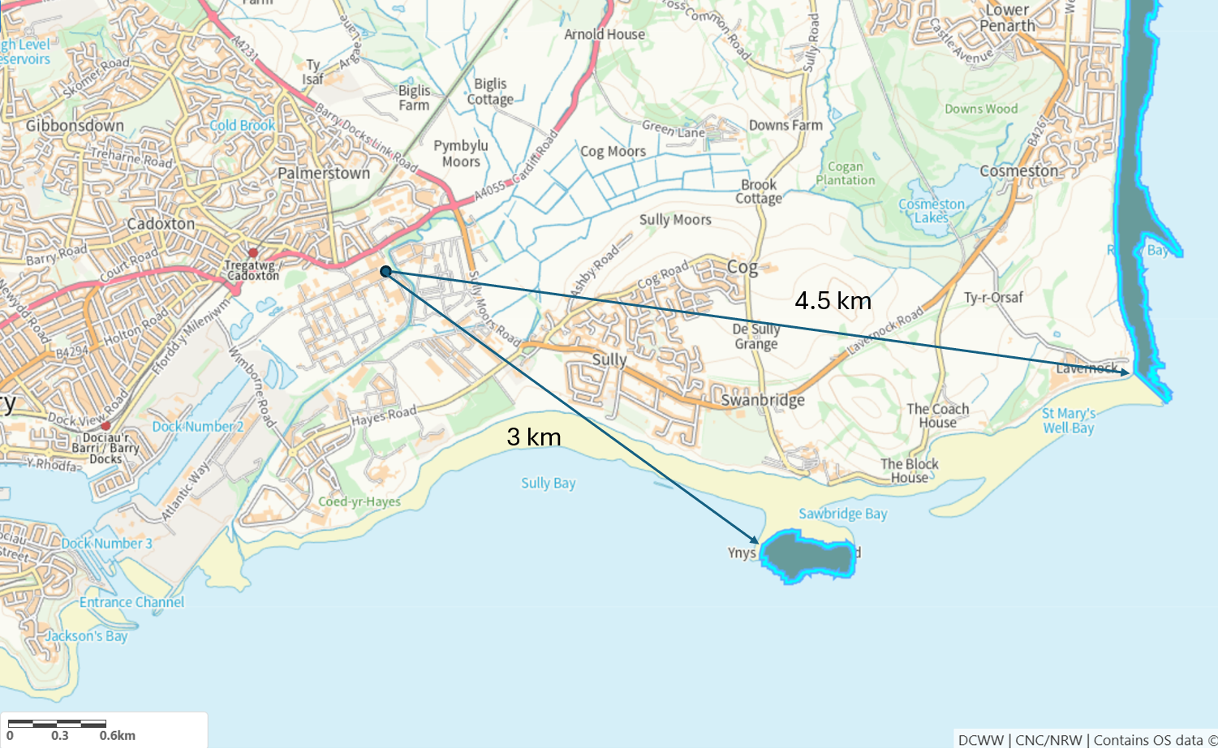
7 | Plan or project documents, including any application documents | - Part A Form  - Part C2 Form  - Part C3 Form  - Part F1 form  - Appendix A – Non Technical Summary  - Appendix B - Main activities update – Section 15  - Appendix C – Contents of Main activities  - Appendix D – Environmental assessment, Resource efficiency and Climate change  - Appendix E – Climate change agreements  - Appendix F – Map of authorised release points  - Appendix G – ODMS Overview and LRQA letter – Management system  - Appendix H – Dow Silicones UK Ltd Companies House Registration  - Request for confidentiality  - Charging banding tool – separate document  - OPRA scoring spreadsheet – separate document - https://cyfoethnaturiolcymru.sharepoint.com/:u:/r/teams/Regulatory/Permitting/SE%20EPR%20Regulated%20Industry/EPR-BR9685IX/PAN-026441%20-%20E-mail%20Containing%20updated%20permit%20variation%20documentation.msg?csf=1&web=1
8 | Environmental Statement (ES) | N/A
9 | Pre-application correspondence | N/A
10 | NRW team responsible for preparing this HRA report, and lead officer | Christopher Betteridge (Senior Permitting Officer (Secondment))  Regulated Industry Permitting Team
11 | Team or person responsible for approving the plan or project (competent authority role) | As row 10

2. Determining the need for a Habitats Regulations Assessment
2.1 Is there any possibility that the plan or project could negatively affect any European sites? | No  The only impact pathway for damage to the sites identified is emissions of particulates. The IAQM Guidance on the Assessment of Mineral Dust Impacts for Planning guidance document indicates that impacts on sites that are greater than 1km from the source of particulates are negligible and do not need to be assessed. Whilst related to quarries, the guidance is applicable to emissions of particulates from installations. The sites European sites identified are at least 3km from the installation and so we do not consider there to be an impact pathway. Furthermore, the applicant has submitted H1 assessment which confirmed that emissions of PM10 and PM2.5 from the 5 authorised release points are insignificant. Hence there is no hazard.  A Habitats Regulations Assessment (HRA) is not required because there is no conceivable impact pathway to any of the National Site Network sites identified by virtue of the scale or location or nature of the project.
2.2 Is the whole of the plan or project directly and only connected with or necessary to the management of one or more European sites, for the purposes of conserving the habitats or species for which the European site(s) is/are designated? | N/A
2.3 Is there a possibility that the plan or project could affect any other feature of the European site(s) concerned, or of another European site, in a way that would undermine that feature’s conservation objectives? | N/A

6. Conclusion

HRA is not required because there is no conceivable impact on any European sites.  (As documented in section 2.1) | X
HRA is not required because the whole of the plan or project is directly connected with or necessary to the management of one or more European sites, for the purposes of conserving the habitats or species for which the site(s) is/are designated, and the plan or project is not likely to have a significant effect on any other European sites.
(As documented in section 2.2 and 2.3)
This project is a renewal of a current permission which complies with NRW agreed criteria for ruling out likely significant effects of a renewal without conducting a project-specific LSE test. Therefore, it is considered not likely to have a significant effect on any European sites, either alone or in-combination with other plans or projects.
(As documented in section 3.1 of this form)
The plan or project has been screened for likelihood of significant effects and is considered not likely to have a significant effect on any European sites. (As documented in section 3.2 of this form, and section 5 if applicable)
In light of the conclusions of an appropriate assessment it has been established that the plan or project will not adversely affect the integrity of any European sites, taking into account any conditions or restrictions as applicable, either alone or in-combination with other plans or projects.
(As documented in section 4 of this form, and section 5 if applicable)
In light of the conclusions of the appropriate assessment, it has not been ascertained that the plan or project will not adversely affect the integrity of any European sites, as documented in section 4 of this form, and section 5 if applicable.
Approval for the plan or project cannot be given unless either:
- the plan or project specification, and/or the terms under which it might be approved, are modified so as to remove the risk of adverse effects, and a revised HRA is prepared, or
- the plan or project (not being an SSSI consent*) satisfies the requirements for a derogation and a Derogation Notice is prepared and submitted for consideration by the appropriate authority, normally Welsh Ministers
(*SSSI consents cannot be given as derogations)
Signed:

Name: Christopher Betteridge Position: Senior Permitting Officer (Secondment)

Date: 25/09/2025

Was this HRA conclusion an escalated decision? YES or NO | No

