Annex (iv) – SSSI Assessment Form
SSSI Assessment for permit/licence and deployment applications | 
To be completed by Permitting Officers for any applications for a permission which Natural Resources Wales has considered under S28I duty to notify SNCB and take their advice into account. This applies to all proposed permissions within a SSSI, and to operations outside the SSSI boundary which are likely to damage its special features.
NRW as a Section 28G authority has, when exercising its functions, a general duty to take reasonable steps, consistent with the proper exercise of its functions, to further the conservation and enhancement of the flora, fauna or geological or physiological features by reason of which the site is of special interest’

Part 1 – SSSI Assessment
Part 2 – Formal notification to SNCB (to be completed if part 1 assessment concludes likely damage, not likely to damage because of conditions or you cannot conclude no likely damage)
Part 3 – Decision

Part 1 – SSSI Assessment

- Permitting officer/team | Victoria Seller, Installations and RSR Permitting
- Permit application reference and site name | PAN-028481  Deeside Power Station, Weighbridge Road, Deeside Industrial Park, Deeside, Flintshire, CH5 2UL. SJ 29750 71250.
- a. SSSI name(s)  b. location  c. NRW Operational Area/Environment Team | a. Afon Dyfrdwy (River Dee) 31WDW, Dee Estuary / Aber Afon Dyfrdwy 31WHJ, Inner Marsh Farm 31WTC, Shotton Lagoons and Reedbeds 31WBU  b. Flintshire/Cheshire  c. North East/Flintshire and Wrexham Environment Team
- Brief description of proposal | This is an application to vary the environmental permit for the Deeside Power Station installation, held by Deeside Power (UK) Limited. A link to the permit documents is available on our Public Register, here.  The Installation is currently permitted to operate as a Combined Cycle Gas Turbine (CCGT) baseload power station with a net rated thermal input of 927MW and with no restrictions on operating hours. There are two CCGTs at the installation. However, these ceased operation as a fossil-fuel electricity generation activity in 2018 and have since been converted into synchronous compensators which do not burn any fuel and provide reactive power to the National Grid. The variation application seeks to remove the CCGT activity and associated controls from the permit. The converted CCGTs will remain in the permit, but will be added as Directly Associated Activities (DAAs) as they no longer involve the combustion of fossil fuels.  This variation application is to remove the CCGT activity and add 11no. natural gas-fired reciprocating engines to the permit. The purpose of the engines is to generate electricity for supply to the National Grid, and thus, going forward, the installation will operate as a peaking power plant.  The net rated thermal input of each engine is 9.91MW and the combined aggregated thermal input is 109MW. The engines will operate for an average of 1500 hours per year as a five-year rolling average, with a maximum of 2250 hours per year in any one of those five years. The engines will be used to generate electricity at times of increased power demand on, or reduced power supply to, the National Grid. Operation of the engines will result in the release of airborne oxides of nitrogen (NO_{x}) and the deposition of nutrient nitrogen and acid.  The change from a baseload power plant to a peaking power plant, with the associated significant drop in net rated thermal capacity and operating hours, represents a net benefit to protected sites within the the vicinity of the installation.  Given that the CCGTs ceased operation in 2018, it should be noted that they are therefore not included in the background NO_{x} concentration data available in the 2020-22 APIS data.  The applicant has undertaken detailed and precautionary dispersion modelling of air emissions impacts, i.e. considering the highest/worst impact possible for a number of variables as explained in their submission. This includes modelling with 5 years of meteorological data, and considering the highest modelled impact from different modelling “runs”. The modelling has been subject to detailed auditing by NRW experts, who are satisfied that the predictions within the applicant’s submitted report are suitable for use in variation determination.  The CCGT activity includes an emergency diesel-fuelled back-up generator as a DAA. This generator has a net rated themal input of 1.035MW. It will remain in the permit after the grant of the variation. Given the infrequent expected operating regime of the generator and it’s small net rated thermal input, it has not been included in the dispersion modelling as emissions from it are expected to be negligible.  The generator has associated with it a tank for the purpose of storing diesel. Given that the generator is already included in the permit, we have assessed the risk associated with the storage of diesel in its tank, and are satisfied that the operator has appropriate management techniques in place to prevent uncontrolled release of fuel. We are also satisfied that appropriate controls are in the permit to take enforcement action against the operator if we find that these techniques have not been adequately implemented. We have therefore not addressed the uncontrolled release of diesel from this tank further in this SSSI assessment.  The new engines will require the storage of engine oil (clean and waste). The site will have two tanks for this purpose: one 10,000l tank to store new engine oil, and one 10,000l lank to store used engine oil, prior to off-site disposal.  The new engines will also generate intermittent noise.  This SSSI assessment therefore focusses on:  - the 11 point source emissions to air (associated with each of the 11 reciprocating engines) The pollutants to air comprise: oxides of nitrogen (NO_{x:} NO and NO₂ expressed as NO₂) from the natural gas-fired combustion plant;  - Intermittent noise associated with the operation of the engines; and  - Storage of clean and waste oil.  For this type of activity, a screening radius of 2km around the installation is used to determine the set of SSSIs that could be potentially impacted. This is in line with our guidance. The SSSIs within 2km of the installation are:  - Afon Dyfrdwy (River Dee) 31WDW – 0.9km west  - Dee Estuary / Aber Afon Dyfrdwy 31WHJ – 182m west  - Inner Marsh Farm 31WTC – 1.9km north east  - Shotton Lagoons and Reedbeds 31WBU – 184m south  The activity will not take place within the boundary of any of the SSSIs.  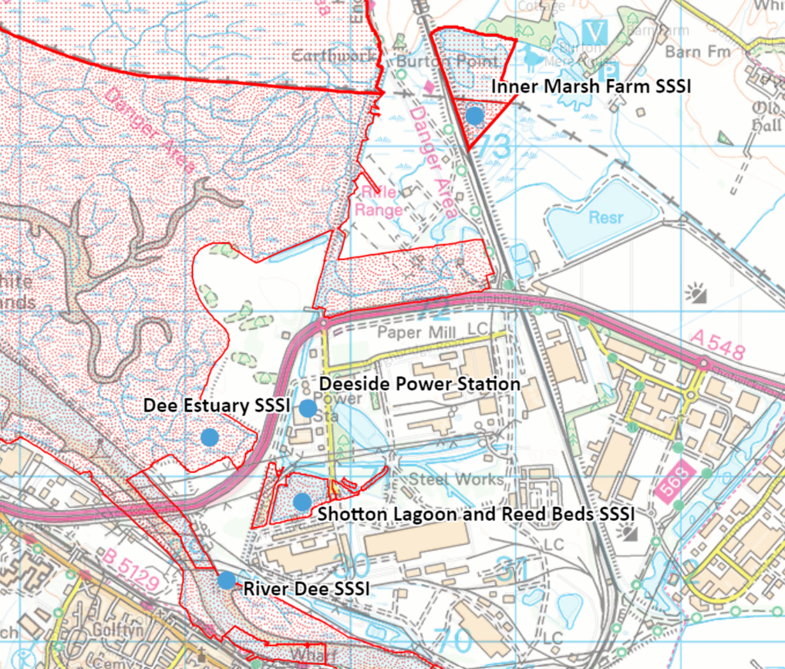
- What aspects of the proposed permission are likely to damage the SSSI features of special interest?

Potential impacts to the features of the SSSIs are as follows:
- the 11 point source emissions to air (associated with each of the 11 reciprocating engines) The pollutants to air comprise: oxides of nitrogen (NO_{x:} NO and NO₂ expressed as NO₂) from the natural gas-fired combustion plant;
- Intermittent noise associated with the operation of the engines; and
- Storage of clean and waste oil.

Dee Estuary (Aber Afon Dyfrdwy) 31WHJ

This SSSI is notified for a large number of plant and animal species, many of which are sensitive to nutrient nitrogen deposition and acid deposition. As a conservative approach, in this assessment, we have used the lowest of the range of critical loads (CLo)* for nutrient nitrogen deposition and acid deposition that are listed on the APIS website. For this SSSI, these are:
- Nutrient nitrogen deposition – 10 kgN/ha/yr; and
- Acid deposition – 5.071 keq/ha/yr (MaxCLmaxN)
*A note on the saltmarsh feature of this site
In line with Bobbink (2022), we have used a CLo of 10 kgN/ha/yr for Atlantic upper-mid and mid-low saltmarsh, and 20 kgN/ha/yr for pioneer saltmarsh. Unless otherwise specified, 10 kgN/ha/yr has been used in this assessment as a conservative approach.

Afon Dyfrdwy (River Dee) 31WDW
This SSSI is notified for a large number of plant and animal species, many of which are sensitive to nutrient nitrogen deposition and acid deposition.

The lowest nutrient nitrogen deposition (NDep) CLo associated with this SSSI is for the Luronium natans notifed feature. The NDep CLo for this feature is a minimum of 2 kgN/ha/yr. However, Luronium natans is only present in management units in and directly adjacent to Bala Lake. Given the distance between this area of the SSSI and the installation, in this assessment we have adopted the next most stringent NDep CLo listed on the APIS website for the notified features.
As a conservative approach, in this assessment, we have used the lowest of the range of critical loads (CLo) for nutrient nitrogen deposition and acid deposition that are listed on the APIS website. For this SSSI, these are:
- Nutrient nitrogen deposition – 10 kgN/ha/yr; and
- Acid deposition – applicant’s use of the APIS Critical Load Function Tool.
Inner Marsh Farm 31WTC
This SSSI is notified for a number of plant and animal species, many of which are sensitive to nutrient nitrogen deposition and acid deposition. As a conservative approach, in this assessment, we have used the lowest of the range of critical loads (CLo) for nutrient nitrogen deposition and acid deposition that are listed on the APIS website. For this SSSI, these are:
- Nutrient nitrogen deposition – 6 kgN/ha/yr; and
- Acid deposition – 11.087 k_{eq}/ha/yr (MaxCLmaxN)
Shotton Lagoons and Reedbeds 31WBU
This SSSI is notified for one animal and three habitats features. All are sensitive – or potentially sensitive – to nutrient nitrogen and acid deposition. As a conservative approach, in this assessment, we have used the lowest of the range of critical loads (CLo) for nutrient nitrogen deposition and acid deposition that are listed on the APIS website. For this SSSI, these are:
- Nutrient nitrogen deposition – 10 kgN/ha/yr; and
- Acid deposition – 5.071 k_{eq}/ha/yr (MaxCLmaxN)
Further information on the SSSIs can be found in the site Citations.
The following activities are likely to cause damage:

The installation is located approximately at distance from all four SSSIs and hence the activity is not likely to directly damage any of the flora, fauna or geological or physiological features which are of special interest from disturbance, habitat loss or physical damage which are typically associated with direct activity within a protected site boundary. The only emissions to water will be uncontaminated surface water run-off.

The proposed change to the industrial facility only relates to aerial emissions: no changes to emissions to surface water or groundwater are associated with the variation application, and therefore no impact pathway exists via these mechanisms. There is also no impact from vibration. The engines used to generate electricity have the potential to generate noise, and therefore, a potential impact pathway exists. Noise is expected to minimal and, in the context of the surrounding industrial landscape, will have neglible impact on species within the above listed habitats sites.

Potential impacts to the features of the SSSIs are therefore as follows:
- the 11 point source emissions to air (associated with each of the 11 reciprocating engines) The pollutants to air comprise: oxides of nitrogen (NO_{x:} NO and NO₂ expressed as NO₂) from the natural gas-fired combustion plant;
- Intermittent noise associated with the operation of the engines; and
- Storage of clean and waste oil.

The operation of the engines will require the storage of clean and waste oil. The applicant has completed a risk assessment for this activity which is based on CIRA c736 guidance, which is considered best practice. We have reviewed this assessment and are satisfied that the operator will have the appropriate techniques and management controls in place to manage the risk from uncontrolled release of clean and waste oil.

If granted, the variation will remove from the permit emissions to water points W2a, W2b and W3, which are currently permitted to discharge to the River Dee. These emission points were in place to discharge uncontaminated surface water (W2a and W2b) and cleaned cooling water and boiler blowdown water (W3). The only emission points to water will be surface water drainage from the site via the existing emission point W1. W1 previously discharged abstracted cooling water back to the River Dee, and had a number of associated monitoring and reporting requirements attached to it given its use in as process cooling water in the CCGT activity. If the variation is granted, W1 will only be used to divert clean, uncontaminated rainwater to the River Dee. Removal of emission point W3, and the monitoring and reporting requirements previously in place for W1, represents a net benefit to the Afon Dyfrdwy (River Dee) SSSI.

The installation is currently permitted as a ‘baseload’ (i.e. continuously operating) natural gas power station, comprising two combined cycle natural gas turbines (CCGT), with a net rated thermal input capacity of 927MW. The operator wishes to change the operating profile to that of a ‘peaking plant’, which means that the site will be called upon to provide electicty to the National Grid during times of reduced supply and / or will result in an overall reduction of in flow and and mass release rate of pollutants to air from the stacks. Given that the new operating profile will utilise natural gas engines, the pollutant profile will remain the same – i.e., oxides of nitrogen (NO_{x}: NO and NO₂ expressed as NO₂) remains the only pollutant of concern.

The new operating profile will involve a substantially reduced aggregated net rated thermal input capacity of 109MW compared to the ‘baseload’ operating profile. The installation will also be permitted to operate for a maximum of 1500 hours per year as a five-year rolling average, with no more than 2250 hours per year in any one of those five years. This represents a substantial reduction in permitted operating hours compared to the ‘baseload’ operation.

The CCGTs ceased operation as a fossil-fuel electricity generation activity in 2018 and have since been converted into synchronous compensators which do not burn any fuel and provide reactive power to the National Grid. This means that the contribution from the site to the ambient background concentration of NOx is not reflected in the latest (2020-22) background concentration data available on APIS. We have taken this into account in our assessment and further explanation of the significance of this is given below.

The following operations requiring consent (ORC) is relevant for consideration for this assessment:
“7 Dumping, spreading or discharging of any waste materials.”
This ORC is relevant for the spreading of air pollutants and release of polluting liquids described above.

The following SSSI(s) features and potential impacts have been considered to assess the likelihood of damage:

The sites contains a number of features which may be sensitive to the impacts of NO_{x} emissions across its full extent.

The applicant has provided a detailed assessment of NO_{x} impacts, using detailed modelling to determine the significance of the NO_{x} emissions and deposition. This is available on our Public Register, here.

The air quality modelling has calculated process contributions (PC) and predicted environmental concentrations (PEC) at locations within the SSSI and compared them against the relavent environmental standard to predict if impacts are to be significant using the accepted guidance on determining significance of air quality modelling results. Impacts can generally be screened out as insignificant where they are under 10% for short term impacts and 1% for long term impacts (please refer to guidance for further information).

Dee Estuary (Aber Afon Dyfrdwy) 31WHJ / Afon Dyfrdwy (River Dee) 31WDW
Toxic contamination from airborne NO_{x} – short term assessment

Emissions of NOx were assessed against the short term (daily average) critical level of 75 μg/m³.

Two of the Process Contributions (PC) for this site were predicted to be >10% of the daily average CLe:
- Receptor E18: PC 9.77 μg/m³ (13%)
- Receptor E20: PC 7.71 μg/m³ (10.3%)

For Receptor E18, the Predicted Environmental Concentration (PEC), which include ambient concentrations of NO_{x}, taken from the APIS website, is 31.4 μg/m³, which is 42% of the CLe.

For Receptor E20, the PEC is 29.3 μg/m³, which is 39% of the CLe.

As the PECs equate to <70% of the daily average CLe, we are satisfied that the predicted releases screen out at the second stage of the screening criteria and it can be considered that airborne emissions of NO_{x} are not likely to damage the features of the SSSI.

It should also be noted that an assumption of 100% capacity operating for a continual period of 24-hours is an unlikely operating scernario.

Toxic contamination from airborne NO_{x} – long term assessment

Emissions of NOx were assessed against the long term (annual average) critical level of 30 μg/m³.

Five of the PCs for this site were predicted to be >1% of the annual average CLe:
- Receptor E18: PC 0.34 μg/m³ (1.1%)
- Receptor E19: PC 0.46 μg/m³ (1.5%)
- Receptor E20: PC 0.85 μg/m³ (2.8%)
- Receptor E25: PC 0.54 μg/m³ (3.6%)
- Receptor E26: PC 0.43 μg/m³ (1.4%)

The PECs for these receptors are as follows:
- Receptor E18: PEC 11.4 μg/m³ (37%)
- Receptor E19: PEC 11.3 μg/m³ (38%)
- Receptor E20: PEC 11.7 μg/m³ (39%)
- Receptor E25: PEC 11.3 μg/m³ (38%)
- Receptor E26: PC 11.2 μg/m³ (37%)

As the PECs equate to <70% of the annual average CLe, we are satisfied that the predicted releases screen out at the second stage of the screening criteria and it can be considered that airborne emissions of NO_{x} are not likely to damage the features of the SSSI.

Nutrient enrichment from NO_{x} deposition

Deposition of nutrient nitrogen from airborne NO_{x} was assessed against a CLo of 10 kgN/ha/yr.

One of the PCs for this site was predicted to be >1% of CLo:
- Receptor E20: PC 0.12 kgN/ha/yr (1.2%)

The Predicted Environmental Concentration (PEC) is therefore 16.42 µg/m³, which is 164% of the CLo.

The calculation of the PEC is based on an annual background concentration for nitrogen deposition of, which is taken from the APIS dataset for ‘moorland (short vegetation)’. We consider this background concentration to be appropriate for use in this assessment.

Although the PEC is >70% of the relevant CLo, this should be viewed in the context of temporal trends in background nitrogen deposition concentration in the region.

Graph 1 in Appendix 1 shows rate of nutrient nitrogen deposition at the Estuary since 2005 (the full time period over which such records are available). The orange line shows the background nitrogen deposition concentration over time for short vegetation.

Background nitrogen deposition has been above the CLo of 10 kgN/ha/yr since “records began”. There was a recent increase over the last decade which now seems to have retraced. N-dep is reducing in the short-term, but a long-term view shows levels relatively stable over the period.

Receptor E20 is located in this section of the SSSI:

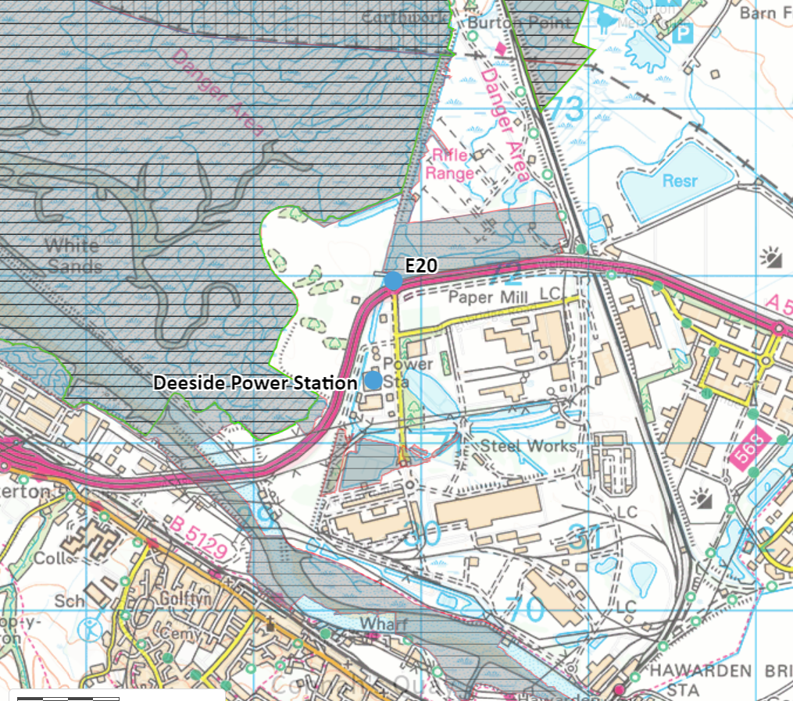

Maps 1 and 2 in Appendix below show the spatial distribution of plant species in this section of the Dee Estuary in more detail.

The area is characterised by Mesotrophic grassland, Communities of salt-marsh, Swamps and tall-herb fens, and some open land and woodland habitats. This distribution of species indicates that the area is typical of a transitional community between saltmarsh habitat and terrestrial habitat. The presence of transitional community here suggests that, although the background nutrient nitrogen deposition rates are higher than the relevant CLo for upper-mid and mid-low Atlantic Saltmarsh, the habitat is not being adversely impacted by this to a significant degree.

Map 2 shows that the point of maximum impact in this section of the Estuary is located in an area of Mesotrophic grassland – NVC code MG1. This NVC code is not included in any of the Annex I features for which the Dee Estuary SSSI is designated.

Given that:
- changes to the installation mean that the overall mass concentration of NOx emitted will be greatly reduced (given the change from ‘baseload’ to ‘peaking’ operation);
- the background nitrogen deposition, although high, is stable, and has remained unchanged for some time;
- The other PCs modelled for Dee Estuary SSSI have shown no exceedance of the significance threshold for assessment of impact from nutrient nitrogen deposition;
- Species distribution indicates the presence of transitional habitat, which suggests that significant adverse impact from existing nutrient nitrogen deposition is unlikely; and
- The point of maximum impact in this section of the Estuary is located in an area of Mesotrophic grassland (NVC code MG1) which does not form part of any of the notifiable features for which the Dee Estuary SSSI is designated.

Therefore, likely significant effects from the proposed peaking plant can be ruled out upon first screening as the PC is less than the screening threshold of 1% of the long-term CLe. It can be considered that deposition of nitrogen via airborne emissions of NO_{x} is not likely to damage the features of the SSSI.

Acidification from acid deposition

All PCs are below 1% of the relevant CLo for acid deposition.

Inner Marsh Farm 31WTC
Toxic contamination from airborne NO_{x} – short term assessment
Toxic contamination from airborne NO_{x} – long term assessment
Nutrient enrichment from NO_{x} deposition
Acidification from acid deposition

All PCs are below 1% of the relevant CLes and CLos.

Shotton Lagoons and Reedbeds 31WBU

Toxic contamination from airborne NO_{x} – short term assessment

All PCs are below 10% of the relevant CLe for short term (daily average) NO_{x}.

Toxic contamination from airborne NO_{x} – long term assessment

Emissions of NOx were assessed against the long term (annual average) critical level of 30 μg/m³.

One PC for this site was predicted to be >1% of the annual average CLe:
- Receptor E58: PC 1.08 μg/m³ (3.6%)

The PEC for this receptor is as follows:
- Receptor E58: PEC 11.8 μg/m³ (40%)

As this PEC equates to <70% of the annual average CLe, we are satisfied that the predicted releases screen out at the second stage of the screening criteria and it can be considered that airborne emissions of NO_{x} are not likely to damage the features of the SSSI.

Nutrient enrichment from NO_{x} deposition

Deposition of nutrient nitrogen from airborne NO_{x} was assessed against a CLo of 10 kgN/ha/yr.

One of the PCs for this site was predicted to be >1% of CLo:
- Receptor E58: PC 0.16 kgN/ha/yr (1.6%)

The PEC for this receptor is as follows:
- Receptor E58: PEC 16.96 kgN/ha/yr (170%)

The calculation of the PEC is based on an annual background concentration for nitrogen deposition of 16.8 kgN/ha/yr, which is taken from the APIS dataset for ‘moorland (short vegetation)’. We consider this background concentration to be appropriate for use in this assessment.

Although the PEC is >70% of the relevant CLo, this should be viewed in the context of temporal trends in background nitrogen deposition concentration in the region.

Graph 1 in Appendix 1 shows the The below is an area of the Dee Estuary SAC. The orange line shows the background nitrogen deposition concentration over time for short vegetation.
Background nitrogen deposition has been above the CLo of 10 kgN/ha/yr since “records began”. There was a recent increase over the last decade which now seems to have retraced. Nutrient nitrogen deposition is reducing in the short-term, but a long-term view shows levels relatively stable over the period.

Given that:
- changes to the installation mean that the overall mass concentration of NO_{x} emitted will be greatly reduced (given the change from ‘baseload’ to ‘peaking’ operation);
- the background nitrogen deposition, although high, is stable, and has remained unchanged for some time; and
- The other PCs (4no.) modelled for Shotton Lagoon and Reed Beds SSSI have shown no exceedance of the significance threshold for assessment of impact from nutrient nitrogen deposition

We are satisfied that nutrient nitrogen deposition from airborne emissions of NO_{x} is not likely to damage the features of the SSSI.

Acidification from acid deposition

All PCs are below 1% of the relevant CLo for acid deposition.

Dee Estuary (Aber Afon Dyfrdwy) 31WHJ

Disturbance (noise)

The site is an existing, permitted installation, which is currently permitted to carry on combustion of natural gas in gas turbines. The associated risk from noise on the species located in the Dee Estuary SSSI has therefore been assessed and deemed to be of significantly low impact for the installation to operate. The operator has an existing noise management plan, which details the measures they must take to control the impact of noise arising from the installation. This forms part of the permit and is therefore legally enforceable.

The new operation will be similar in make-up in that it also involves the combustion of natural gas to generate electricity. If permission is granted for the new activity, the impact from noise will be significantly reduced given that the permitted annual operating hours will reduce to 1500 per year from 8760 per year. The reduced operating annual operating hours of the installation therefore represents a net benefit in terms of noise to the habitat.

The installation is located in a heavily industrialised are, and therefore the soundscape in its vicinity is made up of a variety of industrial noise sources. It is highly likely that birds inhabiting the SSSI have become acclimitised to these sounds over time.

As the impact pathway remains, at worst, unchanged, and at best, a net benefit, we conclude that the features of the SSSI are not likely to be damaged as a result of disturbance from noise.

Afon Dyfrdwy (River Dee) 31WDW

Changes to water characteristics (flow, turbidity, level, velocity, temperature, flooding, acidification [other than acid deposition from air – see below] etc).

The operation of the engines will require the storage of clean and waste oil. The applicant has completed a risk assessment for this activity which is based on CIRA c736 guidance , which is considered best practice. We have reviewed this assessment and are satisfied that the operator will have the appropriate techniques and management controls in place to manage the risk from uncontrolled release of clean and waste oil. Conditions compelling the operator to control and manage the storage of potentially polluting liquids are already in place in the permit; these conditions will remain in any varied permit granted. The operator will update their Environmental Management System to include procedures for the management and control of the storage of potentially polluting liquids.

If granted, the variation will remove from the permit emissions to water points W1 and W3, which are currently permitted to discharge to the River Dee. These emission points are in place to discharge cleaned cooling water and boiler blowdown water (W1) and cooling water intake (W3). The only emission points to water will be surface water drainage from the site via the existing emission points W2a and W2b. W2a and W2b divert clean, uncontaminated rainwater to the River Dee. Removal of emission points W1 and W3 represents a net benefit to the Afon Dyfrdwy (River Dee) SSSI.

As the removal of emission points to water W1 and W3 represents a net benefit to the SSSI and we are satisfied that the operator will have the appropriate controls in place to prevent the uncontrolled release of stored oil, we conclude that the features of the SSSI are not likely to be damaged as a result of changes to water characteristics.

- Summary of any informal advice received from internal experts (if required and including pre-app advice)
- Recommendation  If you conclude not likely to damage because of conditions or likely to damage part 2 of this form needs to be completed (see below).  If you or the officer you have asked for informal advice cannot conclude whether the permission will impact the SSSI then you need will need to complete part 2 of the form. | The proposed permission is not likely to damage the flora, fauna or geological or physiological features which are of special interest.
- Signature and date assessment made | Victoria Seller, 14/05/2026
- Officers name and job title | Victoria Seller, Lead Specialist Permitting Officer


Permitting
Formal Notification under Section 28I of the Wildlife and Countryside Act 1981

Part 2 Formal notification under S28I – To be completed for all permit applications assessed as: not likely to damage because of conditions, likely to damage SSSI and those where we are unable to conclude no likely damage.

- Date Notice of intention to permit activity likely to damage SSSI sent to NRW (SCNB) | .
- Advice received from NRW (SNCB)

Environment Teams and Marine Area Management and Advice Teams are expected to log and issue formal statutory advice through our CAMS system. The advice letter generated can simply by attached/appended here. ET/MAAMT can just refer to that here or write a summary of advice here too.

To be completed by environment officers.
Within 28 days of receiving notice from a permitting/licensing regime, you should advise whether the operation:
• Should be allowed to proceed.
• Should be allowed to proceed with certain conditions.
• Should not proceed.

Please ensure all advice provided is evidenced and comprehensive. Advice provided may be scrutinised as part of a formal appeal.

- Name and job title of conservation/marine officer (sign and date)
Part 3 – To record NRW decision following SNCB Advice
- DECISION  Provide reasoning for your decision and how you have considered advice from NRW(SNCB) in the box opposite and delete text in blue that is not relevant. This might be the same as the info and decision in part 1 of the form  Large amounts of supporting information can be appended to this form. | The proposed permission is not likely to damage any of the flora, fauna or geological or physiological features which are of special interest  The permission is not likely to damage any of the flora, fauna or geological or physiological features which are of special interest because of conditions  The permission is likely to damage
- Natural Resources Wales (Section 28G Authority) (permitting service) is minded to  Delete as appropriate  If this decision is not in line with advice received from NRW(SNCB) please outline your reasoning (please note that you should try to resolve any differences in opinion) | Issue the permission  Issue the permission with conditions to ensure no damage to SSSI  Refuse the permission due to likely damage to SSSI
- Is decision in line with advice from SNCB  If your decision is not in line with the recommendations from SNCB you must formally notify them using the appropriate online form or letter.  Record the date the notice/letter was sent opposite and save a link. The permitted operation cannot commence for 21 days following service of this notice. | Yes/No  If No record date notice was sent to SNCB
- Signature and date assessment completed
- Officers name and job title

Appendix 1
Graph 1. Time series data for background nutrient nitrogen deposition rates in the Dee Estuary.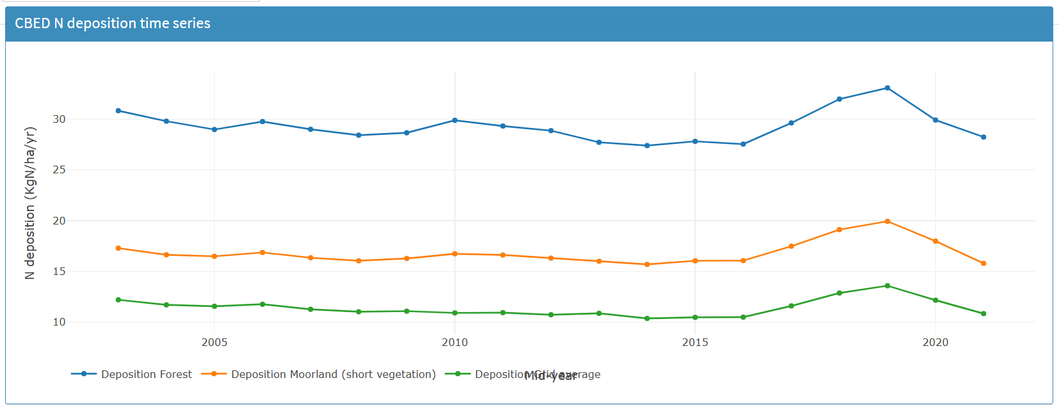

Map 1. Location of the section of Dee Estuary SAC / SPA / Ramsar in which Receptor E20 is located (land circled in green). Survey data taken from Dargie, T. 2001. NVC survey of the saltmarsh and other habitats in the Dee and Clwyd estuaries 2000. CCW Contract Science Report no. 450. Countryside Council for Wales, Bangor.
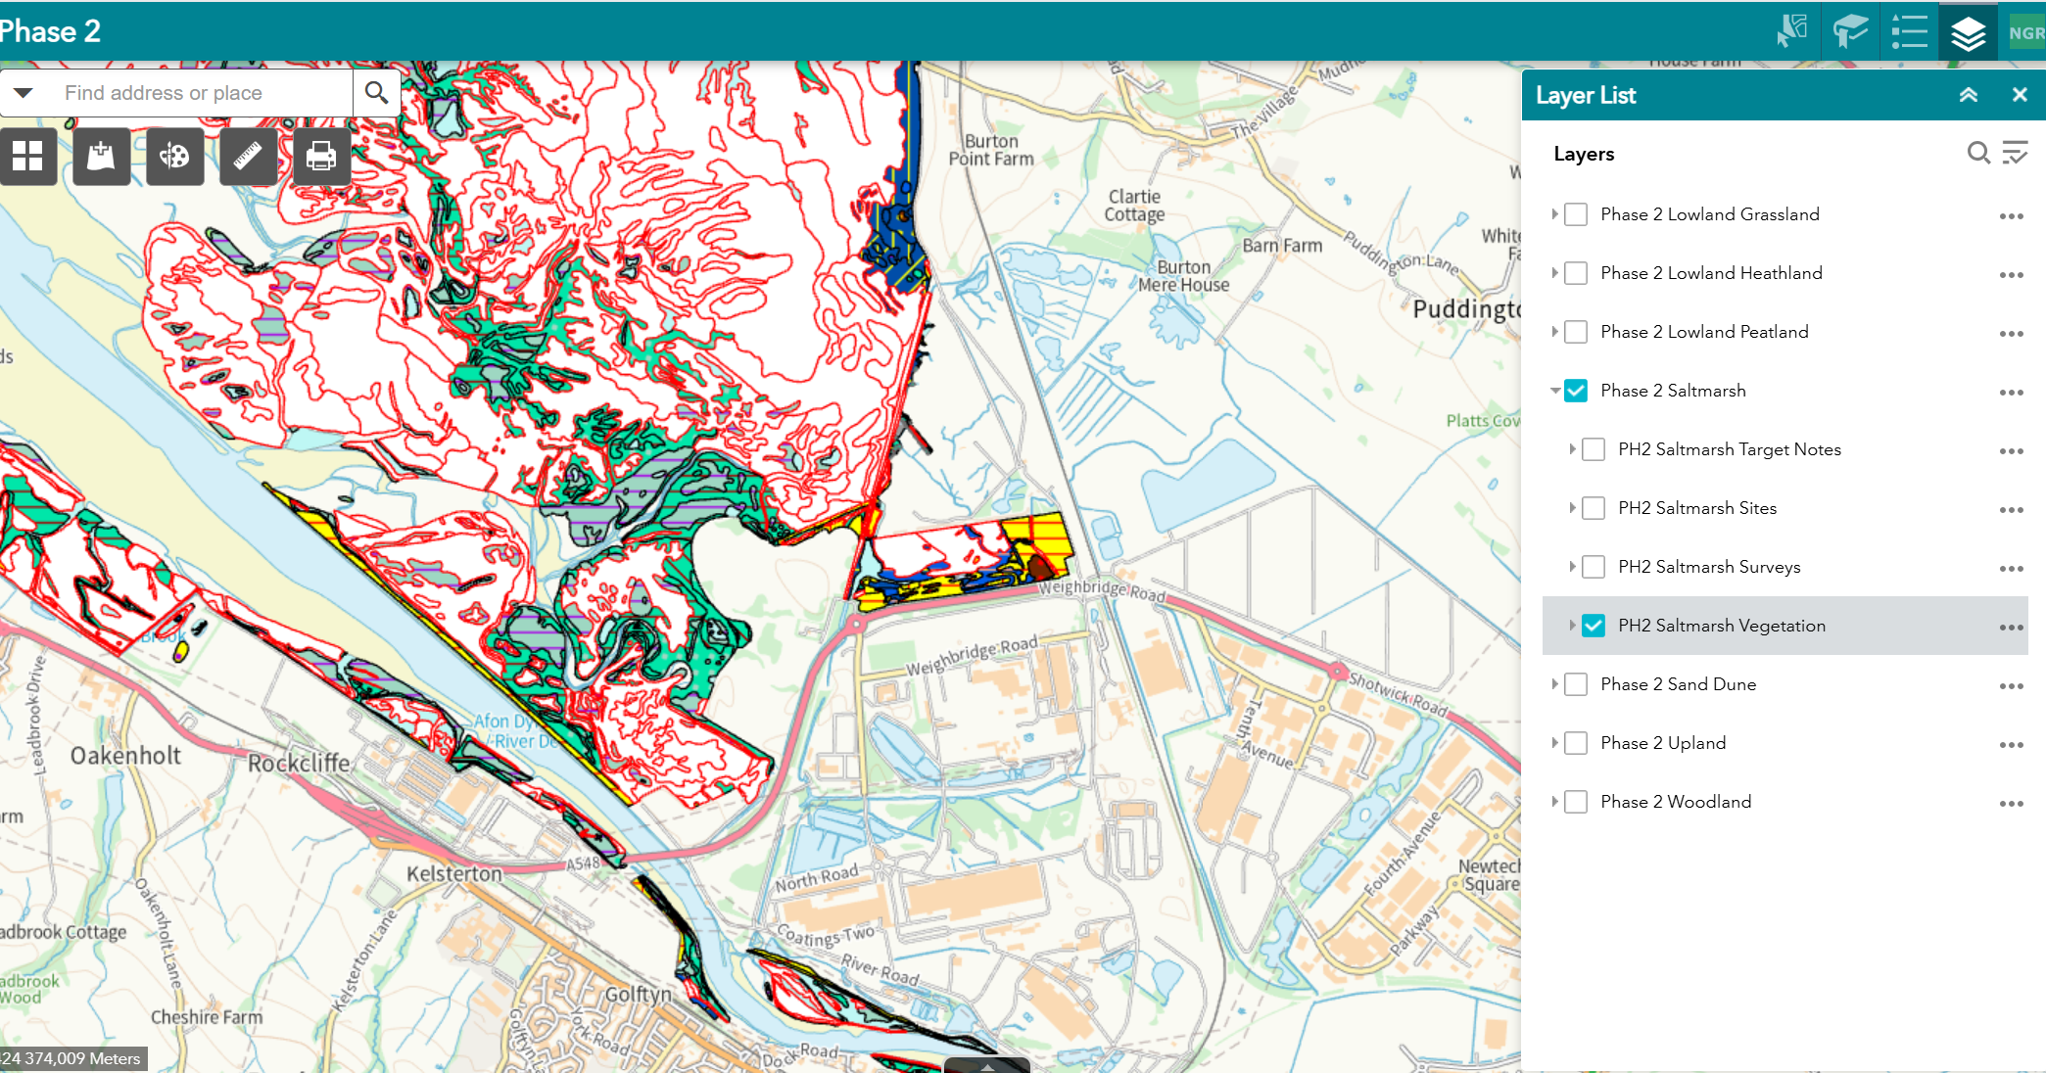
E20

Map 2. Area in question shown in detail. Key to species and habitats types given below.
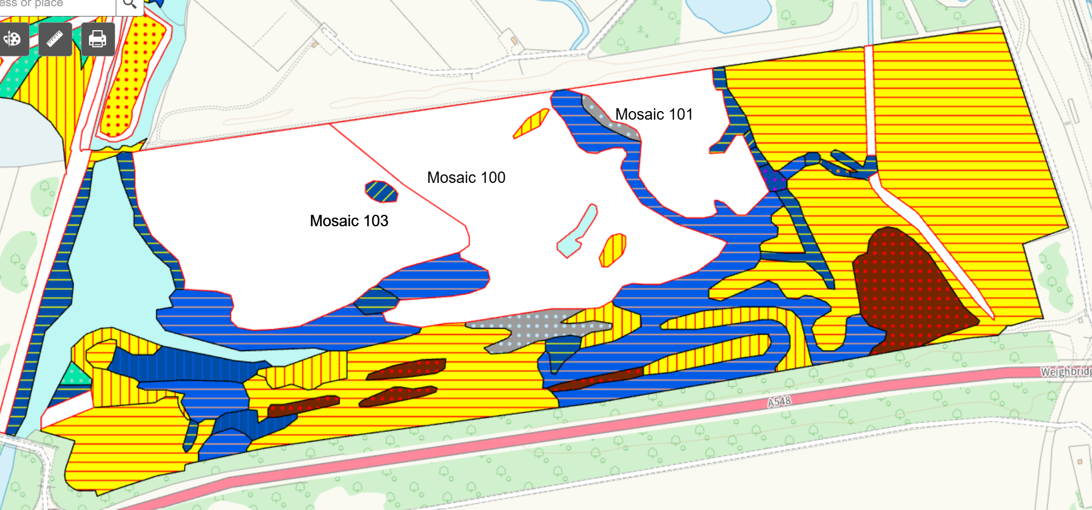
E20

Key
NVC code |  | Code name | Broad habitat category | Percentage split (mosaics)
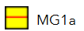 |  | Arrhenatherum elatius grassland, Festuca rubra sub-community | Mesotrophic grassland
 |  | Arrhenatherum elatius grassland, Urtica dioica sub-community | Mesotrophic grassland
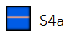 |  | Phragmites australis swamp and reed-beds, Phragmites australis sub-community | Swamps and tall-herb fens
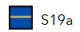 |  | Eleocharis palustris swamp, Eleocharis palustris sub-community | Swamps and tall-herb fens
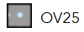 |  | Urtica dioica-Cirsium arvense community | Vegetation of open habitats
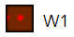 |  | Salix cinerea-Galium palustre woodland | Woodlands and scrub
 |  | Scirpus maritimus swamp, Scirpus maritimus sub-community | Communities of salt-marsh
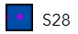 |  | Phalaris arundinacea tall-herb fen | Communities of salt-marsh
Mosaic 103 | MG1 | Arrhenatherum elatius grassland | Mesotrophic grassland | 45%
Mosaic 103 | MG11 | Festuca rubra–Agrostis stolonifera–Potentilla anserina grassland | Mesotrophic grassland | 30%
Mosaic 103 | SM24 | Elymus pycnanthus salt-marsh community | Communities of salt-marsh | 30%
Mosaic 103 | SM24 | Elymus pycnanthus salt-marsh community | Communities of salt-marsh | 25%
Mosaic 100 | MG1 | Arrhenatherum elatius grassland | Mesotrophic grassland | 70%
Mosaic 100 | SM24 | Elymus pycnanthus salt-marsh community | Communities of salt-marsh | 30%
Mosaic 101 | MG1 | Arrhenatherum elatius grassland | Mesotrophic grassland | 100%

APIS - Air Pollution Information System | APIS
Air emissions risk assessment for your environmental permit - GOV.UK
APIS app | APIS
Bobbink, R. et al. (2022). Review and revision of empirical critical loads of nitrogen for Europe. August 2022.
Natural Resources Wales / Find protected areas of land and sea
Air emissions risk assessment for your environmental permit - GOV.UK
AQTAG21 Habitats screening assessments – use of 1% long-term and 10% short-term screening thresholds for all EPR and IPPCR installations bar intensive farming

