Deployment Map

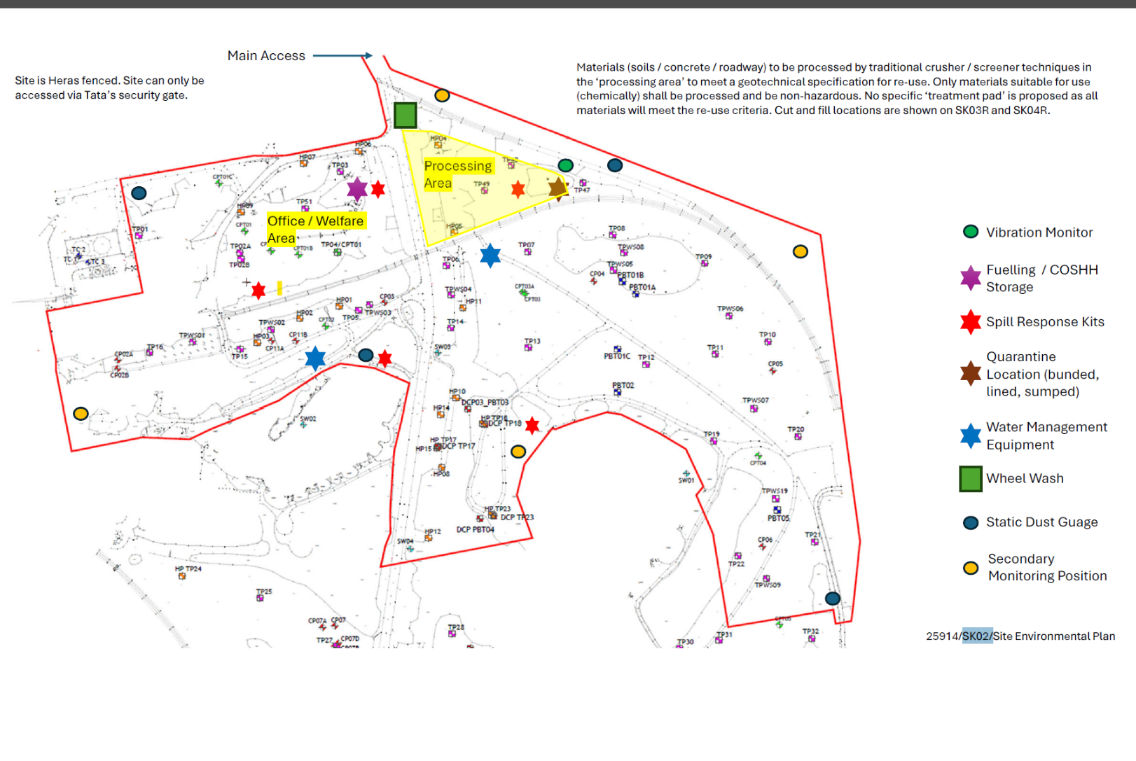

Mymap report
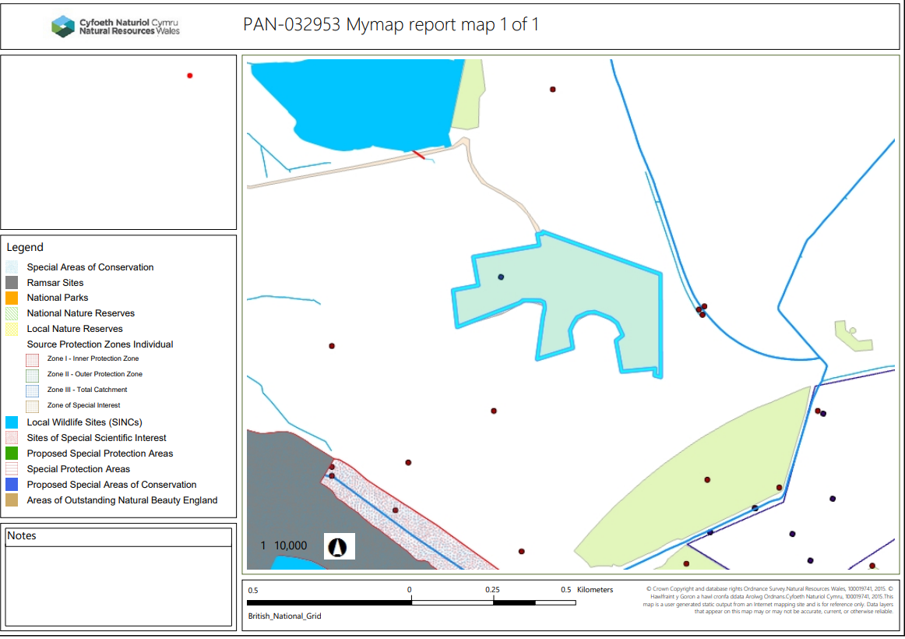

any spring, well or borehole not used to supply water for domestic or food production purposes within 50m – None in range.

any spring, well or borehole used to supply water for domestic or food production purposes within 250m None in range.

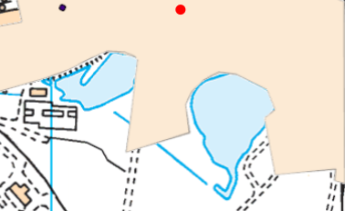
surface water courses
There are two ponds located close to deployment boundary. Need confirmation this complies with distance in permit and is included in CSM with mitigation measures.

Special protection areas (SPA) Potential special protection areas (pSPA) Special areas of conservation (SAC)Candidate special areas of conservation (cSAC) , Ramsar , Site of Special Scientific Interest (SSSI)
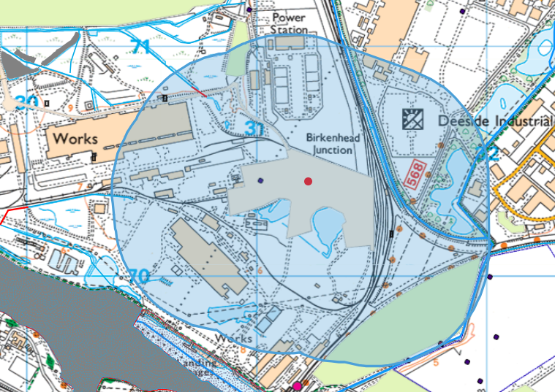
None within 500 meters of site.

within a groundwater source protection zone SPZ) 1 or 2?
The site is not within a source protection zone 1 or 2.

Ancient woodland None in range.

Areas of Outstanding Natural Beauty (AONB) None in range.

Heritage Coast None in range.

Local nature reserves None in range.

Local wildlife sites
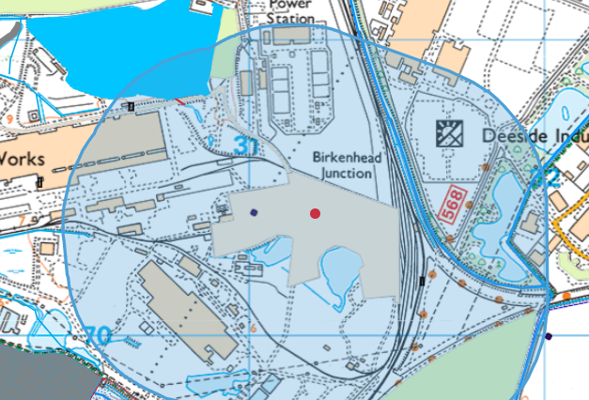
The deployment boundary is located 379 meters from the Shotton Steelworks SINC. The submitted deployment application has included this receptor in the conceptual site model.

National nature reserves None in range.

National parks None in range.

Scheduled ancient monuments None in range.

World Heritage Sites none within deployment area boundary.

Controlled waters such as rivers and lakes See comment in surface waters

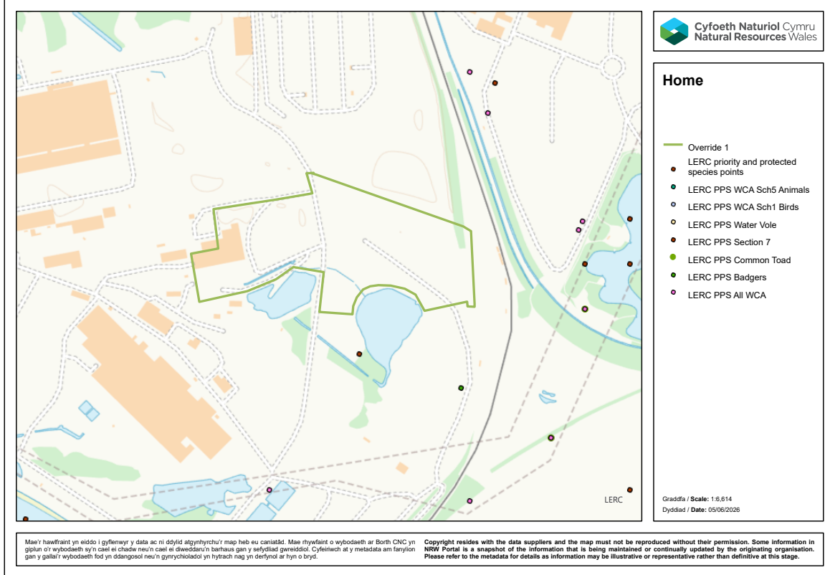
Section 7 Priority species, Nationally Protected Species, European Protected Species
None in range.

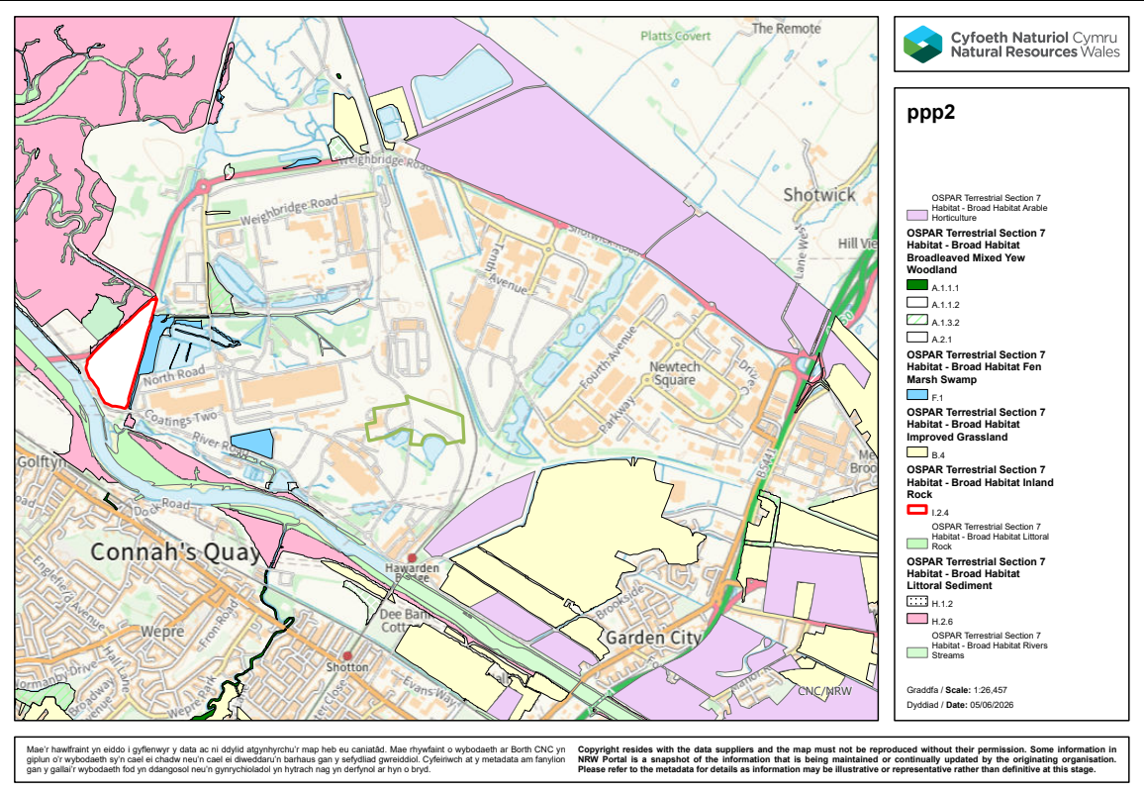
Section 7 Priority habitats
None in range.

