Record of a Habitats Regulations Assessment of a project or spatially-specific plan
OGN 200 Form 1B (with structured tables for likely significant effect screening and appropriate assessment)
Document owner: Head of Business for Natural Resource Management
Version History:
Document Version | Date Published | Summary of Changes
2.0 | 21/10/2024 | Following 2023/24 review of HRA OGNs
Next review date: October 2025

Record of a Habitats Regulations Assessment 3
1. Plan or Project Details 3
2. Determining the need for a Habitats Regulations Assessment 7
3. Considering the likelihood of a significant effect (LSE) 8
4. Appropriate assessment of the plan or project when considered alone 25
5. In combination assessment 28
6. Conclusion 34
7. Consultation with the ANCB and how sections 2, 3, 4 and 5 of this HRA report (as applicable) take into account that advice. 36
9. Appendix - Supporting information 37

OGN 200 Form 1B

Record of a Habitats Regulations Assessment
Plan or project name, brief description or application reference number | PAN-028641 Deeside Power (UK) Limited. Substantial variation application to the environmental permit for:  Deeside Power Station, Weighbridge Road, Deeside Industrial Park, Deeside, Flintshire, CH5 2UL.

HRA iteration/version | N/A

1. Plan or Project Details
Information about the plan or project
1 | Date application received | Duly made 21/02/2025
2 | Applicant details | Deeside Power (UK) Limited  PAN-028461 (NRW Public Register link – here)
3 | NRW team responsible for carrying out, or requiring to be carried out, the plan or project, and name of lead officer | Victoria Seller – Lead Specialist Permitting Officer, Installations and RSR Permitting Team
4 | Activity/ies proposed | This is an application to vary the environmental permit for the Deeside Power Station installation, held by Deeside Power (UK) Limited. A link to the permit documents is available on our Public Register, here.  The Installation is currently permitted to operate as a Combined Cycle Gas Turbine (CCGT) baseload power station with a net rated thermal input of 927MW and with no restrictions on operating hours. There are two CCGTs at the installation. However, these ceased operation as a fossil-fuel electricity generation activity in 2018 and have since been converted into synchronous compensators which do not burn any fuel and provide reactive power to the National Grid. The variation application seeks to remove the CCGT activity and associated controls from the permit. The converted CCGTs will remain in the permit, but will be added as Directly Associated Activities (DAAs) as they no longer involve the combustion of fossil fuels.  This variation application is to remove the CCGT activity and add 11no. natural gas-fired reciprocating engines to the permit. The purpose of the engines is to generate electricity for supply to the National Grid, and thus, going forward, the installation will operate as a peaking power plant.  The net rated thermal input of each engine is 9.91MW and the combined aggregated thermal input is 109MW. The engines will operate for an average of 1500 hours per year as a five-year rolling average, with a maximum of 2250 hours per year in any one of those five years. The engines will be used to generate electricity at times of increased power demand on, or reduced power supply to, the National Grid. Operation of the engines will result in the release of airborne oxides of nitrogen (NO_{x}) and the deposition of nutrient nitrogen and acid.  The change from a baseload power plant to a peaking power plant, with the associated significant drop in net rated thermal capacity and operating hours, represents a net benefit to protected sites within the the vicinity of the installation.  Given that the CCGTs ceased operation in 2018, it should be noted that they are therefore not included in the background NOx concentration data available in the 2020-22 APIS data.  The applicant has undertaken detailed and precautionary dispersion modelling of air emissions impacts, i.e. considering the highest/worst impact possible for a number of variables as explained in their submission. This includes modelling with 5 years of meteorological data, and considering the highest modelled impact from different modelling “runs”. The modelling has been subject to detailed auditing by NRW experts, who are satisfied that the predictions within the applicant’s submitted report are suitable for use in variation determination.  The CCGT activity includes an emergency diesel-fuelled back-up generator as a DAA. This generator has a net rated themal input of 1.035MW. It will remain in the permit after the grant of the variation. Given the infrequent expected operating regime of the generator and it’s small net rated thermal input, it has not been included in the dispersion modelling as emissions from it are expected to be negligible.  The generator has associated with it a tank for the purpose of storing diesel. Given that the generator is already included in the permit, we have assessed the risk associated with the storage of diesel in its tank, and are satisfied that the operator has appropriate management techniques in place to prevent uncontrolled release of fuel. We are also satisfied that appropriate controls are in the permit to take enforcement action against the operator if we find that these techniques have not been adequately implemented. We have therefore not addressed the uncontrolled release of diesel from this tank further in this HRA.  The new engines will require the storage of engine oil (clean and waste). The site will have two tanks for this purpose: one 10,000l tank to store new engine oil, and one 10,000l lank to store used engine oil, prior to off-site disposal.  The new engines will also generate intermittent noise.  This HRA therefore focusses on:  - the 11 point source emissions to air (associated with each of the 11 reciprocating engines) The pollutants to air comprise: oxides of nitrogen (NO_{x:} NO and NO₂ expressed as NO₂) from the natural gas-fired combustion plant;  - Intermittent noise associated with the operation of the engines; and  - Storage of clean and waste oil.
5 | Relevant legislation or statutory basis | Environmental Permitting (England and Wales) Regulations 2016, Industrial Emissions Directive 2010/75/EU
6 | Location | Deeside Power Station, Weighbridge Road, Deeside Industrial Park, Deeside, Flintshire, CH5 2UL. SJ 29750 71250.  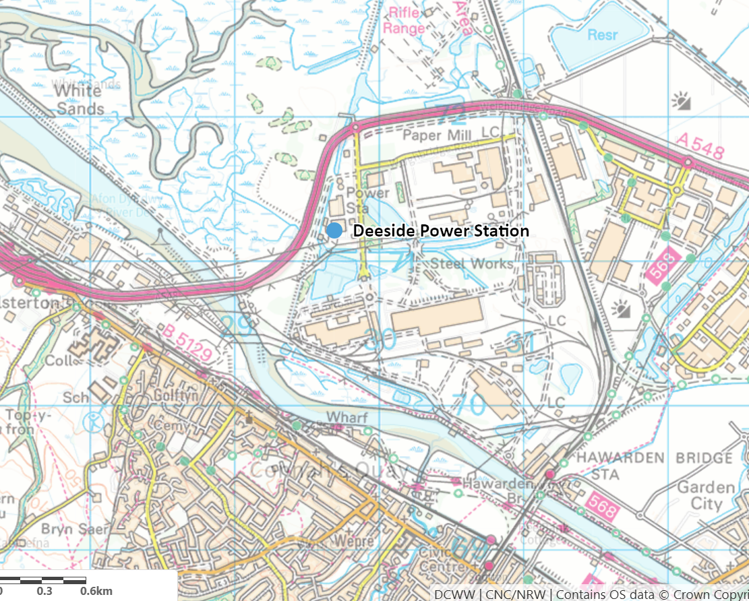
7 | Plan or project documents, including any application documents | Link to the application documents on Natural Resources Wales’ Public Register portal:  PAN-028461
8 | Environmental Statement | N/A
9 | Pre-application correspondence | Please see this DMS folder – ‘pre-application’ category (available only to NRW staff).
10 | NRW team responsible for preparing this HRA report, and lead officer | Victoria Seller, Lead Specialist Permitting Officer, Installations and RSR Permitting Team, Permitting Service, Natural Resources Wales, Welsh Government Offices, Cathays Park, King Edward VII Avenue, Cardiff, CF10 3NQ.
11 | Team or person responsible for approving the plan or project (competent authority role) | As row 10.

2. Determining the need for a Habitats Regulations Assessment
2.1 Is there any possibility that the plan or project could negatively affect any European sites? | No
2.2 Is the whole of the plan or project directly and only connected with or necessary to the management of one or more European sites, for the purposes of conserving the habitats or species for which the European site(s) is/are designated? | N/A
2.3 Is there a possibility that the plan or project could affect any other feature of the European site(s) concerned, or of another European site, in a way that would undermine that feature’s conservation objectives? | Yes

3. Considering the likelihood of a significant effect (LSE)

3.1 Renewal of a project authorisation on the same or more restrictive terms as an extant authorisation
Is this a renewal of an extant authorisation which complies with NRW approved criteria for ruling out significant effects of renewals (see Part 2 of OGN200) without conducting a project-specific LSE test? | No.

3.2 Likelihood of significant effects (LSE) test

3.2.1 Which European sites might be affected by the plan or project?
(a) | Based on the plan or project specification, or information provided in the application, it is considered that these European sites have features which could be negatively affected by the plan or project | Based on the information provided in the permit variation application, it is considered that the following European sites have features which could be affected by the project. The location of these sites (within the 10km screening distance) relative to the site search location point is shown on a map at the end of this document.  - Dee Estuary / Aber Dyfrydwy (Wales and England) (SAC / SPA / Ramsar) (UK0030131)  - River Dee and Bala Lake / Afon Dyfrdwy a Llyn Tegid (Wales) (SAC) (UK0030252)  - Deeside and Buckley Newt Sites (SAC) (UK0030132)  - Halkyn Mountain / Mynydd Helygain (SAC) (UK0030163)  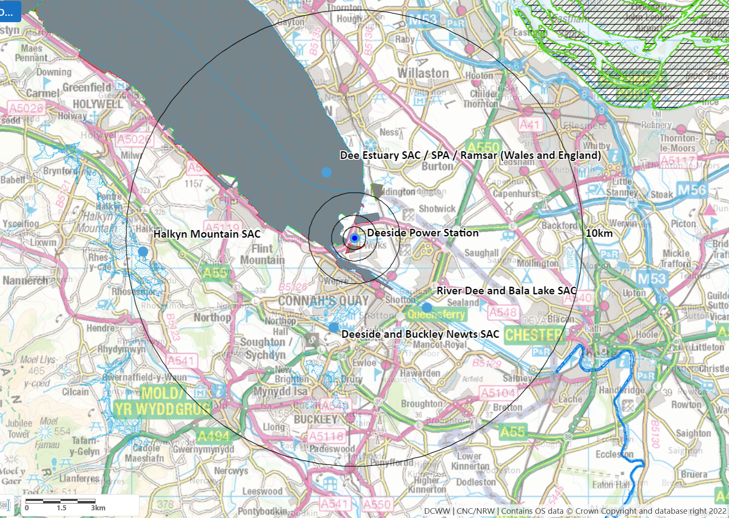
(b) | The potential for the plan or project to negatively affect these European sites was also initially considered, but can be ruled out without further consideration | N/A

3.2.2 Screening for likelihood of significant effect

Table 3.2.2 Screening assessment
Description of general approach to Likely Significant Effect (LSE) screening for air pollutants

The proposed change to the industrial facility only relates to aerial emissions: no changes to emissions to surface water or groundwater are associated with the variation application, and therefore no impact pathway exists via these mechanisms. There is also no impact from vibration. The engines used to generate electricity have the potential to generate noise, and therefore, a potential impact pathway exists. Noise is expected to minimal and, in the context of the surrounding industrial landscape, will have neglible impact on species within the above listed habitats sites.

The operation of the engines will require the storage of clean and waste oil. The applicant has completed a risk assessment for this activity which is based on CIRA c736 guidance, which is considered best practice. We have reviewed this assessment and are satisfied that the operator will have the appropriate techniques and management controls in place to manage the risk from uncontrolled release of clean and waste oil.

If granted, the variation will remove from the permit emissions to water points W2a, W2b and W3, which are currently permitted to discharge to the River Dee. These emission points were in place to discharge uncontaminated surface water (W2a and W2b) and cleaned cooling water and boiler blowdown water (W3). The only emission points to water will be surface water drainage from the site via the existing emission point W1. W1 previously discharged abstracted cooling water back to the River Dee, and had a number of associated monitoring and reporting requirements attached to it given its use in as process cooling water in the CCGT activity. If the variation is granted, W1 will only be used to divert clean, uncontaminated rainwater to the River Dee. Removal of emission point W3, and the monitoring and reporting requirements previously in place for W1, represents a net benefit to the River Dee and Bala Lake SAC.

The installation is currently permitted as a ‘baseload’ (i.e. continuously operating) natural gas power station, comprising two combined cycle natural gas turbines (CCGT), with a net rated thermal input capacity of 927MW. The operator wishes to change the operating profile to that of a ‘peaking plant’, which means that the site will be called upon to provide electicty to the National Grid during times of reduced supply and / or will result in an overall reduction of in flow and and mass release rate of pollutants to air from the stacks. Given that the new operating profile will utilise natural gas engines, the pollutant profile will remain the same – i.e., oxides of nitrogen (NO_{x}: NO and NO₂ expressed as NO₂) remains the only pollutant of concern.

The new operating profile will involve a substantially reduced aggregated net rated thermal input capacity of 109MW compared to the ‘baseload’ operating profile. The installation will also be permitted to operate for a maximum of 1500 hours per year as a five-year rolling average, with no more than 2250 hours per year in any one of those five years. This represents a substantial reduction in permitted operating hours compared to the ‘baseload’ operation.

The CCGTs ceased operation as a fossil-fuel electricity generation activity in 2018 and have since been converted into synchronous compensators which do not burn any fuel and provide reactive power to the National Grid. This means that the contribution from the site to the background concentration of NO_{x} is not reflected in the latest (2020-22) background concentration data available on APIS. We have taken this into account in our assessment and further explanation of the significance of this is given below.

The initial habitats air emissions screening assessment will focus on the point where emissions to air from the industrial source have the highest potential impact on a protected site/feature. Usually this is a point close to the source (point of maximum concentration) and/or the point where a protected feature is present that is most sensitive to impact (point of highest sensitivity). If during Likely Significant Effect (LSE) screening assessment it can be demonstrated that these maximum impacts are insignificant for the most impacted locations (highest pollutant concentration) and assuming highest receptor sensitivity, it is implicit that impact at more distant/less sensitive features is also insignificant, as detailed below in specific instances. Thus a site-wide screening approach, based on the most sensitive features, is the first step of screening assessment.

The assessment uses a standard approach described for air emissions impact on habitats sites, based on detailed dispersion modelling of pollutant releases. First, the Process Contribution (PC) is calculated, which is the maximum concentration of pollutant at a receptor, which is calculated could arise from the source after dilution and dispersion through the air. This is compared with the Environmental Standard (ES) for the pollutant in question, which are classified either as Critical Levels (CLe), or Critical Loads (CLo). The critical level is the maximum concentration (µg/m³) of a pollutant in ambient air which can be present before there is likelihood of the pollutant harming the protected site or its interested features, and are set on a precautionary basis. Critical levels are assigned for oxides of nitrogen (NO_{x}: NO and NO₂ expressed as NO₂). Critical loads are similar, but concern pollutants which are deposited from the air before potentially having a negative effect. These are stated as deposition rates, kg[pollutant]/hectare/year, and are set for total Nutrient nitrogen deposition (kgN/ha/yr – principally from NOx from this industrial source), and for gases which can cause acidification (Kg_{eq}/ha/yr) – again, principally from NO_{x} from this industrial source). Critical levels and loads may be applied broadly to most or all interest features of a protected site (e.g. NO₂), or set individually depending on feature sensitivity (e.g. nutrient nitrogen and acid deposition).

Permitting guidance is that if the PC is <1% of the ES (CLe or CLo) (annual average) and <10% of the ES (CLe) (daily average) at receptors then the emission is insignificant, and will not impact the receptor, and no LSE can be concluded. If not, then the Predicted Environmental Concentration (PEC) is considered. This is the expected concentration of the pollutant, taking into account existing “background” pollution and the proposed additional source. If the PEC is <70% of the ES, then no LSE can be concluded, as the level of pollution likely to cause harm to the site and/or its protected features is very unlikely to be reached.

Owing to being closest, downwind protected site and having some features highly sensitive to air pollutants, potential impacts are generally highest at the Dee Estuary SAC / SPA / Ramsar, so assessment will tend to be most detailed for this site, and for its most sensitive features. Other protected sites/features are less impacted and as stated in permitting guidance, “if it has been determined that emissions will not be significant at the most sensitive features, there is no requirement to consider more distant [and/or] less sensitive, nature conservation sites”.

If this site-wide screening, based on the maximum point impact of emissions and most sensitive feature in the whole designated site, cannot be used to conclude that emissions are insignificant, or that resultant predicted pollutant concentrations are well below critical levels/loads then “no likely significant effect” cannot simply be concluded. Then, appropriate assessment is used to determine, with further information on feature sensitivity and distribution, whether there may be an adverse effect on site integrity.

Description of pollutant dispersion modelling to calculate impact

The applicant has undertaken detailed and precautionary dispersion modelling of air emissions impacts, i.e. considering the highest/worst impact possible for a number of variables as explained in their submission. This includes modelling with 5 years of meteorological data, and considering the highest modelled impact from different modelling “runs”. The modelling has been subject to detailed auditing by NRW experts, who are satisfied that the predictions within the applicant’s submitted report are suitable for use in permit determination.

Using the criteria described above, if on a site wide basis and considering the most sensitive feature, PC is insignificant, or PEC calculation shows that CLe/CLo is unlikely to be breached, then no likely significant effect (LSE) is concluded.

If site wide no-LSE cannot be concluded, then further information is provided, ready to inform appropriate assessment

This screening procedure is in accordance with permitting guidance “AQTAG 21” (2025) for determining likely significant effect.

Feature specific sensitivities to air pollutants are summarised below. This is followed by results for individual pollutants below, grouped by pollutant and by feature-specific sensitivity (or group):
Designated site feature | Relevant conservation objectives |  | Screening conclusion – ‘SCREEN OUT’, ‘SCREEN IN’ or ‘IN COMB’ |  | Explanation
European site name: River Dee and Bala Lake (Wales) / Afon Dyfrdwy a Llyn Tegid (Wales) (SAC) (UK0030252) (0.9km to the west of the search point at the closest point of the SAC)
CORE MANAGEMENT PLAN INCLUDING CONSERVATION OBJECTIVES FOR RIVER DEE AND BALA LAKE/AFON DYFRDWY A LLYN
TEGID SAC Version: 10 - David Hatcher and Heather Garrett, Date: 13.3.08, Approved by: NR Thomas – 15th April 2008.

Air quality feature sensitivity matrix used to inform LSE test below
Interest Feature | NO_{x} as NO₂ (annual/daily CLe¹) | Nutrient Nitrogen lower CLo | Acid Deposition (Max CLo Max N)
H3260 Water courses of plain to montane levels with the Ranunculion fluitantis and Callitricho-Batrachion vegetation | 30/75 | 10 | Not sensitive
S1831 Luronium natans | 30/75 | 2 ² | Not sensitive
S1163 Cottus gobio | 30/75 | Not established | Not established
S1099 Lampetra fluviatilis | 30/75 | Not established | Not established
S1096 Lampetra planeri | 30/75 | Not established | Not established
S1355 Lutra lutra | 30/75 | Not established | Not established
S1095 Petromyzon marinus | 30/75 | Not established | Not established
S1106 Salmo salar | 30/75 | Not established | Not established
Most sensitive CLe/CLo and associated feature | 30/75 – Same for all features | 10 – this low level is considered protective at screening for other features for which a CLo has not been established | Sensitive but load not established – see LSE screening below

Notes:
- As stated on APIS, “These values are not habitat specific, as in critical loads, but have been set to cover broad vegetation types (e.g. forest arable, semi-natural), often with critical values set for sensitive lichens and bryophytes.” So, where APIS site critical load tool indicates a feature which is or contains vegetation (as indicated by annual NOx feature specific CLo), unless otherwise stated on APIS, all other critical levels for the protection of vegetation are also applied. Where the applicable CLo varies depending on vegetation type, unless otherwise indicated by APIS or advice from protected sites advisors, it is assumed that the lowest (most protective) CLo applies to the feature. This includes use of the NO2 24-hour average of 75 µg/m³, without consideration of O₃ and SO₂ levels, and therefore whether the less onerous level of 200 µg/m³ could be applied.
- Luronium natans is only present in management units in and directly adjacent to Bala Lake. Given the distance between this area of the SAC and the installation, we have adopted the next most stringent CLo in this assessment.

European site name: Dee Estuary / Aber Dyfrydwy (Wales and England) (SAC) (UK0030131) (182m to the west of the search point at the closest point of the SAC)

The Dee Estuary European Marine Site comprising: Dee Estuary / Aber Dyfrdwy Special Area of Conservation The Dee Estuary Special Protection Area The Dee Estuary Ramsar Site. January 2010.

Air quality feature sensitivity matrix used to inform LSE test below
Interest Feature | NO_{X} as NO₂ (annual/daily CLe¹) | Nutrient Nitrogen lower CLo | Acid Deposition (Max CL Max N)
H1330 Atlantic salt meadows (Glauco-Puccinellietalia maritimae) | 30/75 | 10 ³ | Not sensitive
H2110 Embryonic shifting dunes | 30/75 | 10 | Not sensitive
H1130 Estuaries | 30/75 | 10 | Not sensitive
H2130 Fixed coastal dunes with herbaceous vegetation (“grey dunes) acid type for N and acid CLo | 30/75 | 5 | 5.071
H2190 Humid Dune Slacks acid type for N and acid CLo | 30/75 | 5 | 5.071
H1140 Mudflats and sandflats not covered by seawater at low tide | 30/75 | 10 | Not sensitive
H1310 Salicornia and other annuals colonising mud and sand | 30/75 | 20 | Not sensitive
H2120 Shifting dunes along the shoreline with Ammophila arenaria ("white dunes") | 30/75 | 10 | Not sensitive
H1230 Vegetated sea cliffs of the Atlantic and Baltic coasts | 30/75 | Not established ² | Not sensitive
S1395 Petalophyllum ralfsii | 30/75 | 5 | Not sensitive
S1099 Lampetra fluviatilis | 30/75 | Not established ² | Not sensitive
S1095 Petromyzon marinus | 30/75 | Not established ² | Not sensitive
H1210 Annual vegetation of drift lines | 30/75 ⁶ | None – not sensitive | Not sensitive
Most sensitive CLe/CLo and associated feature | 30/75 – Same for all features | 5 | 5.071

Notes:
- As above for River Dee and Bala Lake SAC.
- For various features, APIS indicates a sensitivity to a given pollutant, but states that a CLe/o has not been established. This does not affect screening assessment, which is on the basis of the most sensitive feature, and is discussed further below where necessary.
- In line with Bobbink (2022), we have used a CLo of 10 kgN/ha/yr for Atlantic upper-mid and mid-low saltmarsh, and 20 kgN/ha/yr for pioneer saltmarsh. Unless otherwise specified, 10 kgN/ha/yr has been used in this assessment as a conservative approach.

European site name: Dee Estuary / Aber Dyfrydwy (Wales and England) (SPA) (182m to the west of the search point at the closest point of the SPA)

The Dee Estuary European Marine Site comprising: Dee Estuary / Aber Dyfrdwy Special Area of Conservation The Dee Estuary Special Protection Area The Dee Estuary Ramsar Site. January 2010.

Interest Feature(s) | Summary of air quality sensitivities and CLe/CLo applied – used to inform LSE test below
A195 Sterna albifrons (Eastern Atlantic - breeding),  A193 Sterna hirundo (Northern/Eastern Europe - breeding),  A191 Sterna sandvicensis (Western Europe/Western Africa) | Nutrient N CLo of 5 kgN/ha/yr applied for acid grasslands on coastal dunes - for the protection of the species via potential impacts on its broad habitat. This is the same CLo as most protective applied above for the habitat features of the SAC so does not affect the process of screening assessment.  APIS also lists a N CLo of 10 kgN/ha/yr for calcerous grassland/dunes, shifting coastal dunes, also as listed above, but again has no impact on the screening assessment carried out using the lower protective CLo of 5 kgN/ha/yr on a site-wide basis.  The CLe for NOx (30/75 µg/m³) as explained above are applied for protection of the species via potential effects on their habitats. Sensitivity is indicated on APIS. Nevertheless NRW Permitting screening LSE assessment is conducted on the basis of possible effect, using the standard CLe above for the protection of vegetation upon which the species may be dependent.
Features above, A195, A193, A191 plus  A160 Numenius arquata (Europe - breeding) | Acid CLo (MaxCl MaxN) of 5.071 kg_{eq}/ha/yr applied for acid grassland for the protection of the species via potential impacts on its broad habitat (i.e. acid grassland). This is the same CLo as most protective applied above for the habitat features of the SAC so does not affect screening assessment.
A054 Anas acuta (North-western Europe),  A052 Anas crecca (North-western Europe),  A143 Calidris canutus (North-eastern Canada/Greenland/Iceland/North-western Europe),  A130 Haematopus ostralegus (Europe & Northern/Western Africa), A157 Limosa lapponica (Western Palearctic - wintering), Limosa limosa islandica (Iceland - breeding)  A616 Limosa limosa islandica (Iceland - breeding)  A141 Pluvialis squatarola (Eastern Atlantic - wintering)  A048 Tadorna tadorna (North-western Europe)  A162 Tringa totanus (Eastern Atlantic - wintering) | Nutrient N CLo of 10 kgN/ha/yr applied for saltmarshes - for the protection of the species via potential impacts on its broad habitat and/or food supply. This is the same CLo as applied above for the habitat features of the SAC (H1330) so does not affect the process of screening assessment.  No acid deposition sensitivity is indicated, conforming with the information for H1330.  The CLe for NOX (30/75 µg/m³) as explained above are applied for protection of the species via potential effects on their habitats. Sensitivity is indicated on APIS. Nevertheless NRW Permitting screening LSE assessment is conducted on the basis of possible effect, using the standard CLe above for the protection of vegetation upon which the species may be dependent.
A160 Numenius arquata (Europe - breeding) | Nutrient N CLo of 20 kgN/ha/yr applied for Hay meadows - for the protection of the species via potential impacts on its broad habitat. This is the same or higher than CLos applied above for the habitat features of the SAC so does not affect the process of screening assessment.  No acid deposition sensitivity is indicated.  The CLe for NOx (30/75 µg/m³) as explained above are applied for protection of the species via potential effects on their habitats. Sensitivity is indicated on APIS. Nevertheless NRW Permitting screening LSE assessment is conducted on the basis of possible effect, using the standard CLe above for the protection of vegetation upon which the species may be dependent.
A054 Anas acuta (North-western Europe),  A052 Anas crecca (North-western Europe),  A193 Sterna hirundo (Northern/Eastern Europe - breeding), | In addition to the standard CLe applied to all habitats features and described above, APIS indicates a sensitivity for these SPA features to N deposition, but with no critical load established. Acid sensitivity is not identified.  Given the information for the SAC above, this is assumed to correspond to one or more of features H1230 Annual vegetation of drift lines, H1230 Vegetated sea cliffs of the Atlantic and Baltic coasts and H1140 Mudflats and sandflats not covered by seawater at low tide. Given incomplete information, it is therefore protective to screen on the basis of most protective CLe for the entire protected site, of 5 kgN/ha/yr, pending further analysis below. This is done on the basis of the SAC features and their sensitivity, not the SPA features, as their sensitivity is entirely via the dependence on the SAC features.
Dunlin, Calidris alpina (reference number not known) | In compiling this HRA, it is noted that APIS does not identify this interest feature of the SPA. The Dee Estuary European Marine Site Management Plan (January 2010) identifies that this species is dependent on the supporting habitats Estuary Channels, Intertidal mudflats and sandflats, saltmarsh, shingle banks and rocky shores.  Therefore application of the most sensitive screening CLe/CLo identified above ensures protection of this feature, based on any potentially supporting habitat. This demonstrates the importance of protective site-wide screening before feature sensitivity is considered in detail via appropriate assessment as APIS screening information may be imperfect – if site wide screening were not done, this feature may have been overlooked altogether.
 | 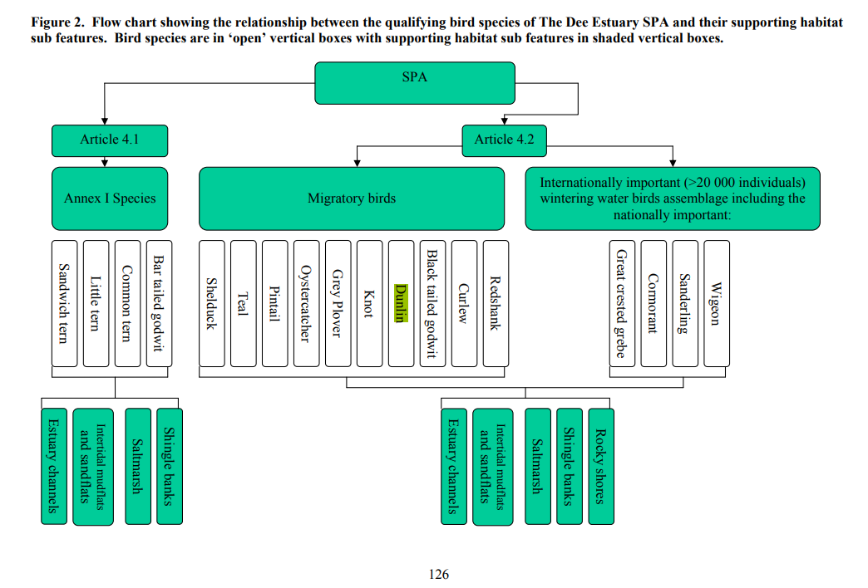

European site name: Dee Estuary / Aber Dyfrydwy (Wales and England) (RAMSAR) (182m to the west of the search point at the closest point of the SPA)
The Dee Estuary European Marine Site comprising: Dee Estuary / Aber Dyfrdwy Special Area of Conservation The Dee Estuary Special Protection Area The Dee Estuary Ramsar Site. January 2010.

Interest Feature(s) | Summary of air quality sensitivities and CLe/CLo applied – used to inform LSE test below
Habitats features H1130, 1140, 1210, 1230, 1310, 1330, 2110, 2120, 2130, 2190 | The habitats features of the Ramsar are all identified and protected under the SAC designation and are considered above. The CLe/CLo applied above are protective of the Ramsar
Waterbird features  Redshank Tringa tetanus  Shelduck Tadorna tadorna  Teal Anas crecca  Pintail Anas acuta  Oystercatcher Haematopus ostralegus  Grey Plover Pluvialis squatarola  Knot Calidris canutus islandica  Black-tailed Godwit Limosa limosa  Bar-tailed Godwit Limosa lapponica  Curlew Numenius arquata  Redshank Tringa totanus  Also  Dunlin Calidris alpina | The waterbird features of the Ramsar are all identified and protected under the SAC designation and are considered above. The CLe/CLo applied above are protective of the Ramsar.  Note the comments above on Dunlin – APIS information is incomplete and a protective screening approach is adopted.

European site name: Halkyn Mountain / Mynydd Helygain (SAC) (UK0030163) (8.1km to the west of the search point at the closest point of the SAC)
CORE MANAGEMENT PLAN INCLUDING CONSERVATION OBJECTIVES FOR MYNYDD HELYGAIN / HALKYN MOUNTAIN SPECIAL AREA OF CONSERVATION SAC EU Code: UK0030163 Version: Final Date: March 2008 (Minor map edit, February 2013) Approved by: Tim Jones, 12th March 2008

Air quality feature sensitivity matrix used to inform LSE test below
Interest Feature | NO_{x} as NO₂ (annual/daily CLe¹) | Nutrient Nitrogen lower CLo | Acid Deposition (Max CLo Max N)
H6130 Calaminarian grasslands of the Violetalia calaminariae | 30/75 | 6 | 5.071
H4030 European dry heaths | 30/75 | 5 | 5.207
H6410 Molinia meadows on calcareous, peaty or clayey-silt-laden soils (Molinion caeruleae) | 30/75 | 15 | Not established
H6210 Semi-natural dry grasslands and scrubland facies on calcareous substrates (Festuco-Brometalia) (* important orchid sites) | 30/75 | 10 | 5.071
S1166 Triturus cristatus | 30/75 | Not established – based on habitat sensitivity | Not established – based on habitat sensitivity
Most sensitive CLe/CLo and associated feature | 30/75 – Same for all features | 5 – this low level is considered protective at screening for other feature for which a CLo has not been established | 5.071 – this low level is considered protective at screening for other feature for which a CLo has not been
Notes:
- As above for River Dee and Bala Lake SAC.

European site name: Deeside and Buckley Newt Sites (SAC) (UK0030132) (2.54km to the south of the search point at the closest point of the SAC)
CORE MANAGEMENT PLAN INCLUDING CONSERVATION OBJECTIVES FOR Deeside and Buckley Newt Sites Special Area of Conservation (SAC) SAC EU Code UK0030132 Version: 1 Date: 7 February 2008 (Minor map edit, February 2013) Approved by: Tim Jones

Air quality feature sensitivity matrix used to inform LSE test below
Interest Feature | NO_{x} as NO₂ (annual/daily CLe¹) | Nutrient Nitrogen lower CLo | Acid Deposition (Max Cl Max N)
H91A0 Old sessile oak woods with ilex and Blechnum in the British Isles | 30/75 | 10 | 2.999
S1166 Triturus cristatus | 30/75 ⁷ | Not established | Not established
Most sensitive CLe/CLo and associated feature | 30/75 – Same for all features | 10 – this low level is considered protective at screening for other feature for which a Clo has not been established | 2.999 – this low level is considered protective at screening for other feature for which a Clo has not been

LSE assessment – based on sensitivities detailed above
All designated features of all protected sites identified above |  | All conservation objectives / hazard impacts other than those arising from air emissions and related air quality levels/loads detailed below |  | There is no impact pathway for any other listed hazard arising from the variation, i.e. habitat loss, physical damage, entrapment, smothering.  As there is no change to permitted operations, there is nothing to assess, no impact pathway, other than airborne pollutants, which are detailed below.  ‘SCREEN OUT’
Dee Estuary / Aber Dyfrydwy (Wales and England) (SPA) |  | Conservation objectives related to disturbance of birds |  | Disturbance (noise)  The site is an existing, permitted installation, which is currently permitted to carry on combustion of natural gas in gas turbines. The associated risk from noise on the species located in the Dee Estuary SPA has therefore been assessed and deemed to be of significantly low impact for the installation to operate. The operator has an existing noise management plan, which details the measures they must take to control the impact of noise arising from the installation. This forms part of the permit and is therefore legally enforceable.  The new operation will be similar in make-up in that it also involves the combustion of natural gas to generate electricity. If permission is granted for the new activity, the impact from noise will be significantly reduced given that the permitted annual operating hours will reduce to 1500 per year from 8760 per year. The reduced operating annual operating hours of the installation therefore represents a net benefit in terms of noise to the habitat.  The installation is located in a heavily industrialised are, and therefore the soundscape in its vicinity is made up of a variety of industrial noise sources. It is highly likely that birds inhabiting the SPA have become acclimitised to these sounds over time.  As the impact pathway remains, at worst, unchanged, and at best, a net benefit, we conclude no likely significant effect from disturbance to the Dee Estuary SPA.  ‘SCREEN OUT’
River Dee and Bala Lake (Wales) / Afon Dyfrdwy a Llyn Tegid (Wales) SAC |  | All conservation objectives / hazard impacts other than those arising from air emissions and related air quality levels/loads detailed below |  | Changes to water characteristics (flow, turbidity, level, velocity, temperature, flooding, acidification [other than acid deposition from air – see below] etc).  The operation of the engines will require the storage of clean and waste oil. The applicant has completed a risk assessment for this activity which is based on CIRA c736 guidance, which is considered best practice. We have reviewed this assessment and are satisfied that the operator will have the appropriate techniques and management controls in place to manage the risk from uncontrolled release of clean and waste oil. Conditions compelling the operator to control and manage the storage of potentially polluting liquids are already in place in the permit; these conditions will remain in any varied permit granted. The operator will update their Environmental Management System to include procedures for the management and control of the storage of potentially polluting liquids.  If granted, the variation will remove from the permit emissions to water points W2a, W2b and W3, which are currently permitted to discharge to the River Dee. These emission points were in place to discharge uncontaminated surface water (W2a and W2b) and cleaned cooling water and boiler blowdown water (W3). The only emission points to water will be surface water drainage from the site via the existing emission point W1. W1 previously discharged abstracted cooling water back to the River Dee, and had a number of associated monitoring and reporting requirements attached to it given its use in as process cooling water in the CCGT activity. If the variation is granted, W1 will only be used to divert clean, uncontaminated rainwater to the River Dee. Removal of emission point W3, and the monitoring and reporting requirements previously in place for W1, represents a net benefit to the River Dee and Bala Lake SAC.  As the removal of the monitoring and reporting requirements attached to emission points to water W1, and complete removal W3 represents a net benefit to the SAC and we are satisfied that the operator will have the appropriate controls in place to prevent the uncontrolled release of stored oil, we conclude no likely significant effect from changes to water characteristics of the River Dee and Bala Lake SAC.  ‘SCREEN OUT’
All interest features – all are either directly subject to this CLe, either directly (vegetation) or to ensure protection of supporting habitat, food source etc (species) either explicitly or implicitly in citation records |  | NO_{x} as NO₂ – annual critical level (CLe) of 30 µg/m³ |  | Emissions to air of NOx  For all sites, likely significant effects from the proposed peaking plant can be ruled out upon first screening as the PC is less than the screening threshold of 1% of the long-term CLe. The emission is insignificant at receptors and there is no LSE.  This is with the exception of five locations within the Dee Estuary SAC / SPA / Ramsar:  - Receptor E18: PC 0.34 µg/m³ (1.1%)  - Receptor E19: PC 0.46 µg/m³ (1.5%)  - Receptor E20: PC 0.85 µg/m³ (2.8%)  - Receptor E25: PC 0.54 µg/m³ (3.6%)  - Receptor E26: PC 0.43 µg/m³ (1.4%)  Significant effects cannot be ruled out.  ‘SCREEN IN’
All interest features – all are either directly subject to this CLe, either directly (vegetation) or to ensure protection of supporting habitat, food source etc (species) either explicitly or implicitly in citation records |  | NOx as NO2 – 24-hour CLe of 75 µg/m3 |  | For all sites, likely significant effects from the proposed peaking plant can be ruled out upon first screening as the PC is less than the screening threshold of 10% of the short-term CLe. The emission is insignificant at receptors and there is no LSE.  This is with the exception of two locations within the Dee Estuary SAC / SPA / Ramsar:  - Receptor E18: PC 9.77 µg/m³ (13%)  - Receptor E20: PC 7.71 µg/m³ (10.3%)  Significant effects cannot be ruled out.  ‘SCREEN IN’
All interest features – for each designated site, we have used the most conservative of the range of CLos in our assessment. This is with the exception of River Dee and Bala Lake SAC, where we have not used a CLo of 2 kgN/ha/yr (for Luronium natans). Luronium natans is only present in management units in and directly adjacent to Bala Lake. Given the distance between this area of the SAC and the installation, we have adopted the next most stringent CLo in this assessment – 10 kgN/ha/yr. |  | Nutrient nitrogen deposition – with feature-specific minimum critical loads screened at the lowest available CLos for each site.  For features where the CLo is “not established” the LSE test is completed assuming the highest N sensitivity for the site (with the exception of River Dee and Bala Lake – see left), and taken to appropriate assessment for further consideration.  (LSE screening for the whole site irrespective of feature distribution) |  | For all sites, likely significant effects from the proposed peaking plant can be ruled out upon first screening as the PC is less than the screening threshold of 1% of the long-term CLe. The emission is insignificant at receptors and there is no LSE.  This is with the exception of one location within the Dee Estuary SAC / SPA / Ramsar:  - Receptor E20: PC 0.12 kgN/ha/yr (1.2%)  Significant effects cannot be ruled out.  ‘SCREEN IN’
All interest features – for each designated site, we have used the most conservative of the range of CLos in our assessment. |  | Acid deposition – with feature-specific minimum critical loads screened at the lowest available CLos for each site.  For features where the CLo is “not established” the LSE test is completed assuming the highest N sensitivity for the site.  (LSE screening for the whole site irrespective of feature distribution) |  | For all sites, likely significant effects from the proposed peaking plant can be ruled out upon first screening as the PC is less than the screening threshold of 1% of the long-term CLe. The emission is insignificant at receptors and there is no LSE.  ‘IN COMB’

TABLE 3.2.3 Screening decision of the plan or project ‘alone’
(a) If the screening conclusion for all features for all sites in Table 3.2.2 is ‘SCREEN OUT’ | The plan or project is not likely to have a significant effect on any European site, and no further consideration under the Habitats Regulations is required in order to determine the approval/application.  Strike out rows (b) and (c) below, delete sections 4 and 5 and complete section 6 (and sections 7 and 8 if applicable).
(b) If the conclusion for any features in Table 3.2.2 is ‘SCREEN IN’ | The plan or project is likely to have a significant effect on one or more European sites and therefore an appropriate assessment is required.
(c) If there are no features in Table 3.2.2 that are ‘SCREEN IN’ and any features that are ‘IN COMB’ | The plan or project is not likely to have a significant effect on any European sites when considered alone, but the possibility of significant effects in combination with other plans and projects needs to be considered.  Strike out rows (a) and (b) above, delete section 4 and go to Section 5.

4. Appropriate assessment of the plan or project when considered alone

4.1 Assessment of plan or project as defined

Table 4.1 Appropriate assessment
European site feature/s | Description of impacts | Assessment in view of conservation objectives | Can adverse effect on site integrity be ruled out? ‘YES’ or ‘NO’
European site name: Dee Estuary / Aber Dyfrdwy (England and Wales) SAC / SPA / RAMSAR (UK0030131, 9013011, 11082)
All features | NOx daily CLe doesn’t screen out. | Two PCs are predicted to be >10% of the CLe.  The background concentration of NO_{x}, given on the APIS website (2020-22 data), is 10.8 µg/m³.  Receptor E18  The Predicted Environmental Concentration (PEC) is therefore 31.4 µg/m³, which is 42% of the CLe.  Receptor E20  The Predicted Environmental Concentration (PEC) is therefore 29.3 µg/m³, which is 39% of the CLe.  It should be noted that an assumption of 100% capacity operating for a continual period of 24-hours is an unlikely operating scernario.  As the PEC equates to <70% of the annual mean CLe, we are satisfied that the predicted releases screen out at the second stage of the screening criteria and it can be considered that no adverse effect on site integrity will be caused. | YES
All features | NOx annual CLe doesn’t screen out. | Five PCs are predicted to be >1% of the CLe.  The background concentration of NOx, given on the APIS website (2020-22 data), is 10.8 µg/m³.  Receptor E18  The Predicted Environmental Concentration (PEC) is therefore 11.4 µg/m³, which is 37% of the CLe.  Receptor E19  The Predicted Environmental Concentration (PEC) is therefore 11.3 µg/m³, which is 38% of the CLe.  Receptor E20  The Predicted Environmental Concentration (PEC) is therefore 11.7 µg/m³, which is 39% of the CLe.  Receptor E25  The Predicted Environmental Concentration (PEC) is therefore 11.3 µg/m³, which is 38% of the CLe.  Receptor E26  The Predicted Environmental Concentration (PEC) is therefore 11.2 µg/m³, which is 37% of the CLe.  As this equates to <70% of the annual mean CLe, we are satisfied that the predicted releases screen out at the second stage of the screening criteria and it can be considered that no adverse effect on site integrity will be caused. | YES
All features | Nutrient nitrogen deposition doesn’t screen out | One PC is predicted to be >1% of the CLo.  The background concentration of nutrient nitrogen deposition, given on the APIS website (2020-22 data), is 16.8 kgN/ha/yr.  Receptor E20  The Predicted Environmental Concentration (PEC) is therefore 16.42 µg/m³, which is 164% of the CLo.  The calculation of the PEC is based on an annual background concentration for nitrogen deposition of, which is taken from the APIS dataset for ‘moorland (short vegetation)’. We consider this background concentration to be appropriate for use in this assessment.  Although the PEC is >70% of the relevant CLo, this should be viewed in the context of temporal trends in background nitrogen deposition concentration in the region.  Graph 1 in Section 9 shows rate of nutrient nitrogen deposition at the Estuary since 2005 (the full time period over which such records are available). The orange line shows the background nitrogen deposition concentration over time for short vegetation.  Background nitrogen deposition has been above the CLo of 10 kgN/ha/yr since “records began”. There was a recent increase over the last decade which now seems to have retraced. Nutrient nitrogen deposition is reducing in the short-term, but a long-term view shows levels relatively stable over the period.  Receptor E20 is located in this section of the SAC / SPA / Ramsar:  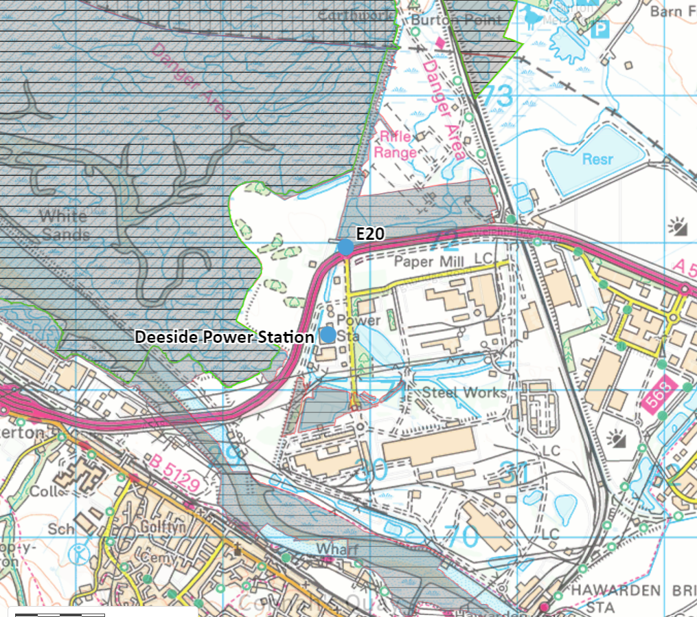  Maps 1 and 2 in Section 9 below show the spatial distribution of plant species in this section of the Dee Estuary in more detail.  The area is characterised by Mesotrophic grassland, Communities of salt-marsh, Swamps and tall-herb fens, and some open land and woodland habitats. This distribution of species indicates that the area is typical of a transitional community between saltmarsh habitat and terrestrial habitat. The presence of transitional community here suggests that, although the background nutrient nitrogen deposition rates are higher than the relevant CLo for upper-mid and mid-low Atlantic Saltmarsh, the habitat is not being adversely impacted by this to a significant degree.  Map 2 shows that the point of maximum impact in this section of the Estuary is located in an area of Mesotrophic grassland – NVC code MG1. This NVC code is not included in any of the Annex I features for which the Dee Estuary SAC is designated.  Given that:  - changes to the installation mean that the overall mass concentration of NOx emitted will be greatly reduced (given the change from ‘baseload’ to ‘peaking’ operation);  - the background nitrogen deposition, although high, is stable, and has remained unchanged for some time;  - The other PCs modelled for Dee Estuary SAC / SPA / Ramsar have shown no exceedance of the significance threshold for assessment of impact from nutrient nitrogen deposition;  - Species distribution indicates the presence of transitional habitat, which suggests that significant adverse impact from existing nutrient nitrogen deposition is unlikely; and  - The point of maximum impact in this section of the Estuary is located in an area of Mesotrophic grassland (NVC code MG1) which does not form part of any of the Annex I features for which the Dee Estuary SAC is designated.  We therefore conclude that no adverse effect on site integrity will be caused.

4.3 Concluding the appropriate assessment of the plan or project alone
Table 4.3 Conclusion of the appropriate assessment alone
(a) If Table 4.1, or the right hand column of Table 4.2 if applicable, is ‘YES’ for all features | It has been ascertained that the plan or project, when considered alone, will not adversely affect the integrity of any European sites.
(b) If there are any ‘NO’s in the right hand column of Table 4.2 | It has not been ascertained that the plan or project, when considered alone, will not adversely affect the integrity of one or more European sites.  Strike out row (a) above and row (c) below, delete section 5 and complete sections 6 and 7, and section 8 if applicable
(c) Are there are any residual effects of the plan or project (net of mitigation measures) which, though not adverse on their own, could be significant when considered in combination with the effects of other plans or projects? | YES

5. In combination assessment
Table 5.1 Identification and assessment of in combination effects
European site name: Dee Estuary / Aber Dyfrdwy (England and Wales) SAC / SPA / RAMSAR (UK0030131, 9013011, 11082), River Dee and Bala Lake SAC (

‘INCOMB’ impacts from screening Table 3.2.2 and/or residual effect from appropriate assessment in section 4 | European site feature(s) concerned | Other plans or projects with effects that might interact with the effects of the plan or project to render its effects significant/adverse (if any) | Nature of the in combination effect (if any) and assessment in view of conservation objectives | Can significant or adverse in combination effects be ruled out for all features?
Daily NOx CLe | All | Not considered further due to the intermitted nature of the operating profile, which makes in combination assessment impossible.
Annual NOx CLe | All | Industrie Cartarie Tronchetti UK Limited - emissions related to this application for Phases 1 and 2 of the development only. (The site has not yet been constructed and so emissions are not considered to form part of the background concentration.);  Castle Cement Limited – emissions related to this application to add a carbon capture plant to the permit only. (The carbon capture plant has not yet been constructed and so emissions are not considered to form part of the background concentration.);  Shotton Mill Limited – emissions related to the entire upgrade of the site;  Deeside SPV Limited – emissions related to this application for a new anaerobic digestion plant permit;  Enfinium Parc Adfer Operations Limited – emissions related to this application to add a carbon capture plant to the permit only.  Uniper UK Limited - Connah’s Quay Low Carbon Power Project; and  Knauf Insulation Limited – new mineral fibres production facility with submerged arc furnace. | The applicant submitted an addendum report to the original AQIA to assess the impacts of proposed changes to the installation in combination with the other plans and projects – listed left. The addendum report is available on our Public Register, here.  Of the sites listed left, the applicant was able to obtain air quality impact assessments for the following plans/projects:  - Industrie Cartarie Tronchetti UK Limited Castle Cement Limited  - Shotton Mill Limited  - Deeside SPV Limited  - Uniper UK Limited ; and  - Enfinium Parc Adfer Operations Limited.  Of these, they discounted Shotton Mill Limited, due to the unavailability of assessment of impact on habitats sites, and Deeside SPV Limited, due to the unavailability of dispersion modelling data. The applicant was unable to locate an AQIA for Knauf Insulation Limited.  The applicant overlaid the PCs from each report in GIS to determine spatial distribution. Where PCs for the other sites fell within a 200m radius of the Deeside Power Station PCs, the PCs were added together to create a ‘cumulative PC.’  This buffer distance was selected to capture relevant cumulative impacts from other sites in close spatial proximity to each other and maintain a consistent precautionary approach. For receptors scoped outside the 200 m buffer and within 2 km of Deeside, ‘gridded’ annual NOx results were used with the receptor location and combined.  This exercise was completed for all ecological receptors and the associated PCs for annual NO_{x}, nutrient nitogen and acid deposition. Daily NO_{x} was discounted due to the intermitted nature of the operating profile, making in combination assessment impossible.  A summary of those cumulative PCs that exceeded the screening threshold of 1% is given below.  Dee Estuary / Aber Dfyrdwy SAC / SPA / RAMSAR receptors  Receptor E18  The cumulative PC is 0.44 µg/m³ (1.5%). The cumulative PEC is 8.94 µg/m³ (29.8%).  Gridded receptor 2  The cumulative PC is 0.78 µg/m³ (2.6%). The cumulative PEC is 11.32 µg/m³ (37.7%).  River Dee and Bala Lake (Wales) / Afon Dyfrdwy a Llyn Tegid (Wales) (SAC) receptors  Receptor E2  The cumulative PC is 0.38 µg/m³ (1.3%). The cumulative PEC is 13.5 µg/m³ (45%).  As this equates to <70% of the annual mean CLe, we are satisfied that the predicted releases screen out at the second stage of the screening criteria.  Gridded receptor 2 and Receptor E2 use PCs from the Enfinium Parc Adfer Operations Limted AQIA.  When considering the PCs from this AQIA, it appears that the applicant used the incorrect set, which has overestimated the contributions from this project.  The Enfinium Parc Adfer Operations Limited AQIA presents results in three formats:  - PCs associated with the (already) permitted facility;  - PCs associated with the carbon capture plant operational; and  - PCs as the difference between the two.  The applicant’s calculation of the cumulative PCs uses set of results 1., which means that, as the Energy from Waste installation is already operational, the contributions from it are effectively counted twice. This represents an overestimation of the contribution from the proposed carbon capture plant.  Reculating the above results with using set of results 2. gives the following:  Dee Estuary / Aber Dfyrdwy SAC / SPA / RAMSAR receptors  Gridded receptor 2  The cumulative PC is 0.43 µg/m³ (1.4%). The cumulative PEC is 10.97 µg/m³ (37%).  River Dee and Bala Lake (Wales) / Afon Dyfrdwy a Llyn Tegid (Wales) (SAC) receptors  Receptor E2  The cumulative PC is 0.25 µg/m³ (0.83%).  Consequently, it can be considered that no adverse effect on site integrity will be caused. | YES
Nutrient nitrogen deposition CLo | All | Industrie Cartarie Tronchetti UK Limited - emissions related to this application for Phases 1 and 2 of the development only. (The site has not yet been constructed and so emissions are not considered to form part of the background concentration.);  Castle Cement Limited – emissions related to this application to add a carbon capture plant to the permit only. (The carbon capture plant has not yet been constructed and so emissions are not considered to form part of the background concentration.);  Shotton Mill Limited – emissions related to the entire upgrade of the site;  Deeside SPV Limited – emissions related to this application for a new anaerobic digestion plant permit;  Enfinium Parc Adfer Operations Limited – emissions related to this application to add a carbon capture plant to the permit only.  Uniper UK Limited - Connah’s Quay Low Carbon Power Project; and  Knauf Insulation Limited – new mineral fibres production facility with submerged arc furnace. | The applicant submitted an addendum report to the original AQIA to assess the impacts of proposed changes to the installation in combination with the other plans and projects – listed left. The addendum report is available on our Public Register, here.  Of the sites listed left, the applicant was able to obtain air quality impact assessments for the following plans/projects:  - Industrie Cartarie Tronchetti UK Limited Castle Cement Limited  - Shotton Mill Limited  - Deeside SPV Limited  - Uniper UK Limited ; and  - Enfinium Parc Adfer Operations Limited.  Of these, they discounted Shotton Mill Limited, due to the unavailability of assessment of impact on habitats sites, and Deeside SPV Limited, due to the unavailability of dispersion modelling data. The applicant was unable to locate an AQIA for Knauf Insulation Limited.  The applicant overlaid the PCs from each report in GIS to determine spatial distribution. Where PCs for the other sites fell within a 200m radius of the Deeside Power Station PCs, the PCs were added together to create a ‘cumulative PC.’  This buffer distance was selected to capture relevant cumulative impacts from other sites in close spatial proximity to each other and maintain a consistent precautionary approach. For receptors scoped outside the 200 m buffer and within 2 km of Deeside, ‘gridded’ annual NO_{x} results were used with the receptor location and combined.  This exercise was completed for all ecological receptors and the associated PCs for annual NO_{x}, nutrient nitogen and acid deposition. Daily NO_{x} was discounted due to the intermitted nature of the operating profile, making in combination assessment impossible.  A summary of those cumulative PCs that exceeded the screening threshold of 1% is given below.  Dee Estuary / Aber Dfyrdwy SAC / SPA / RAMSAR receptors  Gridded receptor 2  The cumulative PC is 0.11 kgN/ha/yr (1.13%). The cumulative PEC is 17.31 kgN/ha/yr (173%).  The cumulative PEC uses data on background nutrient nitrogen concentration taken from APIS. The background dataset used is ‘moorland’, which is considered appropriate for this type of assessment.  Gridded receptor 2 uses PCs from the Enfinium Parc Adfer Operations Limted AQIA.  When considering the PCs from this AQIA, it appears that the applicant used the incorrect set, which has overestimated the contributions from this project.  The Enfinium Parc Adfer Operations Limited AQIA presents results in three formats:  - PCs associated with the (already) permitted facility;  - PCs associated with the carbon capture plant operational; and  - PCs as the difference between the two.  The applicant’s calculation of the cumulative PCs uses set of results 1., which means that, as the Energy from Waste installation is already operational, the contributions from it are effectively counted twice. This represents an overestimation of the contribution from the proposed carbon capture plant.  Reculating the above results with using set of results 2. gives the following:  Dee Estuary / Aber Dfyrdwy SAC / SPA / RAMSAR receptors  Gridded receptor 2  The cumulative PC is 0.011 kgN/ha/yr (0.11%).  Consequently, it can be considered that no adverse effect on site integrity will be caused. | YES
- If the right hand column is ‘YES’ for all rows |  | The plan or project, when considered in combination with other plans and projects, is either not likely to have a significant effect on, or will not adversely affect the integrity of, any European site.
- If any rows in the right hand column are ‘NO’ |  | The plan or project is likely to have a significant effect on, or an adverse effect on, European site/s in combination with other plans or projects.

6. Conclusion
HRA is not required because there is no conceivable impact on any European sites.
(As documented in section 2.1)
HRA is not required because the whole of the plan or project is directly connected with or necessary to the management of one or more European sites, for the purposes of conserving the habitats or species for which the site(s) is/are designated, and the plan or project is not likely to have a significant effect on any other European sites.
(As documented in section 2.2 and 2.3)
This project is a renewal of a current permission which complies with NRW agreed criteria for ruling out likely significant effects of a renewal without conducting a project-specific LSE test. Therefore, it is considered not likely to have a significant effect on any European sites, either alone or in-combination with other plans or projects.
(As documented in section 3.1 of this form)
The plan or project has been screened for likelihood of significant effects and is considered not likely to have a significant effect on any European sites. (As documented in section 3.2 of this form, and section 5 if applicable)
In light of the conclusions of an appropriate assessment it has been established that the plan or project will not adversely affect the integrity of any European sites, taking into account any conditions or restrictions as applicable, either alone or in-combination with other plans or projects.  (As documented in section 4 of this form, and section 5 if applicable) | X
In light of the conclusions of the appropriate assessment, it has not been ascertained that the plan or project will not adversely affect the integrity of any European sites, as documented in section 4 of this form, and section 5 if applicable.
Approval for the plan or project cannot be given unless either:
- the plan or project specification, and/or the terms under which it might be approved, are modified so as to remove the risk of adverse effects, and a revised HRA is prepared, or
- the plan or project (not being an SSSI consent*) satisfies the requirements for a derogation and a Derogation Notice is prepared and submitted for consideration by the appropriate authority, normally Welsh Ministers
(*SSSI consents cannot be given as derogations)
Signed: Victoria Seller

Name: Victoria Seller Position: Lead Specialist Permitting Officer

Date: 14/05/2026

Was this HRA conclusion an escalated decision? YES or NO

7. Consultation with the ANCB and how sections 2, 3, 4 and 5 of this HRA report (as applicable) take into account that advice.
Relevant section of the HRA report | Correspondence and/or meetings with the ANCB | Description of how the comments from the ANCB have been taken into account
2

3
4 | Meeting with Neil Smith on 12/05/2026 and meeting with Heather Lewis on 13/05/2026 | Discussion around the of species present in the area of the Dee Estuary where the applicant’s receptor E20 is located. Specifics of discussion included the Phase 2 Saltmarsh Survey and the distribution of saltmarsh, swamp and grassland habitat types within this area, and the conclusion that this distribution was indicative of transitional saltmarsh habitat type.
5

9. Appendix - Supporting information
Graph 1. Time series data for background nutrient nitrogen deposition rates in the Dee Estuary.

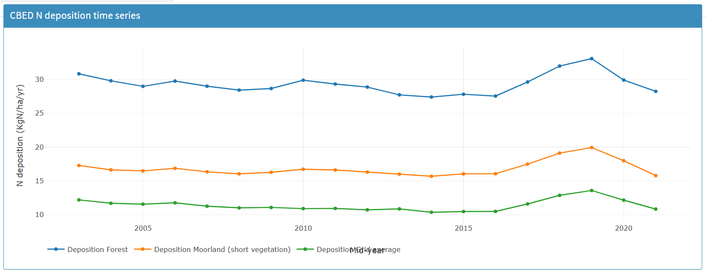

Map 1. Location of the section of Dee Estuary SAC / SPA / Ramsar in which Receptor E20 is located (land circled in green). Survey data taken from Dargie, T. 2001. NVC survey of the saltmarsh and other habitats in the Dee and Clwyd estuaries 2000. CCW Contract Science Report no. 450. Countryside Council for Wales, Bangor.

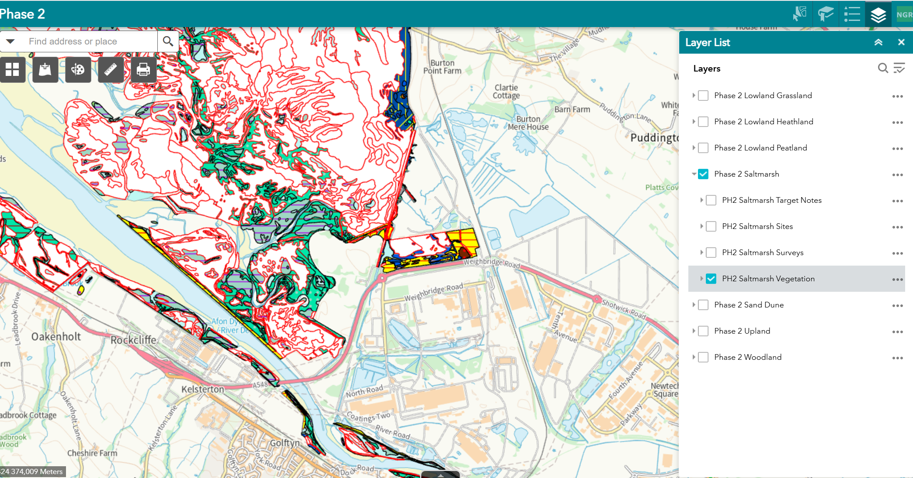
E20

Map 2. Area in question shown in detail. Key to species and habitats types given below.

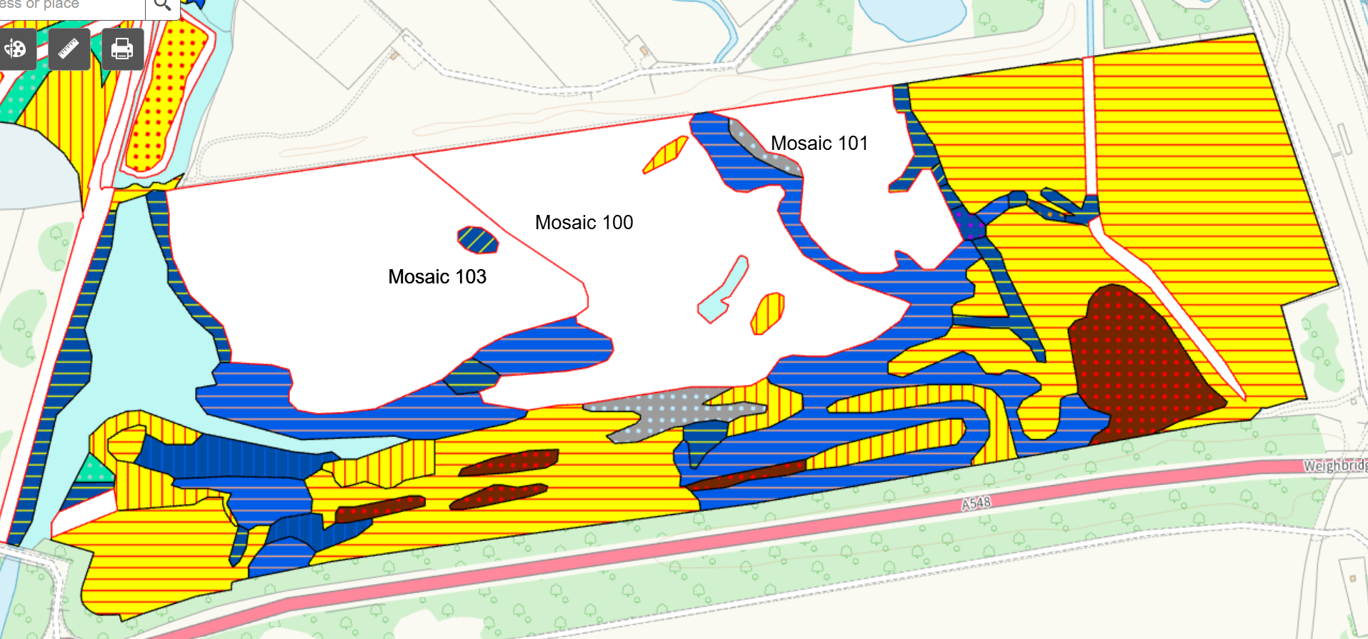
E20

Key

NVC code |  | Code name | Broad habitat category | Percentage split (mosaics)
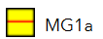 |  | Arrhenatherum elatius grassland, Festuca rubra sub-community | Mesotrophic grassland
 |  | Arrhenatherum elatius grassland, Urtica dioica sub-community | Mesotrophic grassland
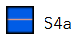 |  | Phragmites australis swamp and reed-beds, Phragmites australis sub-community | Swamps and tall-herb fens
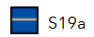 |  | Eleocharis palustris swamp, Eleocharis palustris sub-community | Swamps and tall-herb fens
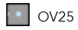 |  | Urtica dioica-Cirsium arvense community | Vegetation of open habitats
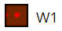 |  | Salix cinerea-Galium palustre woodland | Woodlands and scrub
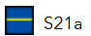 |  | Scirpus maritimus swamp, Scirpus maritimus sub-community | Communities of salt-marsh
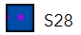 |  | Phalaris arundinacea tall-herb fen | Communities of salt-marsh
Mosaic 103 | MG1 | Arrhenatherum elatius grassland | Mesotrophic grassland | 45%
Mosaic 103 | MG11 | Festuca rubra–Agrostis stolonifera–Potentilla anserina grassland | Mesotrophic grassland | 30%
Mosaic 103 | SM24 | Elymus pycnanthus salt-marsh community | Communities of salt-marsh | 30%
Mosaic 103 | SM24 | Elymus pycnanthus salt-marsh community | Communities of salt-marsh | 25%
Mosaic 100 | MG1 | Arrhenatherum elatius grassland | Mesotrophic grassland | 70%
Mosaic 100 | SM24 | Elymus pycnanthus salt-marsh community | Communities of salt-marsh | 30%
Mosaic 101 | MG1 | Arrhenatherum elatius grassland | Mesotrophic grassland | 100%

APIS - Air Pollution Information System | APIS
CIRIA. Containment systems for the prevention of pollution (C736). Secondary, tertiary and other measures for industrial and commercial premises. 2014.
Deeside Power Station. Air Dispersion Modelling Report. Version 4.0. 23 March 2025
Bobbink, R. et al. (2022). Review and revision of empirical critical loads of nitrogen for Europe. August 2022.
CIRIA. Containment systems for the prevention of pollution (C736). Secondary, tertiary and other measures for industrial and commercial premises. 2014.
Deeside Power Station Schedule 5 Response. Version 2.1. 25 March 2026.
Deeside Power Station Schedule 5 Response. Version 2.1. 25 March 2026.
Dargie, T. 2001. NVC survey of the saltmarsh and other habitats in the Dee and Clwyd estuaries 2000. CCW Contract Science Report no. 450. Countryside Council for Wales, Bangor.

