PAN-032402 My Map Report:
Application maps
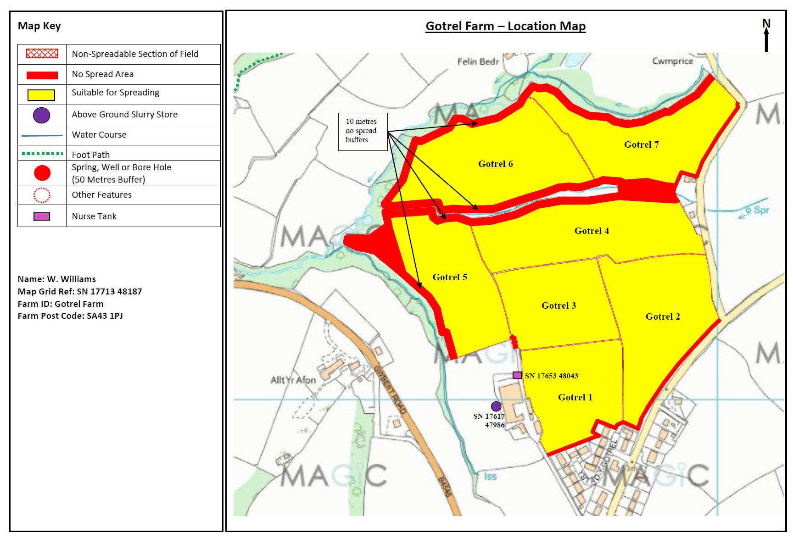
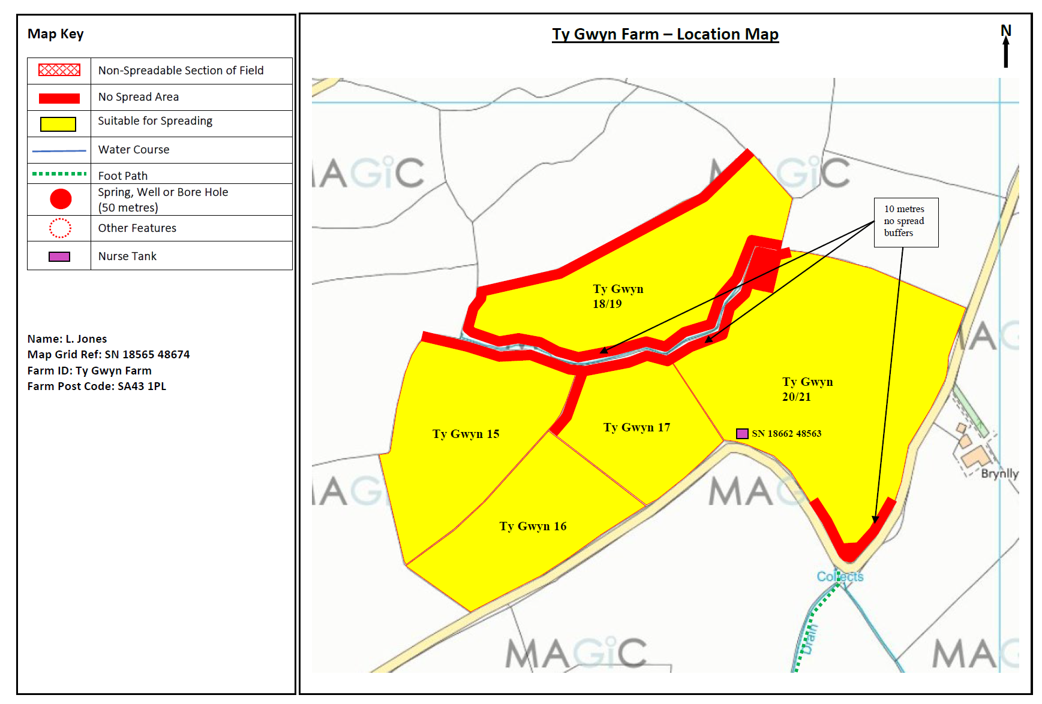
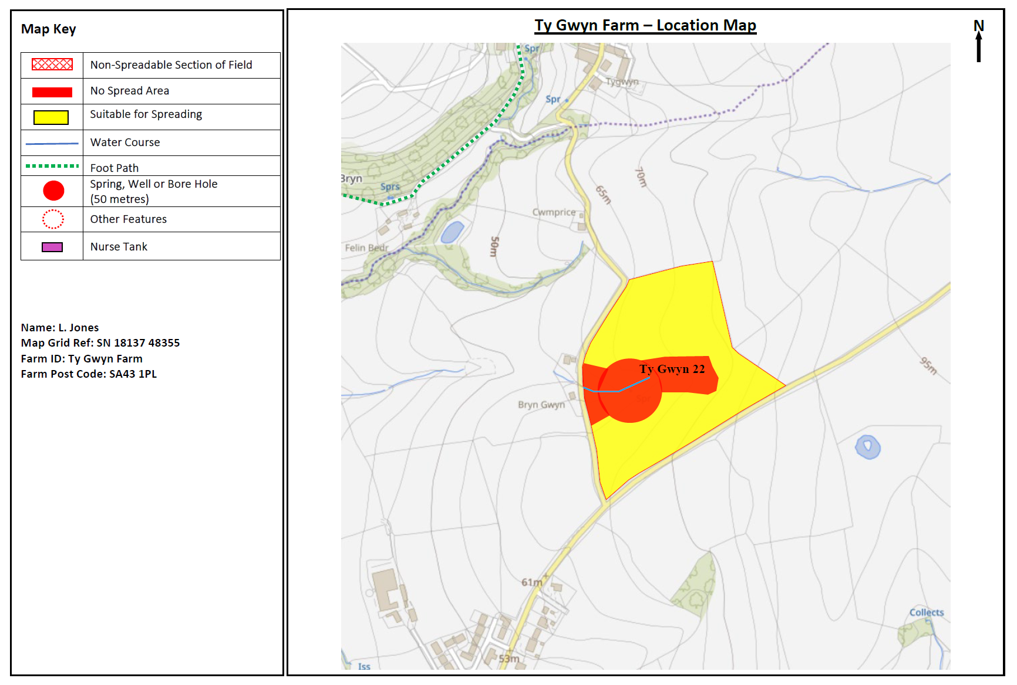
Deployment Boundaries and storage
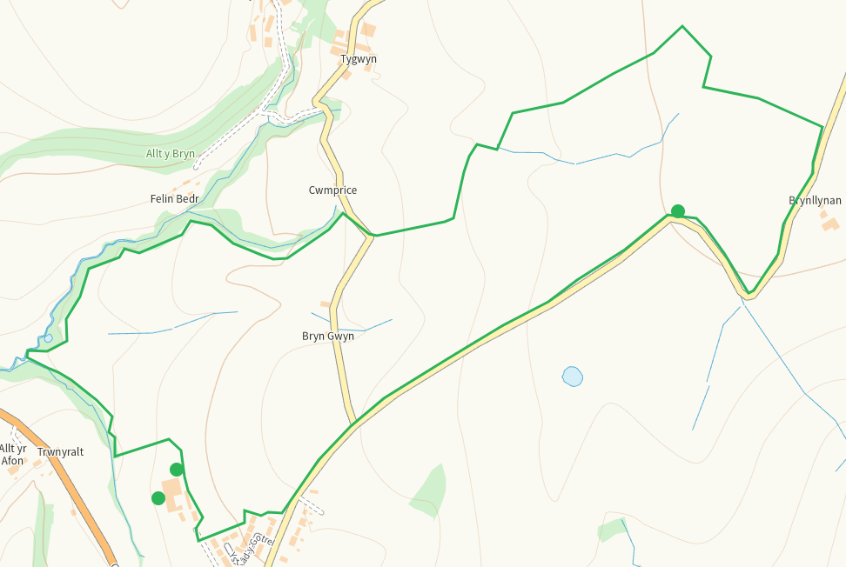
Detailed river network 10m
Multiple in range, all suitably buffered on application maps
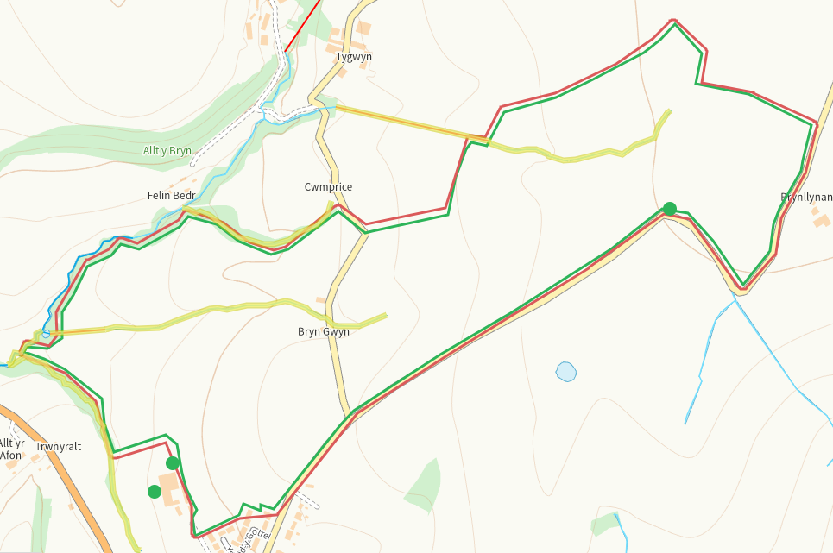
Groundwater source protection zones
none
Any well, spring (or issue) or borehole used for the supply of water for human consumption including from a private water supply or supplies within 50m.
Spring within 22, buffered on application map
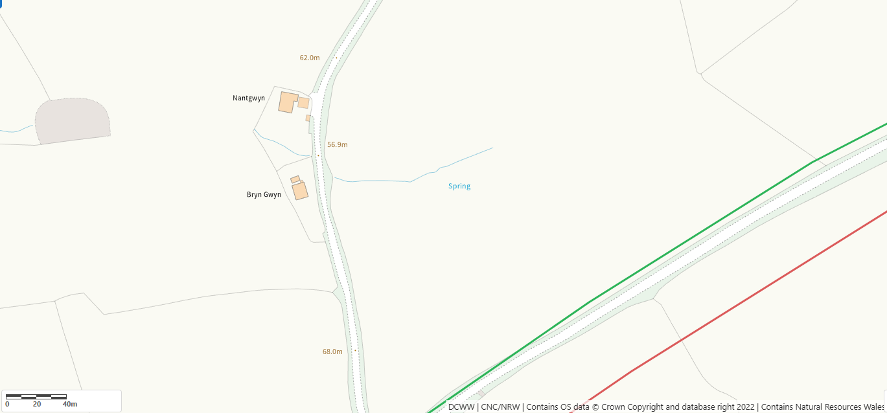
Any well, spring (or issue) or borehole used for the supply of water for human consumption including from a private water supply or supplies within 250m.
Issue SW of 1, on application map
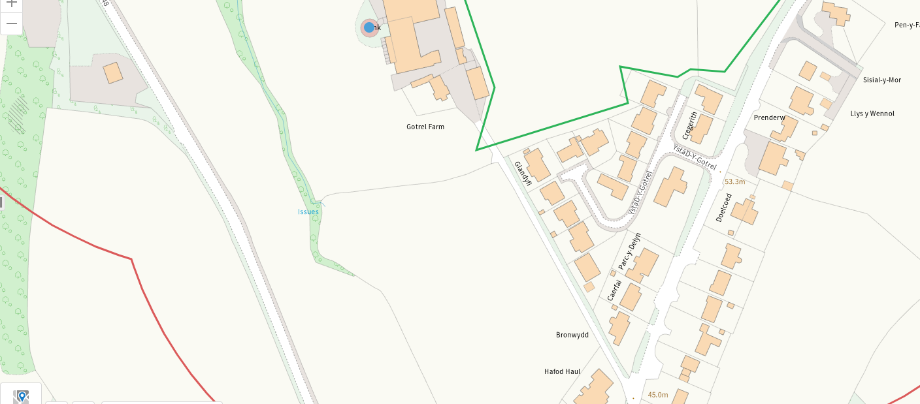
Within Groundwater Safeguard Zone
None
European designated sites- Natura 2000 (SPA, pSPA, SAC or cSAC) or Ramsar- or SSSI within 500m
None
Other protected sites within 500m:
- Protected Species-
Some within range, nil risk from the activity
- Protected Habitats-
Some within range, nil risk from the activity

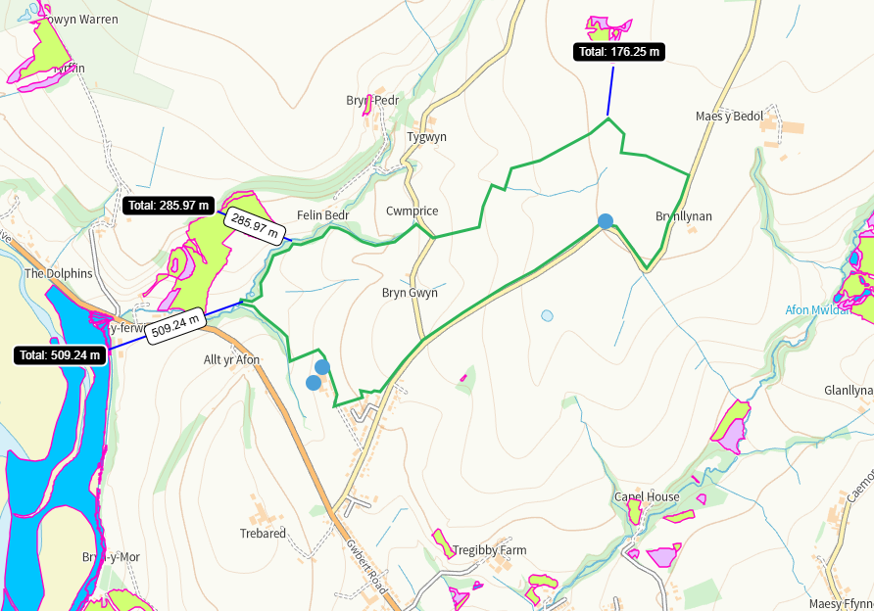
- Scheduled Ancient Monument-
5 withn range, nil risk from the activity
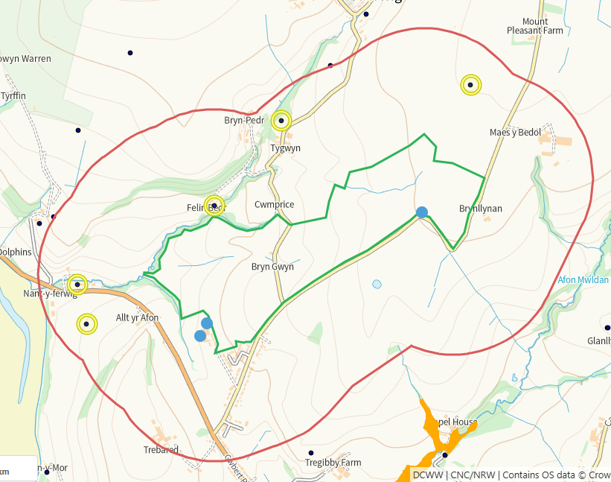
- Local Nature Reserve- no
- National Nature Reserve- no
- Ancient Woodlands- no
- Local Wildlife Sites (SINC)- no
- National Park- no
- Nitrate Vulnerable Zone (NVZ)- ALL Wales
- Groundwater Safeguard Zone- no

Flood risk
none
Public rights of way
none
Distance from Main Farm Address
Adjacent
Slope Map
Buffers are in place for areas of 12+
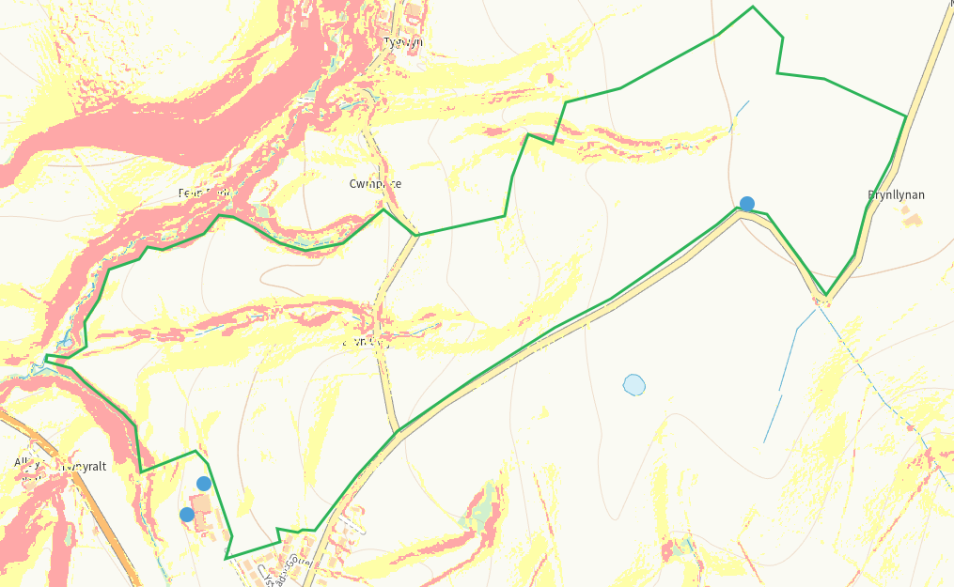

END

