

Notice of variation and consolidation with introductory note
The Environmental Permitting (England & Wales) Regulations 2016

Dŵr Cymru Cyfyngedig

CSO and EO at Cwm Sewage Pumping Station
Off Feidr Brenin
Parrog
Newport
Pembrokeshire
SA42 0RX

Variation number
PAN-032156

Permit number
BP0296401

CSO and EO at Cwm Sewage Pumping Station

Permit Number BP0296401

Introductory note

This introductory note does not form a part of the permit

The following notice gives notice of the variation and consolidation of environmental permit BP0296401.

This permit variation and consolidation is to reflect asset improvements that have been agreed between Natural Resources Wales and Dŵr Cymru Cyfyngedig as part of the National Environment Programme. This permit requires the operator to MCERTS certify the overflow operation monitoring and increase the monitoring frequency to 2-minutes to allow performance against permit conditions to be better regulated.

The MCERTS Storm to Environment EDM Monitoring Point NGR has changed.

The schedules specify the changes made to the permit.

The status log of the permit sets out the permitting history, including any changes to the permit reference number. It is not backdated before 6th April 2010.

Status log of the permit
Description | Date | Comments
Application determined | 18/08/2010 | Permit issued
Regulator-initiated variation PAN-021130 | 05/06/2023 | AMP programme EDM variation.
Variation Issued BP0296401 | 31/07/2023 | Varied permit issued to Dŵr Cymru Cyfyngedig.
Operator-initiated admin variation PAN-024211 | 30/11/2023 | Variation to update the PSKPM document.
Variation Issued BP0296401 | 11/01/2024 | Varied permit issued to Dŵr Cymru Cyfyngedig.
Regulator-initiated variation PAN-022942 | 12/12/2023 | Variation of permit initiated under PR19 review programme to incorporate improvements to be delivered under AMP7.
Variation Issued BP0296401 | 20/08/2024 | Varied permit issued to Dŵr Cymru Cyfyngedig.
Operator-initiated variation  PAN-029036 | 22/04/2025 | Variation to include online storage
Variation Issued  BP0296401 | 26/06/2025 | Varied permit issued to Dŵr Cymru Cyfyngedig.
Regulator-initiated variation PAN-032156 | Duly Made 16/03/2026 | Variation of permit initiated under PR24 review programme to incorporate improvements to be delivered under AMP8.
Variation determined  BP0296401 | Issued  23/04/2026 | Varied permit issued to Dŵr Cymru Cyfyngedig.

End of introductory note.

Notice of variation and consolidation
The Environmental Permitting (England and Wales) Regulations 2016

The Natural Resources Body for Wales (“Natural Resources Wales”) in exercise of its powers under regulation 20 of the Environmental Permitting (England and Wales) Regulations 2016 varies and consolidates

Permit number

BP0296401

Issued to

Dŵr Cymru Cyfyngedig (“the operator”)

whose registered office is

Linea

Fortran Road

St Mellons

Cardiff

CF3 0LT

company registration number 02366777

to operate a water discharge activity at

CSO and EO at Cwm Sewage Pumping Station

Off Feidr Brenin

Parrog

Newport

Pembrokeshire

SA42 0RX

to the extent set out in the schedules.

The notice shall take effect from 23/04/2026.

Name | Date
Joanne Fitton | 23/04/2026

Authorised on behalf of Natural Resources Wales.

Schedule 1

No conditions have been varied by the consolidated permit as a result of a Natural Resources Wales initiated variation.

Schedule 2 – consolidated permit

Consolidated permit issued as a separate document.
Permit
The Environmental Permitting (England and Wales) Regulations 2016

Permit number

BP0296401

This is the consolidated permit referred to in the variation and consolidation notice for variation PAN-032156 authorising

Dŵr Cymru Cyfyngedig (“the operator”)

whose registered office is

Linea

Fortran Road

St Mellons

Cardiff

CF3 0LT

company registration number 02366777

to operate a water discharge activity at

CSO and EO at Cwm Sewage Pumping Station

Off Feidr Brenin

Parrog

Newport

Pembrokeshire

SA42 0RX

to the extent authorised by and subject to the conditions of this permit.

The permit variation and consolidation shall take effect from 23/04/2026.

Name | Date
Joanne Fitton | 23/04/2026

Authorised on behalf of Natural Resources Wales.

Conditions
- Management
  - General management
    - The operator shall manage and operate the activities:
      - in accordance with a written management system that identifies and minimises risks of pollution so far as is reasonably practicable, including those risks arising from operations, maintenance, accidents, incidents, non-conformances and those drawn to the attention of the operator as a result of complaints; and
      - using sufficient competent persons and resources.
    - Records demonstrating compliance with condition 1.1.1 shall be maintained.
    - Any person having duties that are or may be affected by the matters set out in this permit shall have convenient access to a copy of the permit.
- Operations
  - Permitted activities
    - The only activities authorised by the permit are the activities specified in schedule 1 table S1.1.
  - The site
    - The discharge activities shall take place at the discharge point marked on the site plans at schedule 7 to this permit, and as listed in table S3.2; and, the operating techniques that are the subject of conditions prefixed by 2.3 shall be applied at the locations shown, or otherwise described, in schedule 7.
  - Operating techniques
    - For the activity A2, referenced in schedule 1, table S1.1, the activity shall, subject to the conditions of this permit, be operated using the techniques and in the manner described in the documentation specified in schedule 1, table S1.2, unless otherwise agreed in writing by Natural Resources Wales.
    - For the discharge specified in table S3.3:
      - The discharge shall only occur when and only for as long as either:
(i) the flow passed forward is equal to or greater than the overflow setting indicated due to rainfall and/or snow melt or
(ii) the hydraulic capacity of the sewer network downstream of the combined sewer overflow is reached due to rainfall and/or snow melt and the level of storm sewage in the sewer at the combined sewer overflow is greater than the weir level of the overflow structure which is specified as an overflow setting in table S3.3.
The capacity of the sewer network downstream of the combined sewer overflow shall not be altered in any way which would lead to a significant increase in the frequency or volume of the discharge.
      - On-line storm storage must be fully utilised before a discharge occurs. It shall only fill with the excess flows due to rainfall and/or snow melt. The storage shall be emptied and its contents returned to the continuation flow as soon as reasonably practicable. The minimum on-line storm storage required is specified in table S3.3.
      - The discharge shall not be comminuted or macerated and shall have passed through screens as specified and shall not contain a significant quantity of solid matter with a particle size greater than any indicated. All screenings shall be removed from the discharge.

      - Where a mechanically cleaned screen is installed, a telemetry alarm system shall be installed and maintained, as far as reasonably practicable, so as to give the operator immediate notification of a failure of the screen cleaning mechanism, unless otherwise agreed in writing by Natural Resources Wales. The operator shall take all appropriate measures to return the screen cleaning mechanism to normal operation as soon as reasonably practicable after receipt of notification of the failure.
- Emissions and monitoring
  - Emissions to water
    - The limits given in schedule 3 table S3.1 shall not be exceeded.
    - At least 95% of all flow passed forward readings taken in any calendar year while the overflow is operating must be equal to or greater than 92% of the flow passed forward limit specified in schedule 3 table S3.1.
      - For the purpose of this condition the following readings shall not be used in the assessment.
        - data that is not ‘good’ data; or
        - the first flow reading taken after the start of each overflow event.
  - Monitoring
    - The operator shall, unless otherwise agreed in writing by Natural Resources Wales, undertake the monitoring specified in the following tables in schedule 3 to this permit:
      - point source emissions specified in tables S3.1 and S3.4.
    - The operator shall maintain records of all monitoring required by this permit.
    - Monitoring equipment, techniques, personnel and organisations employed for the emissions monitoring programme and the environmental or other monitoring specified in condition 3.2.1 shall have either MCERTS certification or MCERTS accreditation (as appropriate), where available, unless otherwise agreed in writing by Natural Resources Wales.
    - Accessible monitoring points shall be provided and maintained to enable the emissions monitoring programme to be carried out at the monitoring points specified in table S3.4 of schedule 3 and shown marked on the site plans in schedule 7.
    - The operator shall take appropriate measures to ensure that the event recorder remains fully operational at all times within the reference period specified in table S3.1. Any failures shall be remedied as soon as reasonably practicable.
    - The operator shall, for the flow passed forward and overflow operation monitoring required by condition 3.2.1 and table S3.1 to assess ‘flow passed forward’ limit compliance:
      - have appropriate systems in place that allow them to detect and record all issues and failures of the monitoring systems, and any other breaks in the data; and
      - flag all monitoring data as ‘good’, ‘suspect’ or ‘missing’ using an appropriate methodology set out in the operator`s quality management system; and
      - where ‘good’ flow or overflow operation monitoring data is not recorded for at least 90% of a day the operator shall as far as is reasonably practicable determine and record the reasons why and the steps taken to prevent a re-occurrence; and
      - The operator shall take all reasonable measures to return the flow and/or overflow operation monitoring equipment to normal operation as soon as reasonably practicable after becoming aware of a failure.

    - For the flow and overflow operation monitoring required by condition 3.2.1 and table S3.1 to assess ‘flow passed forward’ compliance, and unless otherwise agreed in writing by Natural Resources Wales, there shall be:
      - no more than 14 consecutive days in any calendar year where ‘good’ flow data are recorded for less than 90% of each day; and
      - no more than 14 consecutive days in any calendar year where ‘good’ overflow operation data are recorded for less than 90% of each day; and
      - no more than 37 days in any calendar year that do not have both ‘good’ flow data recorded for at least 90% of each day and ‘good’ overflow operation data recorded for at least 90% of each day.
    - The flow passed forward monitoring specified in table S3.1:
      - shall be capable of recording the flow passed forward with a total uncertainty within +/- 8% at the overflow setting specified in table S3.3; and
      - shall have its total uncertainty assessed as soon as reasonably practicable following MCERTS certification or recertification and in addition whenever a significant change occurs that may impact the total uncertainty; and
      - all assessment reports confirming the total uncertainty shall be retained for at least six years and provided to Natural Resources Wales within 28 days unless otherwise agreed in writing by Natural Resources Wales.
- Information
  - Records
    - All records required to be made by schedule 3, 4 and 5 to this permit shall:
      - be legible;
      - be made as soon as reasonably practicable;
      - if amended, be amended in such a way that the original and any subsequent amendments remain legible, or are capable of retrieval; and
      - be retained, unless otherwise agreed in writing by Natural Resources Wales, for at least 10 years from the date when the records were made.
    - The operator shall maintain convenient access, in either electronic or hard copy, to the records, plan and management system required to be maintained by this permit.
  - Reporting
    - The operator shall send all reports and notifications required by the permit to Natural Resources Wales using the contact details supplied in writing by Natural Resources Wales.
    - Within the time period after the end of the reporting period specified in schedule 4 table S4.1 the operator shall, unless otherwise agreed in writing by Natural Resources Wales, submit reports of the monitoring and assessment carried out in accordance with the conditions of this permit, as follows:
      - in respect of the parameters and monitoring points specified in schedule 4 table S4.1;
      - for the reporting periods specified in schedule 4 table S4.1 and using the forms specified in schedule 4 table S4.2; and
      - giving the information from such results and assessments as may be required by the forms specified in those tables.
    - On request, the Operator shall supply Natural Resources Wales with written details of individual spill events.

  - Notifications
    - Natural Resources Wales shall be notified as soon as reasonably practicable following detection, within the site of the regulated facility of:
    - any malfunction, breakdown or failure of equipment or techniques, accident, or emission of a substance not controlled by an emission limit which has caused, is causing or may cause significant pollution; and
    - any breach of a limit specified in schedule 3 table S3.1.
Any other significant adverse environmental effects, which may have been caused by the activity, shall also be notified to Natural Resources Wales as soon as reasonably practicable following detection.
    - The information provided under condition 4.3.1 shall be supported by sending the information listed in schedule 5 to this permit within the time period specified in that schedule.
    - Natural Resources Wales shall be notified within 14 days of the occurrence of the following matters, except where such disclosure is prohibited by Stock Exchange rules:
Where the operator is a registered company:
      - any change in the operator’s trading name, registered name or registered office address; and
      - any steps taken with a view to the operator going into administration, entering into a company voluntary arrangement or being wound up.
Where the operator is a corporate body other than a registered company:
      - any change in the operator’s name or address; and
      - any steps taken with a view to the dissolution of the operator.
  - Interpretation
    - In this permit the expressions listed in schedule 6 shall have the meaning given in that schedule.
    - In this permit references to reports and notifications mean written reports and notifications, except where reference is made to notification being made “as soon as reasonably practicable”, in which case it may be provided by telephone.

Schedule 1 – Operations
Table S1.1 Activities
Activity reference | Description of activity | Limits of specified activity
A1 | Discharge of storm sewage via Storm Discharge Point | This is the Last-in-Line Overflow for Newport WwTW (permit number BP0063501).
A2 | Discharge of sewage in emergency via Emergency Discharge Point | An emergency shall be defined as the period when the sewage pumping station is inoperative as a result of one or more of the following, which is not due to the act or default of the operator, its agents, representatives, officers, employees or servants;  - electrical power failure;  - mechanical breakdown of duty and standby pumps;  - rising main failure;  - blockage of the downstream sewer.

Table S1.2 Operating techniques
Activity reference | Description of documentation | Parts | Date Received
A2 | Pumping station key protection measures | All | 30/11/2023

Schedule 2 – Waste types, raw materials and fuels
Schedule 2 not in use.

Schedule 3 – Emissions and monitoring
Table S3.1 Point Source emissions to water (other than sewer) – emission limits and monitoring requirements
Effluent and discharge point | Parameter | Limit (including unit) | Reference Period | Limit of effective range | Monitoring frequency | Compliance Statistic
A1 Storm sewage via Storm Discharge Point | Block-counted spills | N/A | 1st January to 31st December inclusive | N/A | 2 minutes | Condition 3.2.3 applies
A1 Storm sewage via Storm Discharge Point | Overflow operation monitoring yes/no or start and end times | N/A | N/A | N/A | 2-minute where yes/no or whenever overflow operates where start and end times | Condition 3.2.3 applies
A1 Storm sewage via Storm Discharge Point | Overflow operation monitoring status (operational / not operational) | N/A | N/A | N/A | 2-minute or whenever operational status changes | Condition 3.2.3 applies
A1 Storm sewage via Storm Discharge Point | Flow passed forward | 13.7 l/s | 2-minute | N/A | Continuous 2-minute instantaneous or averaged flow | Minimum  Condition 3.1.2 applies
A2 Sewage in an emergency via Emergency Discharge Point | Discharge start and end times | N/A | N/A | N/A | Whenever a discharge occurs | N/A

Table S3.2 Discharge points
Effluent Name | Discharge Point | Discharge point NGR | Receiving water/Environment
A1 Storm sewage | Storm Discharge Point | SN 04350 40350 | Newport Bay
A2 Sewage in an emergency | Emergency Discharge Point | SN 04350 40350 | Newport Bay

Table S3.3 Storm sewage discharge settings
Effluent and discharge point | Description of discharge | Overflow setting l/s | Maximum size of solid matter | Screen aperture size | Minimum online storage capacity m³
A1 Storm sewage via Storm Discharge Point | Storm sewage | 13.7 | No greater than 6 mm in more than 1 dimension | 6 mm x 6 mm | 170

Table S3.4 Monitoring points
Effluent and discharge point | Monitoring type | Monitoring point NGR | Monitoring point reference
A1 Storm sewage via Storm Discharge Point | Storm effluent sampling | SN 04468 39700 | Storm Sample Point
A1 Storm sewage via Storm Discharge Point | MCERTS event duration monitoring | SN 04471 39703 | MCERTS Storm to Environment EDM Monitoring Point
A1 Storm sewage via Storm Discharge Point | Flow passed forward monitoring | SN 03807 39188 | MCERTS FPF Monitoring Point
A2 Sewage in an emergency via Emergency Discharge Point | Effluent sampling | SN 04468 39700 | Emergency Sample Point

Schedule 4 – Reporting
Parameters, for which reports shall be made, in accordance with conditions of this permit, are listed below.
Table S4.1 Reporting of monitoring data
Activity Reference | Parameter | Monitoring point reference | Reporting period | Period begins
A1 Storm sewage via Storm Discharge Point | Storm event recorder status operational | MCERTS Storm to Environment EDM Monitoring Point | Annually  Report to be submitted within 2 months | 1st January
A1 Storm sewage via Storm Discharge Point | Storm overflow performance, including total number of block-counted spills | Storm Sample Point  and  MCERTS Storm to Environment EDM Monitoring Point | Annually  Report to be submitted within 2 months | 1st January
A1 Storm sewage via Storm Discharge Point | Duration of total spills | MCERTS Storm to Environment EDM Monitoring Point | Annually  Report to be submitted within 2 months | 1st January
A1 Storm sewage via Storm Discharge Point | Storm sewage discharge start and end times | MCERTS Storm to Environment EDM Monitoring Point | Reports to be provided to Natural Resources Wales upon request | As specified by Natural Resources Wales
A1 Storm sewage via Storm Discharge Point | Flow passed forward monitoring | MCERTS FPF Monitoring Point | Reports to be provided to Natural Resources Wales upon request  Report to be submitted within 28 days unless otherwise specified in writing by Natural Resources Wales | Upon request by Natural Resources Wales
A1 Storm sewage via Storm Discharge Point | Overflow operation yes/no or start and end times | MCERTS Storm to Environment EDM Monitoring Point | Reports to be provided to Natural Resources Wales upon request  Report to be submitted within 28 days unless otherwise specified in writing by Natural Resources Wales | Upon request by Natural Resources Wales
A1 Storm sewage via Storm Discharge Point | Overflow operation monitoring status (operational / not operational) | MCERTS Storm to Environment EDM Monitoring Point | Reports to be provided to Natural Resources Wales upon request  Report to be submitted within 28 days unless otherwise specified in writing by Natural Resources Wales | Upon request by Natural Resources Wales
A1 Storm sewage via Storm Discharge Point | Flow passed forward and overflow operation monitoring annual report | MCERTS FPF Monitoring Point  and  MCERTS Storm to Environment EDM Monitoring Point | Annually  Report to be submitted within 2 months | 1st January
A2 Sewage in an emergency via Emergency Discharge Point | Operation of the emergency overflow | Emergency Sample Point | Reports to be provided to Natural Resources Wales upon request  Report to be submitted within 28 days unless otherwise specified in writing by Natural Resources Wales | 1st January
A2 Sewage in an emergency via Emergency Discharge Point | Emergency discharge start and end times | Emergency Sample Point | Reports to be provided to Natural Resources Wales upon request  Report to be submitted within 28 days unless otherwise specified in writing by Natural Resources Wales | Upon request by Natural Resources Wales

Table S4.2 Reporting forms
Parameter | Reporting format
Storm overflow performance including number and duration of block-counted spills | Annual summary report or other form as agreed in writing by Natural Resources Wales
Storm sewage discharge start and end times | Form as agreed in writing by Natural Resources Wales
Storm overflow event recorder status (operational / not operational) | Annual summary report or other form as agreed in writing by Natural Resources Wales  Percentage of time in the recording period that event duration monitoring equipment is operational
Investigation into the operation of the storm overflow | Electronic format as agreed in writing by Natural Resources Wales.
Flow passed forward monitoring | Electronic format specified by Natural Resources Wales
Overflow operation yes/no or start and end times | Electronic format specified by Natural Resources Wales
Overflow operation monitoring status (operational / not operational) | Electronic format specified by Natural Resources Wales
Flow passed forward and overflow operation monitoring annual report | Annual report format as specified by Natural Resources Wales
Operation of the emergency overflow | Annual summary report or other form as agreed in writing by Natural Resources Wales
Emergency discharge start and end times | Spill event, time and duration reporting format spreadsheet or other form as agreed in writing by Natural Resources Wales

Schedule 5 – Notification
These pages outline the information that the operator must provide.
Units of measurement used in information supplied under Part A and B requirements shall be appropriate to the circumstances of the emission. Where appropriate, a comparison should be made of actual emissions and authorised emission limits.
If any information is considered commercially confidential, it should be separated from non-confidential information, supplied on a separate sheet and accompanied by an application for commercial confidentiality under the provisions of the EP Regulations.

Part A
Permit Number | BP0296401
Name of operator | Dŵr Cymru Cyfyngedig
Location of Facility | CSO and EO at Cwm Sewage Pumping Station, Off Feidr Brenin, Parrog, Newport, Pembrokeshire, SA42 0RX
Time and date of the detection

(a) Notification requirements for any malfunction, breakdown or failure of equipment or techniques, accident, or emission of a substance not controlled by an emission limit which has caused, is causing or may cause significant pollution.
To be notified within 24 hours of detection unless otherwise agreed in writing by Natural Resources Wales.
Date and time of the event
Reference or description of the location of the event
Description of where any release into the environment took place
Substances(s) potentially released/type or nature of sewage released
Best estimate of the quantity or rate of release of substances and/or duration of discharge
Best estimate of the environmental impact of the discharge
Measures taken, or intended to be taken, to stop any emission
Description of the failure or accident.

Part B – to be submitted as soon as reasonably practicable unless otherwise agreed in writing by Natural Resources Wales
Any more accurate information on the matters for notification under Part A.
Measures taken, or intended to be taken, to prevent a recurrence of the incident/breach/exceedance
Measures taken, or intended to be taken, to rectify, limit or prevent any pollution of the environment which has been or may be caused by the emission

Name*
Post
Signature
Date
* authorised to sign on behalf of the operator

Schedule 6 – Interpretation
“accident” means an accident that may result in pollution.
“annually” means once every year.
“application” means the application for this permit, together with any additional information supplied by the operator as part of the application and any response to a notice served under Schedule 5 to the EP Regulations.
“block-counted spill” one or more overflow events within a period of 12 hours or less will be considered to be one spill, one or more overflow events extending over a period of greater than 12 hours up to 36 hours will be considered to be 2 spills. Each subsequent 24-hour duration counts as 1 additional spill and the whole of the 24-hour block is included.
“emissions of substances not controlled by emission limits” means emissions of substances to air, water or land from the permitted activities, which are not controlled by an emission limit.
“EP Regulations” means The Environmental Permitting (England and Wales) Regulations SI 2016 No.1154 and words and expressions used in this permit which are also used in the Regulations have the same meanings as in those Regulations.
“event recorder” a recorder which records the start time and end time of individual overflow events.
“flow passed forward” for the purposes of conditions 2.3.2 and 3.1.2 means, the rate of flow (litres per second) of the waste water arriving at the overflow from its upstream collection system and passed forward to the continuation flow. It does not include any flows that have already been passed forward by the overflow and are reintroduced to the incoming flow upstream of the overflow from any point downstream of it.
“good flow data for at least 90% of each day” means at least 87 fifteen minute or 648 two-minute flow readings are flagged as good in a day.
“good overflow operation data for at least 90% of each day” means at least 648 two-minute overflow operation readings are flagged as good or the overflow operation duration monitor is operational for at least 1,296 minutes in a day.
“MCERTS” means the Environment Agency’s Monitoring Certification Scheme.
“minimum screen capacity flow” means the minimum flow passed through the screens to the outfall when the screen bypass operates.
“monitoring frequency” as used in Table S3.1 in the context of event duration monitoring is the temporal interval at which a change in state between no discharge and discharge is to be detected.
“Natural Resources Wales” means the Natural Resources Body for Wales established by article 3 of the Natural Resources Body for Wales (Establishment) Order 2012. The Natural Resources Body for Wales (Functions) Order 2013 transferred the relevant functions of the Countryside Council for Wales, and functions of the Environment Agency and the Forestry Commission in Wales to the Natural Resources Body for Wales.
“Non-routine planned maintenance” means maintenance, inspection, refurbishment, or replacement of plant and equipment carried out in accordance with a documented maintenance plan, which is foreseeable and can be planned at least 5 working days in advance.
“Non-routine un-planned maintenance” means extra-ordinary maintenance to carry out inspection, refurbishment, or replacement of plant and equipment that is unforeseeable and cannot be planned at least 5 working days in advance.
“overflow” for the purposes of schedule 7, overflow means the weir or orifice or other control which directs excess flow away from the continuation sewer when the flow exceeds the overflow setting due to rainfall and/or snowmelt.
“overflow event” any individual operation, of any duration, of the event recorder or any recorded discharge of sewage from the outfall.
“overflow setting” means the minimum flow passed forward to the continuation sewer when the overflow operates.
“quarter” means a calendar year quarter commencing on 1st January, 1st April, 1st July or 1st October.
“Regular planned maintenance” means scheduled maintenance, inspection, refurbishment, or replacement of plant and equipment carried out periodically and in accordance with a documented maintenance plan, it does not have to take place on specified dates.
“significant pollution” means a high level impact incident as indicated by NRW incident classification system.
“significant spill” any spill that has not been demonstrated to have been, or measured as being, less than 50 m³ in volume.
“Total uncertainty” means the combined (total) uncertainty of the flow rate measurement due to the flow monitoring installation, as determined by an MCERTS inspector, and uncertainties induced between the overflow and the flow monitor as determined by the operator. Allowances for time delays in flow response through the WwTW are taken into account by condition 3.1.2.
“year” means calendar year ending 31st December.

Schedule 7 – Site plans
Site plan 1
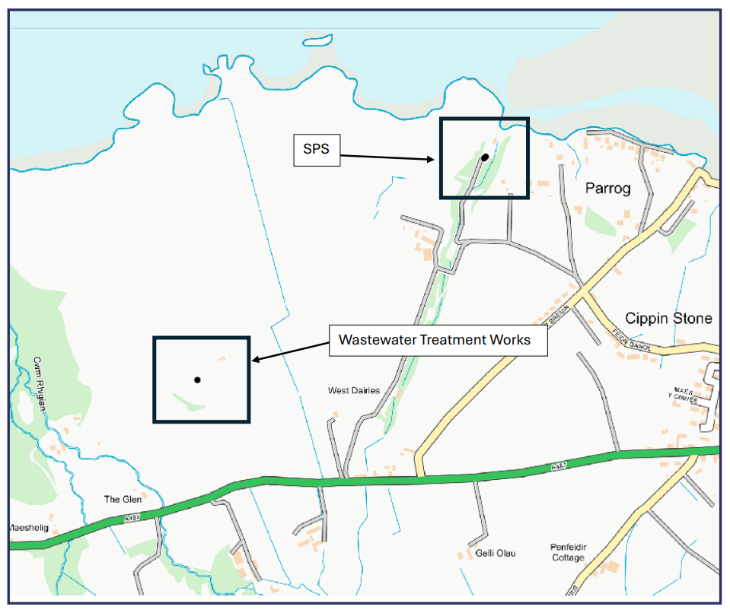
Site plan 2
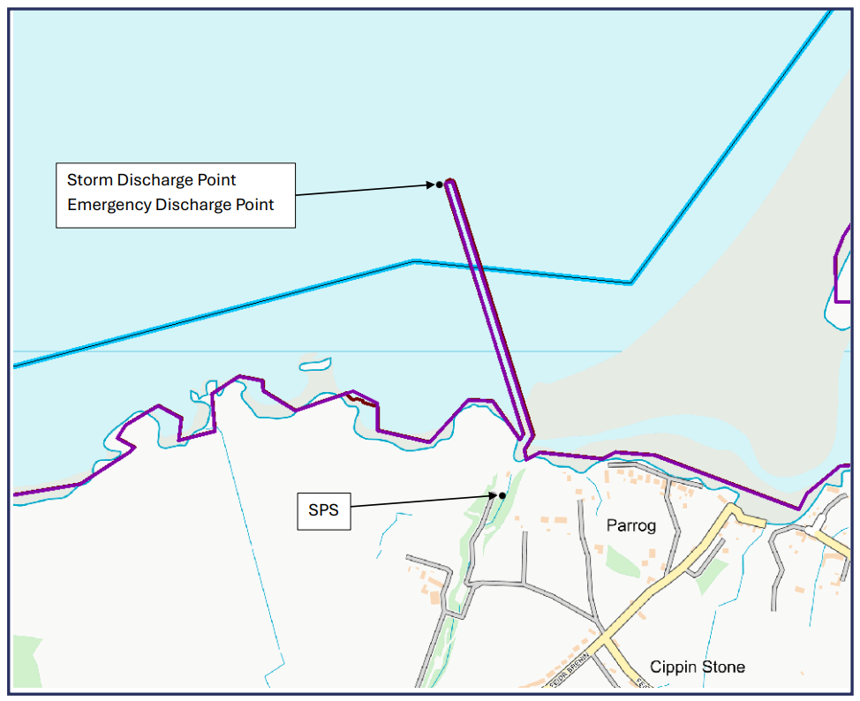
Site plan 3
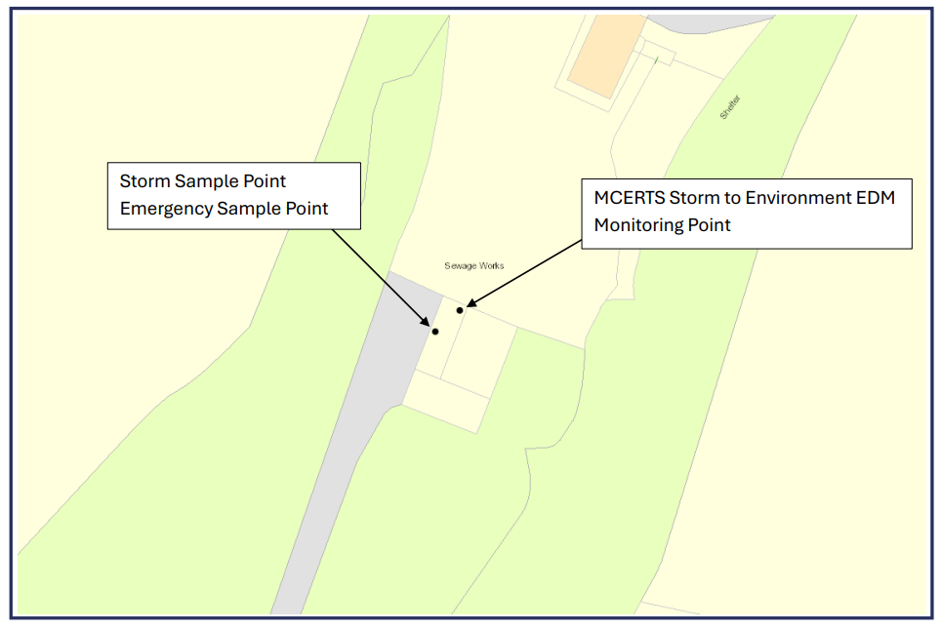
Site plan 4
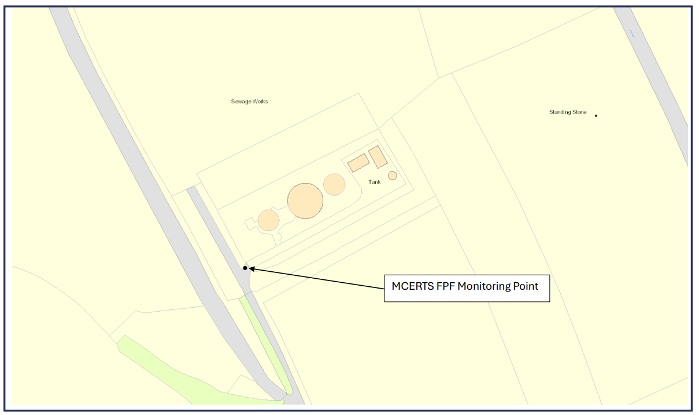

© Crown Copyright and database right 2026. Ordnance Survey licence number 100019741.
END OF PERMIT

