Record of a Habitats Regulations Assessment of a project or spatially-specific plan
OGN 200 Form 1A (with free-text boxes for likely significant effect screening and appropriate assessment)

Document owner: Head of Business for Natural Resource Management
Version History:
Document Version | Date Published | Summary of Changes
2.0 | 21/10/2024 | Following 2023/24 review of HRA OGNs
Next review date: October 2025

OGN 200 Form 1A

Record of a Habitats Regulations Assessment
Plan or project name, brief description or application reference number | PAN-028118  Address: The Royal Mint, Llantrisant, Pontyclun, Rhondda Cynon Taf, CF72 8YT  The Royal Mint is making this application to carry out a ‘normal’ Variation of their existing EPR permit under The Environmental Permitting (England and Wales) Regulations 2016 (as amended) to:  - Increase capacity to receive and process additional WEEE materials; and  - Downscale operations and significantly reduce their coin production operations on site with the decommissioning of several process lines, including:  - Copper Plating Lines - CP2 and CP3;  - Zinc Plating Line;  - Armour 1 and Armour 2 (partial); and  - Brass Plating Line, cyanide treatment plant and associated tanks.

HRA iteration/version | N/A

1. Plan or Project Details
Information about the plan or project
1 | Date application received | 22/01/2025
2 | Applicant details | The Royal Mint, Llantrisant, Pontyclun, Rhondda Cynon Taf, CF72 8YT
3 | NRW team responsible for carrying out, or requiring to be carried out, the plan or project, and name of lead officer | N/A
4 | Activity/ies proposed | Activities affected by the variation:  - Surface treatment of metals – 2.3 Part A (1) a)  - PCB boards and WEEE – 5.3 Part A (1) a) (ii)  - Effluent Treatment – 5.4 Part A (1) a) (ii)  Detail of changes:  - Increase capacity to receive and process additional WEEE materials; and  - Downscale operations and significantly reduce their coin production operations on site with the decommissioning of several process lines, including:  - Copper Plating Lines - CP2 and CP3;  - Zinc Plating Line;  - Armour 1 and Armour 2 (partial); and  - Brass Plating Line, cyanide treatment plant and associated tanks.  The main features of the site’s permit that will change as a result of the variations are:  The removal and decommissioning of the following emission points:  A1, A2, A3, A4, A7, A8, A9, A10, A15, A28, A17, A18, A19, A20, A22, A24, A25, A26, A27, A35.  The addition of the following emission points:  EP1, ERV.  No new environmental permitting activies are proposed as part of this variation.
5 | Relevant legislation or statutory basis | Environmental Permitting (England and Wales) Regulations 2016
6 | Location | The European sites search point was centred on the emission point to air for the site (X 304034 Y 184949). A screening distance of 10km has been used based on the UK Government guidance “Air emissions risk assessment for your environmental permit”. A map below shows the location of the proposed installation location and European sites within the 10km screening distance. The only European site within the screening distance is Cardiff Beech Woods Speacial Area of Conservation.  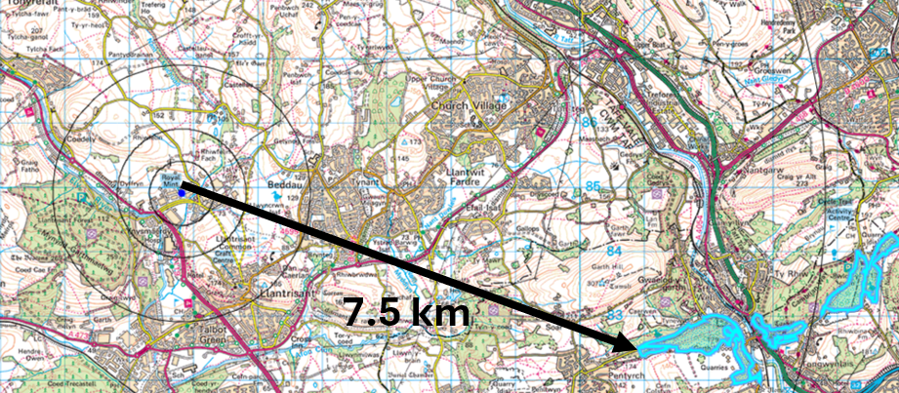
7 | Plan or project documents, including any application documents | - Part A Form  - Part C2 Form  - Part C3 Form  - Part F1 form  - Annex A Fire Prevention and Mitigation Plan  - Duly Making Questions Response Letter  - Air Quality Assessment  - Air Quality Modelling Files  - Environmental Risk Assessment  - Fire Prevention Plan Annex – Receptors  - Sensitive Habitats  - Annex A8 Storage Area Plan  - Application Support Document  - Annex A1 Royal Mint Installation Boundary  - Annex A2 Royal Mint Emission Points  - Annex A3 Historic Site Layout – Building 29  - Annex A4 Site Drainage Plan  - Annex A5 Discharge Points  - Annex A6 MRB Building Layout  - Annex A7 Building 29 Layout  - Appendix 7.2a – ECC Location  - Appendix 7.2e – Penstock and Storm Water Layout  - Royal Mint COMAH SR 2021 – Section 7 Emergency Response  - Emergency Prepardness and Response  - Spill Kit Map  External : document under PAN-028118 see Public register - Customer Portal
8 | Environmental Statement (ES) | N/A
9 | Pre-application correspondence | N/A
10 | NRW team responsible for preparing this HRA report, and lead officer | Christopher Betteridge (Senior Permitting Officer (Secondment))  Regulated Industry Permitting Team
11 | Team or person responsible for approving the plan or project (competent authority role) | As row 10

2. Determining the need for a Habitats Regulations Assessment
2.1 Is there any possibility that the plan or project could negatively affect any European sites? | No.  A Habitats Regulations Assessment (HRA) is not required because there is no conceivable impact pathway to any of the National Site Network sites identified by virtue of the scale or location or nature of the project. The only SAC is Cardiff Beach Wood (7.5 km away).  The air quality assessment demonstrated that all emissions parameters are less than 0.01% and far below the screening threshold of 1% (long term) and therefore are insignificant.  Given the very small scale of emissions and the removal of existing emissions points there is no likely realistic impact pathway that could affect the designated habitats.
2.2 Is the whole of the plan or project directly and only connected with or necessary to the management of one or more European sites, for the purposes of conserving the habitats or species for which the European site(s) is/are designated? | N/A
2.3 Is there a possibility that the plan or project could affect any other feature of the European site(s) concerned, or of another European site, in a way that would undermine that feature’s conservation objectives? | N/A

6. Conclusion

HRA is not required because there is no conceivable impact on any European sites.  (As documented in section 2.1) | X
HRA is not required because the whole of the plan or project is directly connected with or necessary to the management of one or more European sites, for the purposes of conserving the habitats or species for which the site(s) is/are designated, and the plan or project is not likely to have a significant effect on any other European sites.
(As documented in section 2.2 and 2.3)
This project is a renewal of a current permission which complies with NRW agreed criteria for ruling out likely significant effects of a renewal without conducting a project-specific LSE test. Therefore, it is considered not likely to have a significant effect on any European sites, either alone or in-combination with other plans or projects.
(As documented in section 3.1 of this form)
The plan or project has been screened for likelihood of significant effects and is considered not likely to have a significant effect on any European sites. (As documented in section 3.2 of this form, and section 5 if applicable)
In light of the conclusions of an appropriate assessment it has been established that the plan or project will not adversely affect the integrity of any European sites, taking into account any conditions or restrictions as applicable, either alone or in-combination with other plans or projects.
(As documented in section 4 of this form, and section 5 if applicable)
In light of the conclusions of the appropriate assessment, it has not been ascertained that the plan or project will not adversely affect the integrity of any European sites, as documented in section 4 of this form, and section 5 if applicable.
Approval for the plan or project cannot be given unless either:
- the plan or project specification, and/or the terms under which it might be approved, are modified so as to remove the risk of adverse effects, and a revised HRA is prepared, or
- the plan or project (not being an SSSI consent*) satisfies the requirements for a derogation and a Derogation Notice is prepared and submitted for consideration by the appropriate authority, normally Welsh Ministers
(*SSSI consents cannot be given as derogations)
Signed:

Name: Christopher Betteridge Position: Senior Permitting Officer (Secondment)

Date: 16/12/2025

Was this HRA conclusion an escalated decision? YES or NO | No

