Annex (iv) – SSSI Assessment Form
SSSI Assessment for permit/licence and deployment applications | 
To be completed by Permitting Officers for any applications for a permission which Natural Resources Wales has considered under S28I duty to notify SNCB and take their advice into account. This applies to all proposed permissions within a SSSI, and to operations outside the SSSI boundary which are likely to damage its special features.
NRW as a Section 28G authority has, when exercising its functions, a general duty to take reasonable steps, consistent with the proper exercise of its functions, to further the conservation and enhancement of the flora, fauna or geological or physiological features by reason of which the site is of special interest’

Part 1 – SSSI Assessment
Part 2 – Formal notification to SNCB (to be completed if part 1 assessment concludes likely damage, not likely to damage because of conditions or you cannot conclude no likely damage)
Part 3 – Decision
Pink text – drafting notes, to be deleted before completion/consultation.
Blue text – examples, to be replaced with permission-specific information and text turned to black.

Part 1 – SSSI Assessment

- Permitting officer/team | Stuart Whincup  Water Resources Permitting
- Permit application reference and site name | PAN-031009 and PAN-031010
- a. SSSI name  b. location  c. NRW Operational Area/Environment Team | a. CRYMLYN BURROWS SSSI  b. Neath Port Talbot  NGR SS 712927  c.Neath Port Talbot Environment Team
- Brief description of proposal | The applicant Richard Bowen have applied for a new abstraction licence and a new impoundment licence for a new HEP scheme at NGR SN 75553 04360 on the River Clydach near Cilybebyll.  The proposal is to install an impoundment structure at SN 75553 04360 and then abstract water along pipelines to a shared turbine house with another scheme. From the turbine house water will be discarged into an unnamed stream creating a cross catchment transfer before running for approximately 10m before joining the River Clydach. The proposal will result in a depleted reach of 974m.  The following maximum abstraction rates are proposed:  59 litres per second  212 cubic metres per hour  5088 cubic metres per day  1857120 cubic metres per year  The intake design will consist of a concrete weir with a Coanda intake screen with 1.3 mm aperture size.  The intake design includes the following:  - 1.3mm Coanda screen  - A flow split with a 50% take of available flow  - HOF notch to secure the residual flow.  All discharged water will be discharged to SN 74841 03975. The pipe will be fitted with a 25mm vertical bar  The proposed scheme will be approximately 13km upstream of the SSSI boundary.  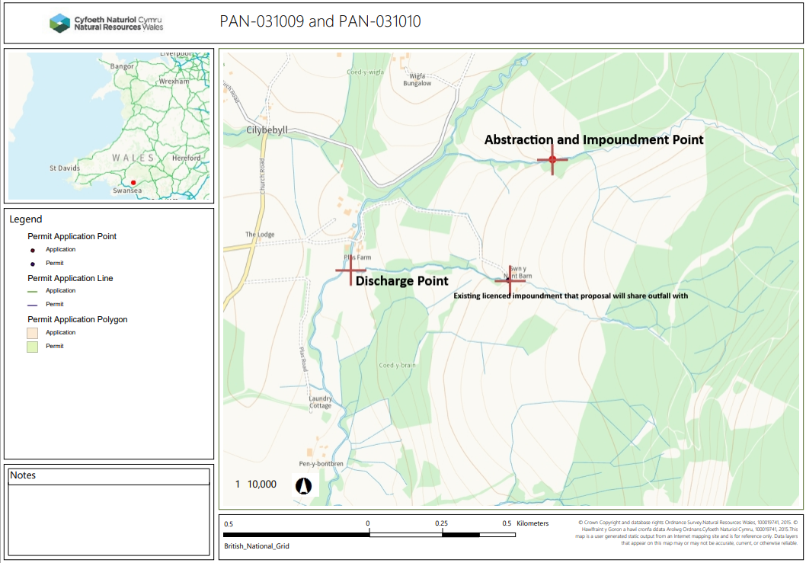  Expected impacts are sediment movement during construction and sediment transfer through the depleted reach.
- What aspects of the proposed permission are likely to damage the SSSI features of special interest?

The following activities are likely to cause damage:

13b. Modification to streams and ditches including their banks and beds, by realignment, re-grading, dredging or cleaning

14. Alterations to water levels and tables and water utilisation including irrigation, storage and abstraction from existing water bodies and through boreholes. Also the modification of current drainage regime, (eg through the installation of new pumps).

23. Erection of permanent or temporary structures or the undertaking of engineering works, including the laying, maintenance or removal of pipelines and cables.

The following SSSI features and potential impacts have been considered to assess the likelihood of damage:

Saltmarsh – no impact pathway. All water will be returned to the watercourse 1km downstream of the proposal and approximately 59km upstream of the SSSI boundary.

Sand dune - no impact pathway. All water will be returned to the watercourse 1km downstream of the proposal and approximately 59km upstream of the SSSI boundary.

Field Wormwood - no impact pathway. All water will be returned to the watercourse 1km downstream of the proposal and approximately 59km upstream of the SSSI boundary.

Important assemblage of invertebrates - no impact pathway. All water will be returned to the watercourse 1km downstream of the proposal and approximately 59km upstream of the SSSI boundary.

Due to all abstracted water being returned to the watercourse 59km upstream of the boundary there is no impact pathway in regard to the abstraction to the SSSI and it’s features.

For the impoundment during construction of the structure there is in an impact pathway in principle due to disturbance of the watercourse and potential change to sediment. However given the distance away from the SSSI boundary and confirmation that best working practises will be undertaken this can be considered de minimis, as such no significant impact is expected.

- Summary of any informal advice received from internal experts (if required and including pre-app advice) | No concerns raised during consultation of this proposal in relation to any potential impacts.  Please see ICE Pack for full details.
- Recommendation | The proposed permission is not likely to damage any of the flora, fauna or geological or physiological features which are of special interest
- Signature and date assessment made | Stuart Whincup 14/05/2026
- Officers name and job title | Stuart Whincup  Water Resources Permitting Officer


Permitting
Formal Notification under Section 28I of the Wildlife and Countryside Act 1981

Part 2 Formal notification under S28I – To be completed for all permit applications assessed as: not likely to damage because of conditions, likely to damage SSSI and those where we are unable to conclude no likely damage.

- Date Notice of intention to permit activity likely to damage SSSI sent to NRW (SCNB)  If you assess activity as being likely to damage even if you think this can be mitigated by conditioning you need to formally notify SNCB send them a copy of this notice with part 1 of this form. Environment teams have 28 days to respond.  Environment teams please complete question 11 and 12 using the information in questions 1-9 | Insert date  We have assessed that [permit ref/name of site] is likely to damage [insert name of SSSI] and request your formal advice. We have assessed that this damage could be mitigated by including conditions[remove if not applicable].  Or  We are unable to conclude that [permit ref/name of site] is not likely to damage [insert name of SSSI] and request your formal advice.  Information on the permit application can be found in Part 1 of this form and [include link to DMS documents if required]
- Advice received from NRW (SNCB)

Environment Teams and Marine Area Management and Advice Teams are expected to log and issue formal statutory advice through our CAMS system. The advice letter generated can simply by attached/appended here. ET/MAAMT can just refer to that here or write a summary of advice here too.

To be completed by environment officers.
Within 28 days of receiving notice from a permitting/licensing regime, you should advise whether the operation:
• Should be allowed to proceed.
• Should be allowed to proceed with certain conditions.
• Should not proceed.

Please ensure all advice provided is evidenced and comprehensive. Advice provided may be scrutinised as part of a formal appeal.

- Name and job title of conservation/marine officer (sign and date)
Part 3 – To record NRW decision following SNCB Advice
- DECISION  Provide reasoning for your decision and how you have considered advice from NRW(SNCB) in the box opposite and delete text in blue that is not relevant. This might be the same as the info and decision in part 1 of the form  Large amounts of supporting information can be appended to this form. | The proposed permission is not likely to damage any of the flora, fauna or geological or physiological features which are of special interest  The permission is not likely to damage any of the flora, fauna or geological or physiological features which are of special interest because of conditions  The permission is likely to damage
- Natural Resources Wales (Section 28G Authority) (permitting service) is minded to  Delete as appropriate  If this decision is not in line with advice received from NRW(SNCB) please outline your reasoning (please note that you should try to resolve any differences in opinion) | Issue the permission  Issue the permission with conditions to ensure no damage to SSSI  Refuse the permission due to likely damage to SSSI
- Is decision in line with advice from SNCB  If your decision is not in line with the recommendations from SNCB you must formally notify them using the appropriate online form or letter.  Record the date the notice/letter was sent opposite and save a link. The permitted operation cannot commence for 21 days following service of this notice. | Yes/No  If No record date notice was sent to SNCB
- Signature and date assessment completed
- Officers name and job title

