PAN-028850 Schedule 5#3

Sampling representativeness (Cr(VI) / WAC)

1. The information provided in the ESSD, Sampling Plan, and EMS Summary sets out the framework for waste characterisation and acceptance in accordance with WM3. However, further clarification is required to confirm that the proposed sampling and testing approach is representative of the material in its final processed form.

It is noted that wastes will be stockpiled and subsequently crushed and screened to produce recycled aggregate (e.g. 6F2) prior to recovery, and that testing of the processed material (including WAC and leachable Cr(VI)) will be undertaken to confirm suitability prior to deposition. However, the documents do not explain how the sampling strategy—primarily based on pre-demolition or pre-processing material—ensures representativeness of the crushed material, particularly given that processing may alter particle size distribution and increase the proportion of fines, which can influence leachability.

Action: Therefore, please provide details of the standard or methodology on which the sampling protocol is based.

This information is required to provide confidence that the WAC and Cr(VI) test results are representative of the material as deposited, and that the conclusions of the conceptual site model and environmental risk assessment remain valid.

Introduction
The three waste streams – monolithic concrete blocks, Pre-Cast Concrete Panels (PCCPs) and brick will be crushed and screened to undergo size reduction to meet the requirements of 6F2 (Highway Works Series 600 specification) before being deposited in the laydown area. The fraction sizes of 6F2 are typically:

Sieve size | % passing (lower and upper limit)
125mm | 100%
90mm | 80-100%
75 mm | 65–100%
37.5 mm | 45–100%
10 mm | 15–60%
5 mm | 10–45%
0.6mm | 0-25%
0.063 mm | 0–12%

The proportion of fines in 6F2 is below 25% with the majority of coarse particles/lumps being between 37.5 -100mm. All waste samples taken for basic characterisation and WAC testing will be crushed or ground/milled before being analysed: -
- Basic characterisation requires the samples to undergo size reduction to form a homogeneous fine powder <250µm
- WAC testing requires the samples to undergo size reduction to <10mm (Part 4) and <4mm (Part 2)

Testing and physical preparation by the laboratory
There are two relevant British Standards which describe the preparation (including crushing and grinding/milling) of wastes prior to analysis.
- BS EN 15002:2015 for sub-sampling prior to WM3 characterisation (including analysis for total metal concentrations)
- BS EN 12457-2 and BS EN 12457-4 for WAC leachability

BS EN 15002:2015
This standard describes the method of preparing representative test portions from the laboratory sample prior to physical and/or chemical analysis (e.g. preparation of eluates, extractions, digestion, and/or analytical determinations) of solid (including monolithic material) and liquid samples and sludge.

Physical methods of sample preparation e.g. crushing and milling are described within the “particle size reduction” section in Annex A (guidance on sample treatment techniques). Crushing and milling are core physical preparation techniques used to reduce particle size in the following typical preparatory sequence:
- Homogenisation
- Drying (if required)
- Particle size reduction (crushing → milling)
- Sieving / fraction separation
- Sub-sampling (e.g. coning & quartering, mechanical splitting)

This ensures that the final test portion meets the particle size requirements of the test method, is representative of the laboratory sample and maintains its chemical integrity.

Crushing is a primary size-reduction step for coarse materials, breaking down large particles or lumps with jaw or impact crushers into smaller fragments suitable for further processing.
Milling (grinding) is the secondary size-reduction step, using ball, ring or cutting mills which results in a more uniform fine powder.

To determine the absolute total concentration of heavy metals (such as lead, cadmium, and chromium), the sample undergoes severe acid digestion to break down the matrix. The method is described in British Standard is BS EN 13657:2002, where aqua regia (a mixture of hydrochloric and nitric acid) is used to digest the solid waste. Although The Standard doesn’t prescribe a single universal sieve size in the summary text, the accepted industry best practice is:
- Step 1: Crush to < 2 mm
- Step 2: Mill to fine powder (commonly < 250 µm, often < 150 µm)

The samples are prepared as a fine powder to avoid incomplete digestion which would lead to under reporting of total metals.

BS EN 12457-2 and BS EN 12457-4 for WAC leachability
These standards are associated with determining which class of landfill can accept the waste, based upon the concentration of leachable metals which are extracted.

BS EN 12457-2 is a single stage most commonly used WAC test. Where waste is prepared by crushing/grinding to achieve a particle size of ≤ 4 mm and is mixed with deionized water at a specific liquid-to-solid ratio (L/S) of 10:1 and agitated in an end-over-end tumbler for 24 hours.

BS EN 12457-4 is a more specific WAC test designed for coarse wastes including rubble and 6F2. Waste is prepared by crushing or grinding to achieve a particle size of ≤ 10 mm and then mixed with deionized water at a specific liquid-to-solid ratio (L/S) of 10:1 and agitated in an end-over-end tumbler for 24 hours.
- ≤ 10 mm is still reasonably conservative
- Includes fines fraction (which is actually important for Cr(VI))
- Retains some particle-scale realism
- Better reflects as-placed hydraulic behaviour
- For Cr(VI), fine fraction may dominate release but Part 4 still captures this, just not as ‘aggressively’ as Part 2.

Recommended approach

Our intention is for all 30 samples to undergo Part 4 testing to characterise leaching behaviour under conditions representative of the as placed 6F2 material.

A subset of 6 samples (2 from each population of monolithic concrete, PCCPs and brick) would also be tested using Part 2 to provide a conservative upper-bound assessment of Cr(VI) leaching, recognising the potential for elevated concentrations in legacy concrete.

- Part 4 = recognised as the primary compliance dataset
- Part 2 = sensitivity / worst-case envelope for Cr(VI)
- Part 4 to be used for compliance with Part 2 used for sensitivity but not used as a pass/fail or as automatic failure criteria.
- Parts 2 and 4 datasets should not be mixed indiscriminately.

Because both tests use 10 L/kg, Part 2 vs Part 4 becomes a ‘clean’ test of how particle size (and therefore realism) controls Cr(VI) release—making the dual-testing a robust approach.

However, if we are unable to find a suitable laboratory to carry out Part 4 testing, then all 30 samples will be analysed using the more common Part 2 test method, which provides a worst case scenario.

Cr(VI) baselining

- Whilst Cr(VI) baselining is proposed for the RCA laydown area, please also provide a site-wide synthesis of available Cr(VI) analytical data, including other relevant areas such as the Turbine Hall footprint where crushed concrete is present.
A concise summary is sufficient (the full report is not required). This will help establish a robust site-wide baseline and support clearer interpretation of future monitoring results.

Site-wide Cr(VI) baseline – summary statement

Table 1 shows total chromium (dissolved) and hexavalent chromium (dissolved) in all boreholes where there has been any detection >LoD (1ug/l for total chromium and 3ug/l for hexavalent chromium). Boreholes where all results were <LoD have been excluded from the table for presentation purposes. A plan showing borehole locations can be found in Figure 1 and Figure 2.

Excluding outliers, measurable total chromium concentrations (detects) greater than 5 times the LoD were recorded in: BH254A, BH412, BH507 and BH508. These boreholes are located within, and adjacent to the Turbine Hall area, where crushed concrete infill in saturated conditions has generated elevated pH and associated chromium mobilisation. No samples from boreholes down-gradient of the former Turbine Hall have concentrations above detection since 2022. Minor detections (less than 5 times the LoD) have been recorded in other areas of the site however these are sporadic with no sustained trend.

The concentration of dissolved chromium is typically below the LoD in samples collected from upgradient borehole BH105A (dissolved chromium has been detected once, in October 2024, with a concentration of 0.009mg/l). One result of 0.006mg/l of hexavalent chromium was also recorded in this borehole in 2022 however this is believed to be an outlier as total chromium on the same date/sample was <0.001mg/l.

There are a number of instances where hexavalent chromium has been observed to be greater than the total chromium, for example in BH611 in October 2025 where 0.04mg/l hexavalent chromium was measured yet total chromium was measured as <0.001mg/l. In some cases, there are confirmed reasons which may explain the discrepancy e.g. sample holding times being exceeded. In all cases other than the turbine hall area there has been no sustained detections of total or hexavalent chromium. Going forward we will ensure such discrepancies are investigated.

Overall, the dataset demonstrates that Cr(VI) occurrence is spatially limited and associated with specific legacy conditions (notably saturated crushed concrete environments), rather than being characteristic of site-wide baseline groundwater quality.

Figure 1 Borehole plan excluding “6” series

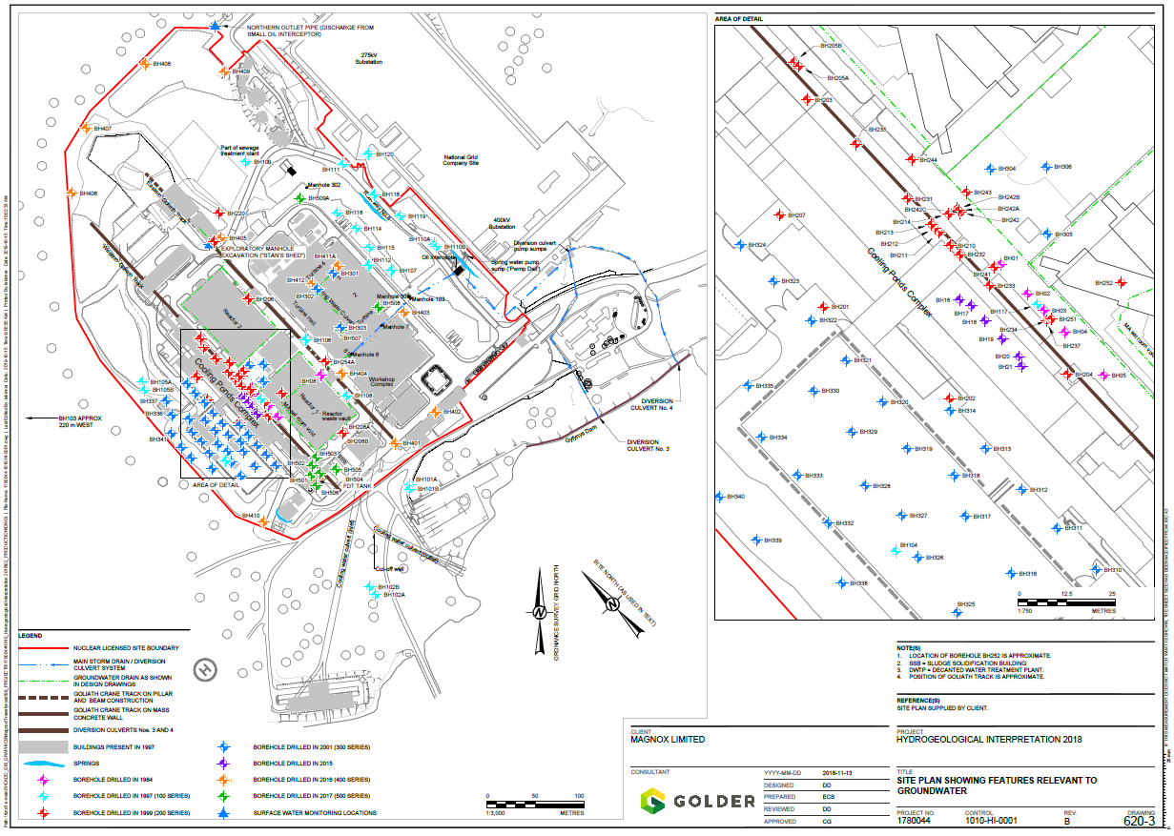
Figure 2 “6” series borehole plan


