Environmental Permitting (England and Wales) Regulations 2016
Regulation 37(12)

WITHDRAWAL OF SUSPENSION NOTICE

To: Gill Waste Recycling Limited
Llanover House
Llanover Road
Pontypridd
Mid Glamorgan
CF37 4DY

Environmental permit: EPR/GP3191SA
Regulated facility: Waste Transfer Depot, Motorworks, Penrhiwfer Road, Williamstown, Rhondda Mid Glamorgan, CF40 1RL

With immediate effect the suspension notice dated 24 April 2023 served under regulation 37(1) of the Environmental Permitting (England and Wales) Regulations 2016 relating to the above environmental permit is withdrawn.

Date: 21 January 2024 Signed: 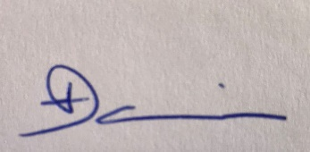
Eleanor Davies
Team Leader, South Central Waste Regulation

Natural Resources Wales
Rivers House
St Mellons Business Park
St Mellons
Cardiff
CF3 0EY

Legislation note
In this document “Natural Resources Wales” means the Natural Resources Body for Wales established by Article 3 of the Natural Resources Body for Wales (Establishment) Order 2012. On 01 April 2013 the Natural Resources Body for Wales (Functions) Order 2013 transferred the relevant functions of the Countryside Council for Wales, and functions of the Environment Agency and the Forestry Commission in Wales to the Natural Resources Body for Wales.

