PAN-033202 Mymap Report
Deployment boundary

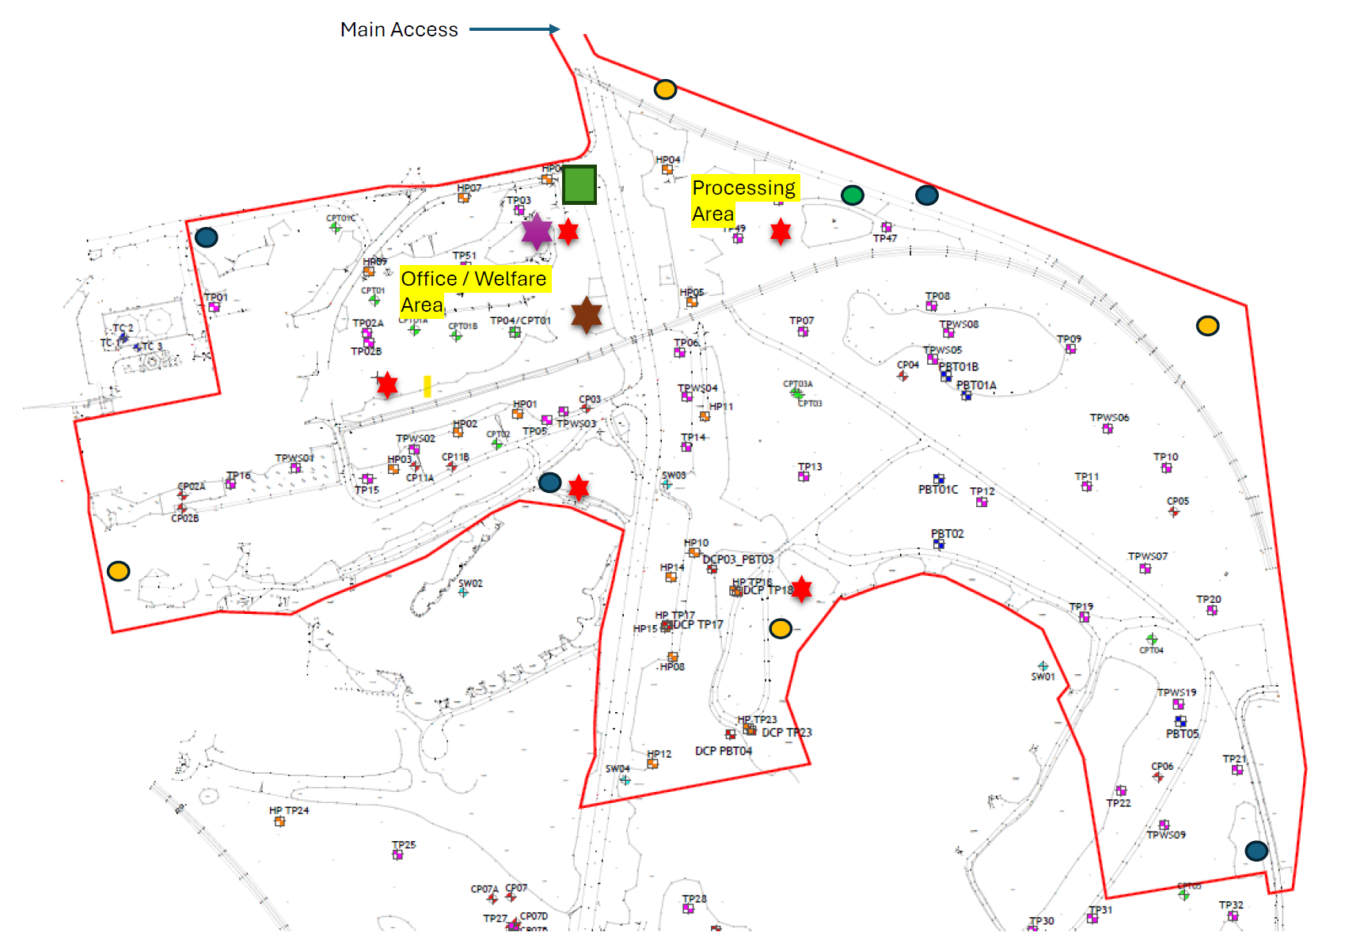
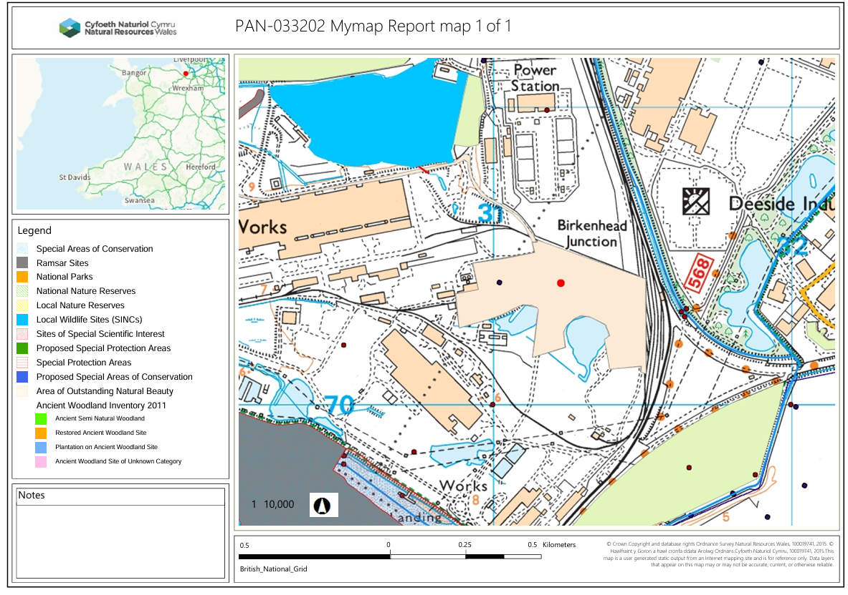
MyMap summary map

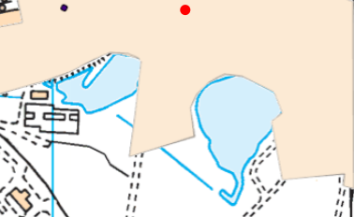
Controlled waters such as rivers and lakes
There are two ponds located close to deployment boundary. These have been considered in the provided CSM.

Special protection areas (SPA) Potential special protection areas (pSPA)
The Dee Estuary (Wales) SPA is located 549 meters from the deployment boundary.

Special areas of conservation (SAC)Candidate special areas of conservation (cSAC),
Ramsar
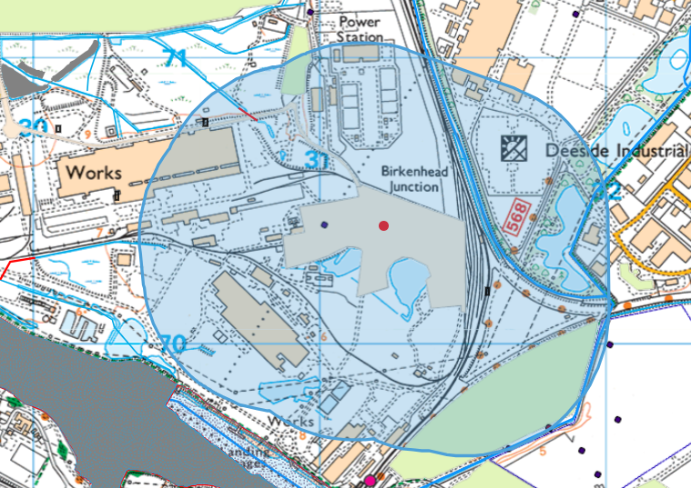
Site of Special Scientific Interest (SSSI)

None within 500 meters of the deployment boundary.

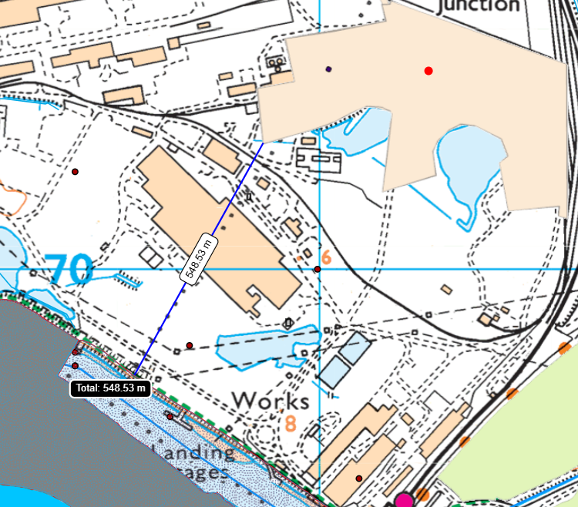
However, the deployment boundary is within 549 metres of the:
- Dee Estuary / Aber Dyfrdwy (Wales) SAC
- River Dee and Bala Lake / Afon Dyfrdwy a Llyn Tegid (Wales) SAC
- The Dee Estuary (Wales) SPA
- Dee Estuary /Aber Afon Dyfrdwy SSSI
- Afon Dyfrdwy (River Dee) SSSI
- Shotton Lagoons and Reedbeds SSS1 (969 metres).
- The Dee Estuary (Wales) RAMSAR
An appendix 4 for information purposes has been saved to the DMS.
No form 1 has been completed but has been included in the decision document of the deployment.

Ancient woodland None in range.

Areas of Outstanding Natural Beauty (AONB) None in range.

Heritage Coast None in range.

Local nature reserves None in range.

Local wildlife sites
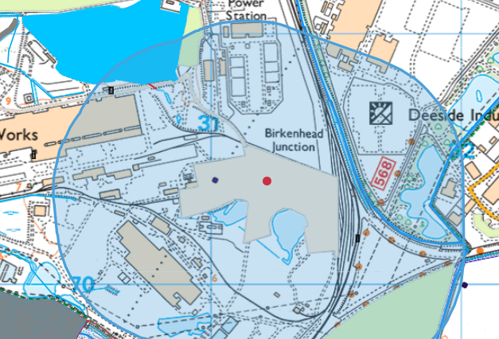
The deployment boundary is located 379 meters from the Shotton Steelworks SINC. The submitted deployment application has included this receptor in the conceptual site model.

National nature reserves none in range.

National parks none in range.

Scheduled ancient monuments none in range.

World Heritage Sites none in range.

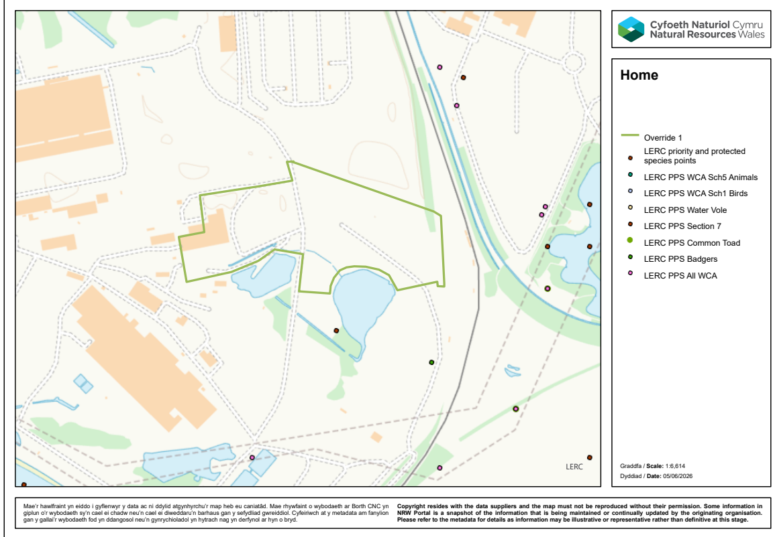
European Protected Species, Nationally Protected Species, Section 7 Priority species
None in range.

Section 7 Priority habitats –
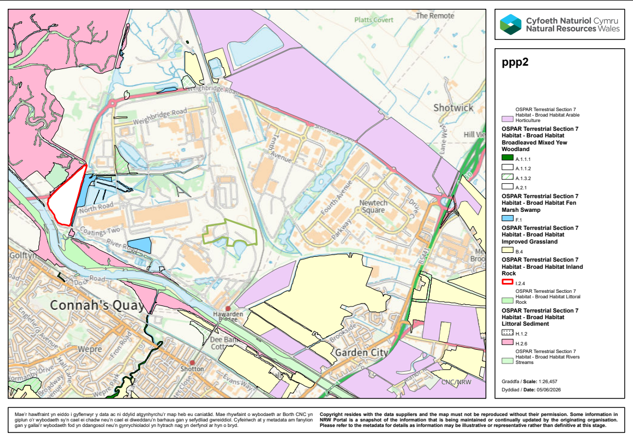
None in range.

