Annex (iv) – SSSI Assessment Form
SSSI Assessment for permit/licence and deployment applications | 
To be completed by Permitting Officers for any applications for a permission which Natural Resources Wales has considered under S28I duty to notify SNCB and take their advice into account. This applies to all proposed permissions within a SSSI, and to operations outside the SSSI boundary which are likely to damage its special features.
NRW as a Section 28G authority has, when exercising its functions, a general duty to take reasonable steps, consistent with the proper exercise of its functions, to further the conservation and enhancement of the flora, fauna or geological or physiological features by reason of which the site is of special interest’

Part 1 – SSSI Assessment
Part 2 – Formal notification to SNCB (to be completed if part 1 assessment concludes likely damage, not likely to damage because of conditions or you cannot conclude no likely damage)
Part 3 – Decision

Part 1 – SSSI Assessment

- Permitting officer/team | Owen Clee  Waste Permitting Team
- Permit application reference and site name | PAN-033202
- a. SSSI name(s)  b. location  c. NRW Operational Area/Environment Team | a. Dee Estuary /Aber Afon Dyfrdwy SSSI &  Afon Dyfrdwy (River Dee) SSSI & Shotton Lagoons and Reedbeds SSSI  b. Deeside Industrial Park, Weighbridge Road, Deeside, CH5 2NH,  River Dee Estuary & River Dee grid ref: SJ 311695, Shotton lagoons and reedbeds SSSI SJ 29938 70903.  c. Northeast Wales waste reg, Flintshire & Wrexham environment team  The deployment boundary is located within 3 SSSIs over a distance of 1km this includes:  - Dee Estuary /Aber Afon Dyfrdwy SSSI (555 metres)  - Afon Dyfrdwy (River Dee) SSSI (555 meters)  - Shotton Lagoons and Reedbeds SSSI (969 meters)  A map of this can be found below.  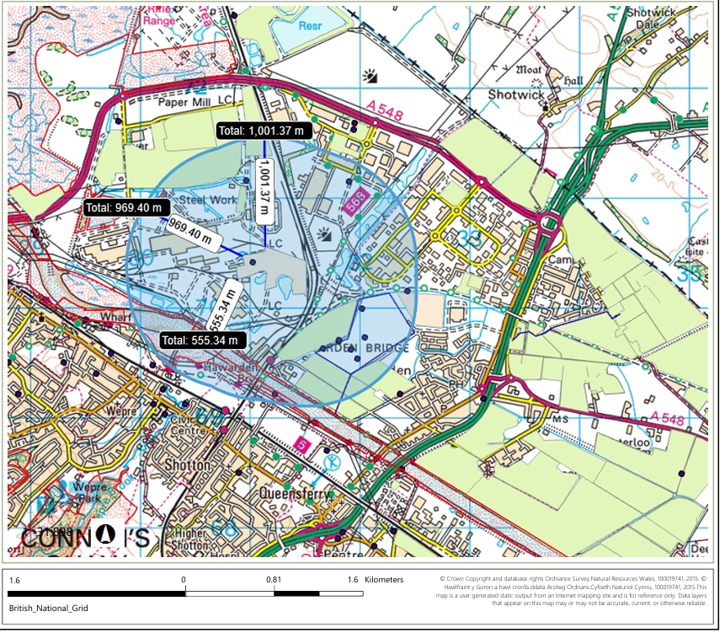
- Brief description of proposal | This is a land remediation deployment for works at Shotton Steelworks, Zone 4, Deeside Industrial Park, CH5 2NH, for the treatment of site-derived waste materials arising from remediation and redevelopment works. The deployment is proposed for a duration of 12 months or less and forms part of the wider redevelopment of the former Shotton Steelworks site.  The deployment will use mobile screening and particle size reduction equipment to process excavated waste materials to produce geotechnically suitable materials for reuse within the development. The treatment is intended to facilitate remediation and engineering reuse and does not involve chemical treatment processes. The applicant is deploying under an English permit (SR2008 No27) which allows for treatment plant for sorting and separation, particle reduction without further treatment (No biological or chemical treatment processes are proposed).  The following waste streams are proposed for treatment:  The total quantity proposed for treatment is approximately 160,000 m³, of which the majority comprises soils and stones classified as hazardous waste under EWC code 17 05 03* due to elevated metal concentrations.  The treatment activity consists of:  - Screening and separation of materials.  - Particle size reduction/crushing of soils, brick and concrete.  - Removal of oversized materials.  - Production of materials meeting geotechnical specifications for reuse within the development.  - Associated storage, handling and stockpiling activities.  The deployment distinguishes between:  - General made-ground materials, including soils classified as hazardous under WM3 (17 05 03*), which are proposed for treatment and reuse.  - Hotspot or visibly contaminated materials, which are excluded from treatment operations.  Hydrocarbon-impacted or otherwise unsuitable materials will be segregated and transferred to a dedicated quarantine area (impermeable with sealed drainage) for characterisation and subsequent off-site treatment or disposal at suitably permitted facilities. Hazardous waste consignments will be managed using the appropriate waste transfer documentation.  A quarantine area with an initial capacity of approximately 1,000 m³ is proposed. The quarantine area will comprise an impermeable engineered containment area with blocked drainage and collection arrangements for contaminated runoff and leachate.  Treatment and stockpiling of the general site materials will be undertaken on existing ground surfaces and/or compacted running platform areas rather than on a purpose-built impermeable treatment pad. The applicant has requested that NRW agree a departure from the default requirement in Table 2.3 of SR2008 No.27 for hazardous soils to be stored and treated on impermeable surfacing with sealed drainage.  The justification given by the applicant were given in the request for information response dated 17/07/26 and included:  - The wastes have been assessed through the Land Contamination Risk Management (LCRM) process and are considered suitable for reuse.  - The treatment is physical only and does not increase contaminant concentrations.  - Hotspot contamination will be removed from the process stream and managed separately.  - The activity is temporary and restricted to defined operational areas.  - Pollution prevention and inspection procedures will be implemented during operations.  From the justifications given we have accepted this in addition to the proximity of the SSSIs to the deployment boundary being over 500 meters. No impact pathway was identified the applicant has provided a Conceptual Site Model and monitoring plans that have adequately mitigated risk to the Dee Estuary /Aber Afon Dyfrdwy SSSI & Afon Dyfrdwy (River Dee) SSSI & Shotton Lagoons and Reedbeds SSSI.  For further information application documents can be found on the DMS.
  Waste Type | EWC Code | Quantity (m³) | Treatment
  Concrete | 17 01 01 | 20,000 | Screening and particle size reduction
  Brick | 17 01 02 | 10,000 | Screening and particle size reduction
  Soils and stones containing elevated metals | 17 05 03* | 130,000 | Screening and particle size reduction
- What aspects of the proposed permission are likely to damage the SSSI features of special interest?

The following activities are likely to cause damage:

Dee Estuary /Aber Afon Dyfrdwy SSSI

- Dumping, spreading or discharging of any materials.
- Infilling or digging of ditches, drains, ponds, pools, marshes, quarries or pits.
- Extraction of minerals including peat, shingle, hard rock, sand and gravel, topsoil, subsoil, shells and spoil.
- Destruction, construction, removal, rerouting, or regrading of roads, tracks, walls, fences, hardstands, banks, ditches or other earthworks, including soil and rock exposures.
- Storage of materials.
- Erection of permanent or temporary structures or the undertaking of engineering works, including drilling or the laying, maintenance or removal of pipelines and cables, above or below ground.

Afon Dyfrdwy (River Dee) SSSI

- Dumping, spreading or discharging of any materials.
- Infilling or digging of ditches, dykes, drains, ponds, pools, marshes, oxbows, backwater channels, mill leats/races, quarries or pits
- Extraction of minerals including peat, shingle, hard rock, sand and gravel, topsoil, subsoil, shells and spoil.
- Destruction, construction, removal, rerouting, or regrading of roads, tracks, walls, wells, fences, hardstands, banks, ditches or other earthworks, including soil and rock exposures.
- Storage of materials.
- Erection of permanent or temporary structures or the undertaking of engineering works, including drilling or the laying, maintenance or removal of pipelines and cables, above or below ground.

Shotton Lagoons and Reedbeds SSSI

- Dumping, spreading or discharging of any materials.
- Infilling or digging of ditches, drains, ponds, pools, marshes or pits.
- Extraction of minerals including shingle, hard rock, sand and gravel, topsoil, subsoil and spoil.
- Destruction, construction, removal, rerouting, or regrading of roads, tracks, wells, fences, hardstands, banks, ditches or other earthworks, including soil and rock exposures.
- Storage of materials.
- Erection of permanent or temporary structures or the undertaking of engineering works, including drilling or the laying, maintenance or removal of pipelines and cables, above or below ground.

The following SSSI(s) features and potential impacts have been considered to assess the likelihood of damage:

Dee Estuary /Aber Afon Dyfrdwy SSSI

Habitats

- Sub-tidal creeks and channels,
- Rocky and sand dunes/shingle.
- Inter-tidal mud and sand flats
- Salt marsh
- Reeds and swamp/other freshwater transitions
- Maritime cliff with its associated heath land and grassland vegetation on Hilbre Island
- Hard inter-tidal habitat including rocky shores
- A range of strandline, fore dune and mobile sand dune communities and the presence of sand hill rustic moth
- Coastal grazing marsh

Birds

- Waterfowl
- Wader
- Shelduck
- Teal
- Pintail
- Wigeon
- Knot
- Black-tailed godwit
- Bar-tailed godwit
- Oystercatcher
- Dunlin
- Redshank
- Grey plover
- Curlew
- Great crested grebe

Fish

- Sea lamprey
- River lamprey

Plants

- Portland spurge
- Dune fescue
- Slender hare’s ear
- Rock sea lavender
- Limonium britannicum celticum;
- White mullein

Afon Dyfrdwy (River Dee) SSSI

Fish

- Salmon
- Bullhead
- Brook Lamprey
- River Lamprey
- Sea Lamprey

Mammel

- Otter

Invertebrates

- Club-tailed dragonfly
- Stonefly
- Isogenus nubecula
- weevil Baris lepidii)

Plants

- Floating water plantain
- Four river habitat types Saltmarsh transition habitats Vascular plants (slender hare’s-ear, sea barley, and hard-grass)

Geological features

- Natural exposures of Upper Carboniferous rocks at Dee Bridge Geology
- Fluvial landforms and processes related to the development of the River Dee

Shotton Lagoons and Reedbeds SSSI

- Population of breeding common tern
- Reedbeds

Potential impact pathways assessed

Dust

This deployment is screening and crushing aggregates wastes so there is the potential for dust emissions from the deployment. Dust emissions can negatively affect the SSSIs due to physical smothering of plants affecting photosynthesis and respiration. There can also be chemical changes/toxicity issues depending on the dust’s composition and potential for changes in soil pH which could disrupt the habitat of for the species in the habitats. This also includes the Estuary environment and riverbed. See section 7 of the appendix 4 on why dust has been ruled out as an impact pathway for the Dee Estuary /Aber Afon Dyfrdwy SSSI, Afon Dyfrdwy (River Dee) SSSI, Shotton Lagoons and Reedbeds SSSI.

Groundwater

As this deployment will use mobile screening and particle size reduction equipment to process and excavate waste materials to produce geotechnically materials for reuse there is a risk to groundwater as the earth is being disrupted and changes to local drainage. See section 7 of the appendix 4 on why groundwater risks have been ruled out as an impact pathway for the Dee Estuary /Aber Afon Dyfrdwy SSSI, Afon Dyfrdwy (River Dee) SSSI, Shotton Lagoons and Reedbeds SSSI.

- Summary of any informal advice received from internal experts (if required and including pre-app advice). | Yes, the deployment application has been internally consulted on as part of the deployment process. However, no responses where received.
- Recommendation | The proposed permission is not likely to damage any of the flora, fauna or geological or physiological features which are of special interest.  Dust controls  - This deployment is not likely to damage the SSSI features from dust emissions because the deployment boundary is located over 550 meters from all SSSI locations. It is highly unlikely if a dust emission did occur that it could cause detriment to the SSSI due the dust dispersing/ diluting in the air over the distance to the SSSI. A dust emission on this scale is also very unlikely due to the deployment’s strict controls on dust controls as outlined in the applications pollution control measures and conceptual site model. This includes the following:  - Dust control measures shall be undertaken to the satisfaction of the Site Manager, the Supervisor and the Client always and works will be stopped if acceptable measures are not in place or being utilised.  - Dust control measures will include as a minimum the damping down of the site with water during periods of dry weather, Using spray bars on crushing activities.  - Dust monitoring works shall be undertaken. static directional frisbee gauges will be deployed around the site perimeter to monitor for the deposition of total suspended particulates.  - If dust levels are a nuisance site-wide, works shall be stopped and contingency measures for dust shall be implemented before works can recommence.  - In the instance of the trigger level being breached, further research will be carried out to determine the source of the elevated levels. If it is concluded that it was a result of site activities, immediate action will take place to mitigate dust levels on the site, such as increasing the frequency of dust suppression and ensuring long-term stockpiles are covered with polythene sheeting. If the problem persists, working practices will be reviewed to keep the airborne dust to a minimum.  - Parameters above exposure standard. Action will be to stop site works, investigate reason and modify ongoing works  - Substantial stockpiles will be located away from sensitive receptors.  - Machinery undertaking particle size reduction to facilitate remedial action and material stockpiles will be located away from sensitive receptors.  - Haul routes will be damped down utilising a tractor towed bowser or equivalent as required.  - For the sake of sustainability encountered processed water may be used for dust suppression. Prior to use water will be deemed suitable via chemical testing and visual appearance.  - Appropriate site speed limits will be enforced.  - Effective vehicle cleaning including a jet wash as required.  - Jet wash bowsers with spray attachments or equivalent will be used to damp down stockpiles / haul routes as required.  - Consideration will be given to placement of debris netting/polythene sheeting if material stockpiles are to remain for extended periods.  - All plant will be modern and fitted with integral dust suppression technology.  - Site personnel will be fully trained and operate plant and equipment in accordance with manufacturers guidelines.  - A trained and responsible manager will be on site during working periods to maintain a logbook and carry out site inspections.  - Daily visual monitoring and monitoring with the use of a hand-held device will be undertaken by trained staff at boundary monitoring locations, with records maintained in accordance with company procedures.  - Static dust deposition (Frisbee) gauges will be deployed, for with data compared against the 200mg/m2/day boundary limits.  - Vehicles will be prevented from idling and all potentially dusty loads entering and leaving site will be covered.  Groundwater controls  - This risk is negligible as the type of materials destined to be processed assessed by the LCRM is suitable for reuse. The non-chemical processing of the made ground to generate a suitable geotechnical material will not increase the risk profile of this ‘acceptable for use’ material, and therefore a Hotspot material shall be managed in accordance with the Interim Remedial Options Appraisal, Remediation Strategy and Verification Plan. These hotspot materials may present a risk to ground and controlled waters, although anticipated volume is minimal. Appropriate hotspot management shall be additionally protective of the downstream works of materials processing.  - LCRM assessments concluded the general site materials do not present an unacceptable controlled waters risk.  - Only material falling within the defined deployment acceptance criteria will be processed. Known hotspot material, visibly or olfactorily impacted material, and other suspect material will be excluded and transferred to the designated quarantine area which contains sealed drainage and impermeable surfacing.  - The deployment is located entirely within an existing industrial site, and no treatment, storage or excavation activities will take place within the SSSI boundaries. The notified habitats, species and geological interests of the Dee Estuary/Aber Afon Dyfrdwy SSSI, Afon Dyfrdwy (River Dee) SSSI and Shotton Lagoons and Reedbeds SSSI are separated from the deployment by existing industrial infrastructure and substantial stand-off distances. Therefore, in the absence of a viable pollutant pathway, damage to the notified features is not expected.  - The proposed activity will not involve the addition of water activities, i.e. abstraction or discharging  - A compacted running platform formed from suitable inert material will be constructed to provide a stable and maintainable working surface. The platform will be inspected and maintained throughout the deployment.  - Treatment is limited to physical screening, crushing and sizing and does not involve chemical treatment.  - The material being processed is effectively the same material already present across the site, and they contend the activity will not materially increase contaminant release.  - No known active drainage runs have been identified within the proposed processing area.  - stockpiles will be located away from drains, boreholes and other preferential pathways;  - Stockpile height, footprint and storage duration will be minimised and controlled  - Exposed surfaces and stockpiles will be managed to minimise erosion, dust and sediment generation  - Operations will be reviewed or temporarily suspended during extreme rainfall or where the working surface cannot be maintained effectively.  - Daily visual inspections will be undertaken for runoff, ponding, erosion, staining, odour and deterioration of the working surface.  - Spill kits and incident-response procedures will be maintained at the operational area.
- Signature and date assessment made | Owen Clee  24/07/2026
- Officers name and job title | Owen Clee  Waste permitting Officer

