PAN-030617 My Map Report: -
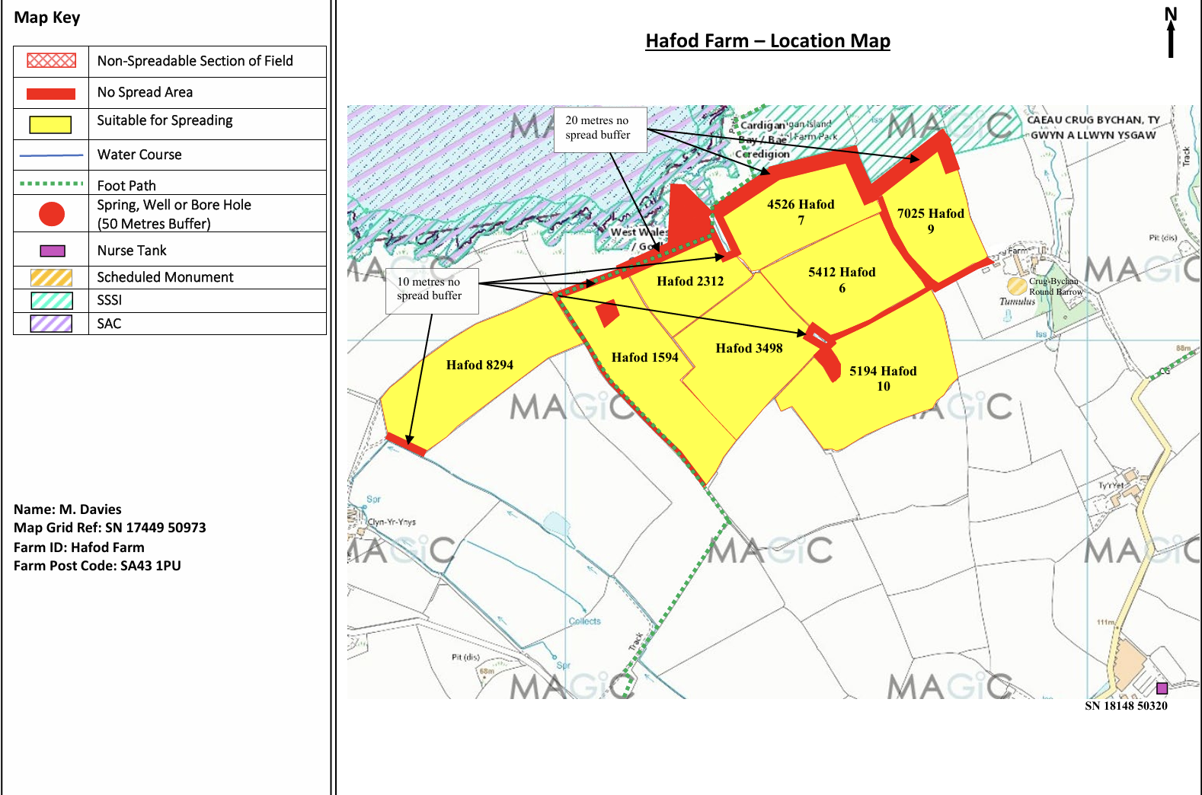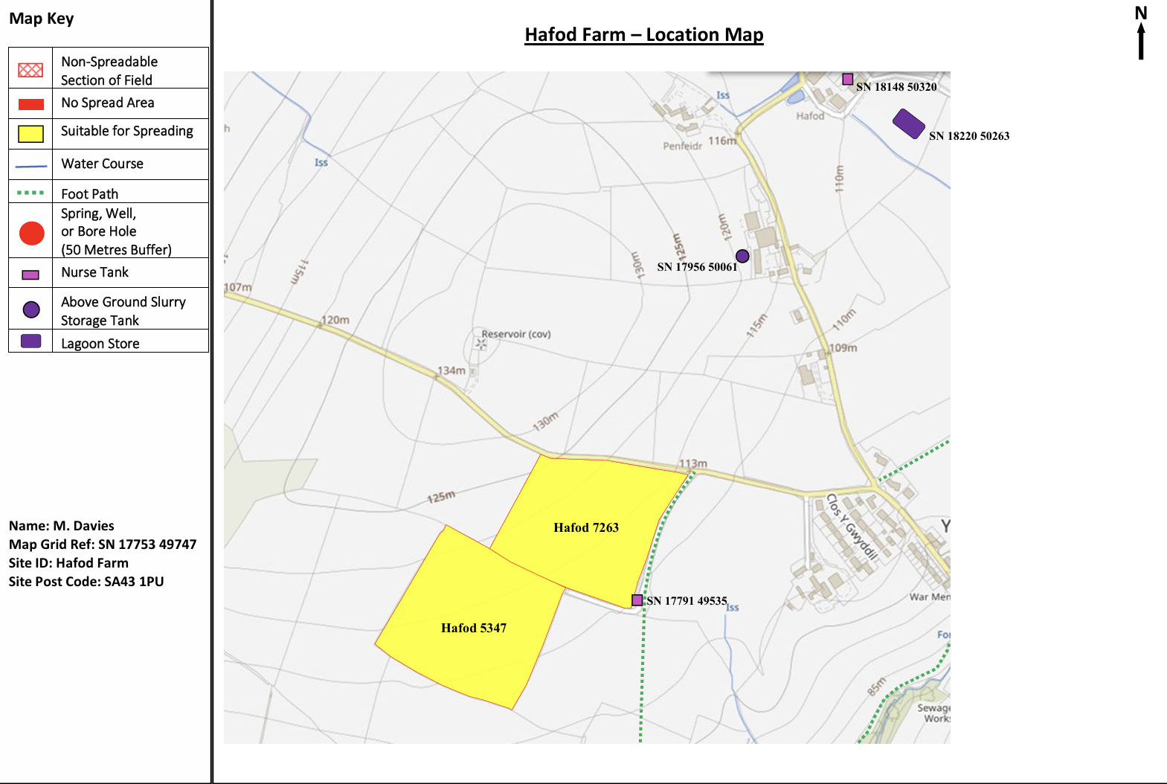

Detailed river network:
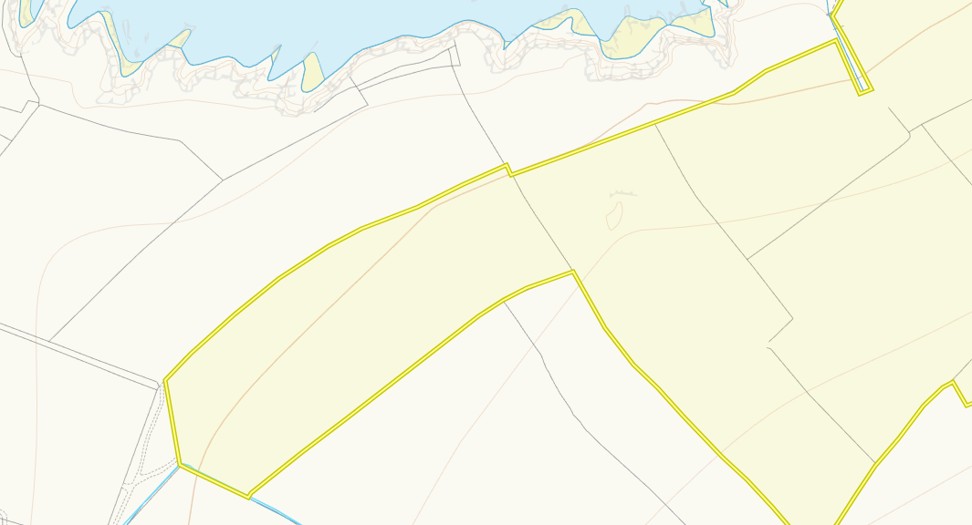
Modified attributions border 8294, 2312 and 7. These have been identified and appropriate 10m buffer zones have been imposed. No action required.
Groundwater protection zones (source)
None in range
any well, spring (or issue) or borehole used for the supply of water for human consumption including from a private water supply or supplies.
None in range
any spring (or issue), well or borehole not used to supply water for domestic or food production purposes within 50m

any spring (or issue), well or borehole used to supply water for domestic or food production purposes within 250m
None in range
European designated sites- Natura 2000 (SPA, pSPA, SAC or cSAC) or Ramsar- or SSSI within 500m

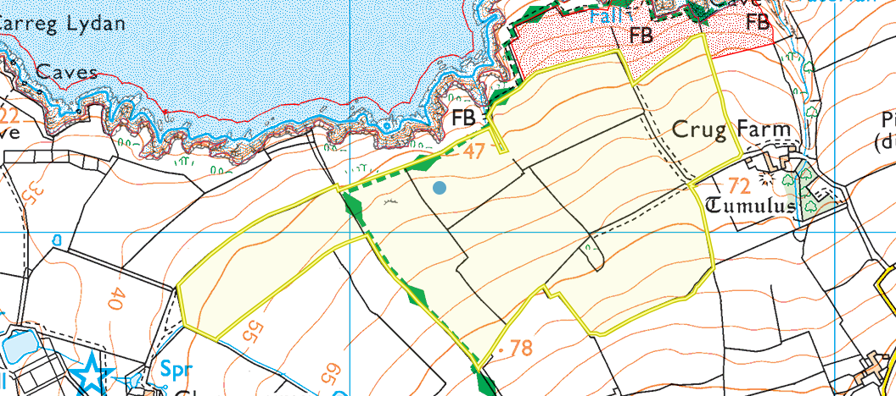
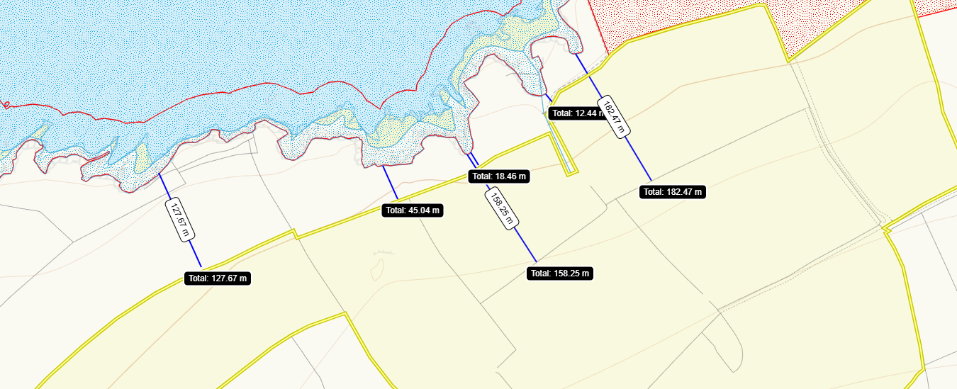
On the border is Caeau Crug Bychan, Ty Gwyn a Llwyn Ysgaw SSSI and Aberath Carreg Wylan SSSI is around 12m from the border.
Cardigan bay SAC west wales marine SAC is around 12m from the border of spreading fields.
Other Other protected sites:
- Protected Species and Protected Habitats-
- 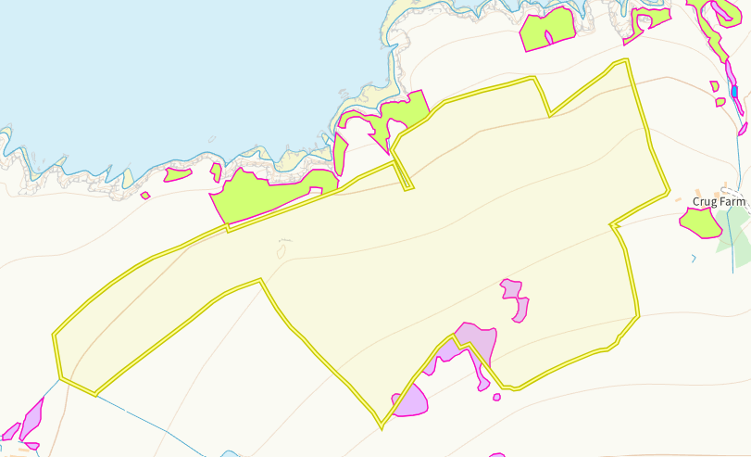
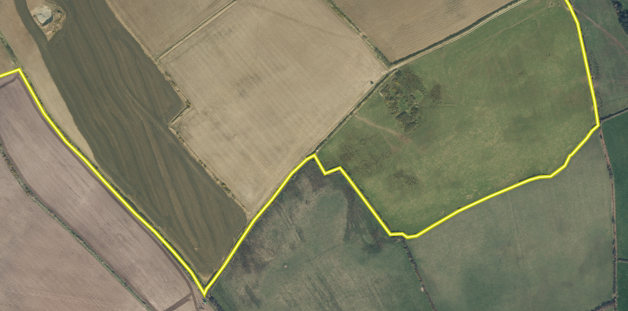

Purple moor grass and rush pastures are seen within the spreading area but from ariel imagery this is not evident in the fields. The main area in the center of the field has also been buffered. No action required.

- Scheduled Ancient Monument- None in range
- Local Nature Reserve- None in range
- National Nature Reserve- None in range
- Ancient Woodlands-
- Local Wildlife Sites (SINC)- None in range
- National Park- None in range
- Groundwater Safeguard Zone- None in range
- ANOBs- None in range
- Hedges, Ditches- Nothing of concern
- Local residents, Housing, schools, Workplaces, Recreational facilities – Identified in OMP

Sloping map
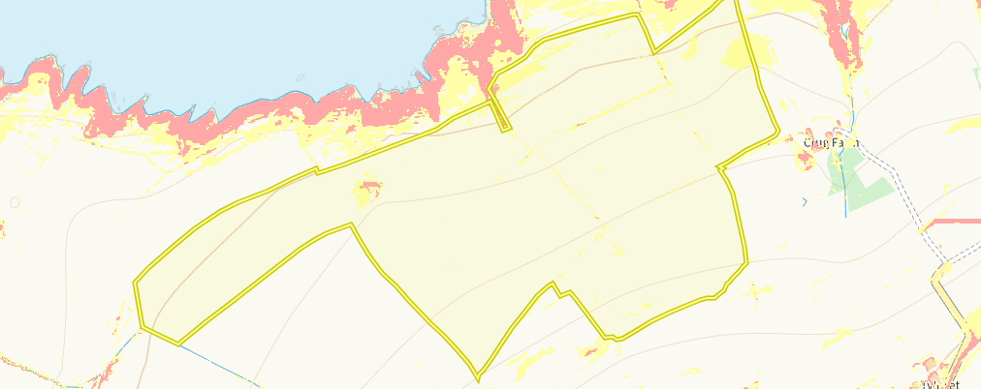

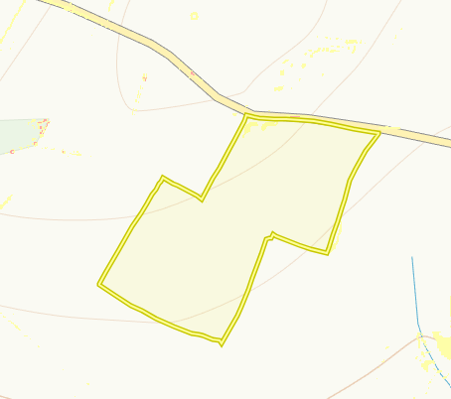

7 -12 degrees (Yellow)- fields Hafod 6, 7, 9, 10,3498, 7263, 1594 12 degrees plus (Red)- fields Hafod 7, 1594. The sloping of the land is in very limited areas. The majority of the spreading areas is flat land. The main areas of slope within the field are buffer areas. Additional buffers are in place to the SAC and SSSI. The waste applications are low with the max 50t/ha and being spread by a precise dribble bar method. Run off risk is low.

