Record of a Habitats Regulations Assessment of a project or spatially-specific plan
OGN 200 Form 1A

- Plan or Project Details 3
- Determining the need for a Habitats Regulations Assessment 6
- Considering the likelihood of a significant effect (LSE) 6
- Conclusion 10
- Consultation with the ANCB and how sections 2, 3 and 4 of this HRA report (as applicable) take into that advice 11

OGN 200 Form 1A

Record of a Habitats Regulations Assessment
Plan or project name, brief description or application reference number | Same terms renewal of abstraction licence WA/056/0053/005  PAN-030960

HRA iteration/version | N/A

1. Plan or Project Details
Information about the plan or project
1 | Date application received | 17/11/2025
2 | Applicant details | Stuart Price and Margaret Eirlys Price trading as SH&ME Price
3 | NRW team responsible for carrying out, or requiring to be carried out, the plan or project, and name of lead officer | N/A
4 | Activity/ies proposed | Licenced activity - hydropower scheme comprising of a concrete weir with a stainless steel plate with 3 millimetre perforations, intake tank equipped with a 280 millimetre external diameter gravity feed penstock pipe, HoF notch, split flow channel, turbine, and discharge pipe.  The activity is non-consumptive with the discharge point conditioned in the licence. The licence also conditions fish screening at the intake and discharge points, along with a pre-barrage fish easement to aid fish passage across the scheme.  The scheme is already constructed but may require maintenance. The licence has a condition requiring the Licence Holder to ensure water quantity and quality are not affected during maintenance activities.  The current licence expires 31/03/2026 and the Licence Holder is seeking a same terms renewal to the next catchment common end date.
5 | Relevant legislation or statutory basis | The new licence will be issued under the following legislation:  Environment Act 1995  Water Resources Act 1991 as amended by the Water Act 2003  Water Resources (Abstraction and Impounding) Regulations 2006  Article 3 of the Natural Resources Body for Wales (Establishment) Order 2012  The Natural Resources Body for Wales (Functions) Order 2013
6 | Location | The abstraction is located on the Nant Cwm-du near Senni, Brecon at NGR SN 93942 21588. Map below is taken from the current licence. Point A is the abstraction point and Point Q the discharge point.  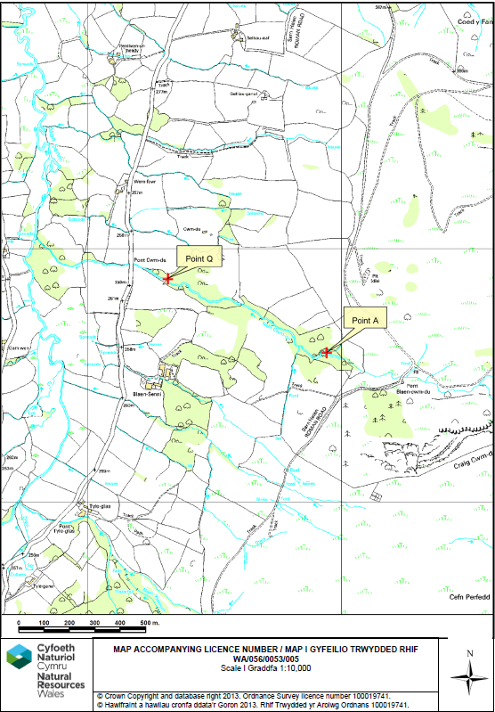
7 | Plan or project documents, including any application documents | Application form WRI can be found in the DMS folder dated 17/11/2025. No further additional plan or project documents were provided to support this renewal application.
8 | Environmental Statement (ES) | N/A
9 | Pre-application correspondence | N/A
10 | NRW team responsible for preparing this HRA report, and lead officer | Water Resources Permitting Team  Sarah Senior (Water Resources Permitting Officer)
11 | Team or person responsible for approving the plan or project (competent authority role) | As per row 10

2. Determining the need for a Habitats Regulations Assessment
2.1 Is there any possibility that the plan or project could negatively affect any European sites? | Yes
2.2 Is the whole of the plan or project directly and only connected with or necessary to the management of one or more European sites, for the purposes of conserving the habitats or species for which the European site(s) is/are designated? | No
2.3 Is there a possibility that the plan or project could affect any other feature of the European site(s) concerned, or of another European site, in a way that would undermine that feature’s conservation objectives? | Yes

3. Considering the likelihood of a significant effect (LSE)

3.1 Renewal of a project authorisation on the same or more restrictive terms as an extant authorisation
Is this a renewal of an extant authorisation which complies with NRW approved criteria for ruling out significant effects of renewals (see Part 2 of OGN200) without conducting a project-specific LSE test? | No

3.2 Likelihood of significant effects (LSE) test

3.2.1 Which European sites might be affected by the plan or project?
(a) | Based on the plan or project specification, or information provided in the application, it is considered that these European sites have features which could be negatively affected by the plan or project | Severn Estuary (Wales) Ramsar, SAC and SPA – ~110.5km downstream of the scheme  Afon Wysg / River Usk SAC – ~1.3km downstream of the abstraction point and ~580m downstream of the depleted reach  (Note: an Appendix 11 was completed for the Afon Wysg / River Usk SAC during the determination of the original application, but a new assessment is being undertaken for this application to ensure the overall conclusion is clearly laid out. No assessment was made for the Severn Estuary site during the original determination.)
(b) | The potential for the plan or project to negatively affect these European sites was also initially considered, but can be ruled out without further consideration | N/A

3.2.2 Screening for likelihood of significant effect

TABLE 3.2.2 Screening assessment
European site name: Afon Wysg / River Usk SAC
Features of interest
- The following feature can be SCREENED OUT (ie the likelihood of a significant effect can be ruled out without further assessment) due to the non-consumptive nature of the activity, the activity is not sited within the SAC, and the feature is not mobile – Watercourses of plain to montane levels with the Ranunculion fluitantis and Callitricho-Batrachion vegetation.

- The following features require further consideration due to their migratory nature – Sea lamprey (Petromyzon marinus); Brook lamprey (Lampetra planeri); River lamprey (Lampetra fluviatilis); Twait shad (Alosa fallax); Allis shad (Alosa alosa); Atlantic salmon (Salmo salar); Bullhead (Cottus gobio); and European otter (Lutra lutra)

During the original determination, it was noted that Atlantic salmon use the Nant Cwm-du for spawning. Also, at an NRW fish survey site, just downstream of the scheme, brown trout, Atlantic salmon, bullhead, and eel had been discovered. Despite concern that the applied for peak abstraction rate and flow split (60%) could significantly impact the habitat available for these features in the depleted reach, modelling demonstrated that there would be no significant impact on flows compared to a 40% take (recommended in NRW guidance for this type of scheme). The abstraction regime was therefore considered sufficient to maintain fish populations within the depleted reach. So for the activity, as applied for, these features could be SCREENED OUT when considered alone.

It is possible otters from the SAC may be found around the abstraction point, discharge point, and depleted reach, although none have been recorded any closer than ~3km downstream on the Afon Senni. As the activity is not expected to impact flows in the depleted reach (as noted above) there should also be no impact on the suitability of the habitat to provide areas for otters to set up holts, find prey etc. So for the activity, as applied for, these features could be SCREENED OUT when considered alone.

The need for an incombination assessment of likelihood of significant effects (LSEs) was considered, but is not required as there are no other new abstraction licence applications in the Nant Cwm-du, the Afon Senni, nor nearby tributaries of the Afon Senni.

European site name: Severn Estuary (Wales) Ramsar, SAC and SPA
Features of interest
- The following features can be SCREENED OUT (ie the likelihood of a significant effect can be ruled out without further assessment) due to the non-consumptive nature of the activity, the distance of the site away from the activity, the non-mobile nature of most features, and the lack of usage of the upstream catchment by the mobile features – Estuary; Subtidal sandbanks; Intertidal mud and sand; Atlantic salt meadow / salt marshes; Reefs; Assemblage of fish species (>100 species); Internationally important populations of migratory bird species; Internationally important populations of wintering bird species; Assemblage of nationally important populations of waterfowl; Hard substrate habitats (rock shores); and Freshwater grazing marsh / Neutral grassland.

- The following features require further consideration due to their migratory nature – Migratory fish (river and sea lamprey and twaite shad); and Migratory fish (salmon, eel, sea trout and Allis Shad).

During the original determination, it was noted that Atlantic salmon use the Nant Cwm-du for spawning. Also, at an NRW fish survey site, just downstream of the scheme, brown trout, Atlantic salmon, bullhead, and eel had been discovered. Despite concern that the applied for peak abstraction rate and flow split (60%) could significantly impact the habitat available for these features in the depleted reach, modelling demonstrated that there would be no significant impact on flows compared to a 40% take (recommended in NRW guidance for this type of scheme). The abstraction regime was therefore considered sufficient to maintain fish populations within the depleted reach. So for the activity, as applied for, these features could be SCREENED OUT when considered alone.

The need for an incombination assessment of likelihood of significant effects (LSEs) was considered, but is not required as there are no other new abstraction licence applications in the Nant Cwm-du, the Afon Senni, nor nearby tributaries of the Afon Senni.

TABLE 3.2.3 Screening decision of the plan or project ‘alone’
(a) If the screening conclusion for all features for all sites in Table 3.2.2 is ‘SCREEN OUT’ | The plan or project is not likely to have a significant effect on any European site, and no further consideration under the Habitats Regulations is required in order to determine the approval/application.
(b) If the conclusion for any features in Table 3.2.2 is ‘SCREEN IN’ | The plan or project is likely to have a significant effect on one or more European sites and therefore an appropriate assessment is required.
(c) If there are no features in Table 3.2.2 that are ‘SCREEN IN’ and any features that are ‘IN COMB’ | The plan or project is not likely to have a significant effect on any European sites when considered alone, but the possibility of significant effects in combination with other plans and projects needs to be considered.

4. Conclusion
HRA is not required because there is no conceivable impact on any European sites.
(As documented in section 2.1)
HRA is not required because the whole of the plan or project is directly connected with or necessary to the management of one or more European sites, for the purposes of conserving the habitats or species for which the site(s) is/are designated, and the plan or project is not likely to have a significant effect on any other European sites.
(As documented in section 2.2 and 2.3)
This project is a renewal of a current permission which complies with NRW agreed criteria for ruling out likely significant effects of a renewal without conducting a project-specific LSE test. Therefore, it is considered not likely to have a significant effect on any European sites, either alone or in-combination with other plans or projects.
(As documented in section 3.1 of this form)
The plan or project has been screened for likelihood of significant effects and is considered not likely to have a significant effect on any European sites. (As documented in section 3.2 of this form, and section 5 if applicable) | X
In light of the conclusions of an appropriate assessment it has been established that the plan or project will not adversely affect the integrity of any European sites, taking into account any conditions or restrictions as applicable, either alone or in-combination with other plans or projects.
(As documented in section 4 of this form, and section 5 if applicable)
In light of the conclusions of the appropriate assessment, it has not been ascertained that the plan or project will not adversely affect the integrity of any European sites, as documented in section 4 of this form, and section 5 if applicable.
Approval for the plan or project cannot be given unless either:
- the plan or project specification, and/or the terms under which it might be approved, are modified so as to remove the risk of adverse effects, and a revised HRA is prepared, or
- the plan or project (not being an SSSI consent*) satisfies the requirements for a derogation and a Derogation Notice is prepared and submitted for consideration by the appropriate authority, normally Welsh Ministers
(*SSSI consents cannot be given as derogations)
Signed: Sarah Senior Position: Water Resources Permitting Officer Date: 15/07/2026
Was this HRA conclusion an escalated decision? YES or NO | No

5. Consultation with the ANCB and how sections 2, 3, 4 and 5 of this HRA report (as applicable) take into account that advice

Relevant section of the HRA report | Correspondence and/or meetings with the ANCB | Description of how the comments from the ANCB have been taken into account
3 | Input to Renewal Consultation Exercise | The ANCB advised than an HRA would be required for the mobile species of the Severn Estuary SAC.

