Annex (iv) – SSSI Assessment Form
SSSI Assessment for permit/licence and deployment applications | 
To be completed by Permitting Officers for any applications for a permission which Natural Resources Wales has considered under S28I duty to notify SNCB and take their advice into account. This applies to all proposed permissions within a SSSI, and to operations outside the SSSI boundary which are likely to damage its special features.
NRW as a Section 28G authority has, when exercising its functions, a general duty to take reasonable steps, consistent with the proper exercise of its functions, to further the conservation and enhancement of the flora, fauna or geological or physiological features by reason of which the site is of special interest’

Part 1 – SSSI Assessment
Part 2 – Formal notification to SNCB (to be completed if part 1 assessment concludes likely damage, not likely to damage because of conditions or you cannot conclude no likely damage)
Part 3 – Decision

Part 1 – SSSI Assessment

- Permitting officer/team | Sarah Senior  Water Resources Permitting Team
- Permit application reference and site name | PAN-030960  Nant Cwm-du near Senni, Brecon
- a. SSSI name  b. Location  c. NRW Operational Area/Environment Team | a. Afon Wysg (Isafonydd) / River Usk (Tributaries) - NB: assessed during original application – Appendix 4 saved to the DMS.  b. 1.4 kilometres downstream of abstraction point  c. South Powys Environment Team  a. Penllwyn-yr-Hendy – NB: assessed during original application – Appendix 4 saved to the DMS  b. 2 kilometres downstream of abstraction point on the banks of the Afon Senni  c. South Powys Environment Team  a. Brecon Beacons - NB: assessed during original application – Appendix 4 saved to the DMS  b. 66 metres upstream of abstraction point  c. South Powys Environment Team  a. Afon Wysg (Wysg Uchaf) River Usk (Upper Usk)  b. 8.8 kilometres downstream of abstraction point  c. South Powys and Monmouthshire & Torfaen Environment Teams  a. Afon Wysg (Wysg Isaf) / River Usk (Lower Usk)  b. 55 kilometres downstream of abstraction point  c. Monmouthshire & Torfaen and Blaenau Gwent, Caerphilly & Newport Environment Teams  a. Severn Estuary  b. 100 kilometres downstream of abstraction point  c. Newport Environment Team
- Brief description of proposal | Licenced activity = hydropower scheme comprising of a concrete weir with a stainless steel plate with 3 millimetre perforations, intake tank equipped with a 280 millimetre external diameter gravity feed penstock pipe, HoF notch, split flow channel, turbine, and discharge pipe.  The activity is non-consumptive with the discharge point conditioned in the licence. The licence also conditions fish screening at the intake and discharge points, along with a pre-barrage fish easement to aid fish passage across the scheme.  The scheme is already constructed but may require maintenance. The licence has a condition requiring the Licence Holder to ensure water quantity and quality are not affected during maintenance activities.  The current licence expires 31/03/2026 and the Licence Holder is seeking a same terms renewal to the next catchment common end date.  The abstraction is located on the Nant Cwm-du near Senni, Brecon at NGR SN 93942 21588. Map below is taken from the current licence. Point A is the abstraction point and Point Q the discharge point.  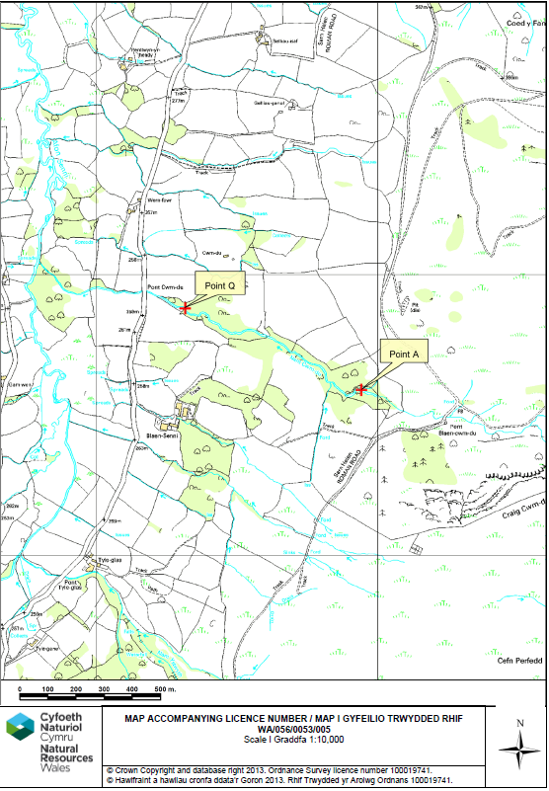
- What aspects of the proposed permission are likely to damage the SSSI features of special interest?
Afon Wysg (Wysg Uchaf) River Usk (Upper Usk)

The following activities are likely to cause damage:
14 The changing of water levels and tables and changes in water utilisation including … abstraction from existing waterbodies …

The following SSSI features and potential impacts have been considered to assess the likelihood of damage due to their migratory nature:
- Atlantic salmon
- Twaite shad
- Sea lamprey
- River lamprey
- Otter

During the original determination, it was noted that Atlantic salmon use the Nant Cwm-du for spawning. Also, at an NRW fish survey site, just downstream of the scheme, brown trout, Atlantic salmon, bullhead, and eel had been discovered. Despite concern that the applied for peak abstraction rate and flow split (60%) could significantly impact the habitat available for these features in the depleted reach, modelling demonstrated that there would be no significant impact on flows compared to a 40% take (recommended in NRW guidance for this type of scheme). The abstraction regime was therefore considered sufficient to maintain fish populations within the depleted reach. So for the activity, as applied for, there is no pathway of impact for the migratory fish features.

It is possible otters from the SSSI populations may be found around the abstraction point, discharge point, and depleted reach, although none have been recorded any closer than ~3km downstream on the Afon Senni. As the activity is not expected to impact flows in the depleted reach (as noted above) there should also be no impact on the suitability of the habitat to provide areas for otters to set up holts, find prey etc. So for the activity, as applied for, there is no pathway of impact for this feature.

What aspects of the proposed permission are likely to damage the SSSI features of special interest?
Afon Wysg (Wysg Isaf) / River Usk (Lower Usk)

The following activities are likely to cause damage:
14 The changing of water levels and tables and changes in water utilisation including … abstraction from existing waterbodies …

The following SSSI features and potential impacts have been considered to assess the likelihood of damage due to their migratory nature:
- Atlantic salmon
- Twaite and allis shad
- Sea and river lamprey
- Brook lamprey
- Otter

During the original determination, it was noted that Atlantic salmon use the Nant Cwm-du for spawning. Also, at an NRW fish survey site, just downstream of the scheme, brown trout, Atlantic salmon, bullhead, and eel had been discovered. Despite concern that the applied for peak abstraction rate and flow split (60%) could significantly impact the habitat available for these features in the depleted reach, modelling demonstrated that there would be no significant impact on flows compared to a 40% take (recommended in NRW guidance for this type of scheme). The abstraction regime was therefore considered sufficient to maintain fish populations within the depleted reach. So for the activity, as applied for, there is no pathway of impact for the migratory fish features.

It is possible otters from the SSSI populations may be found around the abstraction point, discharge point, and depleted reach, although none have been recorded any closer than ~3km downstream on the Afon Senni. As the activity is not expected to impact flows in the depleted reach (as noted above) there should also be no impact on the suitability of the habitat to provide areas for otters to set up holts, find prey etc. So for the activity, as applied for, there is no pathway of impact for this feature.

What aspects of the proposed permission are likely to damage the SSSI features of special interest?
Severn Estuary

The following activities are likely to cause damage:
14 The changing of water levels and tables and changes in water utilisation including … abstraction from existing waterbodies …

The following SSSI features and potential impacts have been considered to assess the likelihood of damage due to their migratory nature:
- Assemblage of fish including Allis shad, Twaite shad, River lamprey, Sea lamprey, Atlantic salmon, and eel.

During the original determination, it was noted that Atlantic salmon use the Nant Cwm-du for spawning. Also, at an NRW fish survey site, just downstream of the scheme, brown trout, Atlantic salmon, bullhead, and eel had been discovered. Despite concern that the applied for peak abstraction rate and flow split (60%) could significantly impact the habitat available for these features in the depleted reach, modelling demonstrated that there would be no significant impact on flows compared to a 40% take (recommended in NRW guidance for this type of scheme). The abstraction regime was therefore considered sufficient to maintain fish populations within the depleted reach. So for the activity, as applied for, there is no pathway of impact for the migratory fish features.

- Summary of any informal advice received from internal experts (if required and including pre-app advice) | The SNCB advised that assessments should be carried out for downstream marine sites if they were not done for the original application. As a result of this advice, assessments were also done for downstream freshwater sites with migratory fish features that were not covered in the determination for the original application.
- Recommendation | The proposed permission is not likely to damage any of the flora, fauna or geological or physiological features which are of special interest due to the lack of an impact pathway.
- Signature and date assessment made | Sarah Senior  17/07/2026
- Officers name and job title | As above  Water Resources Permitting Officer

