METHOD STATEMENT

Project Reference: | EKMB0572 | Document Ref: | MS01
Project Name: | A465 River Clydach Brdige
Client: | Alun Griffiths | Client Ref:
Location: | A465 River Clydach Brdige
Proposed Works: | Bridge refurbishment, bearing, concrete repairs, bridge jacking, propping installation, CP installation, scaffolding.
Scope (brief description of the works):
Prepared by: | Liam Pickering | Position: | Project Manager
Signed: | LP | Date: | 13/07/2026
Reviewed by: | Jordan Gerrard | Position: | Pre-contracts Director
Signed: | JG | Date: | 28/07/2026

Approved by: (Client) |  | Position:
Signed: |  | Date:

ARRIVAL ON SITE
- Ekspan to arrive at site.
- Ekspan site team to receive a site induction.
- Undertake method statement briefing from Ekspan supervisor.

SITE SETUP
- Alun Griffiths to complete site set up and haul road

INSTALLATION OF TEMPORARY PROPS
- Install the propping arrangement in accordance with drawings 9996-DRG-TW-00
- Using a telehandler to install props onto concrete padstone
- Dry fit prop and level using shims whilst prop is still laden on the telehander
- Spot through base plate of prop using a Hilti TE80 or similar with a 20mm diameter masonry drill bit.
- Remove prop by means of telehandler.
- Using a Hilti TE80 or similar drill through spotted holes using a 26mm diameter masonry bit to a vertical depth of 300mm at 4 No. positions per prop location.
- Using a telehandler reinstall prop into excavation. Ensuring telehandler is still laden.
- Dry fit 4 No. M24 x 300mm threaded bars into pre drilled holes.
- Clean each hole thoroughly using compressed air or manual blow-out pump and nylon brush.
- Repeat process as per resin manufacturer’s instructions to ensure clean, dust-free holes for proper bond.
- Prepare resin cartridge and applicator gun.
- Inject resin (HILTI HIT HY 200) into hole from the bottom up, avoiding air pockets.
- Allow resin to cure for the recommended period before releasing the load and tighten with nut and washer.
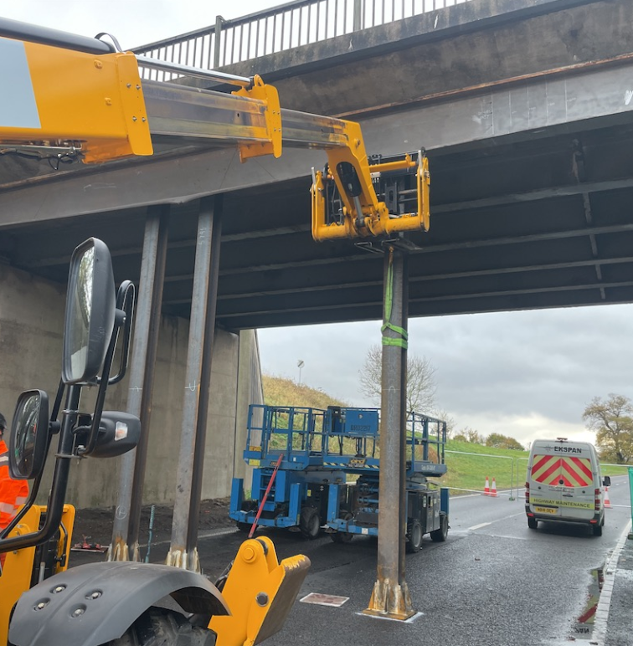

- Repeat above for the remaining prop locations.
HOLD POINT
EKSPAN & Alun Griffths to confirm that the temporary works as been installed as per drawing 9996-DRG-TW-00.
QD11 Hold Point Sign Off Certificate to be signed by Alun Griffths

ERECTION OF SCAFFOLDING
- Lorry will park in an agreed area and will be excluded using barriers.
- The works will begin with the erection of the base level structure. This will commence with the install of upright standards secured in a goalpost formation with affixing ledger on right angle couplers. No standards on a single coupler at any stage. Sole boards throughout.
- Opposing outside standards will now be installed to match the design parameters and secured on load bearing couplers to the inside face via structural transoms. These to be plumbed level.
- The outside standards will now be secured together via its ledger and plumbed level.
- Intermediate standards will now be installed throughout the section and secured with doubles.
- Now we will install the advanced guardrail as shown in the diagram.

- The outside frame will now be installed, again from structural transoms, and measured to suit.
- The outside ledger will now be installed and fixed on right angle couplers and plumbed level.
- Intermediate standards will now be secured to fill the centre of the frame in. No bays to exceed the maximum bay size specified in the design. All legs to be secured on TWO load bearing couplers.
- This sequence will be repeated throughout the line of the structure, to include return sections.
- The first working level will now be installed. This commences with the install of the inside ledger which will be plumed level. The outside ledger will then be installed and plumbed level using transom tubes. All ledgers secured on load bearing couplers and fixed tight throughout.
- The front sway brace will now be installed and the standards plumbed left to right.
- The main ledger bracing will now be installed and transoms used to affix the opposing ledger face.
- We will then board out the scaffolds from a position of safety, installing from below and clamping down any less than 2m in length.

- The lift will now be accessed by installing a temporary ladder stage to the boarded level.
- Once upon the lift operatives will install the bottom handrail and toe board throughout, whilst observing Maximum gap spacings throughout the length of the structure.
- Scaffolders will remain in there ‘Safe Zone’ throughout works with harnesses used as a last resort.
- The next working lift will now be installed, commencing with the inside ledger. This again will be plumbed across on transoms for levelling the outside ledger. All fixed on right angle couplers.
- Sway and ledger braces will now be installed and standards plumbed level throughout.
- Again, the advanced guardrail will be installed from the use of the scaff steps. Then transoms installed and boards affixed from below, to avoid working at height risks.
- The main lift will be fully boarded, double handrailed and toe boarded.
- Screw Jacks will be placed into the top of the standards and once in the correct position will be securely tightened up to the slab above with a sole board to stop any slippage. This will tie the scaffold into place
- Once the scaffold is fully secured monoflex sheeting will be fitted to the outside face of the scaffold from floor to ceiling so to fully encapsulate.
- When works are complete, we will clear all spare before placing a tag and handing over for use.

TANKING OF SCAFFOLDING (PRE HYDRO DEMOLITION WORKS) - EKPSAN
- Ekspan will lay a Visqueen sheet over the boarding to serve as a temporary waterproofing barrier. This will prevent water from the bearing replacement activities from escaping and contaminating the road surface below.
- The Visqueen sheeting will be installed in a double layer to enhance water encapsulation and provide additional leak protection.
- The Visqueen sheeting will be latted and secured to the face of the abutment to maintain its position and effectiveness during the works.
- Debris netting and Monoflex sheeting will be erected around the scaffold to offer supplementary containment, preventing any debris or materials from escaping the work zone.
- All waste materials and debris will be collected and removed from site regularly to maintain a safe and clean working environment.
- 110V LED festoon lighting will be installed along the full length of the abutment to ensure adequate illumination during working hours and for safe access.
- A generator will be positioned at the base of the scaffolding revetment, near the scaffold access steps, to power the lighting system.

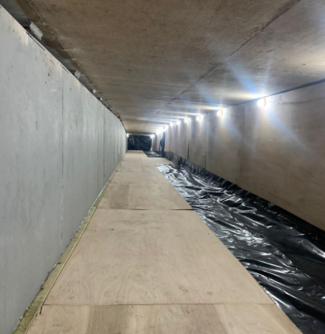

CONCRETE REPAIRS – Gunite Solutions Limited
Hammer Testing
- Engineer signs off access and confirms repair extents.
- GSL operatives carry out acoustic hammer testing under engineer direction.
- Engineer records findings and updates drawings as required.
Hydro-Demolition
- Gunite crew reports to site manager; UHP unit mobilised at South Abutment.
- Jetting units positioned on firm, level ground with safe operator access.
- Supervisor briefs site team on UHP water risks.
- Operators complete GSP setup checks and sign off before starting.
- Hoses routed to minimise trip hazards.
- Working pressure set based on risk assessment and concrete strength.
- Ekspan marks out removal areas; damaged concrete removed via hand-lancing.
- Maintain consistent nozzle distance/angle; check surface regularly.
- Two-person team alternates on lance; stop work if removal exceeds limits.
- All communication via pump operator.
- End of shift: hoses de-rigged, equipment flushed with antifreeze if required.
- Equipment demobilised and area handed over.
Edge Trimming & Preparation
- Before hydro-demolition, perimeter is marked and a 10mm grinder slot cut.
- After breakout, edges trimmed with 110V breaker to achieve perpendicular faces.
Concrete Repairs (Dry Spray)
- Dry spray gun, compressor, and material stored in compound.
- Water pump supplies mains-pressure water to nozzle.
- Hose routes agreed with main contractor.
- Webercem DS loaded dry into gun; conveyed by air; water added at nozzle.
- Repair built up in layers to required thickness; final finish wood-float texture.
- Supervisor inspects lines before full air pressure applied; whip arrestors fitted.
- 2m exclusion zone maintained around nozzleman with barriers/signage.
- Communication via hand signals or radios.
- After spraying, lines cleaned with compressed air.

INSTALLATION OF TEMPORARY JACKING ARRANGEMENT & Restraints
- Install the jacking arrangement in accordance with drawing 9996-DRG-TW-00
- Use telehandler to lift transom beams into place & weld as per EKSPAN temporary works requirements and weld procedures
- Drill and fix restraints (TBC) by EKSPAN TW’s designer
- Use a telehandler to lift the jacking cylinders onto the scaffolding loading bay
- Prepare all contact surfaces for Sikadur 31+ application by coating with mould oil
- Mix Sikadur 31+ as per the manufacturer’s instructions. Apply a layer to the base of the jacking plate, ensuring it is level using a spirit level
- Allow the Sikadur 31+ to fully cure/harden
- Once cured, position the jacking plates on top of the jacking stools
- Mix Sikadur 31+ again (following the same manufacturer’s guidance) and apply a layer to the top plate
- Place the top plate on the jacking cylinder and energise the cylinder until the top plate is level and fully engaged with the soffit/bridge deck

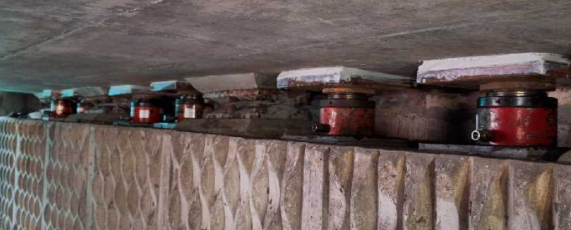

HOLD POINT
EKSPAN & Alun Griffths to confirm that the temporary works as been installed as per drawing 9996-DRG-TW-00

BRIDGE JACKING
- All hydraulic hoses, manifolds, pressure gauges, and LVDTs will be tested and calibrated before arriving on site and visually inspected for damage before installation.
- Hydraulic equipment will be set up beneath the bridge in accordance with jacking layout drawings.
- LVDTs will be installed at pre-determined locations across the width of the structure to monitor vertical movement of the bridge deck relative to the abutment shelf.
- LVDTs will be connected to a central data logger or laptop-based monitoring portal.
- Calibration certificates will be available on site.
- The load transfer will be monitored via hydraulic pressure readings at each manifold and cross-checked with LVDT data.
- Maximum allowable lift of the bridge deck is 2mm.
- A trial energisation of the jacking system will be performed by applying and holding pressure for 5 minutes to confirm there are no hydraulic leaks.
- Jacking to be carried out at night only, when traffic loading is minimal, to reduce dynamic movement of the structure.
- The jacks will be energised gradually, while monitoring the real-time pressure at each manifold, logging LVDT readings via laptop and ensuring load is evenly transferred into all jacks
- During the jacking process locking collars on each jack will be wound down tight and kept in place throughout, to provide mechanical support in the event of hydraulic failure and continuous communication will be maintained between the jacking and monitoring teams.
- Once desired lift is achieved and recorded, hydraulic pressure will be held and monitored.
- Locking collars will remain engaged until further instruction.
- All monitoring data will be saved, reviewed, and included in the QA record.

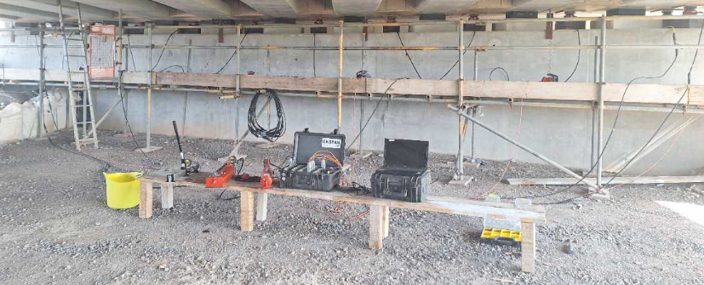

HYDRO DEMOLITION WORKS – BRIDGE BEARINGS
- Prior to commencement, the hydro-demolition contractor will be fully briefed on the scope of removal, which includes the concrete plinths
- Only these specific areas are to be targeted for removal.
- Concrete will be removed using high-pressure water jet cutting techniques.
- All operations will be carried out by a specialist hydro-demolition contractor in accordance with a separate approved Hydro-Demolition Method Statement and Risk Assessment.
- A vacuum tanker will be positioned under the bridge deck, within the designated site compound, to collect wastewater.
- The Siltbuster unit will arrive onsite loaded onto a 3.5Te pickup and will be parked directly beneath the bridge in an appropriate location.
- Wastewater from the hydro-demolition process will be pumped from the scaffold into the Siltbuster unit for treatment.
- Treated water will be discharged via pipework into designated water storage tanks or containers, in compliance with environmental regulations.
- Concrete debris generated during the works will be manually collected using shovels and gorilla tubs.
- Filled tubs will be safely lowered from the scaffold and emptied into a designated concrete waste skip for appropriate disposal.

GUTTERING INSTALLATION
- EKSPAN ES240-40 to be installed as per drawing.
- Operatives will measure and mark bracket locations on the bridge fascia.
- Drill holes using 110v or battery-operated hammer drills. Ensure tools are tethered to the operative or scaffold structure.
- Secure brackets and clip the guttering sections into place, ensuring the correct gradient (fall) toward the downpipes as per the drainage design.
- Apply relevant sealants to joints as specified by the manufacturer.

INSTALLATION OF NEW GIRDER ADAPTOR PLATES
- Confirm area is clean, secure, and all permits (e.g. Hot Work Permit) are in place.
- Inspect jack, welding equipment, and PPE.
- Ensure the adaptor plate and girder surfaces are clean, free from rust, paint, and oil.
- Use a telehandler to lift the new adaptor plates onto the scaffolding loading bay.
- New girder adaptor plates to be set out as per drawing “BP06_301-ATK-SBR-SWTRA-DR-CB-000400”
- Use a motorcycle jack to lift and position the new adaptor plate beneath the girder.
- Align the plate with required tolerances using measuring equipment.
- Once aligned, the client representative will inspect and sign off the line and level before any welding takes place.
- Record sign-off as part of QA documentation.
- Air fed welding masks to be worn whilst hot works are being undertaken.
- Perform 8mm continuous fillet weld to the full perimeter of the adaptor plate, tying it into the existing girder as per the welding procedure specification (WPS).
- Allow sufficient cooling time to prevent distortion.
- Ensure all welding is performed in line with structural steelwork welding codes (e.g. BS EN ISO 9606 or equivalent).
- Allow welds to cool and settle for 24 hours.
- Conduct 100% Non-Destructive Testing (NDT).
- Record results in weld inspection reports and submit to client.
- Remove slag and spatter, clean surrounding areas.
- Collect and dispose of waste materials.
- Final inspection of area and reinstatement if required.

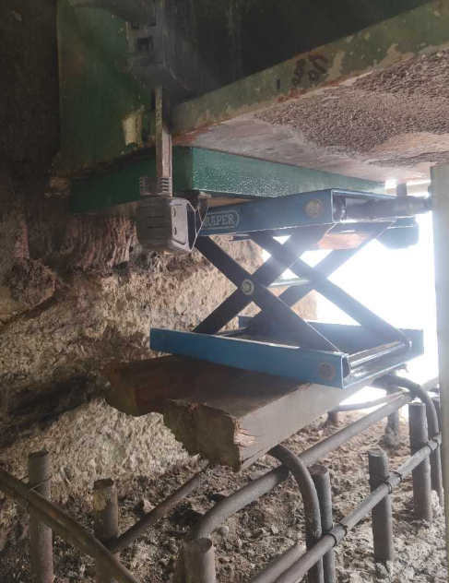

HOLD POINT
EKSPAN & Alun Griffths to confirm that the line and level of the new adaptor plates are correct prior to welding.
QD11 Hold Point Sign Off Certificate to be signed by EKSPAN & Alun Griffths

INSTALLATION OF NEW REINFORCEMENT
- Install proposed bearing plinth reinforcement in accordance with drawing 70107296-WSP-BR6101-108 C01.
- Mark new reinforcement bar positions on concrete surface using chalk, spray paint, or marker, in accordance with approved drawings.
- Double-check spacing and alignment to ensure compliance with design.
- Using a HILTI TE-80, drill holes to the specified 30mm diameter and 210mm embedment depth using appropriate bits.
- Holes must be drilled perpendicular to the surface unless otherwise specified.
- Clean each hole thoroughly using compressed air or manual blow-out pump and nylon brush (if required by manufacturer).
- Repeat process as per resin manufacturer’s instructions to ensure clean, dust-free holes for proper bond.
- Prepare resin cartridge and applicator gun.
- Inject resin (HIT-RE 500 V4) into hole from the bottom up, avoiding air pockets.
- Insert reinforcement bar with a twisting motion to distribute resin evenly and ensure full bond.
- Ensure correct embedment depth is achieved.
- Allow resin to cure for the recommended period before applying load or tying.
- Once resin has cured, tie rebar into place using tie wire and approved tying methods.
- Ensure all reinforcement is securely fastened in accordance with structural drawings.

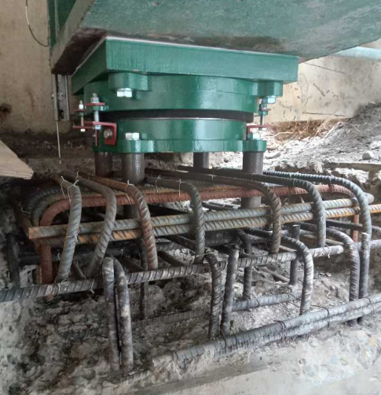

HOLD POINT
EKSPAN & Alun Griffths to confirm that the new reinforcement has been installed as per drawing P06_301-ATK-SBR-SWTRA-DR-CB-000301
QD11 Hold Point Sign Off Certificate to be signed by EKSPAN & Balfour Beatty.

SHUTTER AND CAST CONCRETE TO NEW BEARING SHELF
- Using shuttering timber, install formwork around each bearing to fully contain the pour area.
- Ensure formwork is tight-fitting and well-supported to prevent movement or leakage during the pour.
- Apply mould oil evenly to the internal faces of the shuttering to assist with clean removal after curing.
- Visually inspect and confirm that shutters are free from water, debris, or loose material before concrete placement.
- Mix Parex Tecfast Concrete in accordance with the manufacturer’s instructions, using clean water and suitable mixing equipment.
- Ensure consistent mix quality and mix only what can be placed within the working time of the product.
- Using manageable-sized gorilla tubs, transport mixed concrete by hand up the scaffold access steps to the pour location.
- Avoid overloading tubs to reduce manual handling risk and maintain control on access routes.
- Carefully pour concrete into the shuttered void until it reaches the top of the formwork.
- Lightly tamp or vibrate manually (if needed) to remove air pockets and ensure full compaction.
- Prepare and label 3 No. 100mm concrete cubes from the same batch for compressive strength testing.
- Store cubes in controlled curing conditions or a curing tank, as per BS EN 12390.
- Allow concrete to cure in line with manufacturer’s recommendations, ensuring it is protected from premature drying or frost.
- Shutters to remain in place until sufficient strength gain has occurred (as per QA instruction).

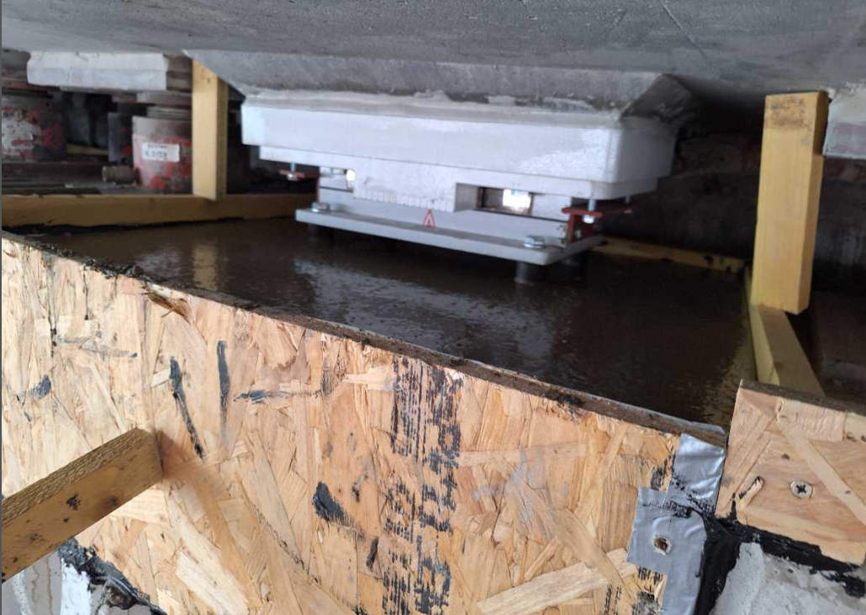

HOLD POINT
EKSPAN & Alun Griffths to confirm the Parex Tecfast Concrete has reached 50N/mm2.
QD11 Hold Point Sign Off Certificate to be signed by EKSPAN & Alun Griffths

SHUTTER AND CAST GROUT BEDS
- Using planed timber, install grout shutters around the base of each bearing.
- Apply silver tape to the inner faces of the formwork to create a smooth, non-bonding surface.
- Shutters to be carefully cut to shape for a snug fit around the bearing base.
- Use timber wedges to support the grout shutters and ensure they are secure.
- Apply sealant around all formwork joints and contact surfaces to prevent grout leakage.
- Confirm that all shutters are free from water, oil, or loose debris before pouring.
- Mix Webertec EP Pourable Grout in strict accordance with the manufacturer’s instructions.
- Mix resin and hardener using a slow-speed mixer until fully blended and uniform in consistency.
- Avoid over-mixing to prevent excessive air entrainment.
- Carefully pour the mixed grout into the prepared shuttered void beneath the bearing.
- Continue pouring until the void is fully filled and grout reaches approximately 5mm up the side of the bearing (maximum).
- Allow the grout to self-level — do not vibrate epoxy-based grouts.
- Pour 3 No. 40mm cubes from the same grout batch using standard moulds.
- Label all samples clearly with mix ID, time, and date.
- Cure cubes in a controlled environment as per Webertec product data sheet.
- Leave the grout to cure undisturbed for the duration specified by the manufacturer.
- Protect from direct sunlight, vibration, and temperature extremes during curing

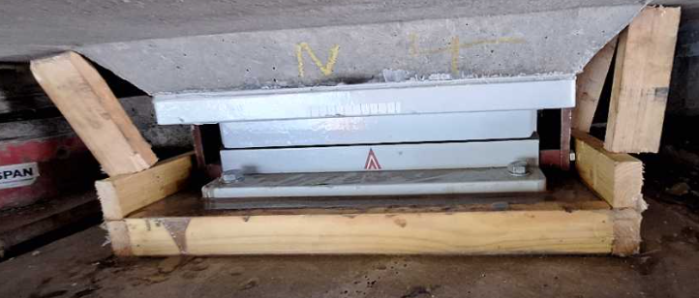

HOLD POINT
EKSPAN & Alun Griffths to confirm the Webertec EP Pourable Grout has reached 50N/mm2.
QD11 Hold Point Sign Off Certificate to be signed by EKSPAN & Alun Griffths.

BRIDGE DE JACK
- Concrete and grout cube test results must be confirmed satisfactory before de-jacking.
- Alun Griffths must provide written approval to proceed with the de-jacking operation.
- Remove all transit bolts or fixings from the new permanent bearings to allow vertical load transfer.
- Reconnect hydraulic hoses, manifolds, and gauges to the jacks.
- Check for cleanliness, proper connections, and secure fittings.
- All equipment, including hydraulic jacks and DTIs, will be inspected for damage or wear.
- Position jacks and DTIs appropriately for simultaneous de-jacking and monitoring.
- Confirm that all staff understand the procedure and emergency stop conditions.
- Install Digital Test Indicators on the abutment head to monitor any vertical movement of the bridge deck during the de-jacking process.
- Zero DTIs prior to starting.
- Begin de-jacking incrementally and simultaneously across all bearing locations.
- Lower jacks in measured steps, transferring the bridge weight evenly and gradually onto the new bearings.
- Monitor pressure at each jack and displacement at each DTI in real time.
- Continue until jacks are fully unloaded and the structure is bearing entirely on the permanent bearings.
- Closely monitor all bearing positions to ensure minimal differential movement across the deck.
- If vertical deflection exceeds values recorded during jacking or if any cracking in the bedding mortar is observed, immediately halt de-jacking and inform the Alun Griffths Project Staff for further instruction.
- Once bridge load is fully transferred, and confirmed release locking collars from hydraulic jacks, disconnect and remove hydraulic equipment from site and confirm all bearing positions are in final seated condition and report to QA team.

REMOVAL OF TEMPORARY WORKS
- The jacking assemblies can be dismantled and removed from the bearing shelf and scaffolding.
- Use telehandler to safely lower hydraulic jacks, props, transom beams and top plates from the scaffold to deck
- Any remaining epoxy to be scraped off with minimal damage to the soffit.
- Remove any debris, fixings, or bonding materials from the area.
- Perform a visual inspection of the soffit, abutment head, and bearing shelf.
- Remove all waste, packaging, and dispose of in accordance with site waste protocols.

PAINT REMEDIALS
- Each bearing shall be inspected, all areas of damaged paint shall be photographed, and the size and extent of damage recorded.
- Paint remedials shall be undertaken as per the below table.
NATURE OF DAMAGE | REMEDIAL TREATMENT
Damage to topcoat only | - Lightly abrade by hand and/or power tool and clean down all areas to receive paint.  - Ensure edges are 'feathered' to provide a smooth transition of each coat  - Carefully touch in with one coat of primer to give a minimum dft (dry film thickness) of 50μm. (max 60μm)
Damage to topcoat and intermediate coat(s) | - Lightly abrade by hand and/or power tool and clean down all areas to receive paint. Ensure edges are 'feathered' to provide a smooth transition of each coat  - Carefully touch in with one coat of intermediate paint.  - After the coating has cured (See product data Sheet).  - Check dft. Minimum dft 150μm Maximum dft 225μm  - Note – It may be necessary to apply multiple coats to achieve the minimum dft  - Carefully touch in with one coat of Hempathane 55810 to give a minimum dft (dry film thickness) of 50μm. (max 60μm)  - After the coating has cured (See product data Sheet). Check dft 150-225μm and 50-60μm respectively.
Extensive damage to full protective system including the primer  coating  (Damage to bare steel) | - Mechanically clean the exposed steel area in accordance with BS EN ISO 8501-1 to give a surface standard of St3.  - Lightly abrade by hand and/or power tool and clean down all areas to receive paint. Ensure edges are 'feathered' to provide a smooth transition of each coat.  - Carefully touch in with one coat of Primer coat  - After the coating has cured (See product data Sheet). Check dft. Minimum dft 125μm, maximum 200μm  - Carefully touch in with a second coat of Intermediate coat  - After the coating has cured (See product data Sheet). Check dft. Minimum dft 150μm, maximum 225μm  - Carefully touch in with one coat of Top coat.  - After the coating has cured (See product data Sheet). Check dft. Minimum dft 50μm Maximum dft 60μm  - After the coating has cured (See product data Sheet). Check dft 125-200μm 150-225μm and 50-60μm respectively.

- Air temperatures, surface temperatures and dew point shall be recorded and painting only undertaken if within datasheet parameters.
- All dry thickness values shall be recorded, and photographs taken at each step of paint remedials. The coating shall be inspected visually for runs, sags and surface blemishes. A visual inspection shall be conducted after each coat to ensure the surface is free from pinholes, sags, drips and runs.

Corbel Installation
- Supply and install jacking corbels in accordance with drawing “BP06_301-ATK-SBR-SWTRA-DR-CB-000301”
- Light abrasive blast to key works surface
- Drill and fix new rebar into the 16no corbel positions
- Build form work using shutter ply and dywidag bar around corbel areas
- Pump concrete into formwork
- Concrete cure approx. 7 days
- Remove formwork & make good of works area

