Annex (iv) – SSSI Assessment Form
SSSI Assessment for permit/licence and deployment applications | 
To be completed by Permitting Officers for any applications for a permission which Natural Resources Wales has considered under S28I duty to notify SNCB and take their advice into account. This applies to all proposed permissions within a SSSI, and to operations outside the SSSI boundary which are likely to damage its special features.
NRW as a Section 28G authority has, when exercising its functions, a general duty to take reasonable steps, consistent with the proper exercise of its functions, to further the conservation and enhancement of the flora, fauna or geological or physiological features by reason of which the site is of special interest’

Part 1 – SSSI Assessment
Part 2 – Formal notification to SNCB (to be completed if part 1 assessment concludes likely damage, not likely to damage because of conditions or you cannot conclude no likely damage)
Part 3 – Decision

Part 1 – SSSI Assessment

- Permitting officer/team | Kayleigh Miles  Water Resources Permitting Team
- Permit application reference and site name | PAN-031363 – Glascoed Weir by pass channel
- a. SSSI name(s)  b. location  c. NRW Operational Area/Environment Team | a. Montgomery Canal SSSI  b. Powys  c. NRW North Powys Environment Team  a. Severn Estuary SSSI  b. Monmouthshire, Newport, Cardiff, Vale of Glamorgan, Somerset  c. NRW Monmouthshire & Torfaen Environment Team  a. River Teme SSSI  b. Herefordshire, Shropshire, Worcestershire  c. Natural England, West Midlands Area Team  a. Wyre Forest SSSI  b. Shropshire, Worcestershire  c. Natural England, West Midlands area team
- Brief description of proposal | Application received for a transfer abstraction licence to operate an existing fish bypass channel on the Afon Cynllaith around the Glascoed Weir. The bypass channel was constructed in 2014 as part of Natural Resources Wales (NRW) ‘Salmon for Tomorrow’ programme. The bypass channel diverts some flows around the Glascoed Weir improving fish passage around the weir, providing fish species and aquatic ecology access to additional habitat in the upper catchment.  The transfer activity was previously licenced under licence WA/054/0001/0001. However, this licence expired and the applicant did not apply to renew the licence.  An application has now been received to reinstate the bypass channel and includes an improved design to the inlet structure as a result of significant scour and storm impacts leading to instability of the structure in 2022, which closed the bypass channel.  The nearest SSSI to the scheme is approximately 24 kilometres downstream from the point in which transferred water is returned to the watercourse (Point Q on map). Water is abstracted (Point A on map) for the purpose of transfer for a distance of approximately 160 metres before being return to the Afon Cynllaith.  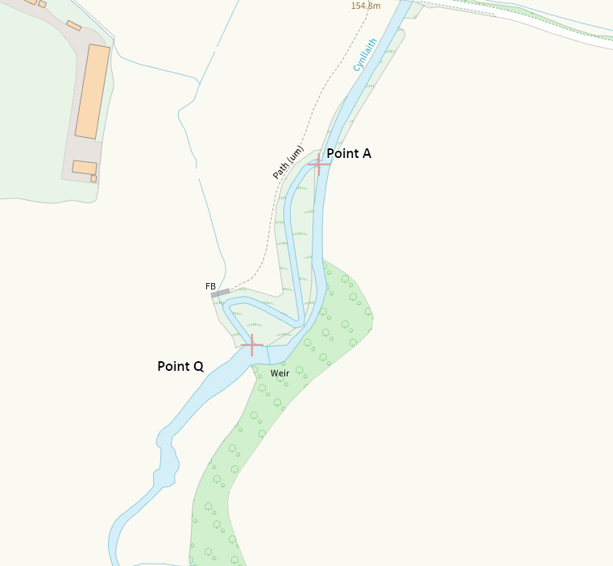
- What aspects of the proposed permission are likely to damage the SSSI features of special interest?

Montgomery Canal SSSI

The following activities are likely to cause damage:

Modification to the structure of the canal and adjacent rivers, streams, springs, ditches, drains, including their banks and beds, as by re-alignment, regrading, damming or dredging.

Alterations to water levels and tables and water utilisation including irrigation, storage and abstraction from existing water bodies and through boreholes. Also the modification of current drainage regime, (e.g. through the installation of new pumps).

The following SSSI features and potential impacts have been considered to assess the likelihood of damage:

The Montgomery Canal is of special interest because it supports aquatic, emergent and marginal plant communities of exceptional richness, including a large population of the internationally rare and threatened floating water plantain Luronium natans and a several other rare and scarce water plants. The canal is one of the most important “still” water bodies in Wales. Features of the Montgomery Canal SSSI include:
- Mesotrophic/eutrophic standing water
- A rich assemblage of aquatic invertebrate (Over ten species of dragonflies and damselflies, water beetles and freshwater molluscs).
- A rich assemblage of aquatic plants to include;
- Floating water-plantain
- Grass-wrack pondweed
- Flowering-rush
- Autumnal water-starwort
- Fine-leaved water-dropwort
- Flat-stalked pondweed
- Perfoliate pondweed
- Long-stalked pondweed
- Greater duckweed

Abstraction activity has the potential to impact the aquatic plant communities designated through several ways:
- reduction in water levels through the site which could result in the loss of the open water conditions that these protected species depend on. This resulting in a loss of habitat and/or species through exposure of submerged plants in lower water levels.
- Changes to water quality due to reduced dilution and water through the site. This could increase water temperatures and/or increase concentrations of pollutants and nutrients moving through the canal which can reduce plant growth. As a result there is the potential for degradation of the ecological condition of the site.

Features of the Montgomery Canal SSSI all depend on the stable water conditions that the site provides. A reduction in water flowing through the site and the potential for poorer water quality as a result has the ability to reduce and/or fragment the SSSIs breeding habitat and habitat available to the designated features and can disrupt their food chains.

Although abstraction can impact the Montgomery Canal SSSI, this application is for the transfer licence which is non-consumptive, all water is returned to the watercourse. The Montgomery Canal is approximately 24 kilometres downstream from the point in which water is returned to the watercourse. Therefore, the proposed permission is not likely to damage any of the flora, fauna or geological or physiological features which are of special interest as there is to be no change in water levels at the site as a result of this proposal.

Severn Estuary SSSI

The following activities are likely to cause damage:

The changing of water levels and tables and water utilisation (including irrigation, storage and abstraction from existing water bodies and through boreholes.

The following SSSI features and potential impacts have been considered to assess the likelihood of damage:

The Severn Estuary lies on the south west coast of Britain at the mouth of four major rivers (the Severn, Wye, Usk and Avon) and many lesser rivers. The immense tidal range (the second highest in the world) and classic funnel shape make the Severn Estuary unique in Britain and very rare worldwide. The intertidal zone of mudflats, sand banks, rocky platforms and saltmarsh is one of the largest and most important in Britain.

The estuarine fauna includes internationally important populations of waterfowl; invertebrate populations of considerable interest; and large populations of migratory fish, including the nationally rare and endangered Allis Shad (Alosa alosa). Seven species of migratory fish move through the Estuary between the sea and rivers. There are particularly large numbers of Atlantic Salmon Salmo salar and Common Eel Anguilla. The other species are Allis Shad, the nationally rare Twaite Shad Alosa fallax, the Sea Trout Salmo trutta, Sea Lamprey Petromyzon marinus and the Lampern or River Lamprey Lampetra fluviatilis.

The estuary has a diverse geological setting and a wide range of geomorphological features, especially sediment deposits. It is important for the interpretation of coastline dynamics and landforms, and also past changes, in sea level, sediment supply, climate and river flow. The estuary's overall interest depends on its large size, and on the processes and inter-relationships between the intertidal and marine habitats and its fauna.

Although the Severn Estuary SSSI is located approximately 250 kilometres downstream of the point in which abstracted water is returned to the watercourse, further consideration of impacts to mobile species designated under the SSSI such as migratory fish is required as part of this application.

Other designated features such as sand banks, mudflats, saltmarshes, estuarine fauna of the Severn Estuary SSSI we can conclude no mechanisms or pathways of impact due to their nature and distance downstream of the scheme. The abstraction takes place entirely outside of the SSSI boundary and is non-consumptive with all water being returned approximately 250 kilometres upstream to the SSSI boundary. Therefore, features which are not migratory, we can conclude that the proposed activity is not likely to damage the SSSI features.

NRW conclude that the proposed permission is not likely to damage any migratory fish species features which are of special interest as the proposal is to benefit fish passage. The Glascoed Weir is a barrier to fish migration; therefore the by-pass channel is beneficial to upstream fish migration around the Glascoed Weir and providing access to spawning grounds and habitats upstream of the Glascoed Weir, which were once not accessible.

River Teme SSSI

The following activities are likely to cause damage:

The changing of water levels and tables including irrigation, storage and abstraction from existing water bodies and through boreholes

The following SSSI features and potential impacts have been considered to assess the likelihood of damage:

The River Teme is the second largest tributary of the River Severn, the notified channel is of special interest for it’s near natural and biologically rich river type associated with sandstone and mudstones.

The River Teme has long been recognised as a quality salmonid and coarse fishery. The fish communities strongly reflect the ecological changes in the river as it descends the catchment. The Teme has a good population of Atlantic stream crayfish Austropotomobius pallipes, a globally threatened and seriously declining species.

The features of the River Teme SSSI which have the potential for impacts of an abstraction activity upstream and outside of the SSSI boundary are the migratory fish species designated under the SSSI –Salmon, bullhead, otter, twaite shad, sea lamprey, and grayling.

Although potential impacts to those have been considered, the proposal of this application is to improve fish passage around a current barrier (Glascoed Weir) which aims to provide access to spawning grounds and habitats upstream of the weir and therefore support the population of the designated migratory species.

NRW conclude that the proposed permission is not likely to damage any migratory fish species features which are of special interest.

Wyre Forest SSSI

The following activities are likely to cause damage:

Alterations to water levels and tables and water utilisation (including irrigation, storage and abstraction from existing water bodies and through boreholes). Also the modification of current drainage operations through the installation of new pumps.

The following SSSI features and potential impacts have been considered to assess the likelihood of damage:

Wyre Forest is one of the largest ancient woodlands in England. The SSSI is the focus of an area of high value for biodiversity associated with the ancient semi natural woodland and grasslands present.

The features of the site which have the potential to be impacted by an abstraction upstream and outside of the SSSI boundary are the otter which are known to frequent the River Severn and Dowles Brook. Potential impacts as a result of lower flows could include damage to otter habitat and supporting habitat of prey species and decline in prey species. However, the proposal is non-consumptive with flow to be retained within the main channel at all times and a significant distance from the SSSI boundary. The River Teme SSSI covers an area which has multiple tributaries therefore, otters have a large area within the SSSI boundary available to them to use as habitat, as well as multiple tributaries outside of the SSSI boundary. Therefore, any potential impacts identified outside of the SSSI boundary which could impact on the range and supporting habitat, and thus population of Otter, can be considered a de minimis (small scale) impact for this proposal. NRW conclude that the proposed permission is not likely to damage the otter feature.

- Summary of any informal advice received from internal experts (if required and including pre-app advice) | N/A
- Recommendation | The proposed permission is not likely to damage any of the flora, fauna or geological or physiological features which are of special interest  Proposal is not likely to damage any features designated under the SSSIs identified by virtue of distance of the proposal to any SSSI and due to the proposal being non-consumptive with the overall aim of improving fish passage around a current barrier to fish migration (Glascoed Weir), providing access to spawning grounds and habitats upstream of the weir and therefore support the population of the designated migratory species.
- Signature and date assessment made | K Miles  29/04/2026
- Officers name and job title | Kayleigh Miles  Water Resources Permitting Officer


