Please note – this document is purely to assist you in making your decision and may not necessarily cover all information you require.
Deployment Details
Deployment Reference Number: | PAN-031367
Permit Reference Number: | EPR/EB3636AK
Permit Holder: | Provectus Remediation Ltd
Site Address: | Maelor Foods, Pickhill Lane, Cross Lanes, Wrexham, LL13 0UE
Grid Reference: | SJ 38635 46645

Administrative Checks- By admin officer
 | Comments
Consultation | Waste reg team:  WasteReg.NE@cyfoethnaturiolcymru.gov.uk  Environment team:  WrexhamFlintshireEnvironmentTeam@cyfoethnaturiolcymru.gov.uk  NLO: No NLO allocated  Land/groundwater remediation only:  Geoscience: geoscience@cyfoethnaturiolcymru.gov.uk  Local Authority Contaminated Land:  environmentalprotection@wrexham.gov.uk  planning@wrexham.gov.uk
Date due: | 23/01/2026
Permit compliance rating and multiplier |  | N/A due to no NLO. Area team for this remediation to be notified at time of issue.

Administrative Checks- By determining officer
 | Action completed or document provided? (Yes, No or n/a) | Comments
Correct fee? | Y | See permit compliance rating and multiplier
Original fee received and cleared | Y | Transaction number: 2151559  Date: 07/01/2026  ref: BS/07012026/8 PROVECTUS REMEDIAT  Amount: 2,251.00
MyMap report completed? | Y
Location map | Y
Site Specific Risk Assessment | Y | SK191266

Saving documents- by determining permitting officer | Y N
Save embedded application documents from application form | Y

Word versions of online forms - NRW View (sharepoint.com)
About your permit | Y N n/a | Comments
What permit is being deployed under? | SR2008 No27 | If the rule set is being used
Has the permit number been given? | Y | EPR/EB3636AK
Is the base permit still live?  Welsh - check DMS/PALS | Y
Has there been any variations | Y | Administrative variation to change office address.
Was the permit issued by the Environment Agency or NRW? | Environment Agency | SR2008 No27  - EA
Has name and address of permit holder been provided? | Y
Has contact information been provided? | Y

Deployment details | Y N n/a | Comments
Have we been consulted on, and agreed to, the Conceptual Site Model/Risk Assessment/Remediation Strategy? | N | Previously returned application PAN-030946.
If yes, have references and contact information been provided? | N/A
If yes, has there been any changes? | N/A
Document uploaded? | N/A
Does the applicant want this application to be assessed without having remediation targets pre-agreed by us? | N/A | Provided previous deployment return doc and remediation statement.
Has there been any other pre-application advice? | N
If yes, have references and contact information been provided? | N/A

About the site | Y N n/a | Comments
The site name, address, NGR given? | Y
Does the site address and 12 digit grid reference match? | Y
Is the site located within the boundary of another Environmental Permit? | Y
If yes, have they provided details? | Y | EPR/AB3591ZQ On site slaughter of animals
Site plan provided? | Y
Has there been an approved deployment in the same area within the last 12 months? | N
Does it include the following?  - Operating boundary  - Security and access arrangements  - Areas of waste soils and contaminated material, substances or products for remediation by the mobile plant  - Location/siting of principal plant and equipment  - Process, treatment, storage, and quarantine areas  - Drainage systems  - Location of boundary monitoring points and pollution control units  - Potential receptors (i.e. housing, watercourses etc.)  - Protected sites (if applicable i.e. SAC, SPA, Ramsar or SSSI within 1km) | 1. Y  2. Y  3. Y  4. Y  5. Y  6. Y  7. Y  8. Y  9. Y | No processing área?  Drain flowing North east to river dee – query if this is alright? No site drainage beyond additional storm drainage – what if this backs up when they block the outflow?

Waste types and quantities | Y N n/a | Comments
Has the waste types, quantities etc and treatment types been provided? | Y | Soils containing ACM’s 4277M³  170503*
Are the waste types and quantities from specified in the operator’s permit? | N/A | No waste codes in permit
Has the document been uploaded? | N/A

Specified activities to be carried out on site | Y N n/a | Comments
Has details on suitability of treatment methods been provided? | Y
Has the operator told us which treatment technology they will use? | Y | Mechanical separation screener and handpicking of asbestos
Are all of the proposed treatment technologies listed in the operator’s permit? | Y | Treatment plant for sorting and separation
Is the treatment technology fit for purpose? | Y | Will soil be retested?
Has details on residual materials/waste been provided? | Y | Still suggesting soil reuse
Are we satisfied that these will be handled appropriately? | Y
Has details on quarantine facilities been provided? | Y | Lockable skips – query where this is  If they’re treating all three stockpiles, they may need a bigger quarantine area.  Referenced 3 stockpiles but there’s 4 on “Existing Stockpile Volumes.pdf”.
Are we satisfied the maximum capacities of the quarantine facilities are suitable to prevent or minimise pollution? | N | Only if solely treating stockpile B, query.
Have the locations of the quarantine facilities been included on the site plan? | Y | Size difference compared to returned app - query
Has the document been uploaded? | Y

Activities involving the import of waste | Y N n/a | Comments
Will the activity involve the import of wastes? | N
Does the site form part of a Cluster project? * | N
Has waste acceptance information been provided? | N/A
Has the document been uploaded? | N/A

Duration of this deployment | Y N n/a | Comments
Is the duration of the deployment 12 months or less? | Y

Management supervision | Y N n/a | Comments
Has the technically competent manager details been provided? | Y | Lucy Hamilton – Correct Primary cert under hierarchy  CC -CLR
Has the nominated competent person details been provided? | Y | David Knapp - Correct Primary cert  CC -CLR
Has the site supervision plan been provided? | Y
Is the site supervision plan appropriate? | Y | One weekly checks by NCP  Site manager on site during active treatment
Has the document been uploaded? | Y

Conceptual site model and risk assessment | Y N n/a | Comments
Has the conceptual site model (CSM)/risk assessment been provided? | Y | Missing some receptors and mitigations.
Has the document been uploaded? | Y

Pollution control | Y N n/a | Comments
Have the pollution control measures been provided? | Y | Asbestos air monitoring
Has the document been uploaded? | Y

Emission monitoring plans | Y N n/a | Comments
Has the site specific monitoring plan been provided?  The following may be applicable:  - Groundwater  - Surface water  - Soil gases  - Air emissions  - Noise  - Vibrations  - Odour  - Volatile Organic Compounds | Y | Provided for air emissions and noise.  Concerns for surface water?
Have the indicator parameters been provided? | Y | Air – monitoring disturbance areas as defined within their pollution control document. Works will stop if concentration of respirable fibres increases above 0.1% w/w trigger level.  Noise - +5dB above background. Do not intend to stop works if exceeded, query.
Has the document been uploaded? | Y

Record Keeping - Commissioning, operating and maintenance | Y N n/a | Comments
Details of record keeping given? | Y | Not sufficient
Document uploaded? | Y | Not sufficient

Supporting documents | Y N n/a | Comments
Have relevant documents been ticked and supplied?  - Site plan showing all required features  - Conceptual Site Model and Risk Assessment  - Pollution Control  - Monitoring Plans  - Record Keeping details | 1. Y  2. Y  3. Y  4. Y  5. Y | Record keeping’s light touch but passable

Confidentiality and national security | Y N n/a | Comments
Has confidentially been claimed? | N
Has national security been claimed? | N

Declaration | Y N n/a | Comments
If signing on behalf of a relevant person, has written confirmation from a relevant person been given? | N/A
Has the operator confirmed they will comply with the conditions of the rule set? | Y
Has a relevant person or approved person signed the declaration? | Y | Lucy Hamilton-Watkins

Site specific risk assessment | Y N n/a | Comments
If there are other potential sensitive receptors has a site specific risk assessment been submitted? | N | Missing some receptors
Does the site specific risk assessment identify all potential?
- Sources of pollution or hazards | Y
- Pathways | Y
- Receptors that can be affected by that source of pollution | Y | Missing some
- Measures that will minimise or mitigate the impact will be put in place | N | Not consistently provided

SSSI/ Appendix 4 assessment | Y N n/a | Comments
Is the site within 1 km of a SSSI?  - If yes, the complete an Appendix 4 CroW assessment. | Y | 99m away
Has a “likely significant effect” been identified?  - If yes, consult with the relevant Environment team team.  - If no, save the Appendix 4 to the DMS as “information only” | N

Habitat Regulation Assessment | Comments
Is the site (project) within 1km of a European Site (SPA, pSPA, SAC or cSAC) or a Ramsar site? | No- there is no conceivable impact pathway between the project and any European site features, due to the location of the project.  Yes- see below
HRA FORM 1 has been completed, its conclusion is as follows:

Stage 2 of OGN200 assessment- Screening for likelihood of a significant effect Assessment of Likely Significant Effect:
The plan or project has been screened for likelihood of significant effects and is considered not likely to have a significant effect on any European sites.

Form 1 saved on DMS

Comments
Consultation responses:
- Geoscience comment to suggest the applicant may want to liase with the Local Authority Contaminated Land Officer regarding the suitability for reuse of soils on site. Previously mentioned to applicant by Louise Bailey on return of their last deployment application. Nothing further to note or action.
MyMap and location assessment: Please see above and mapping reports saved to DMS.

Request for information 1 sent 11/02/26:
- Update all application documents to include the information the applicant provided in response to their previously refused application. Provided.
- Pre-remediation target have not been agreed by us. Just put N/A. Please clarify why this is. NRW were consulted on their remediation statement and did not provide a comment. No further questions.
- Are they intending to retest the soils once handpicking has been completed? Yes, details in remediation method statement.
- Lockable skips not marked on plan. Updated.
- Number of stockpiles and total volume to be treated unclear.Treating SPA, SPB and SPC. Total tonnage still needs confirming. 21/02 total of 7,699 tonnes to be treated across the 3 stockpiles.
- Surface water risks not referred to in monitoring plan and surface drains missing from site plan. Updated.
- Noise mitigation concerns vague. Updated.
- Record keeping vague. Updated.
- CSM missing some receptors and doesn’t provide measures for minimising/mitigating impacts across all suggested sources. Updated.
- Two missing world heritage sites “Cadbury Factory Axe” and “Marchwiel WW2 tablet” from map. Neither applicant nor permitting officer can find any additional proof of existence of these two sites. Applicant asked to confirm that there are no sites present at the locations noted on NRW’s mapping software. 27/02 confirmed no identified notable points on site. No further concern.

Decision
Can the deployment application be approved? | Yes

Permitting Officer: Rhiannon Smith
Date: 27/02/2026

Team leader or ToP approval:Huw Davies
Date:27/02/2026

Appendix 1 – Time recording
Admin/consultations (Permit support) | 50
Determination (waste permitting and consultation response time) | 960
Total (to be added to PALS) | 1010 minutes

Appendix 2 – Location Checks
Designations | Present? | Comments
Special protection areas (SPA)  Potential special protection areas (pSPA) | N
Special areas of conservation (SAC)  Candidate special areas of conservation (cSAC) | Y | River Dee and Bala Lake / Afon Dyfrdwy a Llyn Tegid SAC within 1000m
Ramsar sites | N
Site of Special Scientific Interest (SSSI) | Y | Afron Dyfrdwy (River De) SSSI within 2000m
Ancient woodland | N
Areas of Outstanding Natural Beauty (AONB) | N
Heritage Coast | N
Local nature reserves | N
Local wildlife sites | Y | Bangor on Dee Meadows within 200m
National nature reserves | N
National parks | N
Scheduled ancient monuments | N
World Heritage Sites | Y | Marchwiel, Cadbury Staff - WW2 Tablet, war memorial. Just outside site boundary.  Cadbury factory axe – bronze age. Within boundary.  Three others within 50m of site but no concern of damage from proposed operations due to distance from active site works.
Controlled waters such as rivers and lakes | Y | River Dee and associated drains
European Protected Species | N
Nationally Protected Species | Y | Purple moor grass and rush pasture within 50m
Section 7 Priority species | N
Section 7 Priority habitats | Y

Site is mostly within an SPZ3 (ref 527).
SSSI: 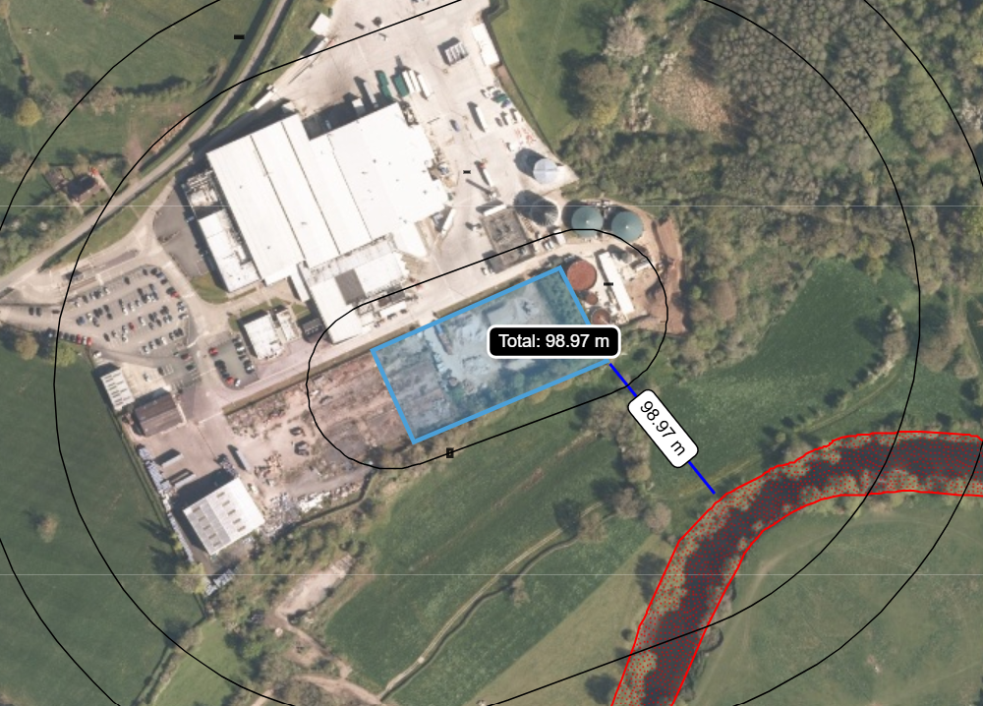

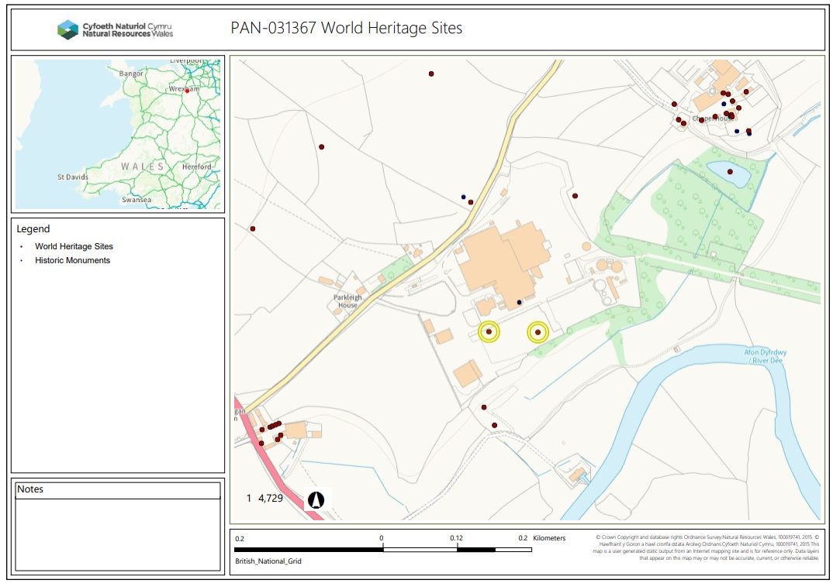

AONB’s, Ancient Woodlands, Scheduled Ancient Monuments, Local and National Nature Reserves, National Parks and Heritage Coasts.
Potential hazards include dust, odours and run-off / leachate.
Receptors to be affected include environmentally sensitive sites, watercourse, local residents, public rights of way, housing, schools, workplaces and recreational facilities.

