PAN-033235 My Map Report:
Application maps
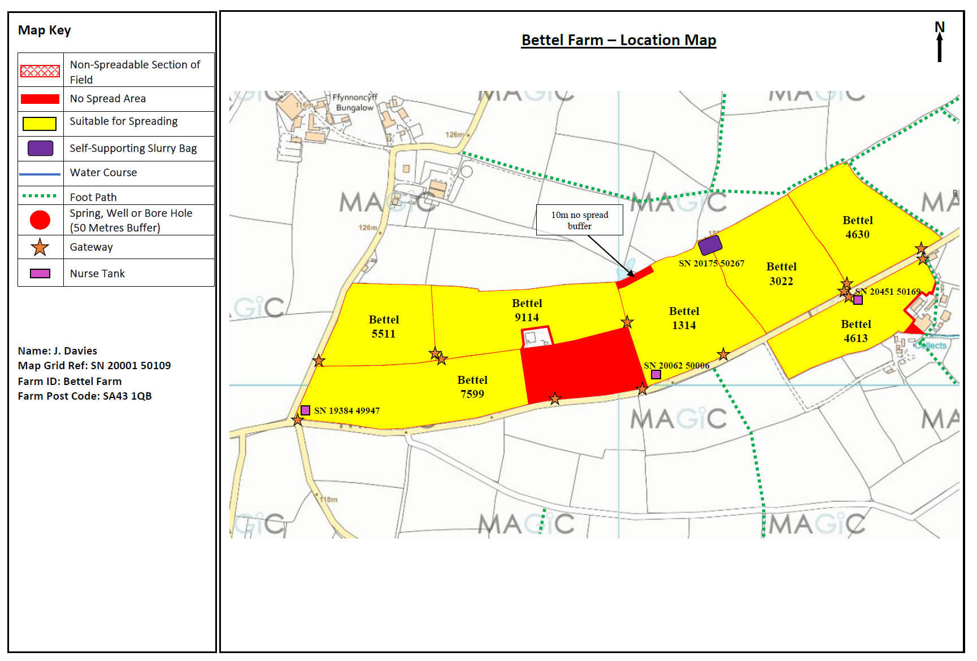
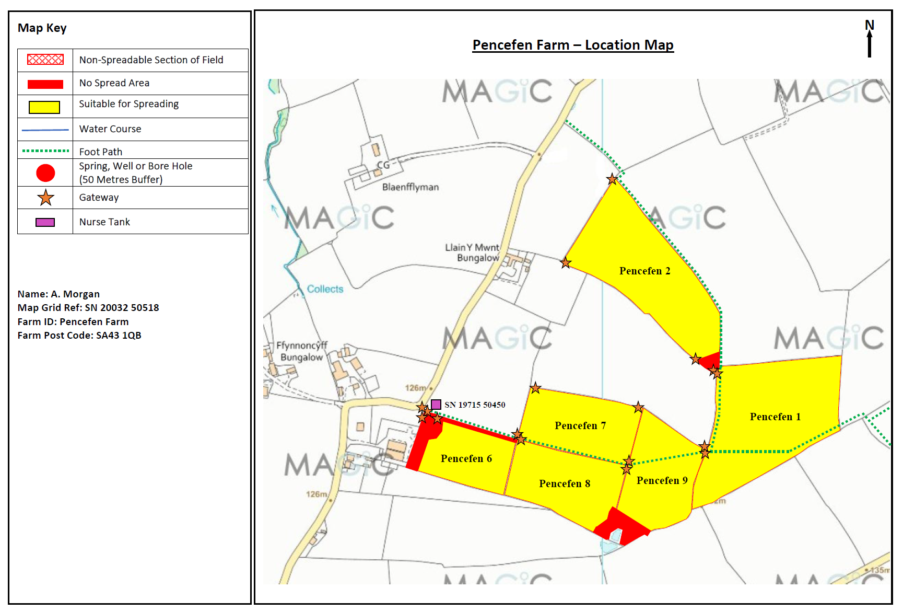
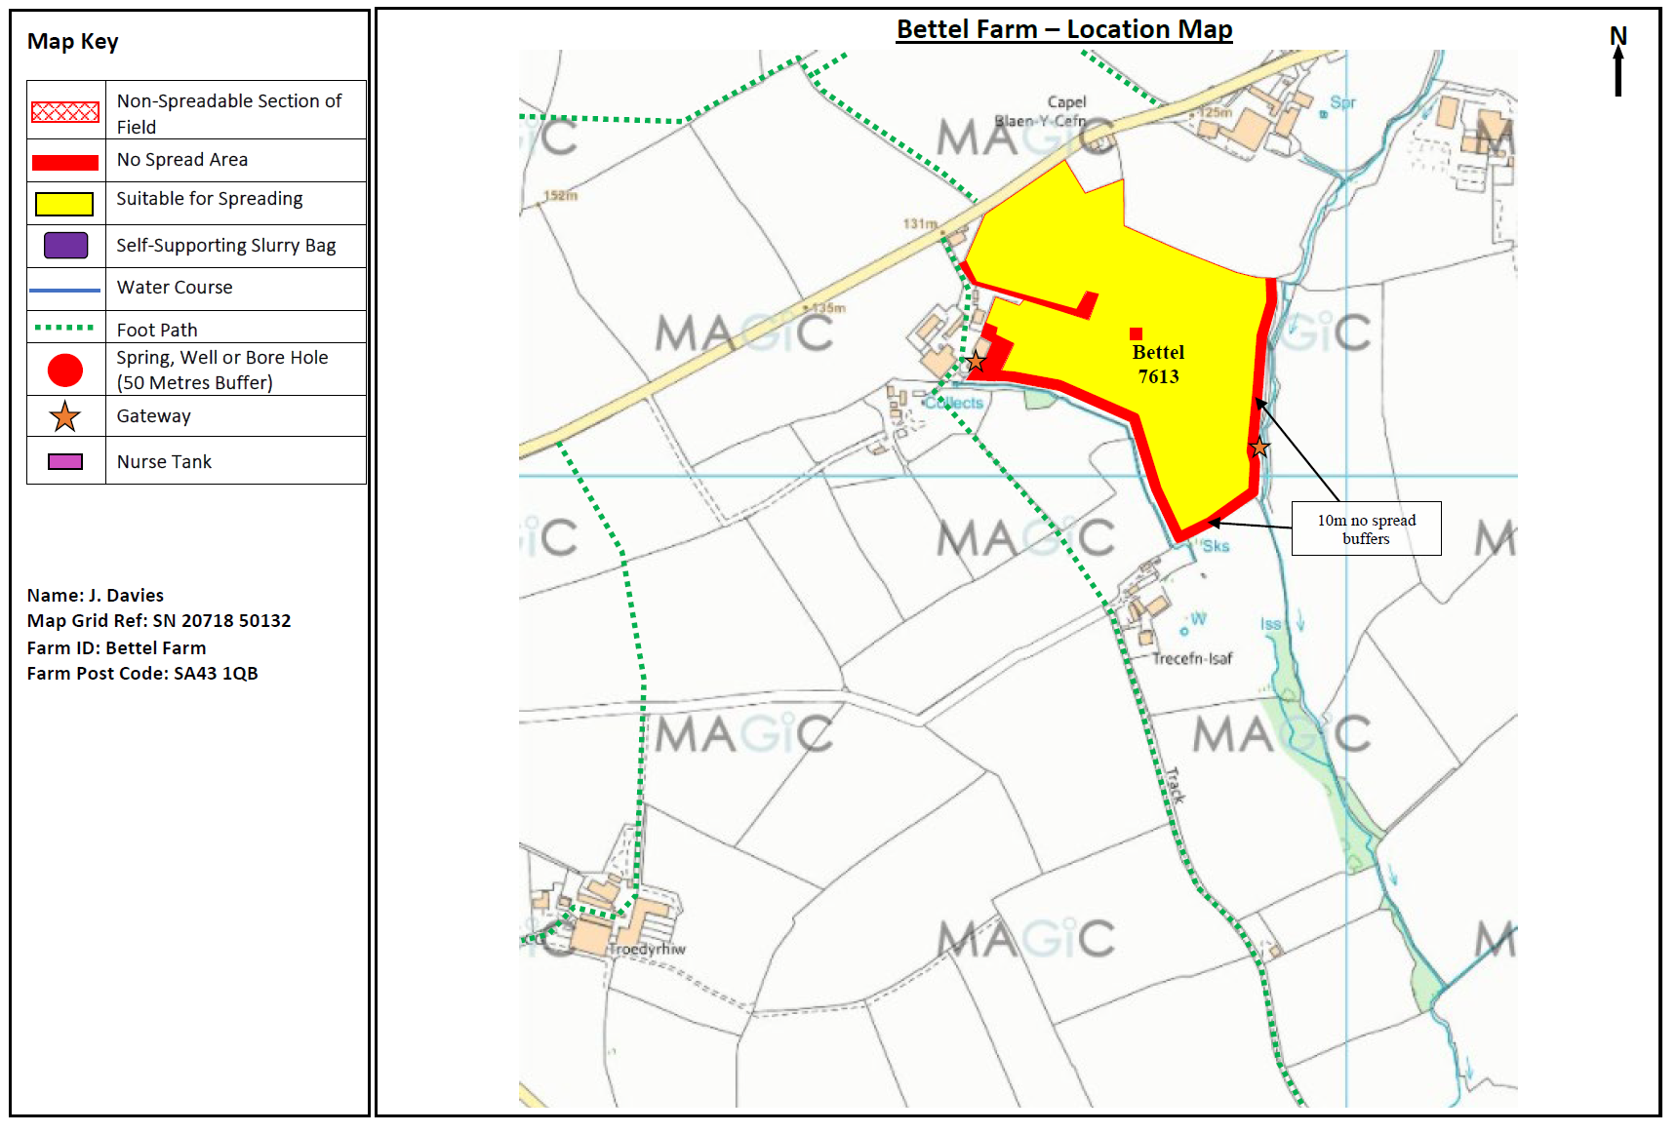
Deployment Boundaries and storage
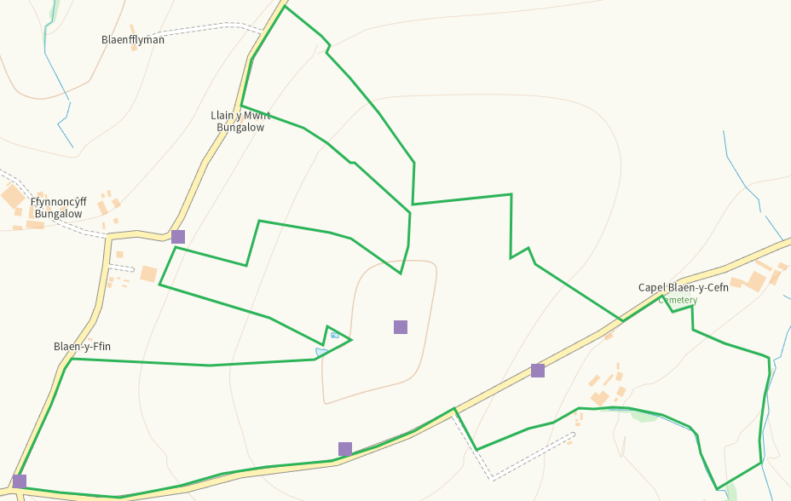
Detailed river network 10m
All buffered on application maps
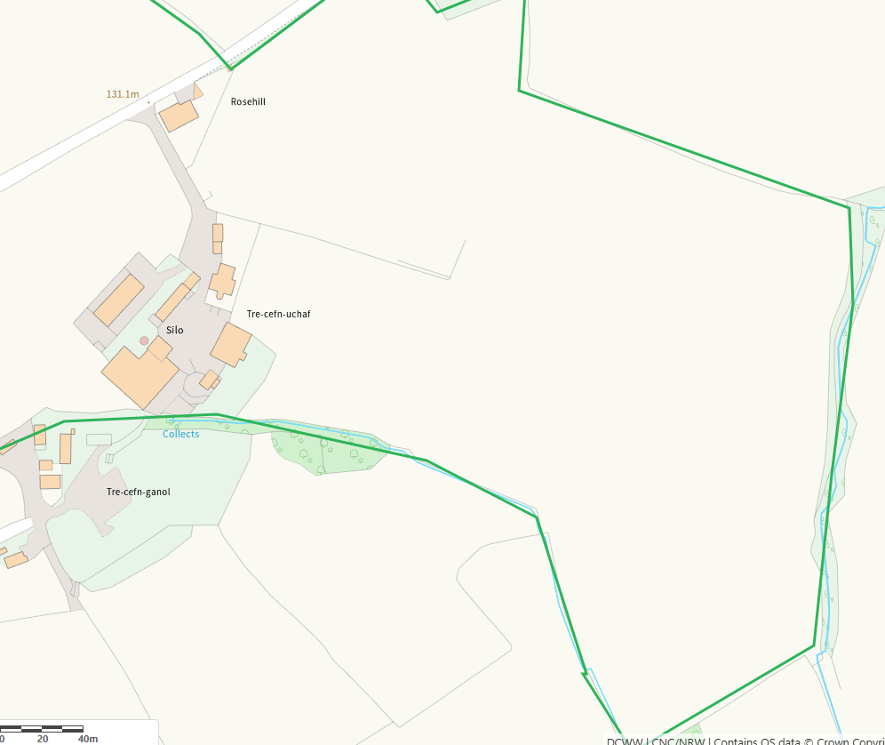
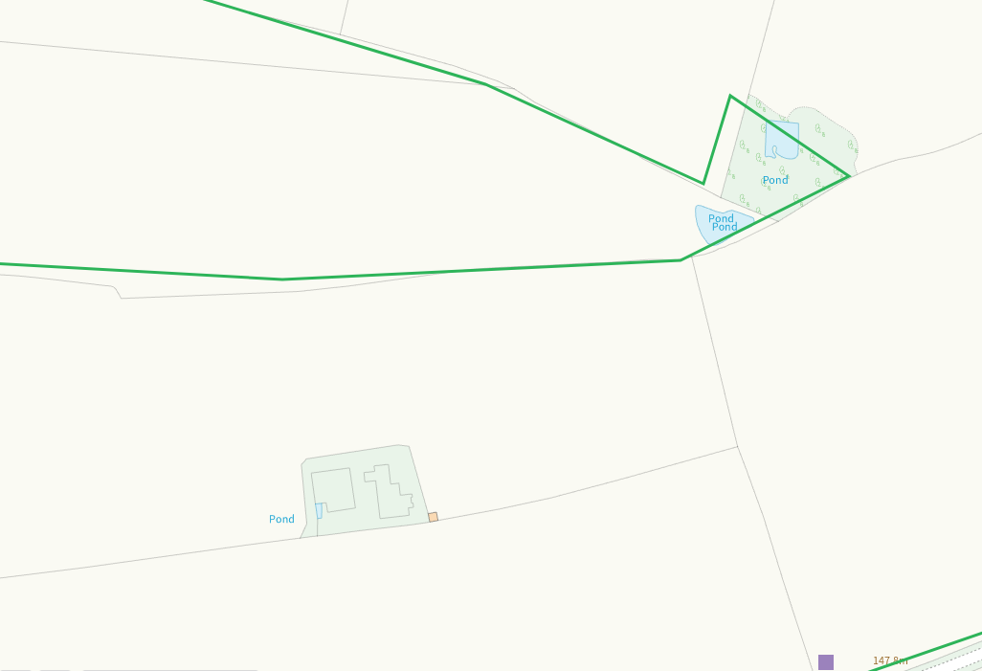

Groundwater source protection zones
none
Any well, spring (or issue) or borehole used for the supply of water for human consumption including from a private water supply or supplies within 50m.
none
Any well, spring (or issue) or borehole used for the supply of water for human consumption including from a private water supply or supplies within 250m.
Nil risk
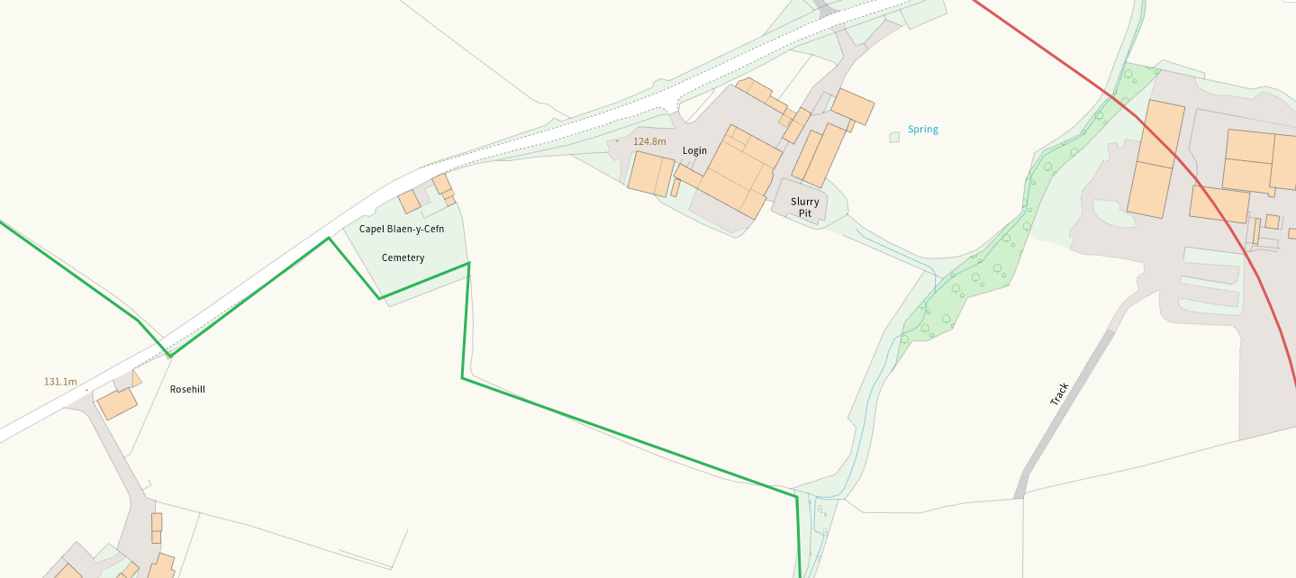

Within Groundwater Safeguard Zone
none
European designated sites- Natura 2000 (SPA, pSPA, SAC or cSAC) or Ramsar- or SSSI within 500m
none
Other protected sites within 500m:
- Protected Species-
Several within range, nil risk from the activity
- Protected Habitats-
Nil risk
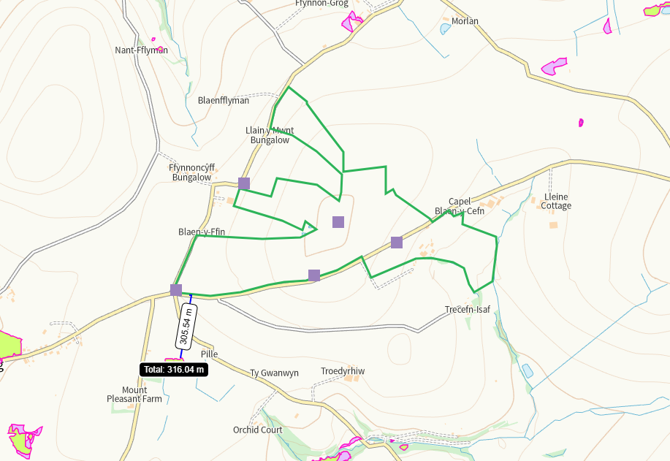

- Scheduled Ancient Monument- none
- Local Nature Reserve- none
- National Nature Reserve-none
- Ancient Woodlands-none
- Local Wildlife Sites (SINC)-none
- National Park- none
- Nitrate Vulnerable Zone (NVZ)- ALL Wales
- Groundwater Safeguard Zone- none

Flood risk
none
Public rights of way
Shown on map
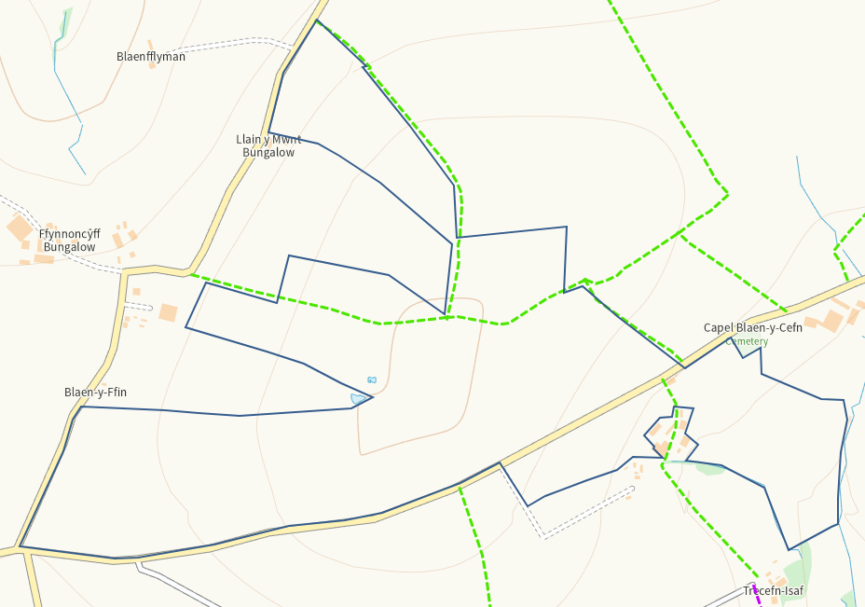
Slope Map
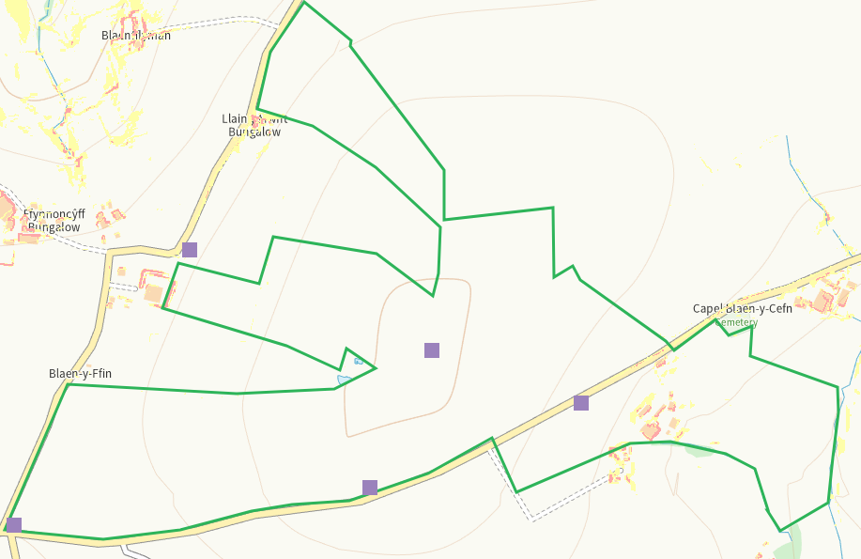
END

