Annex (iv) – SSSI Assessment Form
SSSI Assessment for permit/licence and deployment applications | 
To be completed by Permitting Officers for any applications for a permission which Natural Resources Wales has considered under S28I duty to notify SNCB and take their advice into account. This applies to all proposed permissions within a SSSI, and to operations outside the SSSI boundary which are likely to damage its special features.
NRW as a Section 28G authority has, when exercising its functions, a general duty to take reasonable steps, consistent with the proper exercise of its functions, to further the conservation and enhancement of the flora, fauna or geological or physiological features by reason of which the site is of special interest’

Part 1 – SSSI Assessment
Part 2 – Formal notification to SNCB (to be completed if part 1 assessment concludes likely damage, not likely to damage because of conditions or you cannot conclude no likely damage)
Part 3 – Decision

Part 1 – SSSI Assessment

- Permitting officer/team | Christopher Betteridge (Senior Permitting Officer (Secondment))  Installations and Radioactive Substances Regulation
- Permit application reference and site name | PAN-030961  Barry Cogeneration Plant, Wimbourne Road, Dock No 2, Barry, Vale of Glamorgan CF63 3DH
- a. SSSI name(s)  b. location  c. NRW Operational Area/Environment Team | Hayes Point to Bendrick Rock  x 314488 y 167712  South Wales Central
- Brief description of proposal | This variation application has been made due to the change in future operations at the site.  Decommissioning and physical disconnection of 3 LCP boilers (A1, A2 and A3)  The site will cease operating the high steam consuming production units in June 2026. Once these production units are no longer operational the requirement for steam will be low and the 3 high pressure boilers and associated gas turbines will no longer be required. These 3 LCP high pressure boilers will be decommissioned and physically disconnected. At this point authorised release points A1, A2, A3, A7 and A8 can be removed from the permit.  Removal of 1500 hours limitation on remaining MCP boilers (A4 and A5)  Once the 3 LCP boilers have been decommissioned, the remaining 2 medium pressure boilers are <24 MW each, which falls into the MCP regulations.  The applicant proposes keeping the existing ELV’s and monitoring frequency but removing the 1500 hours limitation from these units in line with MCP regulations.  In the future these boilers will be decommissioned, but only once new suitably sized and positioned boilers have been installed. These new boilers will be added to the Silicones installation permit BR9685IX.  The activity is 0.804 km from the SSSI (displayed on map below)  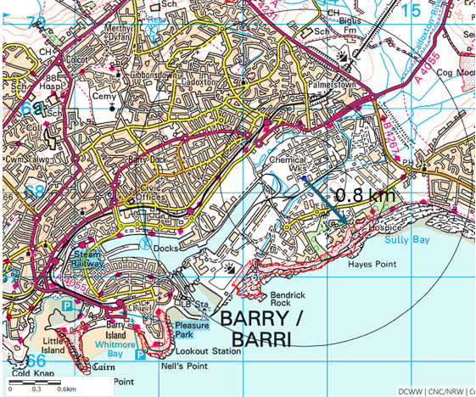
- What aspects of the proposed permission are likely to damage the SSSI features of special interest?

The following ‘Operations Requiring Consent’ (or other activities associated with the permission) that may cause damage) are relevant to the proposed permission.

7. Dumping, spreading or discharging of any materials.

The permit variation may cause additional emissions of particulates (PM10 from the 2 authorised release points)

The following SSSI features and mechanisms of impact have been considered to assess the likelihood of damage.

Hayes Point to Bendrick Rock. This 1.8 km stretch of coastline lies to the southeast of Barry on the northern shore of the Bristol Channel. The whole length of the cliff line and foreshore provides excellent exposures through important rock sections of Triassic age while the vicinity of Bendrick Rock is one of the best localities in Britain for fossil footprints. The site is 29.5 ha in area.

The proposed permission is not likely to damage any of the geological features which are of special interest because the SSSI features are not sensitive to this activity and so there is no potential to damage any of the flora, fauna or geological or physiological features which are of special interest.

- Recommendation | The proposed permission is not likely to damage any of the flora, fauna or geological or physiological features which are of special interest.  There is no potential to damage Hayes Point Bendrick Rock as there is no relevant impact pathway.  Natural Resources Wales is minded to:  Issue the permission
- Signature and date assessment made | 03/09/2026
- Officers name and job title | Christopher Betteridge (Senior Permitting Officer (Secondment))

