OGN 200 Form 1A

Record of a Habitats Regulations Assessment
Plan or project name, brief description or application reference number | PAN-030961  Address: Barry Cogeneration Plant, Wimbourne Road, Dock No 2, Barry, Vale of Glamorgan, CF63 3DH  This variation application has been made due to the change in future operations at the site.  Decommissioning and physical disconnection of 3 LCP boilers (A1, A2 and A3)  The site will cease operating the high steam consuming production units in June 2026. Once these production units are no longer operational the requirement for steam will be low and the 3 high pressure boilers and associated gas turbines will no longer be required. These 3 LCP high pressure boilers will be decommissioned and physically disconnected. At this point authorised release points A1, A2, A3, A7 and A8 can be removed from the permit.  Removal of 1500 hours limitation on remaining MCP boilers (A4 and A5)  Once the 3 LCP boilers have been decommissioned, the remaining 2 medium pressure boilers are <24 MW each, which falls into the MCP regulations.  The applicant proposes keeping the existing ELV’s and monitoring frequency but removing the 1500 hours limitation from these units in line with MCP regulations.  In the future these boilers will be decommissioned, but only once new suitably sized and positioned boilers have been installed. These new boilers will be added to the Silicones installation permit BR9685IX.

HRA iteration/version | N/A

1. Plan or Project Details
Information about the plan or project Complete whichever rows in this table are relevant to the plan or project under consideration – depending on whether this HRA relates to an application by an external party, an NRW project or a plan. There should be no blank rows - if a row is not relevant to the plan/project under consideration put ‘N/A’.

1 | Date application received | 18/11/2025
2 | Applicant details | Andrew Laney  DOW Silicones UK Ltd  Cardiff Road  Barry  Vale of Glamorgan  CF63 2YL
3 | NRW team responsible for carrying out, or requiring to be carried out, the plan or project, and name of lead officer | N/A
4 | Activity/ies proposed | The operator is proposing to decommission and physically disconnect 3 LCP boilers Authorised emission points A1, A2, A3, A7 & A8 can be removed from the permit. Once the 3 LCP boilers have been decommissioned, the remaining 2 medium pressure boilers are <24 MW each, which falls into the MCP regulations. The applicant proposes to keep the permits existing ELVs and monitoring frequency but remove the 1500 hours limitation.  The listed activities in the permit will be updated as follows.  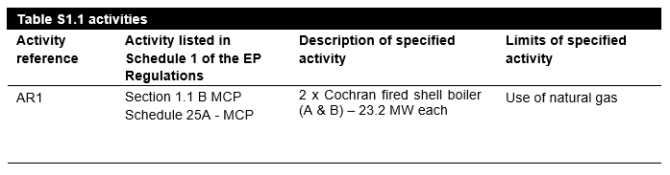
5 | Relevant legislation or statutory basis | Environmental Permitting (England and Wales) Regulations 2016
6 | Location | The European sites search point was centred on the emission point to air for the site (X 313733 Y 168169). A screening distance of 5km has been used based on the NRW guidance “What to do before you apply for a standalone Medium Combustion Plant (MCP) less than 50 MW thermal input that is also a Specified Generator (SG) or Part B activity”. A map below shows the location of the proposed installation location and European sites within the 5km screening distance.  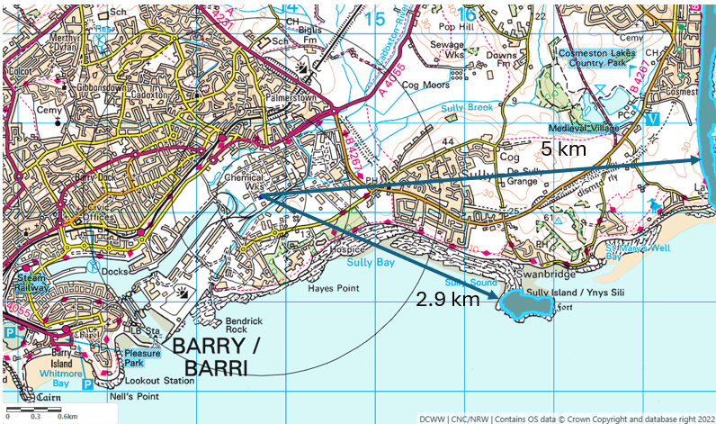
7 | Plan or project documents, including any application documents | Environmental Permit Variation Application Support Document  APPENDIX A – Site Location and Boundary (no change from existing permit)  APPENDIX B – Dow Silicones Uk Ltd Companies House Registration  APPENDIX C – Climate Change Agreement  APPENDIX D – Authorised Release Point Map  APPENDIX E - Management System Summary and LRQA Letter  APPENDIX F – SCAIL template  APPENDIX G – Original IPPC permit issued 2006.
8 | Environmental Statement (ES) | N/A
9 | Pre-application correspondence | Discussions with Geraint Harris / Jude Sartor / Tony Leakey in Licence Supervision dated June 2025. Also decided not to include the existing 5-50MW MCPs in the permit (as part of the Existing Phase II MCP project) are these are due to be decommissioned this year - see emails in Licence Variation dated September 2025.
10 | NRW team responsible for preparing this HRA report, and lead officer | Christopher Betteridge (Senior Permitting Officer (Secondment))  Installations and Radioactive Substances Regulation
11 | Team or person responsible for approving the plan or project (competent authority role) | As row 10

2. Determining the need for a Habitats Regulations Assessment
2.1 Is there any possibility that the plan or project could negatively affect any European sites? | No  The only impact pathways for damage to the sites identified are emissions of particulates, CO, NO_{x} and SO₂. Regarding particulates, the IAQM Guidance on the Assessment of Mineral Dust Impacts for Planning guidance document indicates that impacts on sites that are greater than 1km from the source of particulates are negligible and do not need to be assessed. Whilst related to quarries, the guidance is applicable to emissions of particulates from installations. The sites European sites identified are at least 2.9km from the installation and so we do not consider there to be an impact pathway. Furthermore, the applicant has submitted a H1 and SCAIL assessment which confirmed that emissions of PM10 from the 2 authorised release points are insignificant and can be screened out. Hence there is no hazard.  The submitted H1 assessment also confirms that emissions of CO and SO₂ from the 2 authorised release points are insignificant and can be screened out. The H1 assessment did not screen out emissions of NO_{x} as NO₂, and hence a SCAIL assment was submitted assessing the impact to designated sites. The SCAIL assessment confirms that emissions of NO_{x} as NO₂ from the 2 authorised release points are insignificant and can be screened out.  A Habitats Regulations Assessment (HRA) is not required because there is no conceivable impact pathway to any of the National Site Network sites identified by virtue of the scale or location or nature of the project.

3. Conclusion

HRA is not required because there is no conceivable impact on any European sites.  (As documented in section 2.1) | x
HRA is not required because the whole of the plan or project is directly connected with or necessary to the management of one or more European sites, for the purposes of conserving the habitats or species for which the site(s) is/are designated, and the plan or project is not likely to have a significant effect on any other European sites.
(As documented in section 2.2 and 2.3)
This project is a renewal of a current permission which complies with NRW agreed criteria for ruling out likely significant effects of a renewal without conducting a project-specific LSE test. Therefore, it is considered not likely to have a significant effect on any European sites, either alone or in-combination with other plans or projects.
(As documented in section 3.1 of this form)
The plan or project has been screened for likelihood of significant effects and is considered not likely to have a significant effect on any European sites. (As documented in section 3.2 of this form, and section 5 if applicable)
In light of the conclusions of an appropriate assessment it has been established that the plan or project will not adversely affect the integrity of any European sites, taking into account any conditions or restrictions as applicable, either alone or in-combination with other plans or projects.
(As documented in section 4 of this form, and section 5 if applicable)
In light of the conclusions of the appropriate assessment, it has not been ascertained that the plan or project will not adversely affect the integrity of any European sites, as documented in section 4 of this form, and section 5 if applicable.
Approval for the plan or project cannot be given unless either:
- the plan or project specification, and/or the terms under which it might be approved, are modified so as to remove the risk of adverse effects, and a revised HRA is prepared, or
- the plan or project (not being an SSSI consent*) satisfies the requirements for a derogation and a Derogation Notice is prepared and submitted for consideration by the appropriate authority, normally Welsh Ministers
(*SSSI consents cannot be given as derogations)
Signed:

Name: Christopher Betteridge Position: Senior Permitting Officer (Secondment)

Date: 03/09/2026

Was this HRA conclusion an escalated decision? YES or NO | No

