OGN 200 Form 1A

Record of a Habitats Regulations Assessment

Plan or project name, brief description or application reference number | PAN-033478

HRA iteration/version | 2 – updated to include Severn Estuary SAC & Ramsar

1. Plan or Project Details
Information about the plan or project
1 | Date application received | 22/07/2026
2 | Applicant details | Fitzwilliam Engineering Limited
3 | NRW team responsible for carrying out, or requiring to be carried out, the plan or project, and name of lead officer | N/a
4 | Activity/ies proposed | Temporary dewatering for less than 28 days to facilitate the installation of an underground gas main below the River Rhiw. Excavation of two pits near the River Rhiw are required to be dewatered to facilitate the tunnelling and installation of a gas main pipe below the River Rhiw. A launch pit and reception pit are to be dug about 7 metres deep to launch and retrieve the microbore tunnelling equipment. The abstractions are to last no longer than 28 days, a requirement to meet a temporary licence application.
5 | Relevant legislation or statutory basis | Water Resources Act 1991
6 | Location  Garthmyl, Berriew, Welshpool  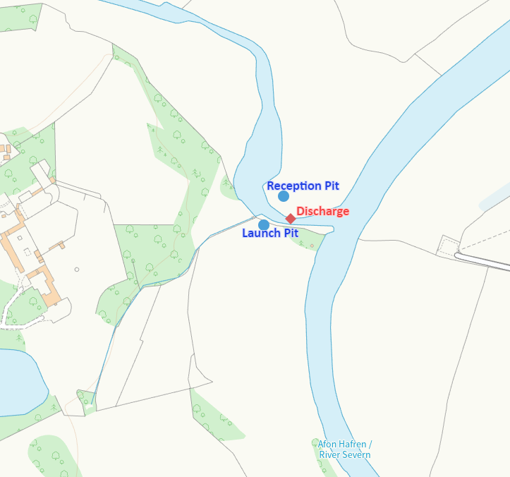
7 | Plan or project documents, including any application documents | Hydrogeological Impact Assessment (v3)  Dewatering schematic  Application Forms WRA & WRD  Water Features Survey  Risk Assessment/Method statement
8 | Environmental Statement | N/a
9 | Pre-application correspondence | N/a
10 | NRW team responsible for preparing this HRA report, and lead officer | Water resources permitting
11 | Team or person responsible for approving the plan or project (competent authority role) | Liz Cole Senior water resources officer

2. Determining the need for a Habitats Regulations Assessment
2.1 Is there any possibility that the plan or project could negatively affect any European sites? | Yes
2.2 Is the whole of the plan or project directly and only connected with or necessary to the management of one or more European sites, for the purposes of conserving the habitats or species for which the European site(s) is/are designated? | No
2.3 Is there a possibility that the plan or project could affect any other feature of the European site(s) concerned, or of another European site, in a way that would undermine that feature’s conservation objectives? | No

3. Considering the likelihood of a significant effect (LSE)

3.1 Renewal of a project authorisation on the same or more restrictive terms as an extant authorisation
Is this a renewal of an extant authorisation which complies with NRW approved criteria for ruling out significant effects of renewals (see Part 2 of OGN200) without conducting a project-specific LSE test? | No

3.2 Likelihood of significant effects (LSE) test

3.2.1 Which European sites might be affected by the plan or project?
(a) | Based on the plan or project specification or information provided in the application, it is considered that these European sites have features which could be negatively affected by the plan or project | Montgomery Canal SAC  Severn Estuary SAC & Ramsar
(b) | The potential for the plan or project to negatively affect these European sites was also initially considered, but can be ruled out without further consideration | Severn Estuary SPA

3.2.2 Screening for likelihood of significant effect
TABLE 3.2.2 Screening assessment
European site name: Montgomery Canal SAC
Floating water plantain/ Luronium natans.
If hydrological connectivity between the dewatering abstraction and the canal potential to drawdown level of water in the canal. This may affect the water plantain survival and thus its distribution range by lowering water levels and potentially reducing water quality. The anticipated impacts from the dewatering will be localised to approximately 50 metres radius and mitigated by the return of abstracted water to the River Rhiw, just downstream of excavation pits. The canal is located over 600 metres west of the proposal and therefore no pathway of impact is possible between the proposal and the designated site. SCREEN OUT.

European site name: Severn Estuary SAC
- Estuaries (which include ‘assemblage of fish species’ as defined in Ramsar feature 2 below). Although potential for draw down in localised stretch of River Rhiw, the applicant is proposing to return abstracted water to the River Rhiw therefore minimising impact. This mitigation is part of the project proposal: the underground water being removed is unwanted and discharging it to the adjacent river is the logical solution. As the period of abstraction is very short term (less than 28 days) it will not cause any significant effects. Fisheries experts have confirmed that given the short term nature of the proposal it will not impact upon any migratory species. SCREEN OUT.
- Subtidal sandbanks. Abstraction is not located near this feature as Severn Estuary is over 250km downstream. No impact pathway possible. SCREEN OUT.
- Mudflats and sandflats. Abstraction is not located near this feature as Severn Estuary is over 250km downstream. No impact pathway possible. SCREEN OUT.
- Atlantic salt meadows. Abstraction is not located near this feature as Severn Estuary is over 250km downstream. No impact pathway possible. SCREEN OUT.
- Reefs. Abstraction is not located near this feature as Severn Estuary is over 250km downstream. No impact pathway possible. SCREEN OUT.
- River Lamprey. Although potential for draw down in localised stretch of River Rhiw, the applicant is proposing to return abstracted water to the River Rhiw therefore minimising impact. This mitigation is part of the project proposal: the underground water being removed is unwanted and discharging it to the adjacent river is the logical solution. As the period of abstraction is very short term (less than 28 days) it will not cause any significant effects. Fisheries experts have confirmed that given the short term nature of the proposal it will not impact upon any migratory species. SCREEN OUT.
- Sea Lamprey. Abstraction is not located near this feature as Severn Estuary is over 250km downstream. No impact pathway possible. SCREEN OUT.
- Twaite Shad . Abstraction is not located near this feature as Severn Estuary is over 250km downstream. No impact pathway possible. SCREEN OUT.

European site name: Severn Estuary Ramsar
- Estuaries (includes fish species assemblage listed in 2. below) . Although potential for draw down in localised stretch of River Rhiw, the applicant is proposing to return abstracted water to the River Rhiw therefore minimising impact. This mitigation is part of the project proposal: the underground water being removed is unwanted and discharging it to the adjacent river is the logical solution. As the period of abstraction is very short term (less than 28 days) it will not cause any significant effects. Fisheries experts have confirmed that given the short term nature of the proposal it will not impact upon any migratory species. SCREEN OUT.

- Assemblage of migratory fish species (including Sea & River Lamprey, Twaite Shad, Allis Shad, Salmon, Sea Trout and Eel). Although potential for draw down in localised stretch of River Rhiw, the applicant is proposing to return abstracted water to the River Rhiw therefore minimising impact. This mitigation is part of the project proposal: the underground water being removed is unwanted and discharging it to the adjacent river is the logical solution. As the period of abstraction is very short term (less than 28 days) it will not cause any significant effects. Fisheries experts have confirmed that given the short term nature of the proposal it will not impact upon any migratory species. SCREEN OUT.

- Internationally important populations of regularly occurring migratory bird species: Bewick’s Swan, 4. European white-fronted goose, 5. Dunlin, 6. Redshank, 7. Shelduck, 8. Gadwal. Abstraction is not located near this feature as Severn Estuary is over 250km downstream. No impact pathway possible. SCREEN OUT.

- Internationally important assemblage of waterfowl. Abstraction is not located near this feature as Severn Estuary is over 250km downstream. No impact pathway possible. SCREEN OUT.

TABLE 3.2.3 Screening decision of the plan or project ‘alone’
(a) If the screening conclusion for all features for all sites in Table 3.2.2 is ‘SCREEN OUT’ | The plan or project is not likely to have a significant effect on any European site, and no further consideration under the Habitats Regulations is required in order to determine the approval/application.
(b) If the conclusion for any features in Table 3.2.2 is ‘SCREEN IN’ | The plan or project is likely to have a significant effect on one or more European sites and therefore an appropriate assessment is required.
(c) If there are no features in Table 3.2.2 that are ‘SCREEN IN’ and any features that are ‘IN COMB’ | The plan or project is not likely to have a significant effect on any European sites when considered alone, but the possibility of significant effects in combination with other plans and projects needs to be considered.

6. Conclusion
HRA is not required because there is no conceivable impact on any European sites.
(As documented in section 2.1)
HRA is not required because the whole of the plan or project is directly connected with or necessary to the management of one or more European sites, for the purposes of conserving the habitats or species for which the site(s) is/are designated, and the plan or project is not likely to have a significant effect on any other European sites.
(As documented in section 2.2 and 2.3)
This project is a renewal of a current permission which complies with NRW agreed criteria for ruling out likely significant effects of a renewal without conducting a project-specific LSE test. Therefore, it is considered not likely to have a significant effect on any European sites, either alone or in-combination with other plans or projects.
(As documented in section 3.1 of this form)
The plan or project has been screened for likelihood of significant effects and is considered not likely to have a significant effect on any European sites. (As documented in section 3.2 of this form, and section 5 if applicable) | X
In light of the conclusions of an appropriate assessment it has been established that the plan or project will not adversely affect the integrity of any European sites, taking into account any conditions or restrictions as applicable, either alone or in-combination with other plans or projects.
(As documented in section 4 of this form, and section 5 if applicable)
In light of the conclusions of the appropriate assessment, it has not been ascertained that the plan or project will not adversely affect the integrity of any European sites, as documented in section 4 of this form, and section 5 if applicable.
Approval for the plan or project cannot be given unless either:
- the plan or project specification, and/or the terms under which it might be approved, are modified so as to remove the risk of adverse effects, and a revised HRA is prepared, or
- the plan or project (not being an SSSI consent*) satisfies the requirements for a derogation and a Derogation Notice is prepared and submitted for consideration by the appropriate authority, normally Welsh Ministers
(*SSSI consents cannot be given as derogations)
Signed: L Cole

Name: Liz Cole
Position: Senior water resources officer

Date: 14/08/2026, Updated version completed 26/08/2026
Was this HRA conclusion an escalated decision? YES or NO | No

7. Consultation with the ANCB and how sections 2, 3, 4 and 5 of this HRA report (as applicable) take into account that advice.
Relevant section of the HRA report | Correspondence and/or meetings with the ANCB | Description of how the comments from the ANCB have been taken into account
2
3 | Update to include Severn estuary SAC,SPA, Ramsar | These designated sites added to screening table 3.2.2
4
5

