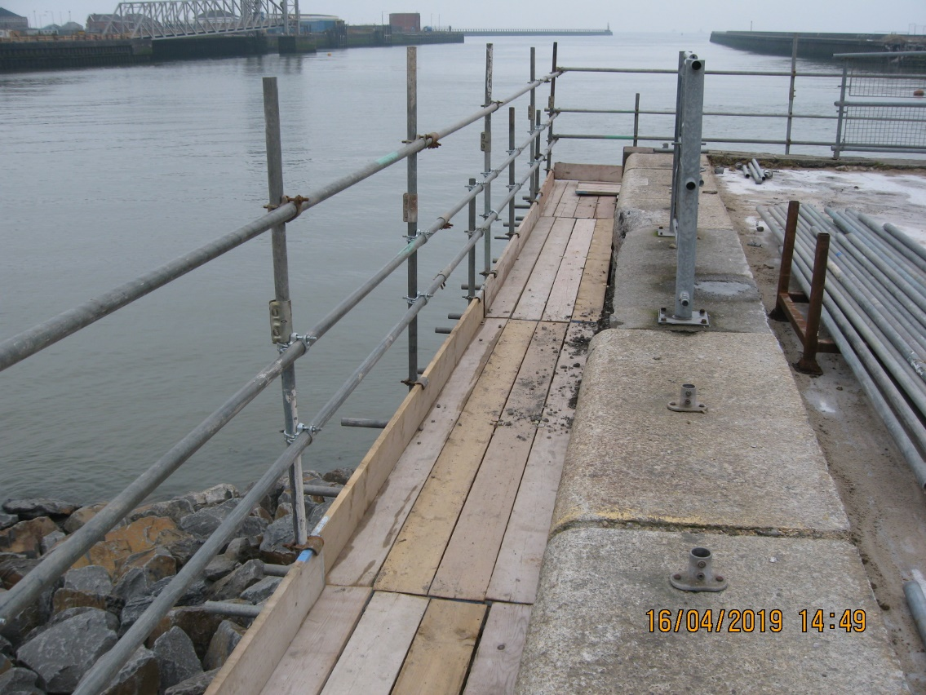
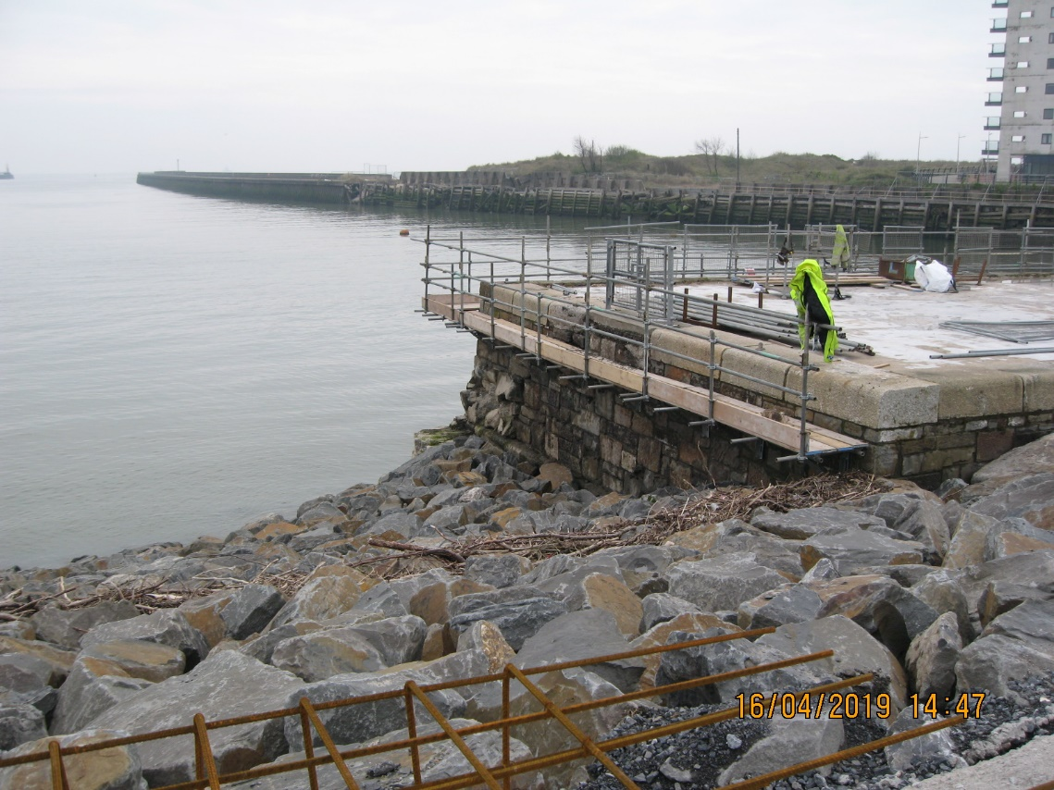
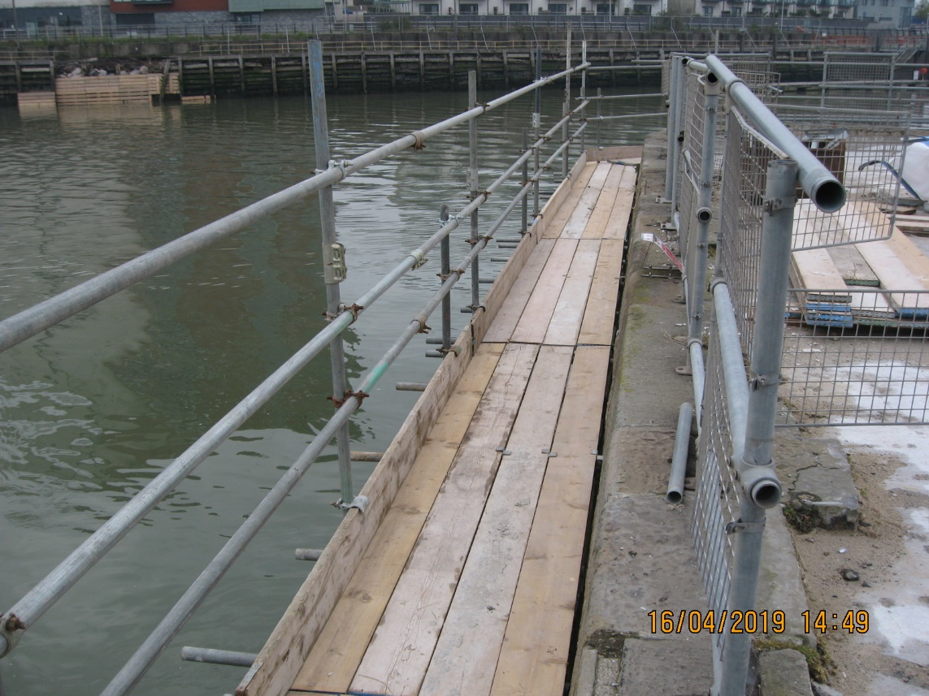
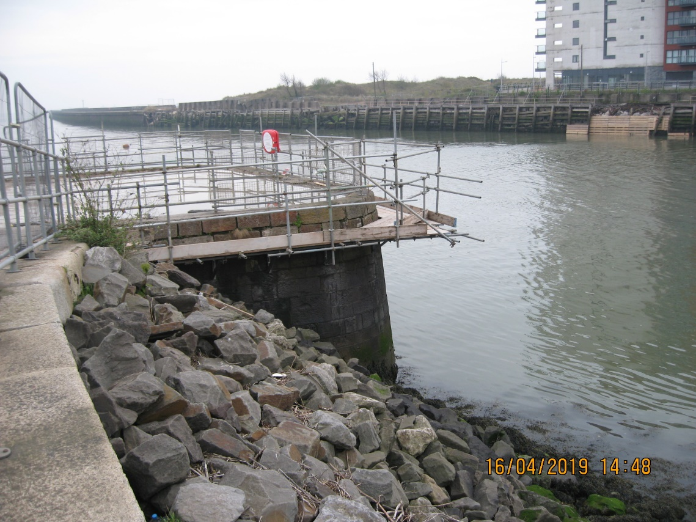
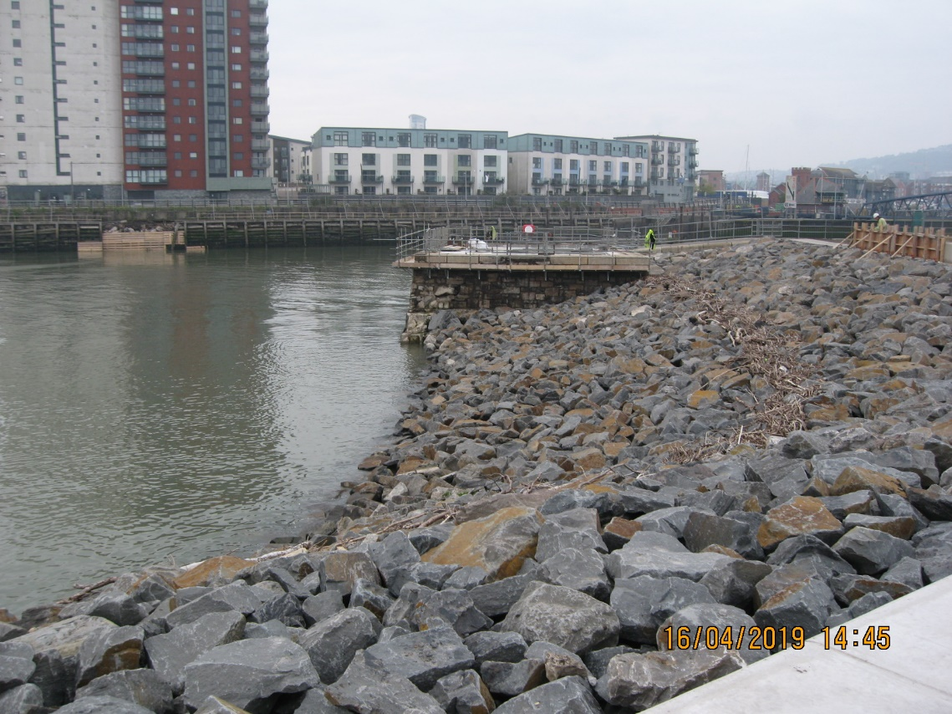
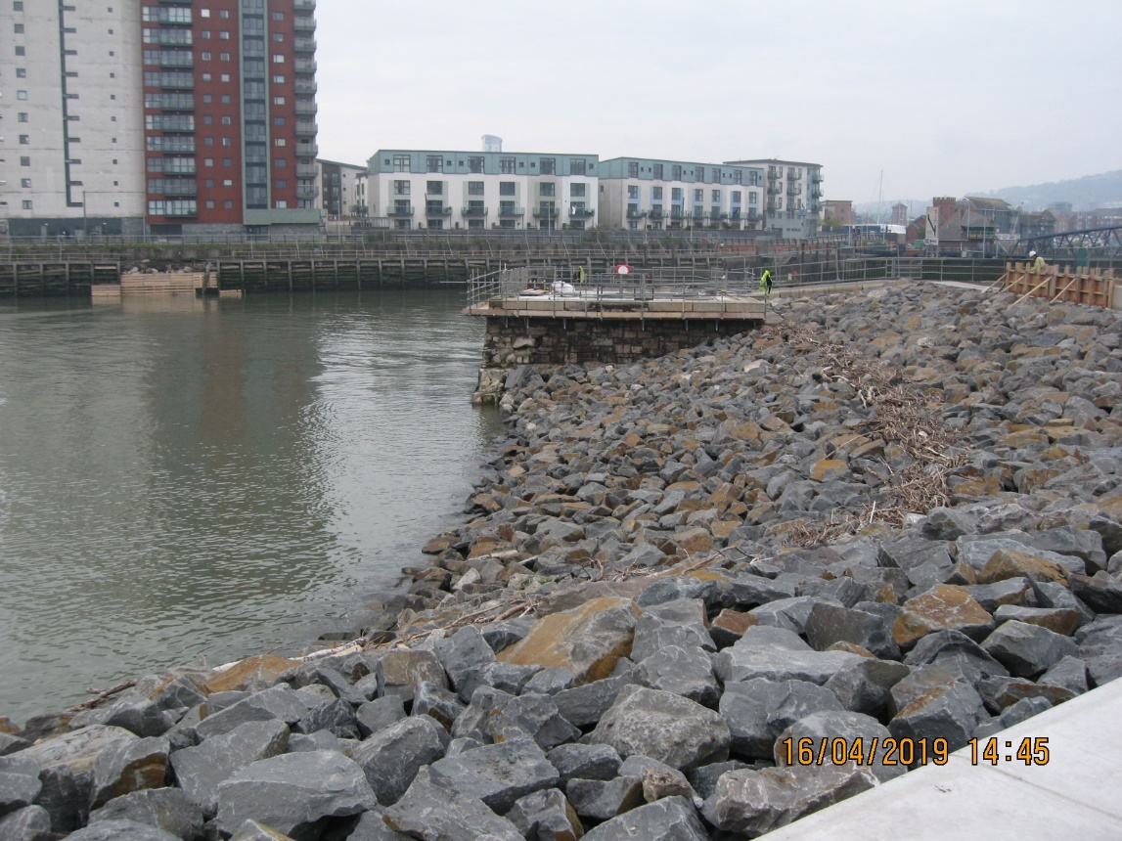
SA1 - SWANSEA - MARINE LICENCE & WFD SCREENING/ ASSESSMENT.
Promenade to be raised to new level with concrete walls

REMOVE DAMAGED
CONCRETE
INFILL WITH
RIP RAP
REMOVE DAMAGED
CONCRETE

