01/05/2019

Our Ref: ML059
Project Ref: CML1859v1

Project Title: River Tawe Revetment Marine Licence Variation Application

Thank you for the opportunity to comment on the potential impact of the above proposed works on the historic environment.

The Marine Licence application and supporting documentation have been considered by the Glamorgan Gwent Archaeological Trust.

On this occasion, GGAT has no objection to consent being granted provided all legislation is followed.

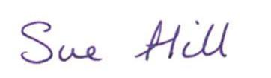

Sue Hill
Heritage Conservation Officer

