21/57/12/0082: Comparison of existing licence map, with map detailing current licence 10 figure NGR and suggested 12 figure NGR

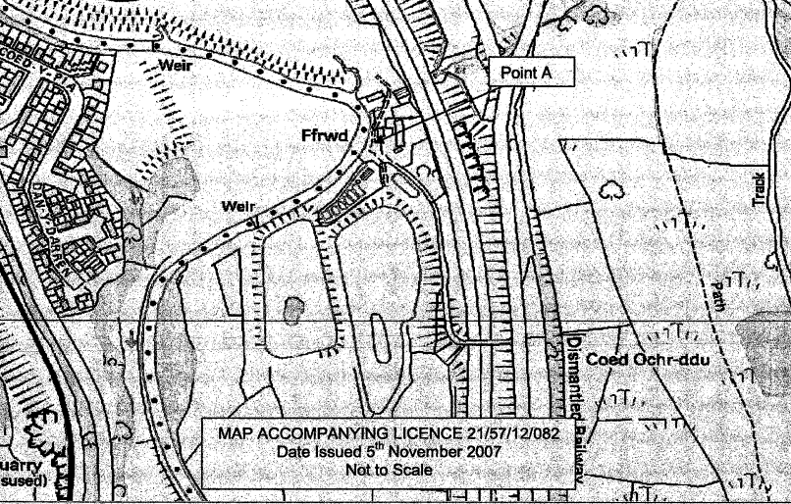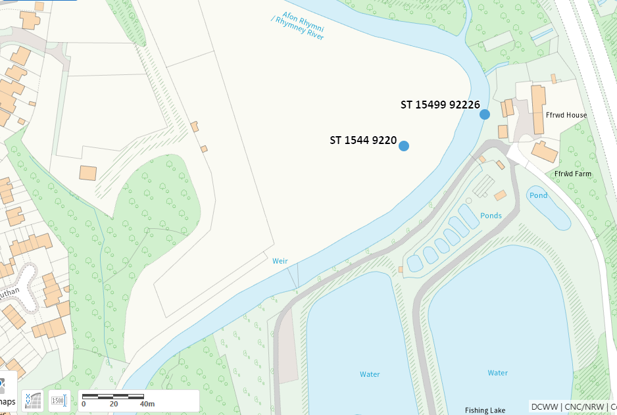
Current 10 figure NGR: ST 1544 9220
Suggested 12 figure NGR: ST 15499 92226

21/57/12/0095: Comparison of existing licence map, with map detailing current licence 10 figure NGR and suggested 12 figure NGR

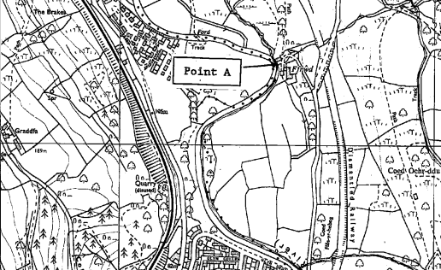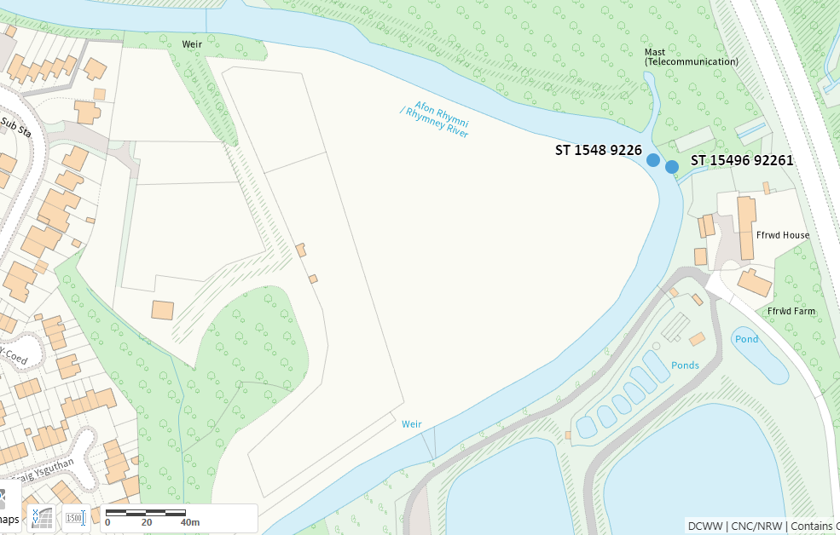
Current 10 figure NGR: ST 1548 9226
Suggested 12 figure NGR: ST 15496 92261

