CRoW Appendix 4 (140_10_SD02)  CRoW Act 2000: Natural Resources Wales application for permission - Formal Notice |  | 
Natural Resources Wales Formal Notice.
Requirements of Section 28I of the Wildlife & Countryside Act 1981 as amended by the Countryside and Rights of Way Act (CRoW) 2000.
Duty in relation to granting any consent, licence or permit for activities likely to damage Sites of Special Scientific Interest (SSSI).
Guide to filling in this form for Natural Resources Wales staff:
To be completed by Permitting Officers for any applications for a permission which the Natural Resources Wales has considered under S28G duties to protect and enhance SSSIs. This applies to all proposed permissions within a SSSI, and to operations outside the SSSI boundary which are likely to damage its special features.
Refer to OI 140_10 ‘Applying the Countryside and Rights of Way (CRoW) Act 2000 to applications for permits with potential for impact on Sites of Special Scientific Interest (SSSI)’, including the flowchart in Appendix 2.
Pink italic text – drafting notes, to be deleted before completion/consultation.
Blue text – examples, to be replaced with permission-specific information.
Ensure you have completed all sections.
- Natural Resources Wales area/region/NPS hub: | EPR Installations permitting, south west area (Port Talbot)
- Name of SSSI: | Margam Moors (33WAR):1.4 km from proposed new boilers  Eglwys Nunydd Reservoir: (33WXY) – 1.6 km from proposed new boilers  Cynffig / Kenfig (33 WAD): 3.1 km from proposed new boilers
- Type of permission: | Environmental Permit
- Date for Natural Resources Wales permit determination: | 19/09/24 but urgent operational need for operational decision by end of June 2024
- Predicted 28 day date for response from NRW conservation/ecology (under S28 I(4)): | N/A – for file only, no need to consult (see below)
- Natural Resources Wales reference no: | BL7108IM – Package Boiler Variation (V018? - TBC)
- National grid reference: | Tata Steel UK Limited  Port Talbot Steelworks  Port Talbot  SA13 2NG  Actual package boiler location within installation SS 7788 8656  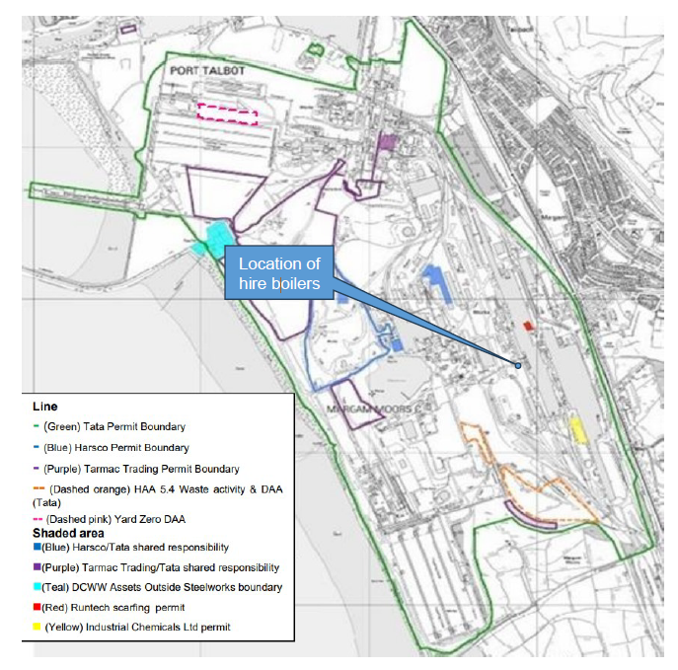  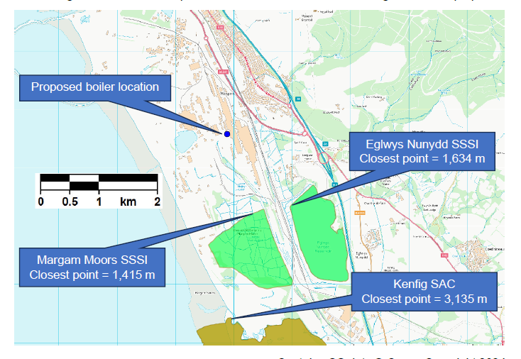
- Description of proposal: | As part of wider transformation plans for the Steelmaking operation:  Plan to install 3 x 10.9 MWth Natural Gas fired Package Boilers (MCPs) to provide temporary steam supply as Blast Furnace steelmaking is wound down. To provide process steam to downstream production which will continue, and to facilitate decommissioning of existing assets, until a permanent new steam boiler is proposed and consented as part of bigger plans to install a new arc furnace steelmaking capability in 2-3 years time and subject to separate consent.  In the context of the overall transformation, 32.7 MWth of new natural gas steam generation capacity is proposed near the centre of the Port Talbot steel site, adjacent to the existing 114 MWth Service Boilers 4 & 5 (A50) which will be permanently turned off. New boilers are more efficient than old, so emission per unit of steam generated will go down. There is over 500 MWth of combustion plant on the site, capable of burning blast furnace gas, coke oven gas, Basic Oxygen Steelmaking Gas, and natural gas. Eventually all of these will cease (expected this year). Removal of these more polluting fuels, and reduction in onsite generating capacity, is a clear environmental improvement in terms of air quality impact on local / regional protected sites which may be impacted, even accounting for the need for a small new boiler of 32.7 MWth capacity operating on the cleanest of these fuels, natural gas. Any additional impact from the new boilers can already be offset against equipment already permanently brought out of service, with the closure of the coke ovens, and associated reduction in NOX emissions by over 1,600 tonnes per year. In this context, the new boilers constitute an overall environmental improvement by allowing the closure of the Service boilers and other assets.
- Is the proposed activity within (wholly or partially) the SSSI boundary? | NO Distances from new source (not installation boundary) to SSSI shown in box 2 above
- Has there been any pre-application discussion or correspondence with NRW conservation/ecology | NO Not necessary – as explained, a clear impact reduction/improvement
- What aspect(s) of the proposed permission may damage the features which are of special interest for the SSSI?

There is no conceivable negative impact on any SSSI, when developments to the industrial installation are considered holistically, owing to the scale, location and nature of the proposals. By permanently turning off old equipment, there is a large environmental improvement, and the new plant facilitates this change while maintaining downstream production.

While 32.7 MWth of new natural gas combustion capacity will be consented (package boilers, 8.4m stacks), this enables the Service Boilers 4&5 (114 MWth, 68m stack) to be taken permanently out of service, and removes the possibility of use of more polluting fuels than natural gas (coke oven gas, blast furnace gas, BOS gas) in this appliance. The new package boiler and old service boiler will not run concurrently (other than potentially some short-term commissioning /testing less than one month. Permitted coke oven gas usage has already ceased across the site with the closure of the coke ovens in March 2024. The associated air emission impact reduction far outweighs the small impact from the new plant (see below). Within 2024, it is expected that >500 MW of combustion activity on the site, as well as blast furnaces and sinter plant, will also cease operation - with far larger beneficial changes to impact than addition of the package boilers.

There are no credible pathways for noise (too small and far for e.g. disturbance risk), water (use and disposal arrangements unchanged from service boilers), meaning that NOX emissions and associated N / Acid deposition are the only credible impact to rule out from needing an consideration for impact on SSSIs, as a result of air emissions from the boilers. As NOX emissions are reduced by permanent the coke oven closure (already happened 20th March 2024, 1600 tonnes NOX per year across the installation), 30 tonnes of NOX emission impact via the new process is insignificant. Furthermore, SCAIL dispersion screening of the new process has indicated impacts at the SSSIs are insignificant (either process contribution ≤1% of environmental standard, predicted environmental concentration ≤100% of environmental standard, or both) but need not be assessed further owing to the associated emission reductions by asset closure. Where N deposition has an “exceeding background”, there will be improvement to this associated with the overall reduction in combustion on site. This improvement will be fully assessed when the application comes in for full site transformation, formally surrendering the existing activities that are ceasing, and assessing the impact of the proposed new arc furnace.

Table 1 – summary of package boiler Screening results
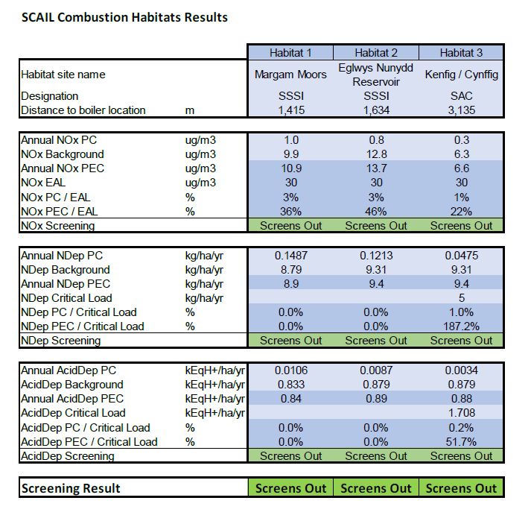

Overall, possibility of damage to SSSIs is dismissed because the work is a net improvement; the new capacity is itself shown to have insignificant impact via SCAIL screening, and new consent is associated with cessation of other manufacturing activity and emissions, the impact improvements of which dwarf the scale of the newly consented boilers.

- Decision
i) The proposed permission is not likely to damage any of the flora, fauna or geological or physiological features which are of special interest.

As explained, the overall site changes proposed are an improvement – a reduction in combustion capacity, move to less polluting fuels, reduction in NOX emissions and associated Ndep/acid dep. At the same time, SCAIL screening modelling has shown the new boiler impact to be of insignificant impact at SSSI receptors when considered on its own, aside from the impact of other concurrent changes.

The only “Conditions” which are needed to reach this conclusion are those inherent to EPR permitted operation:
- Medium combustion plant controls and emission limits
- Permanent cessation of other permitted activity as outlined – coke ovens and COG already ceased, service boilers will cease upon use of the package boilers
- Operating techniques etc as outlined in the application

Natural Resources Wales is minded to:
Issue the permission (no SSSI specific conditions, only those inherent to the installation / permit)

- Name and job title of Natural Resources Wales officer: | David Poole, Senior Specialist Advisor, Industrial Decarbonisation and Standards Regulatory Approaches Team  Following multi-disciplinary decision making meetings 13th June 2024 and 21st June 2024. On behalf of Installations permitting in respect of final decision.
- Date form sent to NRW conservation/ecology | Placed on file on/after 24th June 2024. No need to consult as concluded clear improvement / no net impact requiring assessment/confirmation
For Natural Resources Wales use only, once NRW conservation/ecology response received
- NRW conservation/ecology comment on assessment: | Please delete as appropriate:  i) NRW conservation/ecology advise the operation can go ahead  ii) NRW conservation/ecology advise the operation can go ahead with conditions  iii) NRW conservation/ecology advise against permitting the operation  Please ensure that the NRW conservation/ecology response is attached to this Formal Notice.
- Name and job title of NRW conservation/ecology officer:
- Date of receipt of NRW conservation/ecology response:

