Record of a Habitats Regulations Assessment of a project or spatially-specific plan
OGN 200 Form 1A (with free-text boxes for likely significant effect screening and appropriate assessment)

Document owner: Head of Business for Natural Resource Management
Version History:
Document Version | Date Published | Summary of Changes
2.0 | 21/10/2024 | Following 2023/24 review of HRA OGNs
Next review date: October 2025

Record of a Habitats Regulations Assessment 4
1. Plan or Project Details 4
2. Determining the need for a Habitats Regulations Assessment 5
3. Considering the likelihood of a significant effect (LSE) 6
4. Appropriate assessment of the plan or project when considered alone 12
5. In combination assessment 16
6. Conclusion 19
7. Consultation with the ANCB and how sections 2, 3, 4 and 5 of this HRA report (as applicable) take into account that advice 21
8. Countersignature 22
9. Appendix 1 - Supporting information 23

OGN 200 Form 1A

Record of a Habitats Regulations Assessment
Plan or project name, brief description or application reference number | The Raglan Arms

HRA iteration/version | N/A

1. Plan or Project Details
Information about the plan or project

1 | Date application received | 09/04/2026
2 | Applicant details | DT Contracting (South West) Limited
3 | NRW team responsible for carrying out, or requiring to be carried out, the plan or project, and name of lead officer | Water Quality
4 | Activity/ies proposed | An application has been received, PAN-032397, for a new surface water discharge at Raglan Arms, Llandenny, NP15 1DG. The location NGR is SO 41409 03952.  The applicant is proposing to convert the Raglan Arms existing pub into two 4-bedroom houses.  The proposal incorporates a BioDisc® BD-BN Sewage Treatment Plant with chemical dosing discharging into an unnamed ditch of Nant Wilcae. The tank operates to meet British Standard BS 12566. The proposal features a perforated pipe to address the ditch potentially drying up in warmer months.  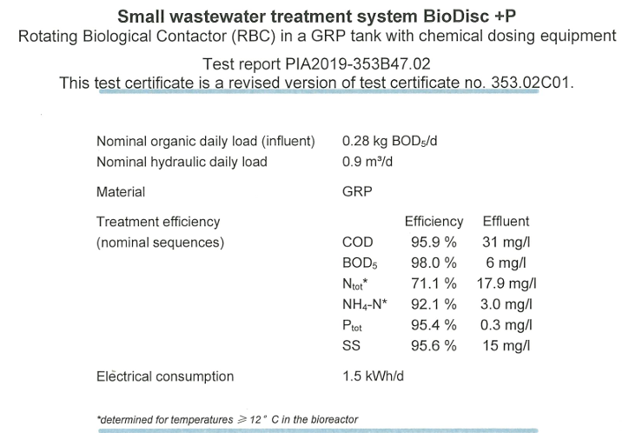  There was previously a septic tank at the site serving the pub.  A sewage effluent discharge of a volume 3.3 m3/day has been estimated.
5 | Relevant legislation or statutory basis | EPR 2016
6 | Location | 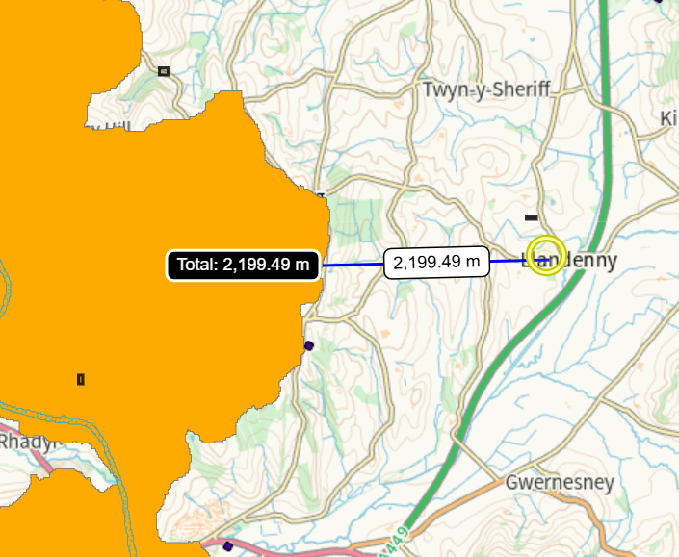  Discharge  SO 41409 03952
7 | Plan or project documents, including any application documents | PAN-032397
8 | Environmental Statement (ES) | N/A
9 | Pre-application correspondence | N/A
10 | NRW team responsible for preparing this HRA report, and lead officer | Water Quality
11 | Team or person responsible for approving the plan or project (competent authority role) | Michael Simmons  Water Quality

2. Determining the need for a Habitats Regulations Assessment
2.1 Is there any possibility that the plan or project could negatively affect any European sites? | Yes
2.2 Is the whole of the plan or project directly and only connected with or necessary to the management of one or more European sites, for the purposes of conserving the habitats or species for which the European site(s) is/are designated? | No
2.3 Is there a possibility that the plan or project could affect any other feature of the European site(s) concerned, or of another European site, in a way that would undermine that feature’s conservation objectives? | Yes

3. Considering the likelihood of a significant effect (LSE)

3.1 Renewal of a project authorisation on the same or more restrictive terms as an extant authorisation
Is this a renewal of an extant authorisation which complies with NRW approved criteria for ruling out significant effects of renewals (see Part 2 of OGN200) without conducting a project-specific LSE test? | No

3.2 Likelihood of significant effects (LSE) test

3.2.1 Which European sites might be affected by the plan or project?
(a) | Based on the plan or project specification, or information provided in the application, it is considered that these European sites have features which could be negatively affected by the plan or project
(b) | The potential for the plan or project to negatively affect these European sites was also initially considered, but can be ruled out without further consideration | N/A

3.2.2 Screening for likelihood of significant effect

TABLE 3.2.2 Screening assessment
European site name: Afon Wysg / River Usk SAC, site code UK0013007
Key features:  Allis shad Alosa alosa  (Key species)  Twaite shad Alosa  fallax (Key species)  River lamprey  Lampetra fluviatilis  (Key species)  Sea lamprey  Petromyzon marinus  (Key species)  European otter Lutra  lutra (Key species)  Watercourses of plain  to montane levels  with the Ranunculion  fluitantis and  Callitricho-Batrachion  vegetation (Key habitat)  Bullhead Cottus gobio  (Important species but not main driver of management or focus of monitoring)  Brook lamprey  Lampetra planer (Important species but not main driver of management or focus of monitoring)  Atlantic salmon Salmo  salar (Important species but not main driver of management or focus of monitoring) | Conservation objectives are taken from:  CORE MANAGEMENT PLAN INCLUDING CONSERVATION OBJECTIVES FOR Afon Wysg/River Usk Special Area of Conservation  Version 3 (September 2022) – Approved by Jon Goldsworthy | Potenital impact pathways :  Nutrient enrichment  Suspended Solids/turbidity/smothering  Impact on food source  Toxins contamination  Physical damage i.e. scouring Change in temperature  Change in Salinity Change pH Change in water levels – i.e. Abstractions | The likelihood of significant effect posed by this proposal cannot be ruled out at this stage so the proposal wil be assessed further in Section 4.

TABLE 3.2.3 Screening decision of the plan or project ‘alone’
(a) If the screening conclusion for all features for all sites in Table 3.2.2 is ‘SCREEN OUT’ | The plan or project is not likely to have a significant effect on any European site, and no further consideration under the Habitats Regulations is required in order to determine the approval/application.
(b) If the conclusion for any features in Table 3.2.2 is ‘SCREEN IN’ | The plan or project is likely to have a significant effect on one or more European sites and therefore an appropriate assessment is required.
(c) If there are no features in Table 3.2.2 that are ‘SCREEN IN’ and any features that are ‘IN COMB’ | The plan or project is not likely to have a significant effect on any European sites when considered alone, but the possibility of significant effects in combination with other plans and projects needs to be considered.

4. Appropriate assessment of the plan or project when considered alone

4.1 Assessment of plan or project as defined

Table 4.1 Appropriate assessment of the plan or project as defined
European site name: Afon Wysg / River Usk SAC, site code UK0013007 | Can adverse effects on site integrity be ruled out? ‘YES’ or ‘NO’
As per Table 3.2.2 | No

4.2 Appropriate assessment of the plan or project taking into account additional conditions or restrictions imposed by the competent authority

Table 4.2 Appropriate assessment of the plan or project taking into account additional conditions or restrictions
European site name: Afon Wysg / River Usk SAC, site code UK0013007
European site Feature | Adverse effect(s) | Can adverse effect(s) be mitigated by additional imposed conditions or restrictions?  ‘YES’ or ‘NO’ | Additional imposed mitigation measure(s) | Can adverse effect on site integrity be ruled out?  ‘YES’ or ‘NO’
As per Table  3.2.2 | As per Table  3.2.2 | Yes | This discharge is apprximatley 2,100m West as the crow flies from “Usk - conf R Gavenny to conf Olway Bk” GB109056040083 waterbody which is located within the overall “failing River Usk phosphorus targets for water bodies in Special Area of Conservation (SAC)” area.  The overall assessment status for “Usk - conf R Gavenny to conf Olway Bk” GB109056040083 waterbody is a “Fail” so nutrient neutrality applies.  The discharge will recerive dilution prior to entering the boundary of the failing waterbody and the proposed discharge volume is relatively low (3.3 m³/day).  The current British Standard performance for treatment plants is:  20 mg/l Biochemical Oxygen Demand (BOD).  30 mg/l Suspended Solids (SS).  20 mg/l Ammonia (NH3)  The proposed BioDisc system is a package treatment plant which complies with EN12566-3, the European/British standard for treatment plants. This treatment plant is designed to produce a high standard of effluent.  The performance of the proposed BioDisc system treatment plant is as follows:  The proposed BioDisc system exceeds the minimum requirement for British Standard performance, producing a very high quality of effluent, with Phosphorus treatment being 95.4% or 0.3 mg/l.  The proposal features a perforated pipe to address the ditch potentially drying up in warmer months.  To show there will be no negative impact on the SAC from increased phosphorus, the proposal must show no additional nutrients are discharged, known as nutrient neutrality. In order to determine if nutrient neutrality has been achieved it is required to calculate the phosphorus loading (volume X concentration) pre and post development. The applicant has provided this as part of their application submission and it is summarised in the table below:  The above table shows that despite the daily volume of treated effluent increasing (+532,125.00 litres) post-development, the improved effluent quality from the treatment plant system brings about a net reduction in annual phosphorus load (-6.02 kg TP/year) and Annual nitrogen load (kg TN/year) (-26.35).  Permit conditions to be applied will ensure the quality of the treated effluent is improved, resulting in a reduced loading of nutrients.  This proposal is considered an existing discharge; an unregulated discharge has been present at the site, associated with a failing septic tank. Granting a permit would bring this discharge under regulatory control, thereby replacing a potentially unknown environmental risk with a regulated activity. This is considered to be an upgrade on the current system and would also enable timely regulatory intervention should any environmental concern arise in the future.  As a mitigation measure to reduce potential environmental impacts, it may be appropriate, if permitted, to include permit limits for phosphate and ammonia via a numeric permit. These limits could be based on the expected performance of the proposed BioDisc treatment system and may be achievable for the operator to comply with. The inclusion of such limits would place the discharge activity under more stringent regulatory control and provide a clearer framework for regulatory intervention should performance issues arise in the future.  This proposal will now be assessed in combination with other relevant projects in Section 5 (below). | No
  Essential Characteristic | Performance
  COD Chemical Oxygen Demand | 95.9% | 31 mg/l
  BOD5 Biochemical Oxygen Demand | 98.0% | 6 mg/l
  SS Suspended Solids | 95.6% | 15 mg/l
  NH4** Ammonia | 92.1% | 3 mg/l
  P Phosphorus | 95.4% | 0.3 mg/l
  Sewage system | Additional population: | Annual wastewater production (litres): | Annual phosphorus load (kg TP/year) | Annual nitrogen load (kg TN/year)
  Septic tank (pre-development) | 60.00 | 657,450.00 | 6.38 | 47.93
  New PTP  (post-development) | 22.00 | 1,205,325.00 | 0.36 | 21.58
  Net change | -38.00 | +532,125.00 | -6.02 | -26.35

4.3 Concluding the appropriate assessment of the plan or project alone
Table 4.3 Conclusion of the appropriate assessment alone
(a) If Table 4.1, or the right hand column of Table 4.2 if applicable, is ‘YES’ for all features | It has been ascertained that the plan or project, when considered alone, will not adversely affect the integrity of any European sites.
(b) If there are any ‘NO’s in the right hand column of Table 4.2 | It has not been ascertained that the plan or project, when considered alone, will not adversely affect the integrity of one or more European sites.
(c) Are there are any residual effects of the plan or project (net of mitigation measures) which, though not adverse on their own, could be significant when considered in combination with the effects of other plans or projects? | Yes

5. In combination assessment

Table 5.1 Identification and assessment of in combination effects
European site name: Afon Wysg / River Usk SAC, site code UK0013007
Potential in combination effects to be considered:

There are no current projects to consider in combination.

Table 5.2 In combination assessment: results
(a) If the answer for all features considered in Table 5.1 is ‘YES’ | The plan or project, when considered in combination with other plans and projects, is either not likely to have a significant effect on, or will not adversely affect the integrity of, any European site.
(b) If the answer for any features considered in Table 5.1 is ‘NO’ | The plan or project in its current form is likely to have a significant effect on, or an adverse effect on, European site/s in combination with other plans or projects.

6. Conclusion
HRA is not required because there is no conceivable impact on any European sites.
(As documented in section 2.1)
HRA is not required because the whole of the plan or project is directly connected with or necessary to the management of one or more European sites, for the purposes of conserving the habitats or species for which the site(s) is/are designated, and the plan or project is not likely to have a significant effect on any other European sites.
(As documented in section 2.2 and 2.3)
This project is a renewal of a current permission which complies with NRW agreed criteria for ruling out likely significant effects of a renewal without conducting a project-specific LSE test. Therefore, it is considered not likely to have a significant effect on any European sites, either alone or in-combination with other plans or projects.
(As documented in section 3.1 of this form)
The plan or project has been screened for likelihood of significant effects and is considered not likely to have a significant effect on any European sites. (As documented in section 3.2 of this form, and section 5 if applicable)
In light of the conclusions of an appropriate assessment it has been established that the plan or project will not adversely affect the integrity of any European sites, taking into account any conditions or restrictions as applicable, either alone or in-combination with other plans or projects.  (As documented in section 4 of this form, and section 5 if applicable) | x
In light of the conclusions of the appropriate assessment, it has not been ascertained that the plan or project will not adversely affect the integrity of any European sites, as documented in section 4 of this form, and section 5 if applicable.
Approval for the plan or project cannot be given unless either:
- the plan or project specification, and/or the terms under which it might be approved, are modified so as to remove the risk of adverse effects, and a revised HRA is prepared, or
- the plan or project (not being an SSSI consent*) satisfies the requirements for a derogation and a Derogation Notice is prepared and submitted for consideration by the appropriate authority, normally Welsh Ministers
(*SSSI consents cannot be given as derogations)
Signed: Michael Simmons

Name: Michael Simmons Position: Water Quality Permitting Officer

Date: 09/09/2026

Was this HRA conclusion an escalated decision? YES or NO | No

