Cardigan Tidal Flood Risk Management Scheme
Outline Construction Traffic Management Plan

Client’s project no. 1234
BUKL project no. 4020123
Prepared for:
Natural Resources Wales (NRW)

27/11/2025
Revision P03

Table of contents

1. Introduction 3
1.1 Purpose of the document 3
1.2 Objectives 3
1.3 Structure of the document 4
2. Existing conditions 5
2.1 Site context 5
2.2 Local highway network 5
2.3 Pedestrian network 6
2.4 Public transport network 7
3. Construction programme and methodology 8
3.1 Construction programme and working hours 8
3.2 Construction compounds 8
3.3 Construction staff 9
3.4 Size of construction vehicles 9
4. Estimated vehicle movements 9
4.1 Construction traffic 9
4.2 Operational traffic 10
5. Vehicle routing 11
5.1 Construction vehicle routing 11
5.2 Construction vehicles – restricted delivery 13
5.3 Site access 13
5.4 Wheel wash facilities 14
5.5 Temporary signage 14
5.6 Temporary closures/management 14
5.7 Traffic management 15
6. Mitigation strategies 17
6.1 Encouraging car sharing 17
6.2 Principal Contractor 17
6.3 Scheduling site deliveries 17
6.4 Procedure for the control of unauthorised entry of vehicles and personnel 18
6.5 Highway condition survey 19
7. Implementing, monitoring and updating 19
7.1 Management of the CTMP 19
7.2 Compliance 21
8. Monitoring and review 22

Details of document preparation and issue:
Version | Prepared | Checked | Reviewed | Approved | Issue date | Status
V01 | JC | WT | AF | - | 10.12.2025 | Draft
V02 | JC | CC | WT | - | 15.12.2025 | Draft
V03 | JC | CC | WT | WT | 22.12.2025 | Issue

Project no. 4020123 |  | Client’s reference no.
File name: | 240771 – Cardigan 0CTMP RSK V01

Notice:
This report was prepared by Binnies UK Limited (BUKL) solely for use by Client’s name. This report is not addressed to and may not be relied upon by any person or entity other than Client’s name for any purpose without the prior written permission of BUKL. BUKL, its directors, employees and affiliated companies accept no responsibility or liability for reliance upon or use of this report (whether or not permitted) other than by Client’s name for the purposes for which it was originally commissioned and prepared.
In producing this report, BUKL has relied upon information provided by others. The completeness or accuracy of this information is not guaranteed by BUKL.

Introduction
Natural Resources Wales have instructed SCP to produce an Outline Construction Traffic Management Plan (oCTMP) to support the proposals for the installation of the Cardigan Tidal Flood Risk Management Scheme (TFRMS) in Cardigan, Ceredigion in west Wales. Herein referred to as the ‘Scheme’.

Purpose of the document
The construction process of the TFRMS will require the movement of equipment and materials to the Scheme as well as staff movements. This oCTMP outlines the management of these movements and their interaction with the surrounding road network operations.
The oCTMP is intended to be an emerging document, such that modifications and necessary interventions can be made following further information and advice from consultees. The oCTMP will be developed into a detailed Construction Traffic Management Plan (CTMP) following the appointment of a Principal Contractor and prior to the start of construction works.
The appointed Principal Contractor will be responsible for the delivery of the Scheme in accordance with the controls documented in any approved CTMP.

Objectives
The oCTMP summarises the specific traffic and transport impacts predicted to arise from the construction works and provides a framework for the management of construction traffic.
The oCTMP only considers the construction phase of the Scheme and has been prepared to ensure that the construction process, and management and mitigation measures, minimise the impact on existing users of the public highway network.
The key objectives of this oCTMP are to:
- Reduce traffic congestion where possible, by reducing the number of trips related to the construction phases, particularly during peak hour periods.
- Provide mitigation for the traffic generated during the construction phase of the Scheme, including Heavy Goods Vehicles (HGVs).
These sub-objectives support the main objectives listed above:
- Establish responsibility for the management of construction vehicles and deliveries throughout the duration of the project construction phase
- Ensure safe vehicular and non-motorised access and egress
- Identify clear controls on routes for HGVs, vehicle quantities and hours of site operations and delivery times
- Identify traffic management measures that will be necessary to accommodate construction traffic
- Minimise the number of private car trips to and from the Scheme, which are likely to be made by construction staff, by encouraging car sharing
- Regularly monitor and review the oCTMP as part of an established management process at each stage of the Scheme
- Inform and update the supply chain and the local community to raise awareness and present the Principal Contractors’ commitment to safe and efficient construction vehicle practices

Structure of the document
The oCTMP contains the following chapters:
- Chapter 2 describes the existing transport conditions and challenges
- Chapter 3 discusses the construction programme and methodology
- Chapter 4 analyses the estimated vehicle movements of the construction phase
- Chapter 5 sets out the vehicle routing to the site
- Chapter 6 details the mitigation strategies to reduce any impacts
- Chapter 7 details the implementing, monitoring, updating and review process
- Chapter 8 outlines the required monitoring and review processes

Existing conditions

Site context
The Scheme is located in Cardigan, within the Ceredigion region of Wales. The proposed flood defences will be constructed along the northern bank of the River Teifi (Afon Teifi), with the permanent works extending from the west at Castle Street (SN177458) to the east by Gloster Row car park (SN180459) as shown in Figure 1.
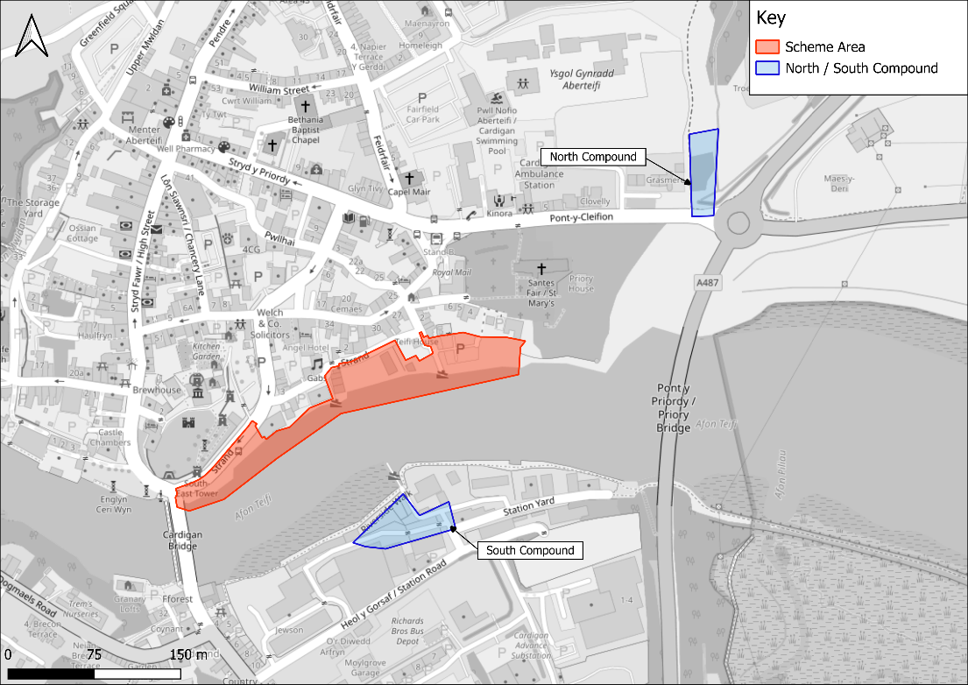
Figure 1: Scheme Area and construction compounds

Local highway network
High-level descriptions of the existing local highway network conditions are provided in Table 2-1.
Table 2-1: Existing conditions of the local highway network
Road Name | Description
Strand | Strand is the main road within the site and is adjacent to the new flood defences. It is the primary access road to the site and where most construction work will take place. Strand is a one-way two-lane road that connects Carrier’s Lane to Bridge Street/High Street and Cardigan Bridge (Castle Street) to reach the A487.
Carrier’s Lane | Carrier’s lane is a main access road to the site, and is a one-way single-lane road connecting southwards from Morgan Street onto Strand. To the northern extent of Carrier’s Lane is the Carrier’s Lane / Morgan Street / St Mary Street junction, facilitating vehicular access from the north-east of the town (via Morgan St) and from the High Street (via St Mary St). This road is also within the flood risk zone. There is on-street parking on the offside of the road.
St Mary Street | St Mary Street is a one-way single-lane road connecting some of the surrounding properties to High Street, Morgan Street, and Gloster Row.
Morgan Street | Morgan Street is a main access road to the site, and is a one-way one-lane road connecting southwards from Priory Street/Pont-Y-Cleifion to Carrier’s Lane.
Bridge Street/High Street | Bridge Street/High Street is a one-way single-lane connecting northwards from Strand to the High Street/Priory Street junction.
Pont-Y-Cleifion | Pont-Y-Cleifion is a main access road to the site, and is a two-way two-lane road connecting the A487 to Priory Street, St Mary Street, and Feidrfair.
A487 | The A487 is the main road connecting the site and Cardigan to the surrounding area and regional road network, and is a two-way two-lane road. To the north, it connects to regional destinations such as Aberystwyth. To the south it connects to destinations such as Fishguard. It is assumed that all HGV movements will use this road as it provides access to the site, and associated compounds, from the north and south.
B4546 | The B4546 is a main egress road from the site, and is a two-way two-lane road connecting Strand/Cardigan Bridge (Castle Street) to the A487. It is anticipated that this road will be used by all vehicles egressing the site.

Pedestrian network
The area surrounding the site comprises mainly of residential/town centre roads with low speed limits. The surrounding highway network benefits from the provision of pedestrian footpaths and streetlighting. From the A487, the route to the Northern Compound also benefits from the provision of both single and double yellow line parking restrictions to prevent vehicles from parking on the footpaths. Additionally, there is a pedestrian crossing point provided on Pont-Y-Cleifion.

Public transport network
The closest bus stop to the Scheme Area is located on Strand, within the Scheme Area (Stop ID: cejamag), which is proposed to be temporarily closed during the construction period. This bus stop provides access to the 408 (Cardigan to Poppet Sands) service. In addition, there is a bus stop located on Bridge Street (Stop ID: cejajtm), approximately 140m from the Scheme Area. This bus stop provides access to the 408 and 430 (Cardigan and Narberth) services.
The closest bus stop to the Northern Compound is on Priory Street outside of the Cardigan Council offices (Stop ID: cejajpm), approximately 270m from the Northern Compound, and the closest bus stop to the Southern Compound is the Golwg-y-castell stop (Stop ID: cejagwp) located approximately 550m from the Southern Compound.
The Priory Street stop provides access to the 408 and T5 (Haverfordwest to Aberystwyth) services. The Golwg-y-castell stop provides access to the 430 service.

Construction programme and methodology

Construction programme and working hours
Construction for the Scheme is expected to commence in early 2027 with the construction programme duration estimated to last for a total duration of 18 months.
The proposed construction working hours would be governed by Ceredigion County Council (CCC) and are typically expected to be limited to daytime on weekdays between 07:30 and 18:00 during the summer and 08:00 and 16:30 during winter months due to decreased daylight hours. If weekend working is permitted, this would likely take place on Saturdays between 07:30 and 13:00. Activities within the site compounds may continue outside of the main construction activity hours. Out of hours works, if required, would be agreed in advance with the Local Authority Environmental Health Officer.
Riverside works would be tide dependent and scheduled outside the hours above. This may necessitate tidal working to expediate the overall programme and would be agreed in advance with CCC.

Construction compounds
There are two proposed temporary compound areas which would be used for plant and material storage and housing welfare units during construction works.
The proposed Northern Compound would be located on the northern side of the Afon Teifi, to the north of Pont-Y-Cleifion Road. This compound area would be used as the main compound and laydown area for the works on the northern bank of the Afon Teifi.
The proposed Southern Compound would be located on the southern side of the Afon Teifi.
Satellite compounds within Areas 1 and 4 of the Scheme Area will be required for welfare facilities and storage at different points of work.
The compound, welfare facilities and parking will be located wholly within the Scheme Areas and will not require the use of the highway or other public areas to load or store materials.
Precise details of the compound layout will be confirmed by the Principal Contractor as part of the full CTMP.
Sufficient on-site parking will be provided by the Principal Contractor for staff, subcontractors and visitors. Parking facilities will be restricted to the temporary compound. Parking on the road verges will be strictly prohibited. The Principal Contractor will be required to monitor and take necessary action to prevent site vehicles parking outside of the agreed parking positions.
Furthermore, there will be enough space on site for a large construction vehicle to turn on site. Therefore, vehicles would be able to manoeuvre in and out of the construction compound in a forward moving gear to deliver and remove materials to and from the Scheme.
Health and Safety signs and relevant construction information including the Principal Contractors information will be displayed on the hoarding at various points around the perimeter of the Scheme.

Construction staff
The average workforce is expected to be 6 to 10 operatives on site per day, comprising general operatives, plant drivers, and supervisors. However, peak workforce numbers are likely to increase to 14 to 18 operatives during periods of overlapping activities such as stone cladding, coping installation, and tidal protection works.
All staff would park within the construction compounds, which are designated to enable all vehicles to park on site to avoid obstruction to the adjacent public highway.

Size of construction vehicles
Regarding the type and volume of expected materials to be delivered, delivery vehicles will not be restricted, aside from the legal limits of size and weight. Associated with the construction phase, the majority of construction vehicles accessing the Scheme Area are considered to be of a ‘normal’ size category (i.e. LGVs and HGVs).

Estimated vehicle movements

Construction traffic

Vehicle types and plant equipment
It is anticipated that the following plant will access the Scheme Area during the construction phase:
- On-site dumpers
- wheeled excavator
- concrete pump
- cement mixer
- road surfacing plant
- hand based machinery
- rollers/vibro plates
- power barrows

Construction vehicle movements
It is envisaged that the construction phase would last for approximately 18 months. The majority of HGV movements are expected to occur between the hours of 07:30 to 18:00 Monday to Friday, ensuring that construction activities are limited during the peak periods (08:00-09:00 & 16:00-17:00). This is to ensure that the Scheme has limited adverse impact on the operation of the local highway network during these peak periods.
Construction of the Scheme will not require significant volumes of traffic, predominantly comprising of vehicle movements relating to staff arriving and leaving the Scheme.
The specific activities which will result in the movement of vehicles, including private vehicles, LGVs and HGVs are outlined in Table 4-1.
Table 4-1: Approximate vehicle movements by activity
Element | Vehicle Movements (bidirectional)
Sheet piling | 8 articulated wagons (40t)
Granular fill / piling platform | 655 tipper wagons (20t)
Granular fill (removal) | 492 tipper wagons (20t)
Rip rap | 137 tipper waggons (20t)
Stone facing | 59 tipper wagons (20t)
Copings | 5 articulated wagons (40t)
Concrete | 133 concrete wagons
Other disposal | Potential need for 20 tipper wagons (20t)
Other vehicles | 12-18 light vehicles

Operational traffic
Once operational, the Scheme will encounter low levels of traffic for maintenance purposes only.

Vehicle routing

Construction vehicle routing
During the construction phase, the access will be managed to ensure that no conflicts occur between incoming and outgoing vehicles.
It is anticipated that the construction traffic will use the main strategic roads close to the Scheme, with route appraisals being undertaken to ensure that the construction traffic routes avoid local settlements and residential areas where possible, minimising the impact on sensitive receptors.
The proposed access route to the northern side of the Afon Teifi would follow the A487 onto Pont-Y-Cleifion via the roundabout, and down Morgan Street and Carrier’s Lane to reach Strand. This route has been selected as it passes the Northern Compound area and allows for transit towards the Scheme Area. The proposed access route to the southern side of the Afon Teifi (i.e. Southern Compound area) would follow the A487 onto the B4546 via the roundabout, and down onto Station Road. This is illustrated in Figure 2.
The proposed egress route from the Scheme Area would follow Strand onto the B4546 via Cardigan Bridge (Castle Street), then onto the A487. The proposed egress route from the Northern Compound would begin at the A487/Pont-Y-Cleifion roundabout and follow the A487. The proposed egress route from the Southern Compound would follow Station Road onto the B4546 to the A487/B4546 roundabout. This is illustrated in Figure 3.
The proposed access route from the Northern Compound to the Scheme Area would be via Pont-Y-Cleifion, Morgan Street, and Carrier’s Lane to reach Strand. The proposed access route from the Scheme Area to the Northern Compound would be via Strand, the B4546, the A487, and then exit at the A487/Pont-Y-Cleifion roundabout. This is illustrated in Figure 4.
The proposed access route from the Southern Compound to the Scheme Area would be via Station Road, the B4546, the A487, then onto Pont-Y-Cleifion via the roundabout, and down Morgan Street and Carrier’s Lane to reach Strand, The proposed access route from the Scheme Area to the Southern Compound would be via the B4546 and Station Road.
There may also be an element of inter-compound trips between the Northern and Southern Compounds. It is anticipated that vehicles making these trips will use the A487, B4546, and Station Road.

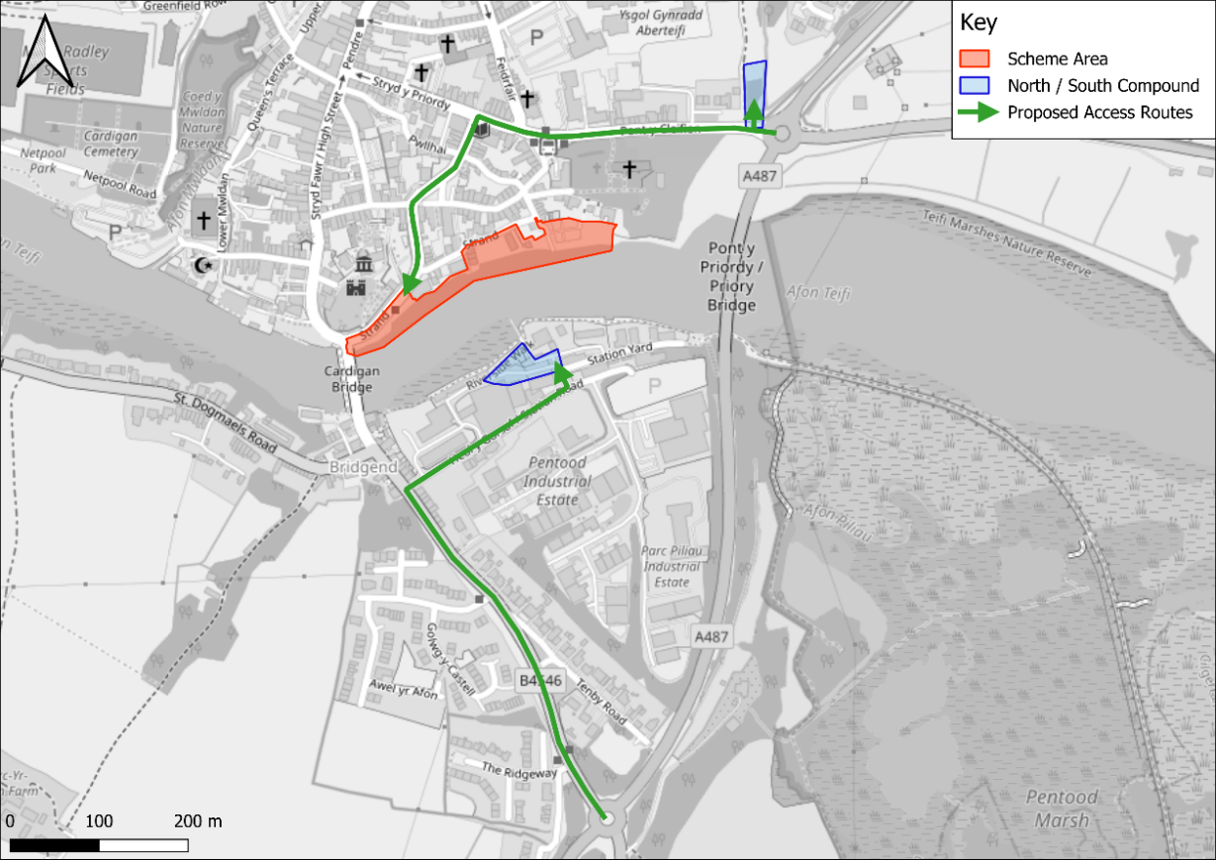
Figure 2: Proposed traffic routes (access)
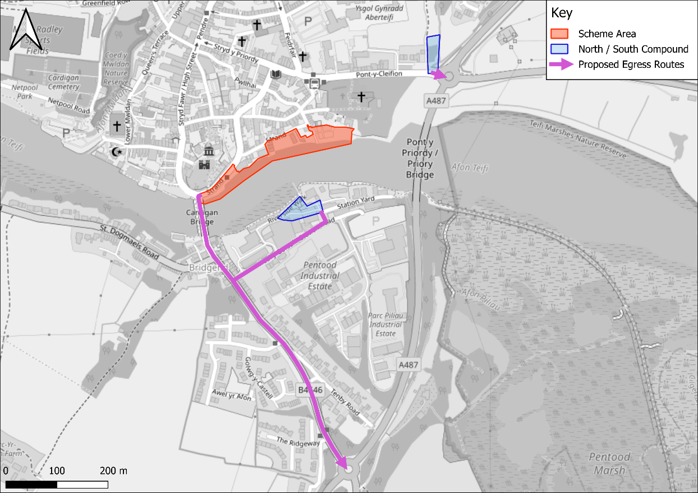
Figure 3 Proposed traffic routes (egress)
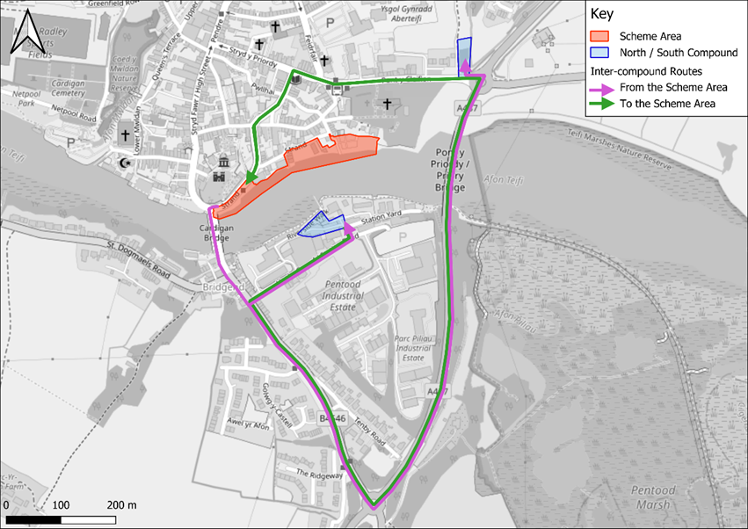
Figure 4: Proposed traffic routes (between Scheme Area and compounds)

Construction vehicles – restricted delivery
The Scheme will operate for construction between 07:30 and 18:00 each weekday during the summer and 08:00 and 16:30 during winter months. Construction will not occur on Bank Holidays.
If weekend working is permitted, this would likely take place on Saturdays between 0730 and 1300. Activities within the site compounds may continue outside of the main construction activity hours. Out of hours works, if required, would be agreed in advance with the Local Authority Environmental Health Officer.
The Principal Contractor will consider the ability to reduce deliveries during network peak hours to minimise impacts on congestion, although this may not be possible for time-sensitive activities or long distance journeys where travel during peak periods will be difficult to avoid.

Site access
Access to the Northern Compound will be from the A487 onto Pont-Y-Cleifion at the roundabout.
Access to the Scheme Area (access to Area 1) will follow Pont-Y-Cleifion, down Morgan Street and Carrier’s Lane to reach Strand.
Access from the Scheme Area would cross Cardigan Bridge (Castle Street) which becomes the B4546 to the roundabout with the A487 to either leave Cardigan, return to the Northern Compound or access the Southern Compound (via Station Road).
Access to the Southern Compound will be from the A487 roundabout onto B4546 and onto Station Road.

Wheel wash facilities
Wheel washing facilities will be provided on site prior to the site exit. Any cleaning will be carried out within the site in the wheel wash area to prevent detritus and deposits from being transferred from the site onto the public highway.

Temporary signage
Advance routeing signage may be considered appropriate for the Scheme to assist with compliance for HGVs. As above, the signage type and location will be agreed in advance with the relevant traffic authority.
All temporary signage and traffic management will be secured by the Principal Contractor through the standard permit process with the Local Highway Authority.

Temporary closures/management
It is anticipated that a Traffic Regulation Order (TRO) in the form of a partial temporary road closure along Strand would be required during construction. The road closure of the left-hand lane will be closed for the duration of the project which will result in the bus stop (stop id: cejamag) on this road being closed during the construction phase. Additionally, the on-street parking in the right-hand lane of Strand will be closed during the construction phase; this will allow cars to continue to be able to travel along Strand connecting to Bridge Street and Cardigan Bridge (Castle Street), rather than prohibiting traffic flow entirely. Figure 2 shows the area of Strand that will be impacted by closures.

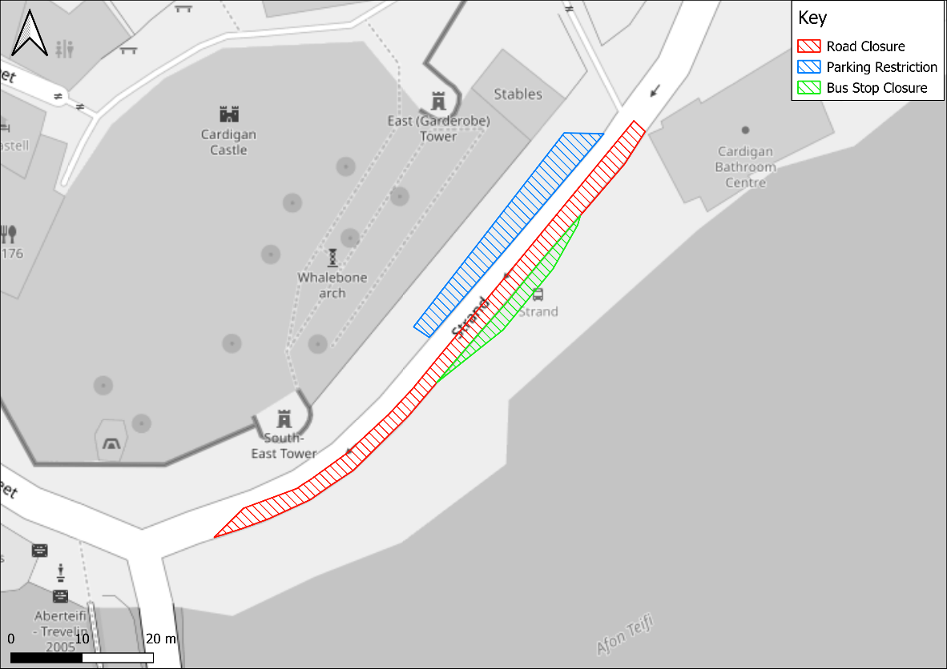
Figure 5: Indicative TRO arrangement

In addition, the pedestrian footway along the left-hand side of Strand will be closed to the public for the duration of the construction phase. Part of the Gloster Row car park will also be temporarily closed. Fencing will be erected to ensure the separation of the public and the ongoing works.
If further closures are required, a programme for the required closures would be drawn up and set out to the Local Highway Authority for discussion/agreement, subject to the required Traffic Regulation Orders being in place. The appropriate application and notice periods will be applied for, from the local authorities and residents will also be informed in advance by letter.

Traffic management
During the construction phase, traffic management will be managed directly by the Project Manager, the Construction Manager and/or the Site Engineer on behalf of the Principal Contractor. The traffic management practice on site will be reviewed weekly. If necessary, safety officers working with various subcontractors will be invited to the Scheme for meetings and site reviews to ensure that the Scheme is managed as safely as possible during the construction phase.
Overall, the management of construction workers and traffic will ensure that:
- The preferred route for HGV deliveries is used at all times by construction traffic unless otherwise agreed with the appropriate Highway Authority.
- All vehicles accessing the Scheme meet their legal obligations for safe operation and obey any traffic signs, road markings, traffic signals and traffic marshals.
- All contractors and subcontractors avoid deliveries during peak periods of traffic flows and periods of congestion and, wherever possible, spreading the flow of delivery vehicles over the working day.
Temporary traffic management measures would be in place during the works to ensure safe access. Measures will include:
- Temporary lane closures on Strand during key delivery or mobilisation activities.
- Suspension of on-street parking to allow the safe passage and turning of delivery vehicles.
- Use of banksmen and traffic marshals to manage vehicle movements and pedestrian safety.
- Time-restricted deliveries to avoid peak pedestrian and traffic periods.
- Advance notification to local residents and businesses to inform of potential disruption.
- A construction delivery management system will be necessary to coordinate vehicle movements and ensure that access conflicts are avoided in the town centre. This may involve the use of a remote holding area outside of Cardigan to manage arrival timings and reduce queuing on approach roads.

Mitigation strategies

Encouraging car sharing
Due to the Scheme’s location, it is recognised that there would be some opportunities for construction staff to travel sustainably via public transport or active travel. However, this will not be attainable for all construction staff, due to the varying origin/destinations.
Construction workers are already anticipated to travel in groups, as is common practice on construction projects. Therefore, staff will be encouraged to car share to reduce single occupancy traffic along routes to the temporary site compounds.

Principal Contractor
The roles of the Principal Contractor will include:
- Overall management of construction traffic.
- Ensuring that the preferred routes for construction vehicles, which have no height or weight restrictions, are always used by construction traffic unless otherwise agreed with CCC as the Highway Authority.
- Ensuring that all vehicles accessing the Scheme meet their legal obligations for safe operation and obey any traffic marshals’ instructions, signs, road markings and traffic signals.
- The provision of safe and adequate vehicle loading/unloading areas.
- Ensuring that there is no parking on the public highway or other areas not deemed appropriate for the temporary storage of vehicles and plant at any time.

Scheduling site deliveries
All delivery drivers visiting the Scheme will wear Personal Protective Equipment (PPE) including hard hat, high visibility vest, protective footwear, eye protection, gloves and full-length trousers.
Where possible, the Principal Contractor will work with subcontractors and suppliers to encourage collaboration to reduce the number of separate deliveries to the Scheme.
A construction delivery management system will be necessary to coordinate vehicle movements and ensure that access conflicts are avoided in the town centre. This may involve the use of a holding area outside of Cardigan to manage arrival timings and reduce queuing on approach roads.
There will be sufficient space for the storage and manoeuvring of construction vehicles and materials on site. Apart from using the public highway to transport the delivery of materials and removal of spoil, all construction vehicle related activities will be carried out on-site.

Procedure for the control of unauthorised entry of vehicles and personnel
A dedicated traffic marshal will control all traffic relating to the Scheme activities.
In the unlikely event that a member of the public enters the construction area, the following protocol would be adopted:
- The relevant aspect of the construction works would cease.
- Construction personnel would explain that the construction area is closed to the public to maintain their health and safety.
- Construction personnel would escort the member of the public out of the construction area and direct them to the nearest alternative route or information sign.
This protocol would be incorporated into the site induction required to be completed by all construction personnel when they first commence work at the Scheme and compliance with this protocol would be monitored by regular spot checks.

Highway condition survey
A pre-condition survey of the roads used to access the Scheme Area will be carried out and agreed with the Local Highway Authority prior to commencement of construction, in order to assess the baseline conditions.
This process will identify and agree any remedial works reasonably attributable to construction activities. Where these are evident, works will be carried out by the contractor post-completion of the construction programme.

Implementing, monitoring and updating

Management of the CTMP
The full CTMP will integrate with all other documentation pertaining to the overall construction execution for this Scheme. Management of the CTMP process will be achieved through the identification of a suitable person as the CTMP coordinator. The CTMP coordinator will provide a key role in delivering a successful CTMP. They will be appointed for the CTMP and be responsible for implementing measures and monitoring the effects of implementation.
The CTMP coordinator will be responsible for setting up and launching the CTMP in accordance with the following schedule, which will be agreed with the LPA and other relevant stakeholders including ensuring a clear and concise communication strategy for the duration of the construction phase.
The CTMP coordinator will ensure that all suppliers are fully aware and compliant with the requirements within the full CTMP, such as vehicle routing arrangements and delivery times.

Management within the public realm
The Principal Contractor will be responsible for the promotion and management of measures to minimise the impact of the construction works on the public highways and Public Rights of Way (PRoW) in the vicinity of the Scheme. These measures will apply to all contractors and subcontractors throughout the development.
The Principal Contractor will be responsible for the management, notification and authorisation, implantation and control by all contractors and subcontractors for the general provisions and measures within the public realm as presented, but not limited to, within the following:
- All temporary measures will be provided, installed and maintained in good condition throughout the extent of the construction activity for which they have been provided.
- No works that will affect the public highway or rights of way will commence until all traffic safety measures required by the construction activity are fully operational to the satisfaction of CCC as the Highway Authority.
- Provision of measures to minimise the effects of nuisance from construction traffic noise, vibration, dust and air quality.
- The correct loading of vehicles and sheeting of loads where necessary to avoid spillage during deliveries.
- Any part of the highway or PRoW that is damaged or disturbed by any activities associated with the implantation of the project will be rectified by CCC as the Highway Authority, at the contractor’s/developer’s cost.
- The operation of plant and equipment will only take place during the agreed construction hours, which are 07:30-18:00 Monday to Friday, with no work permitted on weekends or Bank Holidays.
- Management of on-site access and movement.
The Principal Contractor will ensure that the management and the interface control between the public highway and construction site are managed by a traffic marshal. Vehicles on site shall be managed and controlled to ensure that the Scheme is always safe through planned interventions and segregation.
The management and control strategy will include, but not be limited to the following:
- The provision of relevant information from the construction plan to enable the establishment of safe systems of work and method statements.
- The planning, managing and monitoring of transport movements within the site and the establishment of site rules and regulations that will be used to enforce these movements.
- The systems and monitoring regime to be implemented will ensure that subcontractors make adequate and appropriate provisions within their methodology and method statements to maintain compliance with the construction plan.
- The consolidation of deliveries and smart procurement through the reduction of the number of suppliers and consequently trips to the Scheme. The opportunity to procure several items and materials from one supplier will be investigated and pursued if viable. Where possible, suppliers will be asked to collect materials on their return journeys for recycling.

Management and control of construction logistics
The Principal Contractor will ensure that all contractors and subcontractors undertake the works in accordance with the approved routing, plans and measures presented in the CTMP. Where necessary, they will identify and address any requirements to achieve this, this will include but is not limited to the following:
- Identification of approved routes to all contractor and subcontractor construction vehicles and implement a monitoring regime to ensure compliance.
- The phasing and timing of deliveries to ensure that previously identified working hours and restrictions on delivery times are maintained to avoid unnecessary congestion.
- The timing and notice periods for abnormal load deliveries, where applicable.
- Will ensure that road opening notice procedures and periods for approval are provided.
- Implement restrictions on both on and off-site parking space and within the construction site and within the vicinity of the Scheme on the public highway and public parking areas and implement a monitoring system to ensure compliance.
- Provision of a timely, efficient delivery systems to avoid the stockpile of waste materials on site and the restriction of burning of waste materials on site.
- Ensuring the sealing of all hazardous materials including chemicals, cleaning agents, solvents and solvent-containing products in containers at the end of the working day before storage in suitably protected and bunded areas. Finally, ensuring the waste materials are disposed of in strict accordance with the relevant regulations.

Procedure for the cleaning of vehicles/plant on site
The traffic marshal will inspect all vehicles before they are released from the Scheme onto the public highway. Wheel wash provision will be provided on site prior to the site exit. Any cleaning will be caried out within the Scheme in the wheel washing area to prevent detritus and deposits from being transferred from the Scheme onto the public highway.

Signage
The Principal Contractor will be responsible for the implementation, management and control of measures for traffic management and control throughout the extent and duration of the works. For these works, this is expected to comprise of traffic signs, barriers and other measures where necessary.
Prior to commencement of construction, the Principal Contractor would erect temporary signage on the approved route to the Scheme. The required signage would fall into two broad categories; directional signage on the approved route to the Scheme and warning signage.
Advance routeing signage would be located within the vicinity of the site entrance to warn members of the public of the possibility of HGVs.
Pedestrian and road user safety would be enhanced via the installation of signage and the maintenance of sight lines. This would minimise any adverse impacts on the local road network caused by construction traffic associated with the Scheme.
All temporary traffic signs would be provided in accordance with the Traffic Signs Regulations and general Directions 2016 in locations agreed with and by the relevant authority.

Compliance

Implementation of measures
The site manager will implement and enforce the CTMP. The client and Health and Safety Advisor will monitor, implement and check the vehicle delivery log on their site visits.

Procedure to ensure all drivers, subcontractors, suppliers and visitors sign a copy of the site travel rules
The CTMP will be sent out with all subcontractors and material purchase orders. It will also be introduced to the driver and signed at the induction during a driver’s first visit on site.

Person(s) responsible for enforcement and control
The Principal Contractor’s site manager will be the initial contact, with subsequent personnel being a traffic marshal. The Principal Contractor will ensure that all contractor and sub-contractor vehicles arriving at Site comply with all applicable safety measures and requirements.
Management of the full CTMP will be the responsibility of the CTMP coordinator. The CTMP coordinator will be responsible for delivering a successful CTMP. They will act as the main contact for the full CTMP, with responsibility for ensuring all measures are implemented, monitoring the effects of implementation, and taking remedial actions where they are required.

Monitoring and review
An important part of the CTMP will be the continual monitoring and review of its effectiveness. Regular monitoring and review by the Principal Contractor will help gauge progress towards the objectives and, if necessary, enable the CTMP to be refined and adapted to improve its progression and enhance the effectiveness of subsequent CTMPs.
The CTMP will be reviewed regularly and, if necessary, updated as the construction works progress.
The Principal Contractor will include provision for monitoring and review, which will cover workforce, construction deliveries and waste to ensure that as much waste as possible will be recycled.
Monitoring and review of the procedures proposed in this plan will be caried out monthly or as required during the Health and Safety inspection carried out by the Health and Safety manager. The inspection report will identify failures to comply with this plan and, in consultation with the Project Manager, detail actions and responsibilities to ensure ongoing compliance.
The monitoring of the plan is important for the following reasons:
- It will demonstrate to the local authority the effectiveness of the measures implemented and the progress being made towards the aims and objectives of the CTMP.
- It justifies the commitment of the contractor and of other resources.
- It helps to identify any deficiencies within the CTMP, including any measures that are not effective.
- The data can be shared with any other stakeholders as well as inform the local authority of logistics patterns and common issues.

Data monitoring
A range of data will be collected by the Principal Contractor to monitor key indicators of success. The following data will be collected to achieve specific targets (in brackets) for this Scheme:
- Number of vehicle movements to the Scheme (delivery/collection accuracy compared to schedule).
- Community concerns about construction activities (ensure good relationships with the neighbours).
- Vehicle routing (100% compliance with agreed vehicle access route).
- Unacceptable queuing or parking (zero penalty charge notices issued for delivery vehicles on roads adjacent to the Scheme).
- Compliance with safety and environmental standards and programmes (no complaints from Environmental Health or Health and Safety Executive).
- Anti-idling (avoid unnecessary idling and ensure compliance with anti-idling rules)
- Logistics related incidents (minimise incidents)
- Record of associated fatalities and serious injuries (compliance with Health and Safety standards)
- Methods staff are travelling to site (promote car sharing over individual car use)
- Vehicles and operators not meeting safety requirements (all suppliers and hauliers registered with the appropriate authorities).

