Natural Resources Wales Cardigan Tidal Flood Risk Management Scheme (TFRMS)
Contamination Preliminary Risk Assessment
Project no. 4021883
January 2026
Prepared for:  Natural Resources Wales  (NRW) | Prepared by:  Binnies UK Limited  (BUKL)
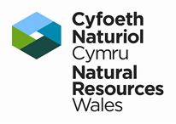 | 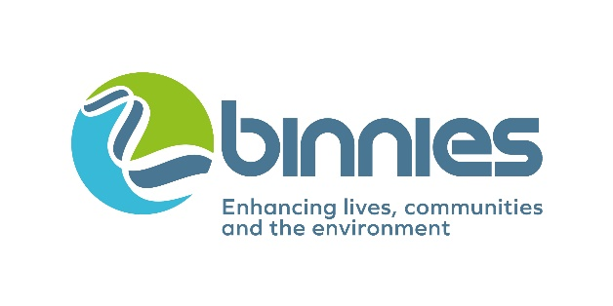
Details of document preparation and issue:
Version no. | Prepared | Checked | Reviewed | Approved | Issue date | Issue status
P01 | Katie Woolhouse  & S Rebours-Smith | Ben Tucker | Charles Rafipay | Alex Humphreys | Jan 2026 | S2

Project no.: | 4021883
File name: | 4021883-BUK-ZZ-00-RP-GE-00003

Notice:
This report was prepared by (BUKL) solely for use by (NRW). This report is not addressed to and may not be relied upon by any person or entity other than NRW for any purpose without the prior written permission of BUKL. BUKL, its directors, employees and affiliated companies accept no responsibility or liability for reliance upon or use of this report (whether or not permitted) other than by NRW for the purposes for which it was originally commissioned and prepared.
In producing this report, BUKL has relied upon information provided by others. The completeness or accuracy of this information is not guaranteed by BUKL.

Table of Contents
1 Introduction 4
1.1 Instruction 4
1.2 Site Details 4
1.3 Proposed works 4
1.4 Scope 5
1.5 Limitations 5
1.6 Sources of information 5
2 Published Information Review 7
2.1 Historical Mapping 7
2.2 Environmental Database Information 9
2.3 Past Land use 10
2.4 Unexploded Ordnance 13
2.5 Geology 13
2.6 Hydrogeology 13
2.7 Hydrology 14
2.8 Mining and Mineral Extraction 15
2.8.1 Mining (non-coal) 15
2.8.2 Surface ground workings 15
2.8.3 Coal Mining 16
2.9 Ground Gas and Radon 16
2.9.1 Ground Gas 16
2.9.2 Radon …………… 16
2.10 Ground Stability 16
2.11 Archaeology 17
2.12 Environmental Sensitivity 17
2.13 Previous WYG Ground Investigation 17
3 Preliminary Geo-Environmental Assessment 20
3.1 Introduction 20
3.2 Sources 20
3.3 Pathways 20
3.4 Receptors 20
3.5 Preliminary Risk Assessment 21
4 Conclusions and Recommendations 29
5 References 30
Appendix A Historical Maps 32
Appendix B Groundsure Report 33
Appendix C Outline Design Drawings 34
Appendix D WYG Ground Investigation Report (2015) 35

1 Introduction

1.1 Instruction
Binnies UK Limited (BUKL) was instructed by Natural Resources Wales (NRW, “the client”) to provide a Contamination Preliminary Risk Assessment for The Cardigan Tidal Flood Risk Management Scheme (TFRMS). A Contamination Preliminary Risk Assessment (PRA) is required to understand the geoenvironmental risks to human health and controlled waters and assess the impact of the proposed works on environmental receptors.

1.2 Site Details
The site is located in Cardigan (Aberteifi), in Ceredigion, southwest Wales. It is positioned along the right bank (northern bank) of the River Teifi (flowing east to west) between grid references SN 17783 45866 and SN 18109 45969. The scheme covers an approximate distance of 400m length of the right bank on the River Teifi, upstream of Cardigan Bridge. The nearest postcode is SA43 1EX. The site is accessed via the road named “The Strand”.
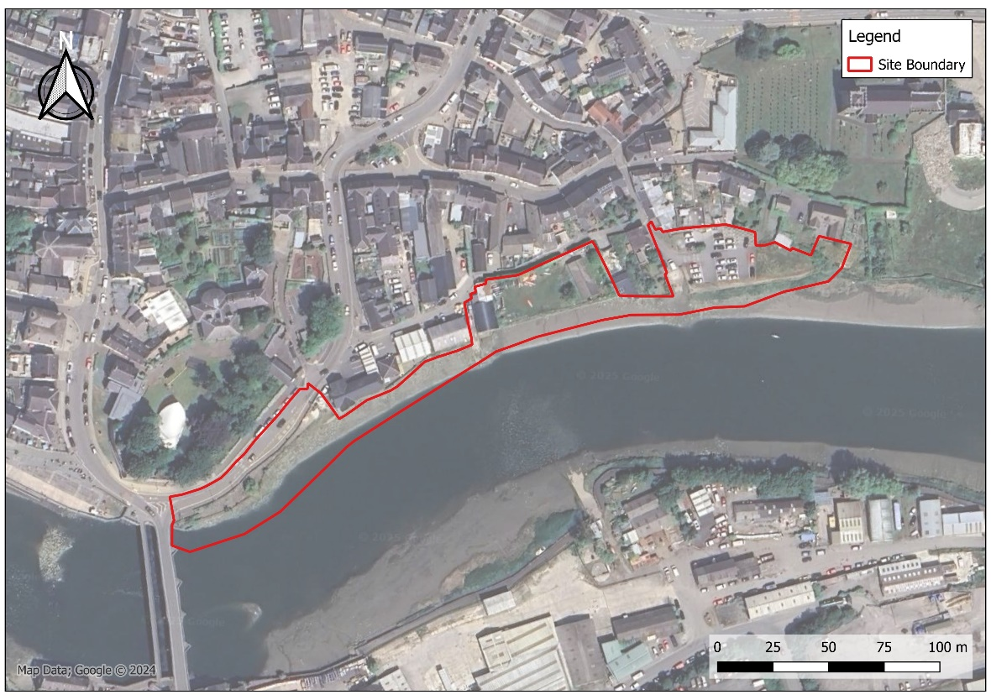 Figure 1-1 Site Location Plan
Cardigan Town Centre is located to the north of the site characterised by a mixture of residential and commercial properties. Cardigan Castle is situated to the northwest. The south side of the river is populated by industrial buildings.

1.3 Proposed works
The proposed works are currently in the outline design phase at the time of writing but are broadly to comprise a flood defence wall to protect the town from flooding. It is understood that this defence will comprise sheet piled walls to varying termination depths to be confirmed by detailed design. An embankment to support these piles is also proposed.
As well as areas of surrounding hard standing / paved surfacing, it is envisaged that some areas of publicly accessible landscaping will also form part of the proposals and so will also require consideration as part of this preliminary contamination risk assessment.
The outline design scheme proposal drawings are provided in Appendix C.

1.4 Scope
The aims of this report are to undertake a contamination preliminary risk assessment to inform detailed design and inform future survey scoping (i.e. assess whether any additional action / intrusive investigations are needed).
The scope of this report is based on the following objectives:
- Review available geological and environmental information for the site, including third-party environmental searches and mapping (Groundsure report);
- Review historical mapping from the Groundsure report to determine the history of the site and nearby surrounding areas;
- Consult and review relevant information held by appropriate statutory authorities;
- Review previous site investigation information where available/ relevant to the scheme;
- Develop an initial conceptual site model and identify potential contaminant linkages;
- Produce a contamination preliminary risk assessment for the scheme and identify the need for any additional actions/ intrusive investigations if required.
These objectives have been selected following relevant guidance documents including the Environment Agency’s model procedures for Land Contamination Risk Management (LCRM) published October 2020. Other guidance documents have also been referenced throughout the report, including those published by the British Standards Institution, Contaminated Land: Applications in Real Environments (CL:AIRE), and the Association of Geotechnical & Geoenvironmental Specialists (AGS).

1.5 Limitations
This report interprets ground conditions based on the information available to Binnies at the time of writing. The nature of a natural material such as soils and bedrock is inherently variable and as such Binnies cannot be held liable should the ground conditions vary widely between exploratory locations. Furthermore, chemical contamination undergoes many transformative effects (including but not limited to chemical reaction with other substances in the environment, degradation, biological uptake, and movement with groundwater). As such, historical data on chemical concentrations is likely to be indicative only and may not provide a true reflection of the current geoenvironmental situation. Any additional limitations and assumptions have been highlighted throughout this report.

1.6 Sources of information
The published information review has been undertaken using data contained within the Groundsure report (GS-SQR-C8M-SGX-TC2). The full Groundsure report can be found in Appendix B and contains the following factual information:
- Historical OS mapping;
- Past land use;
- Waste and landfill sites;
- Current and recent industrial activity;
- Hydrogeology and hydrology (including Water Framework Directive);
- Flooding (river, coastal, surface water and groundwater);
- Designations (environmental, visual, cultural, agricultural and habitats);
- Geology (British Geological Survey (BGS) mapping 10k, 50k, and borehole records);
- Natural ground subsidence (BGS GeoSure);
- Mining and ground workings;
- Ground cavities and sinkholes;
- Radon;
- Soil chemistry; and
- Railway infrastructure and projects (including Royal Mail Tunnels).
Additional sources of information obtained from the following publicly available sources:
- BGS Geological Maps and Memoirs (BGS, 2025);
- Aerial and Street View Photography (Google Earth, 2025; Google, 2025);
- Records of Mines and Mineral Deposits (Groundsure, 2025);
- Unexploded Ordnance (UXO) (Zetica, 2025);
- Additional environmental information (DEFRA, 2025); and
- Flood Records (NRW, 2025).
Existing information has also been reviewed from a Ground Investigation Report undertaken by WYG Environment Planning Transport Ltd (WYG) in 2015 for Natural Resources Wales (NRW); a copy of the WYG report is included in Appendix D for reference (report reference A088137). Relevant contents in the WYG report have been used to aid understanding of the prevailing site conditions and inform the initial conceptual site model and preliminary risk assessment.

2 Published Information Review
Published information has been reviewed and referenced throughout this section with the aim of establishing the site setting and identifying any potential contamination risks with regards to the proposed scheme. This includes review of the procured third-party environmental search report and historical Ordnance Survey mapping (Groundsure) which is included in full in Appendix B. It is noted that a substantial watercourse (River Teifi) lies to the south of the site; features identified to the south of the river and beyond the watercourse have been included for reference given their proximity to the site though the impact on the site is likely to be lower as a result.

2.1 Historical Mapping
Published historical Ordnance Survey maps have been reviewed (Appendix A), together with aerial photography (Google Earth, 2025) and Google Street View photography (Google, 2025) to gain an understanding of the site history and the surrounding areas. The information reviewed dates from 1887 to the present. However, it is noted that the historical data available does have gaps and may not give a full chronology of the development of the site and surrounding areas. A summary of the pertinent information is presented in Table 2-1 below.
Table 2-1: Summary of site history and surrounding areas from mapping
Date | Source (Map Scale) | On-site developments | Off-site developments
1887-1889 | Ordnance Survey 1:10,560 | The map has a low resolution however, it appears to show buildings along the north riverbank within the footprint of the site. | The town of Cardigan is well established and is heavily populated with agricultural land in the surrounding area. Cardigan Bridge is mapped to the southwest of the site, and a ferry crossing is mapped to the southeast of the site. A brickworks is labelled 500m to the north of the site.
1890 | Ordnance Survey 1:2,500 | Confirms unlabelled buildings along the right (north) bank of the River Teifi to the west of the site. A smithy is labelled in the centre-east region within the site boundary. A sparser area with several unlabelled buildings is shown to the east of the site. | No major developments can be seen however the higher resolution reveals more domestic houses to the North of the river with a church and graveyard labelled to the northeast of the site. Immediately off-site to the east is a smithy. To the south of the river, more industrial land is noted with a transport terminal, iron foundry, sawmill, timber yard (all 100m to the south) and smithy (200m to the southwest) labelled.
1904 | County series 1:10,560 | No major developments. | Cambrian Quay is labelled to the west of the site alongside the river. 250m west (beyond the quay), a gas works is labelled. A malthouse is labelled to the North of Cardigan town (380m north of the site).
1906 | County series 1906 1:2,500 | No major developments. The smithy is still present on-site. | Smithy immediately east of the site no longer labelled as such.
1938 | County series 1:10,560 | No major developments. | No major developments.
1948 | County series 1:10,560 | No major developments. | No major developments.
1962-1963 | Provisional 1:10,560 | No major developments. | No major developments.
1965 | National Grid 1:2,500 | The smithy is no longer labelled. The high water level of medium tides is marked. Tivy house is located to the east of the site. | To the northeast, Cardigan and District Hospital is labelled next to the church. Three garages are labelled approximately 100m from the site to the north.
1976 | National Grid 1:2,500 | No major developments. | No major developments. Minor expansion of the industrial estate to the south of the River Teifi.
1980-1981 | National Grid 1:10,000 | No major developments. | The gas works to the west of the quay is no longer mapped. Continued expansion of the town to the north.
1990-1995 | National Grid 1:2,500 | No major developments. | Priory Bridge is now mapped to the east of the site. Significant changes to the industrial site on south of the River Teifi including numerous new buildings, a bus depot and an electrical substation (all approximately 200m south of site).
2003 | Ordnance Survey 1:1,250 | A road is now present where the buildings to the southwest of the site were, a car park is now labelled to the northeast of the site and Priory Bridge is now mapped to the east. | No major developments.
2006 | Google Earth aerial imagery | The former smithy to the centre-east of the site is shown as a small grassy area with an unlabelled building. | No major developments.
2023 | Google Earth aerial imagery | No major developments. | Demolition of the Cardigan and District Hospital is underway to the northeast of the site.

2.2 Environmental Database Information
Key environmental information, including current land use, environmental permits, waste sites, discharge consents and incidents within 500m of the site boundary are summarised in Table 2-2 below.
Table 2-2: Summary of environmental database information
Data type | Entries on-site | Entries off-site | Details
Current / Recent Land Usage
Potentially contaminative industrial sites | 1 | 31 | On-site: Relating to mooring and unloading facilities at the. boat launch ramp.
Potentially contaminative industrial sites | 1 | 31 | Due to the high number of entries, only the most relevant are detailed here.  Off-site:  73m southwest: Vehicle repair garage  86m northeast: Chimney manufacturing  90m southeast: Drilling and welding services  100m south & 108m east: Sewage treatment works  Other notable entries include motoring, construction, waste storage, processing and disposal, cooling and refrigeration, electrical services.
Agency and hydrological
Licensed industrial activities | 0 | 4 | Relates to Cardigan Abattoir LTD (320m southeast, cross gradient). Current status unconfirmed, last date noted as effective is 2015.
Licensed Discharges to controlled waters | 3 | 45 | On-site:  Combined Sewer Overflow (CSO) and Emergency Overflow (EO) at Cardigan Pumping Station (PS) No.2 and also Sewer Storm Overflow at Gloster RW overflow.
Licensed Discharges to controlled waters | 3 | 45 | Off-site:  Mostly relates to sewage treatment works discharges with River Teifi as receiving watercourse.
Pollution incidents to controlled waters, Prosecutions relating to controlled waters, Substantiated pollution incident register, Water Industry Act referrals | 1 | 15 | On-site: Incident date 01/08/2013. No further information is provided.
 | 1 | 15 | Off-site: All incidents noted at either minor impact or no impact. Pollutants include asbestos, oils, sewage, fuel and carcasses.
Waste and Landfill
Active or recent landfills | 0 | 0 | No records within 500m
Licensed Waste Sites | 0 | 8 | All records relate to Viv Williams Skips: Material Recycling Treatment Facility (350m southeast of the site, cross gradient)  Issue Date – 2010,  Status: Issued/effective
Waste exemptions | 0 | 10 | Relating to storing and treating waste for various industries such as factories, plumbing and chemists. Distance ranges from 300m to 470m
Hazardous substances
Fuel station entries | 0 | 2 | Located 90m north (up gradient) and 340m southwest (cross gradient) of the site. Status: Obsolete

2.3 Past Land use
Past land uses are also identified on the Groundsure report and have been reviewed as part of this section, with the salient findings outlined in the following tables; including historical industrial land use (Table 2-3), historical tanks (Table 2-4), historical energy features (Table 2-5), historical garages (Table 2-6) and historical landfills (Table 2-7).
Table 2-3 Potentially contaminative / historical industrial land uses
Land Use | No. Records | Dates | Approximate distance and direction | Details
Land Use <100m of the site
Smithy | 3 | 1906-1948 | On-site | - The historical smithy is now mapped as a residential property and land associated with a scout hut.  - A historical quay located to the west of the site is now occupied by restaurants and cafes.  - The historical hospital to the east of the site has recently been demolished.  - The Iron foundry, railway sidings and unspecified pit are on the south side of the River Teifi and as such, taken to be cross gradient.
Quay | 6 | 1906-1992 | 5 - 90m west and southwest (down gradient)
Hospital | 4 | 1938-1992 | 5-10m east (up gradient)
Iron Foundry | 3 | 1904-1948 | 65-70m southwest (cross gradient)
Railway sidings | 8 | 1888-1962 | 65-198m southeast (cross gradient)
Unspecified Pit | 1 | 1962 | 90m south (cross gradient)
Land Use 100-300m of the site
Railway building | 9 | 1888-1962 | 100-200m south (cross gradient) | - An unspecified wharf is associated with the repurposed quay to the west of the site.  - An ambulance station is still present where historical records exist.  - Records relating to historical gas works, depots and tanks are located in an area now a present-day car park.  - Cardigan Cemetery is present where historical records indicate.
Unspecified Wharf | 1 | 1888 | 125m west (down gradient)
Unspecified Heap | 1 | 1938 | 140m southeast (cross gradient)
Ambulance Station | 2 | 1980-1992 | 140m northeast (up gradient)
Iron Foundry | 1 | 1888 | 160m west (down gradient)
Smithy | 2 | 1888 | 175-225m south and southwest (cross gradient)
Unspecified Pit | 1 | 1980 | 215m southeast (cross gradient)
Gas Works | 5 | 1887-1904 | 260-290m west (down gradient)
Unspecified Depot | 2 | 1980-1992 | 260m west (down gradient)
Rifle Range | 1 | 1888 | 270m southeast (cross gradient)
Cemetery | 3 | 1888-1992 | 275m west (down gradient)
Unspecified Tank | 3 | 1938-1992 | 280-300m west (down gradient)

Historical tanks within 500m have been reviewed and summarised below:
Table 2-4 Historical tanks within 500m
Land Use | No. Records | Dates | Approximate distance and direction | Details
Unspecified Tanks | 13 | 1890-1995 | 80-475m | - The nearest records detail an unspecified tank 80m NE, associated with the hospital; a tank 85m SE, associated with the former railway and 90m W, associated with the historical quay
Tanks | 5 | 1890-1978 | 85-465m
Gas Works | 5 | 1890-1906 | 265-290m

Historical energy features within 500m have been reviewed and summarised below:
Table 2-5 Historical energy features within 500m
Land Use | No. Records | Dates | Approximate distance and direction | Details
Electricity Substation | 7 | 1973-1997 | 165-405m | - The nearest historical electrical substation was located 165m northwest (up gradient) and appears derelict on current aerial imagery.  - Historical gasworks records are associated with an area to the southwest (down gradient) now designated as a cemetery car park.
Gas Works | 4 | 1890-1906 | 265-290m west, down gradient

Historical garages within 500m have been reviewed and summarised below:
Table 2-6 Historical garages within 500m
Land Use | No. Records | Dates | Approximate distance and direction | Details
Garage | 11 | 1965-1997 | 90-120m north (up gradient) | Three historical garage records are located on the north side of the River Teifi. One record is associated with current-day T.M. Daniel Garage. Two records are no longer mapped as garages (Groundsure report dates these as from 1960s to 1990s).

Historical landfill sites within 500m have been reviewed and summarised below:
Table 2-7 Historical landfills within 500m
Land Use | No. Records | Dates | Approximate distance and direction | Details
Landfill | 1 | First recorded 1910 | 475m to the north (up gradient) | Waste type: Inert, industrial, commercial, household. Located on former brickworks.

2.4 Unexploded Ordnance
A review of publicly available unexploded ordnance (UXO) risk mapping indicates that the site is shown to be located in an area with low risk for wartime bombs to be present (Zetica, 2025). Historical mapping showed a rifle range previously existed 270m to the southeast of the site, on the far side of the River Teifi; however, the distance and proximity are such that any small arms UXO in that area unlikely to have affected the site.

2.5 Geology
Published geology has been reviewed including England and Wales Geological Map 1:50,000 scale Sheet 193 titled ‘Cardigan and Dinas Island Solid and Drift Geology’ (BGS, 2002) and the GeoIndex online interactive map viewer by the British Geological Survey (BGS, 2025). Geological information is also included in the third-party Groundsure report and has also been reviewed.
Made Ground is mapped throughout the site and extends along the riverbank west and east of the site, as well as further north into Cardigan Town. Given the mapped distribution of Made Ground along the banks of the River Teifi, it is anticipated that the site is situated on reclaimed land. Superficial deposits are mapped to comprise Tidal River or Creek Deposits along with areas of Glacial Till. Bedrock is shown to comprise the Nantmel Mudstones Formation comprising mudstones of marine origin in distinctively graded beds.
Two geological faults are mapped in the area; 280m southeast (indicated as the Newport Sands Fault) and 330m north of the site (indicated as the Ogof Cadno fault). Both are listed as inferred with unknown displacement.

2.6 Hydrogeology
No abstractions are recorded within 2km of the site and the site is not located within a source protection zone (SPZ).
The superficial aquifer underlying the site is classified as Secondary Undifferentiated. These are aquifers where it is not possible to apply either a Secondary A or B definition because of the variable characteristics of the soil type. These have only a minor value.
Two Secondary A superficial aquifers are located within 200m of the site, with the nearest recorded approximately 180m west. Secondary A aquifers comprise permeable layers that can support local water supplies and may form an important source of base flow to rivers.
The bedrock aquifer is classified as Secondary B which is defined as mainly lower permeability layers that may store and yield limited amounts of groundwater through characteristics like thin cracks (called fissures) and openings or eroded layers.
Groundwater vulnerability is mapped in the Groundsure report as one kilometre grid squares. The site is located near the intersection of four of these kilometre-squares. On-site groundwater vulnerability is shown to be high vulnerability in superficial aquifers and medium vulnerability in bedrock aquifers, as indicated in Figure 2-1.
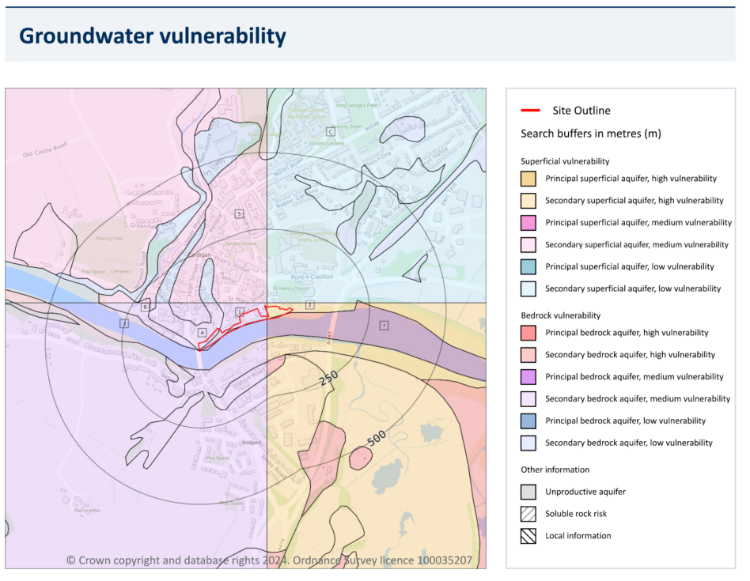
Figure 2-1 Groundwater vulnerability (extract from Groundsure report)

2.7 Hydrology
The site is located within the Teifi Water Framework Directive (WFD) operational catchment. The River Teifi runs along the southern border flowing east to west, discharging into the Irish sea approximately 3km downstream.
The Teifi currently has an overall WFD classification of ‘Moderate’ with a chemical rating of ‘Good’. The Teifi and Coastal Ceredigion groundwater body currently has a WFD classification of ‘Poor’.
There are two nearby watercourses; the River Piliau confluences with the Teifi approximately 230m upstream of the site, and the River Mwldan confluences with the Teifi approximately 300m downstream of the site. Other smaller unnamed tributaries also discharge into the Teifi at various points upstream and downstream of the site.
The site is located within an area classified as having a high risk of river and coastal flooding which is defined as having a greater than or equal to 1 in 30 chance of flooding in any given year. The vast majority of the site is situated in an area designated as Flood Zone 3 which is defined as land with a 1 in 100 or greater chance of flooding each year.
Some areas of the site are at risk of surface water flooding. The highest risk is a 1 in 30 year rainfall event where depths are modelled to reach between 0.1 and 0.3m. The majority of site is not classed as being vulnerable to surface water flooding.
The site is at moderate risk of groundwater flooding on the northern bank of the Teifi. The remainder of the site has a negligible risk.

2.8 Mining and Mineral Extraction
Evidence has been sought to identify any past and present mining, quarrying, and land reclamation operations, which have taken place within the vicinity of the site.

2.8.1 Mining (non-coal)
The site is located in an area containing a Class B Vein Mineral where localised underground mine workings may have occurred in the past. Class B vein minerals may include base metals such as copper, lead, tin, or zinc. While these metals have historically been mined in Wales, no other evidence regarding mining exists at the site. However, a risk for unrecorded metal workings cannot be ruled out.
No other notable records for underground workings within 1km of the site have been identified.

2.8.2 Surface ground workings
Surface ground workings have been identified in close proximity to the site as listed in Table 2-8; these are areas which are likely to have involved ground excavation and may have been backfilled.
Table 2-8 Surface ground workings records within 250m
Land Use | No. Records | Dates | Approximate distance and direction | Details
Quay | 6 | 1906-1992 | 5-90m southwest (down gradient) | Associated with the historical quay to the west of the site
Unspecified Wharf | 1 | 1888 | 125m west  (down gradient) | Associated with the historical quay to the west of the site
Unspecified Pit | 2 | 1962-1980 | 90-215m southeast (cross gradient) | All records are located on the south (left bank) of the River Teifi where various industrial activities have existed.
Unspecified Heap | 1 | 1938 | 135m southeast  (cross gradient)
One record of surface mineral workings (BGS GeoIndex Brit Pit dataset) has also been identified 331m north of the site (up gradient). The commodity has been labelled as sand with the current status now “ceased”.

2.8.3 Coal Mining
The site lies outside the Mining Remediation Authority (formerly known as Coal Authority) Consultation Area and is not located within a coalfield area. Therefore, the risks from historical coal mining activities are deemed to be very low and do not require further consideration.

2.9 Ground Gas and Radon
At this stage, the scheme proposals are understood to comprise construction of a sheet piled flood defence wall, with no buildings or enclosed spaces proposed. An initial review of ground gas and radon risks has been undertaken as part of this preliminary risk assessment for completeness.

2.9.1 Ground Gas
No recorded landfill or waste sites have been identified within influencing distance of the site.
Made Ground is mapped across the site from review of available geological records and is assumed that much of the site is situated upon reclaimed land adjacent to the River Teifi. Generic Made Ground is typically a fairly low risk source of bulk gases, except where there is a high proportion or readily putrescible material in a deep layer of fill (e.g. landfill).
Natural superficial Tidal River/ Creek Deposits are also mapped beneath the site and may contain organic material; however, this is unlikely to pose a significant ground gas source as the organic material is locked in a low permeability matrix/ gas generation rates are typically incredibly low.
In addition to the above, no new buildings or enclosed spaces are proposed as part of the current scheme where ground gases could accumulate, as such no significant risks from ground gas have been identified with no further action required.

2.9.2 Radon
Radon information is included in the Groundsure Report (Groundsure, 2024) using data sourced from the British Geological Survey (BGS) and United Kingdom Health Security Agency (UKHSA).
The site is shown within an area of elevated radon where an estimated 5- 10% of properties are above the Action Level for homes (termed an ‘Affected Area’) of 200 Bq/m⁻³.
However no new buildings or enclosed spaces are proposed as part of the current scheme and thus no significant risks from radon have been identified with no further action required.

2.10 Ground Stability
Two landslips are recorded on 1:50,000 mapping at 130m southwest and 260m northeast of the site. Landslips are defined as mass movement deposits, primarily superficial deposits that have moved down slope under gravity - these affect bedrock, other superficial deposits and artificial ground.
The risk of shrink swell clays, running sands, compressible deposits, collapsable deposits and natural ground subsidence is classified as very low or negligible. The risk of landslides is low to very low.

2.11 Archaeology
Numerous listed buildings are located within 250m of the site. Many are associated with Cardigan Castle and grounds located on the western side of the site. Cardigan Bridge ~25m to the southwest of the site is also listed. The full list can be found in the Groundsure report (Groundsure, 2024).
Cardigan Town is designated as a conservation area. These are areas of special architectural or historical interest where the character and appearance of which is deemed desirable to preserve or enhance.
Four scheduled ancient monument designations are located within 250m of the site and are considered areas of national importance. Cardigan Bridge, Cardigan Castle and two designations for Cardigan Town Walls are all listed.
Cardigan Castle is a registered Park and Garden, defined as parks and gardens assessed to be of special historic importance.

2.12 Environmental Sensitivity
The River Teifi is classified as a Site of Special Scientific Interest (SSSI) defined as areas displaying the best examples of UK flora, fauna or geological or physiographical features. The designation covers the Teifi from headwaters to coast including four Teifi Estuary Woodland and Marshes areas within 2km of the site.
The site is located within a Special Area of Conservation (SAC) defined as areas best representing the range and variety within the European Union of habitats and (non-bird) species. This designation has been assigned due to a wide variety of features of interest that can be found in the Groundsure report (Groundsure, 2024).
Two areas of designated ancient woodland are located approximately 100m and 300m from the site, defined as areas that have been continuously wooded since 1600AD.
Agricultural land designations have been assessed at the site and in the local area. No such designations are present within the site boundary. The closest designation is approximately 20m to the east where a Grade 4 – poor quality agricultural land is present. A Grade 3a – Good to Moderate quality agricultural land is present on the opposite bank of the River Teifi.

2.13 Previous WYG Ground Investigation
Historical information has also been reviewed from a Ground Investigation Report undertaken by WYG Environment Planning Transport Ltd (WYG) in 2015 for Natural Resources Wales (NRW); a copy of the WYG report is included in Appendix D for reference (report reference A088137). Relevant contents in the WYG report have been used to aid understanding of the prevailing site conditions and inform the initial conceptual site model and preliminary risk assessment.
The 2015 ground investigation consisted of 10 no. dynamic sample boreholes, 12 no. hand pits, 1 no. machine excavated trial pit and 1 no. handheld windowless sample borehole. Standpipes were installed to enable ground gas and groundwater monitoring. Geotechnical and geoenvironmental samples were collected and underwent lab analysis.
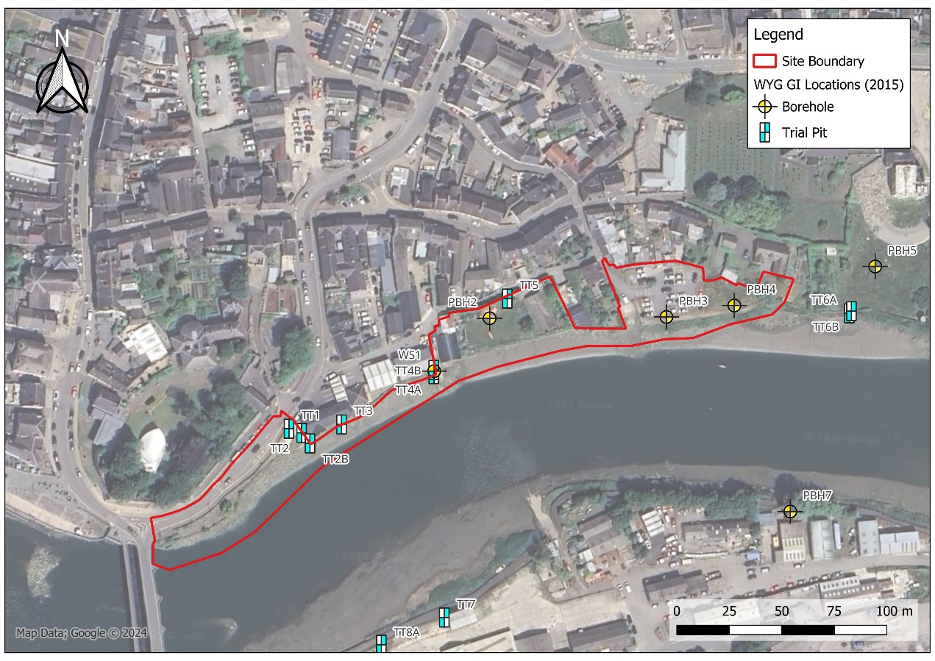
Figure 2-2 Historical GI Locations - WYG 2015 Investigation
The strata encountered broadly consisted of topsoil, Made Ground, Alluvium and Nantmel Mudstones Formation. Made Ground was found in the majority of boreholes at depths up to 5.3m below ground level (bgl) including some anthropogenic materials. Olfactory evidence of contamination was encountered in one borehole (PBH7) at approximately 2.5m bgl, where a hydrocarbon odour was noted, however this location was off-site to the south of the River Teifi/ 80m south of the current proposals.
Groundwater strikes occurred in eight out of ten boreholes and three out of twelve hand pits. All strikes were within the Made Ground or superficial/ alluvial deposits. Groundwater monitoring took place approximately one month after the initial ground investigation, the groundwater level in six boreholes was monitored. Groundwater was recorded between 2.11m and 2.74m bgl. Variable head permeability tests were also undertaken. Four were in coarse grained alluvium and recorded a permeability between 8.8x10⁻⁶ and 4.6x10⁻⁵ metres per second (m/s). One was in the mudstone and recorded a permeability of 3.2x10⁻⁵m/s.
WYG scheduled sixteen soil samples for contamination testing including heavy metals, polycyclic aromatic hydrocarbons (PAH), petroleum hydrocarbons (EPH / BTEX) and asbestos screening and quantification. Ground gas monitoring was also undertaken from boreholes on one occasion by WYG (on 13/04/2015).
To aid this preliminary risk assessment, the historical 2015 WYG contamination testing results have been utilised for an initial screening exercise whereby the results have been screened against Generic Assessment Criteria (GAC) for human health based on the current scheme proposals and a selected proposed Public Open Space (POS) park end-use. It is noted that the testing was undertaken in 2015 and may no longer be representative of the current site conditions and should be treated as indicative only. The results of this initial screening exercise are summarised in Table 2-9.
In summary, none of the results for metals, PAHs, EPH or BTEX compounds were found to exceed the initial Public Open Space (park) GAC screen, however Chrysotile cement bound debris was identified in one sample obtained from the Made Ground in the east of the site (PBH4, quantified at 2.116% of material mass (fibres)). Asbestos fibres were also identified in several other samples of Made Ground though the quantification results were below the limit of detection (<0.001%).
The WYG gas monitoring results showed all methane results <0.1%, maximum carbon dioxide 0.1% and maximum positive flow readings of 0.6l/hr. With reference to BS 8485 (BSI 2019), the results correspond to a gas screening value (GSV) of 0.006l/hr, indicative of a Characteristic Situation 1 (CS1) very low risk classification, though it is noted that only one visit was carried out as part of the works which may not be representative of long-term site conditions.
In addition to the above and as noted in Section 2.9.1; no buildings or enclosed spaces are proposed as part of the scheme where ground gases could accumulate.
Table 2-9 Exceedances: initial screen WYG 2015 contamination data with POS (park) GAC
Contaminant | Concentration | GAC [POS_{(park)}] | Exceedances | Details
Asbestos | 2.116% | <0.001% | PBH4@0.5-1m | Cement-bound Chrysotile ACM debris was recorded within the Made Ground in PBH4 (east of site).

3 Preliminary Geo-Environmental Assessment

3.1 Introduction
Potential contaminant linkages have been established based on the information presented in Section 2. A source-pathway-receptor linkage approach has been adopted (SPR) whereby a viable contaminant linkage requires all three elements to be present for a potential contamination risk to exist. If one component is missing, there is no viable contaminant linkage.
The initial Conceptual Site Model (CSM) incorporates evidence from the review of published information, site walkover and historical ground investigations. The creation of a CSM is a key component of the LCRM methodology and incorporates ground conditions and possible contaminant linkages; it forms the basis for Preliminary Risk Assessment (PRA).

3.2 Sources
The following potential sources of contamination have been identified:
- Extensive Made Ground on and off-site, likely due to historical land reclamation along banks of the River Teifi. Historical 2015 WYG investigation revealed Made Ground up to 5.3mbgl on-site; initial screening of WYG contamination data has identified asbestos in soils on-site (cement bound ACM debris and free fibres).
- Industrial land-use / units on-site, including a historical smithy in the centre-east.
- Car park on-site (east) and road adjacent to the west of the site.
- Historical and current industrial land use in close proximity to the site; including petrol filling stations 90-120m north of the site, hospital and ambulance station 5-160m east of the site, tanks 85-160m east of the site.
- River sediments are also known to have been affected historically in the area by industrial land uses alongside and upstream of the River Teifi, including a foundry, sawmill, and timber yard on the southern side of the river.

3.3 Pathways
The following potential pathways have been identified:
- Dermal contact, ingestion by contact with soil, inhalation of particulates.
- Migration of contaminants in the soil leachate.
- Vertical and lateral migration of contaminated groundwater.
- Disturbing and mobilising river sediments during construction.

3.4 Receptors
Receptors are defined as people, living organisms, ecological systems, controlled waters, atmosphere, structures and utilities that could be adversely affected by sources of contamination. Receptors identified include the following:
- Human Health: Groundworkers / construction personnel and maintenance workers.
- Human Health: Future site users of publicly accessible areas.
- Controlled Waters: The River Teifi to the south which is designated as a SSSI and Special Area of Conservation (SAC).
- Controlled Waters: Underlying Secondary Aquifers.

3.5 Preliminary Risk Assessment
The risk posed by any contaminant in soil or groundwater will depend on the nature of the hazard, the likelihood of exposure, the pathway by which exposure occurs and likely effects on the receptor. Where a contaminant linkage has been identified, an assessment has then been undertaken to assess the risk based on the probability and consequence of an event occurring:
- The likelihood of an event (probability) – considers both the presence of the hazard and receptor and the integrity of the pathway; and
- The severity of the potential consequence – considers both the potential severity of the hazard and the sensitivity of the receptor.

The definition of risk and risk characterisations have been adopted from CIRIA 552, which is reproduced in Table 3-1.
Table 3-1 Risk Classification Matrix (CIRIA C552).
 |  | Consequence
Probability |  | Severe | Medium | Mild | Minor
Probability | High Likelihood | Very high | High | Moderate | Moderate / Low risk
Probability | Likely | High | Moderate | Moderate / Low risk | Low risk
Probability | Low Likelihood | Moderate risk | Moderate / Low risk | Low risk | Very low risk
Probability | Unlikely | Moderate / Low risk | Low risk | Very low risk | Very low risk

The above sources, pathways and receptors have been considered as part of the initial Conceptual Site Model and Preliminary Risk Assessment in accordance with LCRM (2020); the findings of which are presented as Table 3-2.

Table 3-2: Preliminary Risk Assessment (PRA)
Source | Pathway | Receptor | Probability | Consequence | Risk | Assessment of risk and possible mitigation
On-site: Made Ground present across the site  Potential contaminants include heavy metals, sulphates, polycyclic aromatic hydrocarbons (PAH), petroleum hydrocarbons (TPH) and asbestos. | Dermal contact with soils/ dust, ingestion, inhalation of particulates. | Human Health: Groundworkers, construction personnel and maintenance workers. | Likely | Medium | Moderate | Made Ground has been encountered in previous investigations across the site to depths up to circa 5m.  Exposure to groundworkers and personnel likely to be mitigated in part by provision of appropriate personal protective equipment (PPE) and additional measures as necessary during the works, including hand-washing facilities.  Asbestos has been found in Made Ground on-site (WYG) and may pose a risk to workers if free fibres become airborne. Asbestos in soils construction risk assessments will be required to ensure risks from asbestos exposure are adequately assessed and controlled during the works.  Conducting further GI to gather ground contamination data will allow for site specific Generic Quantitative Risk Assessment (GQRA) to be carried out.
 |  | Human Health - Future site users. | Likely | Medium | Moderate | Made Ground has been encountered in previous investigations across the site to depths up to circa 5m.  Asbestos has been found in Made Ground on-site (WYG) and may pose a risk to future site users of publicly accessible areas if free fibres become airborne. Some areas of publicly accessible landscaping and planting proposed with potential risk of exposure for end-users.  Conducting further GI to gather ground contamination data will allow for site specific Generic Quantitative Risk Assessment (GQRA) to be carried out and requirement for any remedial measures to be determined.
 | Infiltration and lateral migration of contaminants through the ground and groundwater. | Controlled Waters: The River Teifi. | Low Likelihood | Medium | Moderate / Low risk | The River Teifi is part of a designated SSSI and SAC. The site and proposed works are located on the banks of the watercourse. Permeability of Made Ground and superficial deposits may allow for the migration of any contaminants down the hydraulic gradient to the river.  Historical WYG GI data (2015) did not identify any obvious/ gross contamination with relatively low concentrations of contaminants recorded in soils though coverage limited.  Proposed sheet piles are also expected to be driven which typically increases density of surrounding soils leading to a reduction of permeability, and are typically a lower risk piling method with respect to contamination. The sheet pile wall construction is also likely to reduce lateral migration of any contamination towards the river.  Conducting further GI to gather ground contamination data will allow a more detailed controlled waters risk assessment to be undertaken.
 | Infiltration and vertical migration of contaminants through the ground and groundwater. | Controlled Waters - Underlying Secondary Aquifers. | Low Likelihood | Medium | Moderate / Low risk | The Secondary superficial aquifer is potentially vulnerable due to high permeability in superficial soils. Made Ground is likely to be hydraulically connected to the superficial aquifer.  Historical WYG GI data (2015) did not identify any obvious / gross contamination with relatively low concentrations of contaminants recorded in soils though coverage limited.  Proposed sheet piles are also expected to be driven which typically increases density of surrounding soils leading to a reduction of permeability, and are typically a lower risk piling method with respect to contamination.  Conducting further GI to gather ground contamination data will allow for a more detailed controlled waters risk assessment to be undertaken.
On-site: Current and historical land use onsite, including historical smithy and industrial units on the riverbank and car park in the east.  Potential contaminants include heavy metals, sulphates, polycyclic aromatic hydrocarbons (PAH), petroleum hydrocarbons (TPH) and asbestos. | Dermal contact with soils/ dust, ingestion, inhalation of particulates. | Human Health: Groundworkers and construction personnel. | Likely | Medium | Moderate | Exposure to groundworkers and personnel likely be mitigated in part by provision of appropriate personal protective equipment (PPE) and additional measures as necessary during the works, including hand-washing facilities.  Asbestos has been found in Made Ground on-site (WYG) and may pose a risk to workers if free fibres become airborne. Asbestos in soils construction risk assessments will be required to ensure risks from asbestos exposure are adequately assessed and controlled during the works.  Conducting further GI to gather ground contamination data will allow for site specific Generic Quantitative Risk Assessment (GQRA) to be carried out.
 | Dermal contact with soils/ dust, ingestion, inhalation of particulates. | Human Health - Future site users. | Likely | Medium | Moderate | Asbestos has been found in Made Ground on-site (WYG) and may pose a risk to future site users of publicly accessible areas if free fibres become airborne. Some areas of publicly accessible landscaping and planting proposed with potential risk of exposure for end-users.  Conducting further GI to gather ground contamination data will allow for site specific Generic Quantitative Risk Assessment (GQRA) to be carried out and requirement for any remedial measures to be determined.
 | Infiltration and lateral migration of contaminants through the ground and groundwater. | Controlled Waters: The River Teifi | Low Likelihood | Medium | Moderate / Low risk | The River Teifi is part of a designated SSSI and SAC. The site and proposed works are located on the banks of the watercourse. Permeability of Made Ground and superficial deposits may allow for the migration of contaminants down the hydraulic gradient to the river.  Historical WYG GI data (2015) did not identify any obvious/ gross contamination with relatively low concentrations of contaminants recorded in soils though coverage limited.  Proposed sheet piles are also expected to be driven which typically increases density of surrounding soils leading to a reduction of permeability, and are typically a lower risk piling method with respect to contamination. The sheet pile wall construction is also likely to reduce lateral migration of any contamination towards the river.  Conducting further GI to gather ground contamination data will allow a more detailed controlled waters risk assessment to be undertaken.
 | Infiltration and vertical migration of contaminants through the ground and groundwater. | Controlled Waters - Underlying Secondary Aquifers | Low Likelihood | Medium | Moderate / Low risk | The Secondary superficial aquifer is potentially vulnerable due to high permeability in superficial soils. Made Ground is likely to be hydraulically connected to the superficial aquifer.  Historical WYG GI data (2015) did not identify any obvious/ gross contamination with relatively low concentrations of contaminants recorded in soils though coverage limited.  Proposed sheet piles are also expected to be driven which typically increases density of surrounding soils leading to a reduction of permeability, and are typically a lower risk piling method with respect to contamination.  Conducting further GI to gather ground contamination data will allow for a more detailed risk assessment.
On-site: Contaminated sediments within the River Teifi foreshore.  Potential contaminants most likely to include heavy metals from surrounding industrial activity, but may also include other contaminants such as polycyclic aromatic hydrocarbons (PAH), petroleum hydrocarbons (TPH). | Disturbance through excavation or piling. | Controlled Waters: The River Teifi | Likely | Medium | Moderate | Contaminants from offsite industrial sources may have washed into the River Teifi and settled in foreshore sediments over time within the site boundary. These may become disturbed by the construction and could migrate into the river without control measures in place (e.g. if contaminated silt is exposed at low tide and left to be in contact with the river at high tide). The chemical nature of the river sediments are currently unknown at present and testing of samples from this material together with consideration of construction proposals should be undertaken to assess the risks further. Sediment control measures and / or preventing water ingress into excavations may prevent a pathway forming between potentially contaminated sediments and controlled waters.
Off-site: Current and historical industrial land use in surrounding areas/ Cardigan Town, including historical tank records.  Potential contaminants include heavy metals, sulphates, polycyclic aromatic hydrocarbons (PAH) and petroleum hydrocarbons (TPH). | Migration of contaminants through soils and groundwater to beneath the site. | Human Health: Groundworkers and construction personnel | Low Likelihood | Medium | Moderate / Low risk | The site is located down hydraulic gradient of the town of Cardigan where several historical and current industrial land uses were identified including historical tank records. Any significant contamination in these areas has the potential to migrate laterally onto the site through soils and groundwater, potentially resulting in elevated contamination concentrations onsite (e.g. a fuel spill).  Review of historical WYG GI data (2015) did not suggest any obvious / gross contamination which may have originated from off-site indicating low likelihood at this stage.  Conducting further GI to gather ground contamination data will allow for site specific Generic Quantitative Risk Assessment (GQRA) to be carried out.
 |  | Human Health - Future site users | Low Likelihood | Medium | Moderate / Low risk | The site is located down hydraulic gradient of the town of Cardigan where several historical and current industrial land uses were identified including historical tank records. Any significant contamination in these areas has the potential to migrate laterally onto the site through soils and groundwater, potentially resulting in elevated contamination concentrations onsite (e.g. a fuel spill).  Review of historical WYG GI data (2015) did not suggest any obvious / gross contamination which may have originated from off-site indicating low likelihood at this stage.  Conducting further GI to gather ground contamination data will allow for site specific Generic Quantitative Risk Assessment (GQRA) to be carried out.
 | Infiltration and lateral migration of contaminants through the ground and groundwater. | Controlled Waters: The River Teifi | Likely | Medium | Moderate | The site is located down hydraulic gradient of the town of Cardigan and lies between it and the River Teifi. Therefore, contaminants from current and historical land uses off-site have the potential to migrate laterally through the site via soils and groundwater and impact the river.  Review of historical WYG GI data (2015) did not suggest any obvious / gross contamination which may have originated from off-site, though coverage was limited.  Proposed sheet piles are expected to be driven which typically increases density of surrounding soils leading to a reduction of permeability, and are typically a lower risk piling method with respect to contamination.  Conducting further GI to gather ground contamination data will allow for a more detailed risk assessment.

4 Conclusions and Recommendations
The Initial Conceptual Site Model (CSM) and Preliminary Risk Assessment (PRA) has identified several potential source-pathway-receptor linkages with respect to human health and controlled waters and further action is required to further assess the risks. This has included the identification of asbestos in soils during historical ground investigation works from 2015 and therefore appropriate risk assessments and mitigation measures for asbestos are likely to be required as part of the construction works; some areas of publicly accessible landscaping are also envisaged as part of the works and remedial measures may therefore be required to mitigate risks to end-users.
Given the limited site coverage during the previous WYG investigations and that the contamination testing data is now several years old, further contamination ground investigation is required for the site to provide more comprehensive and up-to-date data. This will enable more detailed contamination risk assessments to be undertaken for the scheme, including Generic Quantitative Risk Assessment (GQRA) for human health and controlled waters. It is envisaged the further ground investigation will include additional borehole coverage for the scheme, along with sampling and subsequent laboratory contamination testing.
There is a potential to disturb the river sediments along the River Teifi foreshore during the construction works with potential controlled waters risks identified during the preliminary risk assessment, considering the SSSI and SAC status of the watercourse. Little is currently known about the chemical nature of these river sediments which may have been impacted by heavy industry in the wider area; further works are therefore recommended (e.g. sediment sampling and contamination testing) to help review these risks and inform further assessments.
Further assessments for controlled waters should also consider the scheme proposals including the proposed driven sheet pile construction methodology; CL:AIRE Piling and Penetrative Ground Improvement Methods on Land Affected by Contamination, Guidance on Pollution Prevention (March 2025) provides a framework for assessing these risks.

5 References
BGS. (2002). England and Wales Geological Map 1:50,000 Sheet 193: Cardigan and Dinas Island (Solid and Drift Geology). Retrieved November 2025, from https://largeimages.bgs.ac.uk/iip/mapsportal.html?id=1001687
BGS. (2025). BGS maps portal. Retrieved 2025, from https://www.bgs.ac.uk/information-hub/bgs-maps-portal/
BRE Construction Division. (2005). Special Digest 1:2005 Concrete in aggressive ground.
British Geological Survey. (2025). GeoIndex - British Geological Survey. Retrieved November 2025, from https://mapapps2.bgs.ac.uk/geoindex/
British Standards Institute. (2010). BS EN 1997-2:2007 Eurocode 7: Geotechnical design. Ground investigation and testing (incorporating corrigendum June 2010).
British Standards Institute. (2020). BS 8004: 2015 Code of practice for foundations (+A1: 2020).
British Standards Institute. (2015). BS 5930:2015 Code of practice for ground investigations (+A1:2020).
British Standards Institute. (2019). BS 8485:2015 Code of practice for the design of protective measures for methane and carbon dioxide ground gases for new buildings (+A1:2019).
British Standards Institute. (2017). BS 10175:2011+A2:2017 Investigation of potentially contaminated sites - code of practice.
CIRIA. (2001). C552: Contaminated land risk assessment: A guide to good practice. Basingstoke: CIRIA.
Contaminated Land: Applications in Real Environments. (2024). CL AIRE – Sustainable land reuse knowledge centre. Retrieved November 2025, from https://claire.co.uk/
DEFRA. (2025). Multi-Agency Geographic Information for the scheme (MAGIC). Retrieved November 2025, from https://magic.defra.gov.uk/
Environment Agency. (2020). Land contamination risk management (LCRM). Retrieved November 2025, from GOV.UK: https://www.gov.uk/government/publications/land-contamination-risk-management-lcrm
Google. (2025). Google Maps Street View. Retrieved November 2025, from https://www.google.com/streetview/
Google Earth. (2025). Google Earth. Retrieved November 2025, from https://earth.google.co.uk
Groundsure. (2024). Groundsure Map Insights GS-SQR-C8M-SGX-TC2.
Highways England. (2020). CD 622 Managing geotechnical risk.
Groundsure. (2025). Groundsure Insights Viewer. Retrieved November 2025 from https://insights.groundsure.io/
NRW. (2025). Flood map for planning (Wales). Retrieved November 2025, from https://flood-map-for-planning.naturalresources.wales/
Welsh Government. (2023). DataMapWales - Lidar Viewer. Retrieved November 2025, from https://datamap.gov.wales/maps/lidar-viewer/
WYG. (2015). Cardigan Flood Alleviation Scheme Ground Investigation Report, report reference A088137.
Zetica. (2025). UXO Risk Maps. Retrieved November 2025, from https://zeticauxo.com/guidance/risk-maps/

- Historical Maps
GS-JOR-8I3-GJM-GE4_smallScale.pdf
GS-JOR-8I3-GJM-GE4_Landline_indexMap.pdf
GS-JOR-8I3-GJM-GE4_Landline_2_1_largeScale.pdf
GS-JOR-8I3-GJM-GE4_Landline_1_1_largeScale.pdf
GS-JOR-8I3-GJM-GE4_2500_largeScale.pdf

- Groundsure Report

GS-SQR-C8M-SGX-TC2.pdf
- Outline Design Drawings

4021883-BUK-ZZ-00-DR-GE-00001
4021883-BUK-ZZ-00-DR-GE-00002
4021883-BUK-ZZ-00-DR-GE-00003
4021883-BUK-ZZ-00-DR-GE-00004
4021883-BUK-ZZ-00-DR-GE-00005
4021883-BUK-ZZ-00-DR-GE-00006
- WYG Ground Investigation Report (2015)

A088137 - Cardigan FAS factual GI Report April 15 DRAFT.pdf

