Natural Resources Wales Cardigan Tidal Flood Risk Management Scheme (TFRMS)
Land Contamination Risk Assessment
Project no. 4021883
January 2026
Prepared for:  Natural Resources Wales  (NRW) | Prepared by:  Binnies UK Limited  (BUKL)
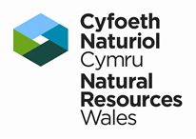 | 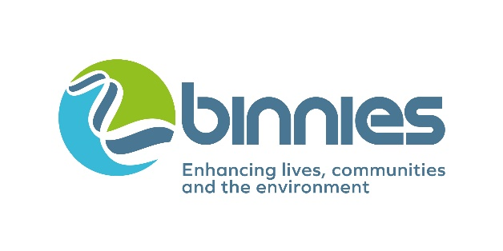
Details of document preparation and issue:
Version no. | Prepared | Checked | Reviewed | Approved | Issue date | Issue status
P01 | S. Rebours-Smith  C. Rafipay | B. Tucker | L. Westoby | A. Humphreys | 30/01/2026 | S3

Project no.: | 4021883
File name: | 4021883-BUK-ZZ-00-RP-GE-00004

Notice:
This report was prepared by Binnies UK Limited (BUKL) solely for use by Natural Resources Wales (NRW). This report is not addressed to and may not be relied upon by any person or entity other than NRW for any purpose without the prior written permission of BUKL. BUKL, its directors, employees and affiliated companies accept no responsibility or liability for reliance upon or use of this report (whether or not permitted) other than by NRW for the purposes for which it was originally commissioned and prepared.
In producing this report, BUKL has relied upon information provided by others. The completeness or accuracy of this information is not guaranteed by BUKL.

Table of contents

1 Introduction 4
1.1 Instruction 4
1.2 Site Details 4
1.3 Proposed works 4
1.4 Scope 5
1.5 Limitations 6
2 Previous Desk Study 7
3 Ground Investigation 9
3.1 CJ Associates Ground Investigation (2022) 9
3.2 Binnies Ground Investigation Report (2022) 10
4 Ground Model 11
4.1 Ground Conditions 11
4.2 Groundwater 12
4.3 Visual and Olfactory Evidence of Contamination 12
5 Contamination Risk Assessments 13
5.1 Human Health 13
5.2 Controlled Waters 14
5.3 Ground Gas Risk Assessment 16
5.4 Off-site Soil Disposal 16
6 Updated Geoenvironmental Assessment 18
6.1 Introduction 18
6.2 Updated Conceptual Site Model and Land Contamination Risk Assessment 19
7 Conclusions and Recommendations 27
7.1 Summary 27
7.2 Human Health 27
7.3 Controlled Waters 27
7.4 Off-site Soil Disposal 28
7.5 Contamination Mitigation during Construction 28
8 References 29
Appendices 31
Appendix A: Outline Design Drawings: 32
Appendix B: WYG Ground Investigation Report (2015) 33
Appendix C: CJ Associates Factual Report (2022) 34

1 Introduction

1.1 Instruction
Binnies UK Limited (BUKL) was instructed by Natural Resources Wales (NRW, “the client”) to undertake a Land Contamination Risk Assessment report for the Cardigan Tidal Flood Risk Management Scheme (TFRMS). This report is required to further understand the geoenvironmental risks to human health and controlled waters and assess the impact of the proposed works on environmental receptors.

1.2 Site Details
The site is located in Cardigan (Aberteifi), in Ceredigion, southwest Wales. It is positioned along the right bank (northern bank) of the River Teifi (flowing east to west) between grid references SN 17783 45866 and SN 18109 45969. The scheme covers an approximate distance of 400m length of the right bank on the River Teifi, upstream of Cardigan Bridge. The nearest postcode is SA43 1EX. The site is accessed via the road named “Strand”.
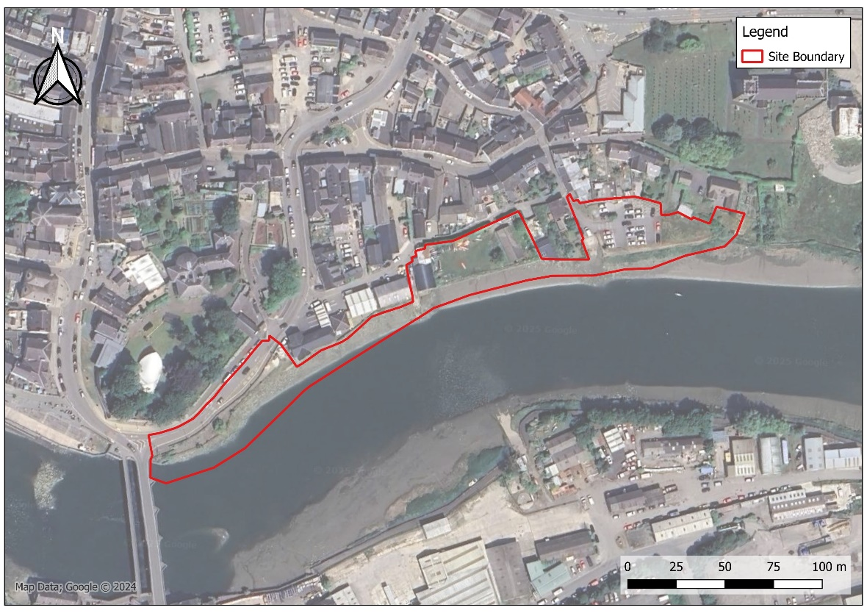
Figure 1-1: Site Location Plan
Cardigan Town Centre is located to the north of the site characterised by a mixture of residential and commercial properties. Cardigan Castle is situated to the northwest. The south side of the river is populated by industrial buildings.

1.3 Proposed works
The outline design for the scheme has been undertaken with the detailed design in progress and at the time of writing this report (Jan ‘26). Proposals are broadly to comprise a flood defence wall to protect the town from flooding. It is understood that this defence will comprise sheet piled walls to varying termination depths to be confirmed by detailed design. An embankment to support these piles is also proposed.
The outline design scheme proposal drawings are provided in Appendix A.
As part of the ongoing detailed design, the proposals have been split into four key zones known as Areas 1-4. Notably for Area 4 (eastern-most section/ Gloster Row car park), the flood defence wall is now to be set back from the existing bank, with ground levels south of the wall (riverside) to be excavated and lowered to broadly align with the existing foreshore and create an extension of the estuarine/ riverine habitat to offset loss elsewhere. A design sketch dated September 25 is provided below for reference:
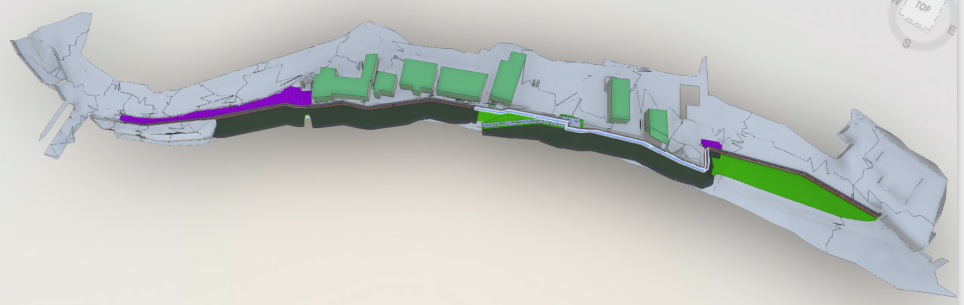
N
Figure 1-2: Binnies Design Sketch, dated September 25.
Proposals are for a new sheet piled flood defence wall including an embankment along the foreshore (dark green/ grey). Sheet piled wall in eastern-most section (Area 4) now to be set-back to create extension of estuarine/ riverine habitat (shaded green/ circled in red).

1.4 Scope
This report follows a Contamination Preliminary Risk Assessment (PRA) undertaken by Binnies for Natural Resources Wales (NRW) ref: 4021883-BUK-ZZ-00-RP-GE-00003, which identified several potential source-pathway-receptor linkages with respect to human health and controlled waters; further action was required to further assess the risks.
The aims of this Land Contamination Risk Assessment Report are to further assess the potential contaminant linkages identified in the PRA, using the results of additional ground investigation works undertaken for the scheme by CJ Associates in 2022 (scoped by Binnies). The assessment broadly follows a Stage 1 Tier 2 Generic Quantitative Risk Assessment (GQRA) in accordance with Environment Agency Land Contamination Risk Management Guidance (LCRM, 2020) guidance.
The scope of this report is based on the following objectives:
Summarise the previous Contamination Preliminary Risk Assessment (Binnies, 2026);
Review and collate information from relevant ground investigations, which includes those undertaken by WYG in 2015 and more recent works for the scheme scoped by Binnies and undertaken by CJ Associates in 2022;
Use contamination laboratory testing data to undertake Generic Quantitative Risk Assessments (GQRA) for human health and controlled waters risk assessments; to enable further quantitative assessment of previously identified potential contaminant linkages;
Update the Conceptual Site Model based on the findings of the GQRA and determine whether any further works are required (i.e. have unacceptable risks been identified that require further action or are risks low enough that no further action is needed);
Provide recommendations and outline any further works required with respect to contamination.
These objectives have been selected following relevant guidance documents including the Environment Agency’s model procedures for Land Contamination Risk Management (LCRM) published October 2020. Other guidance documents have also been referenced throughout the report, including those published by the British Standards Institution, Contaminated Land: Applications in Real Environments (CL:AIRE), and the Association of Geotechnical & Geoenvironmental Specialists (AGS).

1.5 Limitations
This report interprets ground conditions based on the information available to Binnies at the time of writing. The nature of a natural material such as soils and bedrock is inherently variable and as such Binnies cannot be held liable should the ground conditions vary widely between exploratory locations. Furthermore, chemical contamination undergoes many transformative effects (including but not limited to chemical reaction with other substances in the environment, degradation, biological uptake, and movement with groundwater). As such, historical data on chemical concentrations is likely to be indicative only and may not provide a true reflection of the current geoenvironmental situation. Any additional limitations and assumptions have been highlighted throughout this report.

2 Previous Desk Study
A Contamination Preliminary Risk Assessment (PRA) was previously undertaken by Binnies for Natural Resources Wales (NRW) ref: 4021883-BUK-ZZ-00-RP-GE-00003. The salient information from the PRA report has been repeated below for reference.
In summary, development is shown on-site from the earliest historic mapping, with occasional unlabelled buildings in the west along the riverbank, one of which was later confirmed to be a smithy (though since replaced by a residential property); a car park was constructed in the east of the site by 2003. Off-site, notable historical industrial activities included a quay (5 - 90 m west), hospital (5 - 10 m east), iron foundry (65 - 70 m southwest), garages (90 - 120m north), railway sidings and various industrial buildings (65 - 200 m south). Various other features including pits, depots, tanks, and a cemetery were highlighted in the areas surrounding the site.
BGS mapping shows Made Ground to be mapped throughout the site and extends along the riverbank west and east of the site, as well as further north into Cardigan Town. Given the mapped distribution of Made Ground along the banks of the River Teifi, it was anticipated that the site is situated on reclaimed land. Superficial deposits are mapped as Tidal River or Creek Deposits along with areas of Glacial Till. Bedrock is shown to comprise the Nantmel Mudstones Formation comprising mudstones of marine origin in distinctively graded beds.
The superficial aquifer underlying the site is classified as Secondary Undifferentiated whilst the bedrock aquifer is classified as Secondary B. On-site groundwater vulnerability is shown to be high vulnerability in superficial aquifers and medium vulnerability in bedrock aquifers. No abstractions are recorded within 2km of the site and the site is not located within a source protection zone (SPZ).
The River Teifi directly to the south of the site is classified as a Site of Special Scientific Interest (SSSI) and also lies within a Special Area of Conservation (SAC).
An initial review of ground gas and radon risks was undertaken; based on the review and that the scheme proposals are understood to comprise construction of a sheet piled flood defence wall (with no buildings or enclosed spaces proposed) these potential risks were therefore discounted.
The report included review of a historical ground investigation undertaken by WYG in 2015 for a wider area including exploratory holes on-site; a copy of the WYG Ground Investigation Report is included in Appendix B. The strata encountered was broadly described (in sequence) as topsoil, Made Ground, Alluvium and the Nantmel Mudstones Formation. Made Ground was found in the majority of boreholes at depths up to 5.3m below ground level (bgl) including some anthropogenic materials. Groundwater monitoring recorded levels between 2.11m and 2.74m bgl within the Made Ground or superficial/ alluvial deposits (though levels were expected to be tidally influenced).
The WYG testing results were subject to an initial contamination screen based on a selected proposed Public Open Space (POS) park end-use. None of the results for metals, Polycyclic Aromatic Hydrocarbons (PAHs), Extractable Petroleum Hydrocarbons (EPH) or Benzene, Toluene, Ethylbenzene, Xylenes (BTEX) compounds were found to exceed the initial Public Open Space (park) Generic Assessment Criteria (GAC) screen, however chrysotile cement bound debris was identified in one sample obtained from the Made Ground in the east of the site (borehole PBH4, quantified at 2.116% of material mass (fibres)). Asbestos fibres were also identified in several other samples of Made Ground though the quantification results were below the laboratory limit of detection (<0.001%).
The Initial Conceptual Site Model (CSM) and Preliminary Risk Assessment (PRA) identified several potential source-pathway-receptor linkages with respect to human health and controlled waters, and further action was required to further assess the risks. Further contamination targeted ground investigation was recommended for the site to enable more detailed contamination risk assessments to be undertaken for the scheme, including Generic Quantitative Risk Assessment (GQRA) for human health and controlled waters risk assessment.
The potential to disturb the river sediments along the River Teifi foreshore during the construction works was also highlighted and that these sediments may contain elevated contaminants from the surrounding industrial usage along the Teifi; further works were recommended including sediment sampling and testing to help review contamination risks associated with disturbance and inform further assessments.

3 Ground Investigation

3.1 CJ Associates Ground Investigation (2022)
Additional ground investigation works specific to this scheme were scoped by Binnies for geotechnical and geoenvironmental purposes and were subsequently undertaken by CJ Associates (CJA) in 2022; the findings are detailed in the Ground Investigation Factual Report (No. 2071916, May 22) enclosed in Appendix C. Relevant works for this Land Contamination Risk Assessment included the formation of two combined dynamic sample and rotary boreholes undertaken on the riverbank with soil sampling and geoenvironmental laboratory analysis. Installation of two monitoring wells was also undertaken for continuous monitoring of water levels using dataloggers.
A total of ten soil samples were scheduled for ‘Suite E’ broadly comprising heavy metals, PAH, TPH/ BTEX, asbestos screening and asbestos quantification. Waste Acceptance Criteria (WAC) testing was also undertaken on seven soil samples.
Data from both the previous WYG investigation (2015) and more recent CJ Associates investigation (2022) has now been used to inform this Land Contamination Risk Assessment report. A combined exploratory hole plan showing the locations from both investigations is shown below in Figure 3-1.

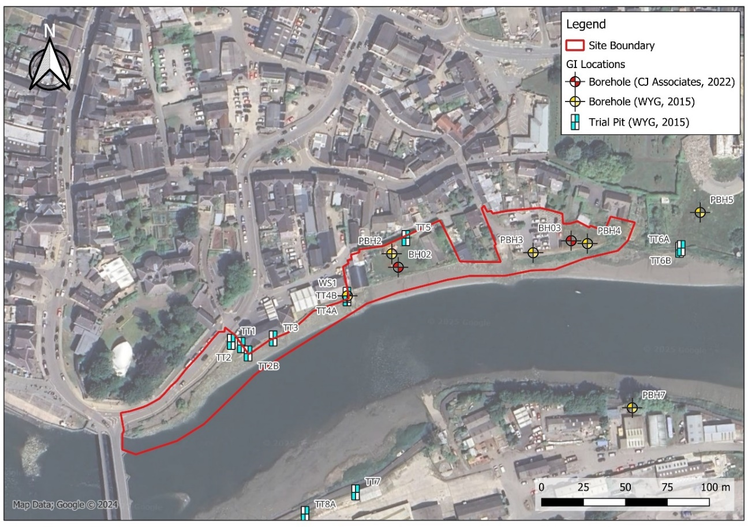
Figure 3-1: Combined Exploratory Hole Location Plan; WYG (2015) and CJ Associates (2022)

3.2 Binnies Ground Investigation Report (2022)
Binnies produced a Ground Investigation Report and Seepage Assessment for the scheme for National Resources Wales (NRW) in 2022, using the findings of the WYG 2015 Ground Investigation Report and additional CJ Associates 2022 Factual Report. Pertinent information has been summarised below; further details on some elements (e.g. groundwater) are included in later sections of the report, where relevant.
The ground conditions were interpreted to comprise a sequence of Made Ground underlain by variable alluvium (River / Tidal Creek Deposits) and bedrock of the Nantmel Mudstones Formation; bedrock was encountered at a depth of 11m bgl in borehole BH03 and proven to the base of the borehole (14.6m bgl).
Assessment of the groundwater conditions was undertaken following a detailed review of the 2015 and 2022 investigation’s groundwater monitoring data, which included groundwater monitoring dataloggers. Groundwater was found to be tidally influenced and unconfined.
Soil permeability was given a characteristic design value of 1 x 10⁻⁵ m/s in both the Made Ground and fine-grained alluvium, with a design value of 5 x 10⁻⁵ m/s in the coarse-grained alluvium. Permeability in the bedrock was not considered relevant based on the proposals and was not assessed.
A detailed contamination assessment was beyond the scope of the report. However, a broad review of the available geo-environmental data was carried out to identify potential risks relating to ground contamination. Risks from asbestos in Made Ground were identified; the 2015 (WYG) detected chrysotile asbestos fibre bundles and cement debris, with the material from borehole PBH4 being quantified at 2.116% of the overall mass; other fibre detections in soils were all quantified at <0.001%. Possible cement bound asbestos tiles were also observed on the foreshore of the site by the investigating supervisor during the 2022 CJ Associates investigation.
Due to the presence of asbestos in the area of works, it was recommended that a site-specific asbestos risk assessment be carried out prior to any works to assess the risk to construction workers and any residual risks associated with disturbing potentially asbestos contaminated ground.
It was recommended that a more detailed review of contamination be undertaken to meet the statutory requirements of any proposed development or construction works.

4 Ground Model

4.1 Ground Conditions

4.1.1 Made Ground
Much of the site is situated upon reclaimed land. In the 2022 investigation, Made Ground was recorded to depths of up to 4.75m bgl (though locally as shallow as 0.5m) and was found to extend slightly deeper in the previous WYG investigation to 5.3m bgl. The Made Ground was found to be of variable composition, broadly comprising sands, silts/ clays and gravels including mudstone and sandstone gravels. Anthropogenic materials were identified in the Made Ground including plastic, wood, tile, ceramic, metal, rope, brick, coal and concrete fragments. Clays and silts were often recorded as soft and dark grey / brown, indicating the presence of organics. A layer of mudstone and concrete cobbles was recorded in borehole BH02 between 0.2m and 0.9m depth, including hessian sacks and polystyrene.
During the CJ Associates works (2022), suspected Asbestos Containing Materials (ACMs) were visually identified in borehole BH03 at 4.75m depth at the base of the Made Gound (black fibrous material); surface fragments of suspected cement-bound asbestos sheeting were also seen along the river foreshore by the investigation supervisor (Figure 4-1).
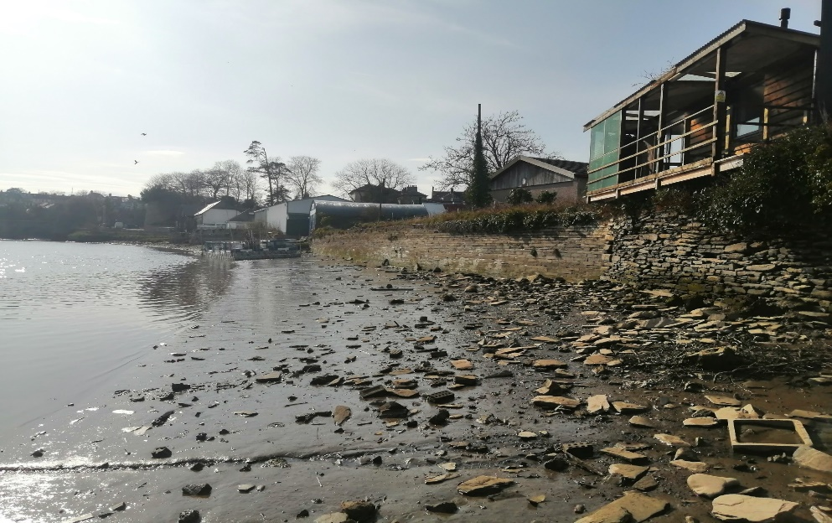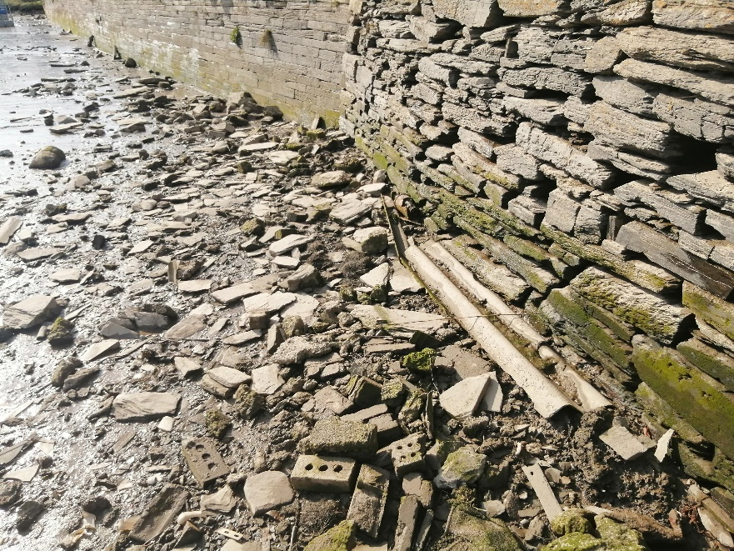
Suspected Asbestos Cement Sheeting
Figure 4-1 – Possible asbestos cement sheeting identified on foreshore in 2022.

4.1.2 Tidal River or Creek Deposits
Beneath the Made Ground, ground conditions are interpreted to comprise superficial Tidal River or Creek Deposits. These typically comprised a variable sequence of sands, silts, clays and gravels. In general, the upper layers were typically more cohesive in nature, including soft dark grey organic silts and fine sands, whilst the lower layers comprised coarser grained sandy gravels (e.g. from 7m depth in borehole BH02 and from 9m depth in borehole BH03).

4.1.2 Nantmel Mudstones Formation
Borehole BH03 (CJA, 2022) was extended via rotary coring techniques into mudstones of the Nantmel Mudstones Formation, described as weak to moderately strong thinly laminated mudstone encountered at a depth of 11m bgl and proven to a depth of 14.6m bgl.

4.2 Groundwater
The previous Binnies Ground Investigation Report (Section 3.2) provided assessment of the groundwater conditions at the site, based on a detailed review of the 2015 (WYG) and 2022 (CJA) investigation data which included groundwater monitoring dataloggers. The salient findings are summarised below.
During the WYG investigation (2015), groundwater strikes were recorded at depths of between 0.58m and 4.00m bgl within the Made Ground and Alluvium, with the follow up monitoring visit recording levels between 2.11m and 2.74m bgl. No groundwater was observed during the CJ Associates investigation (2022). Groundwater strikes and groundwater monitored during the works would have been affected by the changing tidal level of the River Teifi and strike/ level data recorded in exploratory holes during the works may not be wholly representative.
Groundwater monitoring dataloggers were installed as part of both previous ground investigation works to provide continuous groundwater monitoring data (15-minute intervals) over the tidal cycles of the River Teifi. This was undertaken in 2015 between 13th March and 15th December (i.e. a ten-month period) and in 2022 between 8th April and 12th May (i.e. a one-month period).
Maximum groundwater level at high tide ranged between 1.6m and 3.6m Ordnance Datum (OD) with typical groundwater levels at low tide ranging between -0.6 and 1.6m OD. Groundwater was recorded in Made Ground, Alluvium and commonly at the Made Ground/ Alluvium interface. Based on the data it was concluded that the groundwater was unconfined with the level fluctuating with tidal level (i.e. tidally influenced).

4.3 Visual and Olfactory Evidence of Contamination
Along with the presence of generic anthropogenic materials in the Made Ground, the following further visual and olfactory evidence of contamination has been identified during the WYG (2015) and CJ Associates (2022) investigations:

Table 4-1: Visual and olfactory evidence of contamination
Visual/ olfactory evidence | Location | Depth (bgl) | Strata | GI/ Date | Details
Potential asbestos (black fibrous material) | BH03 | 4.75m | Made Ground (base) | CJ Associates, 2022 | Not tested
Possible asbestos cement fragments | River Foreshore | Surface | Surface | CJ Associates, 2022 | Identified at surface by GI supervisor (not tested)
Sulphurous odour | BH03 | 8.30 to  8.35m | Natural superficial soils | CJ Associates, 2022 | At depth in natural soils/ likely organics
A hydrocarbon odour was also noted in the WYG investigation in borehole PBH7 within the Made Ground; however, this was located to the south of the River Teifi and well outside of the current site boundary.

5 Contamination Risk Assessments

5.1 Human Health

5.1.1 Generic Quantitative Risk Assessment (GQRA)
A human health generic quantitative risk assessment (GQRA) has been carried out by screening contamination testing results gathered as part of these investigations against Generic Assessment Criteria (GAC). Considering the future use of the site, Public Open Space (park) GACs have been selected as the most appropriate for assessment of human health risks for the site based on the proposals. GAC have been selected based on a conservative Soil Organic Matter (SOM) of 1%.
The contamination testing results from the WYG investigation (16 samples) and CJ Associates (CJA) investigation (10 samples) have been utilised as part of this GQRA. Following the screening exercise, the following exceedances have been identified above the adopted GAC:

Table 5-1 Contamination exceedances; results screened against POS(park) GAC
GI/ Date | Contaminant | Location/ Depth (bgl) | Result | GAC [POS_{(park)}] | Details
CJA (2022) | Dibenzo(ah)anthracene | BH02  0.5m | 1.79 mg/kg | 1.15 mg/kg | Slight exceedances above human health GAC.
CJA (2022) | Benzo(b)fluoranthene | BH02  0.5m | 15.70 mg/kg | 13.00 mg/kg | Slight exceedances above human health GAC.
WYG (2015) and CJA (2022) | Asbestos Containing Materials (ACMs) | PBH4  0.5 - 1m.  Chrysotile cement debris | 2.116% w/w | <0.001% | Chrysotile asbestos fibres also found in Made Ground within trial trench TT4 and borehole PBH3 by WYG (2015) though quantified <0.001%.  Potential ACM identified in borehole BH03 (black fibrous) and at surface along foreshore (not sampled/ tested to confirm).
As shown by Table 5-1, slightly elevated concentrations of individual PAHs were recorded in one soil sample from borehole BH02 at 0.5m depth. In addition, a sample tested from borehole PBH4 at 0.5 - 1m bgl has recorded chrysotile asbestos cement debris with a quantification result of 2.116%. Chrysotile asbestos fibres were also recorded in two samples during the previous WYG investigation in 2015 (TT4 & PBH3), though the quantification results were both <0.001% which falls below the adopted POS(park) GAC. All exceedances were identified within the Made Ground.
Suspected asbestos containing materials (ACMs) were also observed in the Made Ground in BH03 at 4.75m bgl and at surface along the foreshore in the central-eastern area of the site, though samples were not tested from these materials to confirm the presence of asbestos. Contamination exceedance locations are indicated on Figure 5-1 below.

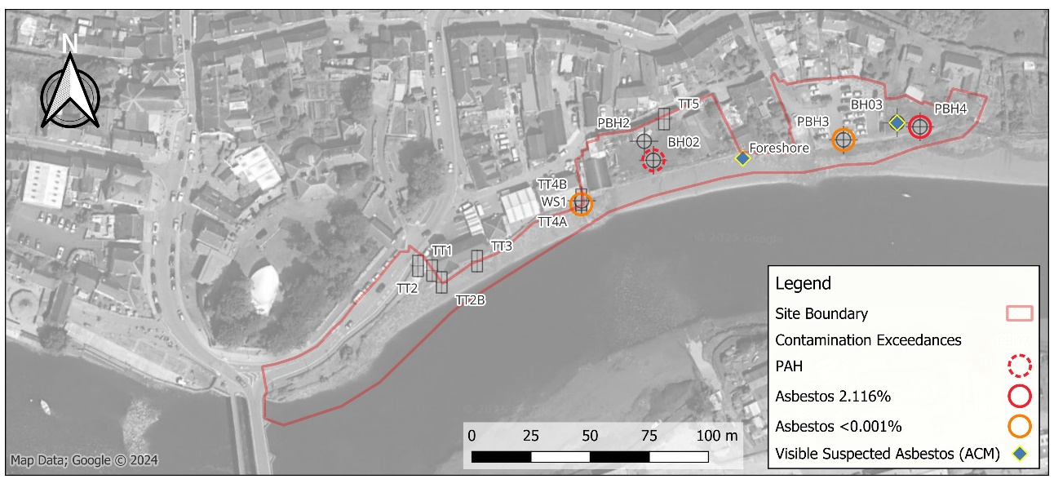
Figure 5-1: Contamination exceedance locations; WYG (2015) and CJ Associates (2022) data.

5.1.2 Recommendations
Given the findings of the GQRA, remediation measures are likely to be required to protect site end-users where Made Ground is present and a potential contamination pathway exists (e.g. any proposed areas of soft landscaping). Site-specific construction work risk assessments will also be required to assess risks from contamination (including asbestos) prior to any works being carried out, so that appropriate mitigation can be undertaken accordingly, including removal of surface ACM fragments identified along the foreshore prior to construction; detailed recommendations are provided in Section 7.

5.2 Controlled Waters

5.2.1 Controlled Waters Risk Assessment
The site is situated immediately adjacent to the River Teifi which is a designated SSSI and within a SAC. No abstractions are recorded within 2km of the site and the site is not located within a source protection zone (SPZ). The superficial aquifer underlying the site is classified as Secondary Undifferentiated whilst the bedrock aquifer is classified as Secondary B.
Ground investigations have generally found groundwater to be in hydraulic connectivity with the adjacent River Teifi and be tidally influenced and unconfined.
The proposed flood defence wall is to be constructed using steel sheet piles which are expected to be driven through the Made Ground and terminate within the underlying superficial soils (Tidal River or Creek Deposits) which are classified as a Secondary Aquifer (undifferentiated). Piles are not expected to reach the underlying bedrock stratum of the Nantmel Mudstones Formation (Secondary B Aquifer). Piling is not anticipated to penetrate an aquiclude.
The ground investigations undertaken to-date have recorded the presence of Made Ground with anthropogenic materials along the line of the proposed sheet piled wall. Groundwater or surface water contamination testing has not been carried out to-date, however no significant visual/ olfactory evidence for contamination has been identified in soils, with typically low contaminant concentrations recorded by soil laboratory testing – some PAH compounds were identified as part of the GQRA (using human health criteria/ not directly applicable to controlled waters), though only marginal exceedances were recorded and the compounds identified have very low water solubility indicating they are unlikely to be dissolved into groundwater and become mobile.
With reference to CL:AIRE publication ‘Piling and Penetrative Ground Improvement Methods on Land Affected by Contamination: Guidance on Pollution Prevention’ (2025), the proposed construction method of driven sheet piling is of small displacement where drag down of contaminants is unlikely to be a significant risk and will not generally create arisings that need to be managed; the potential for introducing a new contamination pathway from the proposed sheet pile construction is considered unlikely.
It is noted that some near-surface trenching is anticipated as part of the works, including works to remove potential obstructions prior to sheet pile installation along the foreshore, which may disturb river sediments. Whilst widespread contamination has not been encountered from the ground investigations, there is the potential that these sediments could be locally contaminated due to surrounding heavy industry along the Teifi and further works are therefore recommended to enable this risk to be assessed further.

5.2.2 Area 4, Set Back Flood Wall
As part of the ongoing detailed design, the proposals have been split into four key zones known as Areas 1-4. Notably for Area 4 (Gloster Row car park), the flood defence wall is now to be set back from the existing bank, with ground levels south of the wall (riverside) now to be excavated and lowered to broadly align with the existing foreshore and create an extension of the estuarine/riverine habitat to offset loss elsewhere.
Based on the Conceptual Site Model (CSM), tidally influenced groundwater is already anticipated to be in hydraulic connectivity with the Made Ground and underlying Alluvium ,and will have been for some time.
Boreholes in the vicinity of the proposed Area 4 cutting (PBH3, PBH4 and BH03) recorded Made Ground between approximately 2m and 5m depth below the surface level of the car park. Current proposals suggest removal of approximately 2 - 3m of soil to facilitate sheet pile wall construction and a gradual sloped profile beyond to adjoin the existing Teifi foreshore. As a result, the majority of Made Ground from this area (potentially all Made Ground locally) is likely to be removed as part of these proposals and disposed off-site. Detailed design proposals are also understood to include provision of erosion and scour protection to this area above the extents of the cut soils; this is currently proposed as a mattress of rock filled bags (rock roll system) over a geotextile membrane which will prevent erosion or scour of any residual soils across this area, including any Made Ground. A nominal thickness of imported clean soils are to be placed above to encourage habitat generation.
The proposals for realigning the new set back flood defence wall section in Area 4 and reducing ground levels here to facilitate new estuarine/ riverine habitat are therefore considered low risk with respect to controlled waters and are unlikely to exacerbate any contamination mobilisation from within the Made Ground on the basis that erosion and scour protection are already proposed across the Area 4 ‘cut zone’ and embedded into the design for this area.

5.2.3 Recommendations
The controlled waters risk assessment at this stage indicates an overall low risk based on the ground investigation information to-date; however, the following further works are recommended, as detailed in Section 7:

- Recovery of groundwater samples from serviceable boreholes and surface river samples from the River Teifi prior to construction, including testing for contamination to determine baseline conditions for controlled waters and inform long term monitoring strategy.
- Undertaking of a sediment sampling exercise along the foreshore to confirm the chemical nature of these sediment materials and determine whether there is the potential for disturbance to negatively impact controlled waters.

5.3 Ground Gas Risk Assessment
The previous Binnies Preliminary Risk Assessment (PRA) concluded the absence of any significant ground gas risks given that sources identified (Made Ground and Alluvium) are typically low risk and that the proposed scheme does not include the construction of any buildings or confined spaces for person-entry where gas could accumulate. With reference to CL:AIRE publication ‘Piling and Penetrative Ground Improvement Methods on Land Affected by Contamination: Guidance on Pollution Prevention’ (2025), vibration caused by sheet piling should also not be sufficient or prolonged enough to cause significant volumes of any potential gas to migrate off-site.
On the basis of the above, no significant ground gas risks have been identified for the scheme.

5.4 Off-site Soil Disposal

5.4.1 Waste Acceptance Criteria (WAC) Testing
Waste Acceptance Criteria Testing (WAC) was undertaken on seven soil samples. The results have been compared against Landfill Waste Acceptance Criteria Limits; exceedances of specified Landfill WAC Limits are outlined in Table 5-2 below.

Table 5-2 WAC testing results: exceedances of Landfill WAC Limits
Contaminant | Max  (mg/kg) | Landfill WAC Limits mg/kg |  |  | Exceedances
Contaminant | Max  (mg/kg) | Inert Waste Landfill | SNRHW  in Non-hazardous  Landfill | Hazardous Waste Landfill | Exceedances
Total Organic Carbon¹ | 6.47% | 3% | 5% | 6% | BH02@0.5m (6.47%)  BH03@0.5m (3.54%)
PAH sum of 17¹ | 104 | 100 | - | - | BH02@0.5m
Antimony² | 0.07 | 0.06 | 0.7 | 5 | BH03@3.0m
Chloride² | 1260 | 800 | 15,000 | 25,000 | BH03@6.0m (natural soil)
Lead² | 2.14 | 0.5 | 10 | 50 | BH02@0.5m
Sulphate as SO₄² | 1061 | 1000 | 20,000 | 50,000 | BH02@4.0m
Notes:
Shaded orange cells indicate exceedance of specified Landfill WAC limit.
¹ Solid Waste Analysis
² Eluate Analysis

5.4.2 Soil Waste Classification
Waste soils will be generated as part of the works, which are likely to require off-site disposal; this includes Area 4, where existing ground levels are to be reduced to facilitate construction of the set back flood defence wall and habitat compensation area.
Soil waste classification did not form part of the project scope, however data from the ground investigations is available and could be used to provide an initial soil waste classification assessment.
Notably, asbestos was recorded in Made Ground locally and quantification testing showed an exceedance of the asbestos hazardous waste limit (0.1%) in one location (PBH4, chrysotile cement debris, 2.116%). Suspected Asbestos Containing Materials (ACM) were identified locally in the Made Ground and also along the foreshore. Some hazardous waste is therefore likely to be generated during construction.
A soil waste classification exercise is recommended using the results of the ground investigation to provide an initial indication of waste classification and likely off-site disposal options. This could be improved with a further soil sampling exercise to target areas of proposed cutting (e.g. Area 4) to better inform the assessment and estimated disposal costs.

6 Updated Geoenvironmental Assessment

6.1 Introduction
During the previous Contamination Preliminary Risk Assessment for the scheme (Binnies, 2026), potential contaminant linkages were identified based on available published information and historical ground investigation information. A source-pathway-receptor (SPR) linkage approach was adopted and initial Conceptual Site Model (CSM) and Preliminary Risk Assessment (PRA) were provided.
This Land Contamination Risk Assessment builds on the previous assessment and considers results of additional ground investigation together with Generic Quantitative Risk Assessment (GQRA), broadly in accordance with the Environment Agency’s LCRM methodology.
The risk posed by any contaminant in soil or groundwater will depend on the nature of the hazard, the likelihood of exposure, the pathway by which exposure occurs and likely effects on the receptor. Where a contaminant linkage has been identified, an assessment has then been undertaken to assess the risk based on the probability and consequence of an event occurring:
- The likelihood of an event (probability) – considers both the presence of the hazard and receptor and the integrity of the pathway; and
- The severity of the potential consequence – considers both the potential severity of the hazard and the sensitivity of the receptor.

The definition of risk and risk characterisations have been adopted from CIRIA 552, which is reproduced in Table 6-1.
Table 6-1 Risk Classification Matrix (CIRIA C552).
 |  | Consequence
Probability |  | Severe | Medium | Mild | Minor
Probability | High Likelihood | Very high | High | Moderate | Moderate / Low risk
Probability | Likely | High | Moderate | Moderate / Low risk | Low risk
Probability | Low Likelihood | Moderate risk | Moderate / Low risk | Low risk | Very low risk
Probability | Unlikely | Moderate / Low risk | Low risk | Very low risk | Very low risk
An updated Conceptual Site Model (CSM) and Land Contamination Risk Assessment has been undertaken based on the findings of this report, including the Ground Model for the scheme in Section 4, and the human health and controlled waters contamination risk assessments in Section 5; the findings of which are presented as Table 6-2.

6.2 Updated Conceptual Site Model and Land Contamination Risk Assessment

Table 6-2 Updated Conceptual Site Model and Land Contamination Risk Assessment
Source | Pathway | Receptor | Probability | Consequence | Risk | Assessment of risk and mitigation
On-site: Made Ground present across the site.  Elevated concentrations of polycyclic aromatic hydrocarbons (PAH) and asbestos. | Dermal contact with soils/ dust, ingestion, inhalation of particulates. | Human Health: Groundworkers, construction personnel and maintenance workers. | Likely | Medium | Moderate | Made Ground has been encountered during investigations across the site to depths up to circa 5m bgl.  Exposure to groundworkers and personnel to be mitigated in part by provision of appropriate Personal Protective Equipment (PPE) and additional measures as necessary during the works, including hygiene facilities.  Asbestos including free fibres, debris and ACM have been found in Made Ground on-site (WYG); potential ACM fragments were also visually identified on the foreshore at surface.  Asbestos may pose a risk to workers if free fibres become airborne. Asbestos in soils construction risk assessments required to ensure risks from asbestos exposure are adequately assessed and controlled during the works.  Visible ACM fragments on foreshore to be removed by specialist prior to construction.
 |  | Human Health - Future site users. | Likely | Medium | Moderate | Made Ground has been encountered in previous investigations across the site to depths up to circa 5m bgl.  Asbestos including free fibres, debris and ACM have been found in Made Ground on-site (WYG); potential ACM fragments were also visually identified on the foreshore at surface.  Asbestos poses a risk to future site users of publicly accessible areas if free fibres become airborne. Some areas of publicly accessible landscaping and planting proposed with potential risk of exposure for end-users.  Remediation strategy required to determine remedial measures for proposed areas of landscaping – likely to include placement of a minimum thickness of clean imported capping soil layer and underlying separation membrane.  Visible ACM fragments on foreshore to be removed by specialist prior to construction.
 | Infiltration and lateral migration of contaminants through the ground and groundwater. | Controlled Waters: River Teifi | Unlikely | Medium | Low risk | The River Teifi is part of a designated SSSI and SAC. The site and proposed works are located on the banks of the watercourse. Permeability of Made Ground and superficial deposits may allow for the migration of any contaminants down the hydraulic gradient to the river.  Ground investigation data from 2015 and 2022 did not identify any obvious/ gross contamination, with relatively low concentrations of contaminants recorded in soils. Marginal exceedance of specific PAHs were recorded at one location, though compounds identified have very low water solubility indicating they are unlikely to be dissolved into groundwater and become mobile.  Proposed construction method of driven sheet piling is of small displacement where drag down of contaminants is unlikely to be a significant risk and will not generally create arisings that need to be managed; the potential for introducing a new contamination pathway from the proposed sheet pile construction is considered unlikely.  Existing ground levels to be reduced in Area 4 (and wall set back) with likely removal of majority of Made Ground (benefit)/ Erosion and scour protection (mattress of rock filled bags) to be provided to cut surface as part of design.  Proposals for groundwater and surface water sampling and testing to determine baseline water quality conditions and inform long term monitoring strategy.
 | Infiltration and vertical migration of contaminants through the ground and groundwater. | Controlled Waters - Underlying Secondary Aquifers. | Unlikely | Low | Low risk | Ground investigation data from 2015 and 2022 did not identify any obvious/ gross contamination with relatively low concentrations of contaminants recorded in soils. Marginal exceedance of specific PAHs in one location, though compounds identified have very low water solubility indicating they are unlikely to be dissolved into groundwater and become mobile.  Ground investigation indicates Made Ground already in hydraulic continuity with groundwater and superficial aquifer. Removal of large quantity of Made Ground from Area 4 likely to result in overall betterment.  Proposed construction method of driven sheet piling is of small displacement where drag down of contaminants is unlikely to be a significant risk and will not generally create arisings that need to be managed; the potential for introducing a new contamination pathway from the proposed sheet pile construction is considered unlikely.  Existing ground levels to be reduced in Area 4 (and wall set back) with likely removal of majority of Made Ground (benefit)/ Erosion and scour protection (mattress of rock filled bags) to be provided to cut surface as part of design.  Proposals for groundwater and surface water sampling to determine baseline conditions and inform long term monitoring strategy.
On-site: Current and historical land use on-site, including historical smithy and industrial units on the riverbank and car park in the east.  Elevated concentrations of polycyclic aromatic hydrocarbons (PAH) and asbestos identified in Made Ground. | Dermal contact with soils/ dust, ingestion, inhalation of particulates. | Human Health: Groundworkers and construction personnel. | Likely | Medium | Moderate | Exposure to groundworkers and personnel to be mitigated in part by provision of appropriate Personal Protective Equipment (PPE) and additional measures as necessary during the works, including hygiene facilities.  Asbestos including free fibres, debris and ACM have been found in Made Ground on-site (WYG); potential ACM fragments were also visually identified on the foreshore at surface.  Asbestos may pose a risk to workers if free fibres become airborne. Asbestos in soils construction risk assessments required to ensure risks from asbestos exposure are adequately assessed and controlled during the works.  Visible ACM fragments on foreshore to be removed by specialist prior to construction.
 | Dermal contact with soils/ dust, ingestion, inhalation of particulates. | Human Health - Future site users. | Likely | Medium | Moderate | Asbestos including free fibres, debris and ACM have been found in Made Ground on-site (WYG); potential ACM fragments were also visually identified on the foreshore at surface.  Asbestos poses a risk to future site users of publicly accessible areas if free fibres become airborne. Some areas of publicly accessible landscaping and planting proposed with potential risk of exposure for end-users.  Remediation strategy required to determine remedial measures for proposed areas of landscaping – likely to include placement of a minimum thickness of clean imported capping soil layer and underlying separation membrane.  Visible ACM fragments on foreshore to be removed by specialist prior to construction.
 | Infiltration and lateral migration of contaminants through the ground and groundwater. | Controlled Waters: River Teifi | Unlikely | Low | Low risk | The River Teifi is part of a designated SSSI and SAC. The site and proposed works are located on the banks of the watercourse. Permeability of Made Ground and superficial deposits may allow for the migration of any contaminants down the hydraulic gradient to the river.  Ground investigation data from 2015 and 2022 did not identify any obvious/ gross contamination with relatively low concentrations of contaminants recorded in soils. Marginal exceedance of specific PAHs in one location, though compounds identified have very low water solubility indicating they are unlikely to be dissolved into groundwater and become mobile.  Proposed construction method of driven sheet piling is also of small displacement where drag down of contaminants is unlikely to be a significant risk and will not generally create arisings that need to be managed; the potential for introducing a new contamination pathway from the proposed sheet pile construction is considered unlikely.  Existing ground levels to be reduced in Area 4 (and wall set back) with likely removal of majority of Made Ground (benefit)/ Erosion and scour protection (mattress of rock filled bags) to be provided to cut surface as part of design.  Proposals for groundwater and surface water sampling and testing to determine baseline water quality conditions and inform long term monitoring strategy.
 | Infiltration and vertical migration of contaminants through the ground and groundwater. | Controlled Waters - Underlying Secondary Aquifers | Unlikely | Low | Low risk | Ground investigation data from 2015 and 2022 did not identify any obvious/ gross contamination with relatively low concentrations of contaminants recorded in soils. Marginal exceedance of PAHs in one location though these compounds identified have very low water solubility indicating they are unlikely to be dissolved into groundwater and become mobile.  Ground investigation indicates Made Ground already in hydraulic continuity with groundwater and superficial aquifer. Removal of large quantity of Made Ground from Area 4 likely to result in overall betterment.  Proposed construction method of driven sheet piling is also of small displacement where drag down of contaminants is unlikely to be a significant risk and will not generally create arisings that need to be managed; the potential for introducing a new contamination pathway from the proposed sheet pile construction is considered unlikely.  Existing ground levels to be reduced in Area 4 (and wall set back) with likely removal of majority of Made Ground (benefit)/ Erosion and scour protection (mattress of rock filled bags) to be provided to cut surface as part of design.  Proposals for groundwater and surface water sampling and testing to determine baseline water quality conditions and inform long term monitoring strategy.
On-site: Contaminated sediments within the River Teifi foreshore.  Potential contaminants most likely to include heavy metals from surrounding industrial activity but may also include other contaminants such as polycyclic aromatic hydrocarbons (PAH), petroleum hydrocarbons (TPH). | Disturbance through excavation or piling. | Controlled Waters: River Teifi | Likely | Medium | Moderate | Contaminants from off-site industrial sources may have washed into the River Teifi and settled in foreshore sediments over time within the site boundary. These may become disturbed by the construction and could migrate into the river without control measures in place (e.g. if contaminated silt is exposed at low tide and left to be in contact with the river at high tide). The chemical nature of the river sediments are currently unknown at present and testing of samples from this material together with consideration of construction proposals should be undertaken to assess the risks further. Sediment control measures and/ or preventing water ingress into excavations may prevent a pathway forming between potentially contaminated sediments and controlled waters.
Off-site: Current and historical industrial land use in surrounding areas/ Cardigan town, including historical tank records.  Elevated concentrations of polycyclic aromatic hydrocarbons (PAH) and asbestos identified in Made Ground though unlikely to have originated from off-site. | Migration of contaminants through soils and groundwater to beneath the site. | Human Health: Groundworkers and construction personnel | Unlikely | Low | Low risk | The site is located down hydraulic gradient of the town of Cardigan where several historical and current industrial land uses were identified including historical tank records.  Ground investigation data from 2015 and 2022 did not identify any obvious/ gross contamination that may have originated from off-site and recorded exceedances of PAHs and asbestos attributed to in-situ Made Ground material rather than an off-site source.
 |  | Human Health - Future site users | Unlikely | Medium | Low risk | The site is located down hydraulic gradient of the town of Cardigan where several historical and current industrial land uses were identified including historical tank records.  Ground investigation data from 2015 and 2022 did not identify any obvious/ gross contamination that may have originated from off-site and recorded exceedances of PAHs and asbestos attributed to in-situ Made Ground material rather than an off-site source.
 | Infiltration and lateral migration of contaminants through the ground and groundwater. | Controlled Waters: River Teifi | Unlikely | Medium | Low | The River Teifi is part of a designated SSSI and SAC. The site and proposed works are located on the banks of the watercourse. Permeability of Made Ground and superficial deposits may allow for the migration of any contaminants down the hydraulic gradient to the river.  Ground investigation data from 2015 and 2022 did not identify any obvious/ gross contamination with relatively low concentrations of contaminants recorded in soils. Marginal exceedance of PAHs in one location though these compounds identified have very low water solubility indicating they are unlikely to be dissolved into groundwater and become mobile.  Proposed construction method of driven sheet piling is also of small displacement where drag down of contaminants is unlikely to be a significant risk and will not generally create arisings that need to be managed; the potential for introducing a new contamination pathway from the proposed sheet pile construction is considered unlikely.  Proposals for groundwater and surface water sampling and testing to determine baseline water quality conditions and inform long term monitoring strategy.

7 Conclusions and Recommendations

7.1 Summary
This Land Contamination Risk Assessment builds on the previous Preliminary Risk Assessment and considers results of additional ground investigation together with contamination risk assessments broadly in accordance with the Environment Agency’s LCRM methodology, including Generic Quantitative Risk Assessment (GQRA).
The Updated Conceptual Site Model (CSM) and Land Contamination Risk Assessment present in Table 6-2 outlines the revised contamination risks based on the findings of this report.

7.2 Human Health
Moderate contamination risks to human health have been identified associated with the presence of asbestos in Made Ground and also PAHs. Fragments of suspected Asbestos Containing Material (ACM) were also observed at the foreshore during the 2022 investigation works. The following recommendations are therefore made with respect to human health risks:

- Areas of proposed landscaping are envisaged as part of the scheme where site end-users (including the public) may come into contact with contaminated soils. A remediation strategy is therefore required for the scheme, to determine the most appropriate remedial method(s) to eliminate the source-pathway-receptor linkage.

- Given the presence of asbestos, an asbestos in soils construction risk assessment should be undertaken in accordance with relevant guidance (including the Control of Asbestos Regulations 2012) to ensure risks from asbestos exposure are adequately assessed and controlled measures are implemented as necessary during the works, including removal of surface ACM fragments identified along the foreshore prior to construction.

7.3 Controlled Waters
The findings of the controlled waters risk assessment in Section 5.2 concluded an overall low risk to controlled waters based on the findings from the ground investigations to-date and the scheme proposals including the proposed sheet piling methodology. A potential moderate risk however still remains associated with potentially contaminated sediments within the River Teifi foreshore associated with industry and mining in the wider area. The following recommendations are made with respect to controlled waters:

- Recovery of groundwater samples from serviceable boreholes and surface water samples from the River Teifi prior to construction including testing for contamination to determine baseline water quality conditions for controlled waters and to inform long term monitoring strategy.

- Undertaking of a sediment sampling and testing exercise along the foreshore, to confirm the chemical nature of these sediment materials and determine whether there is the potential for disturbance to negatively impact controlled waters.

7.4 Off-site Soil Disposal
Waste Acceptance Criteria (WAC) testing has been undertaken as part of this investigation, however a formal waste classification exercise using the contamination testing data was not part of the project scope. Some hazardous waste is likely to be generated during construction due to presence of asbestos in soils and potentially other contaminants with associated costs for disposal.

- A soil waste classification exercise is recommended using the results of the ground investigation to provide an initial indication of waste classifications and likely off-site disposal options. This could be improved with a further soil sampling exercise targeting areas of proposed soil removal (e.g. Area 4) to better inform the assessment and estimated disposal costs.

7.5 Contamination Mitigation during Construction
- The following general mitigation measures should also be undertaken to protect controlled waters and construction workers during construction: If trenches are to be excavated in Made Ground to install the sheet piled walls, they should be backfilled with clean fill;
- Formal monitoring of Made Ground, natural soils, and groundwater for potential contamination. Monitoring should include the use of a photo-ionisation detector (PID) for volatile organic compounds / petroleum hydrocarbons, and formal sampling of soils and groundwater should indications of contamination be observed;
- Any visual or olfactory evidence of contamination encountered during construction works should be further investigated to determine spatial extents and concentrations (it is possible that works will need to be stopped during this investigation into unexpected contamination);
- Standard practices for protecting the water environment should be adhered to (e.g. bunded fuel storage, use of plant nappies, suitable spill kits with trained personnel, silt fencing);
- Risks posed to workers from contamination from soils and water are likely to be able to be mitigated in part by appropriate PPE and good personal hygiene along with mitigation to control dust (e.g. dampening down of dry soils). However, asbestos has been identified in soils and further control measures are likely to be required to mitigate risks to workers and the surrounding public from asbestos subject to the findings of an asbestos in soils construction works risk assessment.
- Appropriate PPE should be used at all times.
Appropriate management strategies should be in place to deal with potentially contaminated soils if they are encountered during construction. These should include measures to ensure the safety of construction workers, to prevent further contamination of the environment, and an appropriate storage, testing and disposal strategy if contaminated soils are to be removed from site.
It is advised that the above should be included in the Construction Environmental Management Plan (CEMP) for the project.

8 References
BGS. (1989). England and Wales Geological Map 1:50,000 Sheet 193: (Solid and Drift Edition). Retrieved March 2022, from https://bit.ly/3ReXnbJ

BGS. (2024). BGS maps portal. Retrieved 2024, from https://www.bgs.ac.uk/information-hub/bgs-maps-portal/

Binnies. (2022). NRW NGF CARDIGAN TIDAL FRMS Ground Investigation Report and Seepage Assessment. Chester: Binnies UK Ltd.

BRE Construction Division. (2005). Special Digest 1:2005 Concrete in aggressive ground.

British Geological Survey. (2024). GeoIndex - British Geological Survey. Retrieved from https://mapapps2.bgs.ac.uk/geoindex/

British Standards Institute. (2010). BS EN 1997-2:2007 Eurocode 7: Geotechnical design. Ground investigation and testing (incorporating corrigendum June 2010).

British Standards Institute. (2020). BS 8004: 2015 Code of practice for foundations (+A1: 2020).

BSI. (2015). BS 5930:2015 Code of practice for ground investigations (+A1:2020). Retrieved from British Standards Institution: https://bit.ly/3qbuFgx

BSI. (2017). BS 10175:2011+A2:2017 Investigation of potentially contaminated sites - code of practice. Retrieved from British Standards Institution: https://bit.ly/3qbuFgx

CIRIA. (2001). Contaminated land risk assessment: A guide to good practice. Basingstoke: CIRIA.

CJ Associates. (2022). Cardigan Tidal Flood Risk management – Ground Investigation No. 2071916 Factual Report.

DEFRA. (2022). Multi-Agency Geographic Information for the scheme (MAGIC). Retrieved March 2022, from https://magic.defra.gov.uk/

Environment Agency. (2020). Land contamination risk management (LCRM). Retrieved 2023, from GOV.UK: https://www.gov.uk/government/publications/land-contamination-risk-management-lcrm

Environment Agency. (2024). National LIDAR Programme (England Only). DEFRA. Retrieved from https://environment.data.gov.uk/survey

Google. (2024). Google Maps Street View. Retrieved September 2022, from https://www.google.com/streetview/

Google Earth. (2024). Google Earth. Retrieved March 2022, from https://earth.google.co.uk

Groundsure. (2024). Groundsure Map Insights GS-SQR-C8M-SGX-TC2.

Highways England. (2020). CD 622 Managing geotechnical risk.

Historic England. (2024). Aerial Archaeology Mapping Explorer. Retrieved 2024, from https://historicengland.org.uk/research/results/aerial-archaeology-mapping-explorer/

Mining Remediation Authority. (2024). The Mining Remediation Authority Interactive Viewer. Retrieved from https://bit.ly/3pQMctZ

NRW. (2024). Flood map for planning (Wales). Retrieved 2024, from https://flood-map-for-planning.naturalresources.wales/

Ordnance Survey. (2024). OS Maps Online. Retrieved 2024, from https://osmaps.com/

UK Health Security Agency. (2022). UK Radon Indicative Map. (UK Health Security Agency) Retrieved March 2022, from https://bit.ly/2zFVte3

Welsh Government. (2023). DataMapWales - Lidar Viewer. Retrieved 2024, from https://datamap.gov.wales/maps/lidar-viewer/

WYG. (2015). Cardigan Flood Alleviation Scheme Ground Investigation Report.

Zetica. (2024). UXO Risk Assessment. Retrieved March 2022, from https://bit.ly/2DMxh9W

Zetica. (2024). UXO Risk Maps. Retrieved 2024, from https://zeticauxo.com/guidance/risk-maps/

Appendices

Appendix A: Outline Design Drawings:
4021883-BUK-ZZ-00-DR-GE-00001
4021883-BUK-ZZ-00-DR-GE-00002
4021883-BUK-ZZ-00-DR-GE-00003
4021883-BUK-ZZ-00-DR-GE-00004
4021883-BUK-ZZ-00-DR-GE-00005
4021883-BUK-ZZ-00-DR-GE-00006

Appendix B: WYG Ground Investigation Report (2015)
A088137 - Cardigan FAS factual GI Report April 15 DRAFT.pdf

A088137_2 (Proposed Site Investigation Layout Plan 1.pdf

Appendix C: CJ Associates Factual Report (2022)
2071916 Cardigan Flood Risk Management Factual Report v2.pdf

