Annex (iv) – SSSI Assessment Form
SSSI Assessment for permit/licence and deployment applications | 
To be completed by Permitting Officers for any applications for a permission which Natural Resources Wales has considered under S28I duty to notify SNCB and take their advice into account. This applies to all proposed permissions within a SSSI, and to operations outside the SSSI boundary which are likely to damage its special features.
NRW as a Section 28G authority has, when exercising its functions, a general duty to take reasonable steps, consistent with the proper exercise of its functions, to further the conservation and enhancement of the flora, fauna or geological or physiological features by reason of which the site is of special interest’

Part 1 – SSSI Assessment
Part 2 – Formal notification to SNCB (to be completed if part 1 assessment concludes likely damage, not likely to damage because of conditions or you cannot conclude no likely damage)
Part 3 – Decision
Pink text – drafting notes, to be deleted before completion/consultation.
Blue text – examples, to be replaced with permission-specific information and text turned to black.

Part 1 – SSSI Assessment

- Permitting officer/team | Owen Clee  Waste Permitting
- Permit application reference and site name | PAN-033213  Tir William Richard Farm  Farm location: 316308, 219494  Fields:  CD1 316055, 219485  CD2 316231, 219486  IV WG2 316986, 219515  Top Field East 316007  Top Field West 316048  Bottom Field 316218, 219132  Storage: No storage details proposed
- a. SSSI name(s)  b. location  c. NRW Operational Area/Environment Team | a. River Usk SSSI (Upper Usk)  b. SO 17052 19654  c. South Powys Environmental team
- Brief description of proposal | A land spreading application to spread one waste stream 17 05 06 (dredging spoil) at Tir William Richard Farm, Crickhowell, Powys.  The dredging spoil will be spread on grass fields. The application rate ranges from 750-2,000 tonnes per ha, with a total tonnage to spread 15,324 tonnes.  The application rate of the dredging comply with SR2010no4 as stated in table 2.1 of the permit which allows a maximum of 5,000 t/ha to be spread under the permit. The origin of the dredgings is from the Brecon and Monmouthshire Canal.  The provided waste analysis of the dredging spoil contain 30 samples from across the canal to demonstrate the dredgings are homogeneous in composition. An average of the tested parameters (nutrients and PTEs) has been used to show a representative composition of the dredgings.  The waste will be spread over 13.13 hectares of land within the listed fields at Tir William Richard Farm. All fields under this deployment are agriculturally improved. The dredgings will be spread on delivery; no waste storage is proposed under this deployment.  The dredgings will be spread to the fields by rear discharger spreader which is an appropriate application method for this stackable waste stream. The dredgings will then be allowed to dry before the fields are ploughed via a tractor-mounted plough to a depth of 0.4 meters to incorporate the dredgings into the soil. Further cultivation will be undertaken using a harrow to achieve a uniform soil profile. The fields in this deployment will then be reseeded with grass.  As the dredgings are being incorporated into the soil via ploughing a mixing ratio of the dredgings and the field soil has been used to calculate the concentrations of nutrients and potentially toxic elements. The total nutrients loading from the waste has not been calculated in line with the following Guidance; Land spreading: benefits and risks of the waste types you can use.  The mixing calculation has been based on the provided waste analysis and the provided soil analysis for the fields under the deployment which have also tested for nutrients and PTEs. From this the mixing calculation has been determined based on soil incorporation to a depth of 0.4 meters and a soil density of 1.4t/m³ as stated in the Agricultural Benefit Statement. This is in line with TGN 8.01 section 6.9. The total permissible level of PTEs after mixing has been calculated from Sewage sludge in agriculture: code of practice for England, Wales and Northern Ireland. The application of the dredging after soil incorporation are below the permissible levels stated in this guidance.  Targeted periods of spreading on the grass fields include November. If no opportunity is available in Autumn due to inclement weather or inappropriate ground conditions, the dredgings will be spread in the following Spring of 2027 (March to May). Spreading is expected to occur as a single campaign. The dredging will only be applied to the fields with the weather restrictions outlined in CoGAP. The readily available nitrogen content of the waste is estimated to be 3% from the following guidance: Land spreading: benefits and risks of the waste types you can use.  The wastes will be spread on delivery under one single waste code (17 05 06), so no mixing of waste is occurring.  This deployment is providing the following agricultural benefit under SR2010n04:  - The dredgings will apply an increase to the soil volume (organic matter) while also providing agronomic benefit as a source of, nitrogen, phosphorous and potassium plus trace nutrients which has been demonstrated by the waste analysis. The application and incorporation of the soil dredgings benefit future crop performance and longevity.  Proximity of fields to SSSIs  Fields IV WG2 is located approximately 57 meters from the River Usk SSSI Upper Usk (see map below).  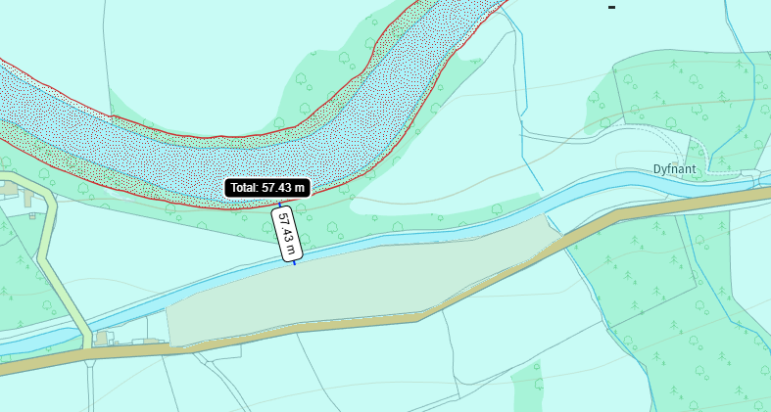  Field CD2 is located approximately 387 meters from the The River Usk SSSI Upper Usk (see map below).  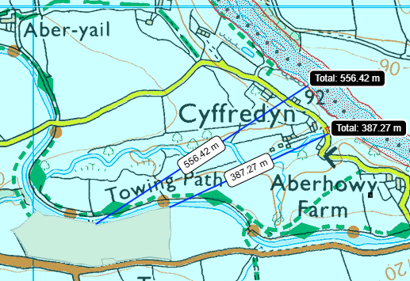  The rest of the fields in this deployment are over 500 meters away and have been screened out of this deployment application as they are not within screening distance of the River Usk SSSI.  For further information on this deployment the documents for this deployment can be found on the DMS.
- What aspects of the proposed permission are likely to damage the SSSI features of special interest?

The following activities are likely to cause damage:

      - Cultivation, including ploughing, rotovating, harrowing and re-seeding.

5. Application of manure, fertilisers and lime except to agriculturally improved
permanent grass, forest and all other unimproved riparian habitats.

7. Dumping, spreading, discharging or storage of any materials.

26. Use of vehicles, vessels or craft likely to damage semi-natural habitats or disturb
species of interest.

The following SSSI(s) features and potential impacts have been considered to assess the likelihood of damage:

Plants

- Welsh thread-moss
- Tiny pocket-moss
- Spruce’s bristle-moss
- River wort
- Rare aquatic lichen Endocarpon adscendens

Mammals

- Otter

Fish

- Atlantic salmon
- twaite shad
- sea lamprey
- brook lamprey
- river lamprey
- bullhead

A variety of invertebrates associated with exposed river sediments.

Potential impacts (mechanisms/pathways)

The main potential impacts assessed include deterioration of water quality, nutrient enrichment and algal blooms, through impact pathways including surface water run-off and/or leaching to the Upper Usk SSSI affecting the features of the SSSI listed above. However, the closest fields under this deployment are located 57 meters from the River Usk Where there is no direct impact pathway from fields IV WG2 & CD2 in range of the SSSI. The Brecon and Monmouthshire Canal is also a physical barrier to the SSSI and the fields listed in this deployment.

The deployment will also be operationally run to reduce impacts to the environment (standard controls) outlined in the deployment application and explained further below in section 7 of the SSSI assessment form. The land spreading activity is not likely to damage the features of the River Usk SSSI due to these reasons listed below.

- Summary of any informal advice received from internal experts (if required and including pre-app advice) | n/a Appendix 4 for information purposes only.
- Recommendation | The proposed permission is not likely to damage any of the flora, fauna or geological or physiological features which are of special interest  - Field IV WG2 contains a 10 meter no spread buffer zone in compliance with SR2010no4 due to the fields bordering the Brecon and Monmouthshire Canal. The no spread buffer zone adds additional distance from the fields to the SSSI (67 meters) further reducing the risk of surface runoff and/or leachate containing nutrients and/or PTEs into the SSSI.  - The Brecon and Monmouthshire Canal is physical barrier to the SSSI and the fields listed in this deployment significantly reducing the likelihood  nutrients and/or PTES from entering the SSSI.  - The dredgings were screened prior to spreading, oversized fractions are not being used in this deployment meaning incorporating the dredgings into the receiving soil is easier and minimizes the risk of runoff and/or leachate.  - Incorporation of the dredgings into the receiving soil will take place within 14 days of spreading and, wherever practicable, within 7 days of spreading. No sediment will remain as a permanent surface layer.  - No storage of the dredgings is proposed under this deployment reducing risks associated with storage.  - Wastes will be applied within reasonable hours, i.e., no spreading between dusk and dawn.  - Machinery is well maintained, and appropriate for the task, i.e., correct tyres/ tyre pressures for the field and ground conditions.  - Spill kits are attached to all machines.  - Following spreading, the fields will be reseeded as soon as practicably possible to minimize the risk of soil erosion/leachate.  - Additional or replacement machinery is available to continue the spreading operation in the event of a breakdown.  - No waste will be left in machinery, buckets and hoppers will be empty and clean at the end of each working shift.  There will be a sufficient number of trained staff available to ensure that the operation continues throughout operational hours.  - In the event of any spill or pollution incident, the Natural Resources Wales will be notified.
- Signature and date assessment made | Owen Clee 03/11/2026
- Officers name and job title | Owen Clee  Senior Waste Permitting Officer

