PAN-033213 My Map Report:

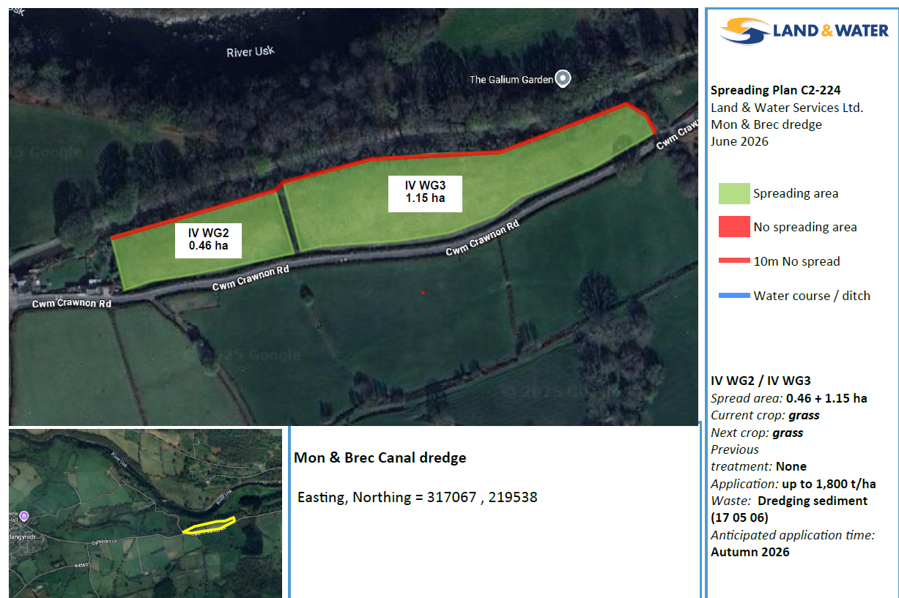
Submitted Maps

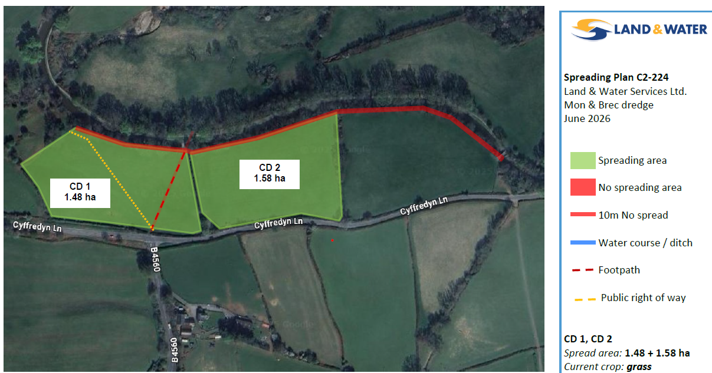

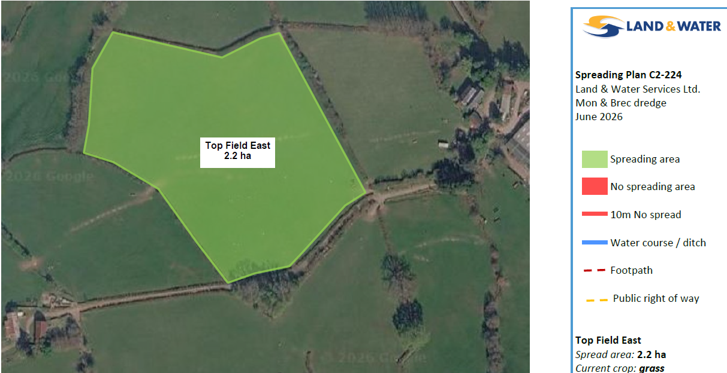

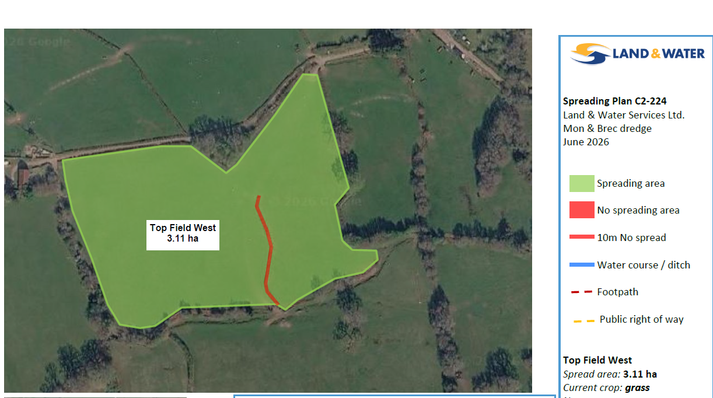

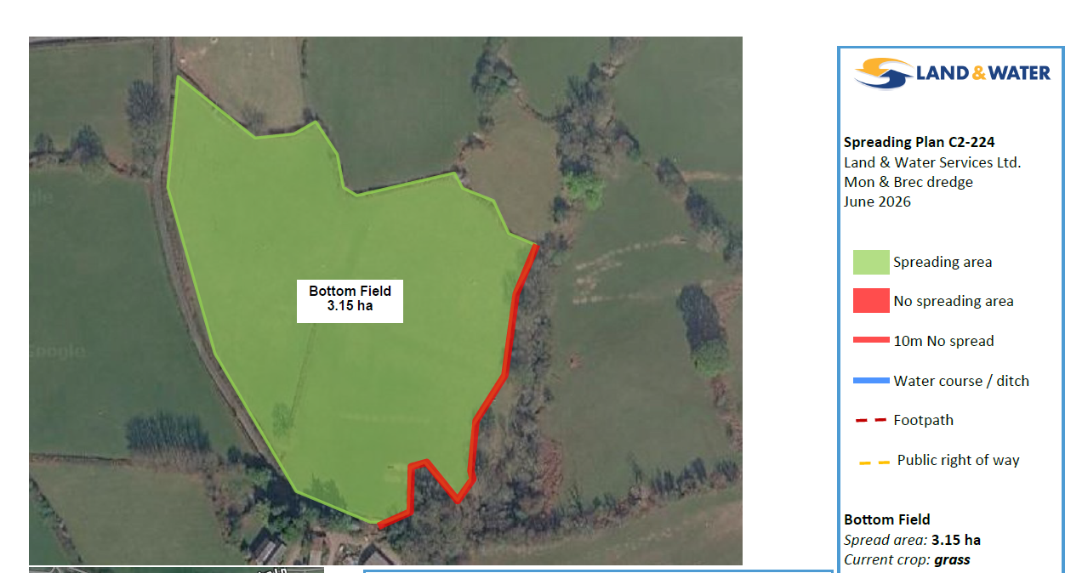

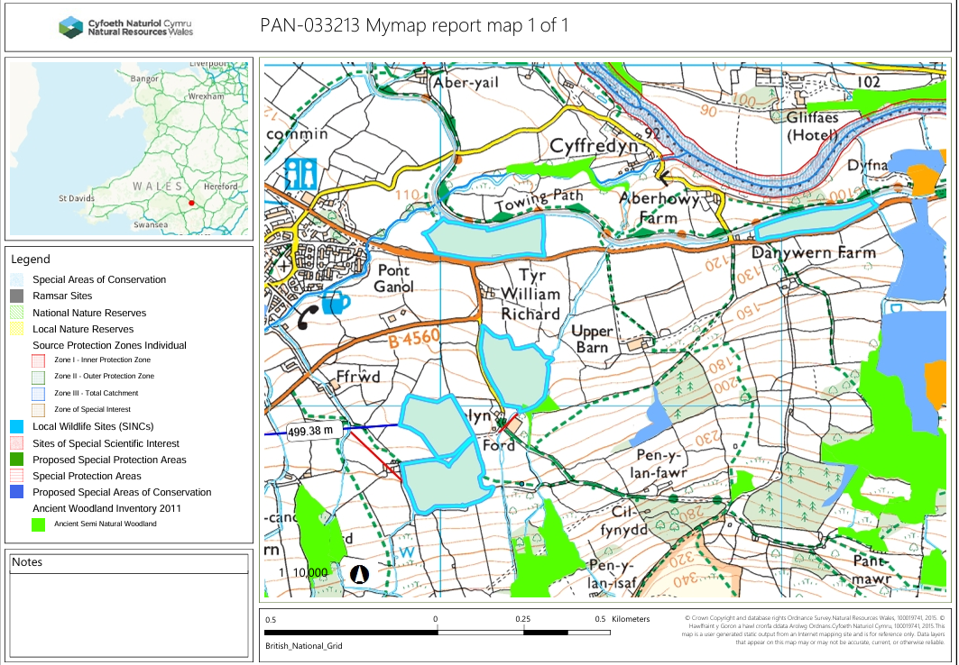
MyMap summary map

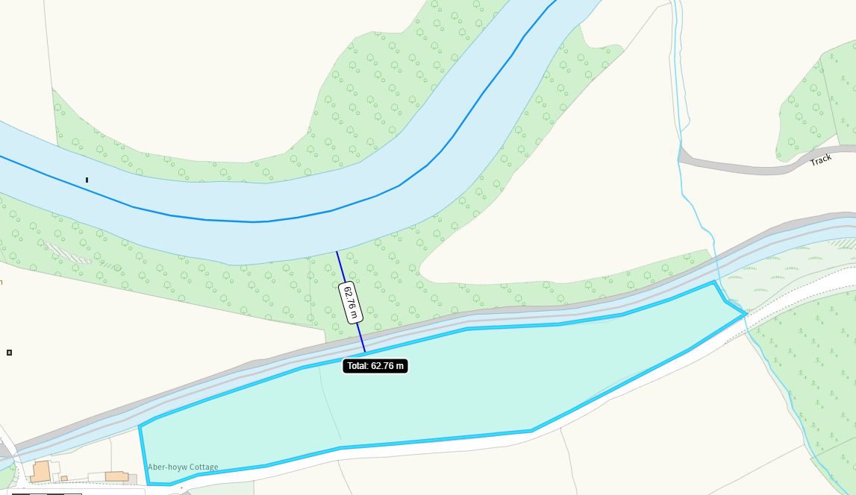
Detailed river network:
Field IV WG2 border the Monmouthshire and Brecon Canal. The submitted deployment map shows a 10 meter buffer zone to prevent the dredging waste from entering the water course in compliance with sr2010n04.
Field IV WG2 is also located 63 meters from the River Usk. Due to the proximity the field is from the River Usk and the implemented no spread 10 meter buffer zone, an impact pathway was not identified.

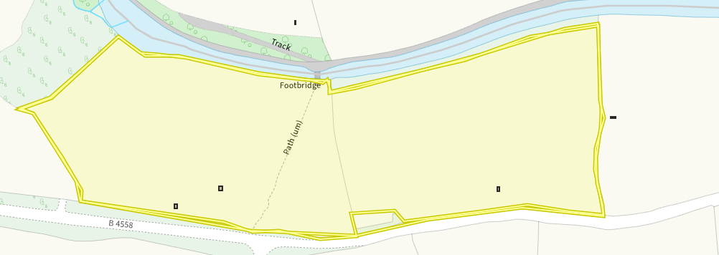

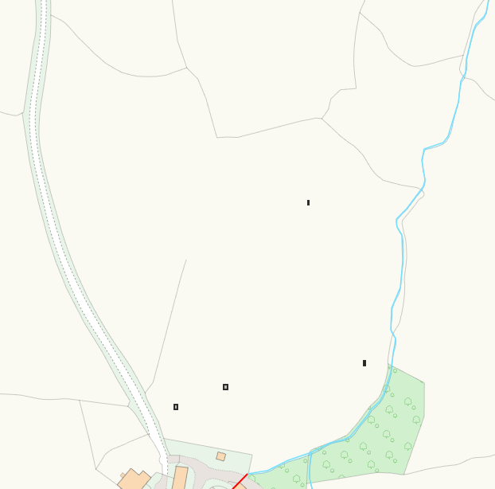
Field CD 1 & CD 2 border the Monmouthshire and Brecon Canal. The submitted deployment map shows a 10 meter buffer zone to prevent the dredging waste from entering the water course in compliance with sr2010n04.

Bottom field eastern side borders a water course. The submitted deployment map shows a 10 meter buffer zone to prevent the dredging waste from entering the water course in compliance with sr2010n04.

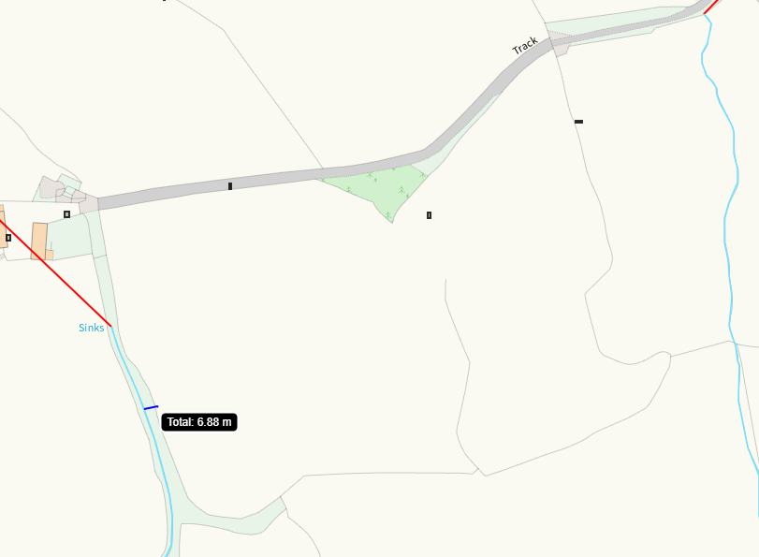
Top Field West Western side is borders a water course. This needs to be buffered to be 10 meters and was resolved in the RFI 1.

Groundwater protection zones (source) – none in range.

Wells, springs or boreholes used for the supply of water for human consumption including from a private water supply or supplies none in range.

any springs wells or boreholes not used to supply water for domestic or food production purposes within 50m none in range.

European designated sites- Natura 2000 (SPA, pSPA, SAC or cSAC) or Ramsar- or SSSI within 500m

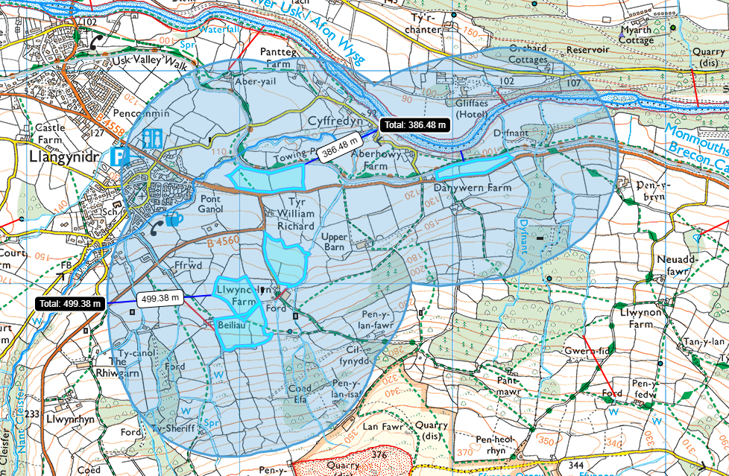
Field IV WG2 & CD 2 are located within 500 meters of the River Usk SSSI (Upper Usk) and River Usk SAC. displayed on site plan in ABS. For further information refer to appendix 4 assessment.

Other protected sites:

- Protected Species- none in range.

- Protected Habitats- none within the deployment fields.

- Scheduled Ancient Monument- none in range.

- Source protection zone none in range.

- Local Nature Reserve- none in range.

- National Nature Reserve- none in range.

- Ancient Woodlands-
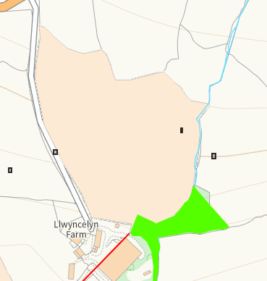
Bottom Field southern boundary borders an ancient woodland, a 10 meter no spread buffer zone is in place, however not marked on site plan. This was resolved in the RFI 1.

- Local Wildlife Sites (SINC)- none in range.

- National Park- All fields are located within the Brecon Beacons was resolved in the RFI 1.

- Public rights of way - correctly mapped.

- Groundwater Safeguard Zone- none in range.

- Hedges- nothing of concern

- Ditches- see slope map below

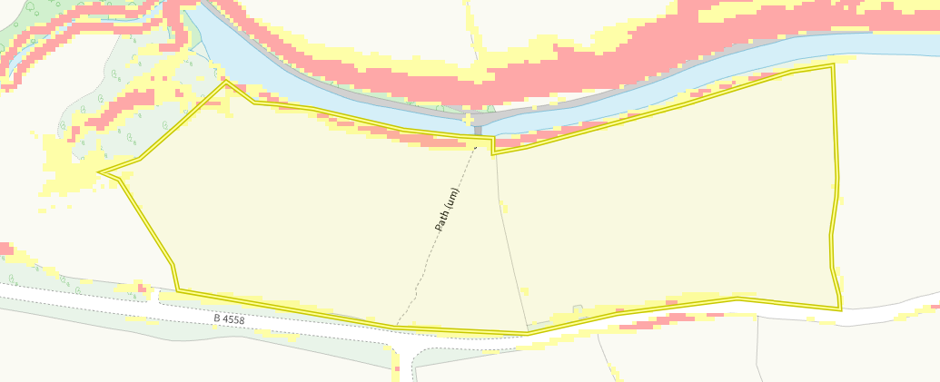
Slope Map
Field CD 1 and field CD 2 are located on flat to gently sloping land (0-7º) . There is not a surface runoff risk.

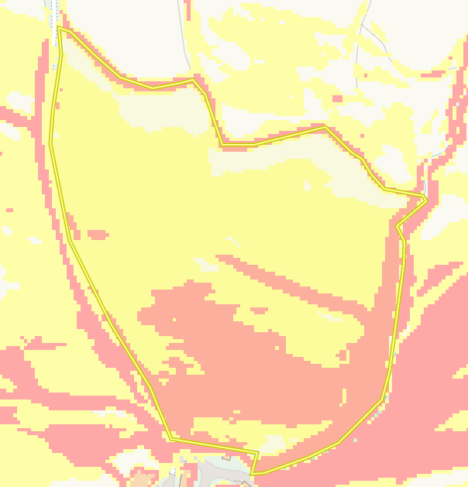
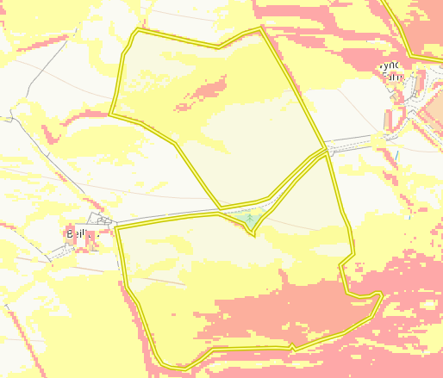
Top field west is located on moderately sloping and highly sloping land. The Waste being spread is stackable and is incorporated into the soil. The runoff is there for low, after soil incorporation the fields will be reseeded to further reduce the risk of soil erosion.

Top field East is located on moderately sloping land. The Waste being spread is stackable and is incorporated into the soil. The runoff is there for low, after soil incorporation the fields will be reseeded to further reduce the risk of soil erosion.

Bottom field is located on moderately (7-12º) & highly sloping land (12+º). The waste being spread is stackable and is incorporated into the soil. The runoff is there for low, after soil incorporation the fields will be reseeded with grass to further reduce the risk of soil erosion.

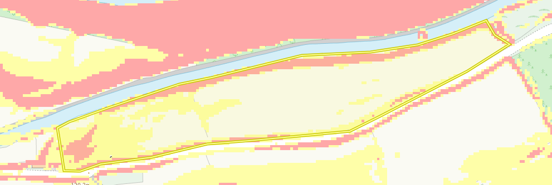
Fields IV WG2 is located on highly sloping land. The Waste being spread is stackable and is incorporated into the soil. The runoff is there for low, after soil incorporation the fields will be reseeded to further reduce the risk of soil erosion.

Flood risk

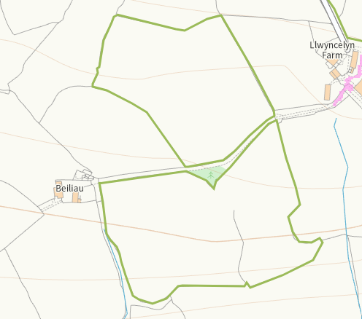
Top Field East & Top Field West is not located on a flood plain. No further action needed.

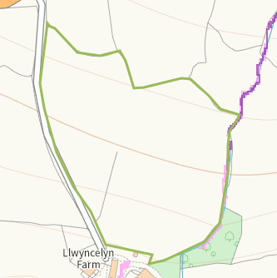
Bottom field is not located on a flood plain. No further action needed.

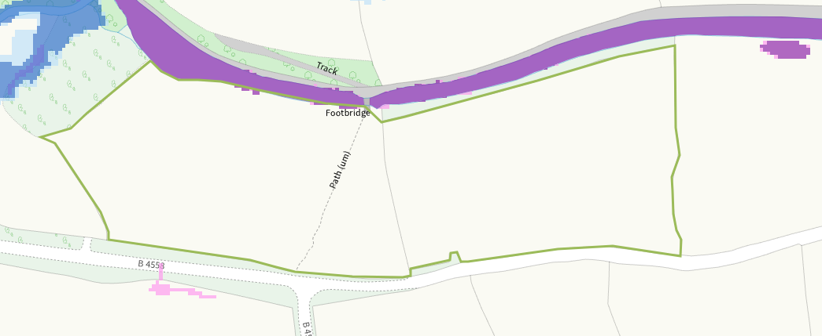
CD 1 & CD2 is not located on a flood plain. No further action needed. The northern edge near the fields is however there is a 10 meter no spread buffer zone in place due to the field bordering a water course.

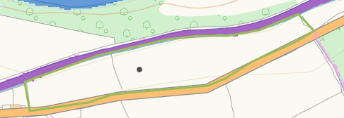
CD 1 & CD2 is not located on a flood plain. No further action needed. The northern edge near the fields is however there is a 10 meter no spread buffer zone in place due to the field bordering a water course.

